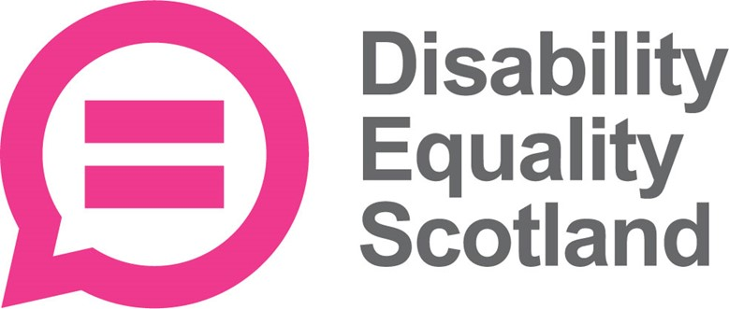
Survey about
the energy price cap
and your heating
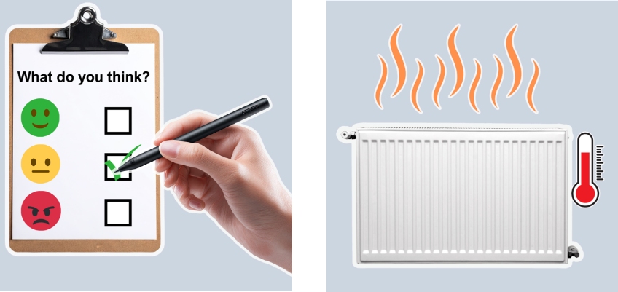


About this document
 | This is an Easy Read survey.
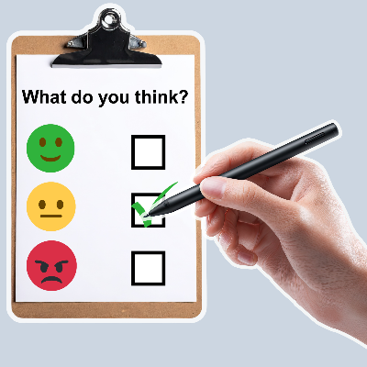 | A survey means a set of questions.  These questions ask you about your experiences now that the energy price cap has gone up.
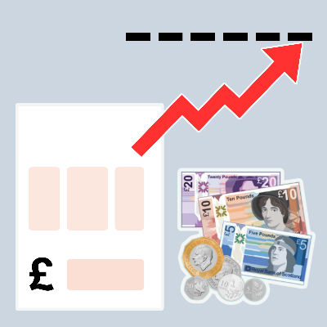 | The energy price cap means the limit that energy companies can charge you for the energy you use.

About this survey
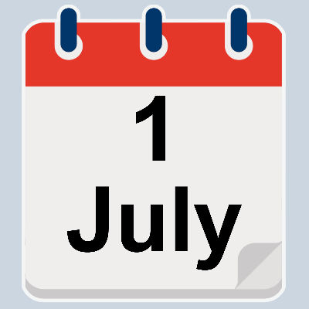 | The energy price cap has gone up 2 times since 1 July 2026.  This means that some people will pay more for their energy.
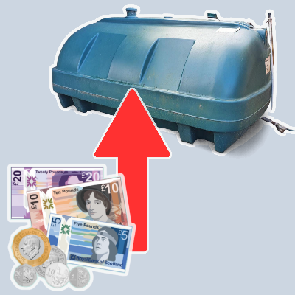 | The price of heating oil has also gone up.
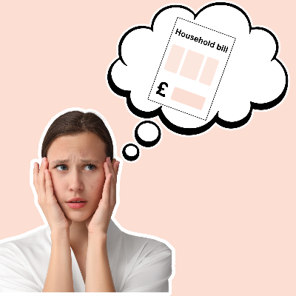 | Last year, people told us that the energy bill is the most difficult bill to pay for disabled people.
 | We want to find out what the new energy price cap means for disabled people.

Our questions
 | Answer our questions to tell us what you think.
 | If you are answering on a screen, you can click the little box next to your answer.  A tick will appear.  If you change your mind you can click it again.
 | If you are typing your answers the space will grow as you type.
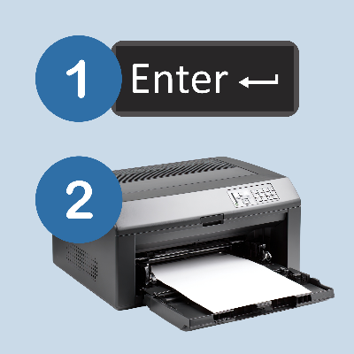 | If you are writing your answers on a paper copy use the Enter button to grow the spaces before you print the pages.

Question 1
 | Who is answering this survey?
 | I am answering the questions for myself. | ☐
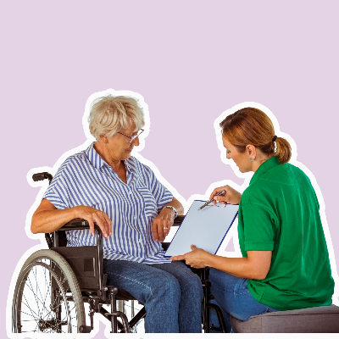 | I am answering the questions for someone else. | ☐

Question 2
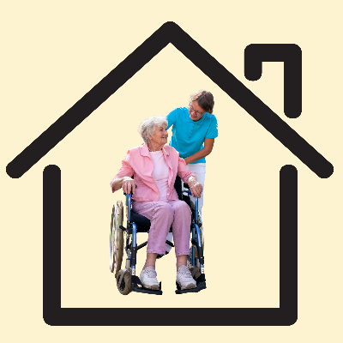 | Who do you live with?
 | I live on my own. | ☐
 | I live with my child or children. | ☐
 | I live with my partner or husband or wife. | ☐
 | I live with my partner or husband or wife and 1 child. | ☐
 | I live with my partner or husband or wife and children. | ☐
 | I live with my parents. | ☐
 | I live with a friend or a flatmate. | ☐

Question 3
 | Who is disabled at home?
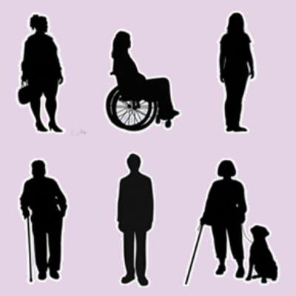 | Me. | ☐
 | My partner or husband or wife. | ☐
 | My child. | ☐
 | My children. | ☐
 | My friend or flatmate. | ☐

Question 4
 | Which council area do you live in?  Type or write your council below.

Question 5
 | Which of these is most true for you?
 | I live in a city. | ☐
 | I live in a town. | ☐
 | I live in a village. | ☐
 | I live in a rural area. | ☐
 | I live on an island. | ☐

Question 6
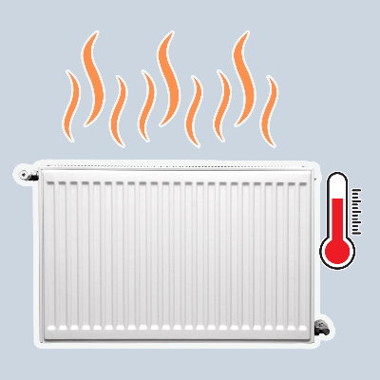 | What type of energy do you use to heat your home?
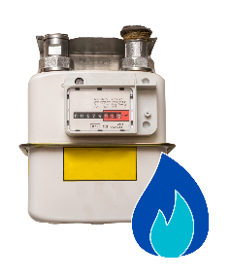 | Just gas. | ☐
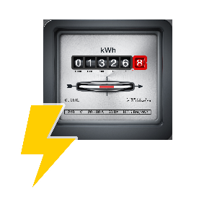 | Just electricity. | ☐
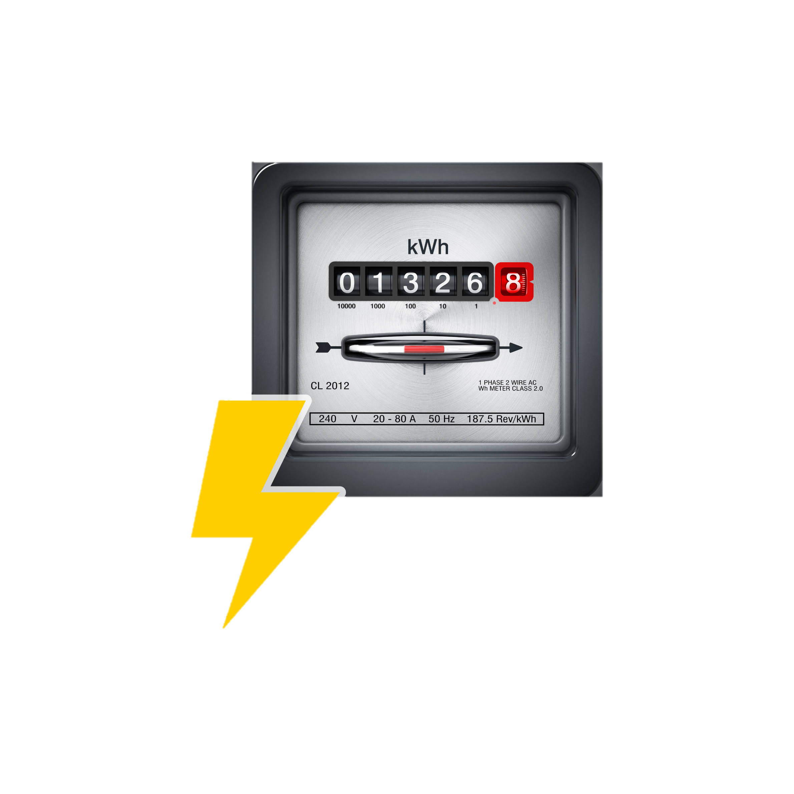 | Gas and electricity. | ☐
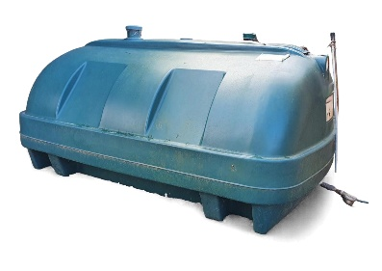 | Just heating oil. | ☐
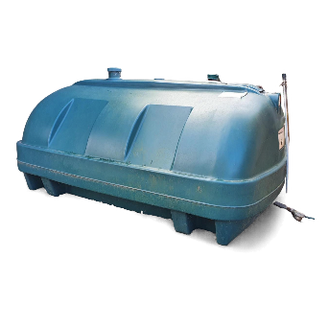  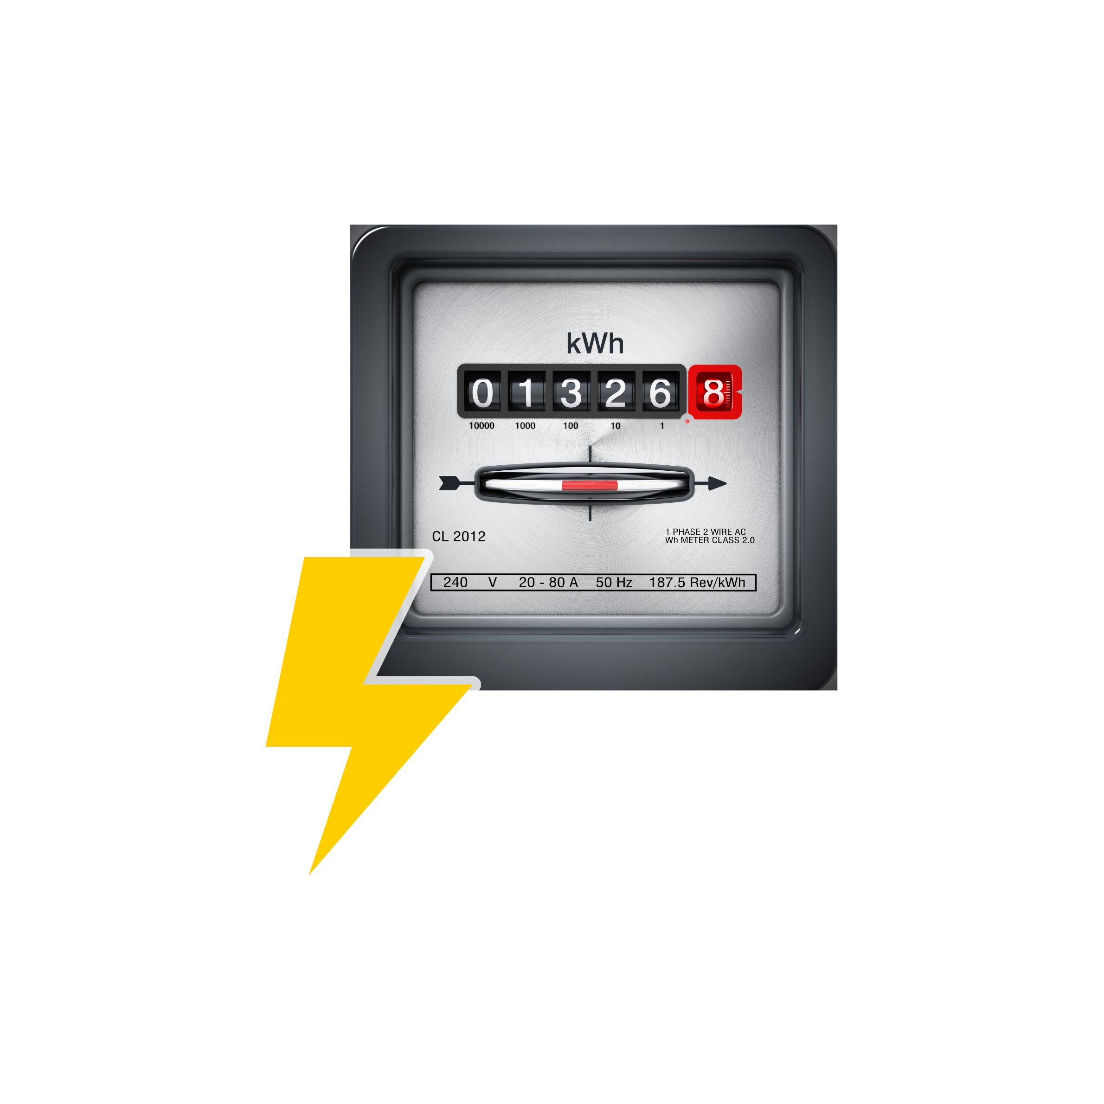 | Heating oil and electricity. | ☐
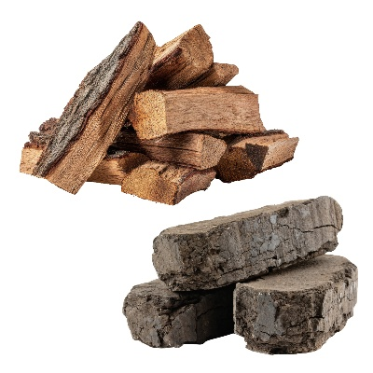 | Just wood or peat. | ☐
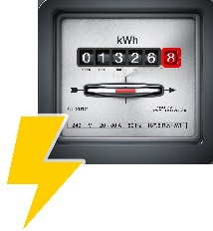 | Wood or peat and electricity. | ☐

Question 7
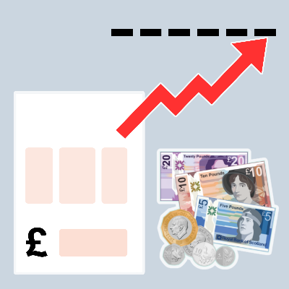 | What type of energy tariff do you have?  An energy tariff is a plan that tells you how much you will pay for your energy.
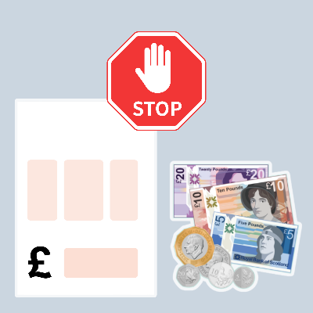 | I have a tariff that is frozen.  In this survey frozen means the tariff will not go up or down.  If you ticked this box please also answer question 9. | ☐
 | My tariff changes but it is still less than the energy price cap.  If you ticked this box please also answer question 10. | ☐
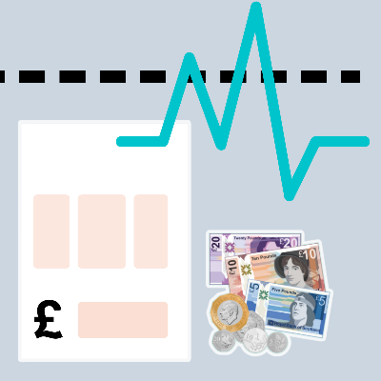 | My tariff changes with the energy price cap.  If you ticked this box please also answer question 10. | ☐
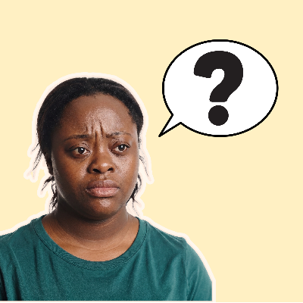 | I am not sure. | ☐

Question 8
 | Have you changed your energy company in the last year?
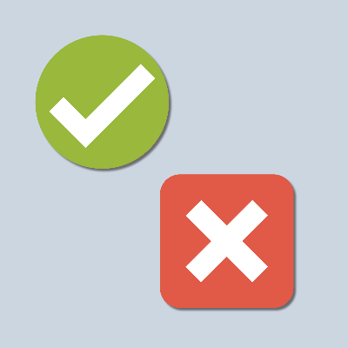 | Yes | ☐
 | No | ☐
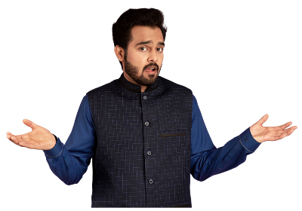 | I am not sure | ☐
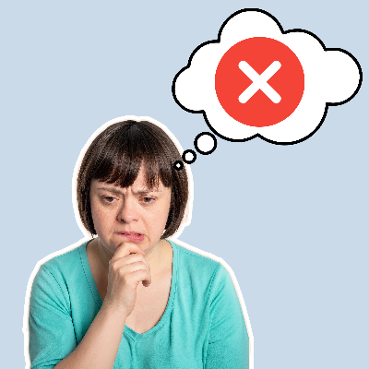 | I did not know I could change. | ☐

Question 9
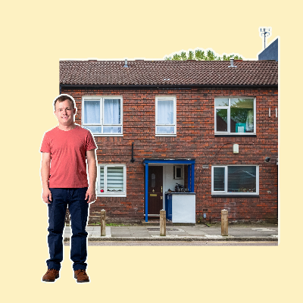 | For people who have frozen their energy tariff, how does freezing your energy tariff affect you?  This might include how independently you can live and get on with your daily life.  Type or write in the box below.

Question 10
 | For people who have an energy tariff which changes, how much extra are you paying since the new energy price cap?
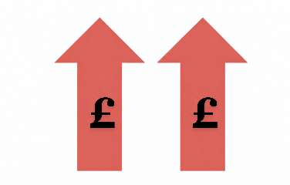 | I pay a lot more. | ☐
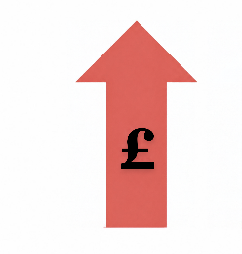 | I pay a bit more. | ☐
 | I pay about the same. | ☐
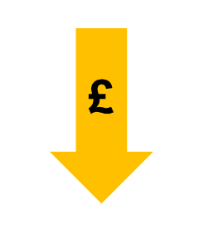 | I pay a bit less. | ☐
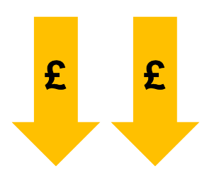 | I pay a lot less. | ☐
 | I am not sure. | ☐

Question 11
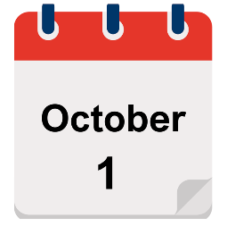  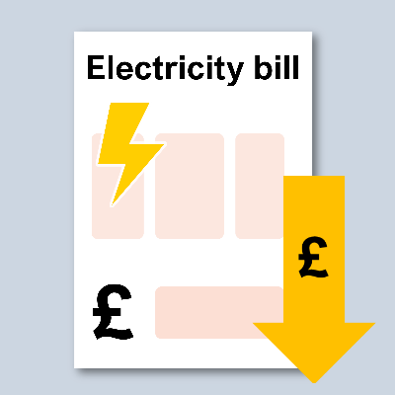 | The UK Government says it will charge less tax on electricity bills from 1 October 2026.
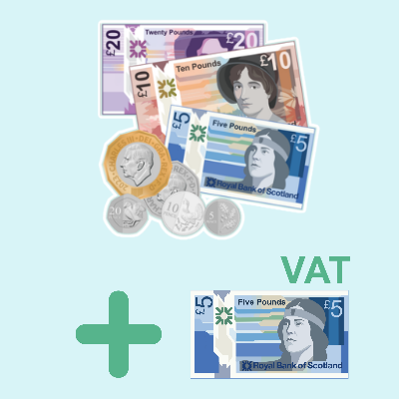 | Tax is the extra money we pay on top of a price, to help pay for the things our country needs.
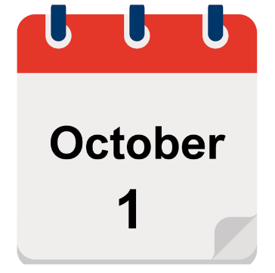  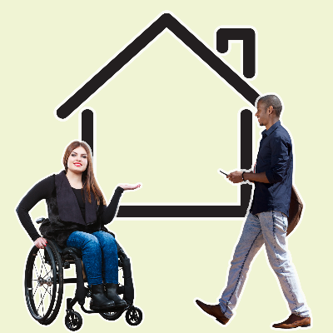 | Since 1 October 2026 when both the changes have been in place, how has your day to day life changed?  This might include how independently you can live and get on with your daily life.  Type or write in the box below.

Question 12
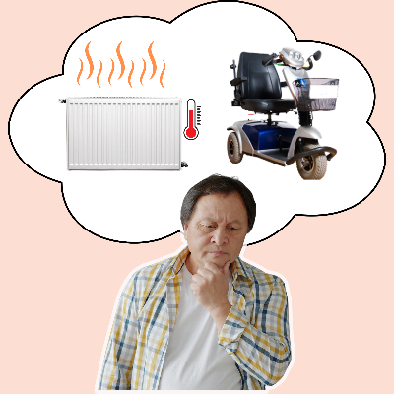 | Since 1 October 2026 when both changes have been in place, have you had to choose whether to turn on your heating OR use your personal independence equipment?  Personal independence equipment can mean things like hoists, mobility scooters or anything else than needs power.
 | Yes I have had to choose 1 or the other. | ☐
 | No I have used both. | ☐
 | No I do not have any personal independence equipment that needs power. | ☐

Question 13
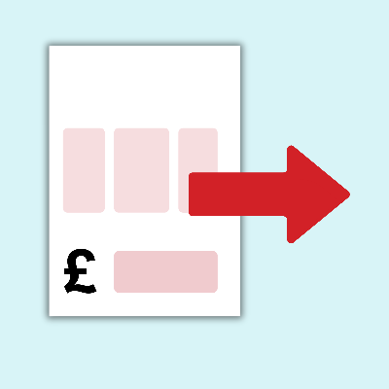 | How much of your income do you spend on heating your home?
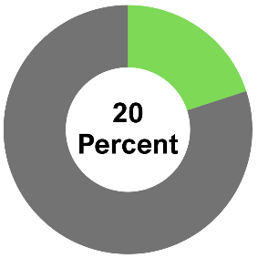   | More than 20 percent. | ☐
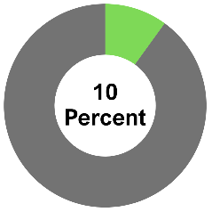  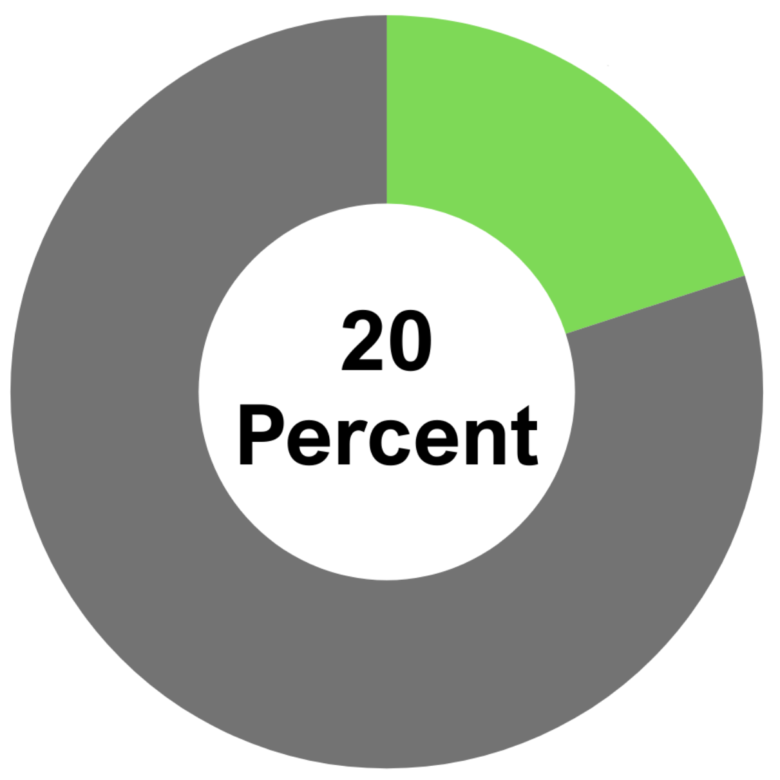   | Between 10 percent  and 20 percent. | ☐
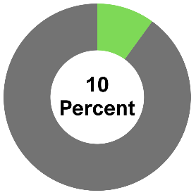 | Less than 10 percent. | ☐
 | I am not sure. | ☐

Question 14
What difference will the UK Government’s lower tax on electricity bills make for disabled people?
Type or write in the space below.

Question 15 – This question is just for people who use heating oil.
 | How much has the cost of heating oil gone up in the last 6 months?
 | It has gone up a lot. | ☐
 | It has gone up a bit. | ☐
 | It has not changed. | ☐

Question 16 – This question is just for people who use heating oil.
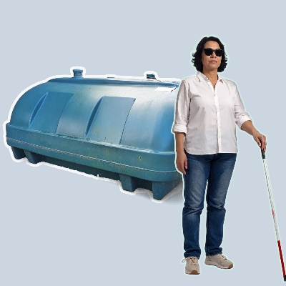 | How has the change in heating oil prices changed your day to day life?  This might include how independently you can live and get on with your daily life.  Type or write in the box below.

Question 17 – This question is just for people who use heating oil.
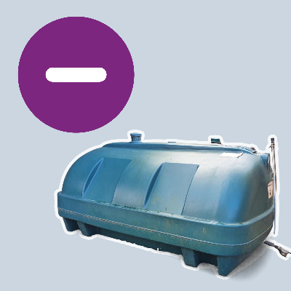 | Have you bought less heating oil over the last year because of the price?
 | Yes I have bought less oil. | ☐
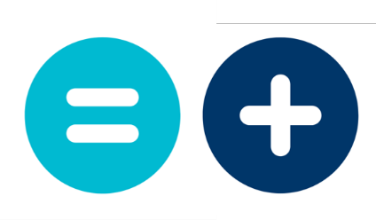 | No I have bought the same amount of oil or more. | ☐
 | I am not sure. | ☐

Question 18 – This question is just for people who use peat to heat their homes.
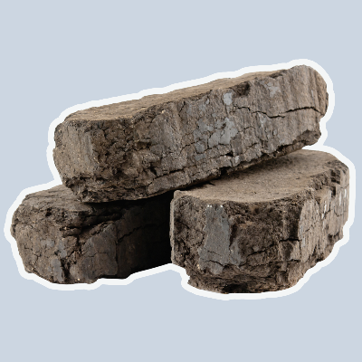 | Peat is a kind of soil, cut from the ground in blocks.  How much has the cost of peat gone up in the last 6 months?
 | It has gone up a lot. | ☐
 | It has gone up a bit. | ☐
 | It has not changed. | ☐

Question 19 – This question is just for people who use peat.
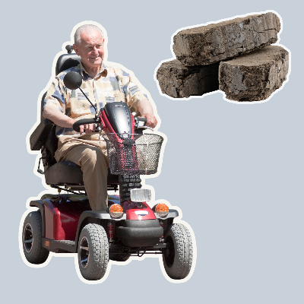 | How has the change in peat prices changed your day to day life?  This might include how independently you can live and get on with your daily life.  Type or write in the box below.

Question 20 – This question is just for people who use peat.
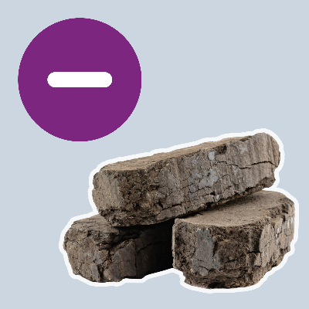 | Have you bought less peat over the last year because of the price?
 | Yes I have bought less peat. | ☐
 | No I have bought the same amount of peat or more. | ☐
 | I am not sure. | ☐
 | This is the end of our survey.  The pictures are from BaseSix, Canva and Age Without Limits.

