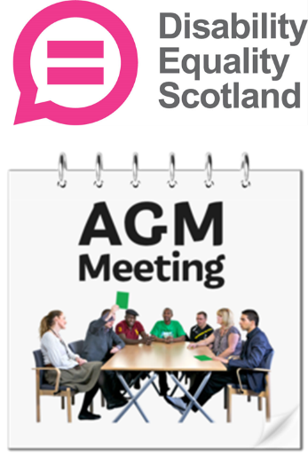
Disability Equality Scotland

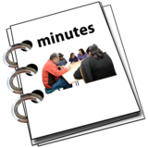
Annual General Meeting
2023 Minutes

Easy Read
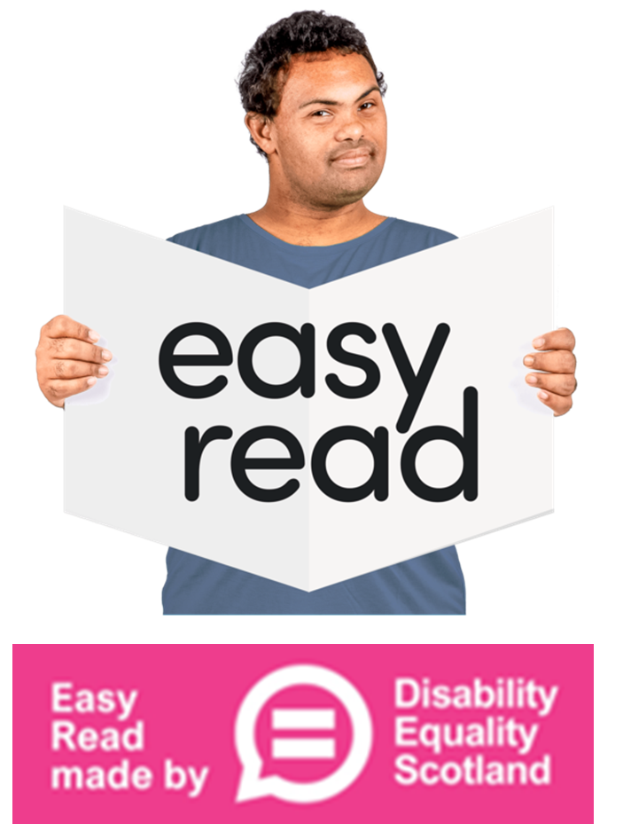

About this document
 | This is an Easy Read document.
 | It is a Minutes document.
 | Minutes means it will tell you what was talked about at our Annual General Meeting in 2023.

About the Meeting
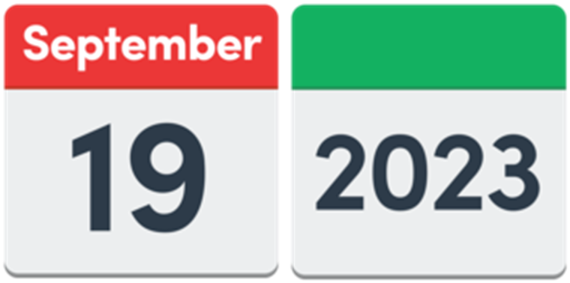 | The meeting happened on 19 September 2023.
 | People joined this meeting in 2 ways.  Some people joined online with Zoom.  Some people came to The Barracks Conference Centre to meet face to face.

Who joined this meeting
 | Members  Naseem Anwar  Linda Bamford  Douglas Bryce - Staff  Ian Buchanan - Staff  Kayla Megan Burns – Convenor  Joanne Devitt  Marian Dick  Frank Drummond  Isabella Gorska  Carolyn Griffiths  Marie Harrower  Ken Johnston  Peter Joyce
Shona McEwan - Staff
Sheila McGhee
Kenny Milne
Jane Moncrieff
Lyn Pornaro – Chief Executive Officer
John Stewart
Scott Stewart – Treasurer
Derek Todd
Zara Todd
Jim Tolmie
John Whitfield
Carolyn Wilson-Smith
Others

Holly Bryon-Staples
Calum Byers
James Davidson - staff
Ian Gallagher - staff
Sonya Kunawicz - staff
Jo Mathews
Yulia Ovcharova - staff
Diane Theakstone

Welcome
 | Kayla Megan welcomed everyone and started the meeting.

The last AGM’s Minutes
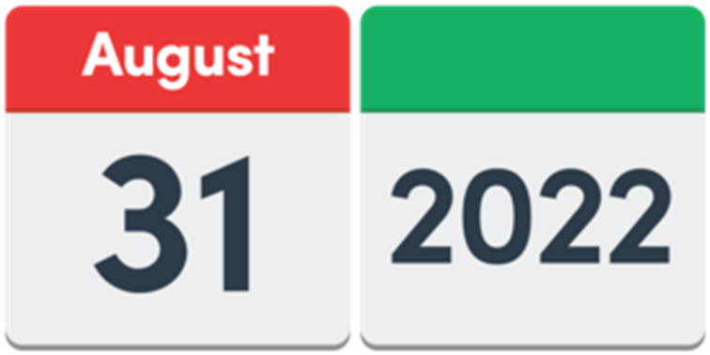 | The last AGM happened on 31 August 2022.
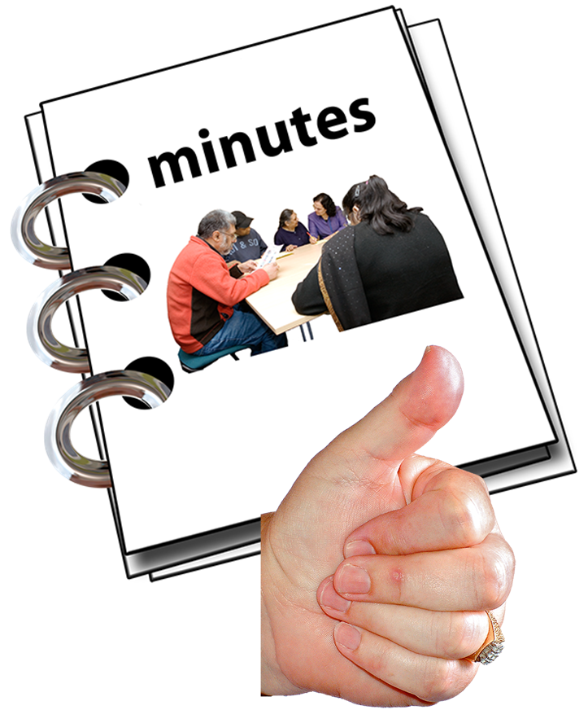 | Everyone agreed that the Minutes document about that meeting was fine.

Annual Report
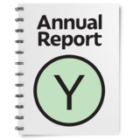 | Lyn had shared the Annual Report before the meeting.  And she talked about it earlier in the day at the Celebration Event.
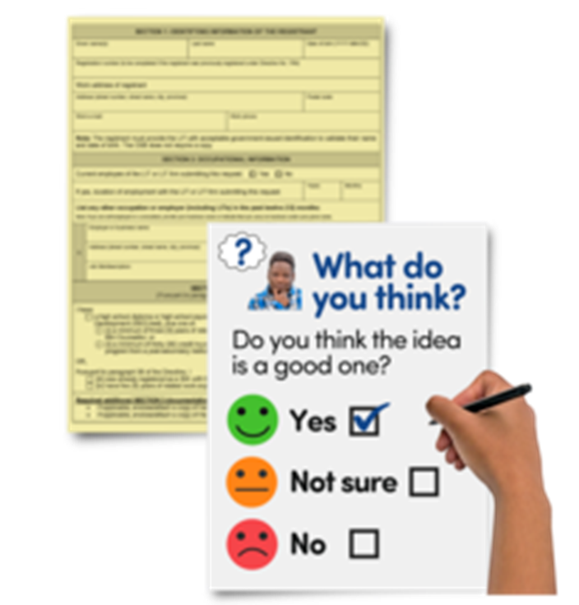 | There were 2 questions to answer:  - Why are consultations not published with an Easy Read version at the same time as the original version?
 | Consultations are questions from the Scottish Government to ask what everyone thinks about new ideas.
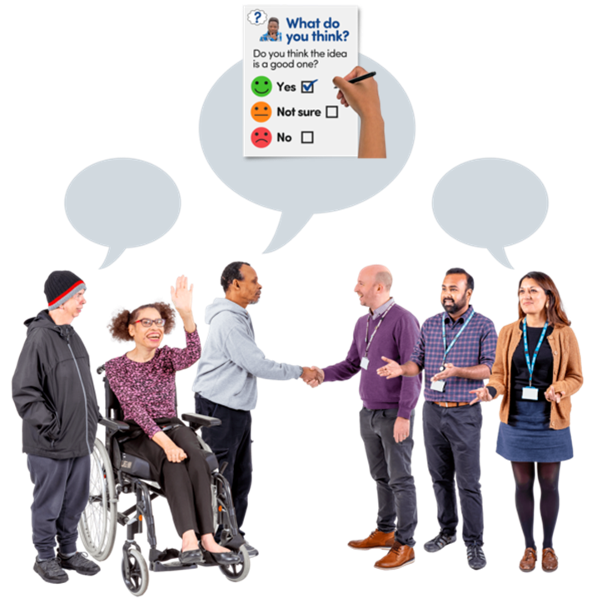 | Lyn said that we are talking to Scottish Government about this.  Some consultations have had an Easy Read version and timing is getting better.
 | - Can we have a list of the partners and organisations that work with Disability Equality Scotland?  Lyn said yes, this is a good idea.

Money information
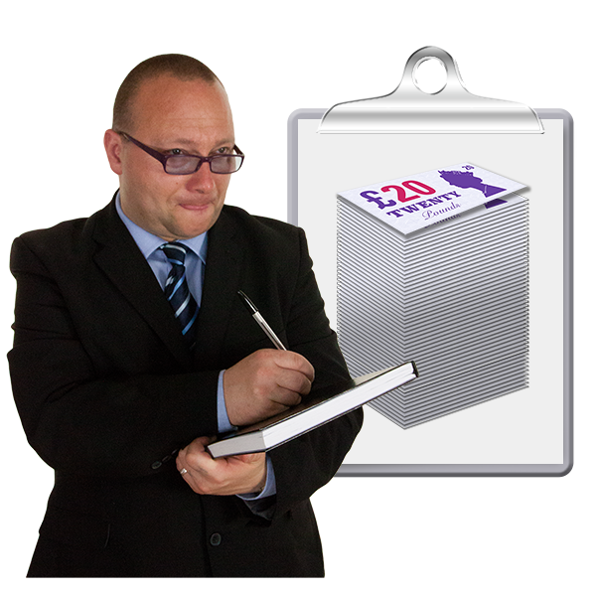 | Scott shared the money report for the last year.  He said that it had been checked by independent experts.
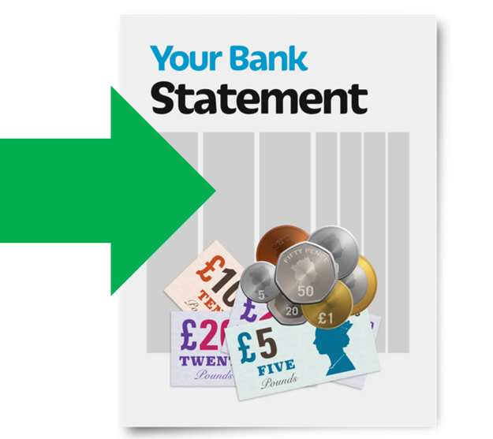 | The total amount that had come in over the year was 4 hundred and 10 thousand pounds.
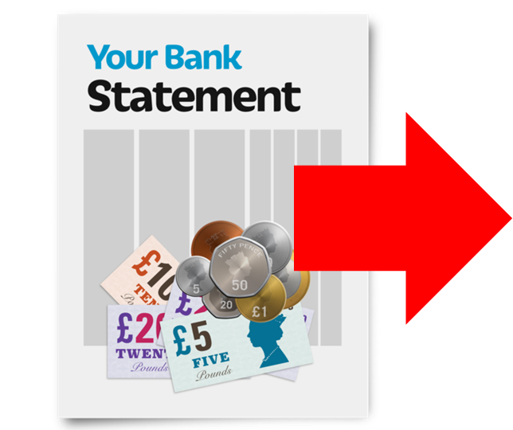 | The total amount that had been spent over the year was 3 hundred and 76 thousand pounds.
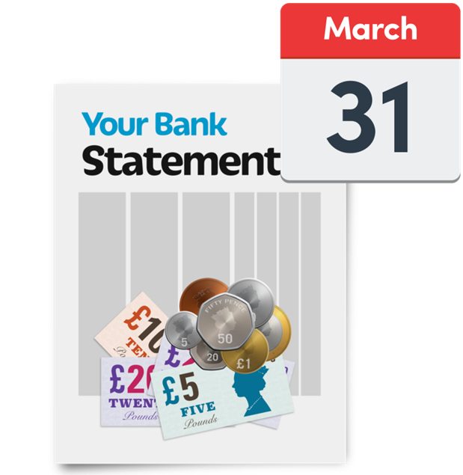 | On 31 March 2023, Disability Equality Scotland had 1 hundred and 82 thousand pounds in the bank.
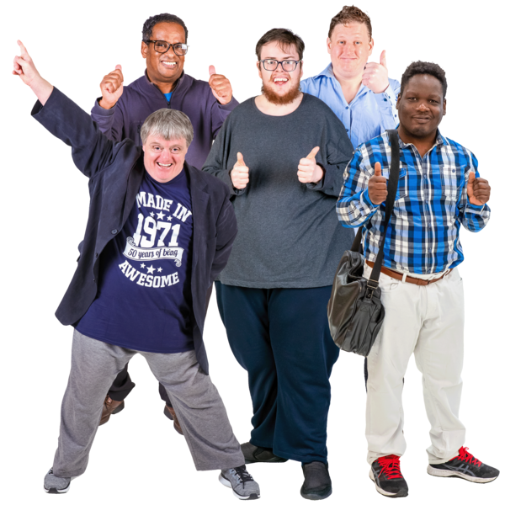 | Everyone agreed this money information.

Changes
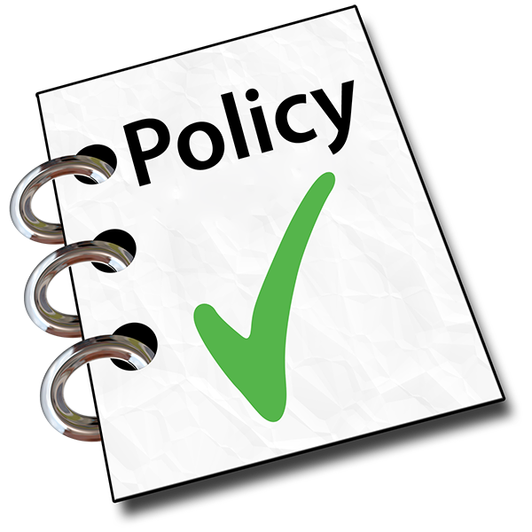 | Kayla Megan said that there are important policy documents called Articles of Association – or Articles for short.
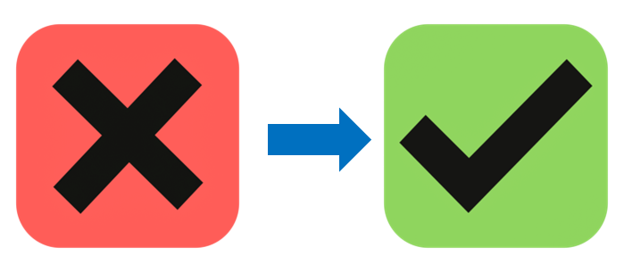 | Sometimes wording in these Articles needs changing as the years go by.
 | The first vote was to change ‘junior members’ to ‘young people’.  All the members who voted agreed this change.

New examiners
Examiners are the experts who check our paperwork and money.

They are independent and fair.

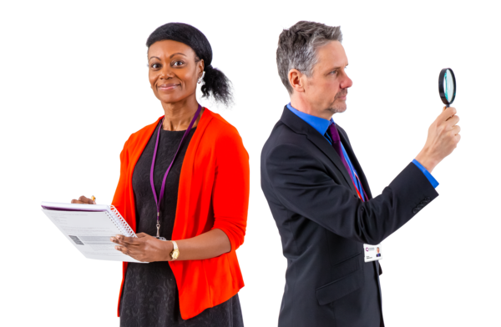 | The second vote was to ask the trustees to find a good examiner.  Trustees are the people who make sure the charity does what it says it will.
 | All the members who voted agreed this change.

New Board members
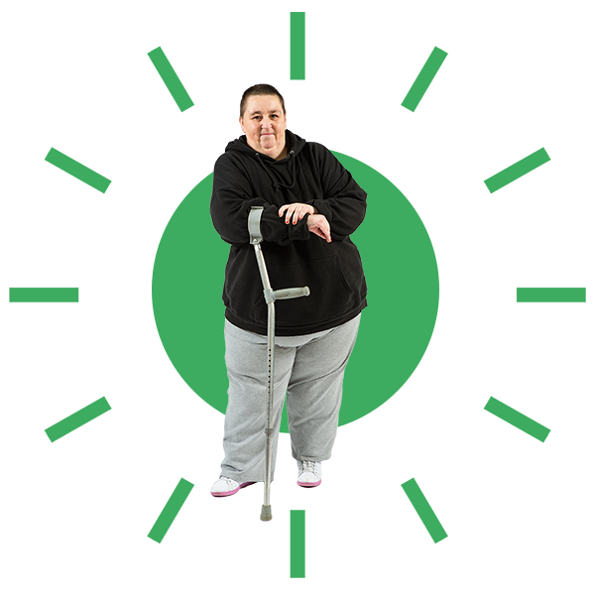 | Kayla Megan said that we need to vote for a new trustee.
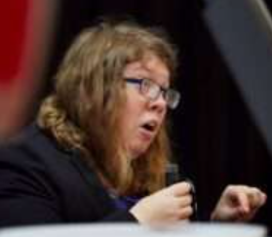 | Zara Todd has joined the board of directors since June 2023.  She works hard to make good changes happen for disabled people.
 | Every member who voted agreed that Zara should become a trustee.
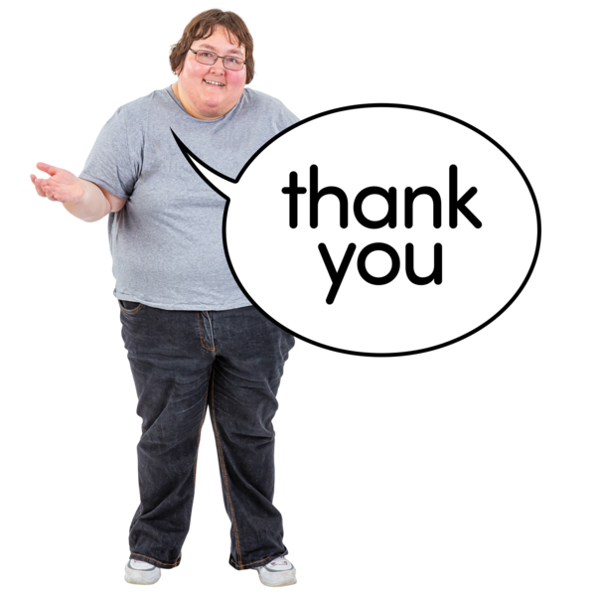 | Kayla Megan thanked everyone for joining this AGM and closed the meeting.

