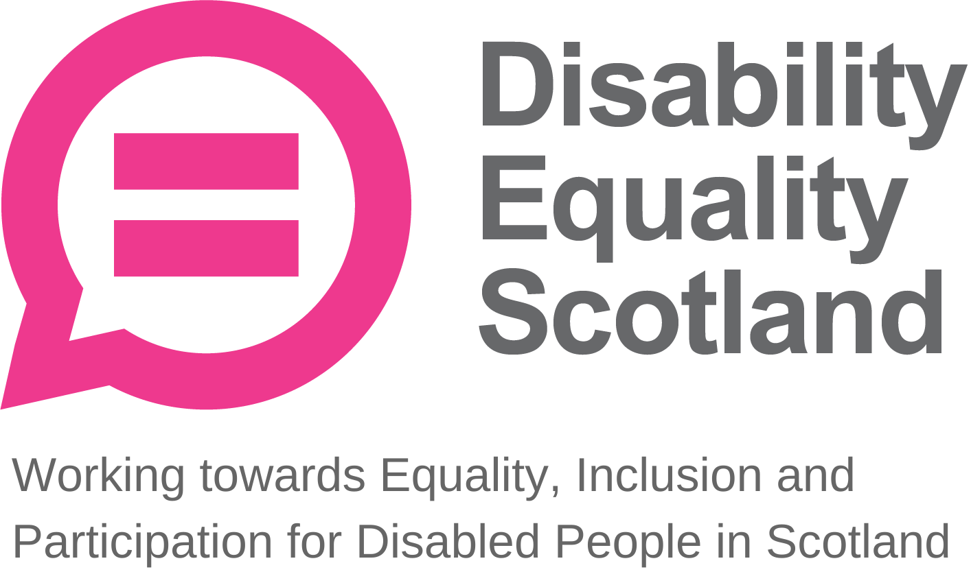
Disability Equality Scotland
Meeting of the Board of Directors
Wednesday 27 July 2022 10.00am
Hybrid meeting – Motability Operations and Zoom

In Attendance: Kayla Megan-Burns (KMB) Convener
Carolyn Wilson-Smith (CWS) Vice-Convenor
Rhianne Forrest (RF) Director
Dorothy McKinney (DMcK) Director
Maureen Morrison (MM) Director
Scott Stewart (SS) Director
Linda Bamford (LB) Director
Marie Harrower (MH) Director

Morven Brooks (MB) Chief Executive Officer
Ian Buchanan (IB) Equality and Access Manager

James Davidson (JD) Communications and Research Officer
Calum Byers (CB) Access and Engagement Coordinator
Shona McEwan (SMcE) Easy Read Worker
Claire Jagger (CJ) Easy Read Worker

Apologies: Kenny Milne Director
Lauren Asher Director
Colin Millar Director

Item 1 Welcome and brief Introductions

KMB welcomed everyone to the meeting and apologised for the technical difficulties and noted this was our first ever hybrid board meeting and thanked IB and CB on their efforts of organising it.

KMB thanked the Board for having them as the chair and hoped this was the first of many positive engagements to come.

Apologies were received from KM, CM, and LA after the meeting was held.

KMB confirmed that the meeting was quorate.

KMB asked that board members and staff remain on mute and raise their physical or virtual hand should they wish to speak.

KMB confirmed that the board briefing paper surrounding mileage had been dealt with via e-mail and that a discussion would instead be held on CEO recruitment. KMB confirmed that the agreement was to return to the previous mileage rate (rather than the reduced rate as part of financial recovery measures) now that organisational finances had stabilised and in response to the rising fuel costs to ensure no volunteers were out of pocket.

KMB requested any director with a conflict of interest regrading the CEO recruitment to declare. SS declared a potential conflict and confirmed he would excuse himself and leave the room for any related discussions.

Item 2 Agreement of Minutes from last meeting

KMB stated that the minutes were emailed for comment and checking shortly after the April 2022 board meeting and asked for confirmation from the board on accuracy and content.

KMB asked if all actions or matters arising from the minutes had been picked up. This was agreed. KMB asked for agreement of minutes from Directors present at the previous meeting.

Proposed by: DMcK
Seconded by: LB

Item 3 Outstanding actions April 2022 Board Meeting

DMcK confirmed completion of action and domestic abuse policies were sent to MB on 22 April.
Item 4 Approval of New Members
KMB and MH declared a conflict of interest as they have recently joined as members and excused themselves from this part of the meeting. CWS took over the chair of the meeting in her capacity as Vice-Convener

MB stated that during the period of 31 March 2022 to 27 July 2022 we had 47 new members join of which 37 were individual, 7 corporate, and 3 young members.

MB confirmed that this now brings our total membership to 1464 and stated that this is a 3.3% increase in total membership during the quarter as opposed to a 2.9% increase during the last quarter.

CWS asked if everyone is happy to approve the new members.

Proposed by: DMcK
Seconded by: SS

The board approved the new members.

It was noted a new member is BBC. There was a discussion to ask if there is an opportunity here to engage with this new member to help promote our campaign messages. MB confirmed yes and agreed to contact BBC to discuss.

KMB and MH re-joined the meeting and KMB resumed the chair.

Action 1: MB to reach out to BBC member to ask if there is an opportunity to share our campaign messages.

Item 5 CEO’s Update

MB asked the board if there were any questions on her update.

LB asked about the face covering exemption campaign.

MB explained that if restrictions are reintroduced then Disability Equality Scotland (DES) were ready to support the campaign again but there is no mention of a physical exemption card returning and that the download option is working well.

LB asked whether there will be an Access Panel in every local authority area, noting from the update that all 32 Local Authority areas were not represented. MB confirmed she was working closely with the EAM to implement this.

MB updated that she attended an active travel workshop in partnership with Network Rail and Sustrans Scotland to take forward our Disability Equality and Access Learning (DEAL) training and that there was a positive conversation with Sustrans Scotland concerning training.

MB confirmed that Access Panels would be crucial in making sure the training delivery was accessible and reflected lived experience.

MB updated that there is currently a pause on the hate crime training but there are plans to carry out a pilot with First Bus and Scotrail.

LB asked if she could share the baseline data report to support the hate crime training project with her network and MB confirmed this would be useful.

KMB thanked MB for her update.

Deputy Chief Executive Officer (DEPUTY CEO) Report

MB confirmed that the Deputy CEO left her post at the end of June 2022 and this was her last update.

DMcK asked if the wording in the Deputy CEO update surrounding the engagement with Police Scotland could be updated. MB confirmed the update would be made and that she had had positive engagement with Police Scotland.

JD provided an update on the meeting he had with the Health and Social Care Alliance (the Alliance) about the cost-of-living crisis. There is another weekly poll planned on the cost-of-living crisis at the end of August followed by a potential webinar.

LB asked JD to share the poll results with the poverty and inequality commission which JD agreed to do.

Action 2: JD to share weekly poll results with the poverty and inequality commission.

Action 3: MB to update reporting on Hate Crime Training with Police Scotland in Board Papers.

Equality and Access Manager’s Report

IB asked for any questions on his report.

MB congratulated IB and CB on their work around the Access Panel Grants (APG) and MB stated she had received positive messages from Access Panels regarding this.

KMB congratulated the team on the Investing in Communities Fund (ICF) application and asked that the Board is kept updated as to the outcome of the application.

Action 4: IB to update board on the outcome of the ICF funding application

Action 5: IB to share link to the new Access Panel Network website with all Directors and Staff.

Board Annual Calendar of Activities

MB highlighted that the Annual General Meeting (AGM) is taking place on the 31 August 2022. MB is finalising the year end accounts and will share with CM.

CB confirmed that a total of 35 people are registered to attend. 9 in person and 26 online.

Action 6: MB to share draft accounts with CM.

Quarterly complaints and feedback
MB stated that there had been no complaints this quarter.

Feedback received from the team leader at the Scottish Government vaccine research team on the high quality easy read work being undertaken at DES.

KMB thanked the easy read team for their hard work.

Reflective learning log

MB stated that no reflective learning had been logged this quarter.

MB asked for any questions from the board on the complaints or reflective learning sections. There were no further questions.

Finance

MB reported that there is over £130,000 in reserves and that we are on track to achieve the reserves policy target of £140,000, 6 months operating costs to provide employment security for our staff team as funding applications were fragile and unstable.

MB confirmed that the money from Garfield Weston has been spent and reported and the Easy Read Trainer role will now be paid from the designated income from the service, which is currently at £9,250.

MB updated that the Access Panel Grant (APG) spend is going well, ahead of the September deadline and thanked IB and CB for their work on the APG.

LB suggested that some APG money could be spent on AGM to offer additional support to Access Panels for travel and expenses, particularly considering rising fuel costs. MB confirmed that Access Panels are already aware of this but IB will update them.

MB asked for any questions from the board on finances. There were no questions from the board.

People

MB expressed her sadness at moving on to her new role with Voluntary Action Orkney but confirmed that Douglas Bryce has been appointed as the new Deputy CEO and will start on 15 August. Douglas has a background in working with Judo Scotland and Lothian Community Transport.

MB confirmed the new project coordinator for the Transport Scotland research project starts today. IB will be in the office later to carry out induction.

LB thanked MB for all the work she has done at Disability Equality Scotland and the board agreed.

Risk Management

The board agreed to update DES07 to reflect the CEO departure. KMB agreed to take this forward with MB and develop business critical transition plans to manage associated risks.

Action 7: MB and KMB to update the Risk Log to reflect CEO departure and develop business critical transition plans.

Challenges for Next Quarter

MB said she has been keeping up with quarterly reviews in the absence of a DEPUTY CEO and that she is here until 7 October.

Priorities for Next Quarter

MB explained her priorities for the next quarter is ensuring that the Deputy CEO and Equality and Access Manager are fully supported.

KMB asked for any questions. There were no other questions.

KMB proposed to extend the meeting by 10 minutes and the board agreed.

*At this point there was a 10-minute comfort break*

Item 7 Future Board Meetings

KMB asked directors whether the current board meeting format is working for them and that they want to make sure directors feel valued.

CWS said that a high level of scrutiny was needed over a period but that a balance could be struck between making sure Directors feel supported and valued and the level of scrutiny.

DMcK said that the board meetings depend on directors reading the papers in advance and that it is important to have the opportunity to discuss issues as a board considering we are moving into a hybrid format.

KMB asked whether there needed to be a more social aspect to board meetings.

DMcK said that a face to face away day could be a good opportunity to get to know each other better.

MH stated she enjoys the motivation Monday emails and enjoys that directors are kept up to speed with operational activities but that she would like to meet everyone soon.

KMB thanked MB for carrying on with the motivation update emails in the absence of a Deputy CEO.

MM suggested that when the new CEO and Deputy CEO are in post that the staff team and Directors meet up and get to know each other. The board agreed to this.

MM also stated that she enjoys the structured nature of the board meetings.

LB said she found the introduction of board briefing papers particularly useful and that she prefers a theme so the conversation is output driven.

MB confirmed that she will be revisiting the sub-committee structure.

Action 8: MB to communicate to all Directors about the Sub Committees and re-establish these groups. MB will also start planning on a future away day.

Item 8 Briefing Paper 1: Fundraising Strategy

MB stated the need for a fundraising strategy and ideas for generating income, how it can be designated, and how it can be spent.

MB confirmed that any money generated would only be spent after the trigger point for the reserves target and that she would build up the budget before any communication went out.

DMcK said she would like to see a more visible connection with strategy and that this would be more impactful and allow the team to see where it fits. MB said she would make that clear in the paper.

SS said that when the target for income generation is reached, we could then determine the next target and the CEO could approach the board with a paper to decide what the next funding target would be.

LB confirmed that she would like to see this focus around member and Access Panel engagement.

MB confirmed that this would provide a governance structure.

MM stated that she has an exclusion list of people they will not take money from. MM happy to share this list with MB and support any work taking it forward.

LB confirmed that the SG had already circulated a list of “excluded partners” for those receiving government finding and that this also needed to be cross checked.

MB will rework the fundraising strategy document and re-issue.

Action 9: MB to update Fundraising Strategy following feedback and will re-present to the board for approval.

Item 9 CEO Recruitment Discussion

SS excused himself from this part of the meeting and stepped out due to a conflict of interest.

KMB confirmed that there are large changes happening and this can produce instability but there is a new opportunity for change from this process.

MB confirmed the advert for the CEO position was going live that afternoon.

DMcK said she was hesitant for a second interview to be part of the process; due to the amount of time it could take for the candidate and the lack of clarity on the purpose and how this would impact on the decision-making process.

IB said that a second interview should not be too much of a surprise to a candidate applying for a CEO position.

DMcK said that a second interview can be useful if there are things on the competency list, we are not comfortable with and which could be picked up in a second interview.

LB said it was important to find out what staff wanted and that a survey can be issued to insure this is tested at interview but given the lack of clarity on the second interview she felt it held less value than a competency-based process.

IB stated a survey does not feel as organic as getting to meet someone face to face and that the staff team might struggle to get a feel for the new CEO from a survey.

DMcK stated a senior staff member could be present on the interview panel on behalf of the staff team. IB agreed to this.

DMcK said it was important that the same process is followed for all candidates with the same interviewers on the panel.

All board members agreed to this.

Action 10: MB and IB to take forward a comms with staff to seek questions they would like to ask potential new CEO during interview. IB will also sit on CEO Interview Panel representing staff team.

Item 10 Close

Before moving to the closing section of the meeting KMB thanked directors for their contributions today.

LB then congratulated KMB on their first chair of the board meeting. All agreed.

Action Points

Action 1: MB to reach out to BBC member to ask if there is an opportunity to share our campaign messages.

Action 2: JD to share weekly poll results with the poverty and inequality commission.

Action 3: MB to update reporting on Hate Crime Training with Police Scotland in Board Papers.

Action 4: IB to update board on the outcome of the ICF funding application

Action 5: IB to share link to the new Access Panel Network website with all Directors and Staff.

Action 6: MB to share draft accounts with CM

Action 7: MB and KMB to update the Risk Log to reflect CEO departure and develop a business-critical transition plan.

Action 8: MB to communicate to all Directors about the Sub Committees and re-establish these groups.

Action 9: MB to update Fundraising Strategy following feedback and will re-present to the board for approval.

Action 10: MB and IB to take forward a comms with staff to seek questions they would like to ask potential new CEO during interview.

