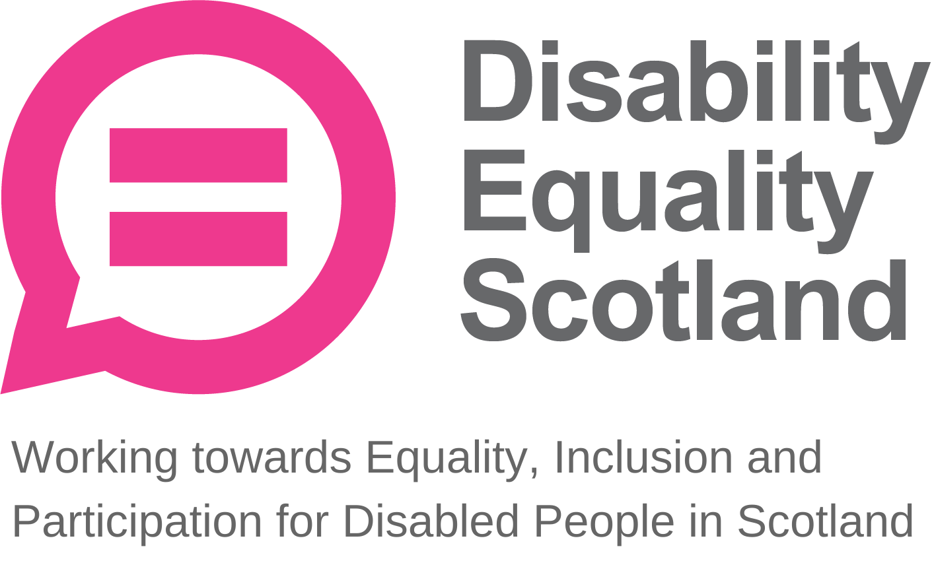
Disability Equality Scotland
Meeting of the Board of Directors
Wednesday 26 April 2022 10.00am
Zoom Virtual Meeting

In Attendance: Linda Bamford (LB) Convener
Scott Stewart (SS) Director
Kenny Milne (KM) Director
Dorothy McKinney (DMcK) Director
Maureen Morrison (MM) Director
Carolyn Wilson-Smith (CWS) Director
Kayla-Megan Burns (K-MB) Director (Convener Designate)
Marie Harrower (MH) Director

Morven Brooks (MB) Chief Executive Officer
Emma Scott (ES) Deputy Chief Executive Officer
Ian Buchanan (IB) Equality and Access Manager
James Davidson (JD) Communications and Research Officer
Alistair Bruce (AB) Access and Engagement Coordinator
Shona McEwan (SMcE) Easy Read Worker
Claire Jagger (CJ) Easy Read Worker

Apologies: Rhianne Forrest Director
Lauren Asher Director
Colin Millar Director

Item 1 Welcome and brief Introductions

LB welcomed everyone to the meeting.

LB asked that during discussions if anyone wanted to contribute, they should raise their hands and LB would confirm who wished to contribute and in what order.

LB asked everyone to remain on mute unless speaking to limit background noise. During decision-making, LB will ask that those not in agreement raise their hand before progressing. LB asked if there were any further comments before moving on. Nothing was raised

LB confirmed that there was one briefing paper to consider at the end of the meeting and confirmed that the board meeting was quorate, and that a majority decision would be taken. LB added that there would be a ten-minute comfort break after from 1100-1110 hours.

LB stated everyone should have received their board papers three weeks in advance and asked if everyone felt they had enough information to make decisions and contribute to the board meeting. The board agreed.

LB welcomed the new Directors K-MB and MH. All those present took a few minutes to introduce themselves.

LB progressed to agenda item 2.

Item 2 Agreement of Minutes from last meeting

LB stated that the minutes were emailed for comment and checking shortly after the January 2022 board meeting and asked for confirmation from the board on accuracy and content.

LB asked if all actions or matters arising from the minutes had been picked up. This was agreed. LB asked for agreement of minutes from Directors present at the previous meeting.

Proposed by: DMcK
Seconded by: KM

Item 3 Outstanding actions 26 January 2022 Board Meeting

MB confirmed that all 3 actions are closed and provided an update on three action points.

Action Point 1 Update: MB to ensure positive feedback is also captured and shared in board papers. This action is now closed.

Action Point 2 Update: MB to provide Fundraising Briefing Paper with papers for next board meeting in April 2022. This action is now closed.

Action Point 3 Update: IB to pass details of the Place Standards Tool via the “Shaping Places for Wellbeing Programme” to the Access Panel Network as a potential useful source. This action is now closed.

LB asked for any other issues or questions relating to the action points. None were raised and LB progressed to agenda item 4, passing over to MB.

Item 4 Approval of New Members
MB stated that during the period 1 January 2022 to 31 March 2022, Disability Equality Scotland had 48 new members join, of which 44 were individual, 2 were corporate and 2 were Young Members. This brings our total membership to 1417.

LB asked if everyone is happy to approve the new members. The board approved the new members.

Item 5 CEO’s Update

MB provided key highlights from her CEO report.

MB updated that our reserves are increasing thanks to Easy Read income. The reserves are currently sitting at £120,000 and it looks like we will meet our 6-month operating costs target comfortably.

Funding has been approved from Transport Scotland and Section 10 Grant Scheme.

MB explained that herself and ES are meeting with Patrick Harvie MSP on 11 May 2022. This followed a Parliamentary session where it was noted there has been a very low engagement with Disabled People Organisations and their needs in relation to inclusive Active Travel ,so this will be a useful connection and forum for DES to input the voices and needs of their members.

MB explained that her meeting with Liam McArthur MSP to discuss our weekly poll findings on the Assisted Dying Bill is pending. MB is working closely with Glasgow Disability Alliance to ensure that findings and communications reflect member’s views and opinions as this is a sensitive topic.

MB updated that last week’s Access Panel Conference had a very good turnout, with good discussions. It was a chance to remind Access Panels to tell us what they are doing so that we can best support them and share the good news.

MB concluded her update. MB asked for any questions on the CEO report. There were no questions.

LB thanked MB for her update.

Deputy CEO Report
MB asked ES for any additions to the Deputy CEO report.

ES updated that recent extra funding had been ringfenced for Transport Scotland’s Easy Read needs and for a part time Project Coordinator.

ES praised LG our Easy Read Trainer for her great Easy Read Training course. She also said that our webinar format has been very well received and appreciated.

MB reminded everyone that inclusive communication was not just Easy Read but all other formats too.

DMcK commented that a fantastic job was being done. So many organisations are approaching DES for support and advice.

ES described work on Orkney that she and FMO have undertaken on Hate Crime at the Pickaquoy Leisure Centre in Kirkwall. ES also updated that she is meeting Police Scotland soon to further work on Hate Crime. ES and FMO are working on filming testimonials from disabled people about hate crime, but it is challenging to find people who are happy to be filmed.

ES stated that the Exemption Card campaign was changing. From 18 April onwards there will be no legislation to wear a face covering. Instead, it will be guidance. This means that GW has received 4 weeks’ notice as there will be no further funding for a helpline.

ES updated that the Pavement Parking Ban Poll has had the highest response we’ve seen, with over a thousand responses, with an overwhelming 95% (964 respondents), not agreeing with the conditions that would allow local authorities to consider making certain streets exempt from the pavement parking ban. This will be fed back into the meeting with Patrick Harvie MSP and into the meeting with Jenny Gilruth, Minister for Transport.

LB asked if there were any questions for ES. There were no other questions.

Linda thanked ES.

MB asked IB (Equality and Access Manager) for his update.

Equality and Access Manager’s Report

IB updated that sadly he had not been successful in his NRAC application on this first try – this was not unusual. However, he stated he will be applying again.

IB explained that Section 10 Grant has been approved and funding is now in place. He also said he was feeling very positive about the new Access Panel Network website nearly being completed. Next steps include a biography section for Access Panels.

IB described his work on Disability Equality Access Learning (DEAL) training and Continuous Professional Development (CPD) accreditation.

IB had recently been in discussions with LG to work in getting DEAL training and Easy Read training CPD accredited.

IB felt that the Access Panel Conference had gone well, with better attendance being online and feedback received to repeat this online format.

LB commented that she felt it was the best AP conference yet with a positive and respectful vibe and great engagement particularly in the breakout groups.

MH commented that DES’ work supporting the campaign for braille labelling of food products working with Oban Access Panel and Sight Scotland had really helped put labelling on the map. She expressed her gratitude to DES and to MB.

LB agreed that braille labelling should be raised and MB reminded everyone that inclusive communication was much more than just Easy Read.

MB thanked IB for his update.

Board Annual Calendar of Activities

MB stated that this had been reviewed by herself and the Convener in preparation for the Board meeting and that everything is on track.

MB explained that Annual Appraisals with staff are underway. Performance Plans are written and the Yearly Budget documentation has been shared appropriately.

MB asked for any questions on the annual calendar. There were no questions from the board.

*At this point, there was a 10-minute comfort break*

Quarterly complaints and feedback
MB stated that we have received no complaints in this quarter, however we have received further positive feedback from our easy read service and training.

LB added that it was good to hear, acknowledge and record positive comments and praise.

LB asked to move on to the reflective learning log.

Reflective learning log

MB stated that no reflective learning had been logged this quarter.

MB asked for any questions from the board on the complaints or reflective learning sections. There were no further questions.

Finance

MB reported that the Easy Read service has significantly raised income. Sitting at £120,000, we are now closer to meeting our 6-month operating costs in reserves to provide the organisation with internal financial stability and reduce the likelihood of the organisational risks around finance that fluctuate due to our funding mechanisms.

MB asked for any questions from the board on finances. There were no questions from the board.

People

MB expressed the organisations collective sadness as AB leaves DES. She thanked him and said he would be very much missed. She thanked AB for supporting IB and for his key role in ensuring that online events ran smoothly. She offered our congratulations for his new role with the ALLIANCE.

IB agreed with MB and said he had enjoyed working closely with AB. He said that AB was instrumental in setting up new Access Panels in Helensburgh and Inverness.

KM hoped their paths would cross again and DMcK thanked AB for his calmness when challenged with all things IT on setting up our virtual webinars and meetings.

MB asked for any questions from the board on people. There were no questions.

MB moved onto the risk management section.

Risk Management

MB stated that she and LB had reviewed the risk log and in particular DES04 Governance and DES05 on Finance. DES04 moved from a 1 to a 2 due to new Directors starting and ensuring they are fully inducted with the organisation. DES05 moved from a 3 to a 1 due to being successful with Transport Scotland funding and Section 10 Grant funding.

This review keeps our overall risk rating at 5.

LB asked for any questions around risks. There were no other questions. MB confirmed that, as usual, the full risk log was available on request.

Challenges for Next Quarter

MB explained that the challenge for this next quarter is to continue meeting strategic objectives and continuing to support staff working from home.

Priorities for Next Quarter

MB explained her priorities for the next quarter is ensuring the new Directors are inducted and welcomed into the organisation and working on the Fundraising Strategy.

LB asked for any questions. There were no other questions.

Item 7 Confirmation of today’s actions

LB shared the following action that she picked up on:

Action Point 1: DMcK will forward policies relating to Domestic Abuse.

Item 8 AOB
LB asked for any other business from the board.

MB said that there had been an email received from a member who has started a petition and wanting DES support. The petition being for free rail travel for disabled people (i.e., extending disabled people’s concessionary travel to Rail). Directors were requested to discuss.

LB said she felt it was a credible petition and agreed from a Board perspective that member’s views should be sought via a poll.

CW-S suggested we make sure that the governance and reputation were in place, but that yes, she supported it.

LB briefly explained the parliamentary process for having petitions accepted and confirmed that this petition had passed this scrutiny process.

KM also said he supported it. He outlined how when there is only 1 space for a wheelchair on a bus, it’s often down to luck. As train carriages have more spaces, he welcomes it.

LB said that these were all good points and added that toilets are often more accessible on trains, Passenger Assistance was more evolved and it could be easier for those who use mobility scooters or mobility aids to travel by train than bus. LB also stated that it would make travel more affordable for disabled people, could reduce journey times and this would help with pain management and care routines and costs. LB confirmed that she supported it.

In principle, Directors agreed to support the petition.

MB and ES are meeting with Jenny Gilruth MSP, Minister for Transport on 8 June 2022, and this would be an opportunity to share the petition, now that ScotRail has come back into public ownership. MB also confirmed we would also share this via a Weekly Poll to gauge what further support there is from our membership.

There was further discussion about the petition and about Passenger Assistance in general. KM asked if there could be training for putting ramps out correctly at train stations. He described his own traumatic experience when this wasn’t done correctly.

MH agreed that Passenger Assistance was too hit and miss.
LB thanked everyone for raising these points and said she would discuss further with Stakeholder groups and with ES. ES said she would raise this at the next ScotRail Stakeholder Equality Group meeting she chairs.

Further discussions raised issues of staff attitude and respect being needed. CW-S stated that, in her opinion, training in the past where staff had used blindfolds, headphones and wheelchairs had been very powerful.

ES said that in terms of attitudes, she and FMO are developing an emotive video with Police Scotland, using disabled people’s stories.

K-MB briefly asked all those present if she could screenshot the meeting as a positive experience for her to celebrate. Everyone agreed.

Item 9 Board Briefing Paper 1 – Staff Fundraising Scoping Session

MB introduced the briefing paper to the board to seek agreement on what we are aiming to fundraise for. Directors were invited to provide comment and suggestions to allow further work on developing a Fundraising Strategy.

MB talked through the document, stating that it describes who we are, how we plan to raise funds, for what purpose and what approach we will take. For example, to offer financial support to focus groups that can be setup to increase and encourage engagement, where focus group members are offered a fee to attend and help DES develop strands of the strategy.

LB felt it was a good idea to use engagement events and focus groups. She suggested setting aside a pot of funds to help people to join focus groups, engage and acknowledge their contributions as experts by experience.

DMcK agreed that you get more “buy in” with a specific ‘ask’ to aim for.

MB said that the staff team had suggested the possibility of a paid Fundraiser post. MM agreed and was going to suggest the same thing. She suggested finding a consultant or making a part time post.

LB summarised that the Board were being asked if they agree in principle to the reasons for fundraising and the two pilot areas as phase one i.e., to support member engagement and to set up focus groups to sense check strategy development and acknowledge their expert contributions.

The Board agreed.

MB thanked everyone for comments and explained this now helps in drafting the organisations Fundraising Strategy.

Item 10 Close

Before moving to the closing section of the meeting the Convener, on behalf of the Board of Directors, again thanked AB for his contribution to DES and wished him well in his new ventures.

LB then thanked Directors and the staff team for their contributions today and for their support over the years to her as Convener. She thanked everyone for their guidance, hard work and commitment to the stability and development of the organisation, which had allowed it to grow and be more visible for its members.

LB stated that she was pleased to hand over the role of Convener to K-MB and Vice-Convener to CW-S

K-MB said that they were looking forward to starting, learning and connecting. CW-S said she agreed with K-MB and felt they had big boots to fill. They thanked everyone.

Minutes reviewed and agreed: 27 July 2022
Proposed: DMcK
Seconded: LB
Signed:

Kayla-Megan Burns, Convener

