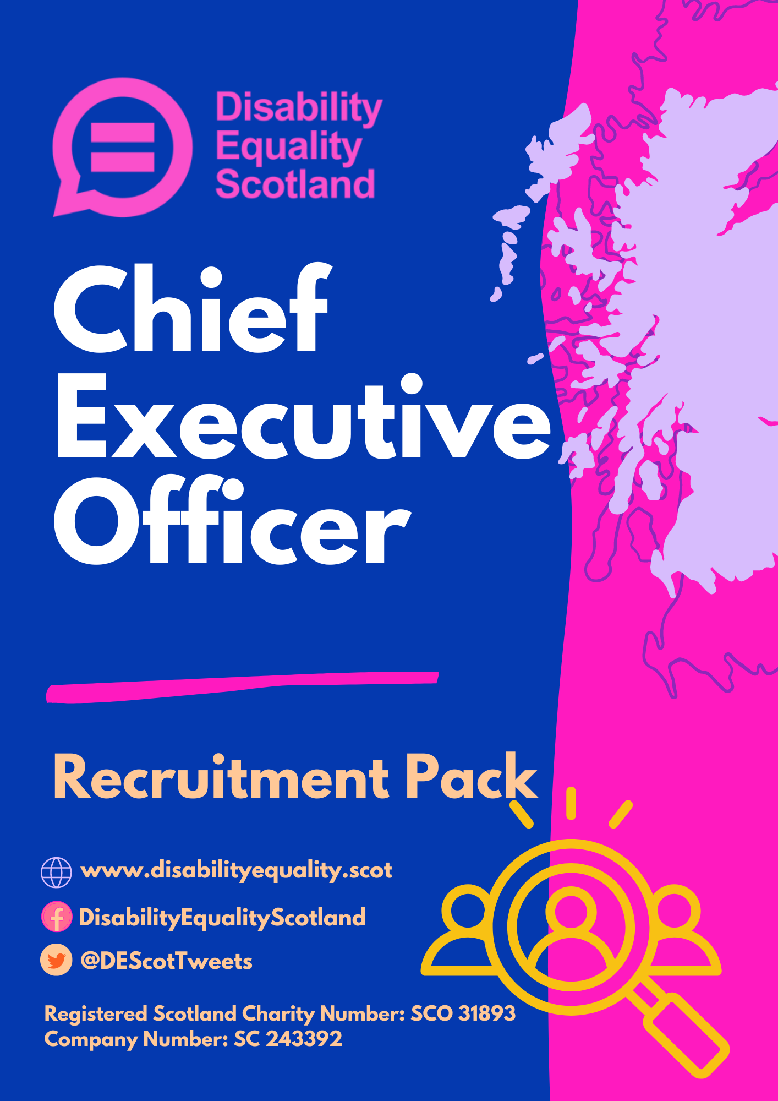

Introduction
Thank you for your interest in the role of Chief Executive Officer at Disability Equality Scotland.

We are looking to appoint a new Chief Executive Officer who can lead this dynamic organisation and build upon the fantastic achievements from the past 6 years.

Disability Equality Scotland is a national charity working to make life more accessible, equal and inclusive for disabled people in Scotland. We represent the views of individuals with any type of impairment, as well as disability organisations and groups who share Disability Equality Scotland’s values.

Our current Chief Executive Officer of 6 years is stepping down in October 2022. She has led the organisation and has enabled it to grow and succeed, with increased membership, funding, and reputation across the Third Sector in Scotland. We are therefore seeking an individual who can build on the successes of the last six years and for someone who has the vision and passion to take the organisation into its next chapter.

I hope you find this recruitment pack informative and useful. If you feel you have what it takes to lead Disability Equality Scotland, and you’re passionate about improving access and inclusion for disabled people then I’d encourage you to apply.

Kayla-Megan Burns
Convenor of the Board of Directors
Disability Equality Scotland

About Disability Equality Scotland
We are a membership organisation for disabled people and disability groups/organisations.

We promote access in its widest sense, including access to the built and
natural environment and access to the same opportunities as are enjoyed by
others in our communities thus promoting a life of dignity, respect, choice and
independence. This extends beyond physical access to include access to
information, access to inclusive communication and inclusion in decision-making, whether with planners over inclusive design or transport providers
about accessible travel.

Our aim is for every disabled person to have the opportunity to participate in
a fulfilling life and to enable them to reach their full potential.

We represent the views of individuals with any type of impairment, as well as
disability organisations and groups who share Disability Equality Scotland’s
values.

As a membership organisation we listen to the views of disabled people and champion on their behalf. We work to influence the policies of the Scottish Government, which affect how disabled people live and we work to encourage others to be inclusive and informed in their attitudes towards disabled people.

We are also the umbrella organisation for all disability Access Panels in
Scotland, and we are the principal provider of support and guidance to the
Access Panels presently representing disabled persons at a local level
throughout Scotland. Access Panels are committed to improving access and
equality in its widest form, which means access to the physical environment,
Education, Housing, Health, Social Care, Transport, Leisure & Recreation
and Social Justice amongst other areas.

Our Vision
Working towards Equality, Inclusion and Participation for Disabled People in
Scotland

Our Mission
Our mission at Disability Equality Scotland is to give all disabled people in
Scotland a voice with trust, care and empathy. We will use what we hear to
advocate for and enable change to improve lives.

We will achieve this through:
- Working with Access Panels
- Working with members
- Working with partners and stakeholders

You can download a copy of our current Strategic Plan 2020 – 2023
DES-Strategic-Plan-2020-2023-PDF.pdf (disabilityequality.scot)
Job Description

Job Title: Chief Executive Officer
Grade: 1A
Salary: £45,500
Hours: 35 Hours
Contract: Fixed term contract to 30 September 2024
Location: Office based / Flexible
Holidays: 25 days increasing to 30 days after 10 years’ service + 12 public holidays
Pension: 7% of salary employer pension contributions

Job Description Summary
The Chief Executive is responsible for providing leadership, developing and implementing Disability Equality Scotland’s strategic and operational plans, leading on partnership and business development, and being an effective advocate for the organisation and its stakeholders.

He/she will lead a senior management team.

The Chief Executive Officer is responsible for ensuring financial control and supporting and advising on good governance across all aspects of the organisation.

This post is a first-tier post directly responsible and reporting to the Board of Directors.

Leadership
- Be the face and voice of the organisation - its principal ambassador.
- Lead, support and motivate all staff and secure their loyalty and commitment to the organisation’s aims, objectives and ambitions.
- Seek out, develop and maintain effective working relationships with all relevant organisations and individuals to promote the work of the organisation and facilitate the implementation of its strategic objectives.
- Lead by example, instilling a culture of professionalism and inclusion, supported by coaching, training and development.
- Work and co-ordinate with Disability Equality Scotland’s managers and to share and gain best practices to achieve the organisations mission.
- Provides advanced functional and/or specialty leadership throughout the organisation.
Strategy
- Liaise with the Board in relation to the development of the organisation’s strategic vision and be responsible for leading the implementation of it.
- Be responsible for the development and delivery of the organisations agreed business plans.
- Identify and assess strategic risks, issues and opportunities and take responsibility for initiating and leading associated changes.
- Seek out and implement opportunities for innovation and ensure that Disability Equality Scotland remains at the forefront of positive change in disability equality.
- Work to develop best practice for the management, development and engagement of staff.
Partnership and Business Development
- Lead the promotion and development of Disability Equality Scotland’s work, raising the organisation’s profile and maximising its reach.
- Seek out, develop and nurture beneficial partnerships with supporters, partners, other charities and all relevant authorities/organisations, including maintaining good working relations with pre-existing partnerships.
- Work towards the achievement of long-term sustainability, developing the organisation’s business model and maximising income, for example from fundraising and earned income.
- Adopt a creative and innovative approach to development, remaining open to new ideas and opportunities.
Operations
- Be responsible for the implementation of all the organisation’s operational plans.
- Take executive responsibility for all functions including the office, administration, finance, fundraising, communications, and IT.
- Ensure that Disability Equality Scotland’s services, contracts and projects are delivered to the highest standard with due regard for timescales, targets and budgets.
- Take overall responsibility for the recruitment, management and effective deployment of staff; apply robust HR processes covering recruitment, performance management, appraisal and remuneration.
- Line manages the Deputy CEO and Equality and Access Manager.
- Be responsible for the maintenance and efficient use of the organisation’s assets.
- Working within the overall governance framework of Disability Equality Scotland, using very wide discretion and initiative over all areas of the organisation’s activities without management direction, subject only to review by the Board.
- Makes decisions for the organisation that determine the strategic and operational direction of the organisation.
- Signs legally binding commitments for Disability Equality Scotland acting on own authority.
- Corporate responsibility for the human resources function for the organisation.

Financial Control
- Corporate responsibility for the financial resources and physical assets of the organisation.
- Lead and direct the financial planning, forecasting, control, reporting and management of the organisation's finances and resources, to include support for, and engagement of the Board of Directors and sub-groups to ensure regulatory compliance and sustainable organisational growth.
- Take executive responsibility for the financial leadership of the organisation, including forecasting and strategic budget leadership.
- Ensure that the organisation’s financial resources are managed effectively, and that Disability Equality Scotland remains in good financial health, identifying risks and taking appropriate action.
- Liaise with the Board of Directors to develop and lead on the implementation of the organisation’s financial plans, including setting budgets, formulating income generation strategies and overseeing all fundraising activities.
- Maintain effective financial management and control systems; ensure delivery within budgets and to performance targets and oversee production of annual accounts and annual reports.
Governance and Compliance
- Liaise with the Board to ensure that the organisation’s overall governance structure, policies and procedures are appropriate and effective, taking remedial measures and implementing changes, as necessary.
- Attend all Board meetings (held four times a year) and prepare papers in advance of each meeting detailing matters of interest and concern regarding the organisation’s activities during the previous period; ensure that the Board is made aware in a timely fashion of any matters requiring its attention.
- Develop and maintain effective operational policies and processes in all the organisation’s functions. Review and update scope and content to meet legal, regulatory and best practice needs.
- Oversee the development and practical application of all organisational policies and procedures e.g., regarding health and safety, equality and diversity, and safeguarding.
- Ensure that the organisation complies with best practice in all areas of operation including Health and Safety.
- Ensure that collection and protection of personal information complies with current Data Protection regulations.
- Ensure that all the organisation’s activities are conducted safely and that Health and Safety policies are understood and followed by everyone.
- Ensure that all major risks are identified and regularly reviewed, and that systems and procedures are in place to mitigate all such risks; be responsible for the development and implementation of the charity’s Risk Log.
General
- Carry out any other duties as may be reasonably requested.
- Be conversant with all aspects of the operation and willing to cover and provide support should the need arise.
- This role involves overall responsibility for the procurement and deployment of substantial resources or substantial responsibility for information. The responsibility includes long term planning of the procurement and deployment of resources and/or information policies, changing the source, nature, level, and composition of such resources to meet service and other requirements.

Demands of this post
This is a demanding post that requires flexibility and the ability to manage a heavy workload with competing demands and deadlines.
The post requires a high level of communication skills and interpersonal skills, displayed both internally with staff and externally with partners, funders and stakeholders.

Person Specification
You will have had a significant leadership role in a charity or not for profit organisation with a successful track record of working effectively with a board.
You must demonstrate that you:
- Are committed to supporting vulnerable people.
- Are a successful leader with the ability to engage and inspire.
- Can see the big picture and plan for the future.
- Are financially literate with a strong understanding of the organisation's finances.
- Have successfully led people to deliver organisational change.
- Can build and manage relationships with a diverse range of stakeholders, both internally and externally.
You should be able to demonstrate and provide evidence of the following skills and qualities as well as the criteria listed under Essential and Desirable within your application.
Skills / Knowledge / Experience Required | Essential (E)  Desirable (D) | Evidence
- Knowledge/Education/Qualifications/Job Experience
Graduate or post graduate or professional qualification and / or more than 3 years’ work experience | E | A
Demonstrable practical procedural knowledge:  - High level PC literacy - Microsoft windows package (Word, Excel, PowerPoint)  - WordPress and web content management  - Online event hosting and website accessibility  - Online event management software  - Social Media communication  - Project Management  - Research methodologies  - HR  - Financial Control and Development  - Strategic Reporting | E | A
Theoretical knowledge:  - Scottish Parliament policy development  - Community engagement and development (Third Sector and Local Authority)  - Principles of accessibility and inclusion  - Equality Act 2010  - Human Rights  - Community Development | E | A / I / P
Demonstrable Experience:  - Volunteer management and support  - Project management  - Campaign design and delivery  - Event management  - Survey design  - Consultation and engagement  - Line Management  - Strategic Development  - Public speaking  - Partnership / Relationship Building  - Leadership  - Decision Making | E | A / I / P
- Communications
Depth of skill is greater with more emphasis on external communications plus there is a requirement to do most of the following:  - Influence the highest levels of strategic decision making across Disability Equality Scotland.  - Communicate accessibly internally and externally to influence a wide range of stakeholders across multiple functions and external bodies, including Scottish Government officials.  - Use interpersonal skills to change and influence opinions of large groups of people.  - Lead external relationships between staff and external bodies.  - Disability Equality Scotland’s spokesperson for all media communications. | E | A / I / P
- Staff Responsibility
Full management responsibility for line management of employees including from a strategic and operational perspective with authority to implement solutions to short term and long-term people management issues including the management of change. | E | A / I / P
- IT and Resources
The work involves overall responsibility for the procurement and deployment of substantial resources or substantial responsibility for information. The responsibility includes long term planning of the procurement and deployment of resources and/or information policies, changing the source, nature, level, and composition of such resources to meet service and other requirements. | E | A / I / P
- Finance
Corporate responsibility for the financial resources and physical assets of the organisation. | E | A / I / P
- Training
Corporate responsibility for the human resources or HR function. | E | A
- Decision Making
- Working within the overall governance framework of Disability Equality Scotland, using very wide discretion and initiative over all areas of the organisation’s activities without management direction, subject only to review by the Board.  - Makes decisions for the organisation that determine the strategic and operational direction of the organisation.  - Signs legally binding commitments for Disability Equality Scotland acting on own authority. | E | A / I / P
- Leadership
Provides general direction to others:  - Directs the work of a project with responsibility for assigning work, checking results, controlling costs, and handling staff or making recommendations thereon, or;  - Full responsibility for quality and quantity of work, costs, methods, input into discipline, transfers and/or promotions, or;  - Provides advanced functional and/or specialty leadership throughout the organisation | E | A / I / P
- Working Conditions
Corporate responsibility for the human resources or HR function | E | A

Essential Requirements are those, without which, a candidate would not be able to do the job. Desirable Requirements are those which would be useful for the post holder to possess and will be considered when more than one applicant meets the essential requirements.

Evidence: Application (A); Interview (I); Presentation (P); References (R)

CEO Line Management

How to apply
If you are interested in applying, please download the recruitment pack and application form from www.disabilityequality.scot/joinus

- Chief Executive Recruitment Pack
- Our Recruitment Process
- Application Form
- Equal Opportunities Monitoring Form
Applications should be sent to: morven@disabilityequality.scot or via post to:

Disability Equality Scotland
Suite 204B, The Pentagon Centre
36 Washington Street
Glasgow
G3 8AZ

Please note that CVs are not accepted and a full application is required.

Please contact us if you require the application pack in an alternative format admin@disabilityequality.scot

Closing date for applications: Wednesday 17 August 2022 at 12pm
First stage interviews: 5 / 6 September 2022

