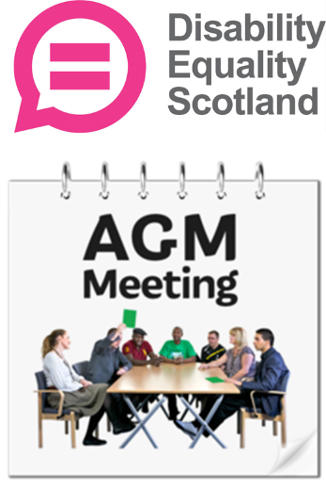 | Disability Equality Scotland  Annual General Meeting
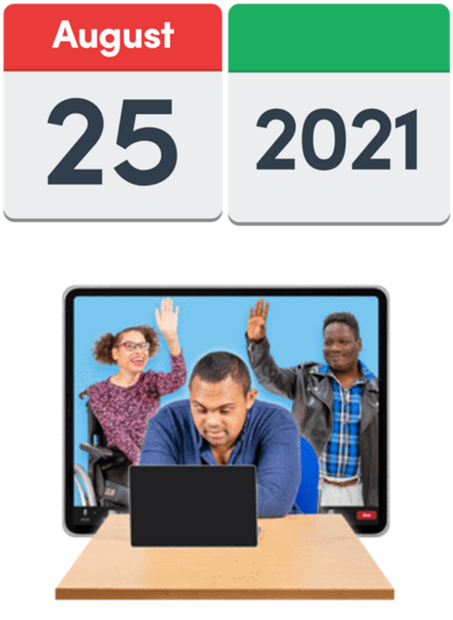 | This meeting happened on 25 August 2021.  This meeting happened on Zoom.
Who was there?
Individual Members
Andy Stuart
Chris Colebrook
David Gallant
Deidre Aiken
Grace Clements
Jacki Aston
Lynne Buchan
Paula McGuire
Philip Gerrard
Stephanie Bain
Tracey Clark

Corporate Members
Bernhard Anderson – Barra Access Panel
Bobby Park – Glasgow Access Panel
Caroline Gould – Skye and Lochalsh Access Panel
Frank Drummond – Tweeddale Access Panel
Hilary Stubbs – MACS
Jamie Smith – West Dunbartonshire Access Panel
Jim Tolmie – Oban Access Panel
John Ballatine – Edinburgh Access Panel
John Callander – Aberdeenshire South Access Panel
Ken Johnston – Oban Access Panel
Kirstie Black – Central Aberdeenshire Access Panel

Mel Todd – Centre for Inclusive Living Perth and Kinross
Mike Harrison – Midlothian Access Panel
Peter Joyce - North Ayrshire Access Panel
Rosemary (no full name given)
Robert Dick – Stirling Access Panel
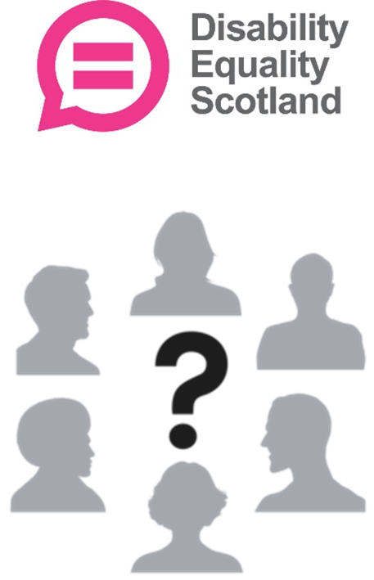 | Disability Equality Staff  Morven Brooks - Chief Executive Officer  Emma Scott - Operations Manager  Ian Buchanan - Access, Training and Engagement Manager  James Davidson - Communications and Research Coordinator  Alistair Bruce – Events, Training and Membership Administrator  Lucy Gibbons – Easy Read Trainer  Directors  Linda Bamford – Convener  Dorothy McKinney - Vice Convener  Colin Millar – Treasurer  Carolyn Wilson Smith  Susan Fulton  Kenny Milne  Scott Stewart  Maureen Morrison  Lauren Asher

Accessibility Team
Elizabeth Mooney – British Sign Language Interpreter
Niamh Cochrane – British Sign Language Interpreter
Gail Richardson – Closed Captioner
Paula McGuire – Closed Captioner
1 Welcome
Morven welcomed everyone.
She said there were 48 people at this online meeting.

Morven introduced:
- Linda – the Convener
Colin – the Treasurer
Morven thanked Susan and Janis.
They have both left Disability Equality Scotland as Directors.
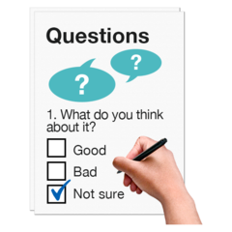 | Linda the Convener thanked:  - all members and staff for working hard during the COVID-19 pandemic  - members who had answered the weekly polls  She said that the poll answers had helped let Scottish ministers and people making decisions know more about what disabled people thought.
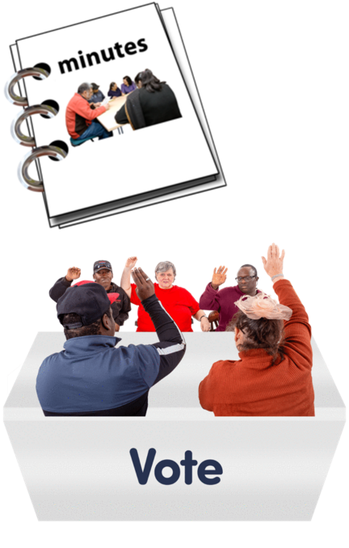 | 2 The Minutes from last year’s AGM  There was a vote to agree the Minutes from 25 August 2020.  They were agreed.
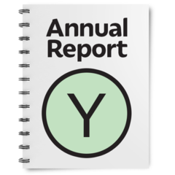 | 3 The Annual Report 2020 to 2021  Morven said that this year had been a very successful for Disability Equality Scotland.
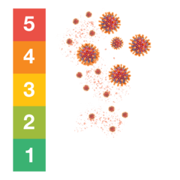 | Disability Equality Scotland made sure it listened to its members during COVID-19.
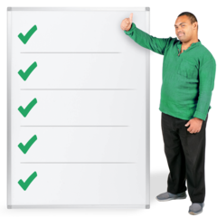 | 13 things that Disability Equality Scotland have done this year
 | 1. We have lots more members now. We have over 1 thousand 2 hundred in total.
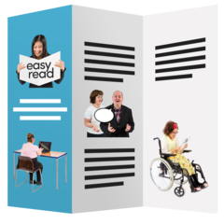 | 2. We shared important COVID-19 health information with our members in newsletters and our magazine called Open Door.
 | 3. We organised the Scottish Government’s Face Covering Exemptions cards.
By the end of March 2020 we had sent out:
- 60 thousand cards by post
- 40 thousand digital cards
We answered nearly 3 thousand phone calls to our helpline.
4. We had 6 webinars to talk with disabled people and disability organisations.
They covered things like the Thistle Assistance Card and 20-minute Neighbourhoods.

5. We have made our Inclusive Communication Hub website better.
We have told people how important it is to have information shared in lots of accessible ways.

6. We have had more and more work making Easy Read documents with our Easy Read Service.
We have worked on 52 Easy Read projects for organisations, including the Scottish Government.
 | 7. We have collected our members thoughts in our 52 weekly poll questions.
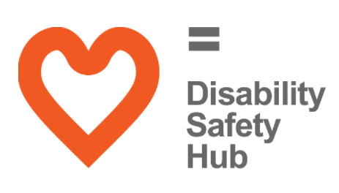 | 8. We have made our Disability Safety Hub website better.  There is now:  - COVID-19 advice  - a mental wellbeing guide  - scam advice
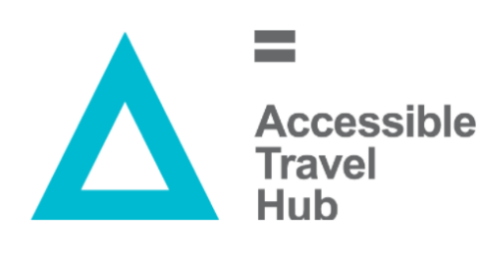 | 9. We had nearly 100 thousand visits to our Accessible Travel Hub website  This was because we had useful information about public transport during the pandemic.
10. We held 5 events to bring together disabled people and transport organisations.
They talked about experiences using public transport in different parts of Scotland.
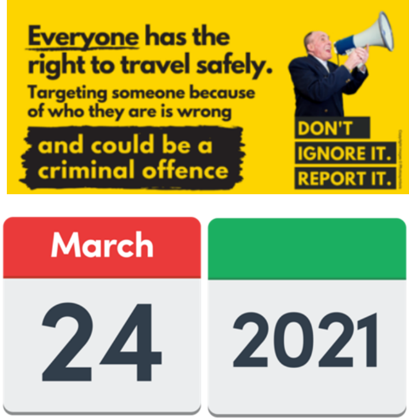 | 11. We made a Hate Crime Charter for public transport.  On 24 March 2021 we shared this campaign on our social media channels and our information reached 56 thousand people.  We think our campaign reached over 300 thousand people over all  We were thanked by the Scottish Ministers.
 | 12. We have carried on making our Inclusive Design Hub better.
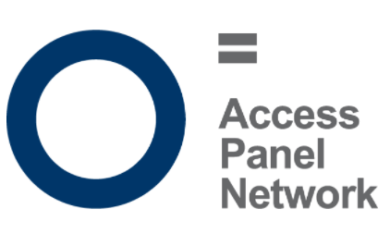 | 13. We have supported our 35 Access Panels across Scotland.
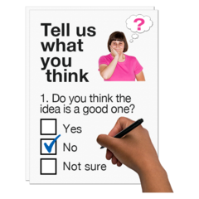 | Morven said that there will be a new Members Survey every year.  Everyone will get an email about this, after this meeting.
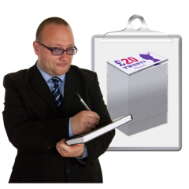 | 4 Treasurer’s Report  Colin said that it’s been a good year.
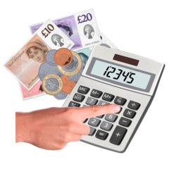 | Last year we took in 1 thousand pounds more than we spent.  But this year we took in 30 thousand pounds more than we spent.  This is because we took in extra money from:  - Easy Read service  - funds for the Exemption Card work
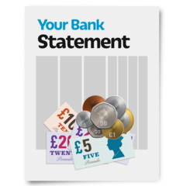 | Last year we finished with 50 thousand pounds in our bank account.  This year we finish with 80 thousand pounds in our bank account.
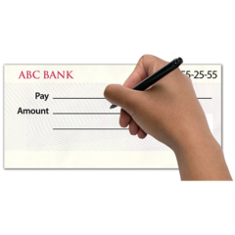 | We spent over 340 thousand pounds.
 | Colin said that a Fundraising Plan is being written to bring in more money.
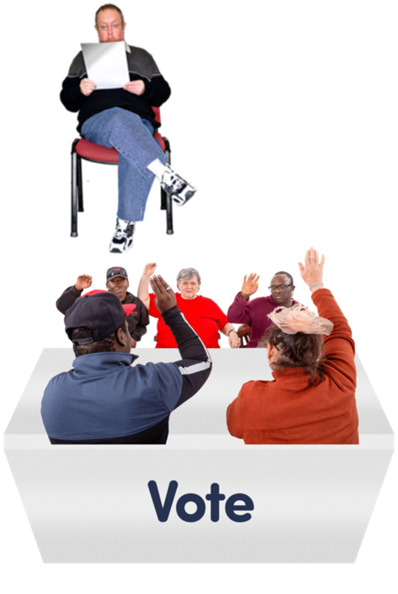 | He said that the Board of Directors agreed these accounts on 28 July 2021.  There was a vote to agree this report about the accounts.  It was agreed.
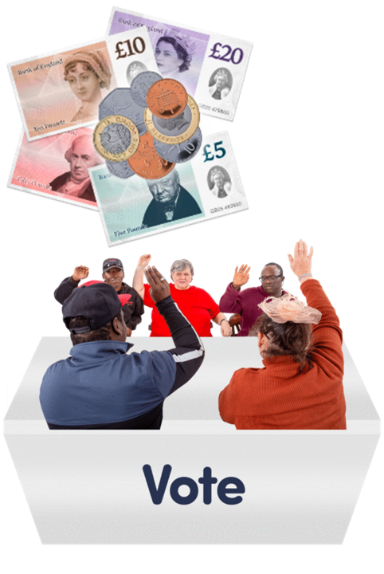 | 5 Approval of Fees and Subscriptions  Colin said nothing has changed.  There was a vote to agree the fees and subscriptions.  They were agreed.
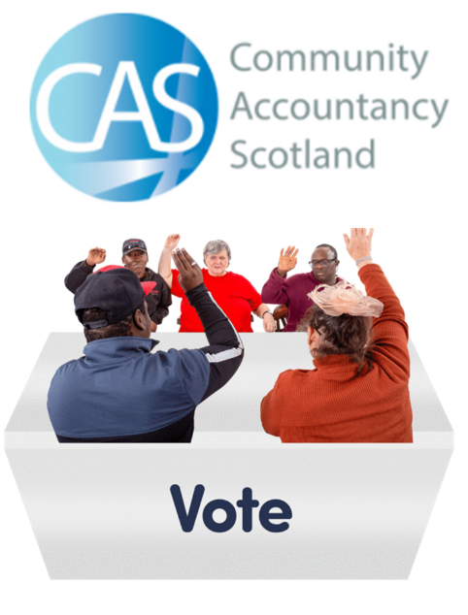 | 6 Finance Examiners  Colin said that Community Accountancy Scotland will carry on working for Disability Equality Scotland during 2021 and 2022.  There was a vote to agree this.  It was agreed.
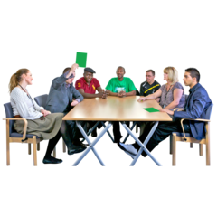 | 7 Voting for the Board Directors  Morven said that some Directors were hoping to be voted for again.  Members who could vote had already been given:  - a link to an online voting form  - information about each Director
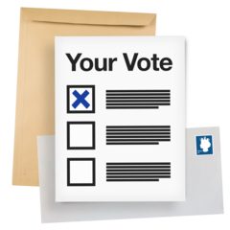 | Morven said that 15 votes had been sent in early. These are called proxy votes.  More than half the votes need to say yes so that a Director can stay.
Members were asked to vote for or against these Directors staying:
Lauren Asher
Rhianne Forrest
Carolyn Wilson-Smith
Colin Millar
Kenny Milne
Maureen Morrison
Scott Stewart
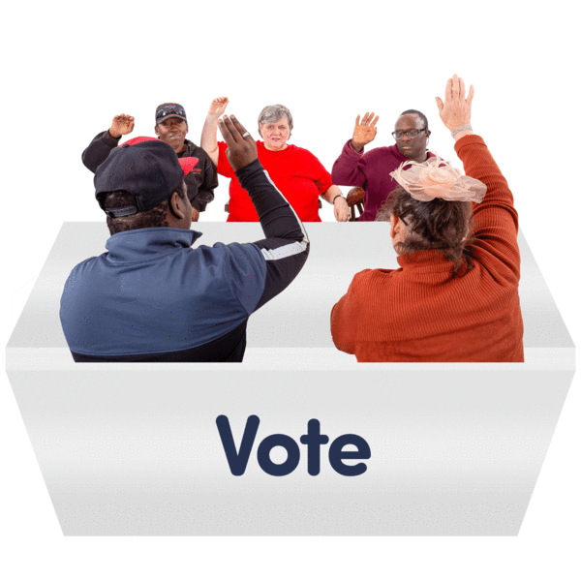 | The members voted.  There was a short break.  After the break, Morven said that all 7 Directors had been voted to stay on.
8 Questions and Ideas

Morven introduced all the Directors.
Rhianne could not be at this meeting.
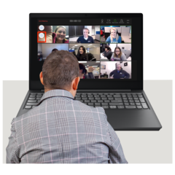 | Someone said in the Chat messages that the Meeting was not as accessible as it could be.  Someone said they had not been emailed the paperwork before the meeting.  Morven said that the team would think about these comments.  She asked everyone to check their contact details to make sure that information was getting to them.
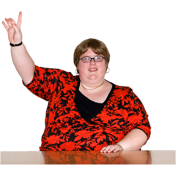 | Some members asked questions about the Access Panels.  Morven asked them to get in touch with staff members Ian or Alistair for this information.
Linda thanked the members for taking part in the weekly polls.
She said that the answers have helped:
- make new policies
- make plans to move out of lockdowns

A member asked some questions about social care service support.
Colin and Morven said that Disability Equality Scotland has taken part in talks about this.
Colin said that disabled people who have a Personal Assistant are their employer.
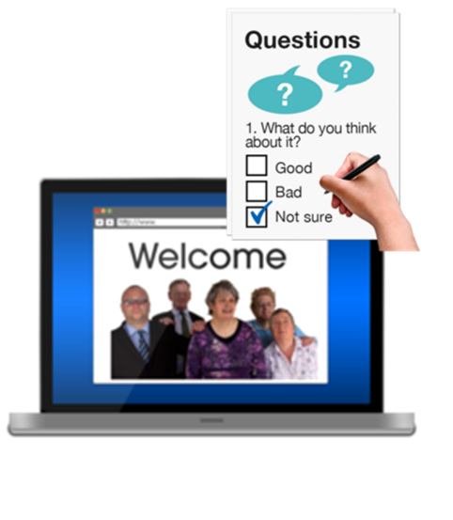 | Some members had ideas for new weekly poll questions.  Morven said that poll questions stay open and can be looked at again at www.yoursayondisability.scot.
Thank You

Morven thanked everyone for joining this meeting.

 | She asked if everyone could do a quick survey for feedback about the meeting.
 | The meeting ended.
Copyright images © Photosymbols. Prepared by Disability Equality Scotland

