Annual General Meeting Directions
Date: Wednesday 31 August 2022
Time: 1.00pm - 3.00pm
Venue: Motability Operations Ltd, Forthstone, The Stones, 56 South Gyle Crescent, Edinburgh, EH12 9EB
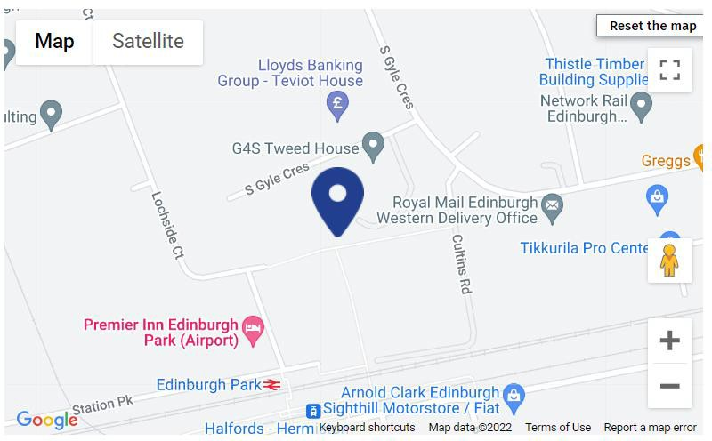

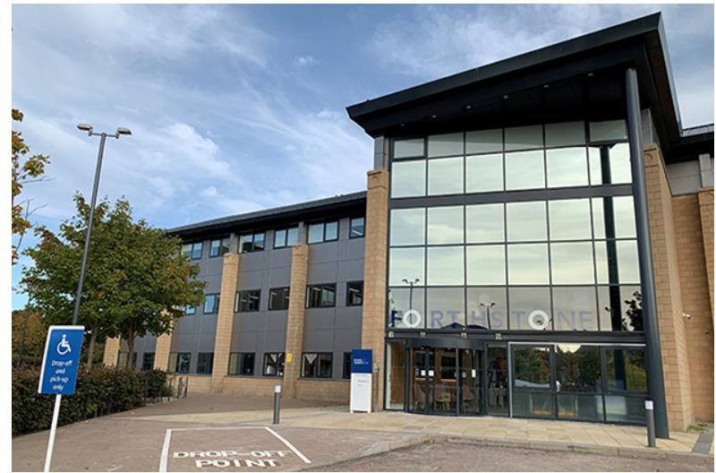

Annual General Meeting

Driving Route to Motability Operations from Glasgow
- Take Port Dundas Rd and Dobbie's Loan/A804 to M8 6 min (0.9 miles)
  - Head north towards Killermont St (148 ft)
  - Turn left onto Killermont St (423 ft)
  - Turn right onto W Nile St (148 ft)
  - Continue onto Port Dundas Rd (0.3 miles)
  - Turn right onto Dobbie's Loan/A804 (0.1 miles)
  - Use the middle lane to turn left onto Craighall Rd/A879 (154 ft)
  - Slight right
- Follow M8 to The City of Edinburgh Bypass/A720 in Edinburgh. Take the A720 exit from M8 (38 min) (39.7 miles)
  - Merge onto M8 (29.8 miles)
  - Keep right to stay on M8 (9.5 miles)
  - At Hermiston Gait Roundabout, take the 1st exit onto the A720 slip road to City Bypass North (0.4 miles)

- Continue on The City of Edinburgh Bypass/A720 to your destination in Edinburgh (5 min) (1.8 miles)
  - Merge onto The City of Edinburgh Bypass/A720 (0.7 miles)
  - At the roundabout, take the 4th exit (0.5 miles)
  - At the roundabout, take the 2nd exit onto South Gyle Broadway (0.3 miles)
  - At the roundabout, take the 3rd exit onto South Gyle Crescent (0.2 miles)
  - At the roundabout, take the 1st exit onto South Gyle Park (341 ft)
  - Turn right to stay on South Gyle Park (223 ft)
  - Turn left
  - Destination will be on the left (98 ft)
Please Note: These directions are for planning purposes only and sourced from Google Maps. You may find that construction projects, traffic, weather, or other events may cause conditions to differ from the map results, and you should plan your route accordingly. You must obey all signs or notices regarding your route.

Annual General Meeting

By Rail to Edinburgh Park Station

From Aberdeen:
- ScotRail
- Journey Time: 2 hours 38 minutes
  - DEPART 9:04AM from Aberdeen
  - ARRIVE 11:22AM Edinburgh Waverley
  - DEPART 11:33AM Edinburgh Waverley to Dunblane
  - DISEMBARK at Edinburgh Park 11:42AM
From Edinburgh:
- ScotRail
- Journey Time: 11 minutes
  - DEPART 12:08PM from Edinburgh Waverley
  - DISEMBARK at Edinburgh Park 12:19PM
From Glasgow:
- ScotRail
- Journey Time: 56 minutes
  - DEPART 11:15AM from Glasgow Queen Street
  - ARRIVE 12:02PM Haymarket
  - DEPART 12:11PM Edinburgh Haymarket to Dunblane
  - DISEMBARK at Edinburgh Park 12:11PM
Inverness:
- LNER and ScotRail
- Journey Time: 3 hours 22 minutes
  - DEPART 07:55AM from Inverness (LNER London Kings Cross)
  - ARRIVE 10:44AM Falkirk Grahamston
  - DEPART 10:53AM Falkirk Grahamston to Edinburgh (ScotRail)
  - DISEMBARK at Edinburgh Park 11:17AM

Stirling:
- ScotRail
- Journey Time: 40 minutes
  - DEPART 11:34AM from Stirling
  - DISEMBARK at Edinburgh Park 12:14PM

Annual General Meeting

By Tram

From Edinburgh Airport:
- Journey Time: 15 minutes
- Make way to nearest tram stop, estimated 4 minutes away by foot
- Take Tram towards York Place to Edinburgh Park Station (Departs every 8 minutes)
- DISEMBARK at Edinburgh Park Station

Walking / Wheeling Route to Motability Operations from Edinburgh Park Tram Station

- Journey Time: 11 minutes
- Walk east towards Lochside Court (0.1 miles)
- Turn left onto Lochside Court (351 ft)
- At the roundabout, take the 1st exit onto Redheughs Avenue (0.2 miles)
- At the roundabout, take the 2nd exit onto South Gyle Park (397 ft)
- Slight right (371 ft)
- Turn right (23 ft)
- Turn right (52 ft)
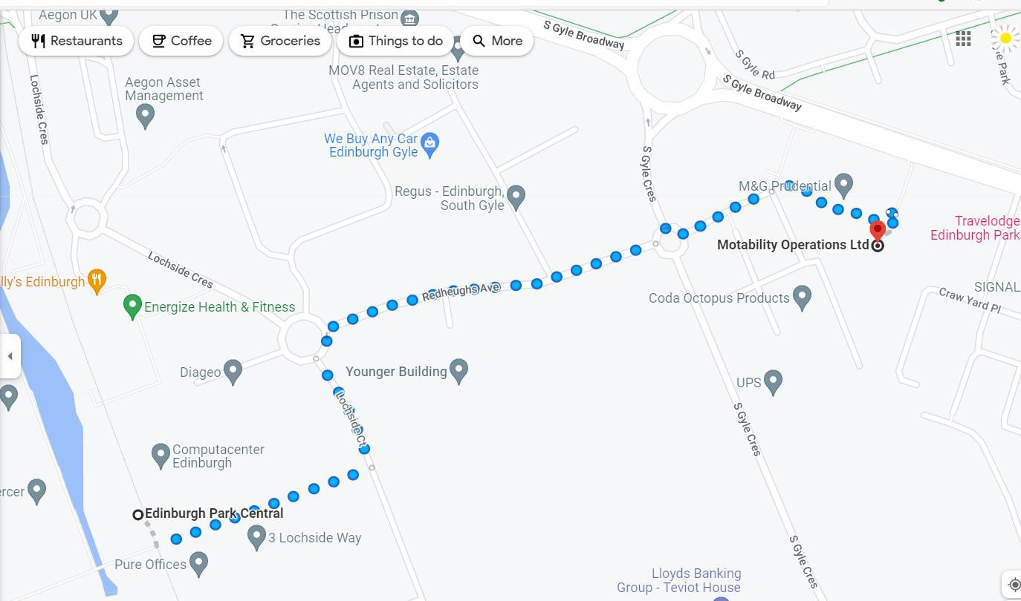

Annual General Meeting

Taxis
Edinburgh Taxis Tel: 0131 235 2085
Website: https://www.edinburghpremiertaxis.co.uk
Central Taxis
Tel: 0131 229 2468
Website: https://www.taxis-edinburgh.co.uk/

Car Parking
Ample on-site parking for any drivers, including covered Wheelchair Accessible Vehicles parking and electric charging points.
The car park has 11 accessible bays, 7 of which have electrical vehicle charging capabilities. We can book these out as required for delegates. There is another 30 spaces in the general car park should they be required. Please indicate on your booking form should you wish to reserve car parking.

Facilities at Motability Operations
- Coffee shop for any refreshments
- Changing Places Toilet (as well as other accessible toilet facilities).

