Sponsorship Registration Form
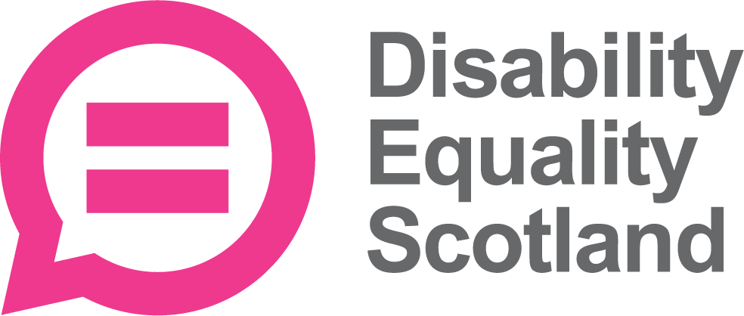
Your opportunity:
As a sponsor of Disability Equality Scotland, your investment will further our vision of working towards equality, inclusion and participation for disabled people in Scotland.

Sponsorship perks:
Website
Your organisation logo featured on our website. Our Sponsors

Open Door Magazine
Your organisation logo included in our Open Door Magazine, which is read by disabled people, third sector organisations, decision makers and members of parliament. Open Door Magazine

Disability Equality Scotland News
Your organisation logo added to the footer of our members newsletter, reaching over 1,500 disabled people each month.

Social Media
We will regularly promote your organisation through our social media channels – Twitter/Facebook, reaching over 8,000 social media followers.

Article in Open Door Magazine
We will publish one article a year about your organisation in our magazine.

Weekly Poll Surveys and Summary Report
You can submit your own question to poll our members, your networks and wider using our weekly poll tool. Weekly Polls

Easy Read Service Discount
We have the expertise to convert your information into the accessible Easy Read format. Contact us and we can arrange for a 20% discount on up to 5 documents, per year. Easy Read Service

Easy Read Training
Help improve your communications by taking part in our Easy Read training course. Sponsors receive 10% discount per Individual booking or 20% discount per group booking minimum 6 people. Easy Read Training

Additional benefits of being a sponsor:
- Free year-round advertising being listed as a valued Sponsor on our website and in our magazine and newsletters

- Add to your own publicity materials: “A proud sponsor of Disability Equality Scotland.”

- Take pride and pleasure in investing in the local community

- Network at our events

- Receive all our regular newsletters, Open Door Magazine, weekly polls and event invites

Contact details:
Name
Organisation/Company
Address
Telephone
Email
Website URL

Sponsorship category applying for (please tick):
Income
(Please provide a copy of latest Annual Accounts)
Less than £250,000 |  | £250
Between £250,00 and £500,000 |  | £500
Between £500,000 and £1 million |  | £1000
£1 million and more |  | £2000
If your organisation receives funding from Equality and Human Rights Fund managed by Inspiring Scotland you can receive 25% Discount. Check this box if you receive this funding.

