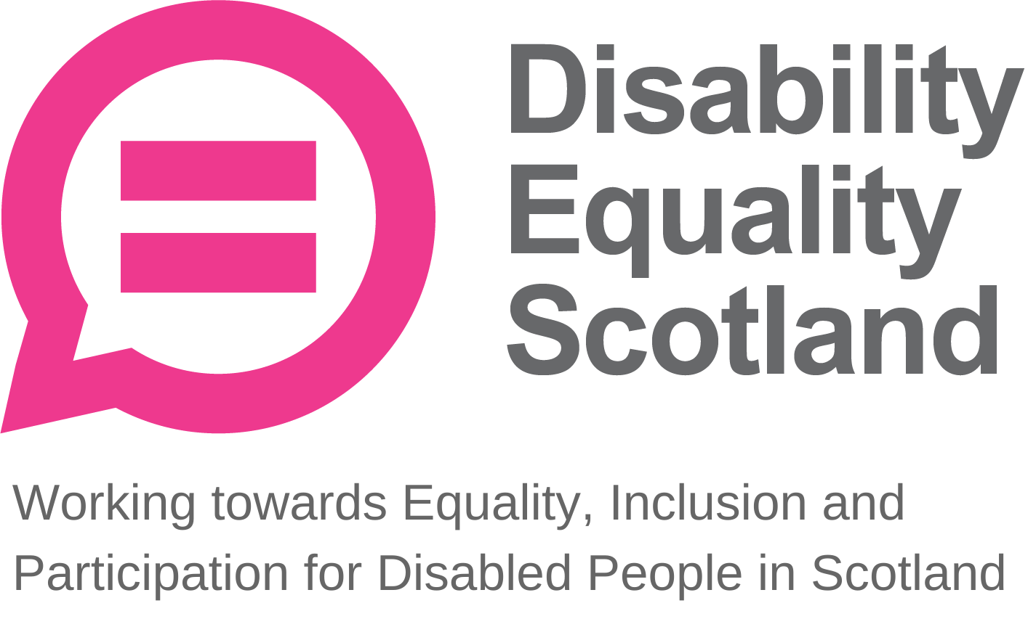
Disability Equality Scotland
Meeting of the Board of Directors
Wednesday 26 January 2022 10.00am
Zoom Virtual Meeting

In Attendance: Linda Bamford (LB) Convener
Scott Stewart (SS) Director
Kenny Milne (KM) Director
Colin Millar (CM) Director
Dorothy McKinney (DMcK) Director
Maureen Morrison (MM) Director

Morven Brooks (MB) Chief Executive Officer
Emma Scott (ES) Deputy Chief Executive Officer
Ian Buchanan (IB) Equality and Access Manager
James Davidson (JD) Communications and Research Officer
Alistair Bruce (AB) Access and Engagement Coordinator

Apologies: Carolyn Wilson-Smith (CWS) Director
Rhianne Forrest (RF) Director
Lauren Asher (LA) Director
LA joined the closed session.

Item 1 Welcome and Apologies

LB welcomed everyone to the meeting.

LB asked that during discussions if anyone wanted to contribute, they should raise their hands and LB would confirm who wished to contribute and in what order.
LB asked everyone to remain on mute unless speaking to limit background noise. During decision-making, LB will ask who is not in agreement to raise their hand before progressing, and when closing an agenda section, she will ask if there were any further comments before moving on.

LB confirmed that there was one closed session of the board meeting. LB confirmed that the board meeting is quorate, and that a majority decision will be taken. LB added that there would be a five-minute comfort break after the main session before the closed session begins.

LB stated that MB would chair us through agenda items 5 and 6.

LB stated the agenda timings for the day including for the comfort break, closed session and close of meeting. LB stated everyone should have received their board papers three weeks in advance and asked if everyone felt they had enough information to make decisions and contribute to the board meeting. The board agreed.

LB progressed to agenda item 2.

Item 2 Agreement of Minutes from last meeting

LB stated that the minutes were emailed for comment and checking shortly after the October 2021 board meeting and asked for confirmation from the board on accuracy and content.

SS suggested a change on page 9 of the minutes, concerning the statement that “most calls to Disability Information Scotland concern neighbourhood harassment and hate crime”, requesting clarification that this is changed to “many calls”. SS happy for this change to be made without his involvement and the minutes approved.

LB confirmed that all actions or matters arising from the minutes had been picked up and asked for agreement of minutes from Directors present at the previous meeting.

Proposed by: LB
Seconded by: SS

Item 3 Outstanding actions 27 October 2021 Board Meeting

MB confirmed that all actions are closed and provided an update on three action points.

Action 1 Update: IB to share summary report from Access Language seminar. This report was shared on 7 January 2022, and feedback was received from Directors on this paper. This action is now closed.

Action 2 Update: JD and AB met with RF and LA to convene the youth membership subgroup. Actions from this meeting are underway, and this action is now closed.

Action 3 Update: MB to take forward planning for Convener and Vice Convener roles, to be discussed in closed session of the board today. This action is now closed.

LB asked for any other issues or questions relating to the action points. None were raised and LB progressed to agenda item 4, passing over to MB to introduce the paper.

Item 4 Approval of New Members
MB updated the board on the reasons for the GDPR data cleanse of the membership, adding that the membership database is reviewed regularly due to undeliverable emails and other reasons, and that this process keeps us in line with GDPR good practice and our own data protection policies. The last data clean highlighted 142 out-of-date records.

MB stated that during the period 1 October 2021 to 30 December 2021, DES had 72 new members join, of which 60 were individual, 9 were corporate and 3 were members. This brings our total membership to 1377.

SS asked for clarification on one new member. MB confirmed the individual represented Inspiring Scotland.

LB asked if everyone is happy to approve the new members. The board approved the new members.

Item 5 CEO’s Update

MB provided further key updates from her CEO report.

MB updated on the Access Language seminar report produced by IB, adding that a concern was raised regarding the terminology of ‘proper training.’ It was identified that this language is not correct as we recognise the varying experience that Access Panel members have.
MB stated that DES have been training Access Panels for the past two years on IB’s DEAL training course, and we continue to ask Panels to provide feedback to further develop the course.

DES have been assured by lawyers and Equality and Human Rights Commission (EHRC) that the term ‘Access Audit’ is fine to use within the typical context of Access Panel work. MB added that while we are trying to provide some level of uniformity of how Access Audits are undertaken, there are limits to how we can do this as the umbrella body. MB added that we are also pursuing the Scottish Qualification Authority (SQA) accreditation process for the Disability, Equality and Access Learning (DEAL) course.

LB thanked MB for her update.

MB continued to explain that DES has undertaken a partnership working agreement with NHS 24 and relevant Access Panels. The purpose of the partnership working agreements, allows us to be fully transparent in what the work entails and who is involved. This sets out the scope and manages the expectations of all parties involved.

Access Panels stated they were happy for the funds received from this agreement to be directed towards a Network-wide Access Panel grant fund. MB was pleased that Access Panels were considerate of the Network as a whole.

LB added that last week Public Health Scotland and Improvement Service Scotland, who run the Place Standards Tool, announced further guidance around assessing accessible places, which may be of benefit to Access Panels. This was being progressed via the “Shaping Places for Wellbeing Programme” and this site and the work of the group may be of interest to Access Panels (Shaping Places for Wellbeing Programme | Improvement Service). IB agreed to pass this onto the Access Panel Network as a potential useful source.

Regarding the update in the CEO report about the youth membership subgroup’s planned work on the “Year of Stories”, LB asked whether, following the Scottish Government’s launch of free bus travel for under 22s, we could ask if young members have experience of this service yet and is so describe what difference it made to their ability to use public transport.

JD added that accessible transport is an option within the stories template to young members, so we should hopefully receive content regarding free bus travel launch.

MB highlighted that we have also made a change to the organisations Sickness and Absence Policy, where self-certification has increased to 28 days from 7 days. DMcK asked for clarity if this was a temporary change, whereby MB confirmed this is as it is to reduce pressure on GPs during the present time.
MB concluded her update. MB asked for any questions on the CEO report. There were no questions.

Deputy CEO Report
MB asked ES for any additions to the Deputy CEO report.

ES provided an update on the Easy Read training course, stating that we can launch this course on the week commencing 28 February, where we will start collecting some feedback and developing further interest.

ES stated that the plan to host a Disability Roundtable has been put on hold for now. Instead, we have explored the idea of consulting members on the upcoming Disability Delivery Plan, however Heather Mole from the Scottish Government Equality Unit has asked us to hold off planning for this for the moment.

ES added that the next Transport Scotland webinar is taking place on 24 February 2022, and we are working with Transport Scotland to make sure we have a full panel of transport operators available to answer questions from our members.

ES stated that for upcoming hate crime work, ES and FM met with the new Police Scotland liaison following PC Rose’s rotation out of the department. Subsequently, the replacement liaison was redeployed, and PC Rose is back working with us.

PC Rose has now finalised the first draft of the training, while FM is collecting experiences from disabled people and we should be able to pilot before the end of March 2022. ES added that our hate crime work with NorthLink Ferries is ending, however FM is being retained on the staff team under new funding to take forward further hate crime work.

ES updated the board that the new contract for the face covering exemptions helpline starts this week. We launched a digital card in October 2021, which has been increasing in use and is currently seeing three times the demand of physical cards. Fortnightly meetings with the Scottish Government’s public health team continue, and we will continue reviewing use of the service.

ES added that JD shared a Weekly Poll on ScotRail’s ticket station closures, and 95% of members disagreed with the proposals to reduce staffing resources to support passengers. We have shared the summary report from the poll as our formal response to this consultation with ScotRail.

LB asked, in relation to this Weekly Poll, how many respondents there were. JD added that responses to the Poll were around 250 in total, which is a strong response especially considering 95% are opposed to the proposed changes. ES added that disabled passengers see the support provided by these staff as much more than just buying a ticket, it is also the broader support and reassurance that staff can provide on a journey.

LB asked whether Transport Scotland have sight of their final budgets. ES stated that we have shared an initial draft of a budget, and we are hopeful we will receive funding, including for an additional member of staff. ES added that she was not sure if there would be any impact of Graeme Dey’s resignation as Minister for Transport on the funding decision.

Afternote: Ms Gilruth has now been appointed as the Minister for Transport.

LB added that she joined the webinar on travel assistance cards and heard a lot of feedback that transport staff simply do not understand what these assistance cards do. LB raised concerns that the measure of success for Thistle Assistance is centred around how many cards are distributed rather than user feedback. ES added that DES has previously raised the need for monitoring and evaluation of the Thistle Assistance Card with their team. Transport Scotland’s Accessibility team are keen to promote Thistle Assistance, but feedback from our webinars has yet to be actioned.

MB progressed to IB’s report, asking IB if he had any further updates for the board.

Equality and Access Manager’s Report
IB shared that he has an interview date for National Register of Access Consultants (NRAC) in March 2022, and if successful IB can be added to the public register for NRAC as an auditor. The next step after this would be to be registered as a Consultant.

IB stated that the Section 10 funding application will be ready to submit next week following edits from internal feedback from the team.

IB is also preparing to host a series of National Planning Framework 4 (NPF4) consultations with Access Panels. The consultation process from the Scottish Government seems positive and they are keen to listen to the views of disabled people here.

IB shared his gratitude that the Access Language report was well received by Directors.

IB stated that as Secretariat, he will host the Cross-Party Group (CPG) on Disability next week on the topic of the Disability Employment Gap.

LB congratulated IB on his upcoming NRAC interview.

LB asked if she could receive an invite to the upcoming CPG meeting.

LB added regarding the partnership working agreement that she feels more confident knowing that the partnership agreement will set the scope and prevent any misunderstanding between those involved.
Also, regarding the NPF4 consultation, coordinating input from Access Panels would be great method of gathering evidence for the submission and the approach to consultation from the Scottish Government is strong.

MB added that IB is looking to deliver a smaller version of the DEAL training course for staff and Directors. SS asked if Disability Information Scotland staff could receive this training to uplift his staff’s knowledge on Access Panels in general. MB asked that Disability Equality Scotland staff and Directors receive this training first, and this would then be available for delivery to SS’s team.

MB asked for any other questions on the Equality and Access Manager’s report.

Board Annual Calendar of Activities
LB asked if anything is not on target within the annual calendar.

MB stated that we are in the process of applying for Section 10 and Transport Scotland funding, and we should receive confirmation soon. MB added that as soon as we have these budgets set, we will have a new yearly budget to share with the board. MB stated that we are in the process of updating our redundancy policies.

MB asked for any questions on the annual calendar. There were no questions from the board.

Quarterly complaints and feedback
MB stated that we have received no complaints in this quarter, however we have received positive feedback from our easy read service. LB asked that we utilise this section of the report for positive feedback also.

LB asked to move on to the reflective learning log.

Reflective learning log
MB stated that we are looking at our financial processes internally, as Inspiring Scotland alerted us to the fact that we could be assessed at any time on how we manage our funding monies. MB added that this should not be a problem, and we are just providing assurance to Directors on our processes.

LB added that the proposal for inclusive communication legislation and principle in the Public Sector Equality Duty (PSED) consultation would tie in with our growing awareness of easy read communications. MB added that another proposal about how learning through lived experience is central to equality planning also ties into our work.

DES will respond to the PSED consultation.

MB asked for any questions from the board on the complaints or reflective learning sections. There were no questions.

Finance
LB asked for additions for finances.

MB added that the variance total does not tally with income and expenditure due to the payment received from Garfield Weston Foundation for Easy Read Training. The balances show a cumulative balance and this line shows us the remaining balance within the budget.

MB added that with Easy Read income, we now have over £92,000 in our reserves and approaching our target of £140,000 to cover instances such as redundancies and 6 months running costs as a business continuity measure. MB will take forward a Fundraising Briefing Paper with the board at the April 2022 board meeting.

MB asked for any questions from the board on finances. There were no questions from the board.

People
MB stated that we maintain good communication between the team working remotely. With the announcement on Covid-19 restrictions yesterday, some workplaces are being encouraged to come back to the office, but MB does not feel this is necessary for staff to follow as we are working well remotely and through a hybrid model where needed and within government guidelines and our online consultation events are working well.

MB asked for any questions from the board on people.

LB added that other disability networks are concerned that there will be a move back to face-to-face only events, and asked that we consider this even if it means a hybrid approach. MB added that Weekly Polls will pick up on these feelings around physical or online events, and we will remain led by our members here.

MB moved onto the risk management section.

Risk Management
LB added that there was one risk under review this quarter, DES05 finance, due to Transport Scotland and Section 10 funding ending in March 2022. The likelihood for this risk was increased to 3, however we are more confident of continuing funding compared to previous years. Regardless, we do still have to undertake redundancy meetings with staff covered by these funds.

This review brings our overall risk rating down to 5, which is very resilient and shows a good culture of risk management and business continuity and resilience planning. With the three-year funding, this will help some of that, but some of this funding will be on a one-year basis so this will always be a fluctuating risk and the “reserves held” target is linked to DES05 as a mitigating action. .

LB asked for any questions around risks. There were no other questions.

Challenges for Next Quarter
MB stated that she has started a briefing paper on a fundraising strategy, which will go to Directors to discuss what our approach and first actions should be.

MB added that Covid-19 restrictions would also be considered in relation to supporting staff working remotely over the next quarter.

LB added that Pam Duncan-Glancy MSP raised a question to the First Minister about the distance-aware badge scheme, raising concerns around labelling people as disabled. LB added that our priorities should be moving away from labelling people in this way, and instead focusing on public health messaging to support disabled people.

MB added that we have been monitoring similar feedback on the face covering exemption card helpline and agreed that she is concerned about the use of distance aware badges.

Item 7 Confirmation of today’s actions

LB shared the following actions that she picked up on:

Action Point 1: MB to ensure positive feedback is also captured and shared in board papers.

Action Point 2: MB to provide Fundraising Briefing Paper with papers for next board meeting in April 2022.

Action Point 3: IB to pass details of the Place Standards Tool via the “Shaping Places for Wellbeing Programme” to the Access Panel Network as a potential useful source.
Item 8 AOB
LB asked for any other business from the board.

LB thanked ES for the Motivation Monday updates, which help to keep the board connected to the work of the organisation between sub group meetings and quarterly board meetings.

There was no other business for the board meeting.

LB gave her for thanks to everyone for joining today, adding that she is glad that we spent more time going over operational reports given how busy the team has been.

Item 9 Close
LB closed the board meeting formally.

Footnote:

The closed session of the Board discussed the recruitment of a new Convener as part of the succession planning for the Convener’s second and final term ending in Aug 2023. The Board also discussed recruiting one new Director to bring the Board up to its maximum of 11 Directors.

The current convener gave commitment to assisting the “Convener Designate” during the handover period and for the remainder of the current Conveners term.

Those in attendance unanimously agreed to the recruitment and selection process, timeframes and which Directors would work with the CEO to take this forward.

This process has now commenced.

Minutes reviewed and agreed: 27 April 2022
Proposed: Dorothy McKinney
Seconded: Scott Stewart
Signed: 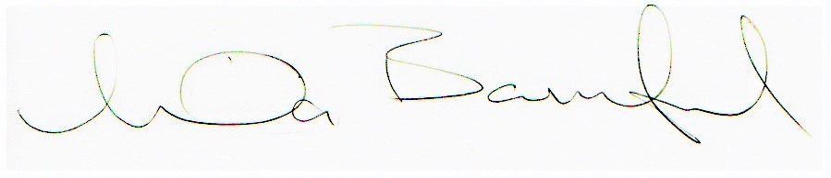
Linda Bamford, Convenor

