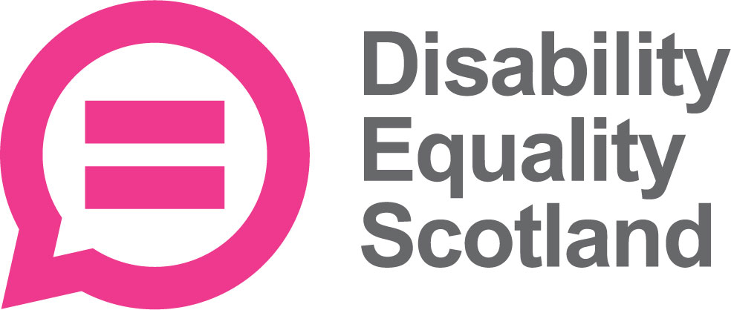 | Disability Equality Scotland  Meeting of the Board of Directors
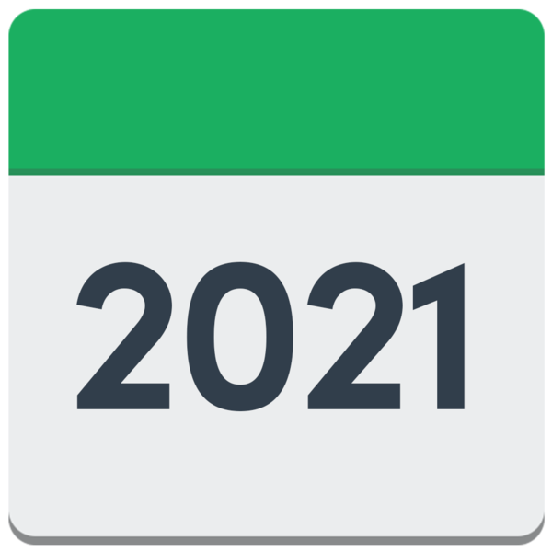  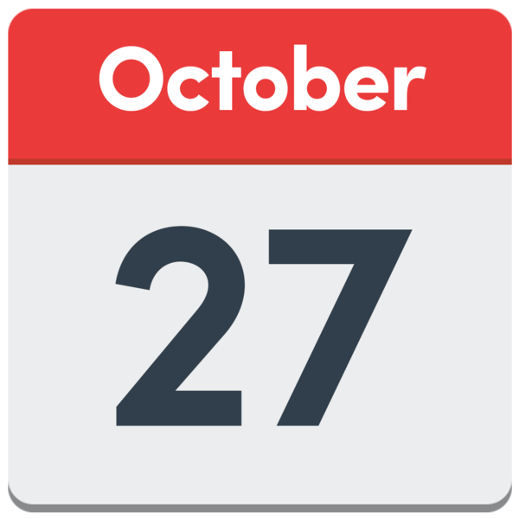 | 27 October 2021  at 10am on Zoom
 | Who was there?
Directors

- Linda Bamford – Convener
- Scott Stewart
- Carolyn Wilson-Smith
- Kenny Milne

Staff
- Morven Brooks – Chief Executive Officer
- Emma Scott – Operations Manager
- Ian Buchanan – Access, Training and Engagement Manager
- James Davidson – Communications and Research Coordinator
- Alistair Bruce – Access and Engagement Administrator
- Lucy Gibbons – Easy Read Trainer
- Shona McEwan – Easy Read Worker

Who could not come?
- Colin Millar – Director
- Rhianne Forrest – Director
- Dorothy McKinney – Director
- Maureen Morrison – Director
- Lauren Asher – Director

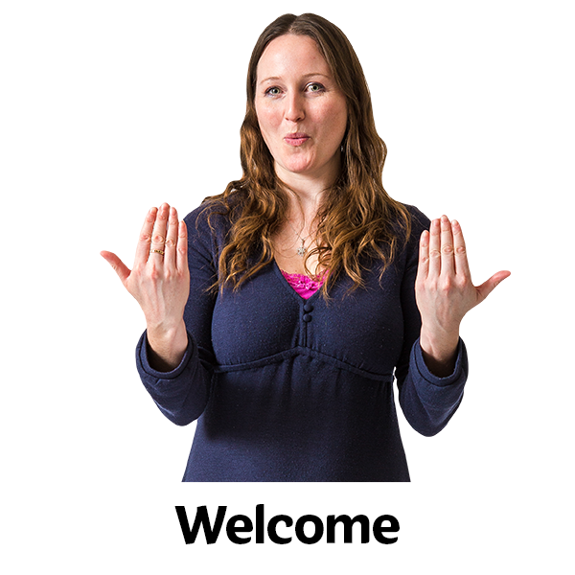 | Welcome  Linda welcomed everyone to the meeting.
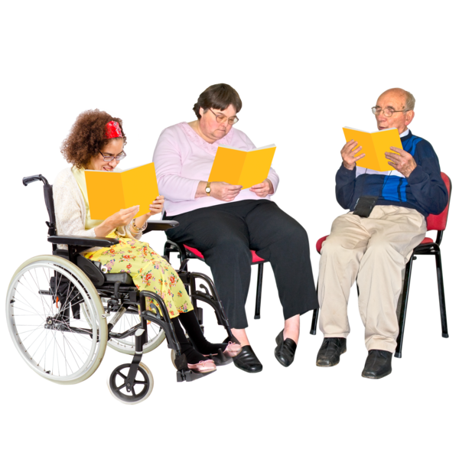 | Linda checked that everyone had had their board papers in enough time.
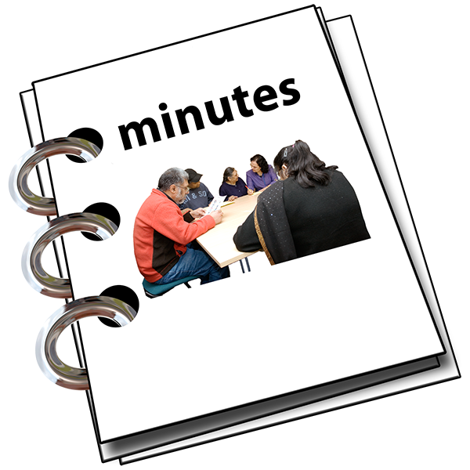 | Are the Minutes of the last meeting right?
 | Everyone agreed that the minutes of the last meeting were right.
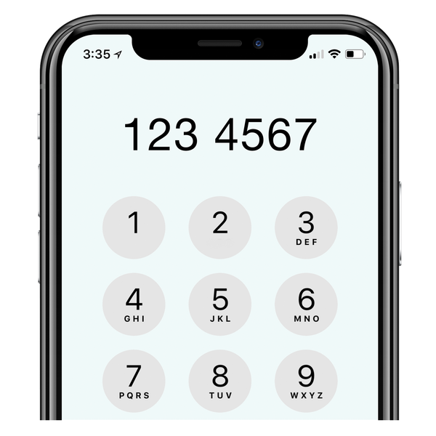 | Linda talked about a point in the last minutes.  She said that a partner organisation had asked for a list of contact details for people who had come to a webinar.
Morven said we would never give out contact details.
But the names of who came to public meetings can be shared.

 | What actions still need doing from the 28 July 2021 meeting?
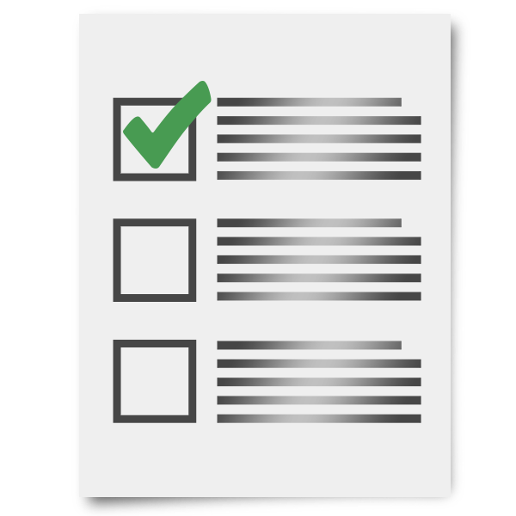 | Morven said that all actions have been done.  She asked Ian and James to tell us about Action 1 and Action 2.
Action Point 1- Access Language seminars

Ian said that the Access Language Seminar happened on 14 October 2021.
17 Access Panels joined the seminar and there was lots of talk.

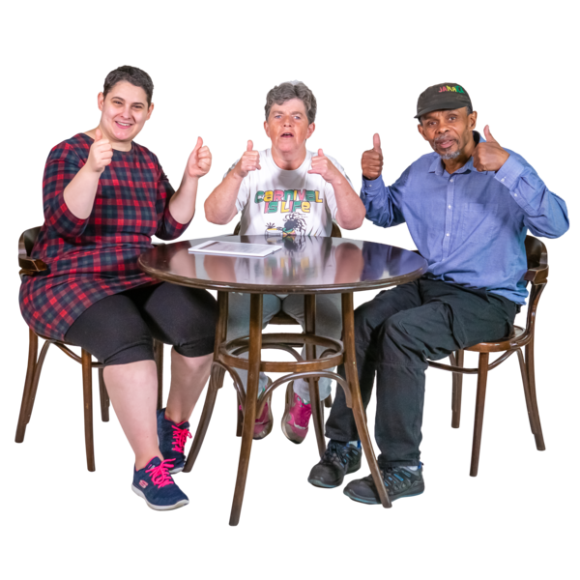 | Most people agreed that ‘access audit’ was a good phrase.  It is also in the 2010 Equality Act.
Most people did not like these words:
- lived experience assessment
- suitably qualified person
1 member sent in a paper beforehand with ideas about who should do access audits.
But not enough people agreed.
 | There was no agreement about what language should be used.
Most people liked ‘Access Report’.
Most people thought it was more important that the assessments are done well, than worry about the name.
 | There was talk about laws and insurance.
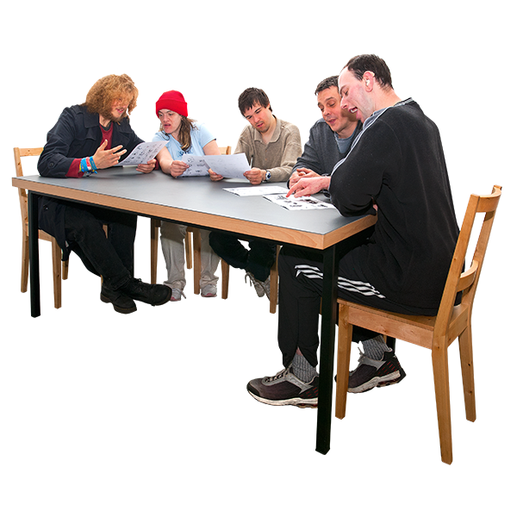 | Action Point 2 – Youth membership working group  James said that the Youth membership group met on 6 October 2021.
 | He said that there was lots of talk and some actions to do.
The ideas were things like:
- working with YouthLink
- working with Young Scot
- Year of Stories in 2022
- using TikTok
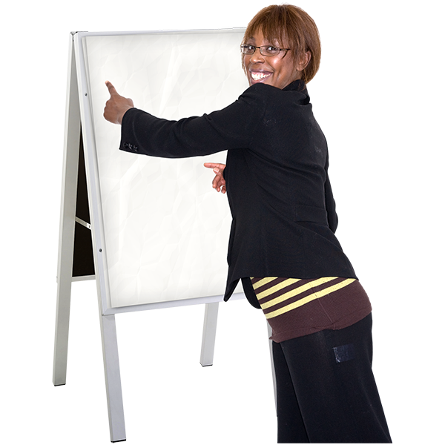 | James said that 1 idea is to run an access training course for young people.
We did not get funding for a Youth Engagement Coordinator.
But we can still plan for this role in the future.

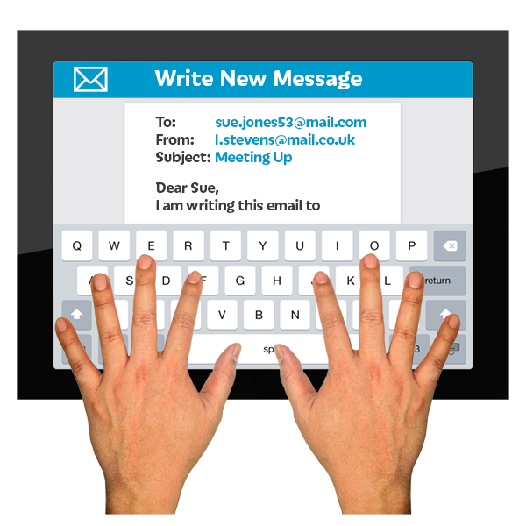 | Linda asked if we could contact the team organising ‘The Promise’ to tell them about our youth membership.

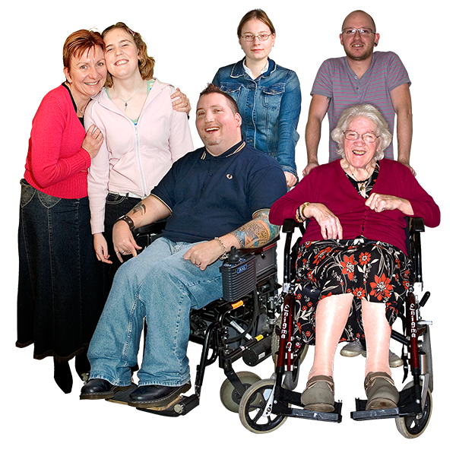 | New Members
Morven said that 61 new members have joined between 1 July 2021 and 30 September 2021.

1 corporate member asked to leave.

We now have a total of 1 thousand 4 hundred and 48 members.

Linda asked if everyone was okay with the new members joining.
Everyone said they agreed.
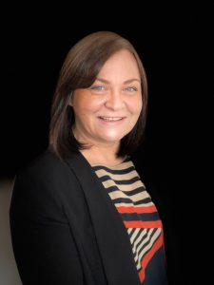  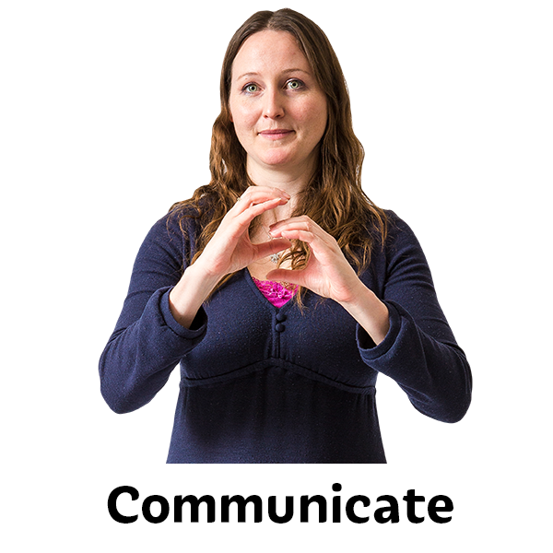 | Update by the Chief Executive Officer (CEO) Morven
Morven said that when deafscotland closed, the Inclusive Communication Alliance also ended.
But she is going to meet with Camphill Scotland to see if we can work together on inclusive communication.
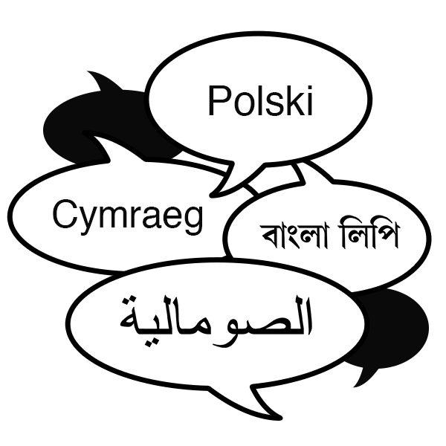 | Inclusive communication is making sure that information is made in lots of different ways.  This means that people can get information in a way that suits them.
 | Morven said that the Equality and Human Rights Fund has given us 5 hundred thousand pounds for the next 3 years.
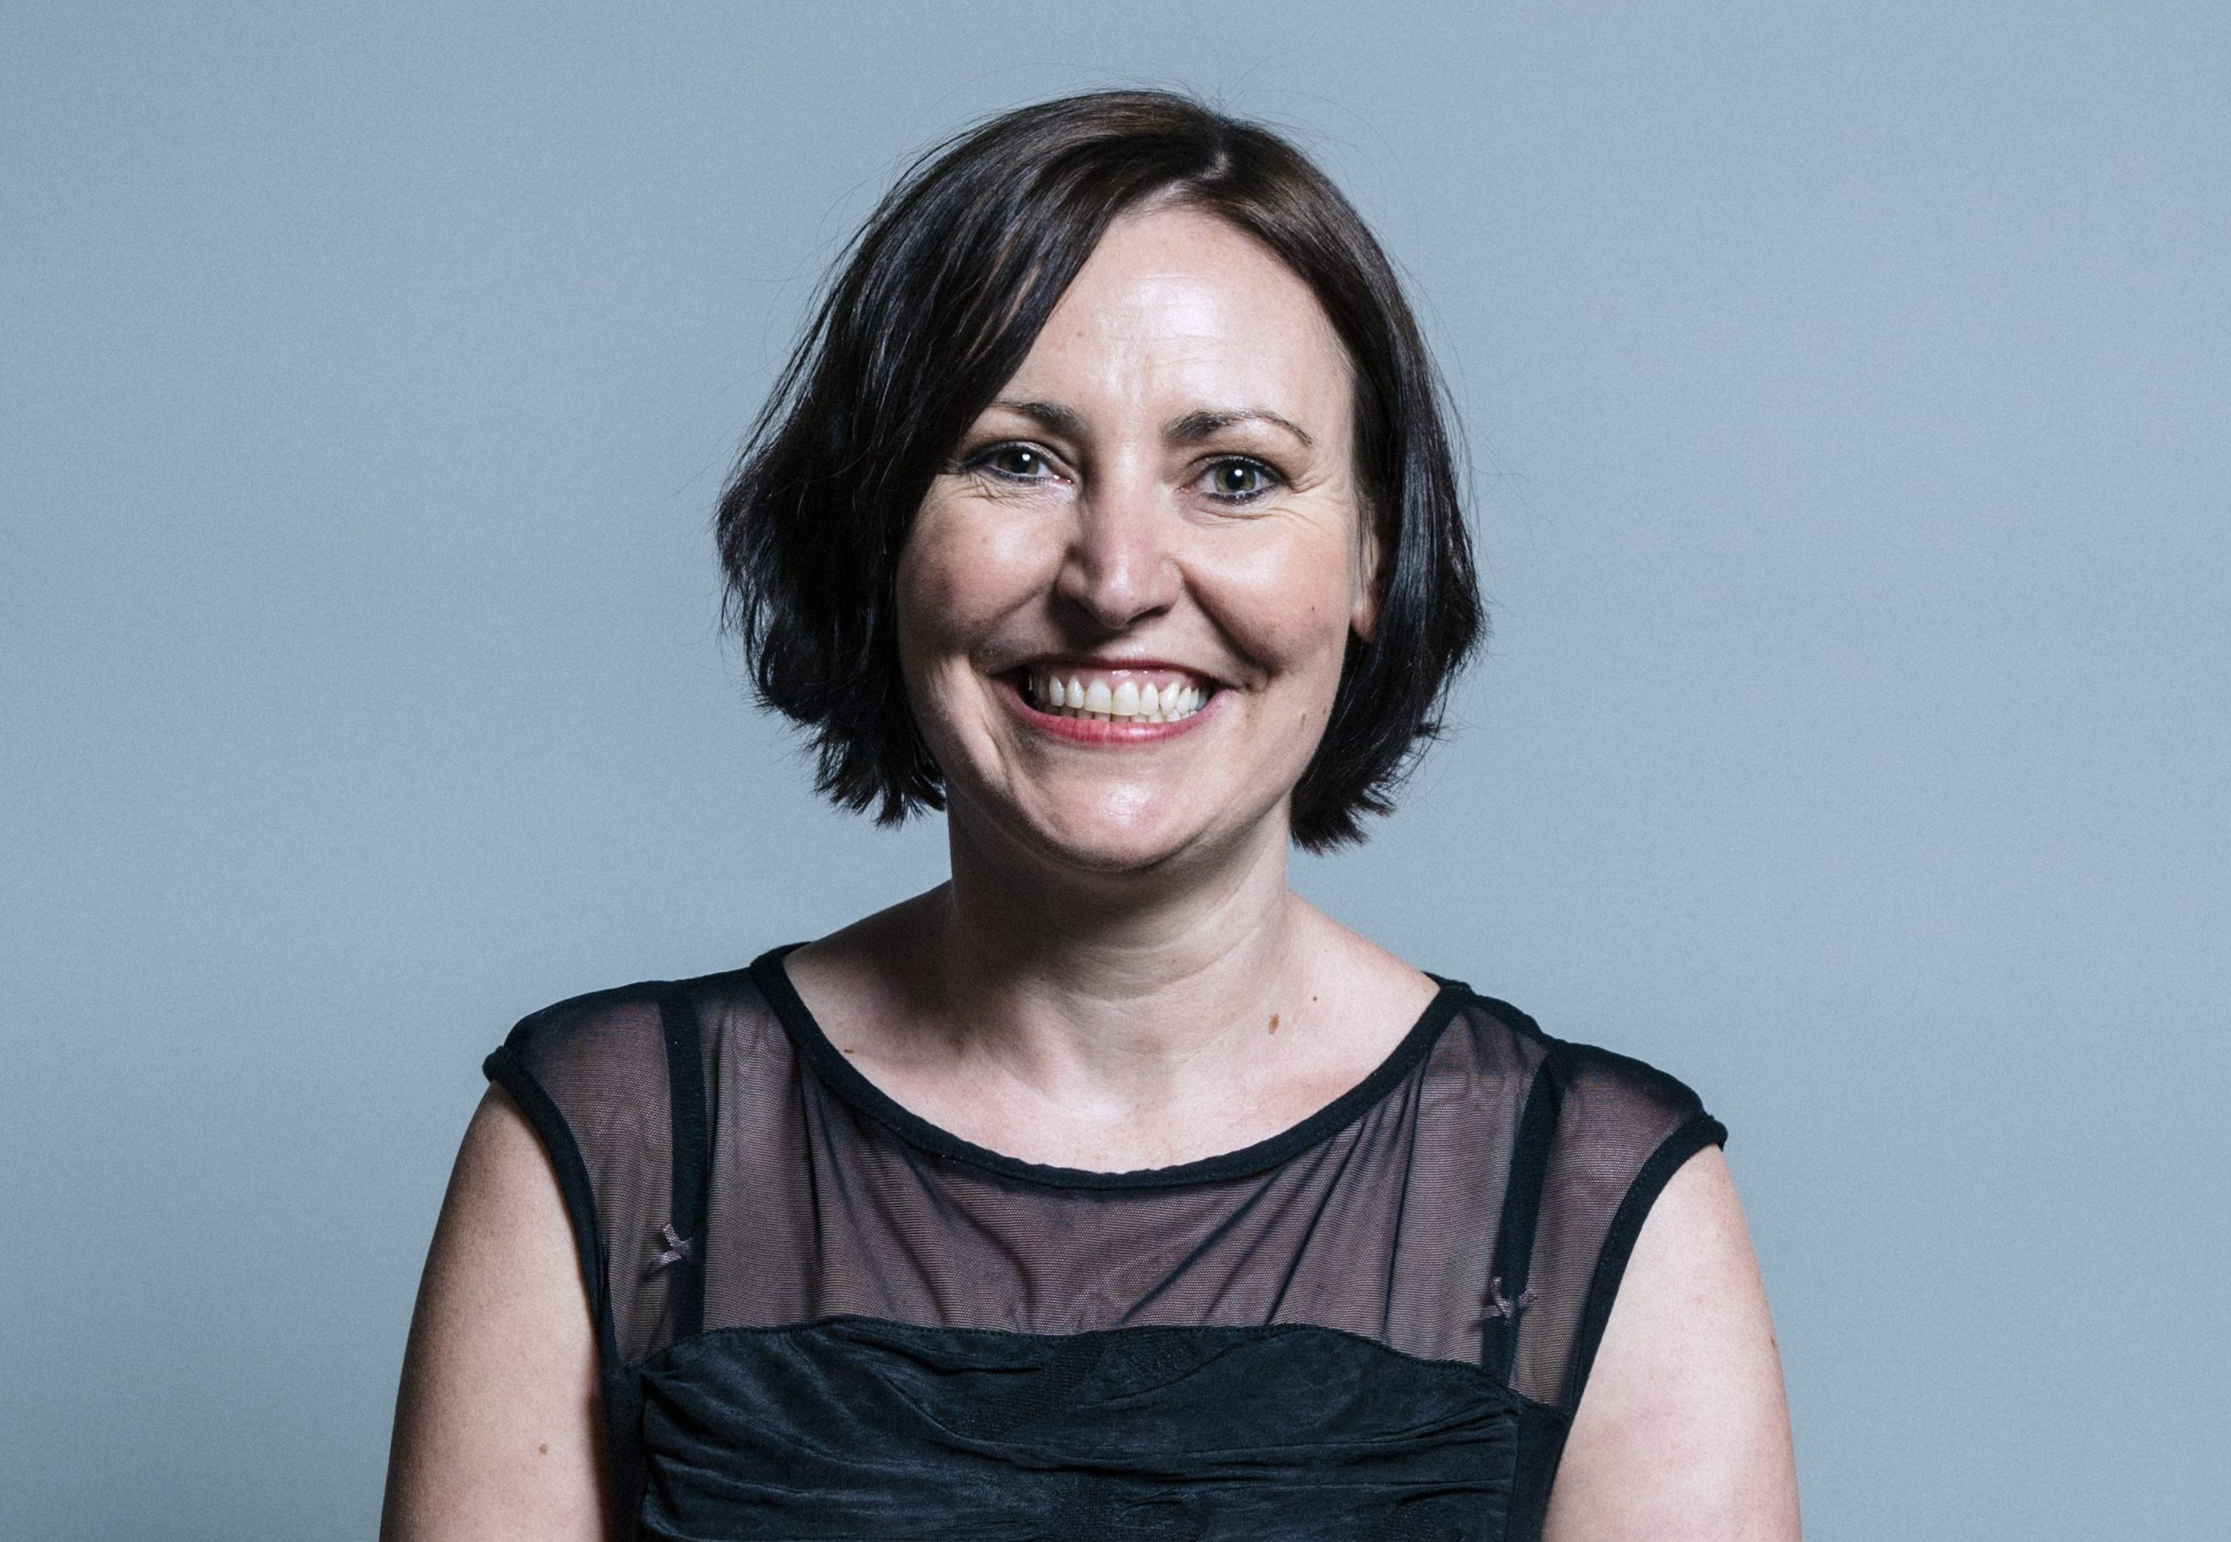 | Vicky Foxcroft is the Labour Party’s Shadow Minister for Disabled People.
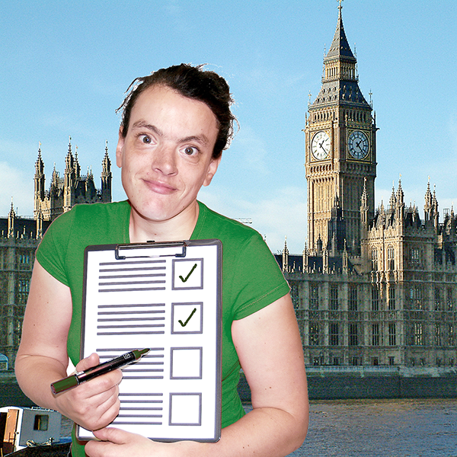 | Morven met Vicky to talk about:  - plans for disabled people  - the Green paper  Most of the meeting was about helping Vicky with advice about how to run events in a way that is accessible to everyone.
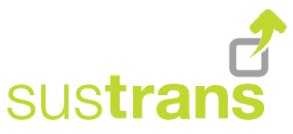 | Linda asked about Sustrans. She asked if Sustrans can use our Access Panels and our members to help their projects.  Morven said that the meetings had been cancelled but we will get in touch with Sustrans again.
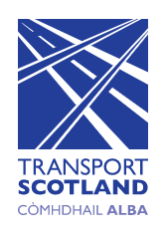 | Morven said that she is meeting Karen Furey from Transport Scotland.  They will talk about:  - how Disability Equality Scotland can help with Active Travel  - the Active Travel Delivery Plan
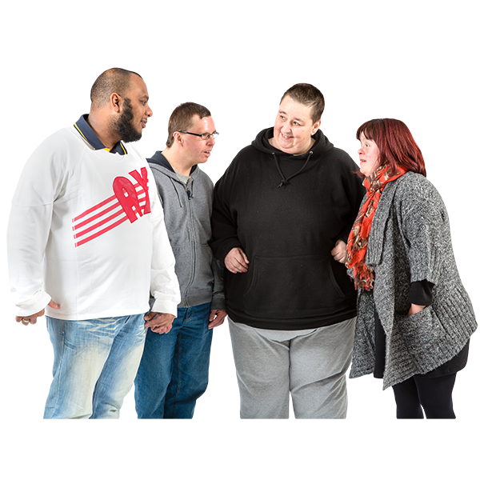 | Linda said that the Access Panels could help with:  - Spaces for People  - using Equality Impact Assessments to make decisions
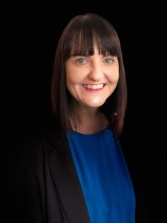 | Report by Operations Manager – Emma
Emma said we have hosted these events:
- returning to public transport after Covid
- hate crime
- Covid Recovery Bill
Lots of people came.
They said the events were well run.
They also said the Easy Read documents were good.
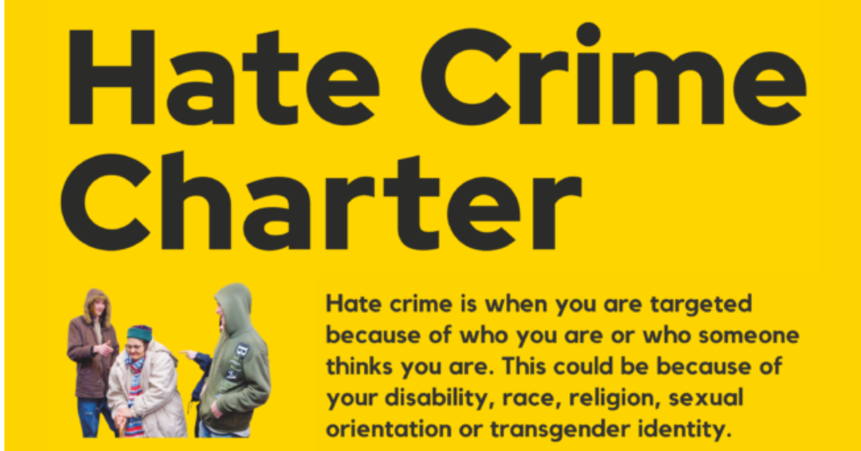 | The Hate Crime charter work is going well.  Emma thanked Linda for helping the Mobility and Access Committee for Scotland (MACS) become a Hate Crime charter supporter.
Emma said that ZetTrans and the Community Transport Association in Scotland are also supporters.
This means we have 12 organisations supporting the Charter.
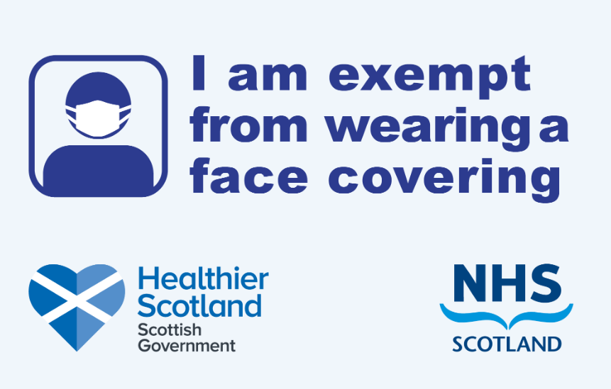 | Emma said that there is a new button on the Face Covering Exemptions website which lets people download the card.  10 thousand people have downloaded their card in the first month.
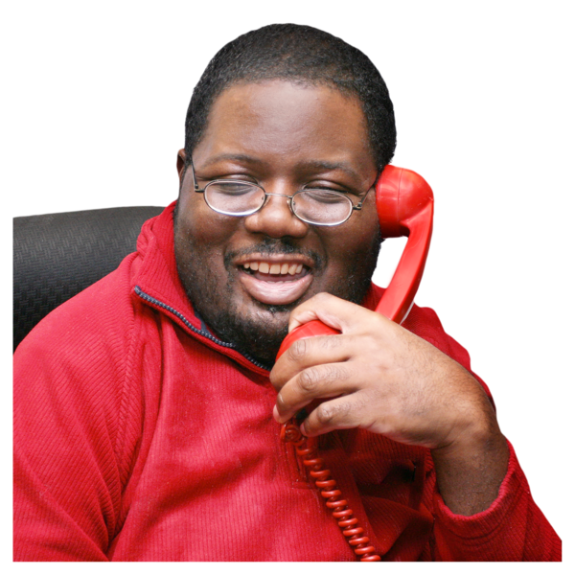 | Now hardly anyone is calling the helpline.
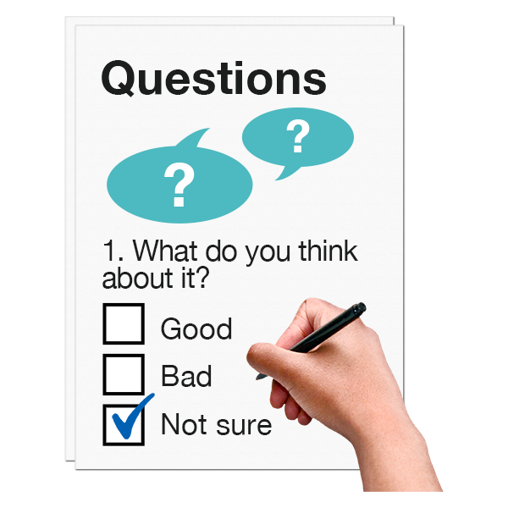 | Emma said that more than 100 members have answered the yearly members Survey.
Emma is working with our Projects Coordinator.
They are making a video to help train organisations about disabled peoples issues and about hate crime.

It has been hard to find people who are happy to be filmed.
Emma asked if anyone knows anyone who might help.

Emma said that the 20 Minute Neighbourhood work has gone well.
There will be a final report, which will get shared.

Emma thanked the Easy Read team.
There has been a lot of Easy Read work.
Lucy has run her first Easy Read training course online. She had excellent feedback.

 | Linda said that lots of the documents were tricky to put into Easy Read.
 | Linda also told Emma that she had done a great job meeting with Christina McKelvie – Minister of Scottish Parliament.
Scott asked about using volunteers for the hate crime video.
He said that lots of phone calls to the Disability Information Scotland helpline were about hate crime.
He will invite some people to get in touch with Disability Equality Scotland.

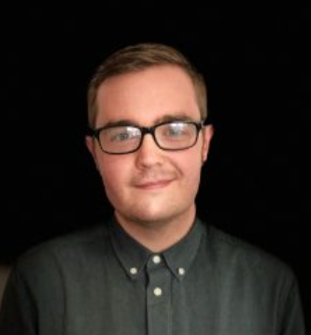 | Report by Equality and Access Manager – Ian Buchanan
Ian said he now through to the second stage on the National Register of Access Consultants – also called NRAC.
Everyone said he had done well.
Ian said the first Cross Party Group meeting about Disability happened in September.
Ian was the Secretatiat.
A Secretariat is in charge of things like:
- organising meetings
- making meeting Minutes
 | Ian said that the Access Panel Survey had fewer replies than last year.
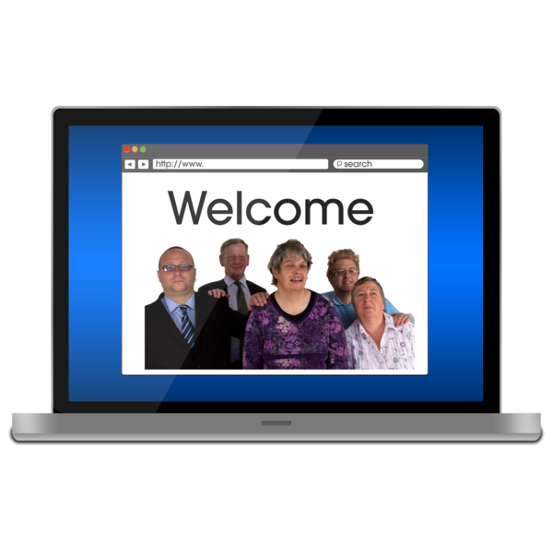 | Ian said he is still working on the new Access Panel website design.
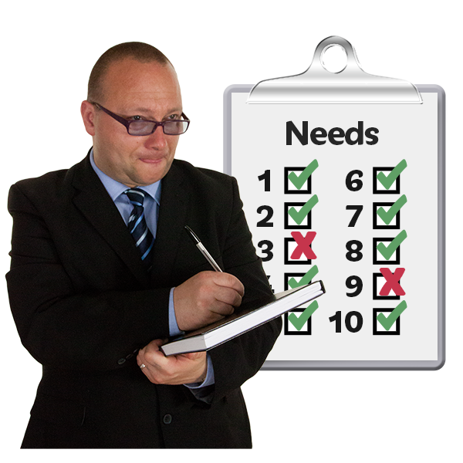 | Ian said he had visited the Motability offices in Edinburgh.  He helped to do an access audit.  The access audit showed that it was a very accessible building.  It would be good for an Access Panel Conference in the future.
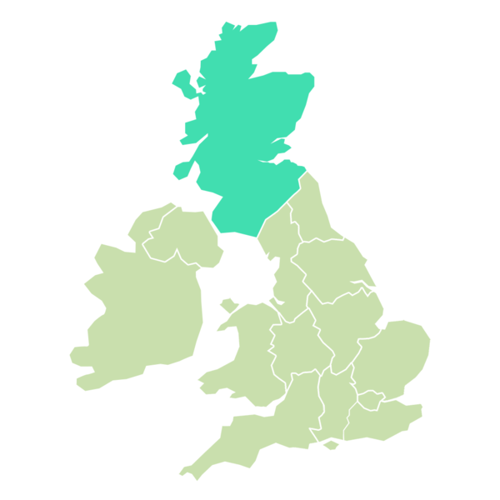  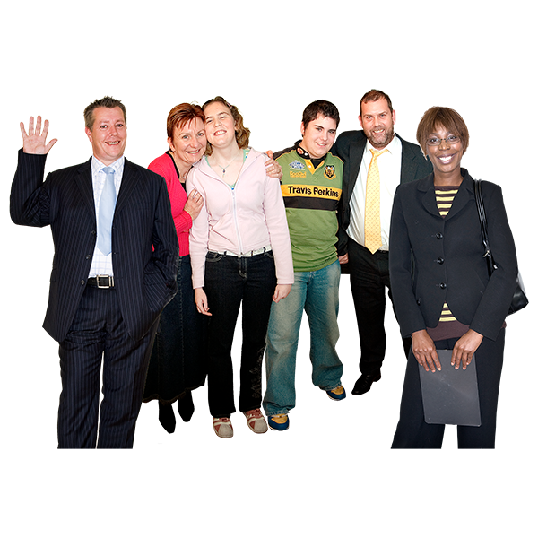 | Ian said that there are new Access Panels in:  - Inverness area  - Argyll and Bute Council area  He thanked Alistair for his hard work. The feedback has been very good.
Carolyn said she had heard there were some local problems with Motability.
But Motability is always friendly and happy to fix problems.
Morven said that Motability are a sponsor with Disability Equality Scotland.
She thought Access Panels might be able to work together with Motability.
 | The meeting stopped for a comfort break.
 | What is happening this year
 | Linda said that she and Morven look at the Calendar of Activities 4 times during the year.
Morven said that everything is happening at the right time.
This includes:
- checking staff are doing a good job
- money
- looking at risks

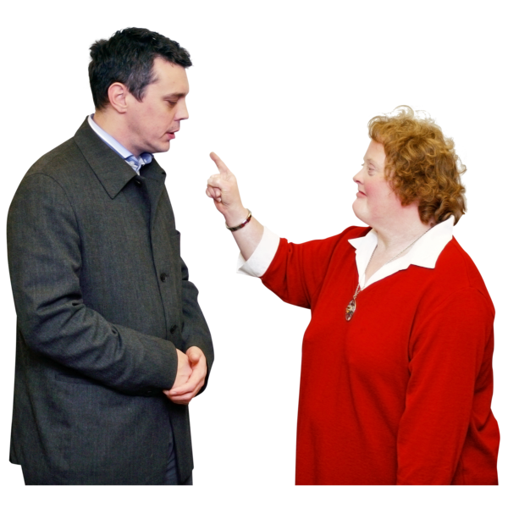 | Complaints  Morven said there had been 1 complaint.  The person complaining said that they could not access the Annual General Meeting online event.
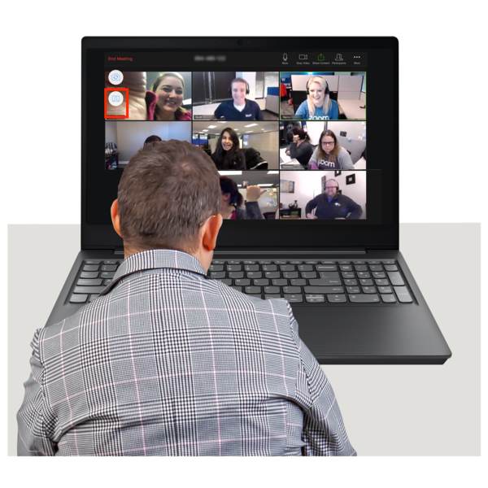 | We have now stopped using the webinar style.  There were talks about whether to carry on online meetings. For now we will carry on online.
What we have learned

Linda said that at the last meeting we had talked about making a Code Of Conduct.
A Code Of Conduct is a list of all the ways that we agree to keep meetings positive.

 | Money
 | Morven said that we have 83 thousand pounds saved.
 | People
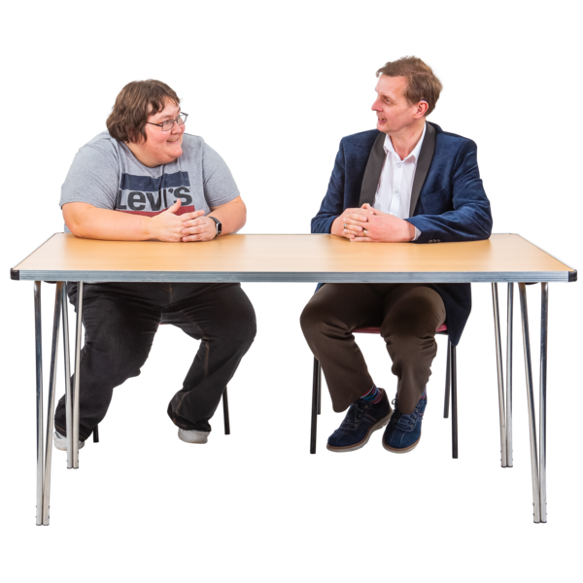 | Morven said that staff are having 1 to 1 meetings to see how well they are doing their jobs.  Staff are asked every week what they have learned.  We stay in touch with staff who work from home very well.
Risk Management - things that might cause problems

Linda said that the 2 risks called Finance and People are at less risk now.
Everyone agreed

 | Our risk score has come down to 5 now. This is good.
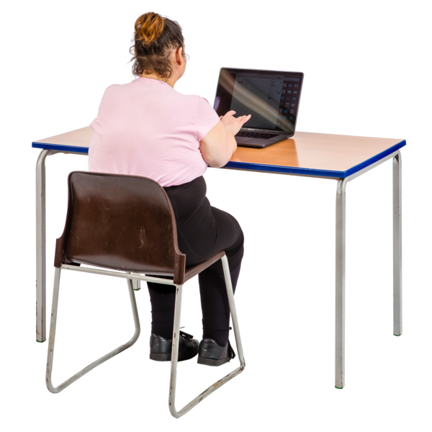 | Linda told everyone that they could ask to see the risk paperwork at any time.
 | What do we need to do in the next three months?
Morven said that we need to:

- keep looking ahead – this is also called horizon-scanning
- check we are meeting our targets in our Plan

Morven said that we are looking to get a new Convener and a new Vice Convener.
This is because Linda and Dorothy are stepping back.

 | Linda asked anyone who is interested in being Convener or Vice Convener to fill in their forms.
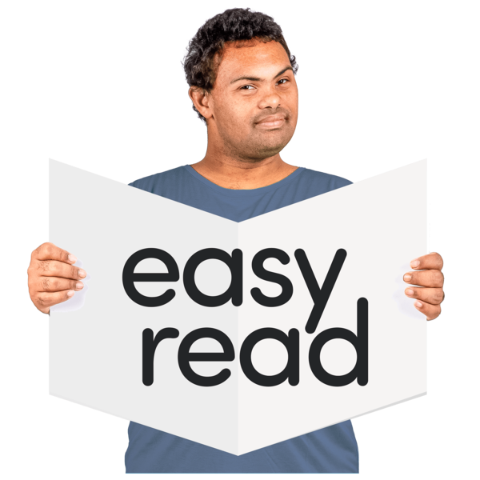 | Morven said that the focus over the next 3 months is:  - Easy Read work  - Fundraising Plans
 | What actions need to happen from today’s meeting?
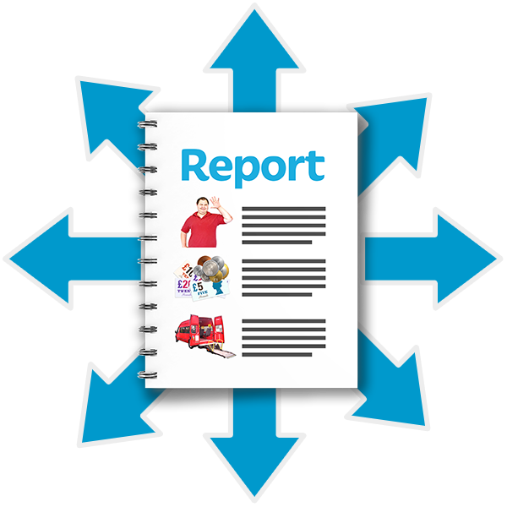 | Action 1: Ian will share the Access Language Seminar report.
 | Action 2: James will get in touch with the ‘The Promise’ team to talk about our work and young members.
 | Action 3: Morven will sort out the voting for the new Convener and Vice Convener roles.
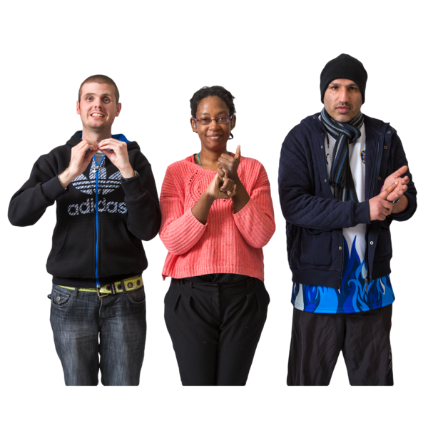 | Any Other Business  Kenny said that he had enjoyed the British Sign Language training.  Linda thanked the Disability Equality Scotland team for their hard work.

The Meeting Ended
Linda thanked everyone for coming and the meeting ended.

