Disability Equality Scotland
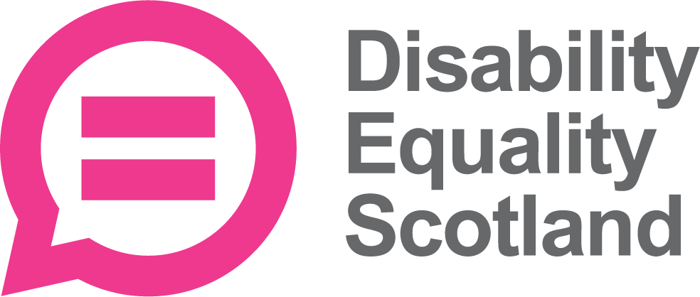

Information about
becoming a Convener

Easy Read
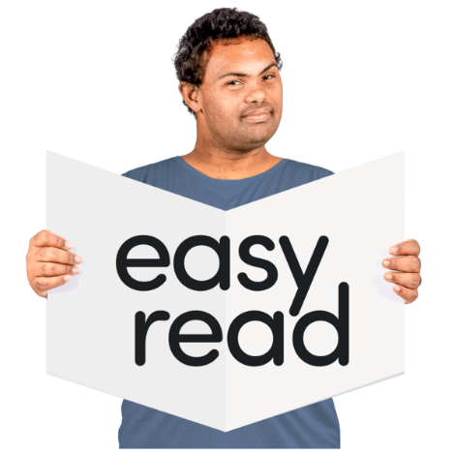

Copyright images © Photosymbols. Prepared by Disability Equality Scotland

 | Who we are
 | Disability Equality Scotland is a national organisation with members.
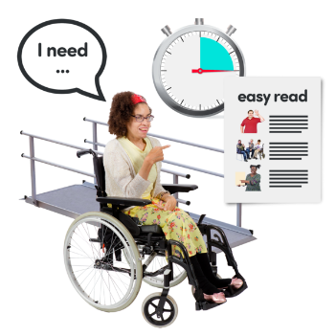 | We work to get full access for disabled people and to make sure they are included.
We speak for:
- people with any type of impairment
- disability organisations
- groups who share our values

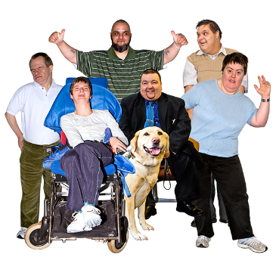 | We want people to have equal access to buildings and the outdoors.  We want all people to have equal chances to be independent and have full, enjoyable lives.
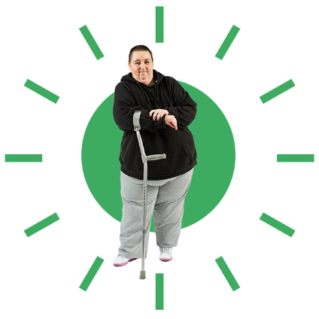 | The Convener role  We want a new Convener to join Disability Equality Scotland and support our Chief Executive Officer.
 | This is a voluntary role, which means you won’t be paid.
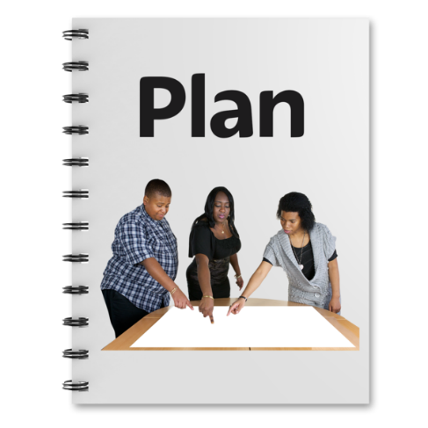 | We are half way through our Strategic Plan actions.
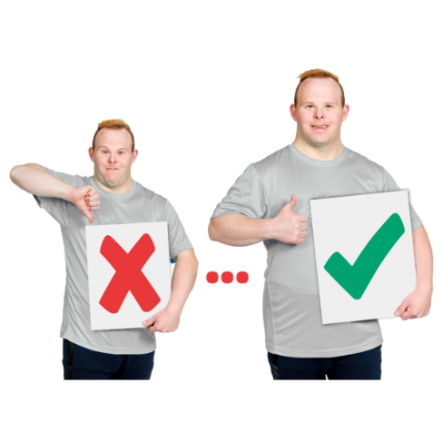 | We are working on:  - making more listening and talking events  - supporting our Access Panels across Scotland  - making great relationships with our stakeholders  Stakeholders are the organisations and people who are interested in our work.
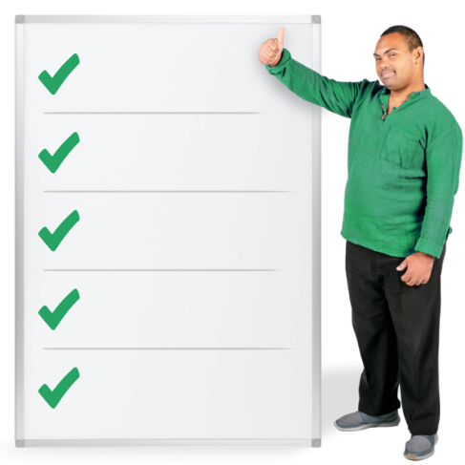 | We want a new Convener to lead our Board of trustees.  We want the new Convener to:  - make sure we do a good job for our members  - go to events and meetings for Disability Equality Scotland  - sign money paperwork  - make sure the Chief Executive Officer is doing their job well
You will need to be:
- a leader
- enthusiastic
- good at working with people
- ready to join in new activities

You will get:
- induction support to help you join in
- training
- the tools, devices and paperwork you need
- paid back for expenses like travel and accommodation if it is needed
- a named person to support and guide you
- team members to help and advise you

 | How Disability Equality Scotland is led
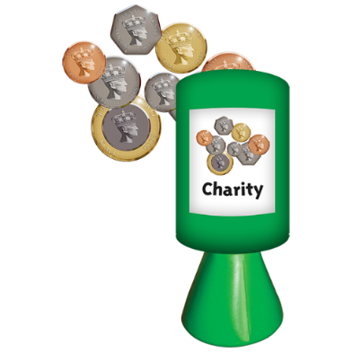 | We are a registered Scottish charity.
We have Trustees who stay with us for up to 3 years.
The Convener is also a Trustee.

 | You can find out more about our Trustees by clicking on https://disabilityequality.scot/meet-the-team
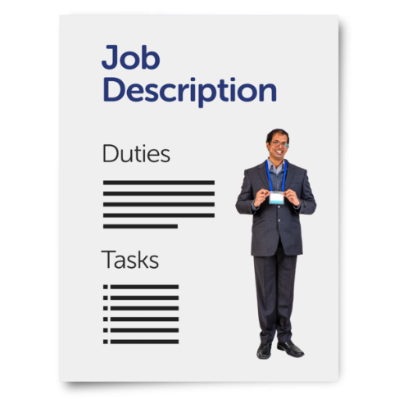 | What does the new Convener have to do?
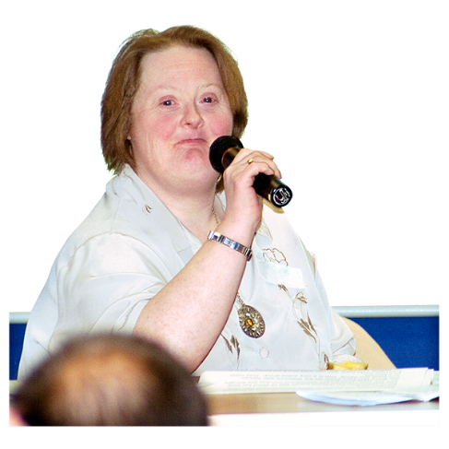 | Leading  You will be a leader.
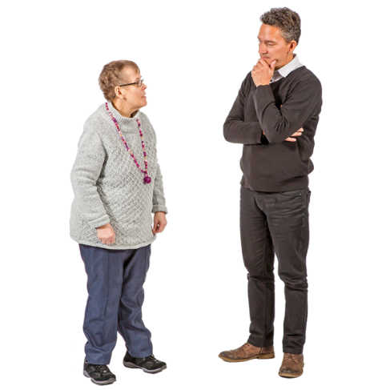 | You will be the line manager for the Chief Executive Officer.
 | You will lead Board meetings. This is also called chairing a meeting.
You will sometimes be the spokesperson for Disability Equality Scotland.
You will help make sure that Disability Equality Scotland is seen as a positive organisation.
You will make sure that Trustees are joining in with good decisions.
You will make sure that the Board has the right support and information.
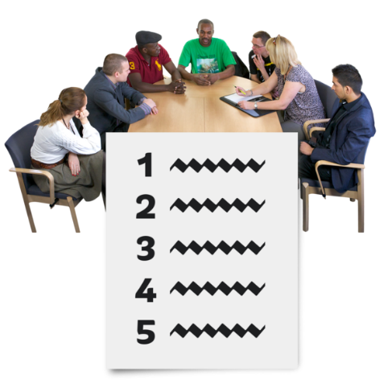 | You will work with the team to make sure that these things are ready for each meeting:  - an agenda  - supporting information
Governance
Governance means how the organisation is run.
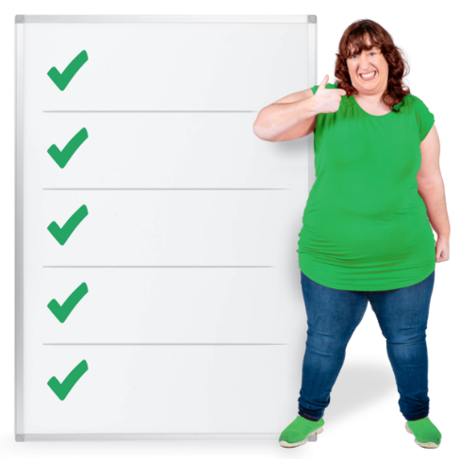 | You will make sure that the Board of Trustees does a good job and keeps to the Scottish Charity Regulator rules.
 | You will make sure that Disability Equality Scotland keeps to its Article of Association and all the rules that go with this.
 | You will make sure that the finances are okay.
 | You will make sure that the Board of Trustees support the Strategic Plan.
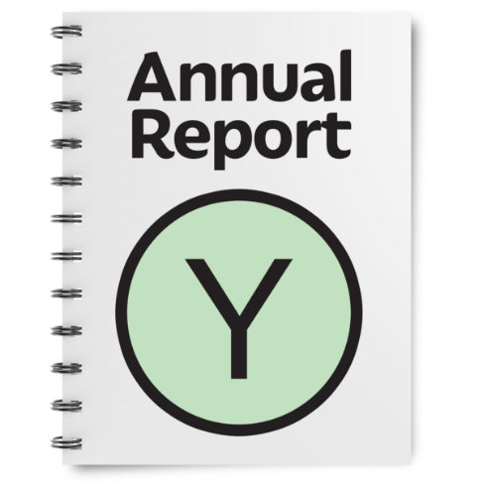 | You will help the Board of Trustees to check the Annual Report and the accounts.
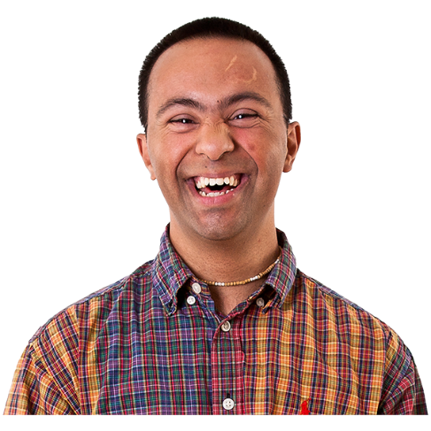 | You will help bring positive change and helpful talking and listening.
 | You will help to fix any arguments with the Board of Trustees.
 | You will look at progress and membership often, to help keep skills and experience balanced.
Managing the Chief Executive Officer
You will be the line manager for the Chief Executive Officer.
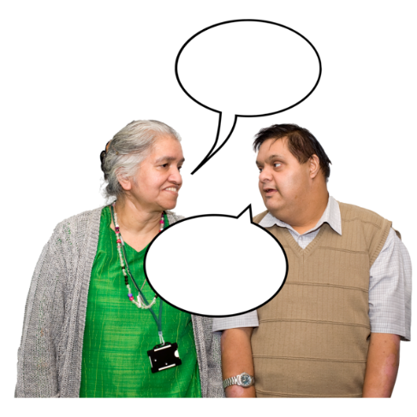 | You will build a very good working relationship with the Chief Executive Officer.
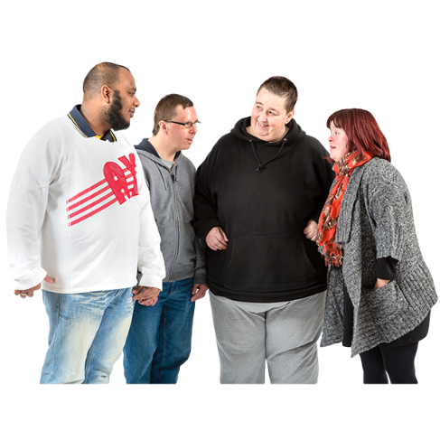 | You will make sure that there is a very good working relationship between the Trustees and the staff team.
 | You will support and guide the Chief Executive Officer and give them coaching if they need it.
 | You will give feedback and a yearly report to the Directors about how the Chief Executive Officer is doing.
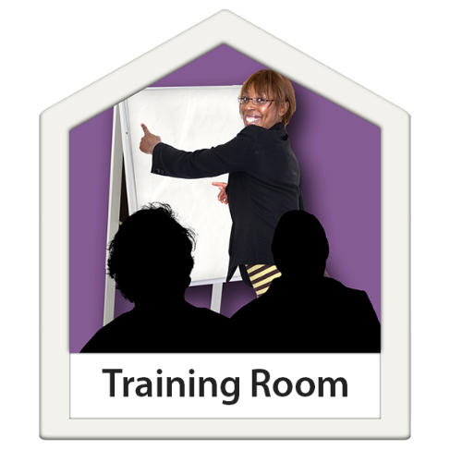 | You will make sure that the Chief Executive Officer has:  - chances for development  - support outside the organisation
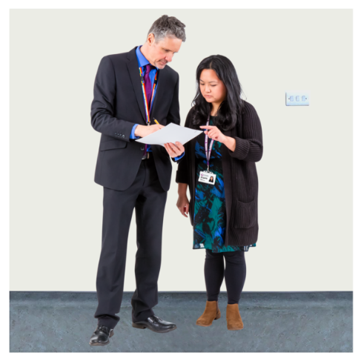 | You will work with the Chief Executive Officer to make sure that Trustees and staff members do the actions they need to, from Board meetings.
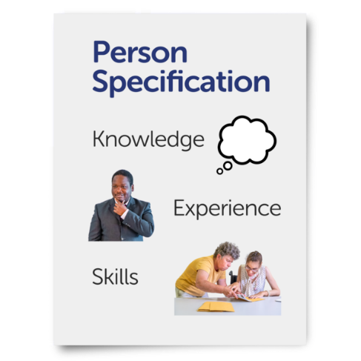 | Skills and Knowledge that you must have
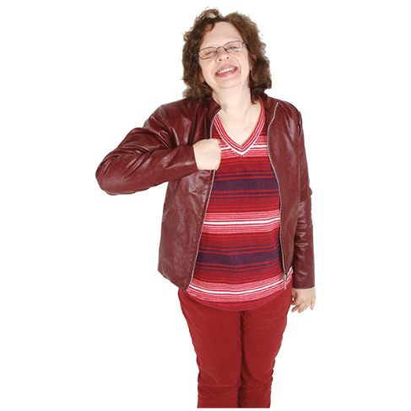 | You will be have experience of being a Charity Trustee before.
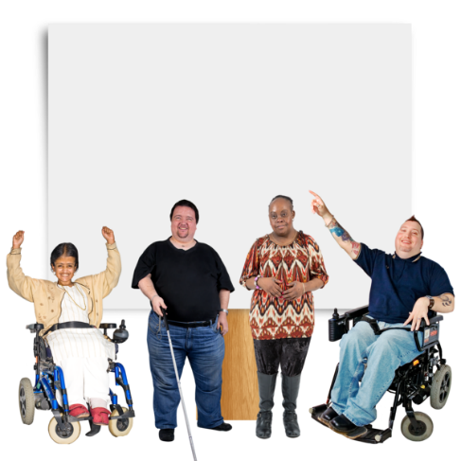 | You will know about these things very well:  - equality  - disability  - inclusion for disabled people
 | You will be a very good speaker to people from lots of different backgrounds.
 | You will make good and fair decisions and explain what you think really well.
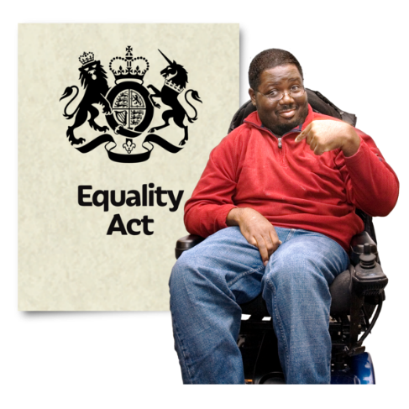 | You will understand the Equality Act 2010 and use it in your work.
 | You will understand the jobs of a Convener.
You will be very good at:
- thinking about data and information
- reading lots of tricky information fast
- leading
- working with other people
- getting good solutions and decisions
- chairing meetings
- helping stakeholders join in

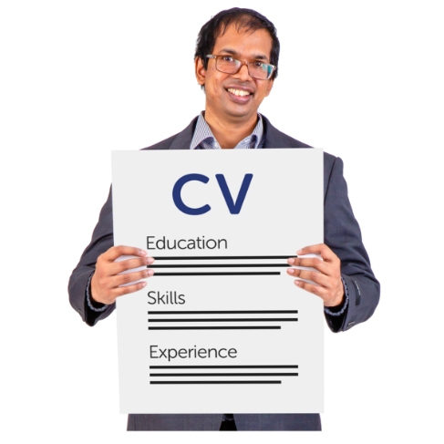 | Other skills and knowledge that you might also have
You might be able to work very well with stakeholders like:
- Scottish Government
- Scottish Parliament
- the media
- other charities
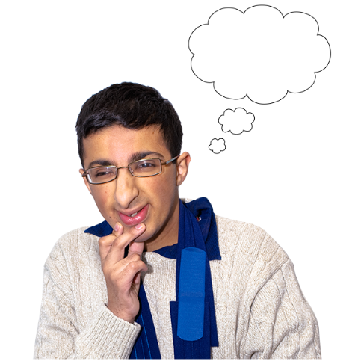 | You might know about:  - change management  - cultural development  from working in charities.
 | How much time to I need to give?
 | You will be asked for no more than 8 days a year.
 | We have Board meetings 4 times a year, so 4 of your days will be at these meetings.
Our next Board meeting is 27 April 2022, from 10am to 12pm. The meeting is online by Zoom.
If you get the Convener role, you need to come to this meeting.
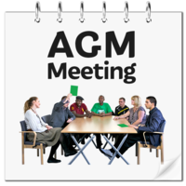 | 1 of your days will be for our Annual General Meeting.  This year we think this meeting will be during August, from 1pm to 3pm.
1 of your days will be for our Access Panel Conference, in the spring of each year.
Other days might be used for meetings or training.

 | How will I communicate?
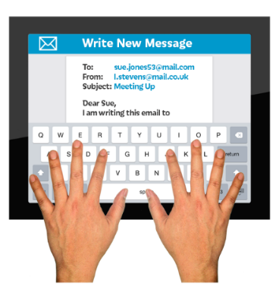  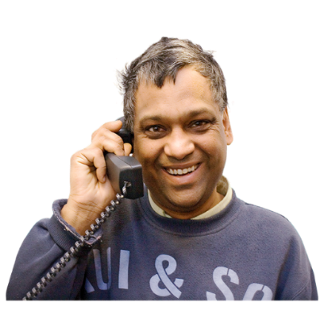 | We will need to reach you by email or phone in between meetings.
Other information
We welcome applications from people who come from different backgrounds and have different life experiences.
 | If you are chosen to be the new Convener, we will need to do a check on the Protecting Vulnerable Groups scheme.
If we ask you to come to an interview, it will be on:
- Monday 28 March 2022
- Tuesday 29 March 2022
You must be free on both these days.
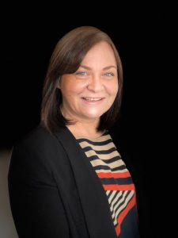 | If you would like to apply to be a Convener you can:
 | - call Morven Brooks, the Chief Executive Officer, on 0141 378 6625
 | - email us for an application pack at admin@disabilityequality.scot

