Disability Equality Scotland
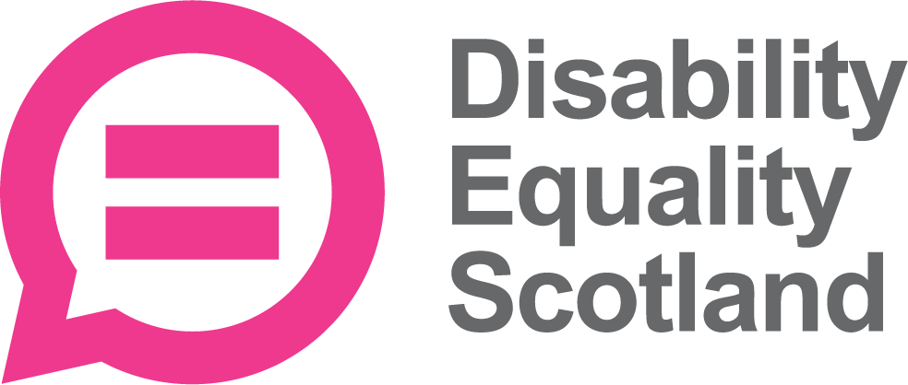

Information about
becoming a Director
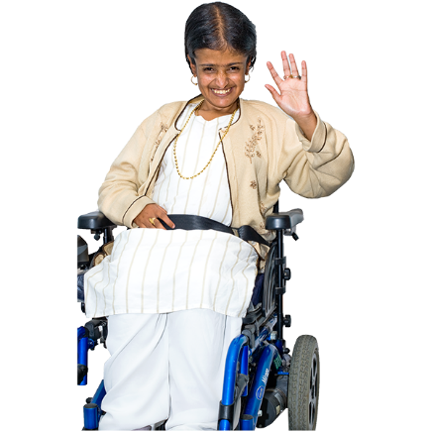

Easy Read
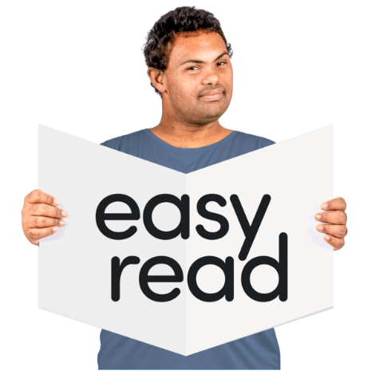

Copyright images © Photosymbols. Prepared by Disability Equality Scotland 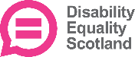

 | Who we are
 | Disability Equality Scotland is a national organisation with members.
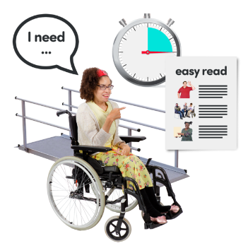 | We work to get full access for disabled people and to make sure they are included.
We speak for:
- people with any type of impairment
- disability organisations
- groups who share our values

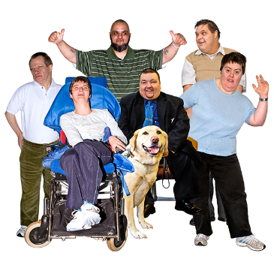 | We want people to have equal access to buildings and the outdoors.  We want all people to have equal chances to be independent and have full, enjoyable lives.
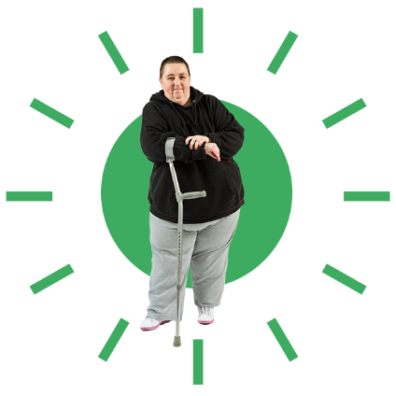 | The Director role  We want a new Director to join our Board of Directors.
 | This is a voluntary role, which means you won’t be paid.
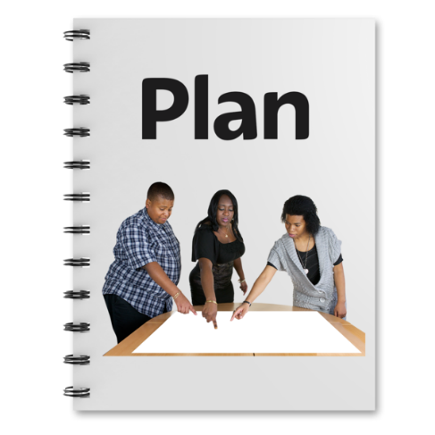 | We are half way through our Strategic Plan actions.
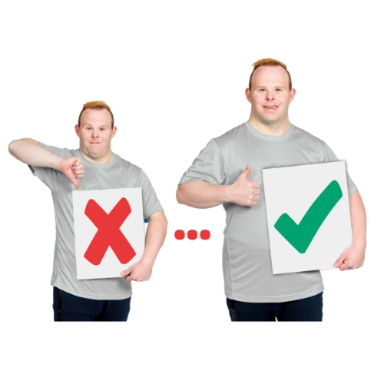 | We are working on:  - making more listening and talking events  - supporting our Access Panels across Scotland  - making great relationships with our stakeholders  Stakeholders are the organisations and people who are interested in our work.
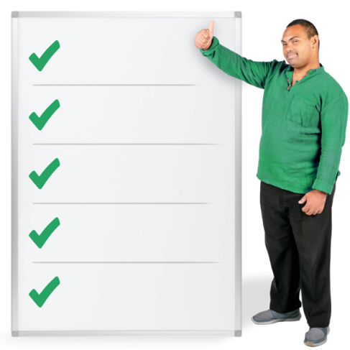 | We want a new Director who may have 1 or more of these:  - lived experience of a disability  - experience of being a leader  - fundraising skills  - knows about:  - Social Model of Disability  - Accessibility – things like audits and assessments  - The Equality Act of 2010  - volunteers  - Access Panel Network
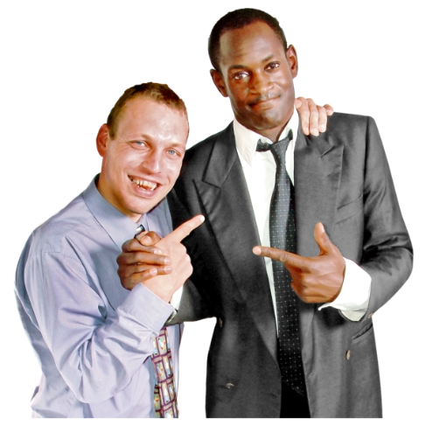 | You will need to be:  - enthusiastic  - good at working with people  - ready to join in new activities
You will get:
- induction support to help you join in
- training
- the tools, devices and paperwork you need
- paid back for expenses like travel and accommodation if it is needed

 | How Disability Equality Scotland is led
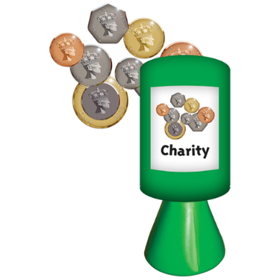 | We are a registered Scottish charity.
We have Trustees who stay with us for up to 3 years.
The Directors are also Trustees.

 | You can find out more about our Trustees by clicking on https://disabilityequality.scot/meet-the-team
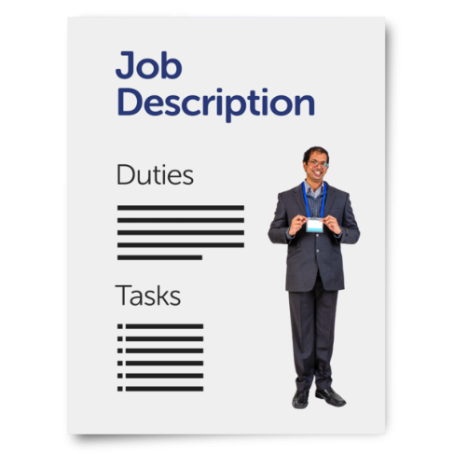 | What does the new Director have to do?
 | You will work closely with other Board members to lead and support work on the Strategic Plan.
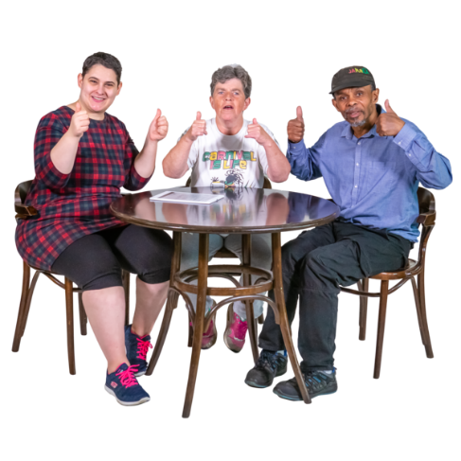 | You will help check that Disability Equality Scotland is working fairly and well.
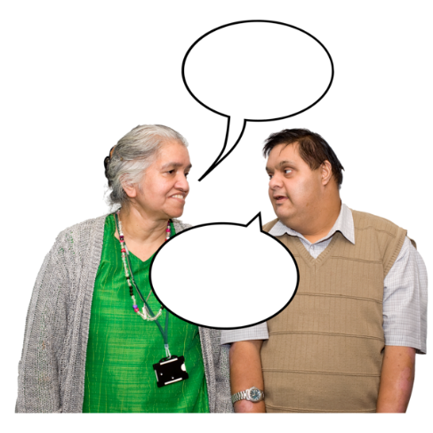 | You will communicate with:  - Board members  - the Chief Executive Officer  - staff  - stakeholders  - Access Panels and members
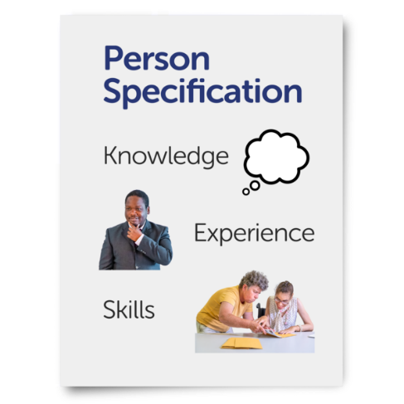 | Skills and Knowledge that you must have
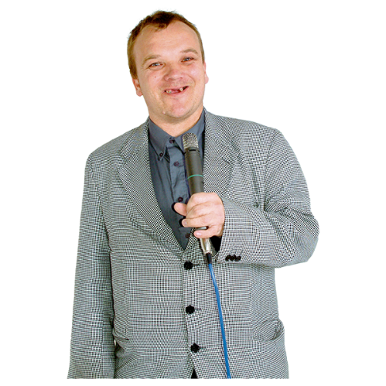 | You will be a great speaker.
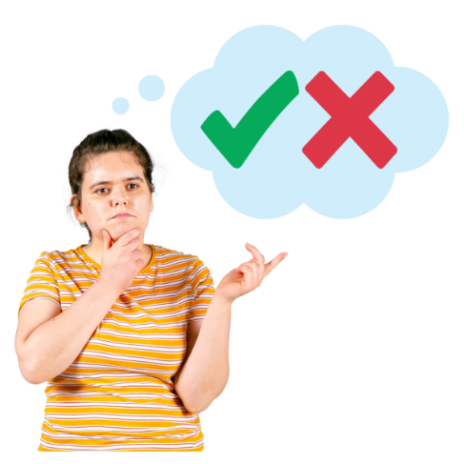 | You will make fair and clear decisions.
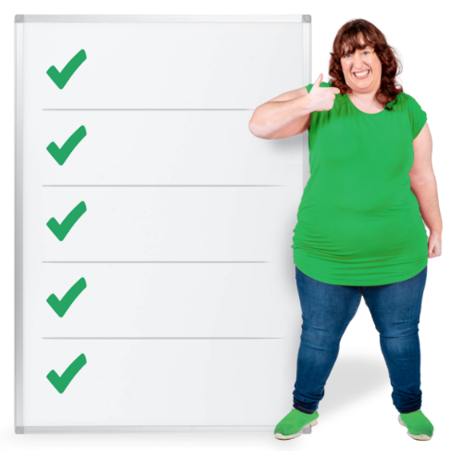 | You will understand what Board members need to do.
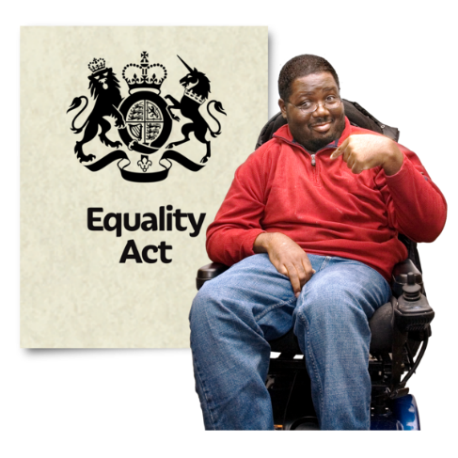 | You will understand the Equality Act 2010 and use it in your work.
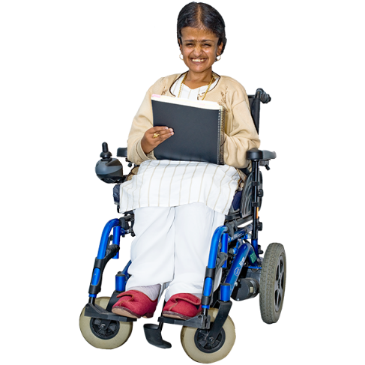 | You will know about what life can be like for a disabled person.
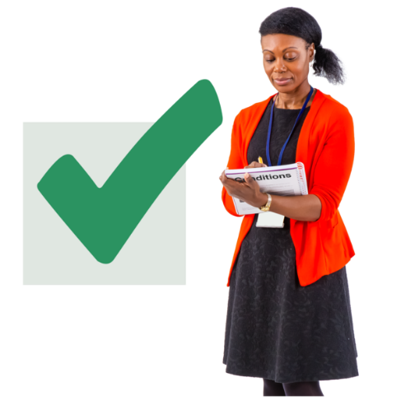 | You will know about Disability Access Audits – which check something is accessible for disabled people.
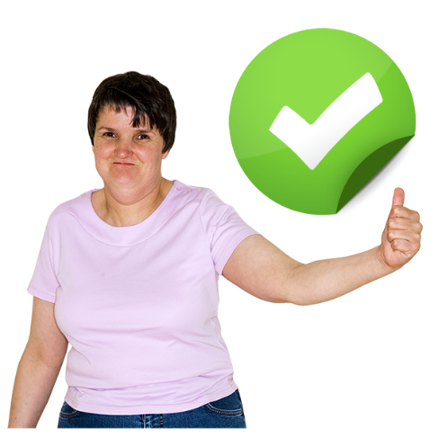 | Other skills and knowledge that you might also have
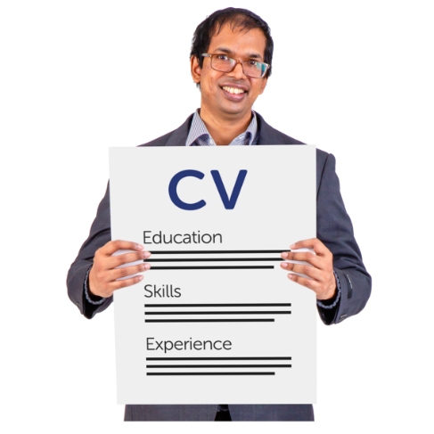 | You might have experience of being a Trustee of a charity.
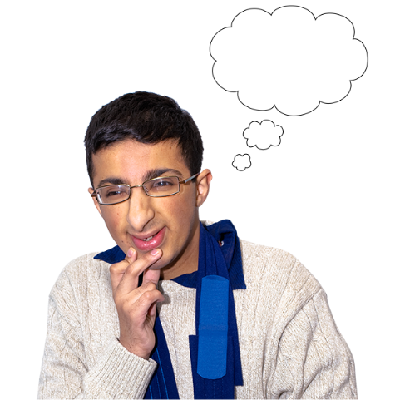 | You might know where you have gaps in your knowledge and want to learn more.
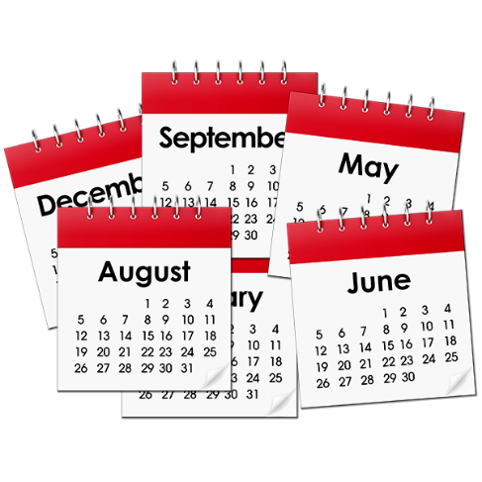 | How much time to I need to give?
 | You will be asked for no more than 8 days a year.
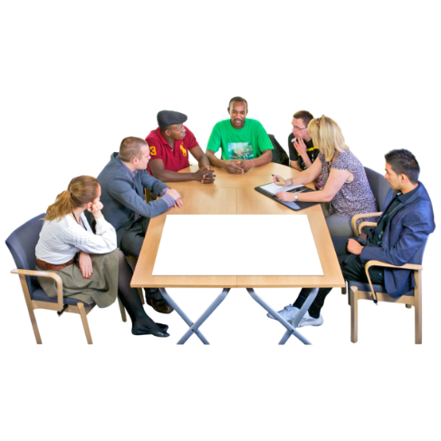 | We have Board meetings 4 times a year, so 4 of your days will be at these meetings.
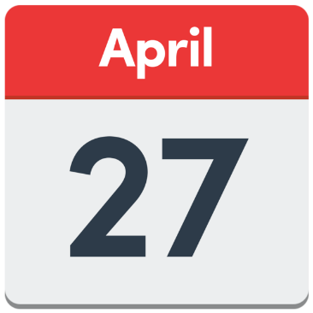 | Our next Board meeting is 27 April 2022, from 10am to 12pm. The meeting is online by Zoom.  If you get the Director role, you need to come to this meeting.
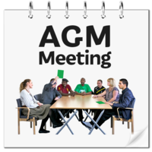 | 1 of your days will be for our Annual General Meeting.  This year we think this will be during August, from 1pm to 3pm.
1 of your days will be for our Access Panel Conference, in the spring of each year.
Other days might be used for meetings or training.

 | How will I communicate?
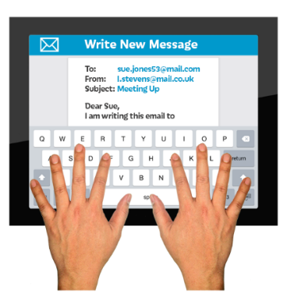  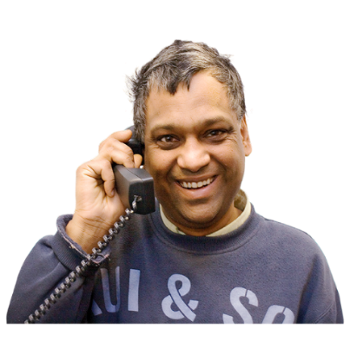 | We will need to reach you by email or phone in between meetings.
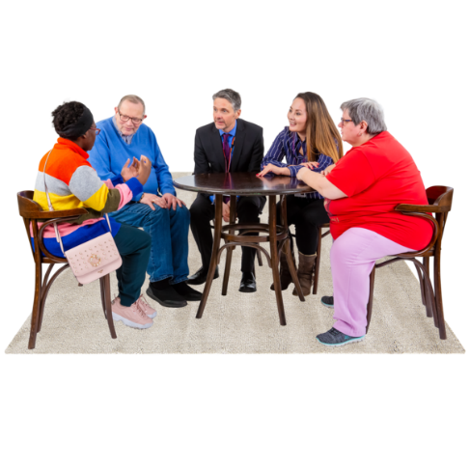 | It is very important that you are able to join in and want to join in.
Other information
We welcome applications from people who come from different backgrounds and have different life experiences.
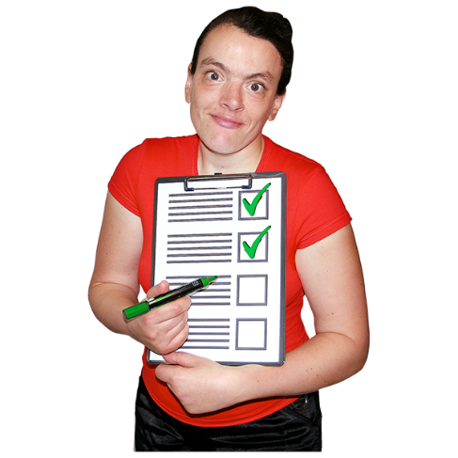 | If you are chosen to be a new Director, we will need to do a check on the Protecting Vulnerable Groups scheme.
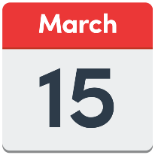 | If we ask you to come to an interview, it will be on Tuesday 15 March 2022.  You must be free on this day.
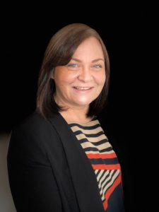 | If you would like to apply to be a Director you can:
 | - call Morven Brooks, the Chief Executive Officer, on 0141 378 6625
 | - email us for an application pack at admin@disabilityequality.scot

