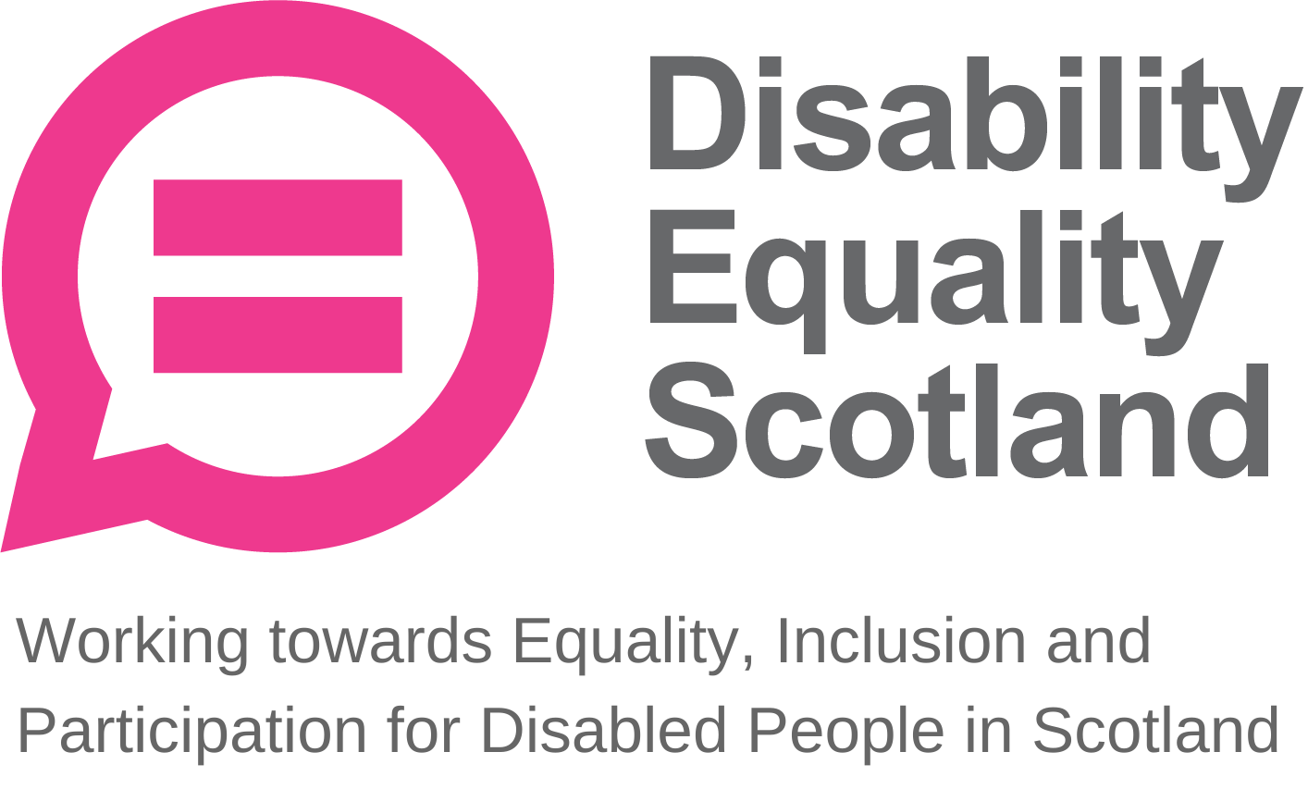
Disability Equality Scotland
Meeting of the Board of Directors
Wednesday 28 July 2021 10.00am
Zoom Virtual Meeting

In Attendance: Linda Bamford (LB) Convener
Scott Stewart (SS) Director
Susan Fulton (SF) Director
Carolyn Wilson-Smith (CWS) Director
Dorothy McKinney (DMcK) Director
Rhianne Forrest (RF) Director

Morven Brooks (MB) Chief Executive Officer
Emma Scott (ES) Operations Manager
Ian Buchanan (IB) Equality & Access Manager
Alistair Bruce (AB) Access and Engagement Administrator
Lucy Gibbons (LG) Easy Read Trainer

Apologies: Lauren Asher (LA) Director
Claire Jagger (CJ) Easy Read Worker

Kenny Milne, Maureen Morrison and Colin Millar were not in attendance and did not submit apologies.

Item 1 Welcome and Apologies
LB welcomed everyone to the meeting. LB asked that during discussions if anyone wanted to contribute, they would raise their hands and LB would confirm who wished to contribute and in what order. LB asked everyone to remain on mute unless speaking to limit background noise. During all decision-making, LB will ask who is not in agreement to raise their hand before progressing, and when closing an agenda section, she will ask if there were any further comments before moving on.

It was confirmed that there was no closed session of the board.

LB stated the agenda timings for the day, with close of meeting set for about 11:30am. LB stated everyone should have received their board papers three weeks in advance and asked if everyone felt they had enough information to make decisions and contribute to the board meeting.

LB progressed to agenda item 2.

Item 2 Agreement of Minutes from last meeting
LB stated that the minutes were emailed for comment and checking shortly after the 28 April 2021 board meeting and asked for confirmation from the board on accuracy and content. No one raised any concerns. LB confirmed that all actions or matters arising from the minutes had been picked up and asked for agreement of minutes from Directors present at the previous meeting.

Proposed by: SS
Seconded by: SF

Item 3 Outstanding actions 28 April 2021 Board Meeting
LB stated that actions 3 and 4 are closed.

Action 1: Access Language seminars. IB has been looking to set up and convene the Access Sub-Committee. IB was able to meet with SF, and CWS and KM will provide feedback on the paper produced. It was agreed that this action can now be closed.

Action 2: Youth membership working group. MB has received the draft briefing paper from AB and JD to take forward youth engagement and membership discussions. MB and RF had a brief discussion about this and agreed to convene a subgroup around youth engagement. With other priorities taking place, the briefing paper won’t come out until mid-August now. In terms of board oversight, this action was now closed.

LB asked for any other concerns or questions relating to the action points. No concerns were raised, and LB progressed to agenda item 4, passing over to MB to introduce the paper.
Item 4 Approval of New Members
MB stated that for the period of 1 April 2021 to 30 June 2021, we had 99 new members join (98 Individual and 1 Corporate). The new corporate member is Crohn’s and Colitis UK. This brings our total membership to 1388 (1217 Individual, 128 Corporate, 5 Young Members, 38 Access Panels). This is a 62% increase in total membership over the past year.

LB asked if everyone is happy to approve the new members. The board approved the new members.

Item 5 CEO’s Update
MB stated that on strategic development, the Annual Report and Accounts have been completed and are awaiting feedback from the board. MB apologised to the board for the quick turnaround time for feedback, this is because members need the opportunity to provide input before the AGM. MB asked for comments on these accounts.

LB and SS stated that this report was laid out more clearly than in past, adding that it was good to see our reserves target met to give us flexibility around funding streams.

MB stated that the third notification of the AGM will be going out shortly to members with the Annual Report and Accounts.

MB provided an update on the recent funding application with Inspiring Scotland, as they had returned with a decision about our funding, however final details are pending a public statement from the fund and Ministers. MB will be looking at the budgets and looking at how we take this forward, however it appears likely that activities will stay as they are for the moment. More information and discussions will come at a later date. MB asked for questions on funding from the board.

DMcK asked if the funding would secure the staff teams positions and avoid redundancy meetings for those in roles attached to this funding, a position that would be very welcome. MB confirmed that it would.

There were no further questions.

MB added that, regarding the Access Sub-Committee, IB will be taking forward the development of the webinars for the Access Panels. On organisational development and growth, MB stated that we now have LG in post for conducting easy read training work following successful funding from Garfield Weston Foundation. MB explained that there is potential for the easy read service to see a decrease in the income it generates, but any losses here should be offset by the fee charged for the training. We do receive regular income, including a steady stream of easy read requests from Scottish Government, and our Easy Read Workers will continue to provide this service. MB asked to keep in mind however that the overall aim of our easy read work is to increase awareness of easy read and inclusive communications.

MB updated that she had recently met with Heather Mole, who replaced Annie Milovic at the Equality Unit. The conversation focused on inclusive communication and Heather, who is a former BSL interpreter, appeared to understand and support our aims as an organisation in this area.

MB concluded her update. MB asked for any questions on the CEO report.

LB updated everyone that she and MB have spoken about the Governance top tips and agreed to send them when relevant activity and decision-making was taking place, for example when the Fundraising Strategy discussions start, a governance top tips on fundraising will be sent round. LB added that under board governance point E, on office bearer roles of Convenor and Vice-Convenor, that LB and DMcK plan to step back into Director roles but remain available to support the new Convenor and Vice-Convenor for the last year of their second and final term.

SF added that it must be a great feeling for staff to not have to have any redundancy conversations at this time.

LB thanked the team for their contribution to the funding application.

MB moved onto the Operation Manager’s report.

Operations Manager Report
MB asked ES for any additions to the Operations Manager report.

ES provided an update on the face covering exemptions project, which has now distributed over 90,000 cards. There are still meetings with Scottish Government every two weeks on progress and changes in guidance, and recently there has been a slight increase in demand, but the helpline is dealing with fewer calls. The helpline opening hours have decreased from three days a week from 28 June, to two days from this Monday (26 July). The good news is that the project has been extended until October, and we will remain in contact with SG about changes.

On our webinar commitments, ES added that we have hosted two successful webinars and are working towards 19 August for next one on the topic of returning to public transport.

Regarding hate crime, ES wrote to the Cabinet Secretary for Justice about the latest report on disability hate crime statistics from the Crown Office and Procurator Fiscal Service and received a response to work with the Secretary for Social Justice, Housing and Local Government (Shona Robison) as this now falls under their remit. ES and Fiach will take forward a meeting on 12 August with Ms Robison’s civil servants to talk through potential next steps for our hate crime work.

ES stated that the Weekly Poll continues to provide critical feedback on really fantastic topics, such as face covering legal requirement poll helping to inform decision making, as well as on topics such as street clutter and long Covid.

ES welcomed LG, who started last week and has made great progress already on planning the development of easy read training.

LB pointed out that we have similar findings about disability hate crime from Scottish Household Survey report produced by Transport Scotland (Disability and Travel, July 2021) and asked if Disability Equality Scotland can push the results of this report. ES raised this point at the recent ScotRail Stakeholder Equality Group and agreed that we can push this further.

DMcK praised the impact that the team is having across the whole sector and is always impressed with the work detailed in weekly email updates each Monday from ES.

MB progressed to IB’s report, asking IB if he had any further updates for the board.

Equality and Access Manager Report
IB met with SF yesterday to discuss the upcoming Access Language seminars and received good feedback from SF around how we communicate with Access Panels about this.

IB updated the board that Disability Equality Scotland have been appointed as Secretariat for Scottish Parliament Cross Party Group (CPG) on Disability. IB has spoken to Jeremy Balfour MSP (CPG Convenor) and Julia Shillitto (Jeremy’s Caseworker) to arrange the next meeting for September, where the group will plan out the high-level timetable for the year. The agendas for each CPG meeting are open to change, and we can share invites with membership and Access Panels.

IB is also working with AB on membership and outreach events to support Access Panels who are struggling, as capacity and membership has been exacerbated by the pandemic. There is a timetable in the diary for this and target Panels and regions have been identified.

IB added that the Access Panel Members Forum project has shown a few issues, and IB has returned to the web developer on this work to address this. IB is also preparing a briefing paper about funding for new community development workers/officers to support the Access Panel Network, and the first step is to ask Access Panels what they would want from a community development team.

MB asked for any questions on the Equality and Access Manager’s report.

LB asked in regard to our CPG Secretariat work whether there will be an opportunity to feed in our members agenda. IB confirmed this, stating that it is a good opportunity shape the discussions of the CPG, bring in our partner organisations and work towards shared objectives.

MB added that we are writing to the Scottish Parliament’s Corporate Body to request funds for BSL and captioning support for the CPG on Disability meetings, adding that there needs to be a budget for this to make these meetings accessible.
IB stated that this letter has been drafted, and this will be forwarded to our Parliament-appointed Clark to go to the Corporate Body. Every CPG is allocated a pot of funding, but without physical meetings, this should be used for communications support such as BSL and captioning.

MB asked for any questions on the Equality and Access Manager’s report.

SF asked whether the Access Panel Forum would have an accessible alternative for those who cannot use or access it. IB envisaged a Forum approach for the website as an addition to current communications, not a replacement for it, adding that we will retain regular email communications for Access Panels so as to not exclude anyone. The Forum is a more technical approach for Panels to talk between each other and share ideas, which is currently not possible via email.

LB progressed to the Annual Calendar of Activities.

Board Annual Calendar of Activities
MB highlighted within the calendar that the Annual Report has been drafted, accounts are now ready, and we will be reporting to members on this in advance of our AGM.

Quarterly reviews are in progress with all staff. On funding, we will be reviewing our own business plans.

MB asked for any questions on this. There were no questions from the board.

Quarterly complaints
MB stated that the organisation received one complaint from an individual who said we were not answering their emails. It transpired this individual was attempting to contact the Scottish Government and was referring to a Scottish Government contact page and not Disability Equality Scotland’s website.

Reflective learning log
There has only been one learning opportunity from this last quarter.

ES explained that in a recent webinar, last-minute replacement BSL interpreters were not briefed properly about the event being recorded and were uncomfortable about this arrangement. As an outcome, they wanted us to state clearly when we upload the webinar to our YouTube account that it is a live recording and so interpretation may be inaccurate. When booking BSL support we always make clear that events will be recorded and uploaded, asking suppliers to ensure that interpreters are comfortable with this arrangement.

Another learning point from webinar is that a partner had asked us to share the final attendee list and contact details for information, however we had not communicated to attendees that we may share their contact details after the event. ES stated that we may need to evaluate how we approach this in future.

MB asked for any questions from the board on the complaints or reflective learning sections. There were no questions.

Finance
MB stated that reserves for the organisation are now sitting at over £75,000, and we are now looking to meet six-month reserves target. The last two quarters have seen an income generation of just over £10,000, and we are meeting budgets very well. Online webinars are cutting costs compared to a physical approach, and feedback from members has been to keep to online meetings for now, however we will consider an approach to hybrid meetings in future.

LB wanted to congratulate MB for managing budgets well at this time.

MB asked for any questions from the board on finances. There were no questions from the board.

People
MB stated that all staff quarterly reviews taking place. Staff meetings have been moved to Monday morning, and coffee mornings take place on Wednesdays to keep staff connected while remote working, however this remains optional. MB is meeting regularly with line managers. Training requirements are taken on board regularly.

MB added that some staff recently took part in a Start to Sign BSL course, and MB is looking to arrange further training with Directors if they wish to do so.

RF asked about the content of the Start to Sign BSL course. MB responded that it is a basic introduction to BSL, but very enjoyable.

MB asked for any questions from the board on people. There were no questions from the board. MB moved onto the risk management section.

Risk Management
MB stated that we are currently managing 14 organisational risks and during the last review taken with LB we looked more closely at two risk areas. MB summarised these risk areas.

DES05 – Budgets available to sustain operational performances. Likelihood at the time was increased from two to three as our funding was currently being received, so MB explained that the likelihood may change after the recent funding decision from Inspiring Scotland.

DES08 – People and the risk of failure to train and develop staff to properly achieve our funding objectives. Likelihood was increased to two, due to considerations around the recruitment and introduction of our new Easy Read Trainer post, as well as the changes to the Helpline Administrator post and re-election of five Directors at the upcoming AGM on 25 August 2021.

MB asked for any questions around risks. There were no questions from the Board.

MB added that the average risk score for April-June 2021 is now at six.

Challenges for Next Quarter
MB stated that a key priority is finalising our application with the Equality and Human Rights Fund, as we need to make sure that we complete this process successfully.

Priorities for Next Quarter
MB stated that our current key strategic priorities of hate crime, inclusive communication and accessible travel remain our key priorities as an organisation.

MB is working on finalising our response paper to the Social Renewal Advisory Board’s (SRAB) January report “If Not Now, When?”, summarising discussion from our internal strategy session in May, and this will be distributed to Directors for comment.

MB stated that as usual, increasing easy read contracts is a priority, adding that we have now recruited an Easy Read Trainer to further this work.

A further priority for MB is the fundraising strategy, which will be developed after coming back from annual leave. There is a new Scottish CEO for the Chartered Institute of Fundraising, and we will look to become a member with them.

Final priority is to have our Annual Report and Accounts approved by members.

LB asked for any questions from the board. There were no questions.

LB thanked MB for her update.

Item 7 Confirmation of today’s actions
LB shared the following actions from the meeting:

Action 1: Directors to notify MB if they are interested in taking part in a Start to Sign BSL introductory training session.

Action 2: MB to circulate response paper to SRAB report with Directors by 18 August.

Item 8 AOB
LB asked for any other business from the board.

As this is her last meeting before retiring from the board at end term, SF wanted to thank everybody for their input, feedback and support during her time serving as a Director. SF has thoroughly enjoyed her time on the board and wished the organisation well for the future.
The board and staff provided their thanks for all her contribution and expertise, particularly regarding access and supporting the Access Panels.

Item 9 Close
LB closed the board meeting formally.

Minutes reviewed and agreed: 27 October 2021
Proposed: Carolyn Wilson-Smith
Seconded: Linda Bamford
Signed:
Linda Bamford, Convenor

