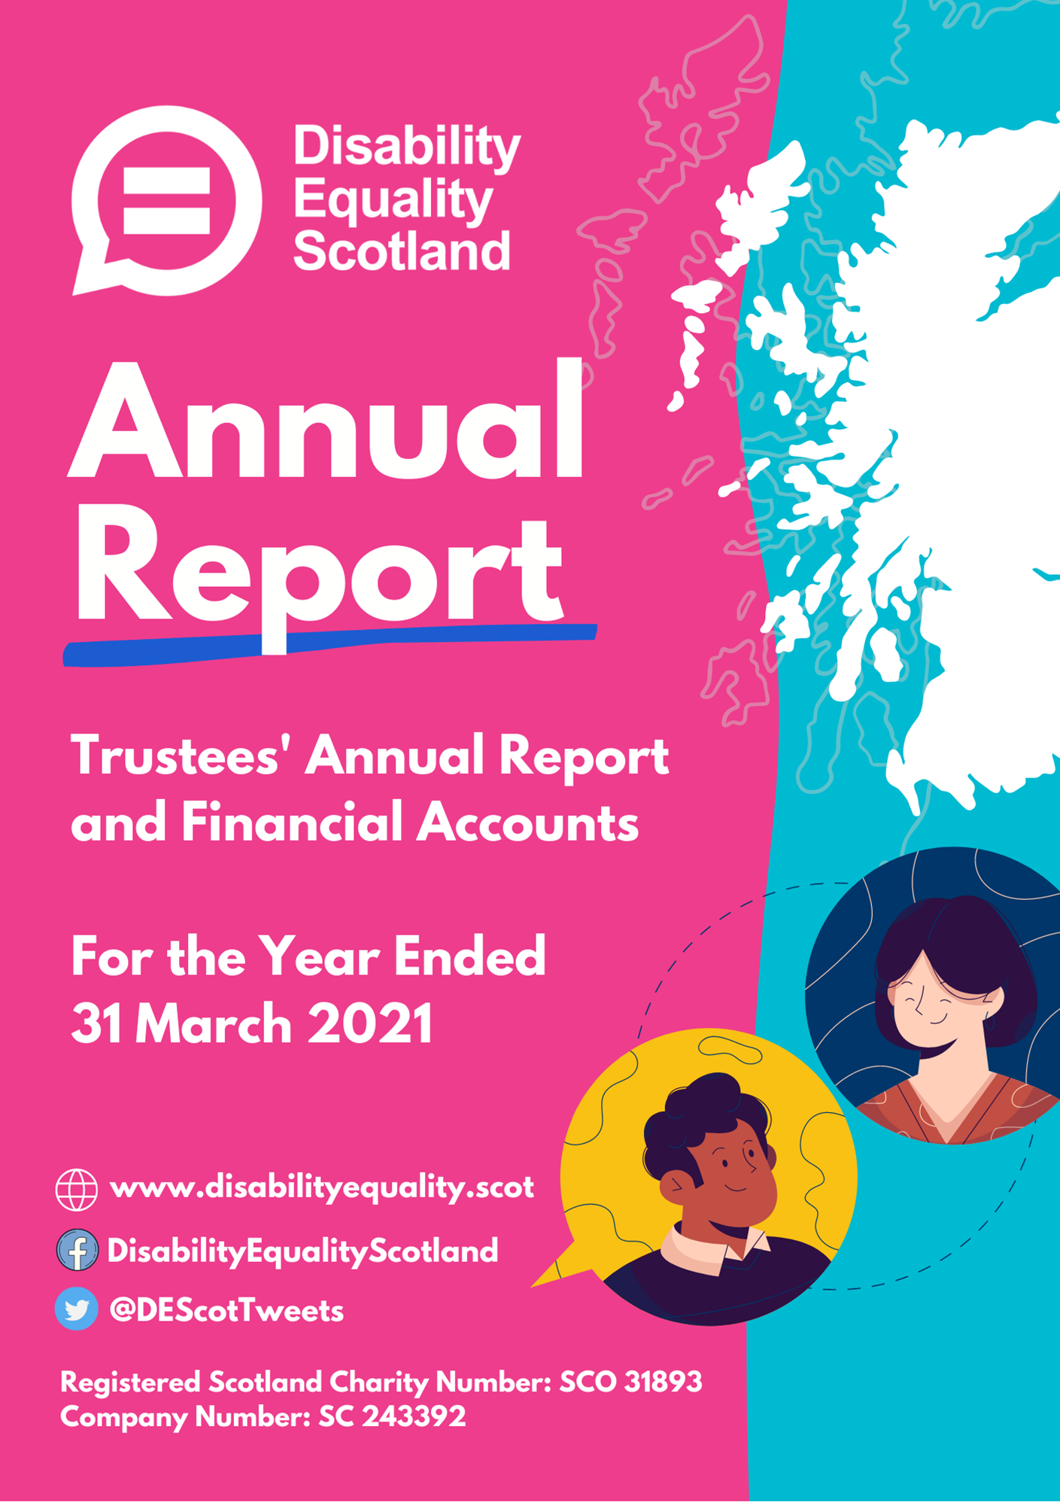

Contents

Page
Introduction from the Convener and
Chief Executive 3 to 5
Report of the trustees 6 to 32
Summary Presentation of Financial Accounts 33 to 34

Introduction from the Convener and
Chief Executive
Moving Forward with Disability Equality Scotland
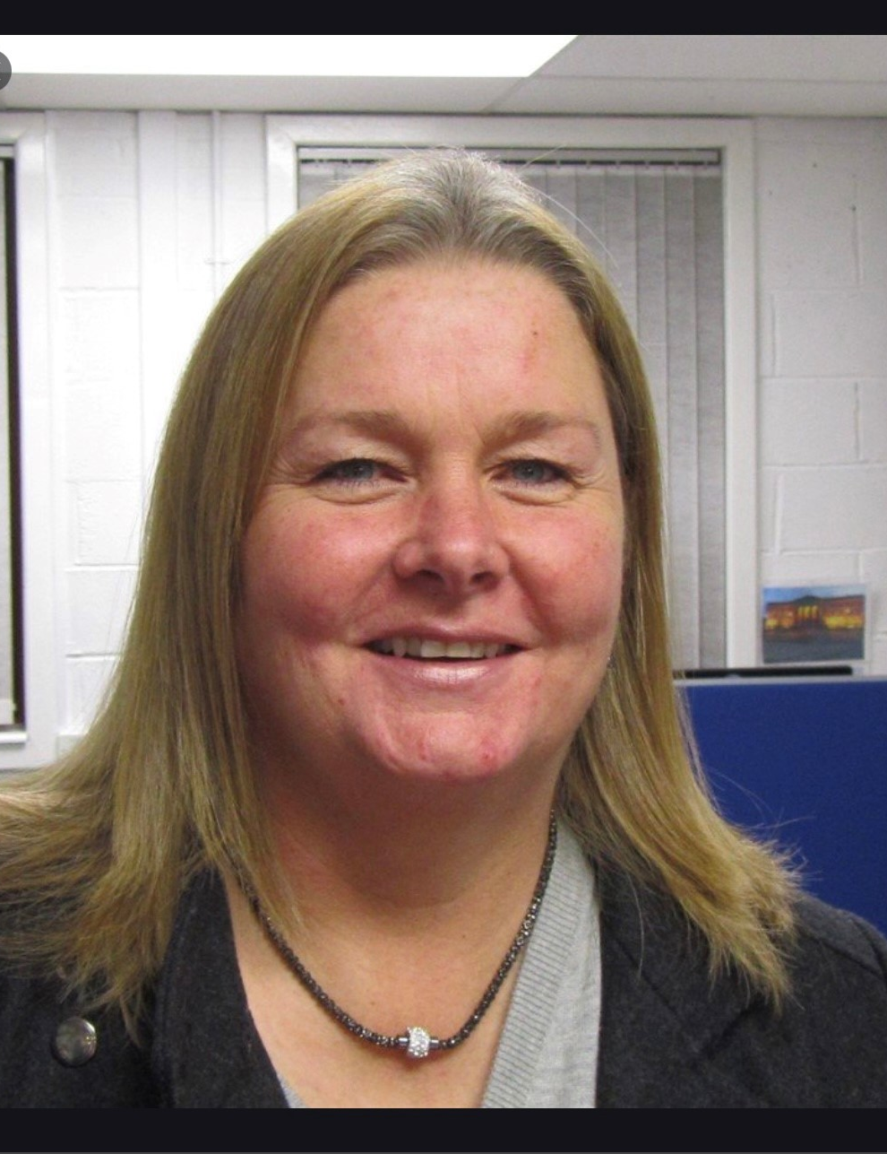
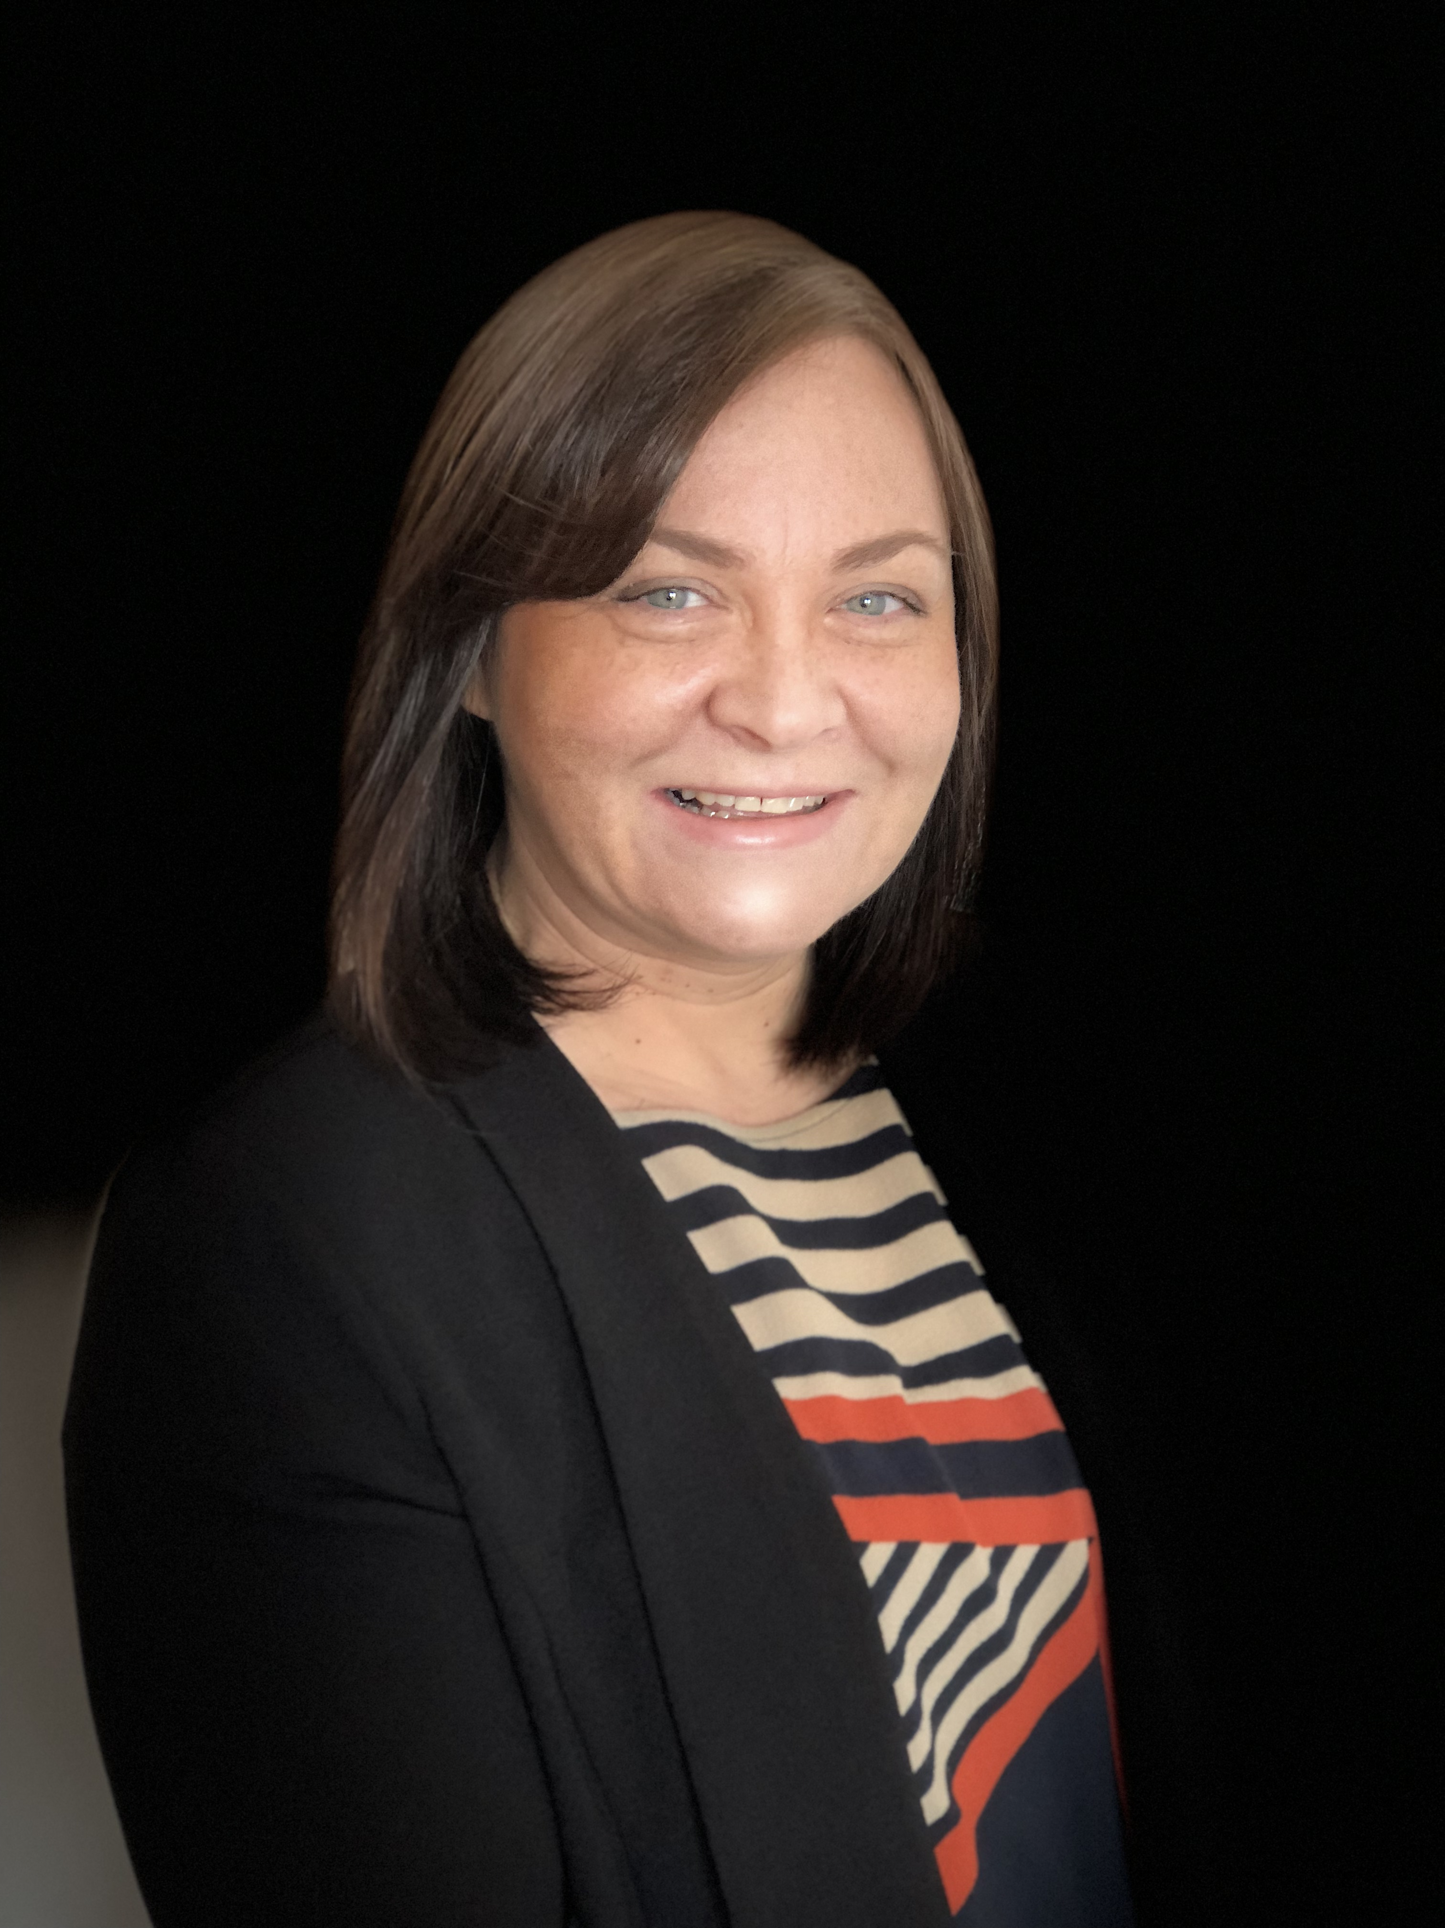
Our mission at Disability Equality Scotland is to give all disabled people in Scotland a voice with trust, care and empathy.
We will continue to use what we hear to advocate for and enable change to improve people’s lives. The best example of this has been hearing the harrowing stories of challenge and abuse many disabled people experienced for being exempt from wearing a face covering. We took this to the Scottish Government, and we have been administering the national Face Covering Exemption Card on their behalf since October 2020.
This last year has allowed us to really strengthen our purpose and align our working practices with our vision and mission. We have worked to reach more disabled people than ever before to create a greater impact and we will keep driving change until society works for everyone. While much has been achieved, there is still more to do: we must challenge injustice, challenge exclusion, change attitudes and ensure disabled people have a stronger voice and the power to make changes at home and in our society. We want to support disabled people to realise their ambitions. We will be bold in challenging the Scottish Government and businesses to move faster towards achieving equality and inclusion for disabled people and we will challenge attitudes so that disabled people can fulfil their aspirations and reach their full potential.
We endeavoured to improve the lives of disabled people by leading on several projects across accessible transport, hate crime awareness and inclusive communication.
At a local level, Scotland’s network of Access Panels have continued to be a vital resource in improving access to the built environment and wider social inclusion for communities across the country. We are aware how much communities appreciate and benefit from the work (and results) of their local Access Panels.
We have taken significant steps to help grow Disability Equality Scotland and identified priority areas to focus on going forward.
Tackling Disability Hate Crime
We built on the successful pilot of the Hate Crime Charter and worked with our partners at Transport Scotland, Police Scotland, British Transport Police, Sestran and People First Scotland to launch the first ever National Hate Crime Charter on 24 March 2021. The Charter aims to encourage transport providers, members of the public and other services to support a zero-tolerance approach to hate crime on public transport.
Demonstrating Digital
The Covid-19 pandemic has demonstrated the importance of a strong online presence and we are pleased that our websites themed on accessible transport, inclusive communication, and disability hate crime have all continued to experience increased levels of traffic and engagement. We have also seen an increase in attendance with our online webinar events, and we hope to continue with these for the years to come, through a hybrid approach offering face-to-face meetings and events as well as an online option.
We have also benefitted from increased digital engagement with our members though our weekly polls, where we get the opportunity to get feedback on issues important to our members and raise these issues with relevant Ministers, organisations and departments.
Engaged Board and Robust Governance
We benefit from a fully engaged Board who participate in governance decisions through our board meetings and sub-committee meetings. They have also played an active role in developing our new three-year growth strategy. The skills mix of our Board gives access to wider knowledge and experience in some of our priority areas of work to support our staff team when needed. Our Board have also regularly attended or presented at meetings such as the Access Panel Conference and themed webinars to hear from our members and contribute their own experiences.
Developing our Team
Our staff team have worked exceptionally hard this last year, making sure the needs of disabled people always came first, in our communications, weekly polls and webinars. The Board of Directors would like to formally thank the staff team for their tremendous commitment to the organisation and for responding so well to the changes brought about by the Covid-19 pandemic.
The work described within this report took place during the Covid-19 pandemic. We have had to adapt how we met our funders outcomes, however, overall, the organisation has performed exceptionally well, sharing how the impact of Covid-19 has been disproportionately felt by disabled people, to amplify the changes needed to reduce inequalities as we start to #BuildForwardBetter and level up on equality, accessibility and inclusion.
The organisation remains financially secure despite the Covid-19 pandemic. Yet we face a significant challenge to grow to enable us to support the demands that disabled people will face in the years ahead. This will require a resilient and innovative approach from Disability Equality Scotland. A challenge we intend to meet.
Linda Bamford Morven Brooks
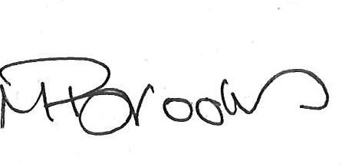

Convener Chief Executive Officer
Trustees’ report for the year ended
31 March 2021
The trustees present their report, incorporating their strategic report and financial accounts for the year ended 31 March 2021. The financial accounts have been prepared in accordance with the accounting policies set out in the notes to the financial statements and comply with the charitable company’s Articles of Association and the Companies Act 2006.
Our Vision
Working towards Equality, Inclusion and Participation for Disabled People in Scotland

Objectives and activities
We are a national charity working to make life more accessible, equal, and inclusive for disabled people in Scotland.
Our aim is for every disabled person to have the opportunity to participate in a fulfilling life and to enable them to reach their full potential.
Our Mission
Our mission is to give all disabled people in Scotland a voice with trust, care and empathy.
This annual report covers progress on Disability Equality Scotland’s objectives and activities between 1 April 2020 and 31 March 2021.
Our objectives as set out in our governing document are:
- to promote the benefit of disabled people in Scotland by encouraging communication between disabled people and national and local organisations concerned with the inclusion of disabled people in society.
- to advance the education of the public about disability equality and accessible environments, and to effect positive change in attitude and awareness of disability.

Main Objectives for the Year
Disability Equality Scotland has been involved in many projects, all of which focus on the organisation’s principles to:
- Improve disabled people’s access to participation and engagement in society through increased support, services, and awareness around disability equality.
- Improve understanding and reporting of disability hate crime across Scotland.
- Promote connectivity between Access Panels and improve access to support for volunteer members in delivering on equality and inclusion-based work.
- Increasing awareness and knowledge of Access, Inclusion and Equality within the Access Panel Network.
- Planning and design professionals will have access to a range of resources, best practice, advice, and solutions aimed at accessibility / inclusive design.
- Disabled people will have ongoing involvement and further opportunities to provide their views on Accessible Transport in Scotland, contributing to the progress of the Accessible Travel Framework development and implementation.
- Disabled people, transport operators, staff and other stakeholders will have access to accessible travel guidance, information, and signposting via an Accessible Travel Hub.
- There will be a joined-up approach to tackling disability hate crime and negative behaviours towards disabled people on public transport across Scotland.
The following pages are the main areas of work delivered through Scottish Government funding from the following directorates: Equality Unit, Section 10 (Access Panel Project), Transport Scotland (Bus, Accessibility and Active Travel Directorate), Transport Scotland Ferries Accessibility Unit and Covid-19 Public Health Directorate.

Membership
We work with our members to promote equality for disabled people in Scotland.
We regularly ask our members for their views on many diverse policy issues, which then directly feed into our policy work and government policies, plans and consultation responses. This last year has been no exception, with member’s feedback influencing key Covid related guidance.
We make sure members have opportunities to meet and network with relevant audiences. We help members make the right connections.
During the period from 1 April 2020 to 31 March 2021 we had 496 new members join us, resulting in a 62% increase in our overall membership, this brought our membership total to 1296 members:
Total Membership: 1296 (1126 Individual, 127 Corporate, 5 Young Members, 35 Access Panels).
- Individual members: increased by 72.7%, from 652 to 1126.
- Corporate members: increased by 13.4%, from 112 to 127.
- Access Panels: 2 new members joined us, increasing our Access Panel members to 35.
- Young Members: We created a new Young Membership category, and now have 5 young members.
What difference has our Membership made?
Members are at the heart of all our work and projects. Our members have a direct say in what we do and how we do it, inputting ideas and evidence to direct our work and share their lived experiences to allow us to identify what changes are required in our pursuit for full access and inclusion for disabled people.
“I feel this is the best organisation I joined. It makes me feel respected and included and it sends positive messages about disability. It always has direct and easy to understand information, the staff are supportive and helpful and informative, the events are full of things to help you make changes that you need in your lives, I am enjoying being a member!”

Disability Equality Scotland Newsletter and Open Door Magazine
Over the past year, the monthly newsletter has been an important channel for distributing key public health information to our members about the response to COVID-19. Our members have found the newsletter to be a useful resource which summarises the key guidance and highlights the relevant support that is in place to support disabled people.
Our Open Door Magazine is our members’ magazine. In the last year, two bumper editions have been published:
Issue 54 – Hate Crime Awareness and Safer Communities

Issue 55 – Young People and Face Covering Exemption Awareness

In Issue 55, we were pleased to feature a guest article from Christina McKelvie, the Minister for Older People and Equalities. In the article, the Minister commended Disability Equality Scotland members for sharing their experiences via weekly polls and webinars, which had helped to influence Scottish Government guidance, plans and policy in response to the COVID-19 pandemic.
What difference have our communications made?
We share our communications with members, Ministers, key partners, and stakeholders, highlighting and promoting our work widely. Feedback is always very positive.
“Thank you for your help, information and updates throughout the very unpredictable times. I really appreciate your weekly survey and newsletters.”
“It is great that your newsletter is available in many different accessible formats, and you are leading by example when it comes to inclusive communication.”

Face Covering Exemption Card Campaign
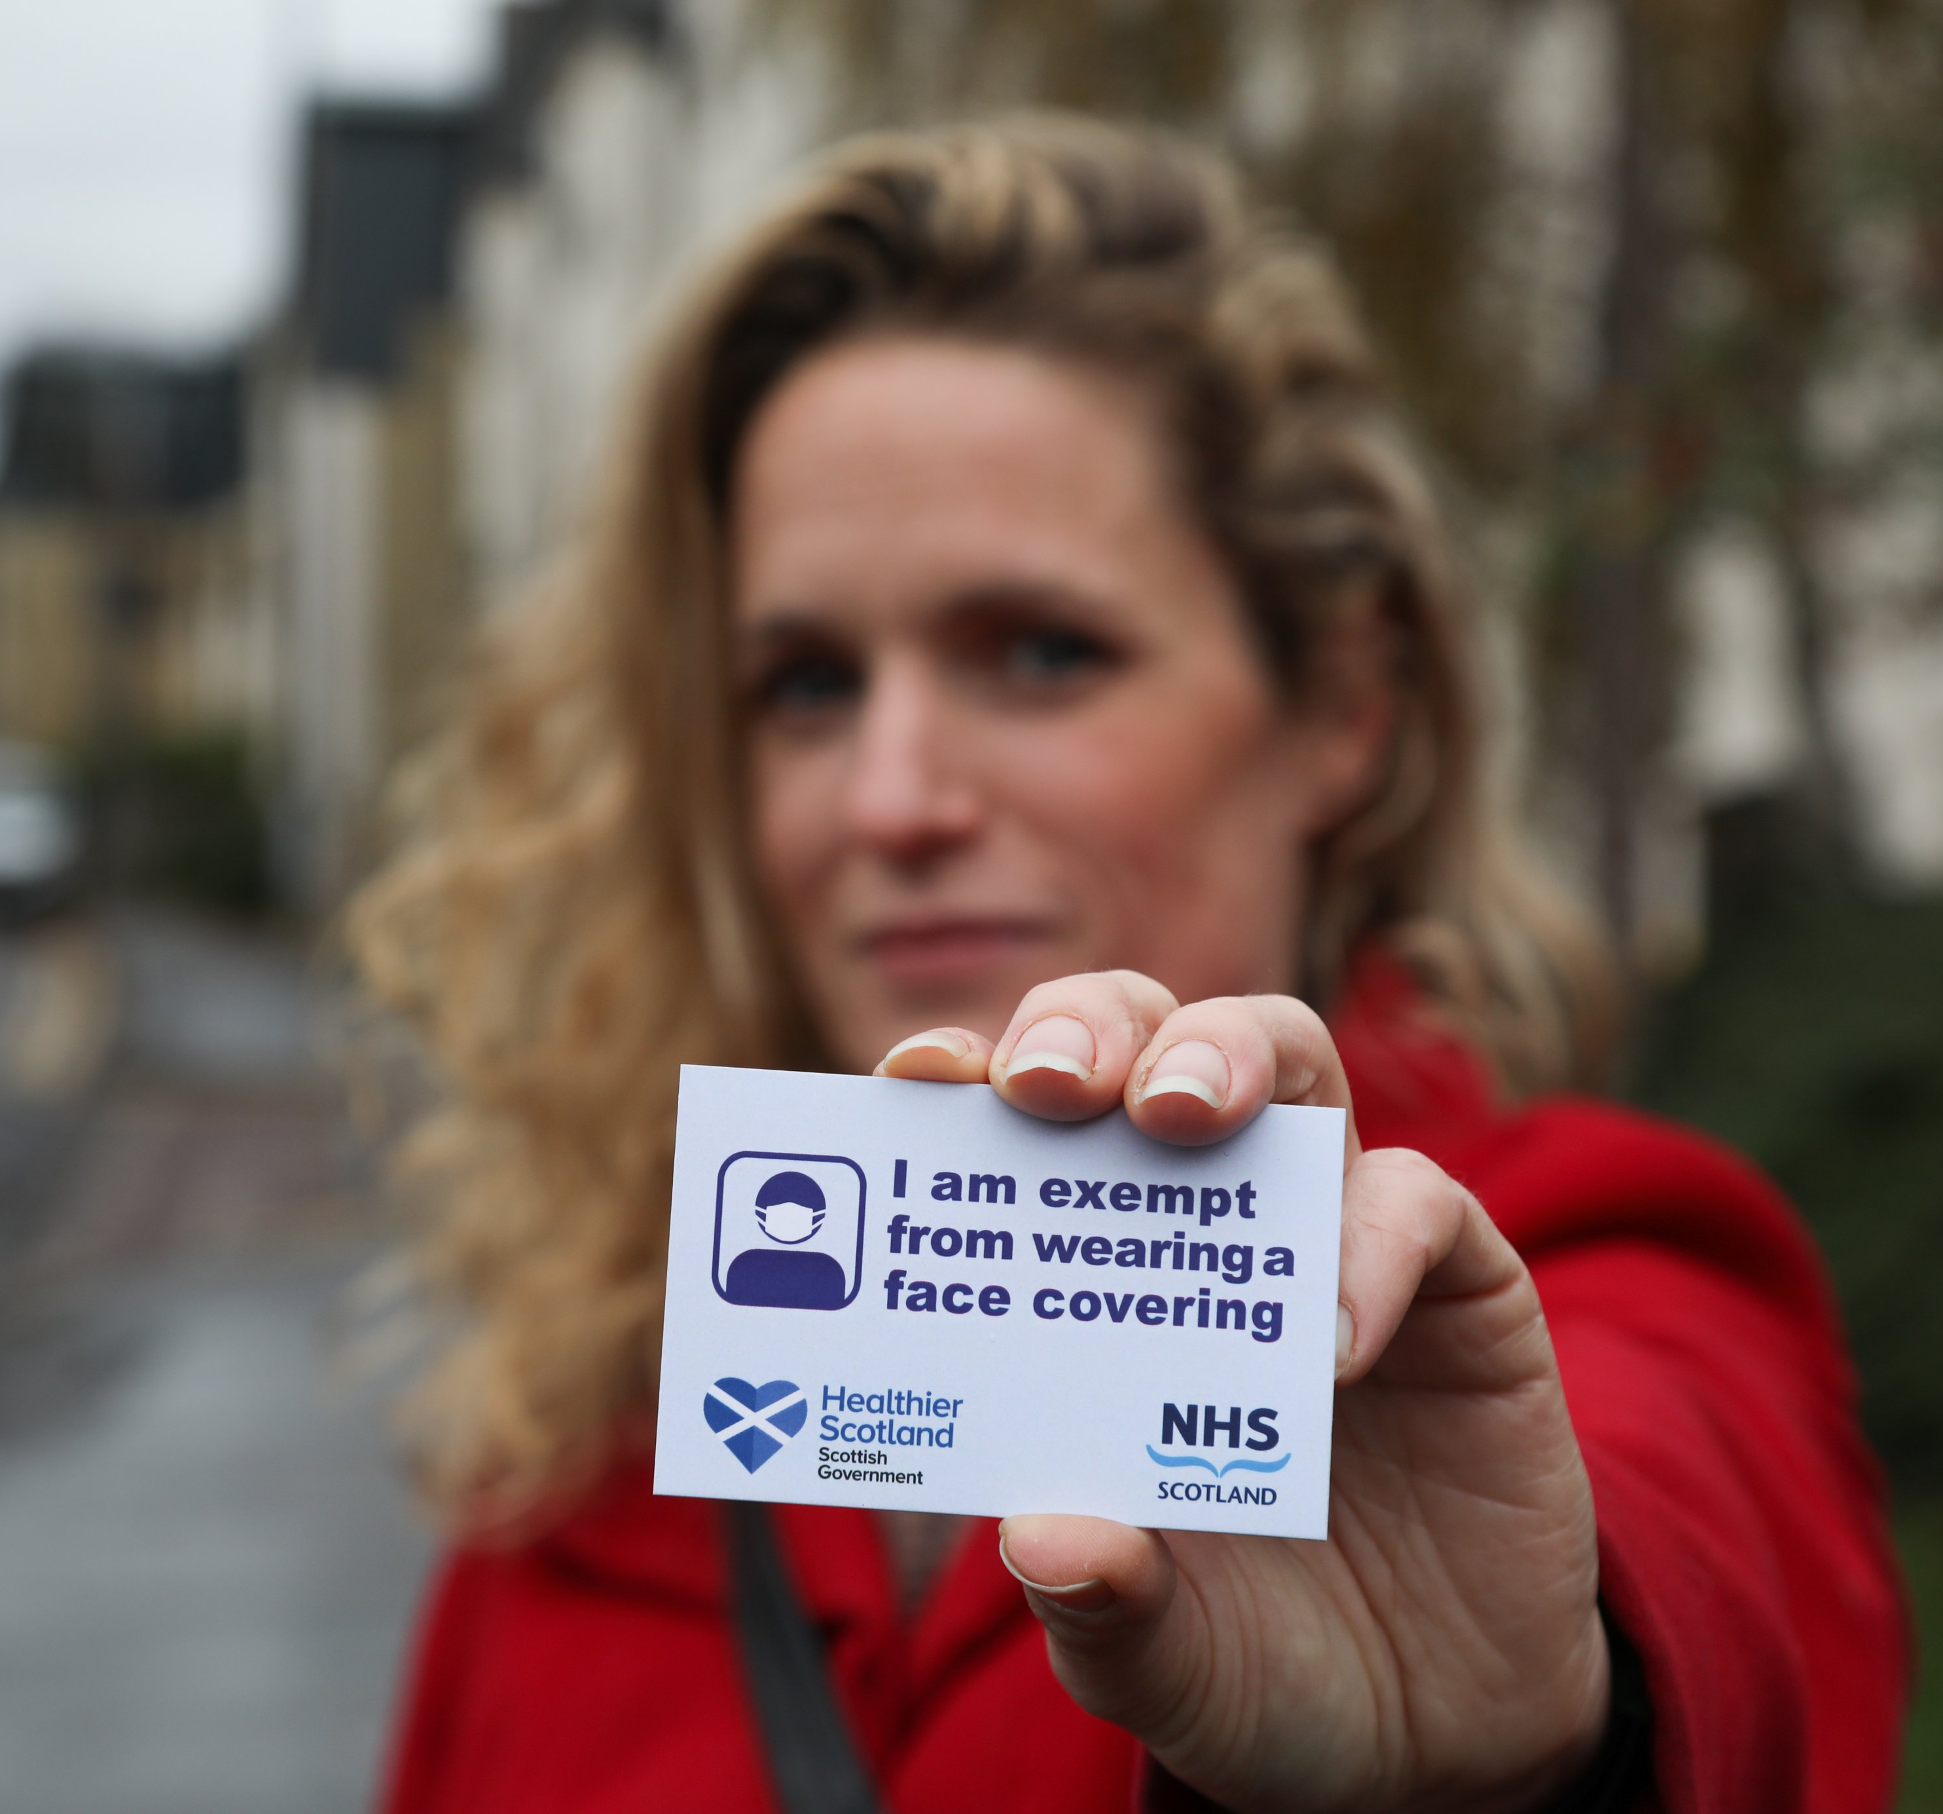
There are situations where some people are unable to, or it would be inappropriate for them, to wear a face covering. The reasons why someone might be exempt are explained on the face covering exemptions page https://exempt.scot/face-covering-exemptions/
Since the introduction of the mandatory wearing of face coverings last summer, and in light of Disability Equality Scotland’s members’ concerns raised through our weekly poll on the introduction of face coverings, we were very happy to work with the Scottish Government to introduce a national exemption card. The card is available through applications on our dedicated website www.exempt.scot or by calling the Freephone helpline number. The project was launched to the public in late October 2020.
Over the first two weeks of the campaign, we received over 1,150 calls to the helpline and nearly 28,000 applications in total.
As at 31 March 2020, we supplied over 61,000 physical exemption cards and over 40,000 digital versions. We have also answered over 2,700 calls to the helpline since it opened. Demand for the cards has varied over the time the project has been running. For example, there was a spike in demand when most of the large supermarket chains announced much tighter implementation of face covering rules in January 2021.
What difference have the Face Covering Exemption Cards made?
At the beginning of February 2021, we issued a feedback survey to card holders. This survey has allowed us to evaluate the impact the card has had since its introduction. As of March 2021, we had sent out over 18,500 invitations to complete the survey and received over 4,250 responses to the survey, a great response rate of 23% from all of the invitations issued. This allowed us to better understand the impact the card has had, and the challenges people continue to face in the community.
Christina McKelvie, Minister for Equalities and Older People
“Let me take this opportunity to thank Disability Equality Scotland and its members for their swift action in realising the urgent need to implement an exemption card through the evidence gathered in your weekly polls.”

Disability Webinars
Our webinars help to bring disabled people together with experts on different topics as well as providing an opportunity to meet with other disabled people.
During the period April 2020 to March 2021, we delivered six Disability Webinars across the following topics:
Access Panels were involved in the planning of the events. Each event welcomed an average of 46 delegates (local disabled people, local authority staff, statutory bodies, MSPs, local private companies and third sector organisations).
Thistle Assistance Card, 11 May 2020
Awareness and use of the card among disabled people.
Spaces for People, 7 July 2020: Discussion on the implementation of the Spaces for People initiative in response to physical distancing
Face Coverings Exemptions, 30 July 2020: Face Covering use on public transport.
Return to Public Transport, 29 October 2020: Discussion about disabled peoples’ concerns about a return to using public transport.
20 Minute Neighbourhoods, 01 December 2020: Discussion about the concept of 20 Minute Neighbourhoods and the impact on disabled people.
Disability Hustings Event, 17 March 2021: A pre-election hustings event with candidates from the five main political parties, discussing key issues for disabled people.

What difference have our Disability Webinars made?
Our webinars help to bring disabled people together with experts on different topics and gives an opportunity to mix with other disabled people. The webinars encourage disabled people to engage with us as an organisation and help to create new memberships. Some feedback from our webinars include:
“Very informative discussions and the webinar was well chaired.”
“I really enjoyed this webinar. It was informative and pitched right. I also found it easier to engage as I didn’t need to plan around my care and travel needs and could engage from home. This reduces the stress and anxiety for me and made me able to focus on the webinar. In hindsight the webinar also helped me with my recovery time as it normally takes me a day or two to control my pain after attending events.”
“Great moderating and contributions from participants. Highly informative!”

Inclusive Communication Hub www.inclusivecommunication.scot
At Disability Equality Scotland, we host the Inclusive Communication Hub in partnership with Sense Scotland. Over the past year, the Hub has experienced steady growth through ongoing content development and sustained promotion with key partner organisations.
We have utilised the Hub as a platform to stress the importance of ensuring key public health messages about the COVID-19 pandemic are shared in a variety of accessible formats. To achieve this, we highlighted relevant resources featured on the Hub which provide an overview of the basic principles of inclusive communication and accessible information. We also created a dedicated resources page which signposts to information and guidance about the response to the pandemic that is being produced in accessible formats, such as audio, British Sign Language (BSL) and easy read.
To help encourage organisations to submit content, we developed a case study template. The purpose of the case studies is to highlight best practice in inclusive communication, which will inspire individuals and organisations to adapt their own processes when producing information and communicating with disabled people. One example of a case study that we produced was in collaboration with NHS Near Me, a video consulting service that enables people to attend appointments from home or wherever is convenient. You can view the case study in full on the Hub: www.inclusivecommunication.scot/case-study-nhsnear-me
We also continue to support the Inclusive Communication Nation Campaign that is developed by the Royal College of Speech and Language Therapists (RCSLT). Scotland would be the first nation to remove the persistent and universal barriers to equality and human rights that our present exclusive approach to communication imposes. We use the Inclusive Communication Hub as a platform to promote the campaign.
What difference has our Inclusive Communication Hub made?
A Disability Equality Scotland member commented on the importance of the Inclusive Communication Hub:
“I am extremely grateful for the work of Disability Equality Scotland, especially the Inclusive Communication Hub which I have described in the past as one of Scotland's national treasures and I still think that.”
Easy Read Service
www.disabilityequality.scot/easy-read-service
Disability Equality Scotland provides an Easy Read service to all sectors as part of our commitment towards improving access to information for all.
Easy Read is an accessible format that makes written information easier to understand by using simple, jargon free language, shorter sentences and supporting images.
We have worked on 52 Easy Read projects providing Easy Read translations for Scottish Government directorates, the Scottish Government Public Appointments Team and for other partners.
These included information on the Economic Recovery Implementation Plan, Impact of COVID-19 on Equality, the Scottish Household Survey and Public Engagement messaging. We also worked closely with the Mental Welfare Commission on nine separate jobs. We have undertaken repeat jobs for organisations we have worked with before, such as the Mobility and Access Committee for Scotland, ALLIANCE, Inclusion Scotland, Police Scotland, NHS24, the Independent Living Fund and the Scottish Human Rights Commission. We have also established new connections with organisations such as Scottish Labour, Connecting Scotland, RNID, the Cairngorm National Park Authority and the Poverty and Inequality Commission.
We work on the easy read version of the Mobility and Access Committee for Scotland’s (MACS) Annual Report each year and this year translated their application form into easy read for those looking to apply for a public appointment with MACS. MACS are a non-departmental public body that advise Scottish Ministers of the transport and travel needs of disabled people.
We were delighted to welcome an additional Easy Read worker to our team in May 2020 to help us meet the demand for this service. We continue to promote our Easy Read service through regular articles in our newsletters and Open Door magazine.
What difference have our Easy Read Service made?
By producing Easy Read documents, we are providing disabled people with the chance to interact and engage with relevant topics and have their views heard. We are encouraged that the Scottish Government continues to recognise the need for Easy Read.
We have received positive comments about our Easy Read Service:
“Great thanks, you made a very good job of converting some quite difficult concepts to Easy Read and it looks good.”
“Easy Read have done a great job with the updates we had asked for. The images they have chosen all work well. Thanks for all your work on this.”
“This looks great, thank you for getting it to me so quickly! I’m very happy.”
“This is fantastic. And a massive piece of work in such a short time! Thank you.”
“That looks all good! And thanks for pulling it together so quickly.”
“Thank you so much for all the work you have put into the document and the turnaround time we all really appreciate it.”
Weekly Polls
www.yoursayondisability.scot
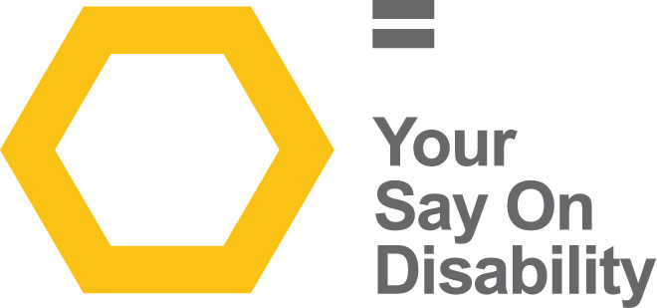
Our weekly polls are a way of gathering feedback from our members on issues that affect everyone.
We have conducted 52 poll questions, resulting in a total of 10,494 responses in this reporting period. Noteworthy polls include:
- 99% experienced difficulties with physically distancing when undertaking essential journeys. (934 responses)
- 86% have noticed ‘Spaces for People’ changes to their local streets, or town centres (484 responses)
- 99% believe retailers are not meeting their legal duty to provide reasonable adjustments for disabled people. (511 responses)
- 94% cannot access key services in their local community within a 20-minute walk or wheel from where they live (447 responses)
- 89% are concerned about being judged for not wearing a face covering (199 responses)

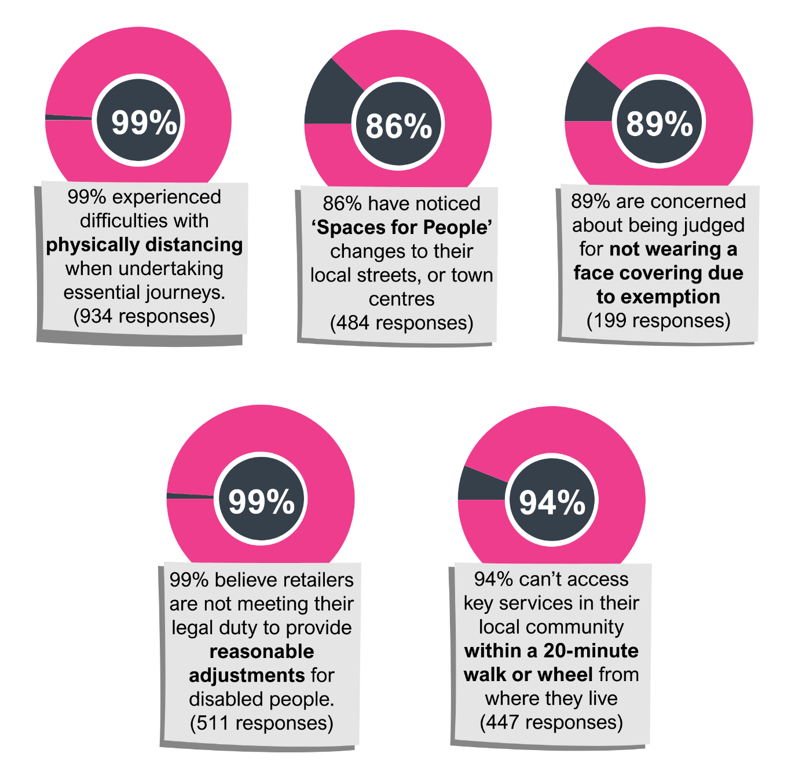
What difference have the Weekly Polls made?
The Weekly Poll has continued to be a vital method for gathering the views of our members on a variety of topics. Our weekly summary reports contributed to Equality Impact Assessments and influenced Scottish Government policy and guidance in response to the COVID-19 pandemic. The polls received praise from our members and various stakeholders, including policy officials and partner organisations.
“I appreciate the chance to take part in government consultations through your weekly survey. I've told numerous organisations and individuals about the survey and how it makes government consultations accessible for me, thereby giving me a voice in them. I hope other disability equality organisations and the Scottish Government will adopt your model.”
“I think your communications are excellent and that your simple one-question poll each week is a model that other organisations could helpfully follow. I also appreciate the summary report the following week and always find it helpful to read other people's comments, responses and views.”
“I am very grateful to be able to take part in the survey each week. This has many functions for me. It gives me a voice. It raises my awareness of issues that other disabled groups are facing. And it also lets me find out about initiatives e.g. that the Scottish Government is taking to address these issues.”

Disability Hate Crime
www.disabilitysafety.scot
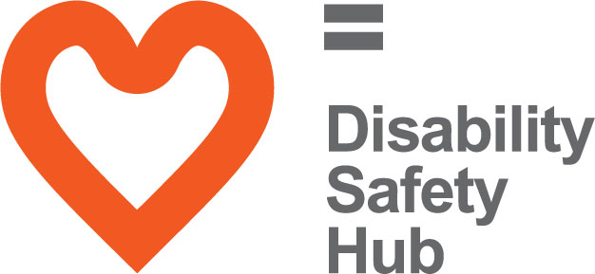
The Disability Safety Hub launched in October 2018 to coincide with National Hate Crime Week.
This hub has two main aims:
- To raise awareness of disability hate crime, helping disabled people to understand what a hate crime is.

- The Hub also wants to help disabled people to report hate crime and shows the different ways you can do this.
On this Hub you will find helpful resources, including case studies and videos of disabled people talking about their own experiences of hate crime.
In response to COVID-19, we adapted content on the Hub to reflect guidance and resources which were being produced to provide support to people during the pandemic. We developed our own mental wellbeing guide, which signposts to relevant resources, including the SAMH ‘Mental Health Information Hub’. We also developed a new resource category that is dedicated to scam awareness in response to the increase in scam related crime during the pandemic.
To assist with promotion, issue 54 of our magazine Open Door was themed on Hate Crime Awareness and Safer Communities. This was an opportunity to generate content for the Disability Safety Hub and to provide an update on the Hate Crime Charter and extension to the ferries network. The magazine featured articles from key stakeholders including Police Scotland, I Am Me and the Central Scotland Regional Equality Council (CSREC).
What difference has The Disability Safety Hub made?
We received positive feedback since the launch of our Disability Safety Hub.
“I found the mental wellbeing guide featured on the Hub to be a useful resource for me during these very difficult times.”
“I was signposted to this Hub for useful resources to ensure disabled people are aware of how to recognise and report disability hate crime. Good to see it is linking closely with I Am Me.”

Accessible Travel
www.accessibletravel.scot
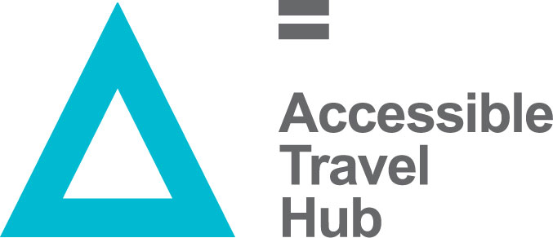
This year our Accessible Travel Hub saw a huge increase in views; just short of 100,000 page views. This increase was mostly due to the valuable information we shared about changes to public transport during the pandemic, including resources relating to the exemption card campaign. It is an encouraging number of users that are viewing the Hub to receive the latest information about accessible transport and the response to COVID-19.
Events
This year, we moved our discussions online via Zoom. We held five events, bringing together disabled people with transport providers and key decision makers to discuss experiences of public transport in different regions around Scotland. In total, we engaged with over 210 people, which includes disabled people, transport providers, local authorities, and equality groups about their experiences of accessible travel.

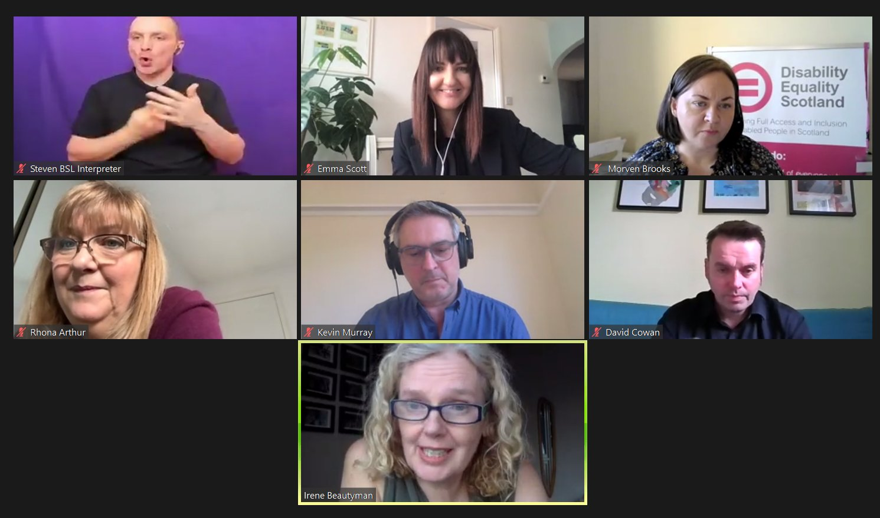
Each event had presentations from a number of providers and partners including, FirstBus, NorthLink Ferries, ScotRail, CalMac Ferries, Confederation of Passenger Transport, Sustrans, SEStrans, Police Scotland, MACS, Guide Dogs Scotland, RNIB, Transport Scotland and Active Travel.
What difference have the Accessible Travel Events made?
“Really enjoyed the 20-minute neighbourhood webinar yesterday and very useful connections made.”
“I thought it was good. Good choice of reps from Transport Operators.”
“Improved my understanding of individual response to face coverings from public transport providers.”
“My question was put to all participants live, it was great to hear their answers. Thank you!”

Hate Crime on Public Transport
In 2020, we built on the successful pilot of the Hate Crime Charter and worked with our partners at Transport Scotland, Police Scotland, British Transport Police, Sestran and People First Scotland to launch the National Hate Crime Charter on 24 March 2021.
We had initially wanted to host a launch event and to ensure the Charter was rolled out across the public transport network. However, key public health messaging relating to Covid-19 took priority and the Working Group agreed to a ‘soft-launch’ on social media.
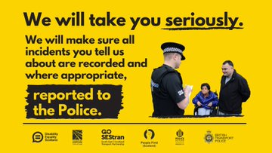
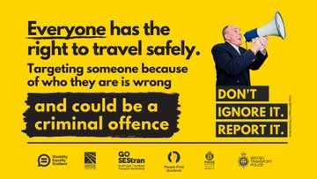
We produced a promotional toolkit to help spread the message of the Hate Crime Charter. Twitter and Facebook messaging from transport partners including ScotRail, Stagecoach, FirstBus, CalMac and NorthLink Ferries used the images we produced to promote the Charter.
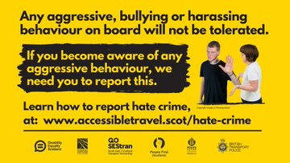
We designed and developed an animated video to help promote the Charter and this was shared widely on social media.
We received a number of retweets of the campaign messages from key equality stakeholders, including Interfaith Glasgow, Victim Support Scotland, LGBT Youth Scotland, Glasgow Disability Alliance, Guide Dogs Scotland, and Scottish Commission for People with a Learning Disability (SCLD).
Ministerial support
The campaign experienced recognition from Scottish Ministers, including a retweet of the campaign materials from Christina McKelvie, Minister for Older People and Equalities.
We worked closely with Transport Scotland and had the endorsement of Cabinet Secretary for Transport, Infrastructure and Connectivity Michael Matheson. He said:

“I fully support the launch of the national Hate Crime Charter for public transport. I commend the work of Disability Equality Scotland and partners for promoting this zero-tolerance approach.
We want Scotland to have a transport network that is safe for everyone to use and this Charter will help to raise awareness of hate crime, in all its forms, and remind everyone that it will not be tolerated.”
Launch day
On the day of launch, the materials shared via Disability Equality Scotland social media channels (Facebook and Twitter) reached a total of 55,954 people. When taking into consideration the social media activity of partner organisations, it is estimated that the campaign materials received an organic reach of over 300,000 individuals.
In total, we received 1,115 page views on the Accessible Travel Hub. The Hate Crime page features key campaign messages, including how to recognise and report hate crime in a variety of accessible formats.
http://accessibletravel.scot/hate-crime/
What difference has the Hate Crime Charter made?
The Hate Crime Charter pilot reached over 1,255,671 passengers in an eight-week period.
The British Transport Police can tell us that 24 reports of hate crime were made during our pilot period. Of these, one came from the pilot area of Fife; specifically, Kirkcaldy train station where our poster was on display.
Awareness has been raised amongst transport staff who feel better equipped to recognise and report hate crime. There is also an acknowledgement from staff that they would benefit from further training. At the pre-pilot stage, 49% wanted further training; by the end of the pilot this figure was 79%.
Ten partners have signed up to pledge their support to the Charter and will be offered training in disability awareness and hate crime. This number is growing all the time.
This work supports the Accessible Travel Framework vision that “all disabled people can travel with the same freedom, choice, dignity and opportunity as other citizens.”
Scottish Transport Awards 2020
Our work on the Hate Crime Charter was shortlisted in the Excellence in Travel Information & Marketing category at the Scottish Transport Awards 2020.
We were disappointed not to win this year as we lost out to Edinburgh Trams – a well-deserved winner.

Inclusive Design Hub
www.inclusivedesign.scot
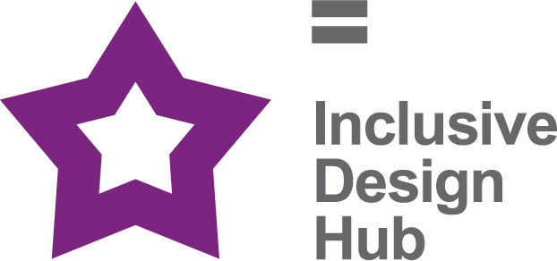
The Inclusive Design Hub is a resource that aims to improve awareness and take-up of best practice in inclusive design for planners, developers, architects, and building professionals in Scotland. The website includes information, articles, access guides, and case studies of best practice. The Inclusive Design Hub will help built environment professionals deliver inclusive environments.

Feedback
The Inclusive Design Hub has received positive feedback and constructive comments, such as additional content and changes to the design and layout:
- Adding additional resources/case studies/news items.
- Suggestions of individuals and organisations to contact for content and to help promote the Inclusive Design Hub.
- Increase accessibility.

Monitoring and Future Plans
We continue to update the resources and publish any relevant news items on the Inclusive Design Hub. A feedback form has been created to allow users to submit any comments and suggestions to help to improve the website.
Going forward, we will continue to utilise the Access Panels and wider stakeholders to produce case studies which will highlight best practice in Inclusive Design.

Access Panel Network
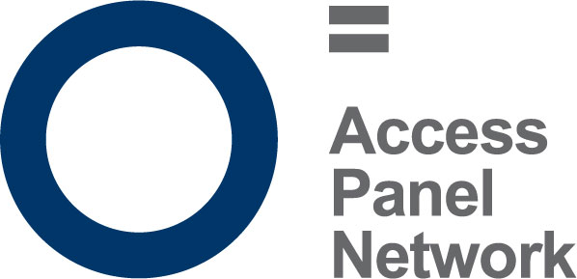
An Access Panel is a group of volunteers, the majority of which are disabled people, or care for a disabled person. They meet on a regular basis, usually monthly, to discuss issues in their local community which affect disabled people, and work towards removing barriers to independent living in their communities to ensure disabled people have access to the same choice, dignity and control as others in our society.
There are currently 35 active Access Panels across Scotland, from Barra and Orkney to the Scottish Borders and everywhere in between. Panel membership varies between 5 and 150 disabled members, and it is estimated that there are around 1000 Access Panel members in total. Not all members are actively involved volunteers, and many contribute in other ways towards their panel, by sharing information, or participating in consultations; other members may simply wish to be kept informed of disability work in their area.
As Panels have typically grown organically around the needs of their locality, they vary greatly in their focus and remit however, they are primarily committed to improving access and equality in its widest form which means access to the physical environment, Education, Housing, Health, Transport, Leisure & Recreation and Social Justice amongst other areas.
Covid resilience has been the theme throughout 2020 and 2021. Access Panels have responded well to new ways of working and they have embraced digital technology. Not being able to undertake access assessments or site visits as regularly as they might have done, Access Panels have had to adapt to using Zoom in order to ensure accessibility remains front and centre with all the new adjustments being made.
Disability Equality Scotland has seen record attendance at this year’s Access Panel Conference owing to the fact that many Panels did not need to travel to attend and could simply join from the comfort of their own home. Going forward, it is important that this new way of working is not taken to mean that transport or the built environment no longer needs to be accessible, and the Access Panel Network will be working to ensure that the recovery phase accelerates the changes necessary for an accessible built environment. This approach also aligns with the Scottish Government’s Programme for Government and Active Travel ambitions and 20 minute neighbourhood aspirations (being able to access your local area, streets and pavements for walking and wheeling being a key part of active travel and inclusive communities to reduce social isolation and loneliness).

Access Panel Grant

Overview and Progress
The Access Panel Grant (APG) is a fund designed to help increase the capacity and outreach of Access Panels right across Scotland. The majority of Access Panels are staffed solely by volunteers who are passionate about increasing access and social inclusion for disabled people in their community.
For the period 1 April 2020 to 31 March 2021, £45,000 was received by Disability Equality Scotland from the Equality Unit, The Scottish Government. The full grant to date has been distributed. There has been an uptake of the grant which has increased this year with most Panels looking for support on things such as ICT equipment, software packages, and remote training. Despite the pandemic, Access Panels have continued their involvement within the local community and have been able to join planning sessions and meet with building contractors thanks to the Access Panel Grant.
Access Panels face many challenges in addition to the pandemic (ageing volunteers, lack of younger volunteers, difficulties in reporting, geographical spread), but the Access Panel Grant has been a lifeline for many Panels who would have otherwise faced a year without funding and a reduced ability to contribute in their usual ways.
Specifically, the Access Panel Grant has enabled Access Panels to remain incredibly active and continue their vital work even throughout lockdown, by using this grant in inventive and resourceful ways.
Over the past year, the grant has been spent not only on core operating costs but also on facilitating accessible tourism through accessible tourism guides and applications; website and social media development; IT equipment, software and broadband bills; video conferencing subscriptions; online training and capacity-building; hearing loops and communication aids; accessibility award schemes; access audit site visit expenses; auditing equipment and informational resources; and much more.
With support from Disability Equality Scotland, Access Panels have successfully moved their activity online where possible, continuing to provide crucial input to proposed changes to their local areas, such as the development of the Spaces for People initiative and Covid-related changed to shared space and the built environment.
Likewise, increased engagement opportunities with elected representatives and their local Councils through video conferencing software has also been made possible through the Grant and technical support and guidance from Disability Equality Scotland. 2021’s Annual Access Panel Conference also took place online, with record attendance from a greater geographical spread of Panels and partners.
Both Disability Equality Scotland and the Access Panel Network will build on this experience in increasing engagement through promoting digital participation and skills building; however, face-to-face interaction is still critical for building partnerships and relationships, so we look forward to meeting again soon.
Staffing
We have changed a lot in the past year, due to Covid-19 our staff team have adapted to working from home and in different ways, however continuing to align with our growing strategic aspirations, and our success is down to the commitment, talents and diversity of our staff. That is why we value and develop our employees to succeed in their careers, as well as contribute to our success.
We aim to provide good jobs at a fair pay and purposeful work, along with the structure and skills to make a difference.

Structure, governance and management
Disability Equality Scotland was established under a Memorandum of Association which established the objects and powers of the charitable company and is governed by the Articles of Association.
Disability Equality Scotland is a charity limited by guarantee and has no share capital. The liability of each member in the event of winding up is limited to £1.

Recruitment and appointment of new trustees
Although not a public body, our board recruitment is competency based.
The skills, knowledge, and experience on our board during 2019-2020 include HR Management, Governance, Strategy Planning, Business Management, Risk Management and Business Continuity Planning, Inclusive Design Principles, Equalities, Access Panel involvement and personal lived experience as a disabled person.
Board members serve a term of three years and are voted in at our Annual General Meeting. The role of the Board is to oversee the work of the organisation and to make strategic decisions about its future.
Our Convener leads the board and offers support to our Chief Executive Officer.

Our Funding

Promoting Equality and Cohesion Fund, The Scottish Government
For this project, we are committed to engaging and disseminating information to disabled people through our publications and online newsletters, easy-read briefings, and events.
We also stated we would improve Access to Social Justice for disabled people, through representation of their views, needs and rights and by supporting the work of those committed to improving equality and inclusion in Scotland.
Finally, we administer the Access Panel Funding Grant to support and protect ongoing volunteer work, to reduce barriers to inclusion and equality at local and national levels.

Section 10, The Scottish Government
We are the umbrella organisation for Access Panels across all of Scotland and work with other partners to improve access and inclusion. We work to empower and promote the rights of disabled people. Our role is to influence and effect change, both locally and nationally, through the network of Access Panels and to support them to work in partnership to address local issues.

Accessible Transport for Disabled People Grant Funding, Transport Scotland
The aim of this project is to work with Transport Scotland and relevant groups to improve the accessibility of transport in Scotland. Our role is to ensure disabled people are informed and included in each stage of the process, including proposing the issues to agreeing actions, to monitoring and feeding back on successes and areas for improvement.
To ensure our member’s voices are heard and integral to plans and policies we also sit on the Accessible Travel Framework Steering Group, which looks to progress the Accessible Travel Framework for Scotland (Going Further).
More recently, and through our input to transport transition planning for emergence from lockdown, we have been invited by Transport Scotland to sit on the Transport Equalities Network to feed in the lived experiences of our members to work towards making public transport more accessible for everyone.

Ferries Accessibility, Transport Scotland

We received funding from the Ferries Accessibility Fund from April 2020 to March 2021 to work with Caledonian MacBrayne to undertake scoping work with staff and customers on the topic of disability hate crime, developing a Hate Crime Charter for the ferry network.

Exemption Card Campaign, The Scottish Government
This project developed in response to the continued demand and need for face covering exemptions for a large number of disabled people and those with long term or limiting conditions who are being challenged for not wearing a face covering. We administer the Scottish Government’s exemption card scheme, including fielding telephone and online requests for exemption cards and fulfilling these requests via post and digitally.
We regularly provided feedback to Scottish Ministers on the issues being raised with us through the helpline.

Reference and Administrative Details
Registered Company number
SC243392 (Scotland)
Registered Charity number
SCO31893
Registered office
Suite 204B, The Pentagon Centre, 36 Washington Street, Glasgow G3 8AZ
Board of Trustees
The following trustees served on the board from 1 April 2020 to 31 March 2021.
- Linda Bamford (Appointed 14 November 2016)
- Dorothy McKinney (Appointed 30 March 2017)
- Maureen Morrison (Appointed 4 December 2017)
- Scott Stewart (Appointed 5 December 2017)
- Susan Fulton (Appointed 24 May 2018)
- Kenny Milne (Appointed 17 May 2018)
- Carolyn Griffiths (Appointed 4 May 2018)
- Colin Millar (Appointed 4 May 2018)
- Janis McDonald (Appointed 5 December 2017; Resigned 19 February 2021)
- Lauren Asher (Appointed 15 October 2020)
- Rhianne Forrest (Appointed 15 October 2020)

Independent examiner
Community Accountancy Scotland, Cameron House, Forthside Way, Stirling, FK8 1QZ
Approved by order of the board of trustees on ....30 July 2021...............
and signed on its behalf by: .....Linda Bamford, Convener
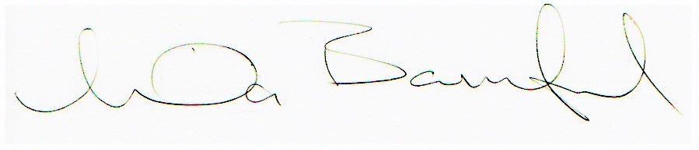

Summary Presentation of Financial Accounts
1 April 2020 - 31 March 2021
Income 2021 2020
Restricted Fund
Scottish Government Equality Unit £95,000 £95,000
Access Panel Grant £45,000 £45,000
Scottish Government Section 10 £80,132 £80,132
Transport Scotland £49,728 £49,728
Ferries Accessibility £12,027 £0.00
Exemption Card Campaign £57,466 £0.00
Total Income £339,353 £269,860

Unrestricted Fund
Easy Read Translation Service £27,836 £13,020
Sponsorships £4,017 £5,459
Total Income £31,853 £18,479
Expenditure 2021 2020
Allocated to Access Panel Grant £23,929 £26,862
Salaries £199,946 £186,195
Rent and service charges £12,359 £12,990
Telephone £2,810 £2,994
Postage and stationery £49,316 £6,691
Subscriptions. recruitment and training £13,135 £7,164
Travel and subsistence £714 £13,782
IT Development £7,187 £5,739
Interpretation £4,998 £2,621
Bank charges £716 £97
Depreciation of tangible fixed assets £257 £107
Accountancy Fees £10,152 £6,112
Legal and Professional Fees £1,631 £2,524
Insurance £4,618 £5,224
Events and Promotional Materials £7,430 £6,913
Governance £1,025 £1,025
Total £340,223 £287,040

Net income / (expenditure) £30,983 £1,300
Balance Sheet
as at 31 March 2021
2021 2020
Current assets
Debtors £6,432 £3,893
Cash at bank and in hand £76,786 £89,733
Total current assets £83,218 £93,626

Creditors
Amounts falling due within one year £2,576 £44,224
Total assets less current liabilities £81,058 £49,402

Funds
Unrestricted funds £45,159 £18,202
Restricted funds £35,899 £31,873
Total funds £81,058 £50,075
Full financial statements which have been examined by Community Accountancy Scotland are available from the company on request.

Disability Equality Scotland
Scottish Charity Number: SC031893
Suite 204B
The Pentagon Centre
36 Washington Street
Glasgow
G2 8AZ
Tel: 0141 370 0968
Email: admin@disabilityequality.scot
Facebook @DisabilityEqualityScotland
Twitter @DEScotTweets
Website: www.disabilityequality.scot

Our Sponsors
We are grateful for the generosity of our sponsors from 1 April 2020 to 31 March 2021:
- AccessAble
- Blackwood
- deafscotland
- Edinburgh Fringe
- Lothian Buses
- Motability
- NHS 24
- RBS
- SEStran
- SPAEN

