Members Survey 2021

Tell us what you think about Disability Equality Scotland.

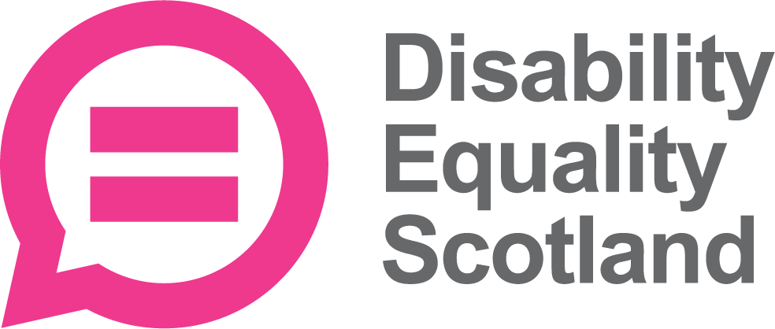
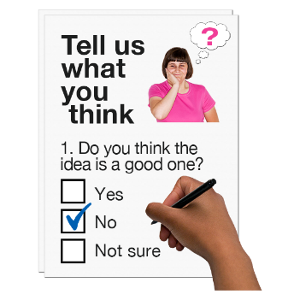

Easy Read

Copyright images © Photosymbols. Prepared by Disability Equality Scotland

Every year Disability Equality Scotland asks its members questions.

Your answers help us make our organisation better.
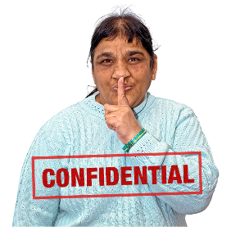 | All your responses will be confidential – no-one will know what you have said.  We keep your information safe.
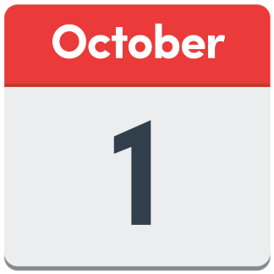 | Please send in your answers by  1 October 2021.
Click the box of the answer you agree with and a tick will appear. ☐

If you change your mind you can click on it again to untick it.

Type your answer if there is a dotted line.

If you are answering on a paper copy, tick the box of the answer you agree with, or write your answer on the dotted line.

Telling Disability Equality Scotland what you think.
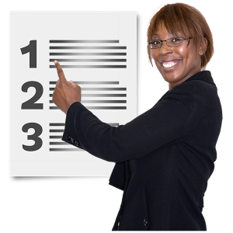 | - Do you feel you have the chance to share your thoughts with us about the things that are important to you?
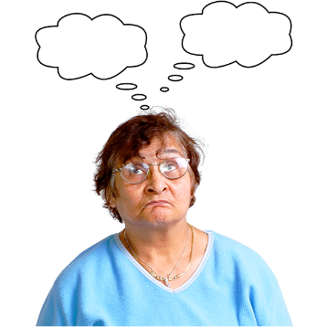 | I’m not sure |  | ☐
 | Yes |  | ☐
 | No |  | ☐
 | - Do you feel you have the chance to join discussions about the things that are important to you?
 | I’m not sure |  | ☐
 | Yes |  | ☐
 | No |  | ☐
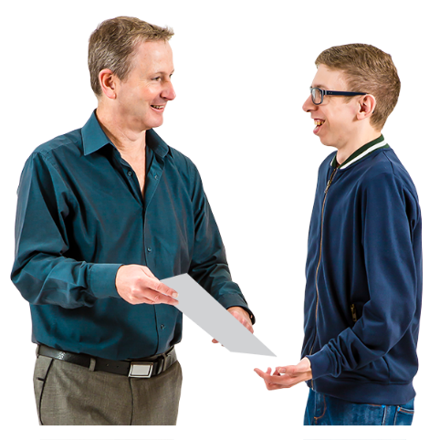 | - Do you get our information in a way that meets your needs?
 | Yes |  | ☐
 | No |  | ☐
 | Not sure |  | ☐
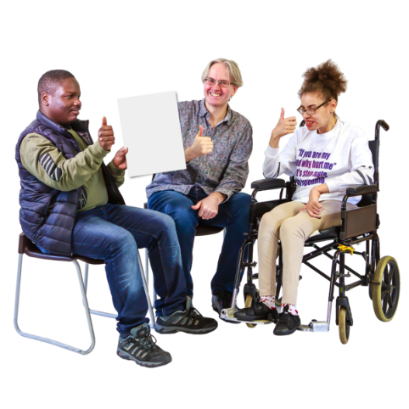 | - Do you feel you know more about disabled people’s experiences, because of our news and projects?
 | Yes |  | ☐
 | No |  | ☐
 | Not sure |  | ☐
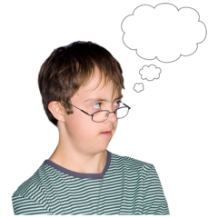 | 5. Please tell us anything else about how you join in with Disability Equality Scotland.  ……………………………………………  …………………………………………....
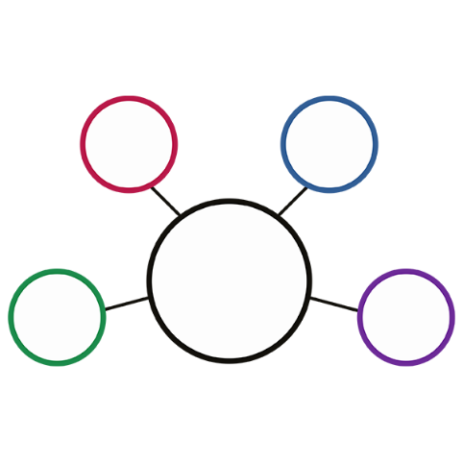 | 6. Disability Equality Scotland works on different projects. Tell us which ones you have heard of?
Access Panel Network
This is at www.accesspanel.scot
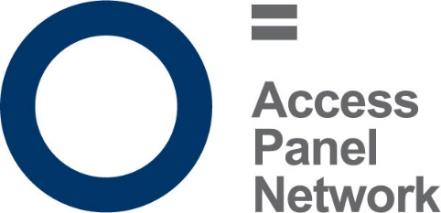 | Yes | ☐
 | No | ☐
 | Not sure | ☐

Accessible Travel Hub
This is at www.accessibletravel.scot

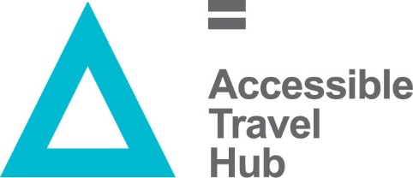 | Yes | ☐
 | No | ☐
 | Not sure | ☐
 | Disability Equality Scotland newsletter
 | Yes | ☐
 | No | ☐
 | Not sure | ☐
Disability Safety Hub
This is at www.disabilitysafety.scot
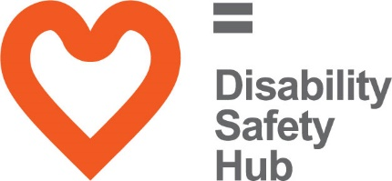 | Yes | ☐
 | No | ☐
 | Not sure | ☐
Easy read service
This is at www.easyread.scot
 | Yes | ☐
 | No | ☐
 | Not sure | ☐
Face Covering Exemptions
This is at www.exempt.scot
 | Yes | ☐
 | No | ☐
 | Not sure | ☐
Inclusive Communication Hub
This is at www.inclusivecommunication.scot
 | Yes | ☐
 | No | ☐
 | Not sure | ☐
Inclusive Design Hub
This is at www.inclusivedesign.scot
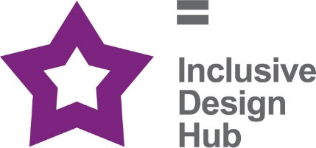 | Yes | ☐
 | No | ☐
 | Not sure | ☐
 | Hate Crime Charter
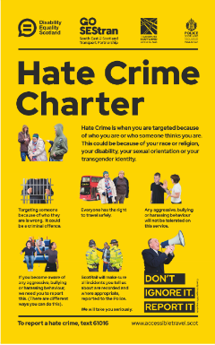 | Yes | ☐
 | No | ☐
 | Not sure | ☐
 | Open Door Magazine
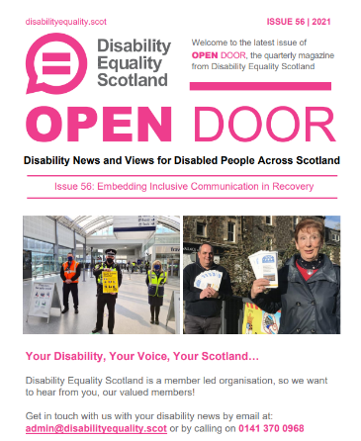 | Yes | ☐
 | No | ☐
 | Not sure | ☐

 | Social media – places like Facebook and Twitter
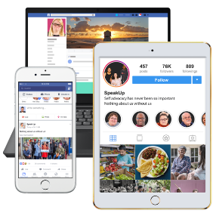 | Yes |  | ☐
 | No |  | ☐
 | Not sure |  | ☐
 | Webinars
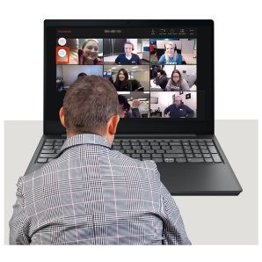 | Yes |  | ☐
 | No |  | ☐
 | Not sure |  | ☐
 | Weekly poll questions
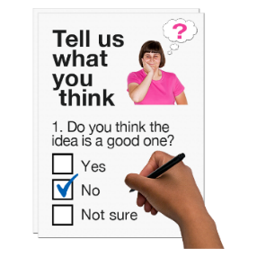 | Yes |  | ☐
 | No |  | ☐
 | Not sure |  | ☐
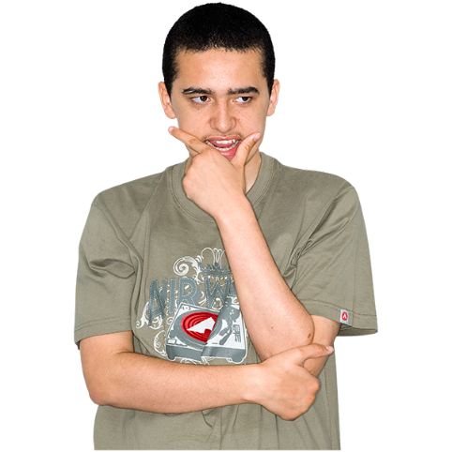 | 7. Please tell us anything else you feel about:  - our projects  - our services  - how we communicate  Write or type on the lines below.
…………………………………………….
…………………………………………….
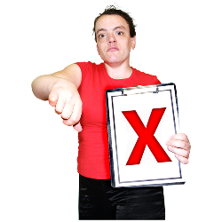  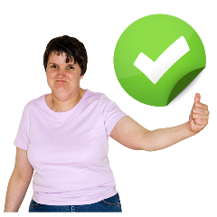 | 8. How happy are you with the different ways you can join in with Disability Equality Scotland?  You can do any of these:  - cross out or take out the answers you don’t want  - draw a loop around the answer you want  - highlight the answer you do want
 | Contact with our staff team
Happy / Not sure /
Not happy / Don’t know

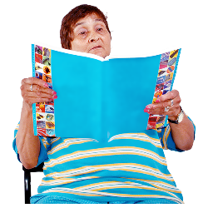 | What is in our monthly newsletter
Happy / Not sure /
Not happy / Don’t know

 | What is in Open Door magazine
Happy / Not sure /
Not happy / Don’t know

 | Topics for our webinars
Happy / Not sure /
Not happy / Don’t know

 | Weekly Poll topics
Happy / Not sure /
Not happy / Don’t know

 | Social media content
Happy / Not sure /
Not happy / Don’t know

 | Keeping in touch with our Local Access Panels
Happy / Not sure /
Not happy / Don’t know
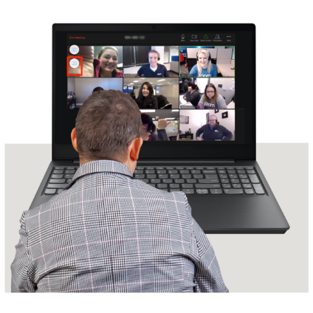 | 9. During COVID-19 we did lots of things online instead of in person.  In the future, how would you like to join in? Tick 1 box.
 | I want to join in with Disability Equality Scotland events online. |  | ☐
 | I want to come to face-to-face Disability Equality Scotland events. |  | ☐
 | I want to join in with both these kinds of events. |  | ☐
 | 10. Please tell us any thoughts you have about joining in with Disability Equality Scotland events.
……………………………………….
……………………………………….
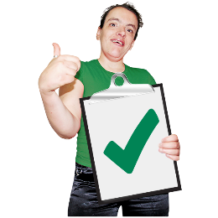 | 11. I think being a member with Disability Equality Scotland is a good thing.
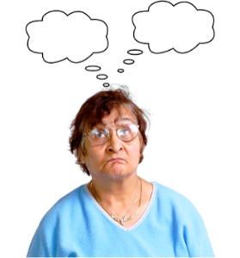 | Yes | ☐
 | Not sure | ☐
 | No | ☐
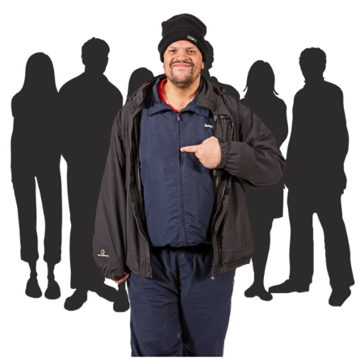 | 12. How could Disability Equality Scotland do more for members? Please write below.  …………………………………………….  …………………………………………….
 | 13. Would you tell someone else that joining us as a member is a good idea?
 | Yes | ☐
 | Not sure | ☐
 | No | ☐
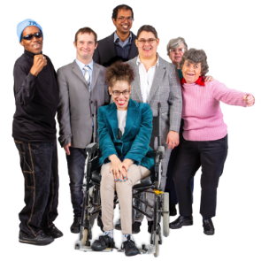 | 14. Do you think Disability Equality Scotland talks for disabled people in Scotland?
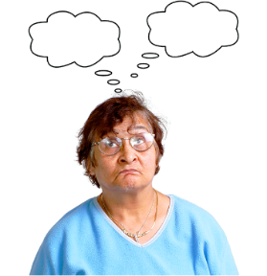 | Yes | ☐
 | Not sure | ☐
 | No | ☐
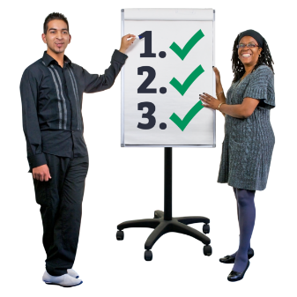 | 15. What should we be working on?  Please put a tick next to the things below that you think we should be working on. You can choose as many as you like.
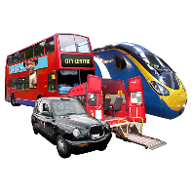 | Accessible Transport | ☐
 | Inclusive Communication | ☐
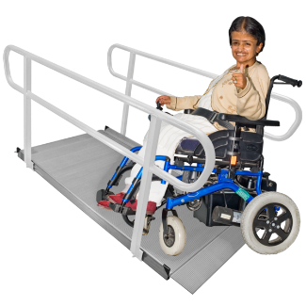 | Inclusive Design | ☐
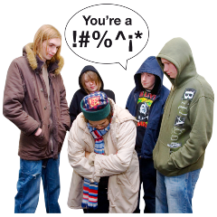 | Disability Hate Crime and Community Safety | ☐
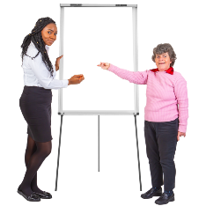 | Equality Access and Inclusion training | ☐
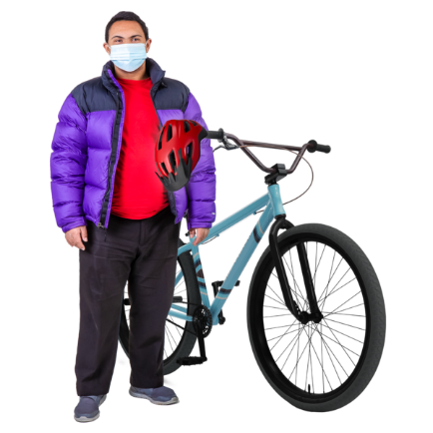 | COVID-19 recovery | ☐
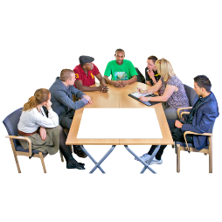 | Access Panel Network | ☐
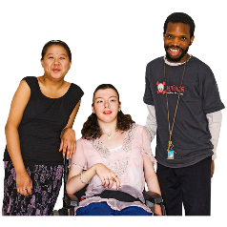 | Young disabled people | ☐
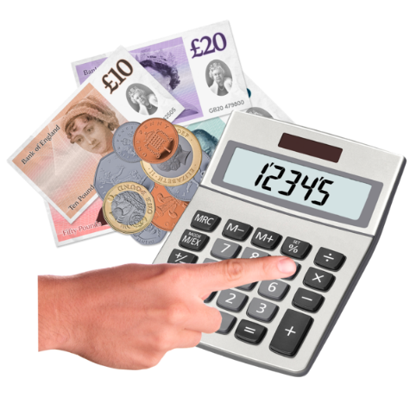 | Social security, benefits and grants | ☐
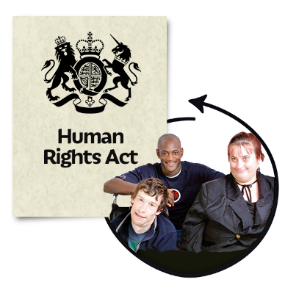 | Human Rights | ☐
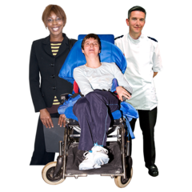 | Health and Social Care | ☐
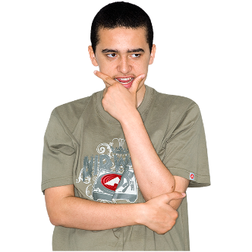 | Other (write or type here)
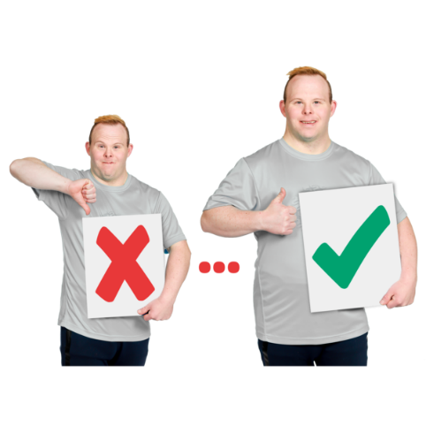 | We need information about our members.  This information helps us know what we need to do as an organisation.
Please tell us about yourself below, but do not tell us your name.
This survey is anonymous, and we will won’t share your answers.

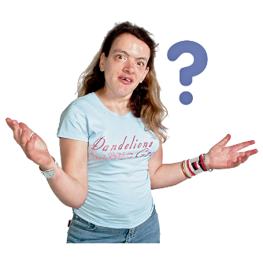 | 16. Tell us why you joined Disability Equality Scotland?  …………………………………………..  …………………………………………..
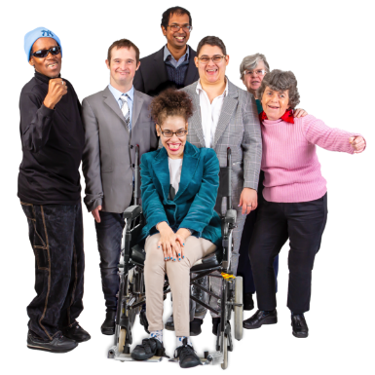 | 17. Do you have any of the following conditions?  Please tick any that:  - have lasted for a year or more  - will probably last a year or more
 | Deaf, deafness, hard of hearing or deafblindness |  | ☐
 | Blindness or other vision impairment |  | ☐
 | A physical disability |  | ☐
 | A learning disability |  | ☐
 | A mental health condition |  | ☐
 | A long-term illness |  | ☐
 | I don’t want to say |  | ☐
 | Other – please type or write
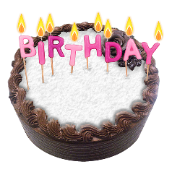 | 18. Please tell us what age you are. Type or write it here:  ……………………………………
 | 19. Please tell us about your gender.
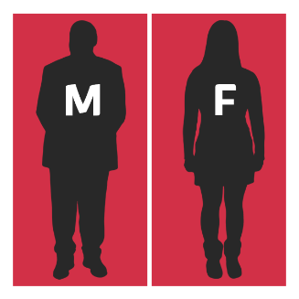 | I am female | ☐
 | I am male | ☐
 | I am non-binary | ☐
 | I describe myself in another way. | ☐
 | I don’t want to answer. | ☐
 | 20. Which 1 of these answers is true for you?
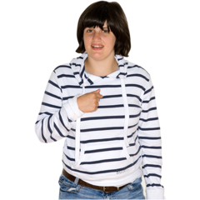 | I am a Young Member - age 12 to age 17. | ☐
 | I am a member of Disability Equality Scotland myself. | ☐
 | My organisation is a member with Disability Equality Scotland. | ☐
 | I am part of an Access Panel. | ☐
When you became a member you agreed to support our aims and give us information to help us meet your needs.
We hope you still want to support us.
You can view our aims on our website: www.disabilityequality.scot/about-us

 | 21. Which 1 of these answers is true for you?
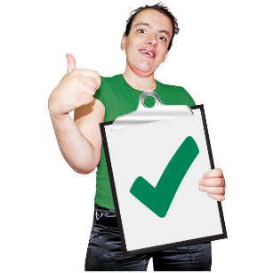 | I support the aims of Disability Equality Scotland and will continue my support. |  | ☐
 | I do not support the aims of Disability Equality Scotland and don’t want to be a member anymore. |  | ☐
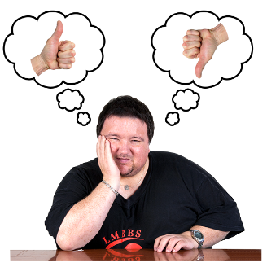 | 18. Do you have anything else you want to say about the work of Disability Equality Scotland?  Please type or write below.
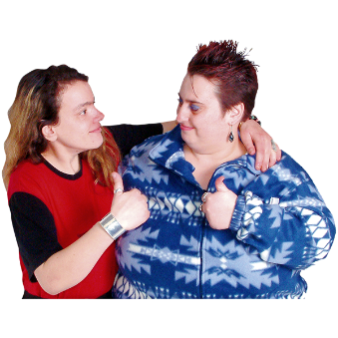 | Thank you for taking the time to answer our questions.  Your answers are important to us.  It will help us know how to support our members and your Access Panel.
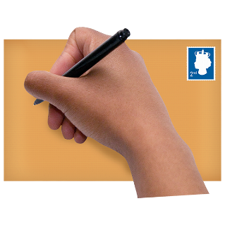 | Please return your answers by saving these pages and emailing them to: alistair@disabilityequality.scot  Or you can post them to:  Alistair Bruce  Access and Engagement Administrator  Disability Equality Scotland  Suite 204B  The Pentagon Centre  36 Washington Street  Glasgow  G3 8AZ
This is the end of the survey.

Copyright images © Photosymbols. Prepared by Disability Equality Scotland

