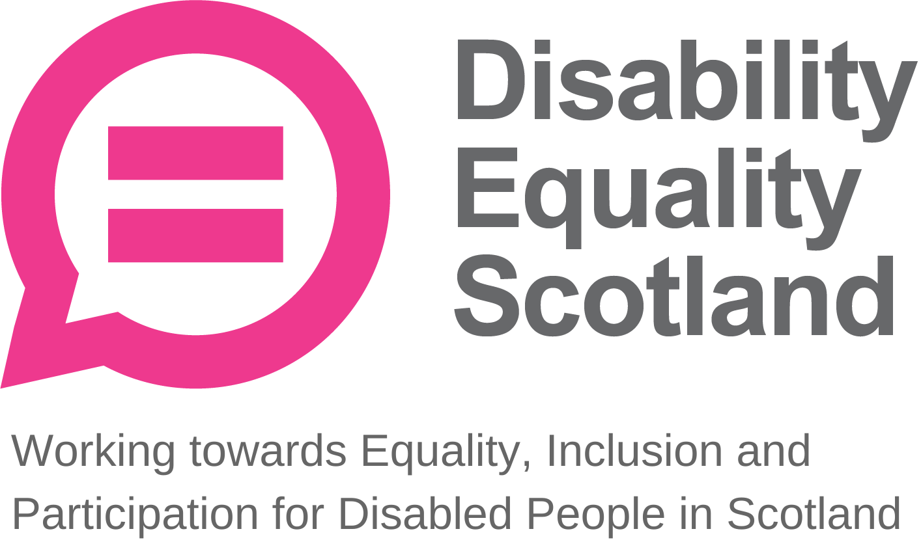
Disability Equality Scotland
Meeting of the Board of Directors
Wednesday 28 April 2021 10.00am
Zoom Virtual Meeting

In Attendance: Linda Bamford (LB) Convener
Maureen Morrison (MM) Director
Lauren Asher (LA) Director
Carolyn Griffiths (CG) Director
Colin Millar (CM) Director
Kenny Milne (KM) Director
Susan Fulton (SF) Director
Scott Stewart (SS) Director

Morven Brooks (MB) Chief Executive Officer
Emma Scott (ES) Operations Manager
Ian Buchanan (IB) Equality and Access Manager
James Davidson (JD) Communications and Research Coordinator
Alistair Bruce (AB) Access and Engagement Administrator
Claire Jagger (CJ) Easy Read Worker

Apologies: Dorothy McKinney (DMcK) Director
Rhianne Forrest (RF) Director

Item 1 Welcome and Apologies

LB welcomed everyone to the meeting. LB formally thanked Janis McDonald for her services to the board of directors after recently stepping down.

MB stated that she had received apologies from DMcK and RF.

LB asked that during discussions if anyone wanted to contribute, they would raise their hands and LB would confirm who wished to contribute and in what order.

LB asked everyone to remain on mute unless speaking to limit background noise. During all decision-making, LB will ask who is not in agreement to raise their hand before progressing, and when closing an agenda section, she will ask if there were any further comments before moving on.

LB stated the agenda timings for the day including comfort break and the intended close of meeting and confirmed that there would be no closed session of the board. LB explained that the meeting should conclude by 11:30pm and that this meeting was to be shorter as there is a strategy session scheduled for 19 May 2021. All Directors confirmed their understanding.

LB stated that MB would chair sessions 5 and 6 today.

LB stated that everyone should have received their board papers three weeks in advance and asked if everyone felt they had enough information to make decisions and contribute to the board meeting. The board confirmed this.

LB progressed to agenda item 2.

Item 2 Agreement of Minutes from last meeting

LB stated that the minutes were emailed for comment and checking shortly after the January 2021 board meeting and asked for confirmation from the board on accuracy and content. No one raised any concerns. LB confirmed that all actions or matters arising from the minutes had been picked up and asked for agreement of minutes from Directors present at the previous meeting.

Proposed by: MM
Seconded by: CG

Item 3 Outstanding actions 27 January 2021 Board Meeting

LB stated that there is one outstanding action. MB provided a quick update on how this action is being taken forward as well as one completed action.

Action Point 1: IB to prepare a brief for the board around the terminology of access audits and surveys to establish Disability Equality Scotland’s position on this. IB agreed to connect with SF on this. MB stated that IB will provide a full update on this during his report, but in brief, he has been in touch with SF to discuss how this will be taken forward with Access Panels. This will take form of ‘language seminars’, but the strategy subcommittee and access subcommittee may wish to discuss how this is taken forward. This will be a further action for MB to update our sub committee terms of reference, as well as develop a plan for how subcommittees can work together on this.

Action Point 2: LB to forward COSLA contacts to IB for the Access Panel Conference. This action has been completed and now closed.

LB asked for any other concerns or questions relating to the action points. Nothing was raised. The board agreed. LB moved to agenda item 4, passing over to MB to introduce and talk though the paper.

Item 4 Approval of New Members
MB stated that for the period of 1 January 2021 to 31 March 2021, we had 302 new members join (295 Individual, 6 Corporate, 1 Young Member). 11 individual members requested to be removed. This provided us with a total membership of 1296, with 1126 Individual, 127 Corporate, 5 Young Members and 38 Access Panels.

MB added that this represents a 29.1% increase in total membership over this quarter, compared to a 14.7% increase in the previous quarter (30 September – 31 December).

SF stated that these membership numbers are incredible and asked whether we are tracking where these members are joining from. AB added that data from the online application form shows that 42% of applications are coming from engaging with the face covering exemption card project, followed by social media and website promotion.

LA asked if there was any other way that we could promote young membership, and whether this was something she and RF could work on promoting together. MB responded that she has reviewed the skills present on the board and is looking at the possibility of a working group on promoting young membership with certain board members and staff. LB added that during the process of discussing end of year appraisals and setting objectives, an increased focus on promoting youth membership was an agreed objective. LB added that it would be a great idea to have LA and RF to work on this.

LB asked if everyone is happy to approve the new members listed in the board papers. The board approved the new members. LB progressed to the CEO’s update.

Item 5 CEO’s Update

MB stated that following the release of our own ‘Manifesto for Change’, she had met with national parties to discuss how our priorities could be incorporated into their own manifestos. These discussions included assurances on creating accessible versions of manifestos, but as the campaign has progressed, this had not materialised. Our recently published Manifesto Tracker has ruffled some feathers in national parties, with our social media posts receiving good traction, and made people realise that all communications should be available at the same time to be truly accessible. This had seen a shift to more inclusive communication methods being adopted by all main political parties.

MB stated that with the strategy session scheduled for 19 May, she is writing a discussion paper focussing on actions taken from the Social Renewal Advisory Board’s (SRAB) report “If not now, when?”. MB was involved in the report’s age and disability circle, and this internal discussion will also be looking at the response paper from the Scottish Government. The aim is to make this report align with our own strategic priorities. MB will share this discussion document shortly.

Action Point 1: MB to share discussion document for strategy session based on the SRAB report.

MB stated that 6 directors are up for re-election, and MB has been in touch with each director about whether at this point they intend to resign or submit for re-election. MB stated that she wants to work more closely with all directors to make full use of skills available on the board.

MB concluded her update. MB asked for any questions on the CEO report.

SF asked about MB’s initial concerns about working with Inspiring Scotland managing the Equality and Human Rights Fund. MB stated that we have a very good relationship with the Equality Unit, while Inspiring Scotland do not know us or what we have achieved over the last few years, at least in the depth that the Equality Unit do. MB added that other disabled peoples’ organisations (DPOs) such as Inclusion Scotland and Glasgow Disability Alliance are in a similar mindset. Following an open discussion with these DPOs, the Equality Unit and Inspiring Scotland regarding our concerns, the Equality Unit had reassured us that they are working closely with Inspiring Scotland in making any final decisions. MB has since attended a surgery session with Inspiring Scotland to address final questions in this process. MB added that this application is looking at core funding, which is something that the organisation had moved away from in favour of project funding before MB’s appointment as CEO. Looking at core activities overall, this application is trying to sum up everything that we do in 500 words, which is a challenge. MB had asked Inspiring Scotland how we do this in 500 words, and they understood that this is a challenge. MB added that from their point of view, are going to receive a lot of applications for this fund, and with this being the only three-year fund that has opened up from the Scottish Government in a long time, it is very important that we get this right.

LB added that, during discussion at the SCVO Hustings with party representatives, there was a unanimous commitment to three-year funding for the third sector. LB also listened to our own Disability Hustings, stating that this was one of the best Hustings events during this election cycle, with the majority of the time available being utilised to allow members to ask questions on issues important to them.

LB also added that feedback after the Access Panel Conference was incredible and encouraged the team to keep doing what they are doing.

LA added that the DES Hustings was the first event she had attended of this kind and agreed that other events were not as on track in terms of allowing questions and engagement. LA felt that we were able to have an open discussion about the issues affecting disabled people, which was great.

MB moved to Operations Manager report.

Operations Manager Report
ES stated that there were a few big projects to update on. The exemptions card project is continuing, and we have seen demand fluctuate due to various circumstances such as schools reopening. We are also seeing traffic move over more heavily to the online request form, as for example, yesterday we had 9 telephone calls, but over 300 requests on the website.

ES explained that since the last board meeting, there has been a change to the practicalities of the service, whereby the Scottish Government have taken over the postage of exemption cards, picking up envelopes from the office via a courier. This has increased waiting times for delivery from next working day, to up to a week. This has not resulted in any negative feedback, however.

ES added that we have received positive feedback from the survey sent out to users of the service who gave permission to be contacted. So far, we have sent approximately 21,000 surveys, and received approximately 5,000 responses. This means a 23-24% response rate which is great, and this is translating into really positive feedback. ES stated that the project has been extended again for a further quarter, until the end of July, and we are keeping an eye on how the latest lifting of restrictions is affecting demand for exemption cards.

ES stated that the Hate Crime Charter has taken up a lot of our time, delivering an online soft launch on 24 March. On launch day, we worked with our partners really well to get the messaging right and reach on the day was just short of 56,000 views, with final views closer to 300,000. The Accessible Travel Hub page got over 1,100 views on the day, now just short of 3,500, with some tweets reaching up to 90,000. We also received an endorsement from the Cabinet Secretary. The next stage involves a bit of monitoring and evaluation, and further engagement, as well as training for transport providers.
LB gave her thanks to ES, adding that the statistics from the face covering exemptions helpline and the Hate Crime launch are great, and better than we could have imagined. LB asked how our application for a ‘blue tick’ on Twitter is going. JD added that for some reason, applications for this have closed for now, but as soon as Twitter bring this back, he will look into this. LB added that this would be really valuable for us, especially as now our reach is expanding, if we have a blue tick, we will come up in a lot more searches and generally raise our profile.

LB also asked whether there has been any progress on the Equality and Human Rights Advisory Group, which ES mentioned in her report. ES responded that Disability Equality Scotland were now represented on a number of different committees, such as the Scottish Courts and Tribunal Service, as well as Audit Scotland’s Equality and Human Rights committee, whose first meeting is on 14 June. ES will feedback on progress from these committees.

MB progressed to IB’s report.

Access Training and Engagement Manager Report

IB stated that since the last board meeting, we had hosted the Access Panel Conference, adding that this was one of our best-attended conferences in a number of years due to the fact that it was held online. The feedback has been fantastic, with 100% of people saying that they would be happy to attend a virtual conference again. We had polled Panels at the start of their pandemic regarding their views on a virtual conference, which was a resounding ‘no’ at the time, however due to the widespread adoption of video conferencing this changed with very positive effect. IB added that it is great to see Panels comfortable with this as the implications for accessibility are fantastic.

IB stated that he is also looking at addressing the ‘access audit’ language, with an email to Access Panels inviting them to an Access Language seminar going out this afternoon. This will allow them to agree on a preferred term for an ‘access audit’, however whatever they decide to call it will have no bearing externally, this is just an internal definition. IB stated his preference for the term ‘lived experience assessment’, following a discussion with SF. IB is also in the process of setting up a National Access Advisory Group (NAAG) looking at how we implement the Social Renewal Advisory Board’s (SRAB) actions specifically on healthcare, aiming to emulate the approach of MACS as a way of getting Panels involved in this high-level work.

MB thanked SF for her presentation at the Access Panel Conference, citing great feedback from attendees, adding that future presentations like this would be welcomed. MB asked, on the topic of Access Language discussions, that IB pause for a moment on his invitation email to Access Panels until after the access subcommittee has been established. IB agreed to update Panels on this change, having notified them previously to expect information on this shortly.

MB asked for questions for IB.

LB thanked IB for his update, adding that she also likes the term ‘lived experience audit’, as it has strong links to approaches taken by other organisations, including the Scottish Government, which places lived experience right at the core. LB also drew attention to the discussion on 20-minute neighbourhoods and the upcoming events on this, stating that this could be an incredibly important theme for Panels to contribute to. She stressed the key message that working with Access Panels is the only way to get these designs right and ensure places are accessible for all and meet everyone’s needs.

SF added that on the ‘lived experience audit’ term, a key advantage of the term is that it would protect the Access Panel legally, as they are clearly stating that they are only providing information from their perspective, so cannot be sued for wrongful or incorrect advice on issues wider than this. IB agreed that the term indicates a snapshot of their lived experience on that day and nothing more.

LB added quickly that we should be careful not to circumvent the discussions and decisions that will come out of the Access Language seminars with Access Panels, as the group needs to come to its own conclusions, not just something that our board is comfortable with.

MB progressed to the annual calendar of activities.

Board Annual Calendar of Activities
MB stated that she is updating the terms of reference for the strategic subcommittees, including how the working groups will operate. MB will have this ready shortly for circulation.

MB asked for any questions on this. There were no questions from the board.

Quarterly complaints
MB stated that we received one email complaint, regarding our Weekly Poll, saying that we should not be asking Covid-related questions to our membership. MB responded to the complainant that the Covid pandemic has had a profound impact on our members, so we will continue to do consult them on how it has affected them but offered the complainant the opportunity to suggest Weekly Poll topics of their own.

Reflective learning log
MB stated that the breakout room format we used at the Access Panel Conference worked really well, adding that dimensional discussion to those in attendance. We are considering taking this forward with further webinars and will continue to monitor how this is received.

MB asked for any questions from the board on the complaints or reflective learning sections. There were no questions from the board.

Finance
MB stated we have now met our first target with our Reserves, which covers three months operating costs as well as redundancy costs. We will now look at a target of six months of these costs, if at any time our funding is at risk, we have additional time to seek alternative funds.
MB is meeting Motability at the end of May; they are currently sponsors with us and MB will look at further sponsorship from them.

MB asked for any questions from the board on finances. There were no questions from the board.

People
MB stated that over this last quarter, we have been holding performance appraisals with all staff, as well as setting new objectives until the 31 March 2022; this process is nearly complete now with all staff. MB added that we are still taking time in our team meetings to discuss lessons learned, and actioning these where appropriate.
We are still using MS Teams for organisational communication, which is working well.

LB added that when looking at end of year objectives, herself and MB have split some high level objectives and re-weighted them, directing focus to the more important objectives. This should help us focus our work. LB reassured the board that this does not mean that we are taking our eye off the ball regarding governance work.

MB will be in touch with MM about the upcoming fundraising strategy, which will feature in future board meeting updates.

MB asked for any questions from the board on people. There were no questions from the board.

LB progressed to the Risk Management section.
Risk Management

MB explained that as of the last review of risks, which took place on 7 April 2021 with LB, we are currently managing 14 organisational risks. In this last risk review we looked more closely at one risk area, which is finance. MB added that even though we have received confirmation from funders from Section 10, Ferries Accessibility Fund and Transport Scotland for the next year, we are just keeping an eye on this risk due to the Equality and Human Rights fund (managed by Inspiring Scotland), since our existing funding from the Equality Unit will end on 30 September 2021. MB has also received a request from Scottish Government to add in Section 10 funding within this application. The applications closing date for the new fund is 14 May 2021.

Challenges for Next Quarter
MB stated that she is continuing to meet with key Ministers and Cabinet Secretaries, and once the new parliament is in place, we will be looking at building partnerships there alongside other organisations. MB has also met with other organisations about new funding, especially the new Equality and Human Rights funding, which is a chance to work collaboratively across the sector and strengthen our role.

MB is still supporting staff working from home, we will continue to support them and keep in touch.
MB has also started drafting the annual report, and gathering the data for this, as well as getting all of our accounts prepared for independent examiners.

MB asked for any questions from the board. There were no questions from the board.

Item 7 AOB
LB asked for any other business from the board that we would need to come back for after the comfort break, otherwise the board will confirm the actions for today and close the meeting before the comfort break, at 11:00am rather than 11:30am.

The board had no other business. LB moved on to confirmation of today’s actions.

Item 8 Confirmation of today’s actions

LB shared the following actions, which she picked up on during the meeting:

Action Point 1: MB to liaise with RF, LA and CG about the ad-hoc youth membership working group.

Action Point 2: MB to update terms of reference for the subcommittees.

Action Point 3: MB to share papers on the strategy session with staff in advance of the meeting on 19 May 2021.

The board confirmed these actions.

LB thanked everyone for their contributions today, praising the efficiency of the meeting and adding that she hopes to see everyone at the strategy meeting on 19 May.

Item 9 Close
LB closed the board meeting formally.

Minutes reviewed and agreed: 28 July 2021

Proposed: Scott Stewart
Seconded: Susan Fulton

Signed: 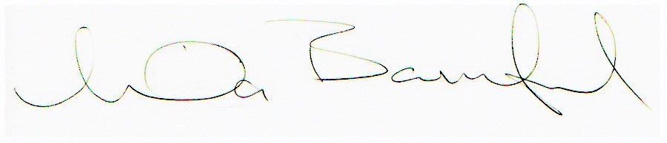
Linda Bamford, Convenor

