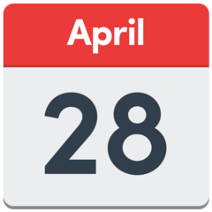  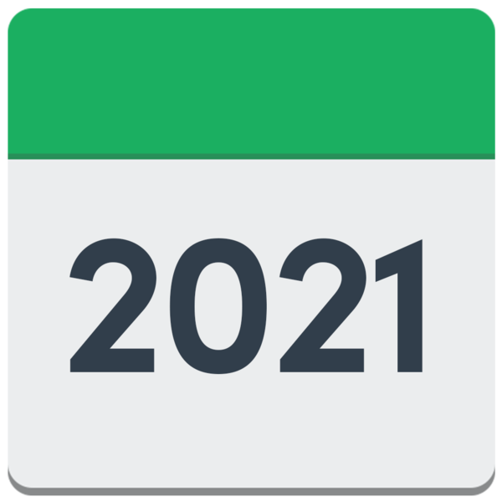  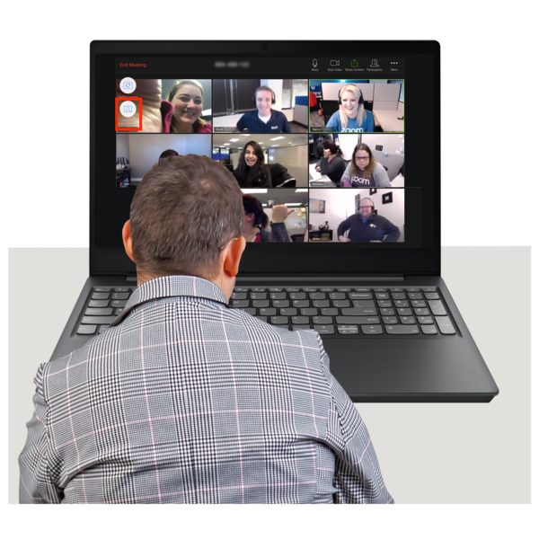  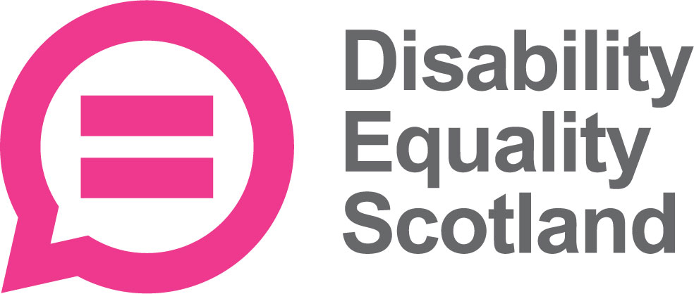 | Disability Equality Scotland  Meeting of the Board of Directors  28 April 2021 at 10am on Zoom
 | Who was there?
Directors
- Linda Bamford – Convener
- Maureen Morrison
- Kenny Milne
- Lauren Asher
- Carolyn Wilson-Smith
- Colin Millar
- Susan Fulton
- Scott Stewart

Staff
- Morven Brooks – Chief Executive Officer
- Emma Scott – Operations Manager
- Ian Buchanan – Equality and Access Manager
- James Davidson – Communications and Research Coordinator
- Alistair Bruce – Access and Engagement Administrator
- Claire Jagger – Easy Read Worker

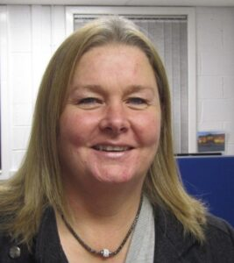  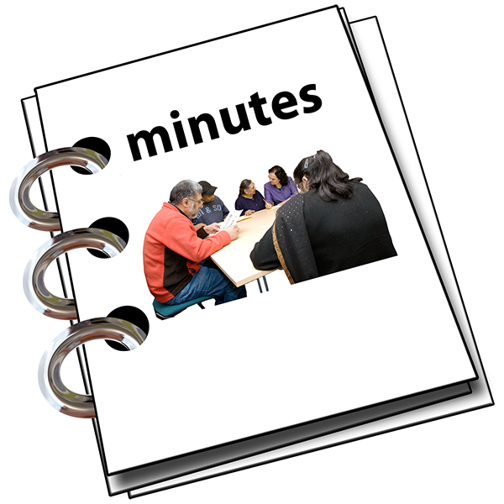 | Minutes
 | Item 1 – Welcome and Apologies
Linda welcomed everyone to the meeting.

Dorothy McKinney and Rhianne Forrest could not come to the meeting.
 | Linda thanked Janis McDonald for her work as a Director. Janis has left now.
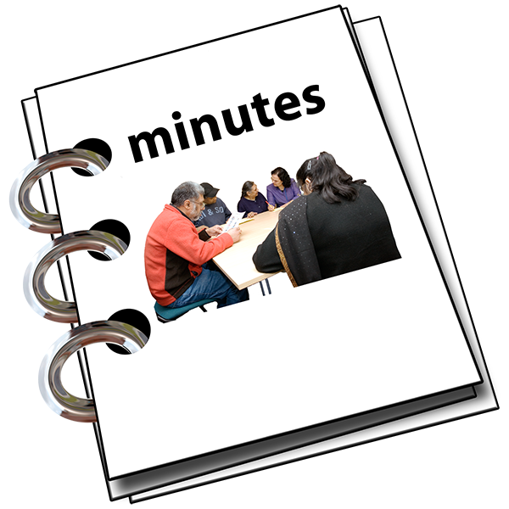 | Item 2 - Are the minutes of the last meeting right?
 | Everyone agreed that the minutes of the last meeting were right.
 | Item 3 - What actions still need doing from the 27 January 2021 meeting?
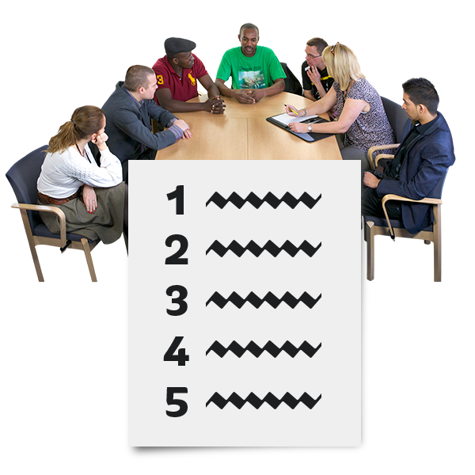 | Linda said there is 1 action still needing doing.  Morven talked about how this is getting on.
Action Point 1:

Ian Buchanan will tell the board about the new wording for access audits and surveys. He will talk with Susan Fulton about this.

Ian wants to have Language Seminar meetings with Access Panel groups.

Morven will help take this forward.
Action Point 2:

Linda will send Ian the names and email addresses of people at COSLA for the Access Panel Conference.

This has been done.

 | Item 4 - New Members
Morven said that 302 new members have joined between 1 January 2021 and 31 March 2021.

There are:
- 295 individual members
- 6 corporate members
- 1 Young member
11 individual members asked to stop being members.

We now have a total of 1296 members.

There are:
- 1126 individual members
- 127 corporate members
- 5 young members
- 38 Access Panels

Susan Fulton said that these numbers are great. She asked if we are finding out where the members are joining from.
Alistair said that nearly half the new members have come from the exemption card project.
Lauren asked how we could get more young members to join.
Morven said she was thinking about making a working group to do this. She said it would be good to work with Lauren and Rhianne on getting more young members.
 | Linda asked if everyone was happy with the new members joining. Everyone said they were happy.
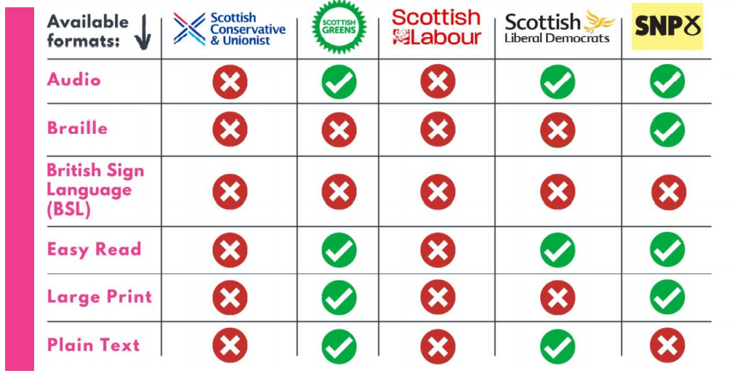  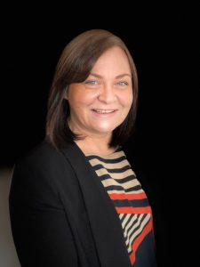 | Item 5 - Update by the Chief Executive Officer (CEO) Morven
Morven said that lots of the manifestos for the election were not also made into Easy Read.
They were also not made in other accessible ways.

Disability Equality Scotland made a simple table to look at each party’s accessible manifestos. It was called the Manifesto Tracker.
There were lots of share and comments on social media.
The political parties quickly made accessible manifestos.

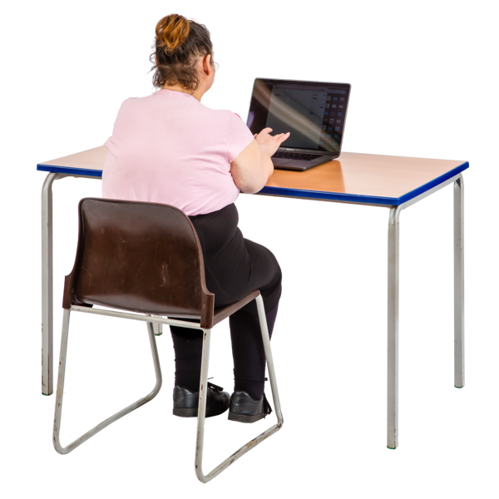 | Morven said she has been writing a paper about the Social Renewal Advisory Board report called ‘If not now, when?’
Action Point
Morven will share the discussion document.

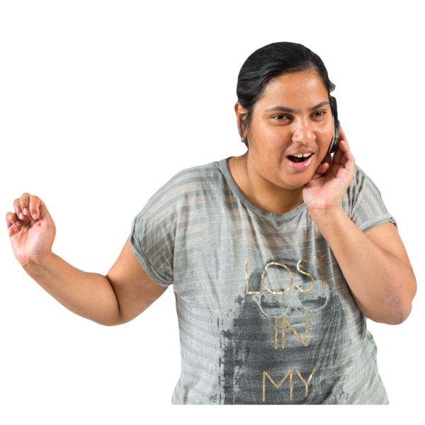 | Morven said that 6 Directors could be elected again. She is talking to them all to see if they want to be elected again.
 | Questions for Morven
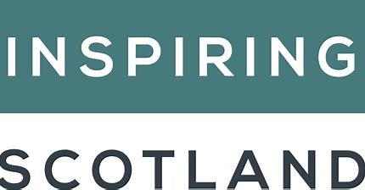 | Susan Fulton asked how we were getting on working with Inspiring Scotland.  Morven said that it is going well. The Equality Unit are working with them too.  Morven is applying for funding from Inspiring Scotland. She said it’s hard to write about everything we do in just 5 hundred words.
Linda said that she was at the SCVO Hustings. Everybody agreed to 3 years of funding.
She said that Disability Equality Scotland’s Hustings was one of the best Hustings. Lauren Asher agreed.
Linda also said that she had heard good feedback after the Access Panel Conference.
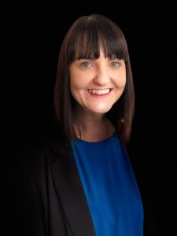 | Report by Operations Manager – Emma Scott
 | Emma said that the Face Coverings Exemption Card project is carrying on.
Most people are now using the online form to ask for a card, instead of phoning us.
The Scottish Government are now posting the cards out. It’s taking longer to get them delivered but no one seems to mind.
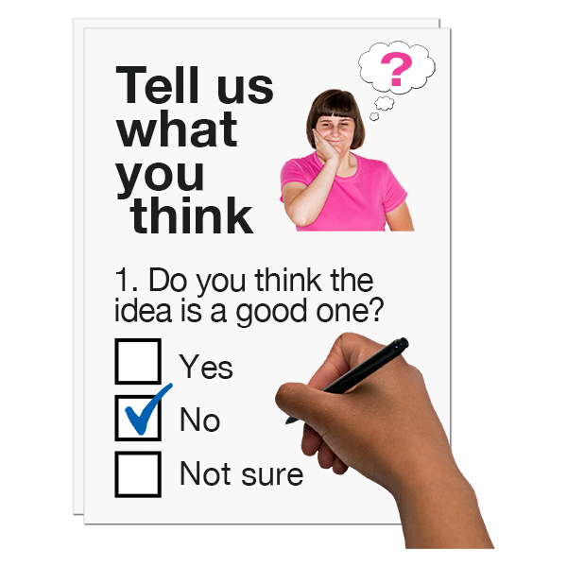 | Emma said we have sent out lots of surveys to see how people felt about getting their exemption cards.  Lots of people told us they were very happy.
Emma said that we have worked hard on the Hate Crime Charter.
It was shared with the public on 24 March 2021.
Many thousands of people saw it online. Lots of people also visited the Accessible Travel Hub page too.
The Cabinet Secretary showed support too.
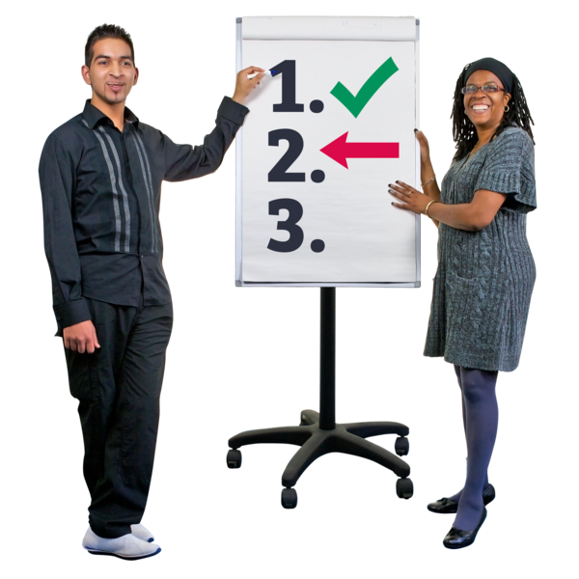 | The next things to do are:  - checking on how it’s going and how it can be better  - sharing the Charter even more  - training for transport organisations
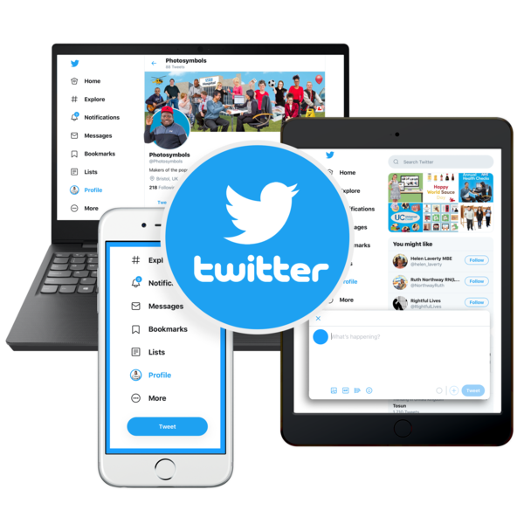 | Linda thanked Emma.  Linda asked if we are going to get a blue tick next to our charity name on social media. This blue tick shows we are the real charity and not a fake page.  James said that Twitter are not letting organisations ask for blue ticks at the moment.
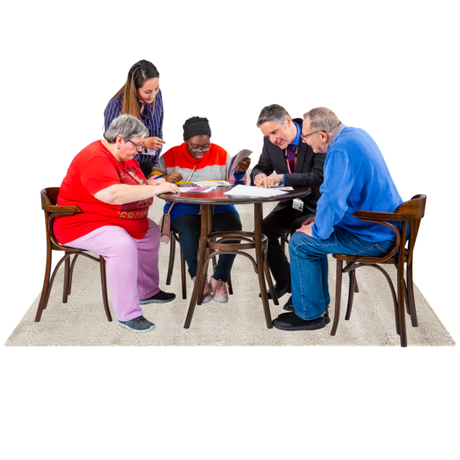 | Linda asked Emma how the Equality and Human Rights Advisory Group work is going.  Emma said that Disability Equality Scotland are now part of lots of different committees. She will share feedback in the future.
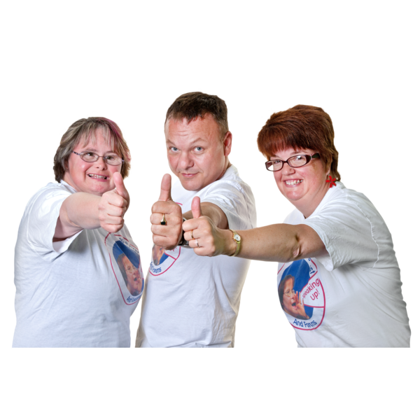 | Report by Access Training and Engagement Manager – Ian Buchanan
Ian said that the online Access Panel Conference was very popular.
Many people joined it online and everyone said that they would be happy to join in again online in the future.
Ian said he wants to make sure that we get the language right when we talk about access audits.
He is organising an Access Language seminar to decide the best words to use in our teamwork.
Ian said he is setting up a National Access Advisory Group (NAAG).
This new group will check how we are acting on the Social Renewal Advisory Board’s advice.
Morven thanked Susan for talking at the Access Panel Conference.
She asked Ian to wait a little while before he emailed the Access Panels. This gives her time to sort out the Access subcommittee first.
A subcommittee is a small group who meet up as part of a bigger committee group.
 | Linda thanked Ian. She and Susan said they like the language ‘lived experience audit’ that Ian had talked about.
 | What is happening this year
 | Morven said that she is writing new guidelines for the meeting groups. She will share the guidelines soon.
Complaints
Morven said there had been 1 complaint by email.
The person complaining said we shouldn’t be asking our members about COVID-19 things in our weekly polls.
Morven had emailed them to say that COVID-19 has really changed many disabled people’s lives and it was important to understand how.
She asked them to give their ideas on other weekly poll questions.
What we have learned
Morven said that using breakout rooms in the online Access Panel Conference worked really well.
 | Money
Morven said that we have enough money saved to pay for 3 months costs.
Next we’ll aim for 6 months costs saved up.
Morven is meeting with Motability in May 2021. We hope they will carry on giving us money.

 | People
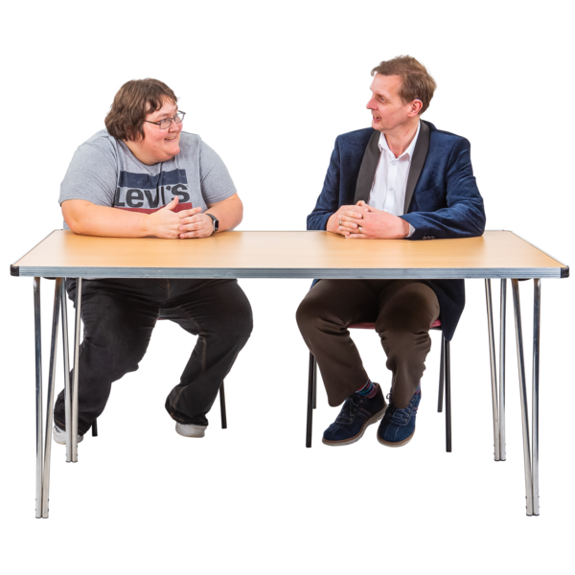 | Morven said we have had 1 to 1 meetings with all staff to see how they are doing.  We’re using Microsoft Teams for our meetings and that works well.  Linda said that she and Morven have changed our targets a bit to make sure that important things are done.
Risk Management (things that might cause problems)
Morven said there are 14 risks at the moment.
She and Linda have looked closely at money risk. Some funders will carry on but some are unsure.

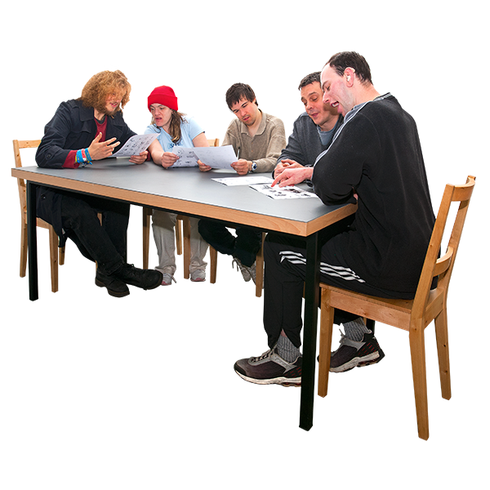  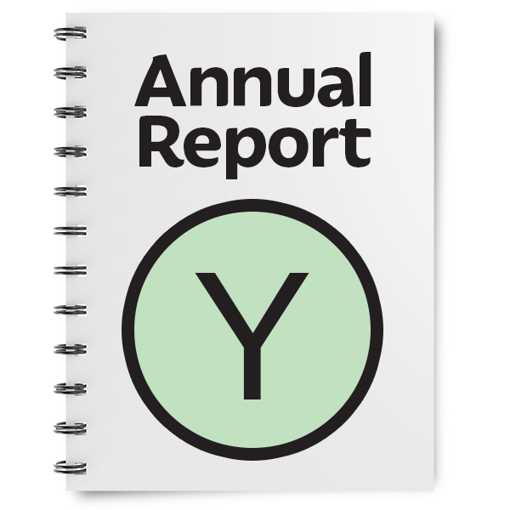 | What do we need to do in the next three months?
Morven said she is still meeting with Ministers and Cabinet Secretaries.

She has met with other organisations which might give us money. Like the Equality and Human Rights fund.

Morven is still helping staff to work from their homes.

She has been writing the annual report and getting our money accounts ready to be looked at.
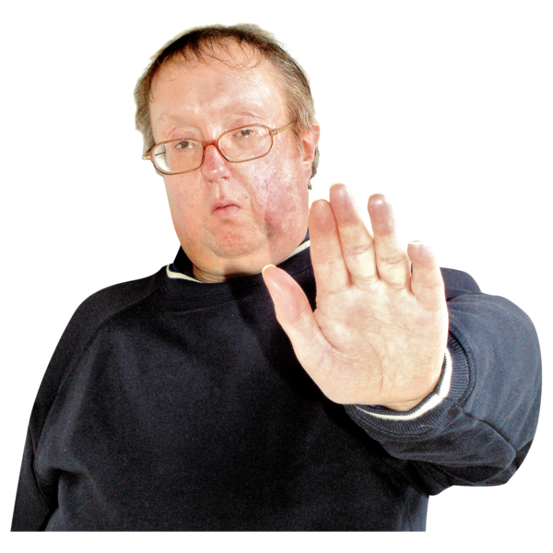 | Item 6- Any Other Business
 | There was nothing else to talk about.

Item 7 - What we have agreed today

Action Point 1: Morven will talk to Rhianne, Lauren and Carolyn about the youth membership working group.

Action Point 2: Morven will write a new document for the subcommittees.

Action Point 3: Morven will share the documents from the strategy session before the meeting.

Item 8 - Meeting End
Linda thanked everyone and the meeting ended.

