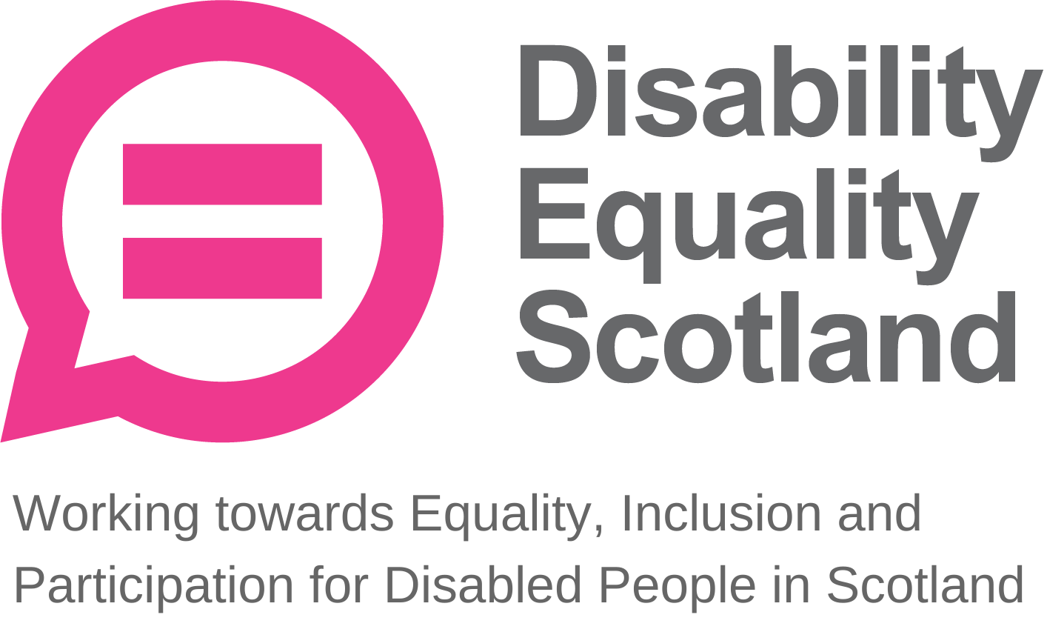
Disability Equality Scotland
Meeting of the Board of Directors
Wednesday 27 January 2021 10.00am
Zoom Virtual Meeting

In Attendance: Linda Bamford (LB) Convener
Dorothy McKinney (DMcK) Director
Maureen Morrison (MM) Director
Lauren Asher (LA) Director
Rhianne Forrest (RF) Director
Carolyn Griffiths (CG) Director

Morven Brooks (MB) Chief Executive Officer
Emma Scott (ES) Operations Manager
Ian Buchanan (IB) Access, Training & Engagement Manager
James Davidson (JD) Communications and Research Coordinator
Alistair Bruce (AB) Events, Training and Membership Administrator

Apologies: Colin Millar (CM) Director
Kenny Milne (KM) Director
Susan Fulton (SF) Director
Janis McDonald (JMc) Director
Scott Stewart (SS) Director

Item 1 Welcome and Apologies
LB welcomed everyone to the meeting. LB asked that during discussions if anyone wanted to contribute, they would raise their hands and LB would confirm who wished to contribute and in what order.
LB asked everyone to remain on mute unless speaking to limit background noise. During all decision-making, LB will ask who is not in agreement to raise their hand before progressing, and when closing an agenda section, she will ask if there were any further comments before moving on.

It was confirmed that there was one board briefing paper, to be taken as a closed session of the board and this paper would need a majority of Directors in attendance decision for or against. LB confirmed that everyone was aware of this and that there was quorate to enable this decision to stand inline the DES’s articles of association. All Directors confirmed their understanding.

LB stated the agenda timings for the day including the comfort breaks and close of meeting.

LB confirmed that the second closed session, open to board members only, would start at 11:50pm and run until 12:15pm. LB stated everyone should have received their board papers three weeks in advance and asked if everyone felt they had enough information to make decisions and contribute to the board meeting. The board confirmed this.

LB progressed to agenda item 2.

Item 2 Agreement of Minutes from last meeting
LB stated that the minutes were emailed for comment and checking shortly after the October 2020 board meeting and asked for confirmation from the board on accuracy and content. No one raised any concerns. LB confirmed that all actions or matters arising from the minutes had been picked up and asked for agreement of minutes from Directors present at the previous meeting.

Proposed by: DMcK
Seconded by: MM

Item 3 Outstanding actions 28 October 2020 Board Meeting
LB stated that there were no outstanding actions other than those captured within the table of action points. MB provided a quick update on how these actions were taken forward.

Action Point 1: SF recommended the use of a website accessibility checker for the exemption card website. MB confirmed that after using this service, some issues were highlighted and amended, and staff were confident in the website’s accessibility. This action was closed.

Action Point 2: RF shared information on Mitchell Library and potential links to support the exemption card campaign. MB stated that she had emailed them and Scottish Library Council, so all Scottish Libraries know about the campaign. No response but will continue here to ensure inclusivity and accessibility. This action was closed.

Action Point 3: IB will provide a VisitScotland update in his report to the board. This action was closed.

Action Point 4: MB updated the Disability Circle Group to attend the webinar. This action was closed.

Action Point 5: IB taking forward Accessibility Award. IB is going through funding applications just now and including considerations for this award in applications. This action was closed from the Board’s log for progression via the operational team.

Action Point 6: RF shared information on the Kickstart scheme. MB stated that since this was raised, she has been in touch with Orkney Kickstart, and has submitted a request for a support role based in Orkney. This action was closed from the Board’s log for progression via the operational team.

LB asked for any other concerns or questions relating to the action points. Nothing was raised. The board agreed. LB moved to agenda item 4, passing over to MB to introduce and talk though the paper.

Item 4 Approval of New Members
MB stated that for the period of 30 September 2020 to 31 December 2020 we had 129 new members join us. These were 120 Individual members, 5 Corporate members and 4 Young members.
5 individual members requested to be removed, and 1 Corporate member asked to be removed. This brings our total membership to 1004.

MB added that this represents a 14.7% increase in total membership over this quarter, compared to a 4.7% increase in the previous quarter (30 July – 30 September). MB stated that this increase has come from our work on the exemption card campaign, and membership is still increasing, adding that we are about to push for membership applications within the feedback survey to approximately 20,000 people.

LB added that after going through the process of amending our articles of association to approve the new young members category, we are happy to push forward with recruiting for this new category and as such hope to see an increase in young members.

LB asked if everyone is happy to approve the new members listed in the board papers. The board approved the new members. LB progressed to the CEO’s update.

Item 5 CEO’s Update
MB stated some key items to highlight regarding organisational funding. The Ferries Accessibility Fund has been confirmed for another year and the exemption card campaign also for a further three months. MB added that we were still receiving a steady flow of requests for exemption cards and that the Scottish Government have informed DES that we are likely to see this continued demand for exemption cards following the First Minister’s public support for stricter face covering regulations across retailers. MB stated that we had issued a press release before the previous weekend, which was reported on by most papers. MB added that the subject has become very emotive, making it all the more important that we push the message that these negative behaviours against those who are exempt are not acceptable.

MB stated that she has also spoken at the Scottish Parliament’s Festival of Politics event, chaired by Jeremy Balfour MSP, which was a good opportunity to share tips on how employers can better support disabled people.

Additionally, we have started planning our Hustings event in collaboration with the ALLIANCE, who have good experience running hustings events.

MB added that another piece of work undertaken is the selection of a new Human Resources service provider. DES have provisionally selected LBJ Consultants, after having received positive references from other third sector organisations, and they are based in Glasgow. DES are hopeful for a more customised service here compared to ELAS, our previous provider.

LB added that seeing our engagement grow wider and getting more members voices across at the level that we are is really positive to see.

MB stated that it has been a continuously busy time for us over the past quarter and this is positive as a lot more people have contacted DES for support and advice. MB is delighted that DES are being seen as a main stakeholder in these discussions with Scottish Government and stakeholders. This has an on-going impact in terms of volume of work for staff, but it is important that we are getting our members’ voices involved at every stage.

DMcK stated that it’s amazing to read through how many interactions we’ve had with individuals and groups over the last quarter.

MB concluded her update. MB asked for any questions on the CEO report. The board had no further questions.

Operations Manager Report
ES stated that we have currently sent out approximately 57,000 exemption cards since the launch of the helpline back in late October 2020. Since then, a new member of staff has joined the team as the helpline administrator.

ES stated that our events have all gone well and are available online. In particular, the 20-minute neighbourhoods topic really took off and we are in discussions with the ALLIANCE for expanding this work.
Regarding the Hate Crime Charter, ES explained that despite changes to Transport Scotland work due to coronavirus we are still taking forward a launch event in early March, however more in an online capacity as in-person events may not be possible.
ES added that we have been successful with Ferries Accessibility Fund to work with NorthLink Ferries, keeping FO’B on board from March 2021 for another year.

LB provided a comment on the Social Renewal Advisory Board’s new report (“If Not Now, When?”, January 2021), suggesting that the board and the staff team get together when the May 2021 Scottish Parliament elections are out of the way to see how this report links to our own strategic plan and 10-point manifesto. In the report, call to action 13 is about inclusive communication, number 14 is about strengthening protection around hate crime and there may be other calls to action that can link to our work. The new Scottish Parliament, whoever that may be, will need to look at this report and use it to look at recovery out of the pandemic.

MB progressed to IB’s report.

Access Training and Engagement Manager Report

IB stated that he is mainly focused on funding for the DEAL training course, adding that the Robertson Trust is an ideal funding partner as it is a 5-year fund, and would fund the Youth Access Panel and Investing and Access projects.

IB stated that Access Panels over the past year have been really resilient and have adapted to working well online. We do however need to think about how they can get back out to conducting access audits and other activities once restrictions begin to lift.

IB is working with AB to plan for this year’s Access Panel Conference. Ms Christina McKelvie, Minister for Older People and Equalities is scheduled to be the keynote speaker for a second year and DES are looking for another guest speaker for the event. IB added that he is asking SF to speak about what she does in the “accessibility role” and how that relates to the work of Access Panels. DES also plan on holding discussion groups, working with Access Panels and stakeholders to find out how everyone can work better together.

IB stated that, to date, VisitScotland have not been very keen to engage with DES.
They have submitted attendance for the Access Panel Conference, so this will be a good opportunity to ask them how Panels can work with them.

MB asked for any questions from the board on the Access Training and Engagement Manager’s report.

DMcK asked about the terminology of access “audits” versus “reviews” or “surveys”. IB responded that you do not need to be NRAC certified to carry out an access audit, as long as you explain your position and experience in this situation and that it is just your opinion. The Centre for Accessible Environments have explained that as long as you explain your methodology within the audit report, anyone can carry out an audit. IB stated that as DES have progressed through this process, in his opinion they can be confident in calling it an audit, however some Access Panels feel more comfortable using “review” or “walkthrough”. There is no legal constraint as long as it is explained properly.

DMcK asked if we need to make clear the distinction. MB agreed that working on an explanatory document internally could be helpful for broad clarification.

Action Point 1: IB to prepare a brief for the board around the terminology of access audits and surveys to establish Disability Equality Scotland’s position on this. IB agreed to connect with SF on this.

LB thanked IB for progressing discussions with VisitScotland. LB added that they tend to refer to Euan’s Guide on access issues, but in LB’s experience and that of many of her contacts, they do not find this very reliable as it goes back to “who is saying what’s accessible?” LB added that in her experience, advice from Access Panels is much more reliable and asked whether we could we hear from COSLA at the Access Panel Conference.

LB asked about progress on the Statutory Consultee Status campaign. IB responded that we have heard back from the Directorate for Communities and Local Government with a number of concerns, and that we are collating responses from Access Panels to get back to the Directorate to keep that conversation going. LB added that within the Social Renewal Advisory Board’s report, call to action 16 talks about empowering local communities and Access Panels play greatly into this. LB asked that we be mindful of the SRAB report in all of our work going forward. LB offered to think of a COSLA contact for the Access Panel Conference and forward this to IB.

Action Point 2: LB to forward COSLA contacts to IB for the Access Panel Conference.

Board Annual Calendar of Activities
MB stated that this is a time for us primarily writing business plans and funding applications, explaining that Transport Scotland have received our application. DES are currently writing to Monica Lennon MSP and Christina McKelvie MSP regarding our Section 10 funding to express the importance of the support element to Access Panels. DES will consider the Access to Health Action Plan working with NHS Grampian and NESTRANS. MB added that we are working more closely with Sustrans and Society of Chief Officers of Transportation (SCOTS).

MB stated that DES have now begun to implement the redundancy process with all staff affected by funding periods coming to an end. MB added that this is a yearly process, and we are optimistic that DES will receive continued funding.

Furthermore, after moving to our new HR service provider, we will be making sure we are up to date with equality and employment law. MB stated that there are so many things that are changing as a result of COVID-19, so DES will need to keep an eye any developments.

MB asked for any questions on this. There were no questions from the board.

Quarterly complaints
MB stated that there were no complaints or constructive feedback through this last period.

Reflective learning log
MB stated that reflective learning points have primarily come from the exemption card campaign, adding that this has been a fast-moving project with very fast learning involved, and just under 60,000 people have been reached. MB added that the team have been working tremendously well during this time and are well into the swing of things.
We have taken on these lessons learned, shared open and transparent conversations with the Scottish Government in the process and both parties are taking forward these lessons.

LB added that the activity that has come through from this campaign and the pace of change it has brought has been incredible. LB thanked staff for being ahead of the curve prior to the implementation of stricter face covering policies in supermarkets.

MB asked for any questions from the board on the complaints or reflective learning sections. There were no questions from the board.

Finance
MB stated that we are managing our budgets very well and have had no issues during this quarter. Easy read has been incredibly busy. Our target reserves goal was £62,000 by the end of March 2021, now sitting at £57,000. DES should have met our target by the end of March. MB thanked both Easy Read Workers for their easy read work. MB updated that DES are making direct contacts and suggestions. MB added that it is always a tricky time of year thinking about where funding is coming from.

LB thanked CJ and SMcE for their easy read work, adding that the quality of work and timeframes for the easy read service is impressive. MB explained that because of the success and volume of requests, we must now think about growing this service and look at developing training for easy read workers, as there is a gap in the market for a service like this.

MB asked for any questions from the board on finances. There were no questions from the board.

People
MB stated that this month, staff are going through quarterly reviews and redundancy discussions. MB thanked staff for patience and understanding during this time.

MB asked for any questions from the board on people. There were no questions from the board.

LB asked that we move to a 10-minute comfort break.

Item 6 Comfort Break
The board took a short comfort break before progressing to the second part of the agenda.

LB progressed to the Risk Management section.

Risk Management

MB explained that this quarter’s risk review was conducted by herself and LB, as well as with RF and LA as they are new to this process.

MB stated that we are currently managing 14 organisational risks and in this last risk review we looked more closely at five risk areas. MB summarised these five risk areas.

DES05 – budgets available to sustain operational performances. Likelihood has increased to three. MB is in the process of planning for April 2021 and beyond.

DES08 – people and the risk of failure to train and develop staff to properly achieve our funding objectives. Likelihood reduced to one, due to the recruitment of the helpline administrator.

DES09b – communications around negative reputational damage caused by stakeholders. This risk remains at one, in consideration of the recent complaint we received. We are keeping this on the radar.

DES10 – ICT system dependency. Likelihood has reduced from two to one as the exemption campaign has gone successfully.

DES11 – ICT system dependencies around our business continuity planning. Likelihood has reduced from three to one.

MB added that the average risk score is now at five, down from seven in the last quarter. MB asked for any questions around risks.

LB added a comment that we are more confident in ICT resilience after the launch of the helpline compared to before, which is positive. Staff have tested the service thoroughly and received no complaints or other issues.

Challenges for Next Quarter
MB stated that funding remains a key challenge as we progress with discussions with funders. DES are continuing to develop relationships and discussions with Ministers and MSPs in line with our strategic plan, as well as continuing to support and develop staff during this tricky time.

Priorities for Next Quarter
MB stated that as usual, increasing easy read contracts is a priority, as well as promoting sponsorship. We also want to prioritise looking after the staff team and their wellbeing especially while working from home.

MB asked for any questions from the board. There were no questions.

LB thanked MB for her update.

Item 7 Confirmation of today’s actions
LB shared the following actions, which she picked up on during the meeting:

Action Point 1: IB to prepare a brief for the board around the terminology of access audits and surveys to establish Disability Equality Scotland’s position on this. . IB agreed to connect with SF on this.

Action Point 2: LB to forward COSLA contacts to IB for the Access Panel Conference.

The board confirmed these actions.

Item 8 AOB
LB asked for any other business from the board.

LB stated that the report coming from the social renewal advisory board (“If Not Now, When?”, January 2021) is important to DES and its members, when thinking about moving out of the pandemic and making sure no one is left behind.

Some of the calls to action within the report chime with the DES manifesto and strategy, so after the May 2021 Scottish Parliament elections when we know who is sitting in what seats we should go through the key points in our strategy to relate to this report. There are so many things DES can use as anchors and levers for our work and DES are ahead of the curve on a lot of them, in response to our members asks and this puts us in good stead to engage with representatives to let our members voices be heard and central in the recovery. LB asked if we are in favour of having this discussion on the 20 calls to action within the report. The board approved this.

LB noted that Sally Witcher is standing down in her role of CEO at Inclusion Scotland to focus on her role as chair of the Scottish Commission on Social Security, and LB wanted to wish her well.

There was no other business for the board meeting. LB asked to move onto the closed session of the board.

Item 9 Close
LB closed the board meeting formally.

Minutes reviewed and agreed: 28 April 2021

Proposed: Maureen Morrison
Seconded: Carolyn Wilson-Smith

Signed: 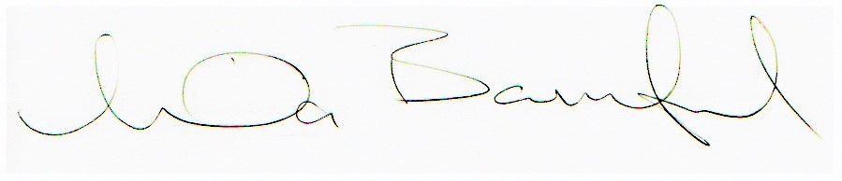
Linda Bamford, Convenor

