Copyright images © Photosymbols. Prepared by Disability Equality Scotland

Disability Equality Scotland
Meeting of the Board of Directors
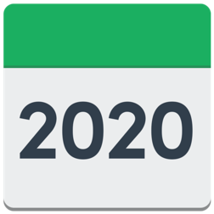  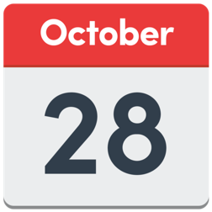 | Wednesday 28 October 2020 10am
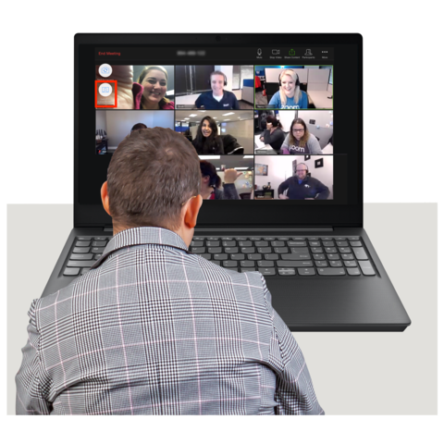 | Zoom Meeting using video conferencing.
Who was at the meeting?:
Linda Bamford – Convener

Scott Stewart – Director

Maureen Morrison – Director

Susan Fulton – Director

Janis MacDonald – Director

Carolyn Griffiths – Director

Kenny Milne – Director

Dorothy McKinney – Director

Colin Millar – Director

Lauren Asher – Young Director

Rhianne Forrest – Young Director

DES staff:

Morven Brooks – Chief Executive Officer

Emma Scott – Operations Manager

Ian Buchanan – Access, Training & Engagement Manager

Claire Jagger – Easy Read Worker

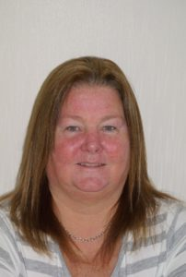 | Item 1 Welcome and Apologies  Linda welcomed everyone to the meeting and told everyone that it will be recorded. No one said they minded.
Linda welcomed our new Young Directors, Rhianne Forrest and Lauren Asher.

She thanked Dorothy, Scott and Morven for working hard to choose Young Directors.

Linda introduced everyone and said anyone could put their hand up to show they wanted to speak.

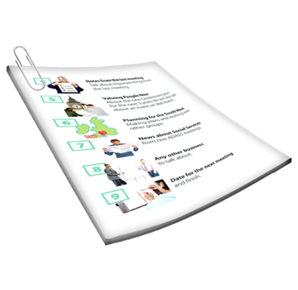 | Linda said there was 1 board briefing paper which would be looked at after this meeting. She explained the timings for this meeting.  Everyone said they got the papers in time and had enough information to make decisions.
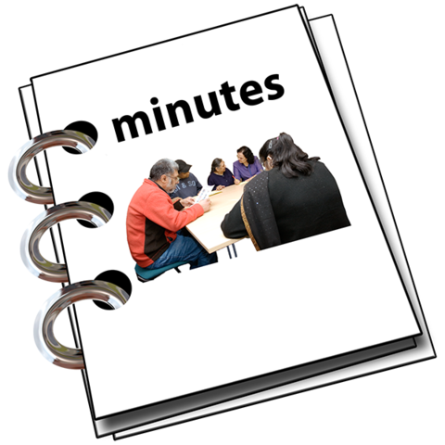 | Item 2 Agreement of Minutes from last meeting  The Board agreed the July 2020 minutes.
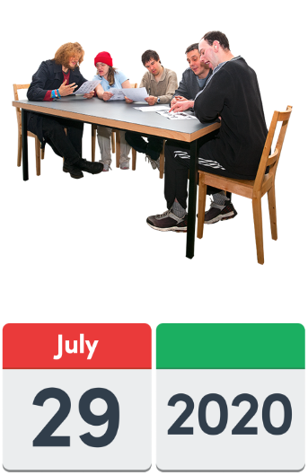 | Item 3 Outstanding actions from the Board Meeting on 29 July 2020  Actions 1 and 2  Morven explained these 2 action points and said that more action is needed on them.
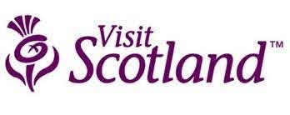 | Action 3: Ian to write a document for future work between Disability Equality Scotland and Visit Scotland.  Morven said that Ian is talking to the Access Panels about their experiences with Visit Scotland.  His document will be ready in January 2021. The board agreed.
Action 4
Linda asked to close this action. Emma will check on it. The board agreed.

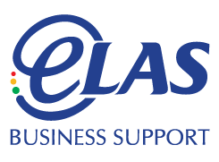 | Action 5: Morven to look at the ELAS contract in January 2021.  ELAS is our Human Resources provider.
Morven said that this point could be closed until January 2021. Dorothy asked if we could start looking at other providers before January. Morven agreed.
The board agreed to close this action point.

Item 4 Approval of New Members
Between July 2020 and September 2020 44 new members joined.
40 are individual members, 3 are corporate members and 1 is an Access Panel member.
Morven said that this big increase is because of our work on exemption cards.

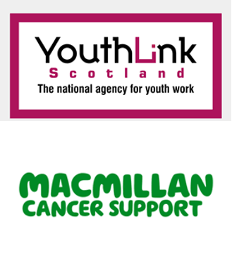 | She also said that YouthLink Scotland and Macmillan Cancer Support are now members.  All the new members were approved by the board.
Rhianne asked if the board has talked to Macmillan Glasgow Libraries about exemption cards for face coverings.
She said that they will print them out for anyone who can’t, for free.

Item 5 Chief Executive Officer’s Update from Morven
Morven said that we are running the Scottish Government face covering exemption card helpline.
We have a website www.exempt.scot and a new helpline administrator.
She thanked the team for their hard work.
Janis asked if we are asking the Scottish Government to make more people aware of exemptions.
Morven said that we were asking them. She had a few directorate meetings to take this forward.
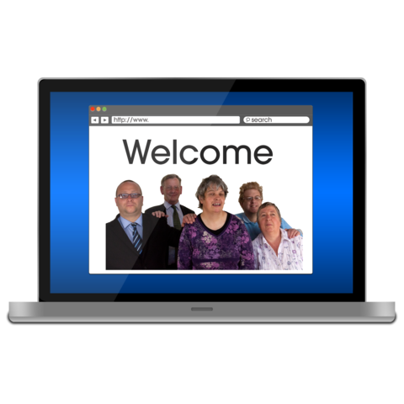 | Susan asked about our website and how accessible it is. She said that www.wave.webaim.org can check websites for things that are missing.  Morven agreed to ask James to check our website again.  Action 1: Morven and James will use this link to check our website.
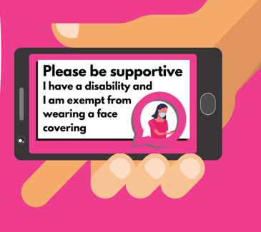 | Rhianne asked for more information about the exemption card. There was some talk about how it is just a tool for confidence.  Janis said people should not have to say what their disability is to get on a bus.
Morven said that we are trying to help organisations to know that they don’t have to ask people to prove their disability.
Janis said that she would not have voted to take the exemption card project on.
Morven thanked Janis and said that different opinions are healthy.

Rhianne talked about a girl who had shown an exemption card to the driver but had not been allowed on to the bus.

Action 2 – Rhianne will share her contact at Mitchell Library with Morven.
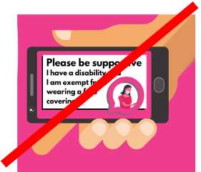 | There was lots of talk about shops and transport providers who might not accept exemption cards.  Emma said that this can be linked to the Hate Crime Charter work.
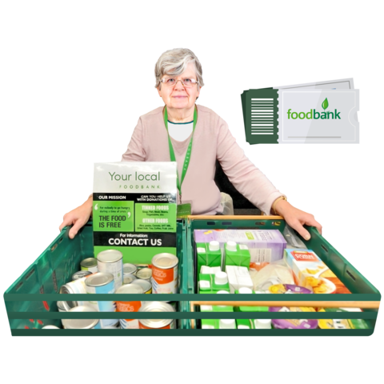 | Linda said that we could use our weekly polls to help the Social Renewal Advisory Board with food poverty feedback.
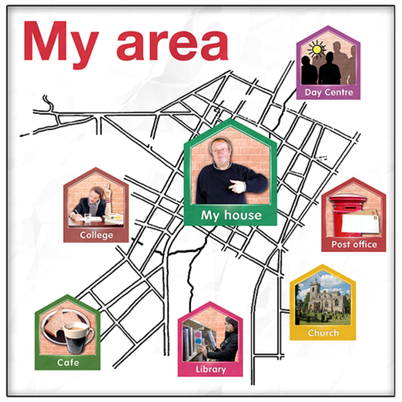 | Linda asked if we could invite anyone from the Age and Disability Circle Group meeting to join our webinar about 20-minute neighbourhoods.  Action Point 3 – Morven will invite people from this group.
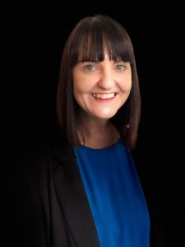 | Operation Manager’s Report by Emma Scott
Emma said that we have about 50 people signed up to our October webinar.
The webinar will be about using public transport again after lockdown.

 | The social media campaign about our Hate Crime Charter reached 15 thousand people.
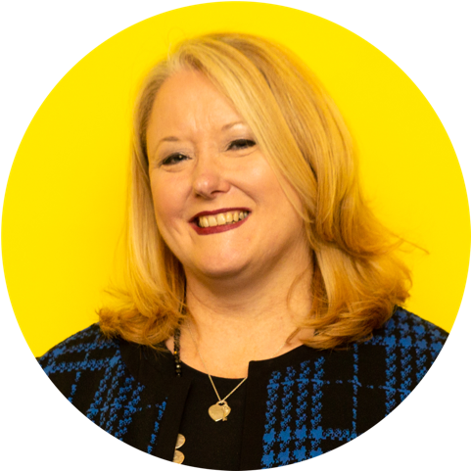 | Emma had a good meeting with Christina McKelvie MSP, who is the Minister for Older People and Equalities.  She has written a blog post about Hate Crime which will go into our Open Door magazine.
Janis asked if we could ask the Minister to put forward a parliamentary motion on hate crime.
Emma said that it wasn’t talked about.
Susan thanked Emma for her hard work.
Linda gave her congratulations to the team.
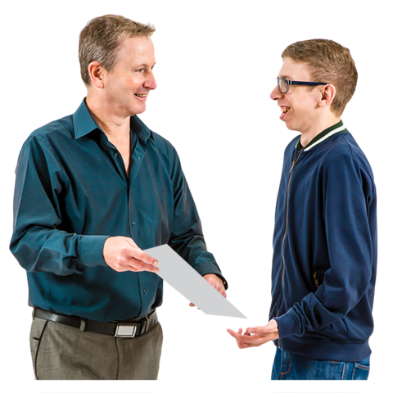 | Linda asked if a survey result could be shared.  Emma said that Fiach has some results from the CalMac Ferry project.  She said he is making good progress and may talk with NorthLink ferries soon.
 | Action Point 4 – Emma will share results from Ferries Accessibility Survey with Linda.
Access Training and Engagement Manager Report from Ian
Ian said he had worked hard on Statutory Consultee Status for the Access Panels.
This would mean that Access Panels must be asked about planning applications.

 | Ian said it was exciting to be writing to all MSPs to push this forward.
 | He said that a new Youth Access Panel will soon be trialled in the Highlands.
Ian said that there was sad news with the passing of the widow of the former Chair of Inverness Access Panel.
He also said that it would be good to make a new Accessibility Award in recognition of the former Chair of Ross-shire Access Panel.
The Board agreed.
 | Action Point 5: Ian will set up the new Accessibility Award.
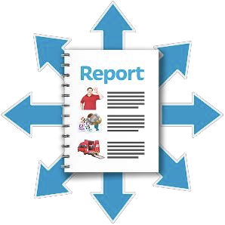 | Annual Calendar of Activities:  Morven said that performance reviews have been done for October 2020.  Policies are being updated when needed.
 | Linda said that she and Morven check the calendar and the finances.
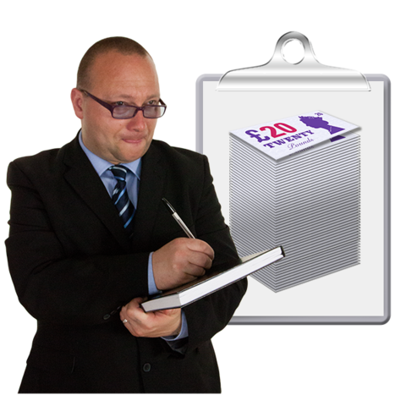 | Quarterly complaints  Disability Equality Scotland had 1 complaint this quarter.  The complaint was sorted out.
Reflective Learning Log
1 learning opportunity has been spotted this quarter.
This was to run webinars for longer to let communication support take place.
Webinars have changed from 45 minutes to 90 minutes.
Finance
Morven said that we are doing well with our budget at this tricky COVID time.
People
Morven said that it has been hard to keep up with staff meetings while we launch the exemption card campaign.
Easy Read worker Claire Jagger has more hours work now.
 | Rhianne said there was a scheme called Kickstart. This allowed someone who was unemployed to be chosen by Disability Equality Scotland to work for half a year, paid by funding.
 | Dorothy thanked the staff for all the work they have done.
 | Action Point 6 – Morven will look at Kickstart funding.
Risk Management
Morven said that she and Linda look at the Risk Management Log at every Chief Executive Officer review.
There are 8 risk areas at the moment:
Risk 05 Finance.
Not getting enough money.
We are getting funds and doing our work for our funders.
The likelihood stays at 2.
Risk 08 People
Not being able to train staff.
We have a new helpline administrator so likelihood stays at 2.

Risk 9 Communications
This stays at 1.
Risk 9b Communications to do with stakeholders
This stays at 1.
Risk 10 IC system
This moves from 1 to 2 because of the exemption card campaign website.
Risk 11 IC system
This moves from 1 to 3 because of the many phone calls we will take for exemption cards.
Risk 12 People
This has moved from 3 to 2 after a positive staff survey.
Risk 13 COVID 19
This has moved from 2 to 1.

7. Challenges for the next quarter
Morven talked about the different groups we meet with, including:
- Equality Unit
- DPO roundtable group
- Transport Scotland

 | Morven also said DES is keeping staff safe with only 3 people in the office. Most people are working from home.
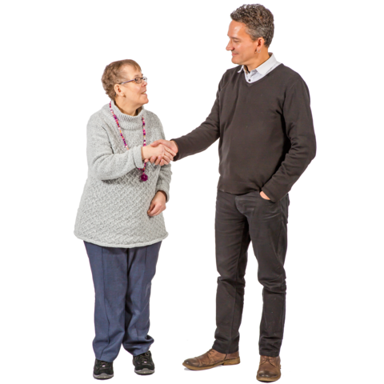 | 8. Priorities  Morven said that getting Easy Read work is important. We get about 4 and a half thousand pounds from Easy Read work every quarter.
 | Morven also said that she wants more sponsorship across other organisations.
 | Item 6 Today’s Actions
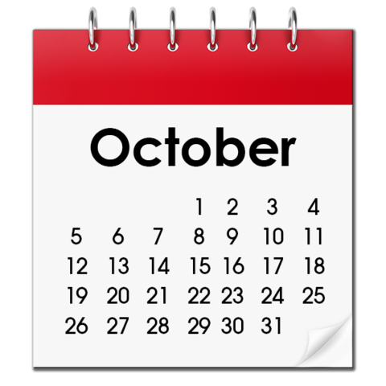 | Action Point 1  Morven and James will use this link to check our website.
Action Point 2
Rhianne will share her contact at Mitchell Library with Morven.
Action Point 3
Morven will invite people from the Age and Disability Circle group.
Action Point 4
Emma will share results from Ferries Accessibility Survey with Linda.
Action Point 5
Ian will set up the new Accessibility Award.
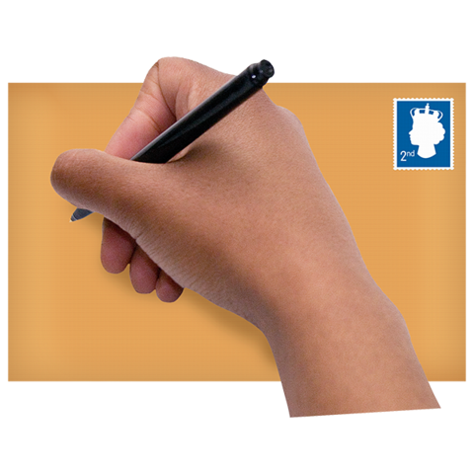 | Action Point 6  Morven will look at Kickstart funding.
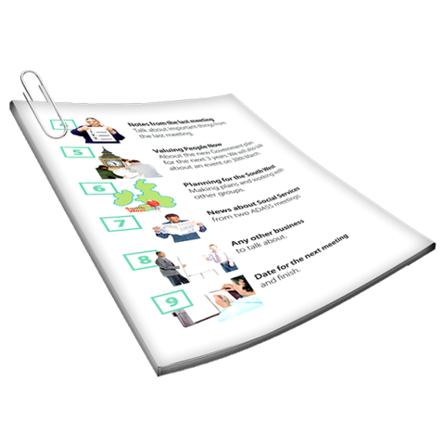
1
Item 7 Board Briefing Paper 1
Linda talked about the funding sources and team outcomes.

2

Item 9 Anything else?
No one had anything else to say.
 | The Meeting finished.

