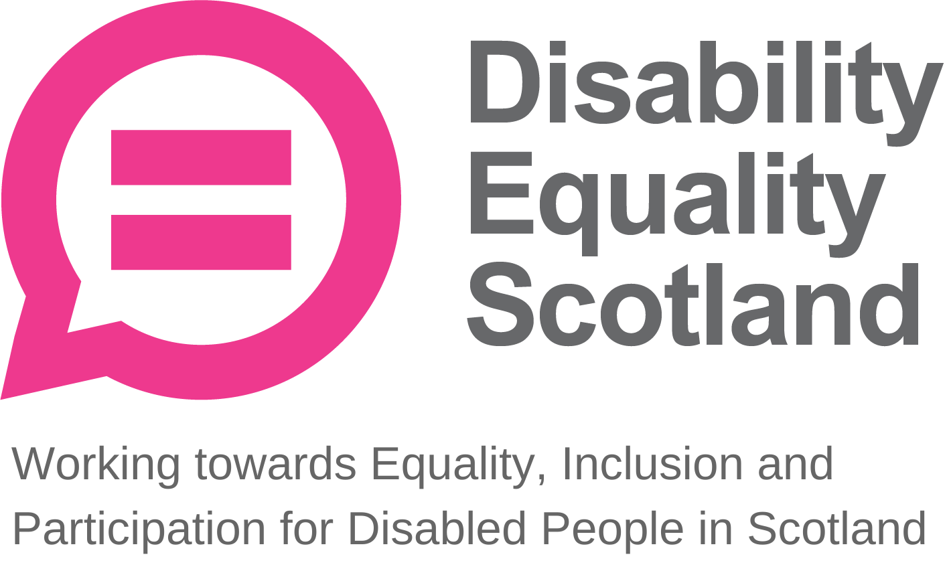
Disability Equality Scotland
Meeting of the Board of Directors
Wednesday 29 July 2020 10.00am
Zoom Virtual Meeting

In Attendance: Linda Bamford (LB) Convener
Scott Stewart (SS) Director
Susan Fulton (SF) Director
Janis MacDonald (JM) Director
Carolyn Griffiths (CG) Director
Kenny Milne (KM) Director
Dorothy McKinney (DMK) Director

Morven Brooks (MB) Chief Executive Officer
Emma Scott (ES) Operations Manager
Ian Buchanan (IB) Access, Training & Engagement Manager
James Davidson (JD) Communications and Research Co-Coordinator
Alistair Bruce (AB) Events, Training and Membership Administrator
Shona McEwan (SM) Easy Read Worker

Apologies: Colin Millar (CM) Director
Maureen Morrison (MM) Director (received after meeting)

Item 1 Welcome and Apologies

LB welcomed everyone to the meeting, Disability Equality Scotland’s second virtual board meeting. LB reminded everyone to please keep microphones on mute unless speaking, and that points should be stated through raising their hand, then LB will address everyone’s points in turn and at the end.

Apologies had been received from Colin Millar.

MB confirmed there was one board briefing paper for discussion at this meeting, but this is not a closed session. This paper concerns the appointment of Young Directors. LB confirmed there would be a comfort break at 11:00am and the meeting should be concluded by 12:00 noon. CG advised that she needed to leave the meeting at 11:00am.

LB stated that all papers had gone out three weeks in advance and asked those participating if they had any questions regarding these papers and if they felt they had enough information to make the decisions that would be required by the Board.

The Board agreed that they had adequate information within the papers and the Young Directors Briefing Paper. The board had no other questions and all Directors confirmed they had received the papers in good time.

Item 2 Agreement of Minutes from last meeting

LB asked for agreement of the minute of the previous meeting in terms of accuracy and content.

The Board approved the content and accuracy of the April 2020 minutes without any changes. The Board agreed to move onto outstanding actions.

Proposer of minutes SS

Seconder of minutes KM

Item 3 Outstanding actions 29 April 2020 Board Meeting

Action 1 The Board agreed that Action 1 is now closed. MB has drafted a briefing paper on board performance appraisals with JM and this will be submitted to the Board for discussion at the October 2020 Board meeting for the closed session.

Action 2 The Board agreed that Action 2 is now closed. Following discussion around Clackmannanshire Third Sector Interface (CTSI) governance training in April Board meeting, MB discussed this with MM. MB made numerous attempts to get in touch with CTSI but received no response. MB will pursue Glasgow’s TSI to see if we can get the same service, though previous concerns of cost persist.

Action 3 The Board agreed that Action 3 is now closed. The Board agreed to discuss the recruitment plan for Young Directors after the comfort break of this meeting.

Action 4 It was agreed that this action was closed and complete.

Action 5 It was agreed that this action was closed and complete.

Action 6 MB updated the Board on the progress of Action 6, which concerned governance issues at an Access Panel. MB stated there has been positive progress since last Board meeting, and we are now content that the Access Panel have started a dialogue with NHS Highland and the MSPs involved. MB no longer feels it is necessary for us to be involved in resolving the issues.

Action 7 It was agreed that this action was closed and complete.

Item 4 Approval of New Members
MB stated that since Board papers were distributed three weeks ago, over 30 new members joined us following our campaign on face covering exemptions. MB had updated this list and asked the Board if there were any conflicts of interest in this new list. LB asked the board to inspect list as some of the names were new since the papers were circulated. The full list of new members was shown as a screen share and LB asked if everybody was happy to approve the 42 new members.

During the period 1 April 2020 to 28 July2020 there were 42 new members join (39 Individual, 2 Corporate, 1 Access Panel) and1 individual member requested to be removed.

Total Membership: 838 (686 Individual, 114 Corporate, 38 Access Panels).

All applications for membership were approved by the Board.

Item 5 CEO’s Update

- Operational Activities

MB stated the Strategic plan has been launched, and we received support from deafscotland to have an accompanying BSL video. This is now live on our website. DES also worked with the ALLIANCE recording a podcast, following our physical distancing weekly poll.

MB stated that the Annual Report for 2019-2020 had been circulated separately to the board papers for comment; MB also in the process of finalising the accounts with the company’s accountants. MB will then share final report with the Board.

Action Point 1: MB to share final Annual Report for 2019-2020, including final financial accounts, with the Board.

2nd AGM notification now gone out, 44 now registered.

MB stated following the success of the face covering campaign, any weekly polls going forward with any similar response rate will be taken forward in a similar campaign approach.
MB stated that she recently met with the Public Health Directorate, who are working on face coverings communications at Scottish Government. As a result of this meeting DES are now able to feed in key messages from our members and are now seen as part of an expert reference group from which the Directorate will draw information from.

MB stressed how important the weekly polls have been, and how the views of our members have been invaluable in this process. MB also discussed her recent opportunity to go onto “The Nine” on the BBC to discuss our face covering exemptions campaign, with the hope of influencing attitudes and behaviours. MB also had the opportunity to do a radio show on Orkney radio on the same topic.

MB then raised the point that our social media campaign on face covering exemptions has been our most high-profile work in a long time and has shown what we can do when taking forward our members’ views. MB stated that we have a good understanding of people’s experiences of exemptions through our call log, which is showing that the issue is not settled, and people are still being challenged and refused entry in public spaces. MB stated that this is an ideal opportunity for DES to adapt the Hate Crime Charter with these messages in order to improve public awareness on the issue, preventing harm to disabled people.

DMK praised MB on her TV and podcast appearances, stating that MB did fantastically well. LB seconded DMK’s compliments, stating that MB had good technique to stick to the key messages throughout the appearance.

LB asked for more detail on MB’s meeting with Monica Lennon MSP. MB stated this meeting followed a prior meeting on DES’s physical distancing briefing paper, which linked back to how disabled people are being treated at this time. Monica Lennon MSP expressed support in the work we are doing, and it was agreed to keep her updated with any progress we are making.
LB asked if anything productive had emerged from the last weekly poll on reasonable adjustments. MB stated that there are good points coming out of this report, for example that 99% of respondents said that retailers are not meeting obligations on reasonable adjustments during COVID-19. MB provided the example that some people are being made to wait outside shops in the queue without support (including seating areas), causing a lot of pain and distress. Shop design layout was also raised as an issue by poll respondents. MB stated that she is keen to find out how changes to one-way systems are an issue for people with mobility issues. Access to toilets are also an issue; some supermarkets are keeping them open, but some are not, including accessible toilets.

We are receiving some good stories about getting support from staff in shops, however overwhelmingly so we are hearing negative stories from members. Especially for those hard of hearing, the shopping experience is very difficult. Carers are also being challenged entry with those they care for. Disabled people are continuing to be asked “why are you out”.

The cost of clear face coverings is also being raised as an issue. Transport and infrastructure also came through, where availability and space are an issue. MB stated that the poll is a great channel to collate and push all of these concerns to decision-makers.

LB noted that we are consistently hitting high numbers on our consultations and praised the team for their work on this.

LB asked the Board if they had any additional questions on MB’s update.

KM stated that he was recently sent a briefing paper by Police Scotland on physical distancing, face masks and unfair challenges against disabled people. Within the paper, Police Scotland are advising strongly to report every incident. MB confirmed that DES had received the same letter and are in the process of converting that to easy read.

JM stated that deafscotland are regularly providing advice to retailers on how to help disabled people. JM was not sure that Scottish Government have done anything to highlight the numbers that are exempt from wearing a face covering, which could be up to 2 million.

MB stated that the Public Health Directorate could be looking at a branded exemption card from Scottish Government. MB explained to the Directorate that this campaign is not just about giving someone a card, but also an opportunity to change attitudes and behaviours at this time. MB stated that DES were also receiving requests for cards from individuals in England and have been in touch with Disability Rights UK about this.

JM expressed dissatisfaction with the exemption card model as it required people to declare that they had a disability when they should not have to. MB agreed with this point however added that the card was available for those who felt that it provided them with a tool to navigate public spaces confidently, and that we are simultaneously working with Scottish Government to change attitudes and behaviours.

MB stated that all staff are explaining to callers enquiring about exemption cards that presenting a card is not a legal requirement, and only for their own confidence. This message is also being reiterated through DES public communications.

KM stated that the cards were helpful for people in the current circumstances but that there needed to be a complete culture change and public education on this to prevent the need for disabled people to carry cards.

IB expressed concern that if there is any government-sanctioned card they could stay in public use to disabled people’s detriment.

MB stated that they have been communicating what the reasonable adjustments are. If someone is unable to wear a face covering, this needs to be understood however there was confusion around at the moment.

Operations Manager Report

LB asked the Board if there were any questions on ES’s update. The Board had no questions. LB noticed the clear increase in responses to the polls and was also pleased with continued staff team events whilst working from home.

DMK passed on her compliments again for all staff team and their work.

Access Training and Engagement Manager Report

LB asked the Board if there were any questions on IB’s update.

DMK stated that although mediation between Access Panel and NHS Highland/MSPs is no longer necessary, she is happy to share her document on facilitating sessions.

Action Point 2: DMK to share facilitation guidance document with team.

LB asked IB for an update on Harris Access Panel, specifically if we had made any progress with Access Panel Grant application for funding wheelchair-friendly beach chairs and mats. IB explained that the Panel are planning for tourist season next year to have everything in place, making beaches on Harris accessible to everybody. LB stated that this is a great idea to help people experience the beaches again. LB also requested an update on Caithness Access Panel and how they have managed to adapt during lockdown, asking whether this is something we should be flagging as a good news story. IB stated that he had spoken to the Panel Chair who was writing up a case study on this and said that he would contact her in relation to this.

LB asked whether the good example of beach buggies with Harris Access Panel is something that could be shared with Visit Scotland.
CG stated that she had a good relationship with Visit Scotland, and this was definitely something that some people were interested in.

LB asked for any additional comments on IB’s update. No comments from the Board.

Action Point 3: IB to prepare briefing paper to outline potential partnership working with Visit Scotland

- Annual Calendar of Activities

MB stated that all tasks within the Annual Calendar of Activities (the organisation’s governance checks and balances) that required completion had been completed, as of the 8 July, other than getting the final accounts for the Annual Report. MB stated that herself and LB have reviewed the activities, risk log and are keeping an eye on the finances with CM (Treasurer).

MB stated that some of the policies and practices were due a review, however this would be a light touch review, and only if there are changes in those areas. MB and ES had agreed to look through this, and if guidance needed, would get in touch with DMK.

Action Point 4: MB and ES to review policies and practices, contacting DMK for support if necessary.

JM stated that GCVS in Glasgow have a good HR support arm; there are minor costs for reviewing HR services but suggests this might be worth exploring.

MB stated that DES were currently contracted with ELAS for this service, however this will be under review in January 2021. MB advised that prior to the renewal date she would look at alternatives to ensure that the service we are getting is cost effective and addresses our needs.

Action Point 5: MB to review ELAS contract in January.

- Reflective Learning Log

LB asked MB to provide a quick update on the reflective learning log.

MB stated that from the reflective learning log there was one point from Strategic Plan to address. When developing the Strategic Plan for 2020-2023, we had not communicated sufficiently with Access Panels. With timings and difficulties around COVID-19, that process had been missed, however we will ensure that we address this in the future.

- Finance

MB stated that finances are looking well, and we managed to successfully support Access Panels to use the Access Panel Grant fund. MB stated that a lot of this was down to the digital participation survey they had been sharing with Panels, flagging the need for IT equipment specifically, whereby a few Access Panels have purchased IT equipment through the APG.

MB stated that easy read work was steadily coming through, providing consistent funding. There was a slight underspend on the Ferries Accessibility Fund final report, however they are happy to roll that through to the next quarter, and CalMac are now having more meetings with Fiach to get things moving on this project. MB said that the team were continuing to work on retaining current and accessing new sponsors MB stated that our relationship with funders continues to be strong, and that all funding grants have been received for the next quarter.

- People

MB stated that quarterly reviews were underway with no significant issues raised and that regular team meetings were being held. MB advised that everyone was working really well and that they were all looking after each other and taking opportunities to engage together as a team given that all were working from home. MB stated that welcoming new members to the team was going well.

- Risk Management

LB touched briefly on risk management and gave an overview of the risks that had moved. For clarity she confirmed that for DES05 the likelihood had reduced from 2 -– 1. She explained that overall, the organisational risk score was the lowest it had been since December 2017, when the Board reformed, and she thanked everyone for their hard work and commitment to building resilience and taking the organisation forward.

LB asked the Board for any other comments.

CG stated that she will leave the meeting during comfort break to attend another commitment.

MB asked for questions for either CEO, Operations Manager or Access, Training and Engagement Manager reports.

The board had no further questions.

Item 6 Confirmation of Today’s Actions including owners and timeframes

Action Point 1: MB to share final Annual Report for 2019-2020, including final financial accounts, with the Board.
Action Point 2: DMK to share facilitation guidance document with team.
Action Point 3: IB to prepare briefing paper to outline potential partnership working with Visit Scotland
Action Point 4: MB and ES to review policies and practices, contacting DMK for support, as necessary.
Action Point 5: MB to review ELAS contract in January.

Item 7 Board Briefing Paper 1: Nominations and Young Trustees Recruitment Plan

Directors are asked to approve:
- Approve nomination wording / criteria laid out
- Agree timescales as set out in our Articles
LB provided context that in January 2020, the Board agreed to take forward recruitment for Young Directors. LB asked MB to open discussion on this.

MB referred to the articles in relation to the appointment of Directors.
MB advised that Youth Link Scotland had expressed interest in supporting our recruitment of both young members and young trustees.

LB stated that there were two separate points: Reappointment of Directors at the AGM and the recruitment process for Young Directors.

Under article 31, when seeking re-election, Directors shall not require to be expressly nominated for re-election. The subclause states that the nomination process will be determined by the Directors.

There was discussion about how the two Directors who were up for re-election ( Linda Bamford and Dorothy McKinney) for a second terms should be appointed and it was agreed that as has been the practice in the past that election would be sought by members at the AGM. It was agreed that this approach complied with the articles, the boards wishes and was transparent.

There was a discussion about the use of Standing Orders to support the Articles and the importance of Articles being clear and understandable

It was agreed to look at this prior to the 2021 AGM

Action Point: MB and Board to review articles for next year, process will begin January 2021

LB moved discussion back to issue of Young Directors.

There was discussion about how the potential young Directors would be identified and the timing given that the AGM was on 25 August 2020.

It was agreed that we would recruit young Directors in the same way as we would any other Director given that they would have the same rights and responsibilities as the rest of the Directors and will be expected to contribute in the same way.

It was also agreed that we notify the AGM of the plan to recruit young Directors and that as per our practice applications will be sought.

MB confirmed this approach, suggesting that we also reach out to Young Scot and other similar organisations

Action Point: MB will work with team to develop recruitment advert and reach out to Young Scot / Youth Link for assistance regarding language in advert.

There was discussion in relation to the age limits being proposed and whether there was a risk of discrimination.

It was agreed that MB undertake an Equality Impact Assessment (EqIA) and ensure that if we are putting an age range on the advert that we are not breaching the Equality Act 2010.

There was also a discussion about whether we should be looking at young people, disabled young people and young people who are carers.

It was agreed that there was a need to ensure that our 50% disabled composition on the board was complied with and that the advert for the role reflected what the Board needed.

The value of being a Director to a young person with lived experience was discussed including how this could prepare them for future roles including public appointments and add to their CV.

MB stated that as long as it is agreed across the Board, and that the EqIA has been carried out (at least partly carried out through the skills audit) and confirmation that we were not discriminating that we should be looking at young disabled people or carers.

It was also agreed that MB would contact other organisations that recruit specifically for young Directors and see what we can learn from them.

It was agreed that MB prepare an EqIA and ensure that we are not discriminating and that this should be reviewed by the Board once it is drafted.

It was agreed that MB prepare the draft by 11/12 August and importantly before the AGM on 25 August so that we can effectively share our intention to recruit young Directors with them.

Action Point: MB to present draft EqIA (on advertising for young disabled candidates for Young Director role) to the Board to allow comment and finalising prior to the AGM on 25 August.

It was therefore agreed that we should launch the advert at the AGM and look to set deadline for submissions for the end of October. LB asked if MB, DMK and SS are happy to be on the panel.

The Board confirmed.

Action Point: MB to seek advice from EHRC on whether advertising for young disabled people is discriminatory. Provide EqIA and feedback from EHRC along with draft advert to board by 12 August 2020

Item 8 AOB

LB asked if there is AOB

LB confirmed that Directors are looking to have a closed session after October board meeting to look at subcommittee structure. JM stated that we should also be discussing organisational performance as well as performance appraisal.

LB suggested splitting the October Board session in the afternoon, with open session from 10am-12pm, comfort break for 30 minutes, then closed session from 12:30pm-1.30pm.

The closed session would be split 50/50 to cover:

- A discussion on the subcommittee structure, led by subcommittee chairs, and
- Board performance appraisals and organisational performance, led by JM.

The Board agreed with this plan.

Item 9 Close

Minutes reviewed and agreed: 28 October 2020

Proposed: Dorothy McKinney
Seconded: Kenny Milne

Signed:

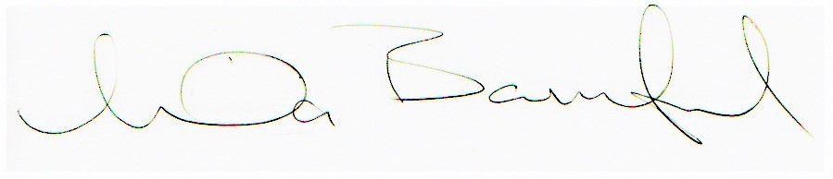

Linda Bamford, Convenor

