Young Membership
Application Form

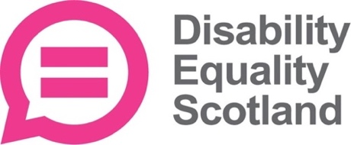

Join us
Disability Equality Scotland is an organisation led by its members, working to make life in Scotland more accessible to disabled people.
We want disabled people to enjoy the same opportunities that are enjoyed by others in our communities, promoting a life of dignity, respect and independence.

Discuss issues that matter to you
This community is a space for you to share and discuss issues that matter to you.
Through starting discussions relating to the experiences of young disabled people in Scotland, we hope to provide a space for you to learn about the positive change that we're working towards.

What difference can you make?
Disability Equality Scotland is constantly listening to the views and experiences of disabled people to improve the way we do things.
We need your voice as a young person to help us do that, so please join our young membership!
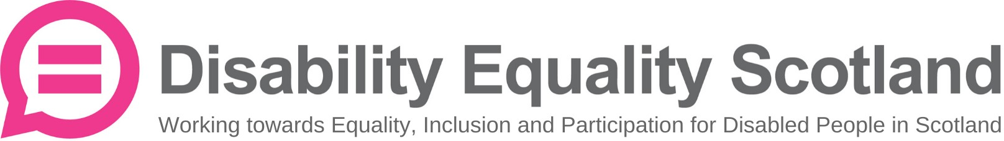

Young Membership/ Join Us!

Applicant Information

First name: | Surname:
Full address (including postcode): | Date of Birth:
 | Email address:
 | Do you need any information in alternative formats, e.g. easy read or plain text?

Parent/Guardian Information
(Under 16s only)
Parent/guardian permission is required for membership applicants under the age of 16. Please include contact details below, and we will be in touch to confirm.
Relationship to Applicant:
First name: | Surname:
Email address: | Phone Number:

Disability Equality Scotland takes data protection and privacy seriously. We will never share data with third parties. Please see our Privacy Policy on our website below:
www.disabilityequality.scot/data-privacy-policy/

