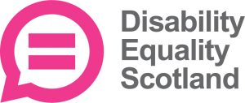
Disability Equality Scotland
Become our Director
Young Director Role Description

 | What is a Director?
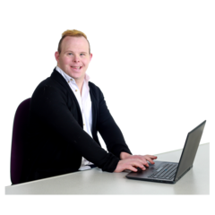 | A Director works with other Directors on the board.  They make sure that the charity is working well.
 | About Disability Equality Scotland
Disability Equality Scotland is a charity.
A charity is an organisation which works to make lives better, without making a profit'.
It works to make life more accessible for disabled people.
 | Disabled people can become members with us.

 | Young Directors
Not many charities have young people on their Board.
We want our Board to have people of all different ages who have a range of knowledge and skills.
We want to have young people on our Board.
This will help us link with other young people and get their views.

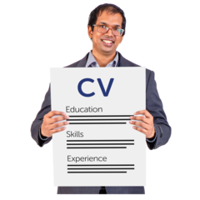 | As a Young Director, you will:  - Make a difference to disabled people’s lives  - Get more confident  - Meet new people  - Learn new skills  - Help Disability Equality Scotland do its work

 | What you will have to do
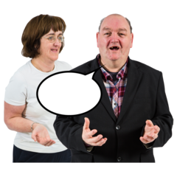 | As a Young Director you will work with our other Directors.  Your job will be to help Disability Equality Scotland do the work it needs to do.  We also want you to tell people about the good work we do.
How we will help you
We will give you training to help you in this role.
You will have someone from our Board to give you help and advice.
We will give you information which tells you what to expect
We will send you board papers 2 weeks before a board meeting

 | Are you interested?
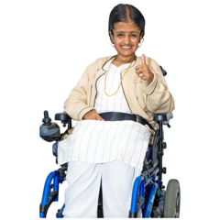 | We want to hear from you if you are:  - Aged between 16 to 24  - Disabled, or understand disability, maybe as a carer  - Enthusiastic and excited to work with us
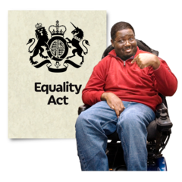 | It would also be good if you know about  - Disability organisations  - The Law  - Equality  - Access to places  - Managing money  - Treating others equally  - Raising money for a charity  - Promoting and selling  - Media  - Policy  - Politics  - Housing

 | How much time will it take?
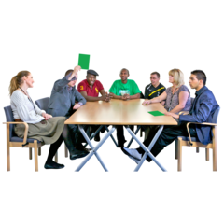 | You will have to come to our Board meetings.  They happen every 3 months  You will need to come to our Annual General meeting once a year.  You will need to come to our Access Panel Conference. This happens once a year.  In total, you will need to work for us 8 days a year.
Sometimes we will need to get hold of you between meetings.
You will need to be able to answer our telephone calls and our emails.
We will do this by phoning or emailing you.

 | If you have to spend any money coming to our meetings, we can give you this money back.
 | How to apply
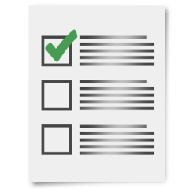 | We have an application form for you to complete.  If you want to apply to be a Young Director, you can contact our office.
The telephone number is
0141 370 0968
Or you can email
admin@disabilityequality.scot

