Dear Applicant

Board of Director Appointment
Voluntary Position

Thank you for your interest in the post of Voluntary Board member with Disability Equality Scotland. Please find enclosed the following documents:

- Role Description
- Application Form
- Disclosure Form
- Equal Opportunities Monitoring Form

Please complete the Application Form, Equal Opportunities Monitoring Form and Disclosure Form and return them along with a copy of your latest CV to:

Morven Brooks, Chief Executive Officer
Disability Equality Scotland
Suite 204B, The Pentagon Centre, 36 Washington Street, Glasgow, G3 8AZ

You may also return them by email to admin@disabilityequality.scot
The closing date for receipt of applications is Friday 25 September 2020. (Please note: applications received after this deadline will not be considered).

Should you require this application pack in a different format please do not hesitate to contact the office.

Yours faithfully
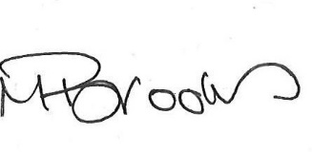

Morven Brooks
Chief Executive Officer
Disability Equality Scotland
Enc.

