Retirement and Re-election of directors

The Company's Articles of Association (Article 31b) contain detailed rules for the appointment and retirement of directors. There is a formal procedure in place to select and appoint new directors to the Board. These directors are required to retire at this Annual General Meeting dated 25 August 2020. They can offer themselves for re-election by members. Under the Articles, all directors are required to submit themselves for re-election at intervals not exceeding three years.

Linda Bamford
Co-opted: 14 November 2016; Ratified at AGM: 12 September 2017

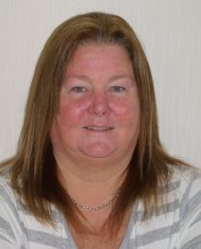
Linda’s career background is mainly in NHS Scotland, initially as a psychiatric and general nurse before moving into Paramedicine with the Scottish Ambulance Service. After 13 years as a frontline paramedic in Glasgow, Linda moved into management, holding various senior management positions within the ambulance service for a further 15 years. She was heavily involved in Accident and Emergency ambulance service provision in various areas in Scotland and led on the previous Patient Transport Service Redesign Strategy. Linda is the recipient of two queen’s medals. One for “Long Service and Good Conduct – Emergency Duties” and the second for “Dedication to the NHS”.
Linda took early medical retirement after several surgeries for a spinal cord injury at L3/4/5 and S1. During her rehabilitation Linda received support from Spinal Injuries Scotland and got involved to help others living with a spinal cord injury. She was previously the Chair of Spinal Injuries Scotland and continues to be an ambassador for the organisation.
Linda is involved in Children’s’ Hearings Scotland and is also a qualified counsellor.
Linda holds two public appointments. She is the National Convener for Mobility and Access Committee for Scotland and Commissioner for the Poverty and Inequality Commission. Both these appointments were made by Scottish Ministers.
Linda has a passion for equality and doing the right thing and strives through her work and volunteering to bring about transformational changes that will assist everyone to lead their lives as they chose.
Linda has a Master’s in Business Administration and brings to the role experience and qualifications in Business and Operational Management, Service Delivery, Corporate Governance, Strategy Planning and Development, Risk Management, Change Management, Team Building and Leadership and Organisational Planning utilising project methodologies.

Dorothy McKinney
Co-opted: 31 March 2017; Ratified at AGM: 12 September 2017

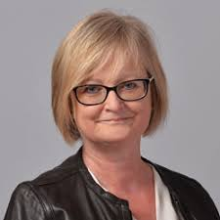
Dorothy grew up in Northern Ireland during the years described as the ‘Troubles’ and believes her intense commitment and passion for equity and fairness grew from these experiences.

Dorothy has over 35 years’ experience in Human Resources, is a trained and experienced Mediator, she has Fellowship of the CIPD and a passion for ‘Doing the Right Thing’. Dorothy is an Associate of a number of companies throughout the UK and is the Board Chair and Director of Edinburgh Gang Show Productions Ltd.

Dorothy’s experience stretches across public, private and third sectors and she now runs her own business focusing on supporting Boards and staff groups to build good relationships, reduce and resolve conflict and have a strong business focus. Dorothy also has a strong commitment to volunteering with young people over many years and this plays an important part in her life.

Dorothy is also a Registered Mediator with the Scottish Mediation Network and undertakes pro bono support for Peer Mediators in local schools.

Dorothy has a strong focus on supporting everyone to live the life they wish to live and not the one other people, systems or processes believe they should.

Back to top

