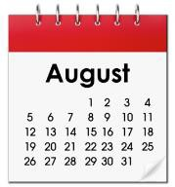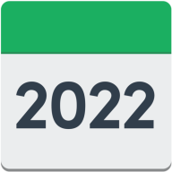 | Date  Wednesday 31 August 2022
to  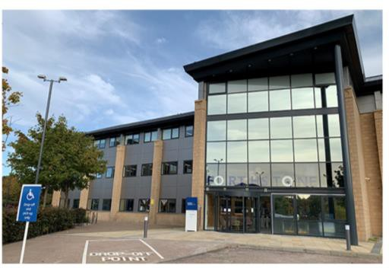 | Time  1:00pm until 3:00pm  Location  Motability Operations Ltd, Forthstone, The Stones, 56 South Gyle Crescent, Edinburgh, EH12 9EB
Video Conference

Click on this link to register (open in new tab)

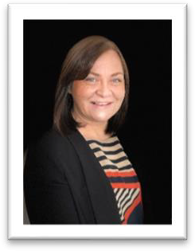 | Webinar Housekeeping  1:00pm – 1:05pm  Morven Brooks, Chief Executive Officer
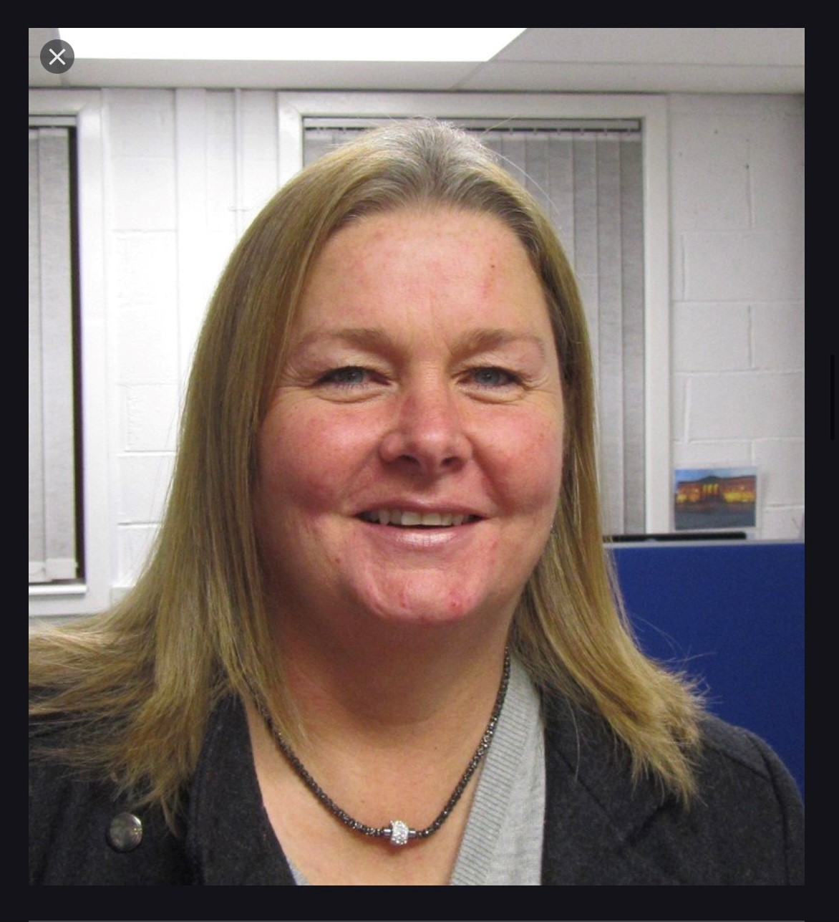  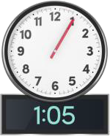 | Welcome  1:05pm – 1:10pm  Kayla-Megan Burns, Convenor  Linda Bamford, Director
Approval of AGM Minutes: 25 August 2021

1:10pm – 1:15pm
Morven Brooks, Chief Executive Officer

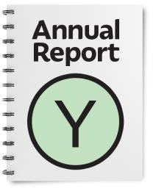 | Presentation of the Annual  Report 2020-2021  1:15pm – 1:35pm  Morven Brooks, Chief Executive Officer
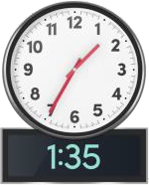  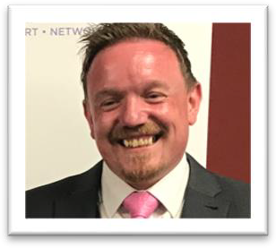 | Presentation of Accounts 2020- 2021  1:35pm – 1:45pm Colin Millar, Treasurer
Review of Fees and Subscriptions payable by Members

1:45pm – 1:55pm Colin Millar, Treasurer

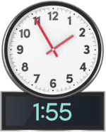 | Delegation to the Board the  reappointment of Independent Examiners  1:55pm – 2:00pm Colin Millar, Treasurer
Election of Board Directors

2:00pm – 2:20pm
Morven Brooks, Chief Executive Officer
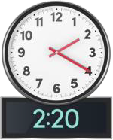 | Comfort Break  2:20pm – 2:25pm

Members Questions

2:25pm – 3:00pm
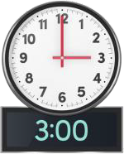 | Close 3:00pm Thank you

