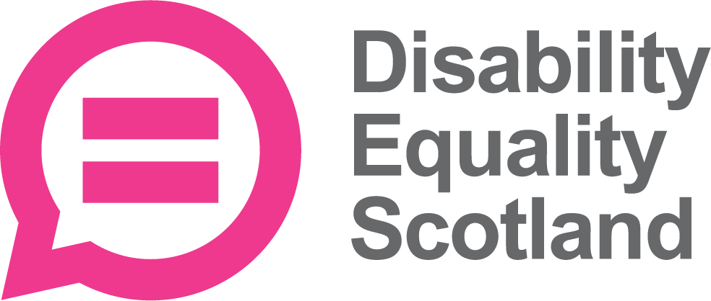

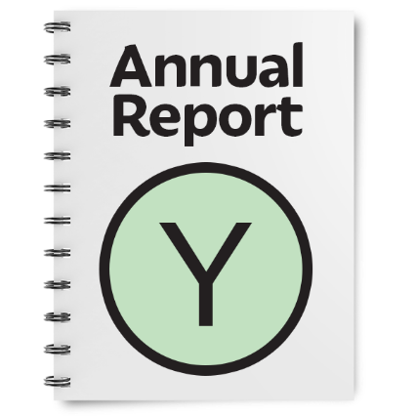
Our work from 1 April 2021 to 31 March 2022

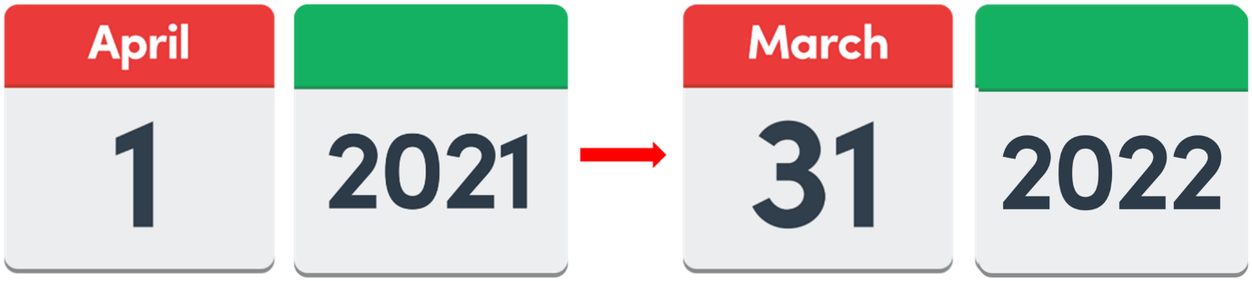

Copyright images © Photosymbols. Prepared by Disability Equality Scotland
Introduction from Morven Brooks and Linda Bamford

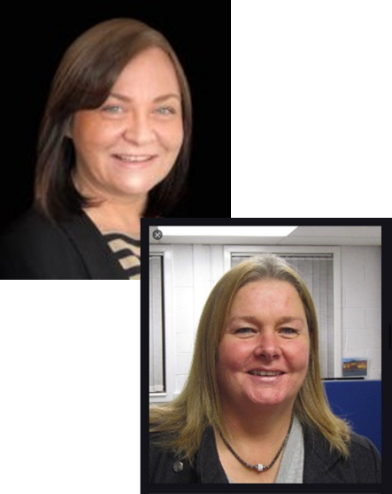 | Morven is our Chief Executive Officer and is the main manager of Disability Equality Scotland.  Linda is the Convenor of the Board of Directors.  Board members are people who look at the work an organisation is doing and check it is working well.
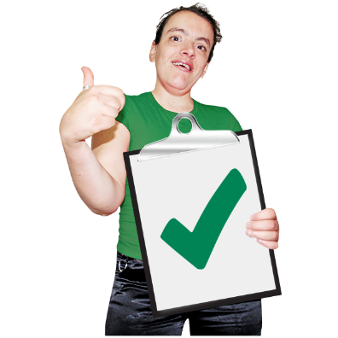 | Disability Equality Scotland wants to make sure all disabled people are listened to.  We will keep using what we hear to make change happen and make people’s lives better.
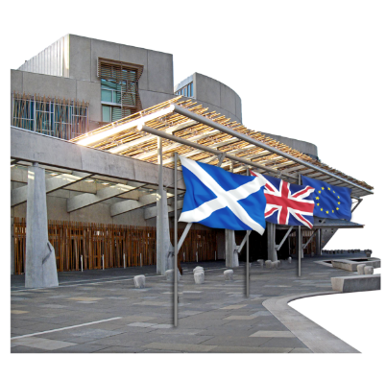  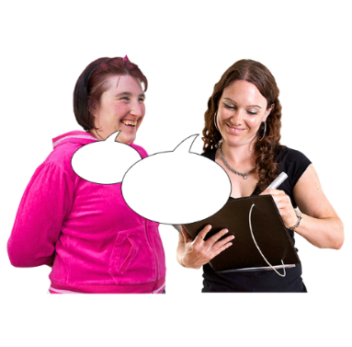 | This year we made sure that the biggest findings from our weekly polls were shared with the Scottish Parliament.
 | We started having our events online so that everyone could join in during the COVID-19 pandemic.
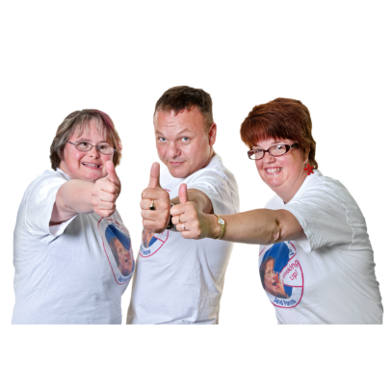 | In May 2021 we asked our members if they had found it easier to join our events online instead of face-to-face.  9 out of every 10 people who replied said yes.
This year 6 out of every 10 members said they would like events that could be joined online and face-to-face.
We will work on doing this.

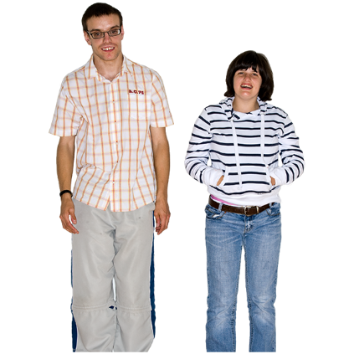 | We are very happy to have 2 new young Directors now.  We thank all our Directors for all their skills and energy.
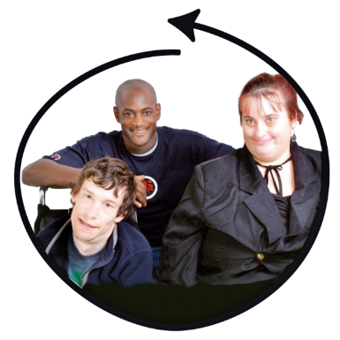 | What does Disability Equality Scotland do?  - We want to make sure disabled people in Scotland are included, treated equally and can access the things they want and need to live a full life
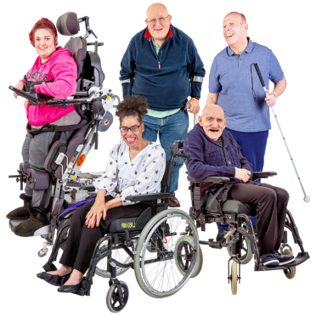 | - We work to make sure all disabled people in Scotland are listened to
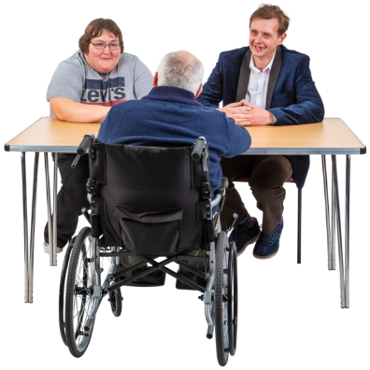 | - We work to be an organisation that disabled people can trust and know that we are honest  - We treat people with care and understand their feelings  - We encourage communication between disabled people and national and local organisations
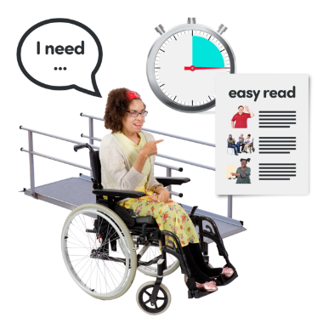 | - We tell more people about disability equality and accessibility  - We work to make sure people think about disability in a positive way
Our objectives – what we want to happen:

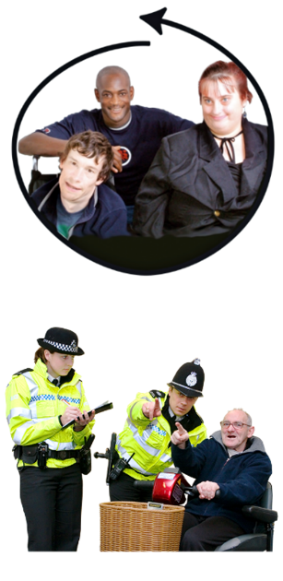 | - Disabled people are included and treated equally because there is good support and services and more people know about disability equality.  2. More people know what disability hate crime is and how to report it.
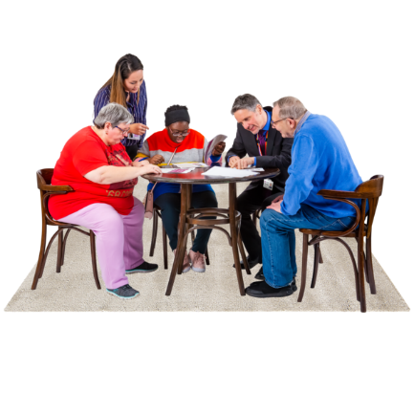 | - Access Panels will link up and support members in their work on equality and inclusion.  - Access Panels will know more about access, inclusion and equality.
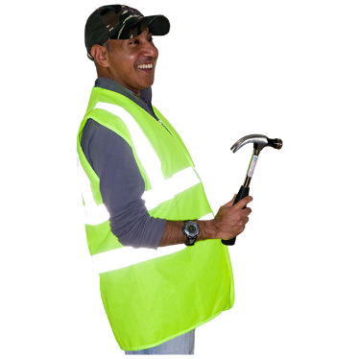 | 5. People who work in the planning and design of buildings and spaces can use our information and advice to support accessibility and inclusive design.
 | 6. Disabled people will give their views about accessible transport and give information to the Accessible Travel Framework plan and how the work will be done.
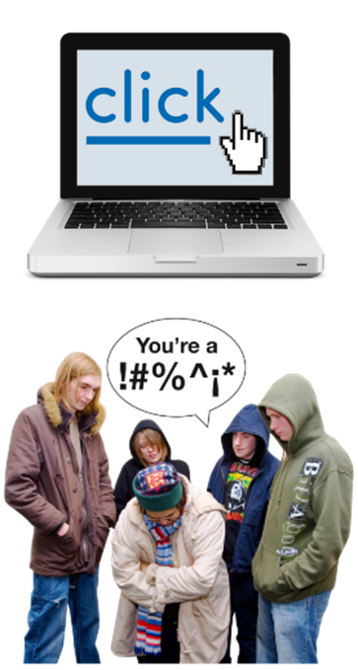 | 7. People will find information and guidance on the Accessible Travel Hub.  8. Organisations will work together to stop disability hate crime and disabled people being abused on public transport across Scotland.
Membership

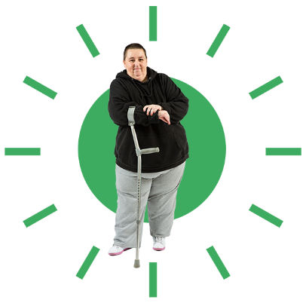 | We ask members what they think.  Members are at the centre of all our work and projects.  Their experiences tell us what changes are needed to make sure disabled people are included and treated equally.
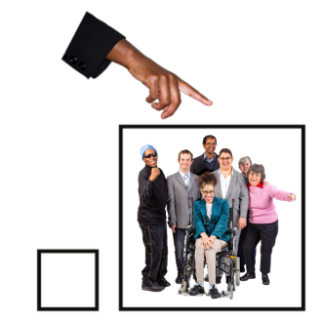 | More members have joined DES in the last year.  We now have nearly 1 thousand 5 hundred members and 38 Access Panels.
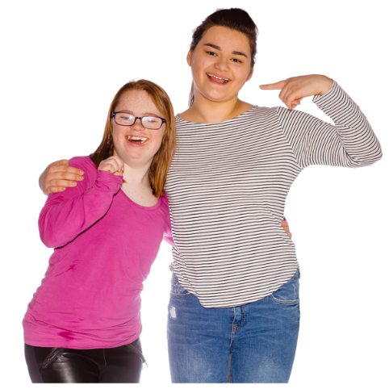 | We have 14 Young Members.
Why our Members are important
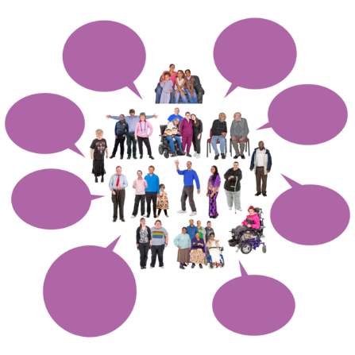 | We did a members survey in August 2021.  1 hundred members filled it in.
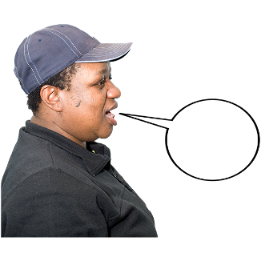 | 77 members felt that they could tell us what they thought.
 | 61 members felt that they could take part in chats and meetings
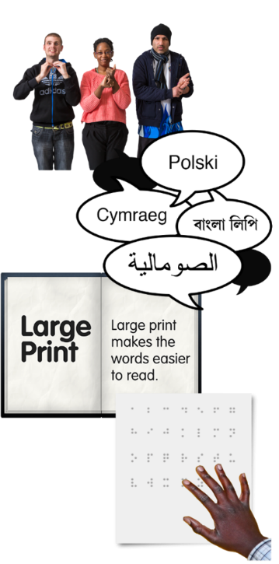 | 85 members felt that they get information in a way that is accessible to them
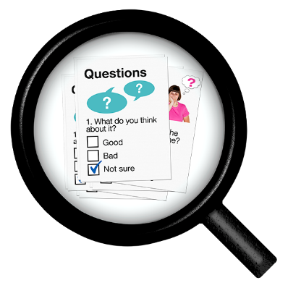 | 83 members were happy with our Weekly Poll topics.
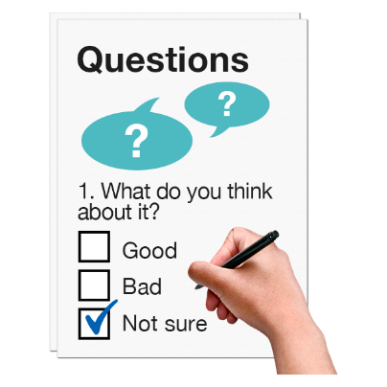 | 95 members knew about the Weekly Polls.
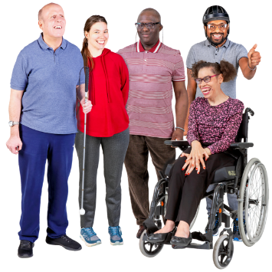 | 72 members felt they get something good from being a member.
 | 77 members agree that we speak up for disabled people.
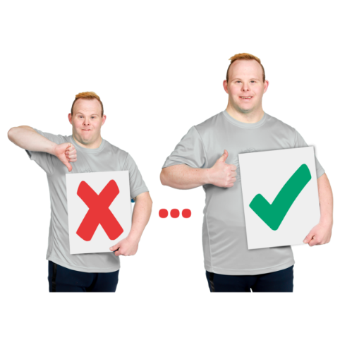 | These results help us see where we need to get better at doing things.
Our Newsletter and Open Door Magazine

Our newsletter comes out every month.

This year it was helpful to members in sharing how COVID-19 rules were changing.
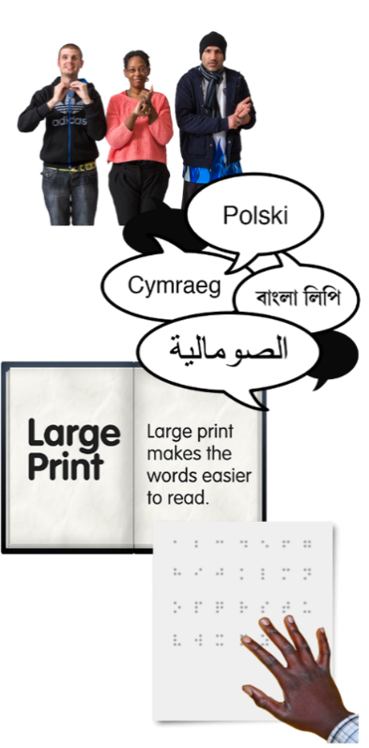 | We made a special issue about Inclusive Communication.  Inclusive communication means being offered things like:  - British Sign Language  - documents in a different language  - Large Print  - braille  - Easy Read
 | We shared articles from organisations who are doing a good job of inclusive communication.
Face Covering Exemption Card Campaign
DES worked with the Scottish Government to introduce a national exemption card at www.exempt.scot
This started in October 2020.

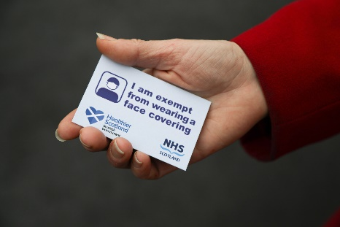 | From April 2021 to March 2022, we have:  - sent out 47 thousand exemption cards by post  - emailed 24 thousand digital exemption cards  - answered nearly 2 thousand phone calls to our helpline
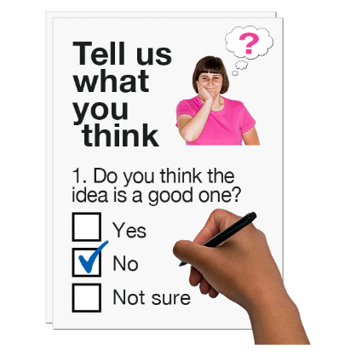 | We sent out a survey to find out how helpful the cards were.  6 thousand people replied.
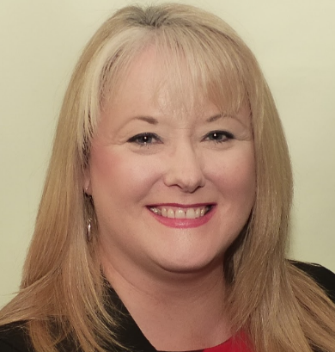 | Christina McKelvie is the Minister for Equalities and Older People.  She thanked Disability Equality Scotland and our members for quickly spotting that exemption cards were needed.
Disability Webinars
A webinar is an online event with:
- presentations
- chat
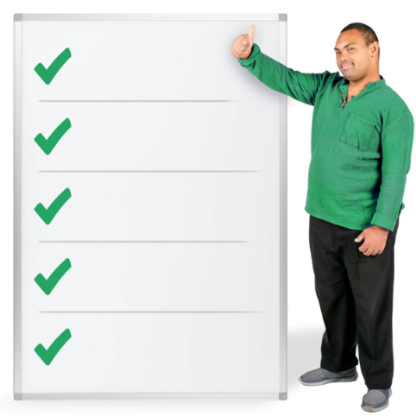 | From April 2021 to March 2022 we ran 8 Disability Webinars about:  - planning a journey  - getting jobs in public authorities  - the Independent Living Fund  - using public transport again after the pandemic  - hate crime  - COVID-19 Recovery Bill  - Assistance cards for travel  - transport staff training
 | People who came said the discussions were very helpful.
Inclusive Communication Hub
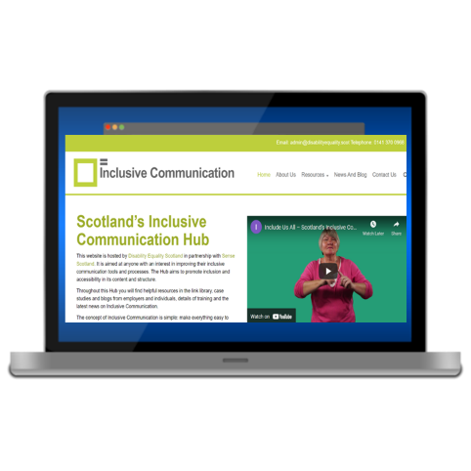 | www.inclusivecommunication.scot  The Inclusive Communication Hub is online in partnership with Sense Scotland.  It gives information about accessible information.  It is getting used more and more.
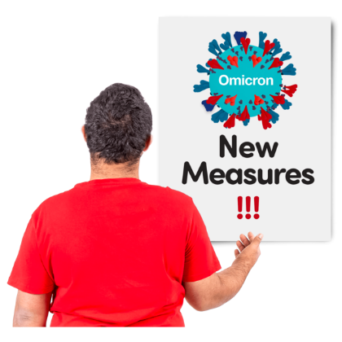 | We used the Hub to say how important it was that COVID-19 information was given in accessible ways.
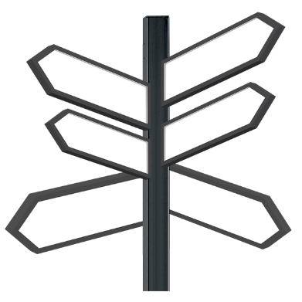 | We made a resources page which told people where to look for pandemic information in ways like:  - audio  - British Sign Language  - easy read
Easy Read Service
www.disabilityequality.scot/easy-read-service
Our Easy Read service makes written information easier to understand.

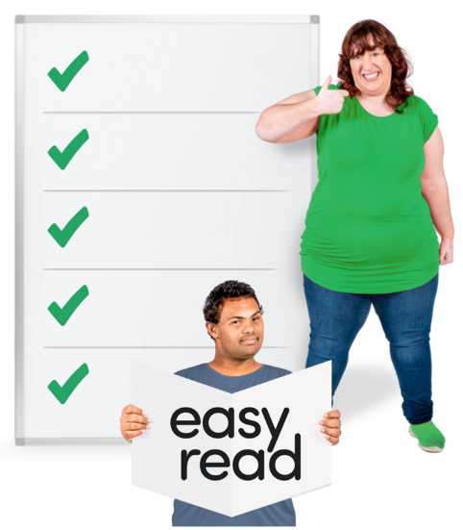 | From April 2021 to March 2022 we worked on 93 Easy Read projects.  Some of these were:  - COVID-19 Self-Isolation Bill  - Transport Scotland’s Annual Delivery Plan  - ALLIANCE  - Inclusion Scotland  - Police Scotland  - Scottish Labour  - Connecting Scotland
 | We are getting more and more Easy Read work, which is a good thing.
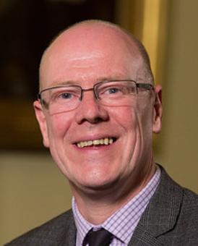 | Kevin Stewart – Minister for Mental Wellbeing and Social Care – thanked us and liked our Easy Read document.
Easy Read Training
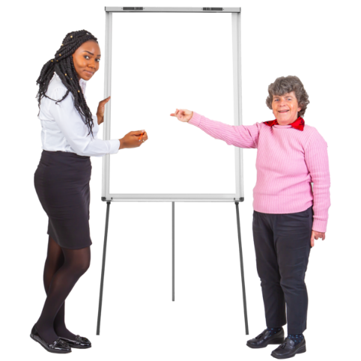  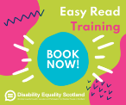 | We have made an Easy Read training course.  The course is to help organisations make their own Easy Read documents.
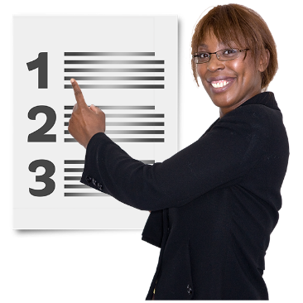 | Training courses have been:  - online  - hands on  - made to suit the organisation
 | We are now charging for the training course.
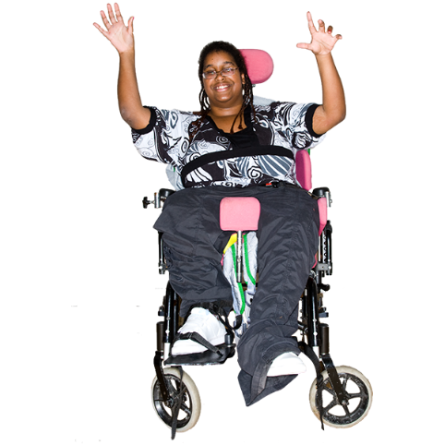 | By March 2022 we had:  - run 5 Easy Read courses  - planned 10 more Easy Read courses  Every single person who has been to this course says they would recommend it.
Weekly Polls
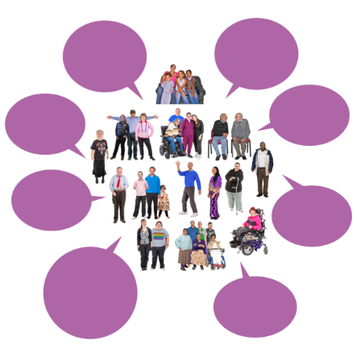 | www.yoursayondisability.scot  Our weekly polls help us find out what our members think.  From April 2021 to March 2022 we have sent out 48 poll questions.  More than 8 thousand people have replied.
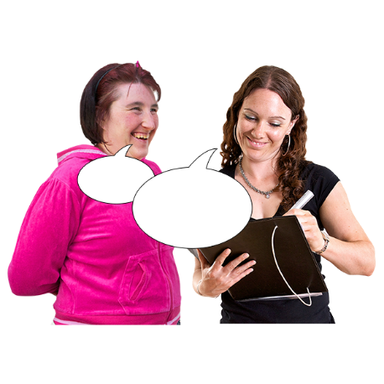 | Polls were about things like:  - face coverings  - having a Basic Income in Scotland  - using cars less  - online meetings and events
The answers from our members have helped get information to things like:
- government consultations
- COVID-19 recovery
- NHS 111 service
- Scottish Parliament talks about accessible toilets on the International Day of Disabled People
- Parliamentary Questions
- Cross Party Groups
- Scottish Parliament Committees

Disability Hate Crime
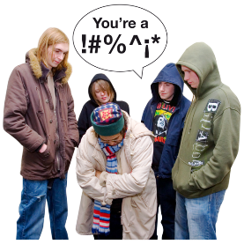 | www.disabilitysafety.scot  The Disability Safety Hub gives people information to help them understand:  - what disability hate crime is  - how to report it
 | The Hub has videos of disabled people talking about their experiences of hate crime.
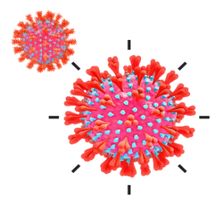 | The Hub also has information about:  - COVID-19 support  - a mental wellbeing guide  - information about scams
We worked with Police Scotland to have a webinar in October 2021.
It was National Hate Crime week and it helped more people to understand hate crime.

Accessible Travel
www.accessibletravel.scot
Lots of people looked at our Accessible Travel Hub this year.
It had information about service changes and COVID-19 information.
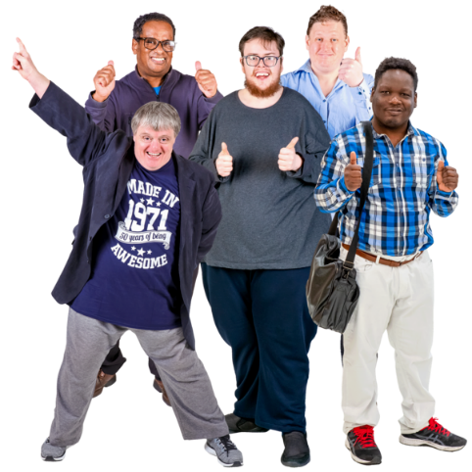 | We used the Hub to let more people know about the Hate Crime Charter.  These organisations said they supported the Charter:  - the Community Transport Association  - ZetTrans Regional Transport Partnership  - the Mobility and Access Committee for Scotland  We now have 14 supporters.
We ran 4 online webinars about transport with 1 hundred and 75 people.
You can find the recordings at https://accessibletravel.scot/webinars/

20 Minute Neighbourhoods
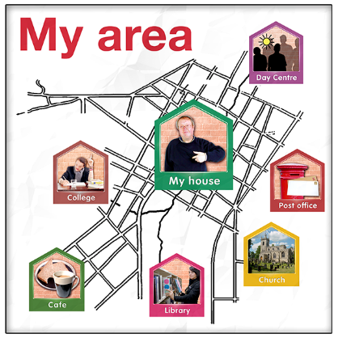 | A 20 Minute Neighbourhood means having most things you need within a 20 minute walk to and from your home.
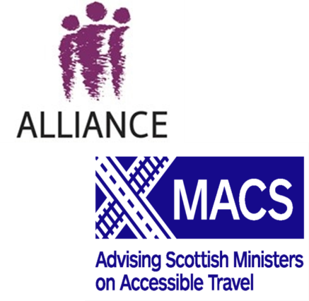 | We worked with:  - the Health and Social Care ALLIANCE  - Mobility and Access Committee for Scotland
 | We ran 4 webinars about 20 Minute Neighbourhoods.
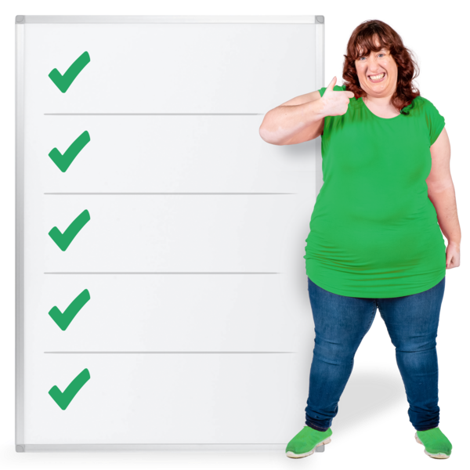 | We talked and listened about:  - getting around  - getting to services  - meeting people  - houses  - green spaces  - design
 | You can find the full report by clicking on https://www.alliance-scotland.org.uk/wp-content/uploads/2022/05/Exploring-20-minute-neighbourhoods-report.pdf
Hate Crime on Public Transport
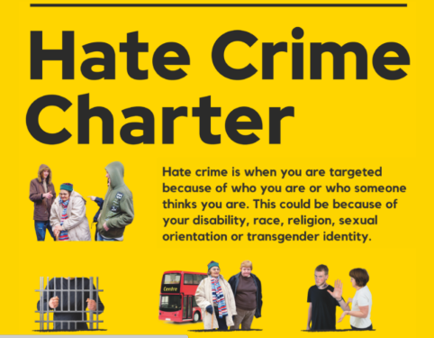 | http://accessibletravel.scot/hate-crime/  We worked with our partner organisations to start the National Hate Crime Charter in March 2021.  More than 3 hundred thousand people saw it on social media.
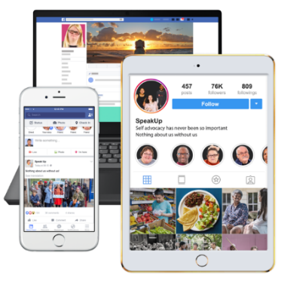 | We made hate crime posters and online images.  These travel organisations shared our posters and images:  - ScotRail  - Stagecoach  - FirstBus  - CalMac  - NorthLink Ferries
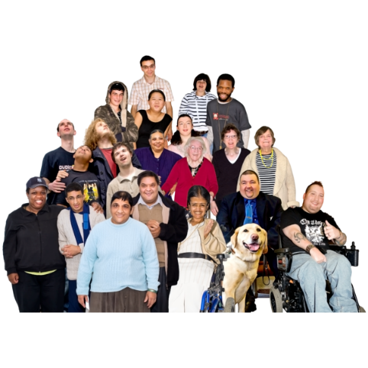 | 15 different transport organisations now support the Hate Crime Charter.
 | We are making a hate crime training course for transport staff.
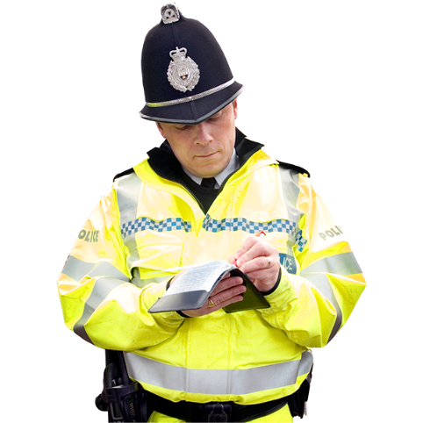 | The Hate Crime Charter was trialled in a few places over 2 months.  The British Transport Police said that they had 24 reports of hate crime in this time.
 | 8 out of every 10 transport staff said that they want more training about hate crime.
Access Panel Network
There are now 38 Access Panels with 1000 members across Scotland
A Panel is a group of volunteers. Most of them are disabled people, or care for a disabled person.
They meet every month to talk about things in their local area that affect disabled people.
They work to have equality and inclusion.
Access Panels have talked a lot about coping with the COVID-19 pandemic.
They did very well to move to Zoom meetings and to include organisations like local authorities.
There are 4 more Access Panels now and many members say that they can join in more easily with online meetings.

Access Panel Grant
The Access Panel Grant is money to help the Access Panels do their work.
This year less money was used for transport costs. More money was used for things like computers.
Access Panels have been:
- checking buildings are accessible
- helping with changes in their local area, like Spaces for People
- meeting with councils
- taking part in our 2022 Access Panel Conference

Staff
Our staff have carried on working well from home and from the office.
We think we are getting stronger because of the skills and efforts of our staff.

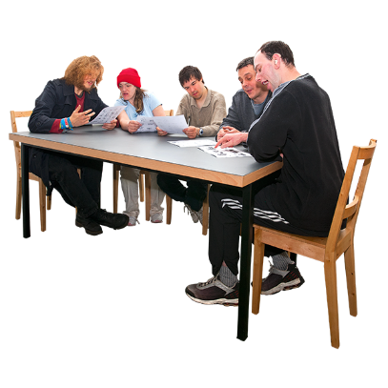 | People are on the Board for three years and are voted in at our Annual General Meeting.  Our Convener leads the board and offers support to our Chief Executive Officer.
Funding – the money we get to do our work
Our money comes from:
- the Scottish Government
- Inspiring Scotland
- Transport Scotland
There are several funds for accessibility and equality that are given to us.

Copyright images © Photosymbols. Prepared by Disability Equality Scotland

