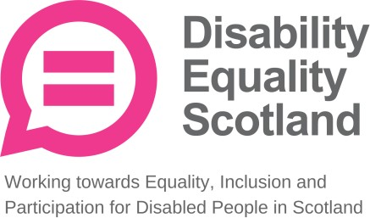
Annual General Meeting 31 August 2022

Retirement, Election and Re-election of Directors

The Company's Articles of Association (Article 31b) contain detailed rules for the appointment and retirement of Directors. There is a formal procedure in place to select and appoint new Directors to the Board. These Directors are required to retire, be elected and re-elected at this Annual General Meeting dated 31 August 2022. Under the organisations Articles of Association, all Directors are required to submit themselves for re-election at intervals not exceeding three years.

Co-opted Directors to be Elected 31 August 2022

Kayla-Megan Burns
Co-opted 29 March 2022

Marie Harrower
Co-opted 29 March 2022

Biographies

Kayla-Megan Burns

Kayla is a climate and social justice activist who has worked locally, nationally and internationally on projects and campaigns covering areas such as the climate emergency, accessibility, the right to education for all, anti-hate, and gender equality.

Originally from Enniskillen, N.Ireland, Kayla moved to Glasgow to pursue studies in Biomedical Science at the University of Strathclyde. Since then Kayla has rapidly built their career, becoming the President and Chair of the Trustee Board at Strathclyde Students’ Union, a member of Strathclyde University Court, becoming a member of the New York Times Generation Climate, and establishing Songplistic to increase the accessibility of making music for all. They regularly speak at various conferences on topics such as business, society, and climate change, bringing their unique experiences and perspectives as a young, disabled, non-binary individual.

Kayla aspires to see a world of social and environmental justice for all and has committed themselves to doing as much as possible to achieve this.

Marie Harrower

Marie has been blind since birth; she was brought up on the Isle of Mull and attended the Royal Blind School in Edinburgh. Marie trained as a physiotherapist at the RNIB school of physiotherapy in London, and qualified in 1972. Marie enjoyed a long interesting and varied career. From 1997 until she retired in 2012, Marie was head physiotherapist in Oban and North Argyll which included some of the inner Hebridean islands. Marie married Kenn in 1975 and have two sons Philip and Gordon. In 1976 Marie was selected for the British paralympic team to compete in the Paralympics in Canada.
Fantastic coaching, tremendous support from Kenn and close friends and luck on the day, allowed her to reach the podium. It was an amazing experience, not an experience that will ever be forgotten. Marie and Kenn have tandemed throughout their married life and now cycle on an e-tandem. Marie is passionate about horse and riding, but these days, just an occasional ride. However, Marie continues to maintain fitness and fun with swimming and walking. She enjoys listening to classical music and participating in choral singing and also enjoys meeting people and participating in committee work and very much appreciates spending time and socialising with family and friends.

