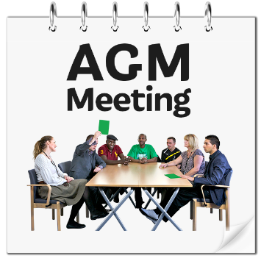
Annual General Meeting Booking Form

Fill out one form for each person

When is the meeting?
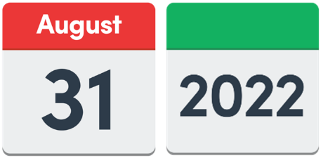 | Wednesday 31 August 2022
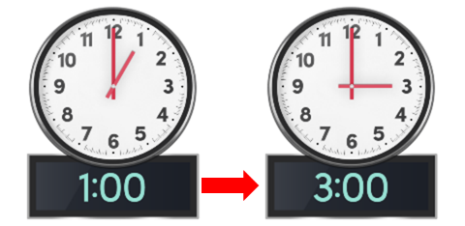 | 1pm to 3pm
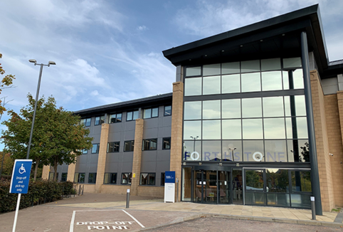 | You can choose to join the meeting at:  Motability Operations Ltd  Forthstone  The Stones  56 South Gyle Crescent  Edinburgh  EH12 9EB
OR you can choose to join the same meeting on Zoom.
A link will be sent to you after we get your booking form.

Tell us how to get in touch with you.
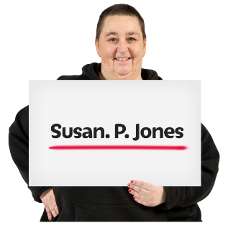 | Name:
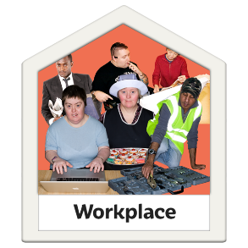 | Organisation:
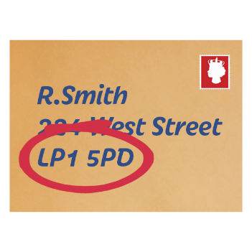 | Address:
 | Postcode:
 | Email:
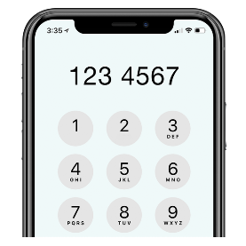 | Telephone Number:
How are you joining the meeting?
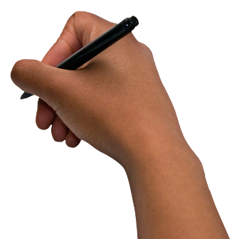 | Please tick 1 box.
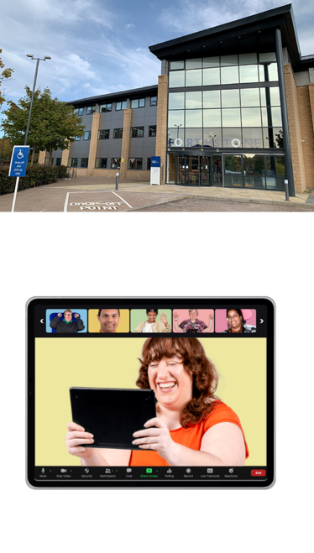 | I am coming to Motability Operations in Edinburgh. ☐  I am joining online using Zoom. ☐
Accessibility Support
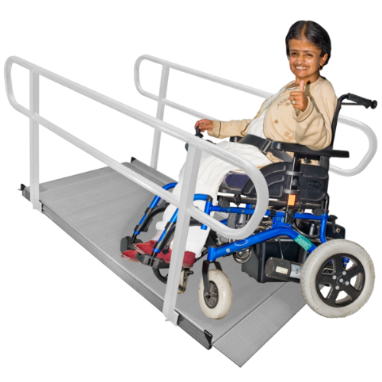 | If you are coming to Motability Operations in Edinburgh for the meeting, do you need any accessibility support?
NO, I don’t need support. | ☐
YES, I need some support. | ☐

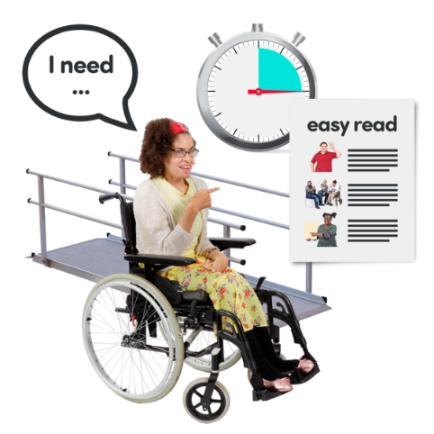 | If you ticked ‘YES’ tell us about the support you need here:
Communication Support

Do you need communication support – for example - large print or a British Sign Language interpreter?
Tick the box for your answer.
Yes ☐
No ☐

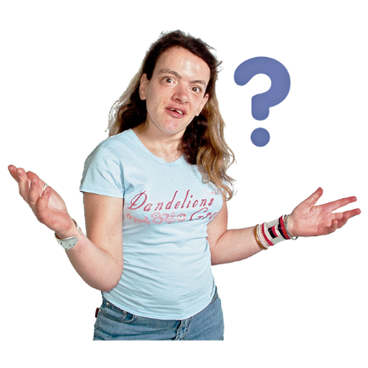 | If you ticked ‘yes’, please tell us how we can support you:
Parking Information
 | This information is just for people who are coming to Motability Operations in Edinburgh for the meeting.
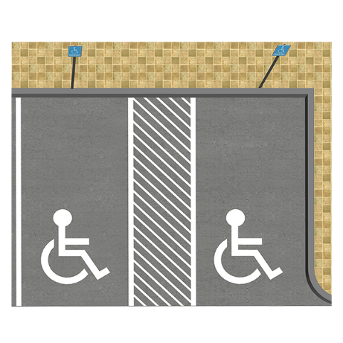 | Motability Operations has:  - 30 parking spaces  - 11 accessible parking spaces  7 of the accessible parking spaces have electric charging points.
 | Would you like a parking space?
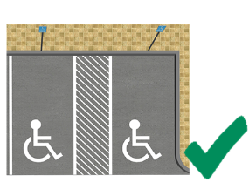 | Yes I would like an accessible parking space ☐
 | Yes I would like a regular parking space ☐
 | No thanks ☐
How to return your form to us
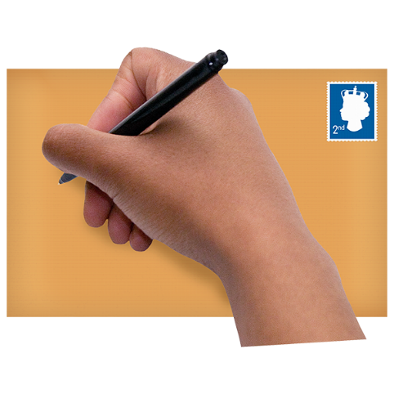 | Please send it to:  Calum Byers  Suite 204B, The Pentagon Centre  36 Washington St  Glasgow G3 8AZ
OR save this form and email it to Calum at:
calum@disabilityequality.scot
 | If you have any questions, please phone Calum on 0141 370 0968.

Copyright images © Photosymbols. Prepared by Disability Equality Scotland

