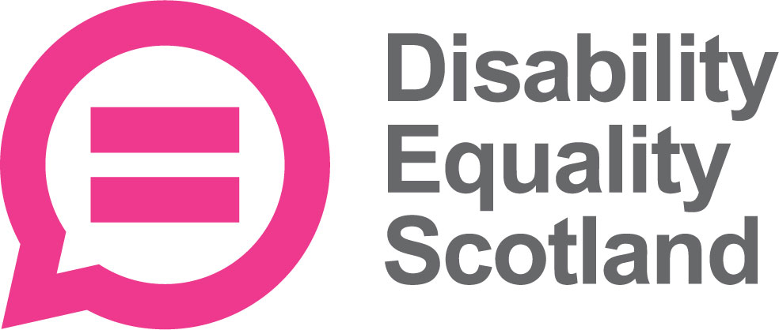 | Disability Equality Scotland  Meeting of the Board of Directors
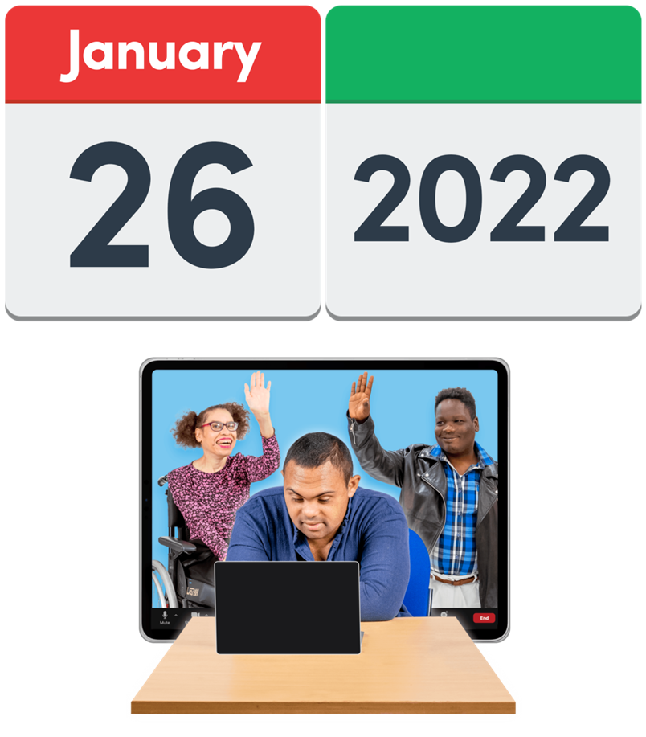 | 26 January 2022  at 10am on Zoom
 | Who was there?
Directors

- Linda Bamford – Convener
- Scott Stewart
- Kenny Milne
- Colin Millar
- Dorothy McKinney
- Maureen Morrison

Staff
- Morven Brooks – Chief Executive Officer
- Emma Scott – Deputy Chief Executive Officer
- Ian Buchanan – Equality and Access Manager
- James Davidson – Communications and Research Officer
- Alistair Bruce – Access and Engagement Coordinator

Who could not come?
- Carolyn Wilson-Smith – Director
- Rhianne Forrest – Director
- Lauren Asher – Director
Lauren joined the closed session.

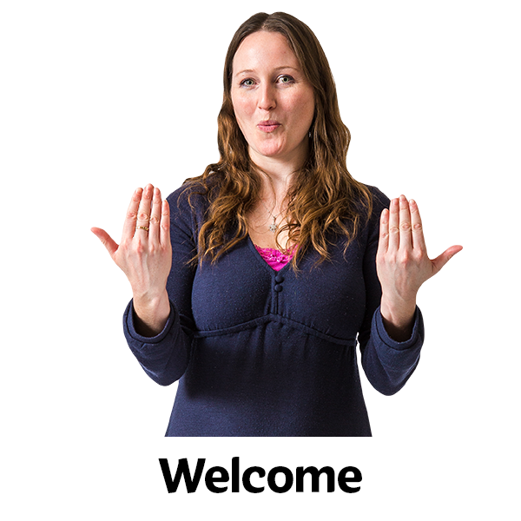 | Welcome  Linda welcomed everyone to the meeting.
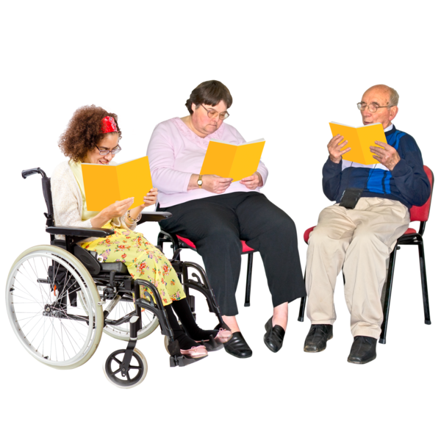 | Linda checked that everyone had had their board papers in enough time.  Everyone agreed that they had got their papers in enough time.
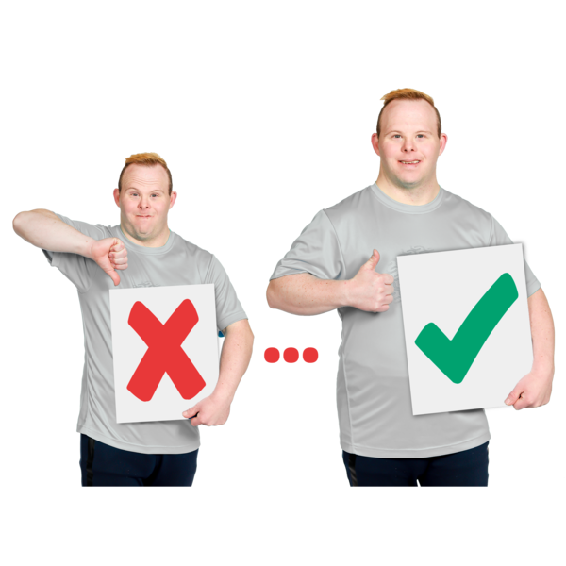 | Are the Minutes of the last meeting right?
 | Scott said that on page 9 it said that ‘most calls’ to Disability Information Scotland were about hate crime. But he would like it changed to ‘many calls’.
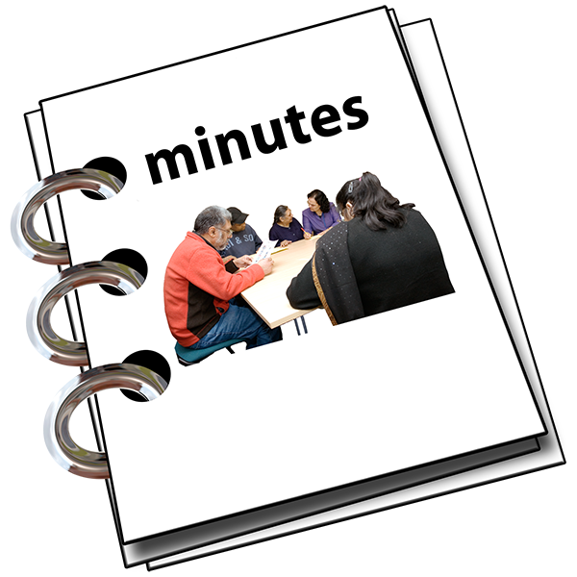 | Everyone agreed that the minutes of the last meeting were right.
 | What actions still need doing from the 27 October 2021 meeting?
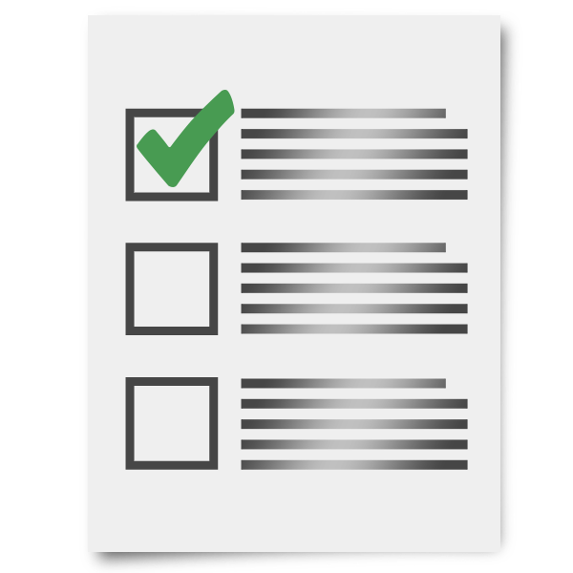 | Morven said that all actions have been done.  She asked Ian and James to tell everyone about Action 1 and Action 2.
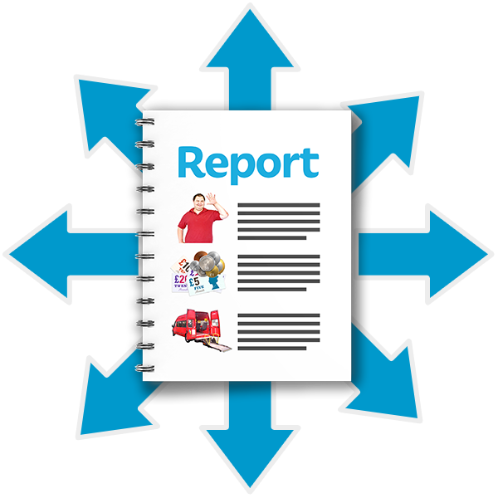 | Action 1: Ian will share the Access Language Seminar report.  This has been done.
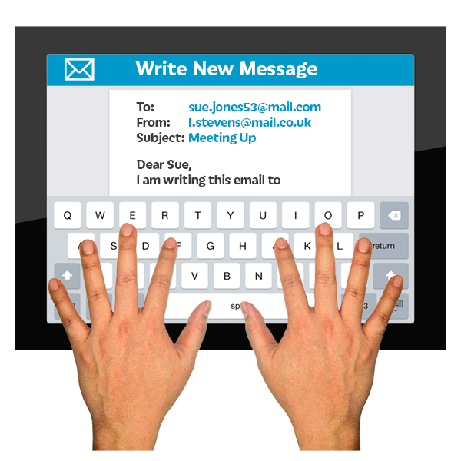 | Action 2: James will get in touch with the ‘The Promise’ team to talk about our work and young members.  This has been done.
Action 3: Morven will sort out the voting for the new Convener and Vice Convener roles.
This has been done.

 | New Members
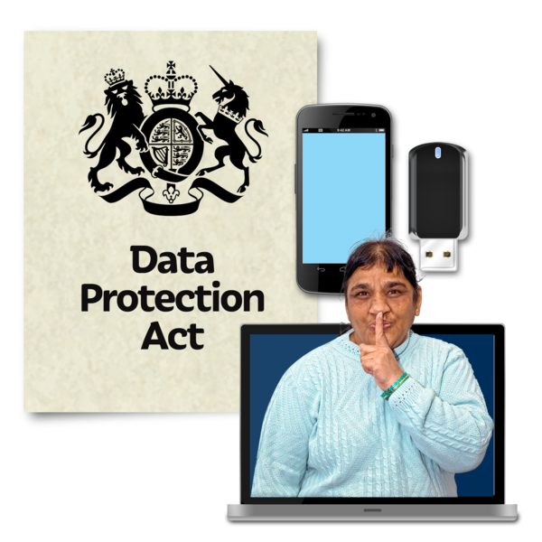 | Morven told everyone about why we need to clean up our database of people’s contact details from time to time.
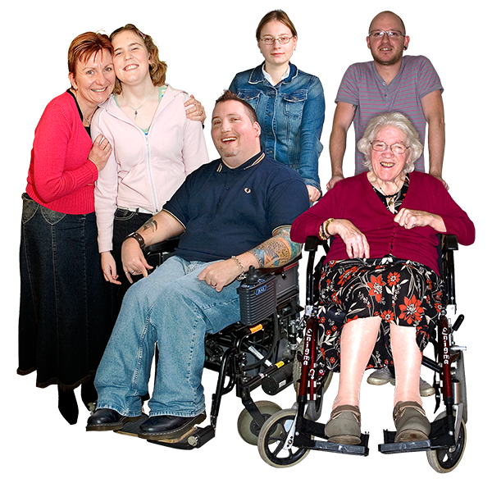
Morven said that 72 new members have joined between 1 October 2021 and 30 December 2021.

We now have a total of 1 thousand 3 hundred and 77 members.
Linda asked if everyone was okay with the new members joining.
Everyone said they agreed.
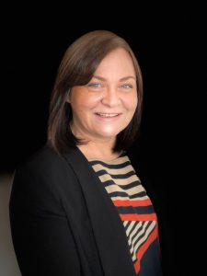  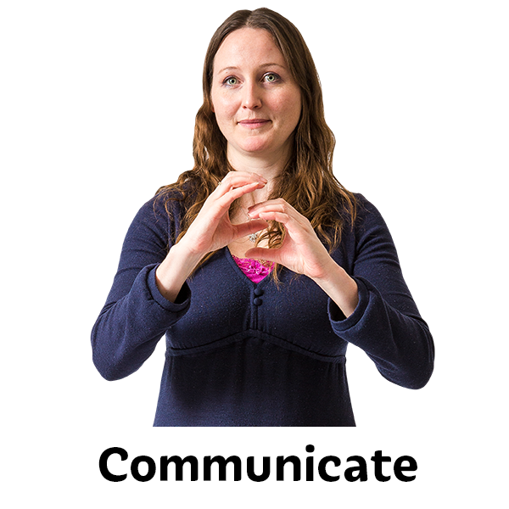 | Update by the Chief Executive Officer (CEO) Morven
Morven said that Ian’s Access Language seminar report had raised an issue.
The issue was about using the words ‘proper training’.

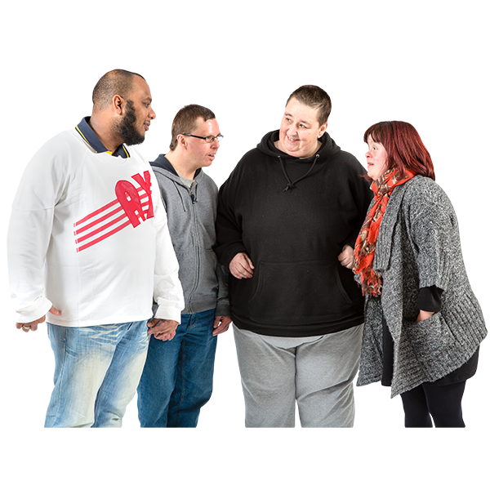 | This isn’t true of all Access Panel members because people have different experience.
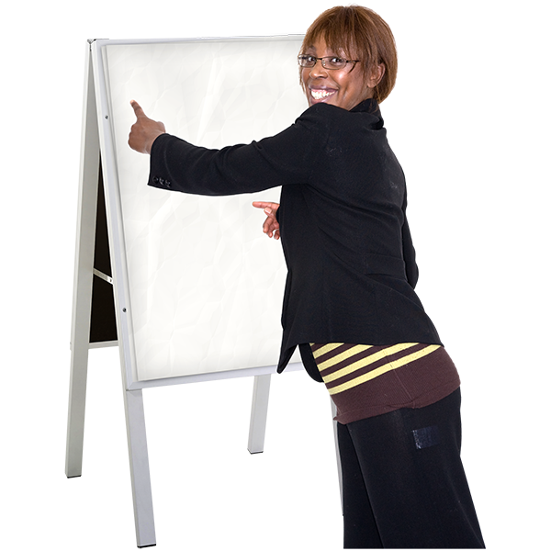 | Morven said that Disability Equality Scotland have been training Access Panels with the DEAL course for 2 years.
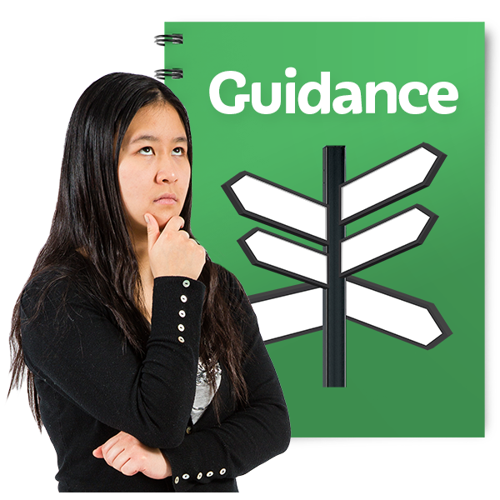 | Morven said that we have checked with:  - lawyers  - Equality and Human Rights Commission  that it’s okay to say ‘Access Audit’.
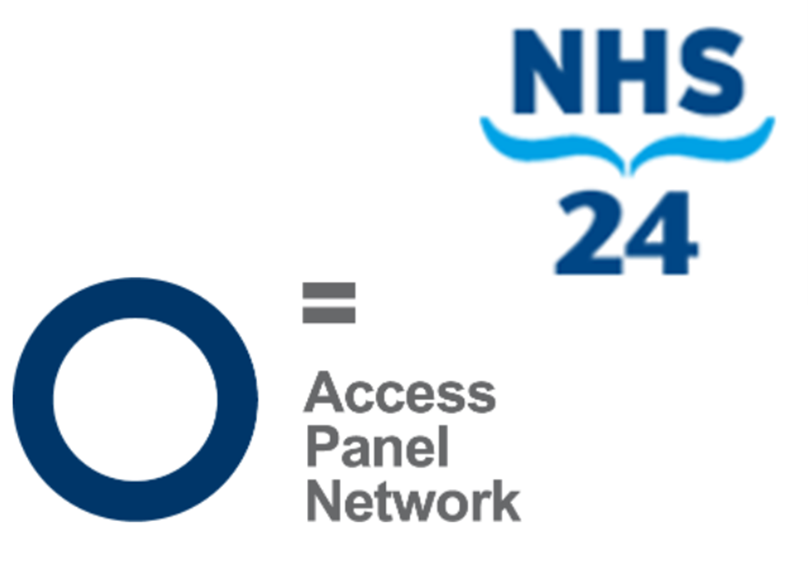 | Morven said that we are working with NHS24 and some Access Panels.  The work has some agreements so that everyone knows what will happen.
 | Morven said that the money from this work will go into an Access Panel grant fund that all Access Panels can ask for.
Linda said that there was more guidance about how to assess an accessible place.
The guidance is from:
- Public Health Scotland
- Improvement Service Scotland
Linda said there was a project called Shaping Places for Wellbeing Programme.
Ian said he would tell Access Panels about it.

 | The website is at Shaping Places for Wellbeing Programme | Improvement Service
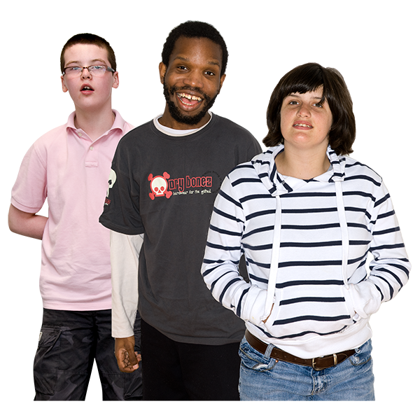 | Linda said she had thought about the youth membership’s work on the Year of Stories.  She thought we could ask young members about their experiences using the free bus travel for under 22 year olds.
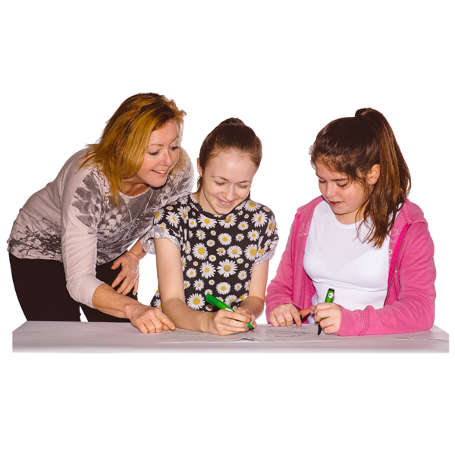 | James said that accessible transport was part of the form sent to young members. He hoped we will get to hear some experiences.
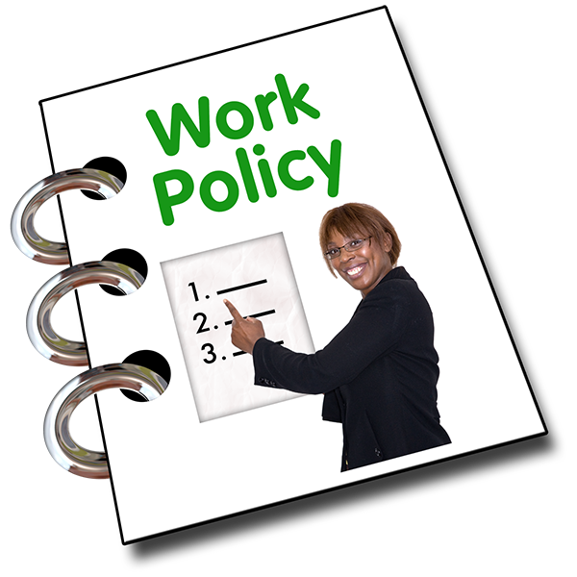 | Morven said there was a change to the Sickness and Absence Policy.
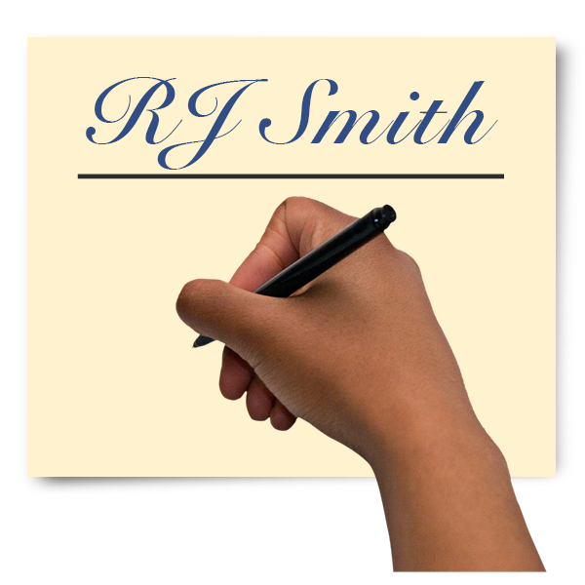 | It used to say that staff could sign their own form to say they were ill for 7 days.  But now staff can sign their own form to say they are ill for 28 days.  This is also called self certification.
Dorothy asked whether this was just for a while.
Morven said it was just for a while, to help doctors after the pandemic.

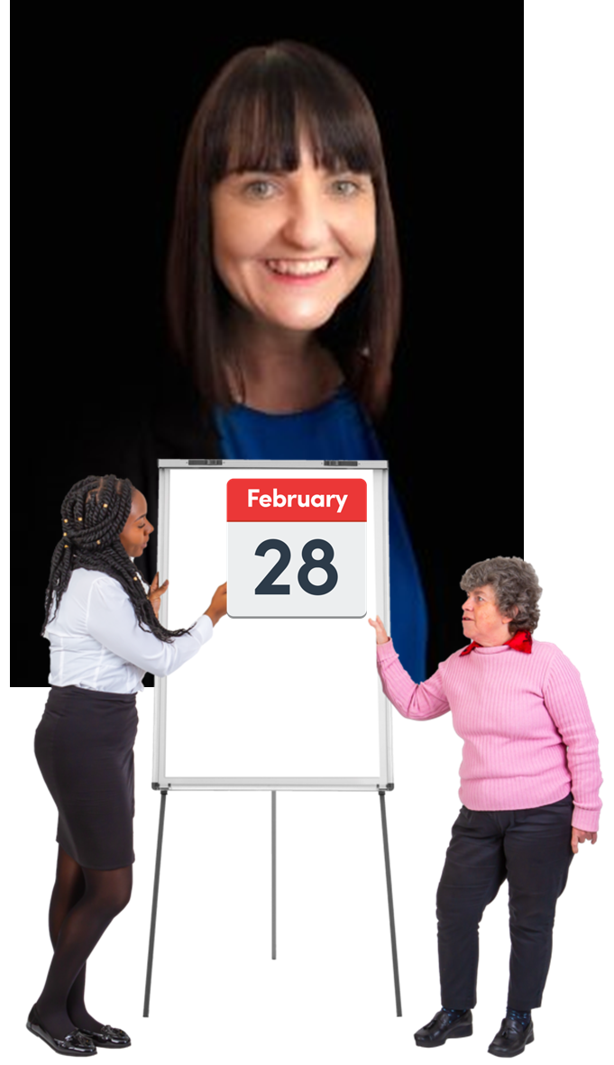 | Report by Operations Manager – Emma
 | Emma said that the Easy Read training course will begin around 28 February 2022.
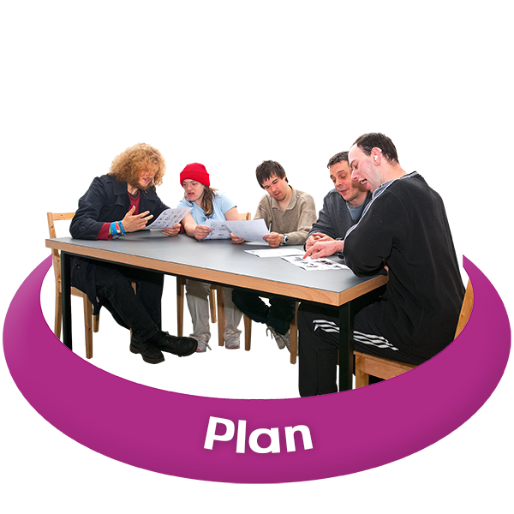 | Emma told everyone that the plans to host a Disability Roundtable have stopped for now.  Instead we are thinking about asking members about the Disability Delivery Plan.
Emma said that the next Transport Scotland webinar is on 24 February 2022.
We hope to have many different types of transport organisations there to answer questions.
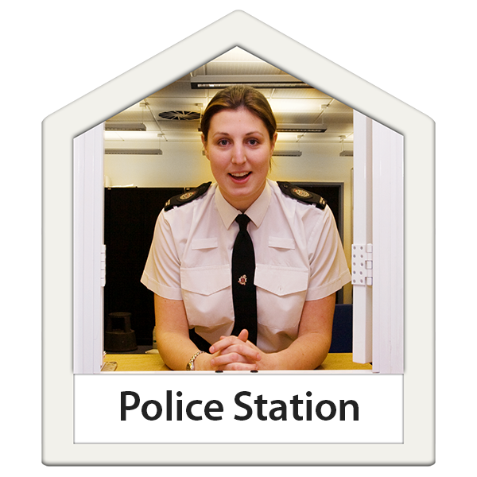 | Emma said she and Fiach met with the new Police Scotland link person.  But this changed and now the link person is Police Constable Rose again.
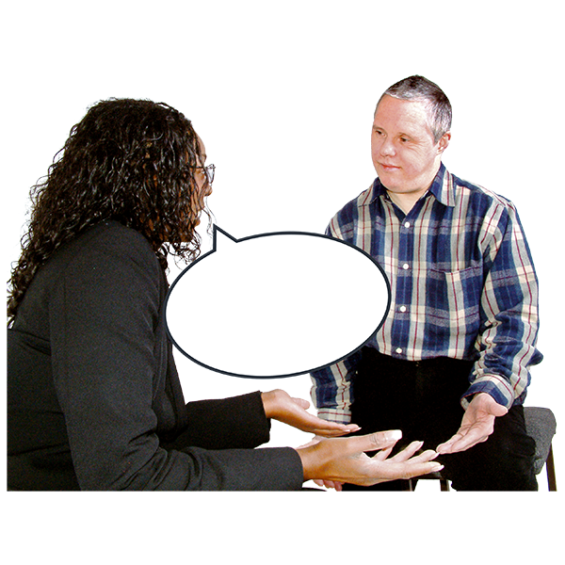 | Police Constable Rose has made the training documents.  Fiach is collecting hate crime experiences from disabled people.
Emma said that the new contract for the face coverings exemption helpline begins this week.
Lots of digital cards are being downloaded.
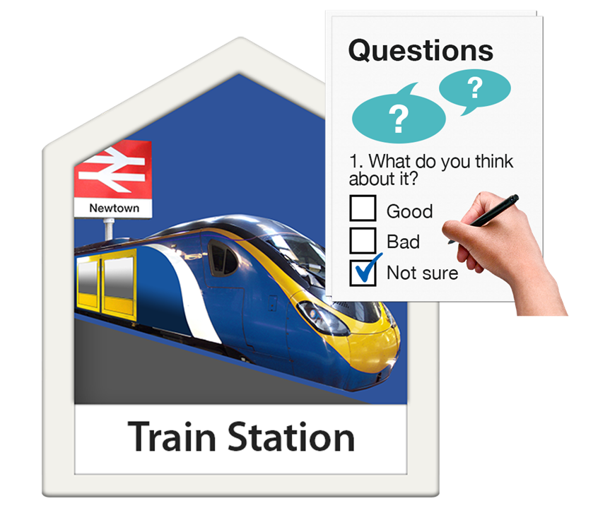 | Emma said that there had been a weekly poll about ScotRail closing many ticket offices.  250 people answered the poll.
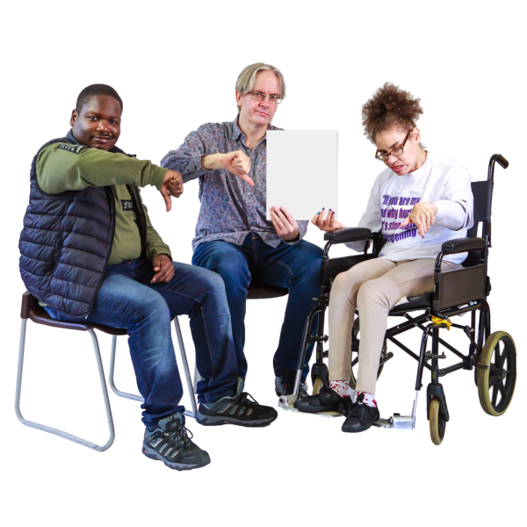 | 19 out of every 20 people who answered did not want the ticket offices closed.
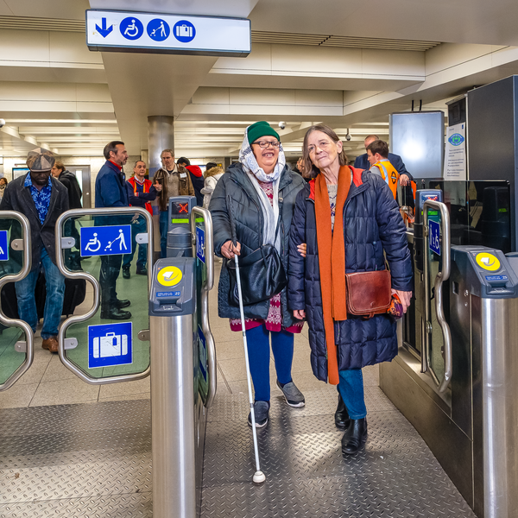 | Emma said that many disabled passengers don’t just want staff at stations so they can buy tickets.  Many want staff there to feel safe and supported.  We have told ScotRail what our members think.
Linda asked if Transport Scotland’s funding is clear yet.
Emma said we are hopeful for funding.
Extra information after the meeting had ended – Ms Gilruth is the new Minister for Transport now.

Linda said that she had joined the webinar about passenger assistance cards.
Lots of people there said that transport staff just don’t know what these cards are for.

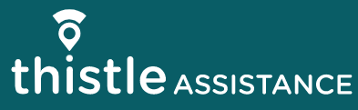 | Linda said she was worried about Thistle Assistance.  Instead of collecting feedback, the success seems to be about how many cards are sent out.  Emma said that Disability Equality Scotland have told Thistle Assistance about this in the past.
 | Report by Equality and Access Manager – Ian Buchanan
 | Ian said he has an interview with the National Register of Access Consultants.
Ian said that the Section 10 funding application is nearly ready to send.
He is also getting ready to lead some consultations with Access Panels. These will be about the National Planning Framework.

 | Ian said he is organising the Cross-Party Group on Disability meeting about the Disability Employment Gap.
Linda said Ian had done really well.
She asked for an invitation to the Cross-Party Group meeting.

 | Linda said she thought that the partnership working agreement will be helpful.
Morven said that Ian is going to run a mini DEAL training course to Disability Equality Scotland staff and directors.
After that he might run it for Disability Information Scotland’s staff.

 | What is happening this year
 | Linda asked if everything was on target to be done on the annual calendar.
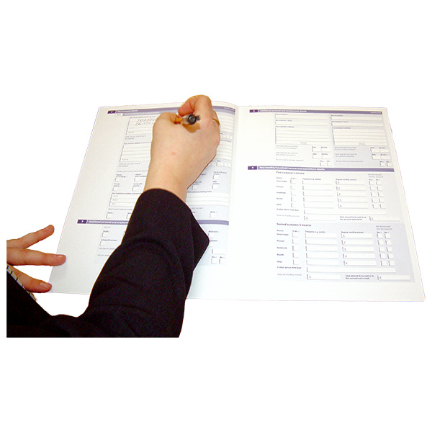 | Morven said that we are applying for:  - Section 10 funds  - Transport Scotland funds  When we hear from them, we can set the yearly budget.
Complaints
Morven said there had been no complaints.
There had been good feedback about the Easy Read service.
What we have learned

Morven said that we could be assessed at any time for our finances and the way we handle money.

So we are looking at our finances and the ways we handle money.

Linda said that new inclusive communication laws and the Public Sector Equality Duty were important.
They link to our Easy Read work.
 | Money
Morven said that we have 92 thousand pounds saved.
We want to have 6 months costs saved.

 | Morven said there will be a Fundraising Paper to share at the next board meeting.
 | People
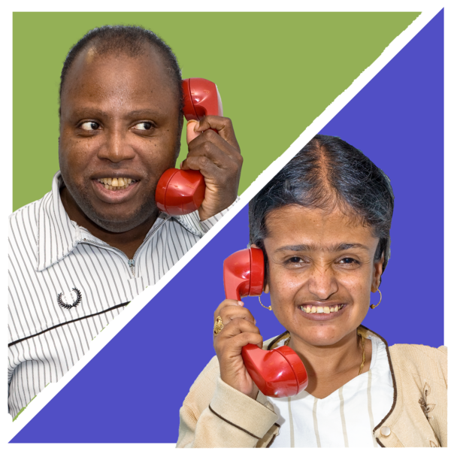 | Morven said that the team works well and keeps closely in touch wherever staff are working.
Linda said that other disability organisations are worried. They are worried that after COVID-19 has ended, events will go back to being face-to-face.
But this is not always easy for disabled people.
She asked if Disability Equality Scotland could run events that were both online and face-to-face.

 | Morven said that we can ask our members this through a weekly poll and follow what they ask for.
Risk Management - things that might cause problems

Linda said that there was 1 risk being looked at – finance.
This has moved to 3 because some funding is not yet certain.
 | Our risk score has come down to 5 now. This is good.
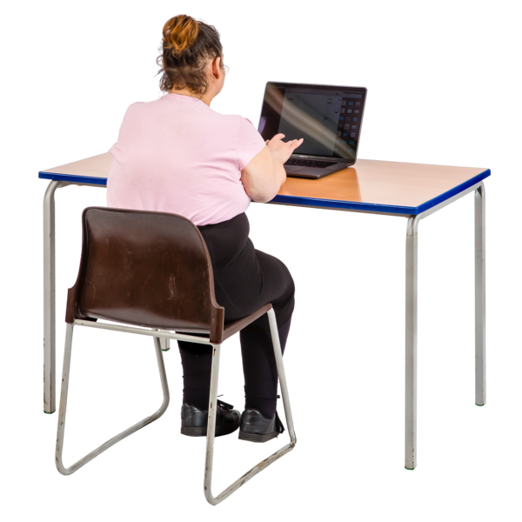 | What do we need to do in the next three months?
 | Morven said that she is writing a briefing paper about Fundraising.
Linda said that Pam Duncan-Glancy MSP had asked the First Minister about the distance aware badge scheme.
The problem is that it labels disabled people.

 | What actions need to happen from today’s meeting?
 | Action 1: Morven will make sure that positive feedback is also shared in board meeting paperwork.
 | Action 2: Morven will share the Fundraising Briefing Paper at the next Board Meeting in April 2022.
 | Action 3: Ian will share a useful Tool and Programme with the Access Panel Network.
Any Other Business

Linda thanked Emma for her Motivation Monday emails.

 | The Meeting Ended
 | Linda thanked everyone for coming and the meeting ended.
 | After the meeting there was a closed session.
The Board talked about choosing a new Convener and a new Director.

Linda said she would help the new Convener settle in.

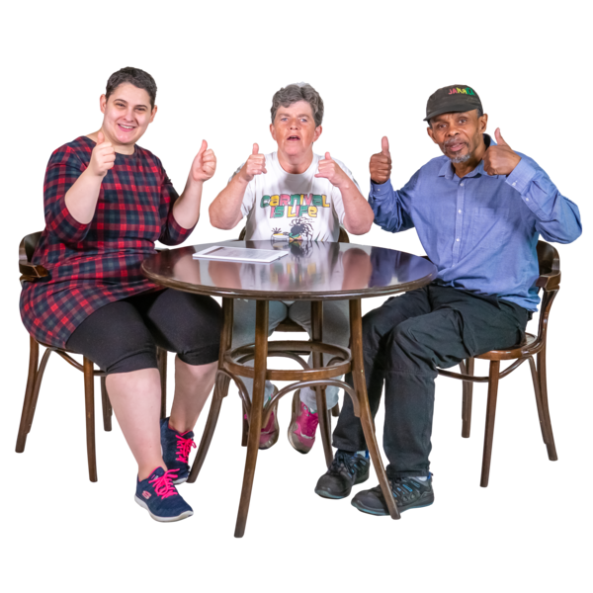 | Everyone agreed how and when choosing a new Convener and Director will happen.

