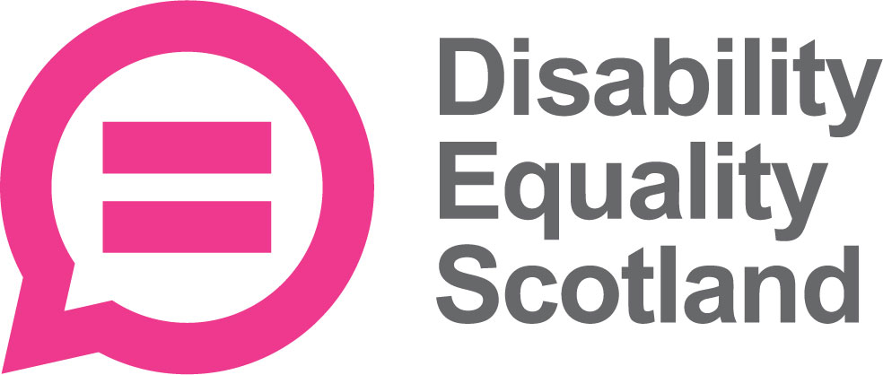 | Disability Equality Scotland  Meeting of the Board of Directors
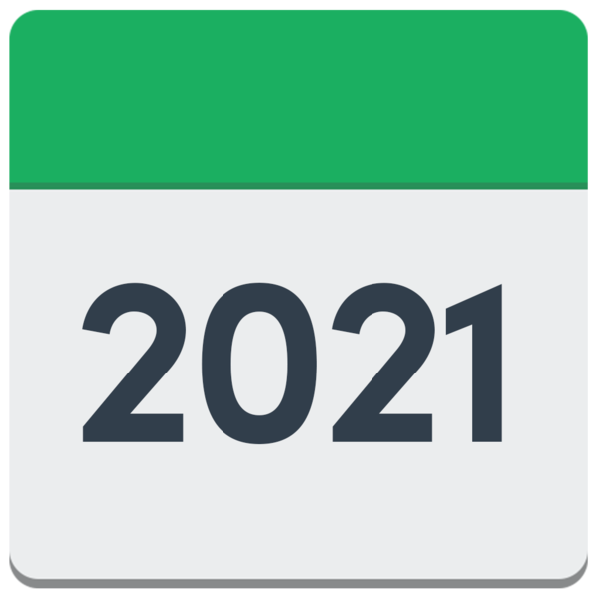 | 28 July 2021 at 10am on Zoom
 | Who was there?
Directors
- Linda Bamford – Convener
- Dorothy McKinney
- Rhianne Forrest
- Carolyn Wilson-Smith
- Susan Fulton
- Scott Stewart

Staff
- Morven Brooks – Chief Executive Officer
- Emma Scott – Operations Manager
- Ian Buchanan – Equality and Access Manager
- Alistair Bruce – Access and Engagement Administrator
- Lucy Gibbons – Easy Read Trainer

Who could not come?
Lauren Asher – Director
Claire Jagger – Easy Read Worker
Kenny Milne
Maureen Morrison
Colin Millar
1 – Welcome

Linda welcomed everyone to the meeting.
She told everyone how to join in using Zoom buttons.

 | Linda checked that everyone had had their board papers in enough time.
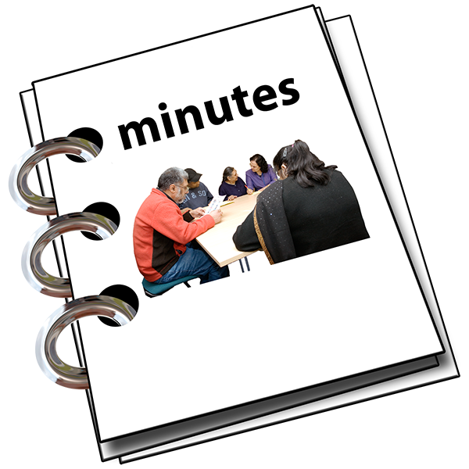 | 2 - Are the Minutes of the last meeting right?
 | Everyone agreed that the minutes of the last meeting were right.
 | 3 - What actions still need doing from the 28 April 2021 meeting?
 | Linda said Action 3 and Action 4 have been done.
Action Point 1- Access Language seminars

Ian has been setting up the Access Sub-Committee.
He met with Susan. Carolyn and Kenny. They are looking at the paperwork.
This action is now done.
Action Point 2 – Youth membership working group

Alistair and James have sent Morven the briefing paper.
Morven and Rhianne have talked and will form a group for encouraging more young members.

This action is now done.

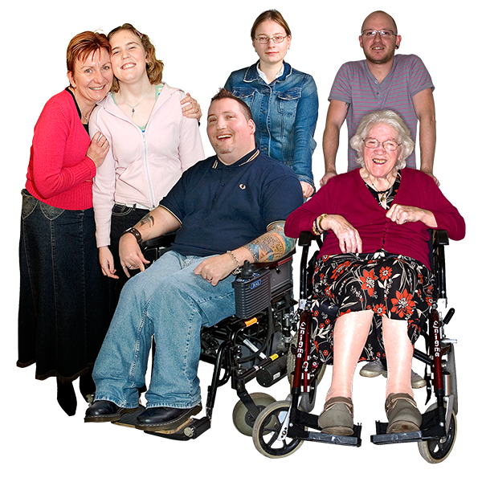 | 4 - New Members
Morven said that 99 new members have joined between 1 April 2021 and 30 June 2021.

There are:
- 98 individual new members
- 1 corporate new member

We now have a total of 1 thousand 3 hundred and 88 members.
So many have joined over the last year.

Linda asked if everyone was okay with the new members joining.
Everyone said they agreed.
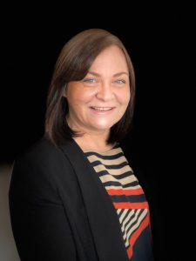  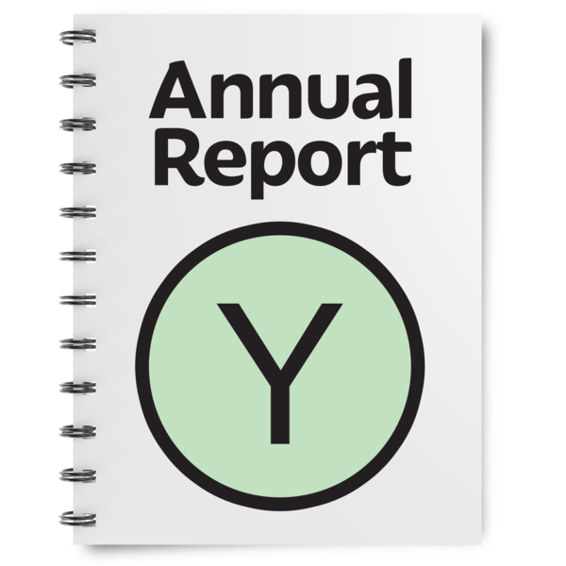 | 5 - Update by the Chief Executive Officer (CEO) Morven
Morven said that the Annual Report and the Accounts are finished.
The directors are looking at them to give feedback.
Linda and Scott said that the report was clearer this year.
They also said that the finances looked good.
Morven said that members will soon get sent:
- the third notice of the Annual General Meeting (AGM)
- the Annual Report
- the Accounts
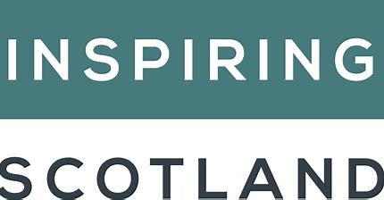 | Morven talked about Inspiring Scotland’s funding.  They are about to make a statement to the public.  It looks like things will stay the same but we should know more in the future.
Dorothy asked if the funding would mean that staff kept their jobs.
Morven said yes.

Morven talked about the Access Sub-Committee.
She said that Ian is organising webinars for the Access Panels.

Morven talked about the Easy Read Service.
She said:
- Lucy is now our new Easy Read Trainer
- we have a steady amount of Easy Read work
- our big aim is to make people more aware of Easy Read and other ways of sharing information

Morven said she had met Heather Mole from the Equality Unit.
Heather understood our aims.
 | Questions for Morven
Linda said that she had talked with Morven about the Governance advice.
This is called Governance Top Tips.
These tips will be shared when the Fundraising Plans begin.
Linda said that she is planning to step down as Convener but stay a Director.
She said that Dorothy is planning to step down as Vice-Convener but stay a Director.
They will support the new Convener and Vice-Convener.
 | Linda thanked the team for helping with the funding application.
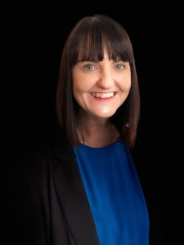  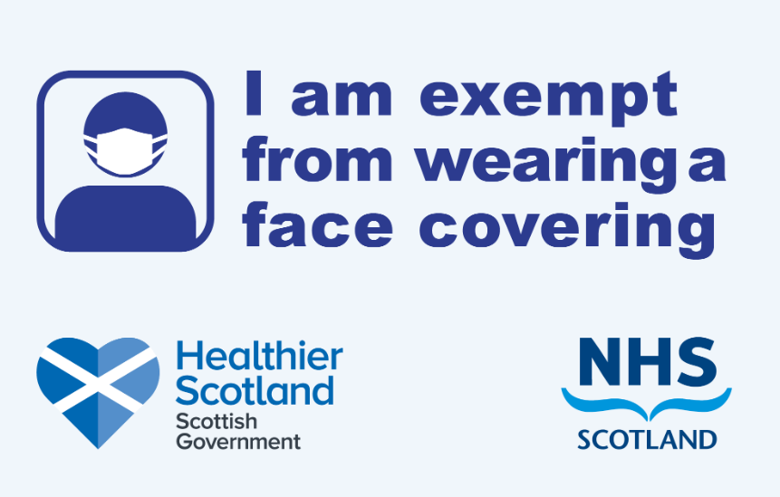 | Report by Operations Manager – Emma
Emma said that the Face Coverings Exemption Card project is carrying on.
We have now sent out over 90 thousand exemption cards.

 | We are meeting with the Scottish Government every 2 weeks.
The helpline:
- is getting fewer phone calls
- is open just 2 days a week from 26 July 2021

Emma said we have organised 2 good webinars.
The next one is around 19 August and it will be about returning to using public transport.
Emma said she had a reply from the Cabinet Secretary for Justice about hate crime.
She and Fiach will be meeting staff of Shona Robison – who is the Secretary for Social Justice, Housing and Local Government.
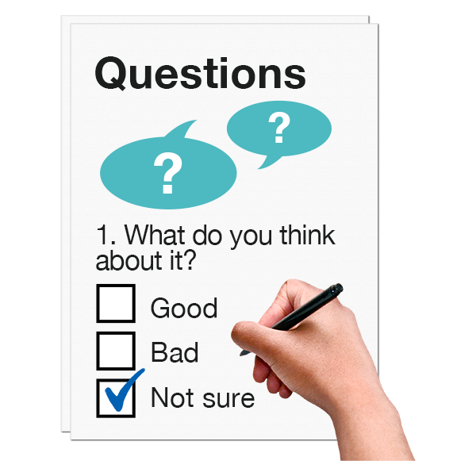 | Emma said that our Weekly Polls are still bringing in lots of helpful feedback from disabled people.
 | She also welcomed Lucy Gibbons as the new Easy Read Trainer.
Linda said that the things we found out about Hate Crime were like the things that another report found.
It was the Scottish Household Survey report of July 2021.
Disability Equality Scotland will share these findings.
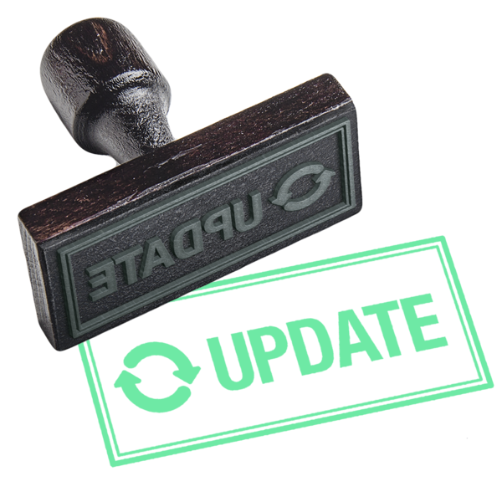 | Dorothy said that she really likes the weekly updates that Emma writes.  She said the whole team is making a real difference.
 | Report by Equality and Access Manager – Ian Buchanan
Ian met with Susan to talk about Access Language seminars.
She told him that there had been very good communication to the Access Panels about the seminars.

 | Ian said that Disability Equality Scotland is now the Secretariat for the Scottish Parliament Cross Party Group on Disability.
Ian said he had spoken to Jeremy Balfour – a Member of the Scottish Parliament – to sort out a meeting in September.
The Cross Party Group meetings are open to Disability Equality Scotland members and Access Panels.
 | Ian and Ali are working together on membership and outreach events to help support Access Panels.
Ian said that the Access Panel Members Forum project has had a few problems.
Ian is working with the website expert to fix these problems.
Ian said that he is writing a briefing paper about funding.
The funding will be to help community workers who are new to supporting Access Panels.
 | Questions for Ian
Linda asked if we can add things to the Cross Party Group meeting agendas.
Ian said yes.
Morven said that we are writing to ask for funding.
The funding is so that we can have British Sign Language interpreters and captioning support at meetings.
Susan asked if the Access Panel Forum will have accessible choices for people who can’t access it.
Ian said he thought the Forum would be extra to the communications not instead of them.

 | What is happening this year
Morven said the Annual Report has been written. The accounts are also ready.
These will be sent to members before the Annual General Meeting.
 | Staff are having Quarterly Review meetings at the moment.
 | We will be looking at our own business plans.
Complaints
Morven said there had been 1 complaint.
The person complaining said that Disability Equality Scotland were not answering their emails.
It turns out that they were trying to reach the Scottish Government and had got confused.
What we have learned
1. Emma said that in our webinar, British Sign Language interpreters who had joined in at the last minute did not realise they were being recorded. They did not want to be recorded.
We always make it clear to our interpreters that we will record their work and use it on places like YouTube.

2. A partner organisation at a webinar had asked for the list of who came to the webinar and their contact details.
But we had not asked people who came if we could share their details.

 | Money
Morven said that we have 75 thousand pounds saved.
Next we’ll aim for 6 months costs saved up.
In half a year we have earned 10 thousand pounds. We are looking after our money very well.

It has been cheaper to organise webinars since the pandemic, instead of real life events.
Lots of members say they prefer webinars. In the future we might do events that use both webinars and real life meetings together.
 | Linda said Morven had done a good job of looking after money during the pandemic.
 | People
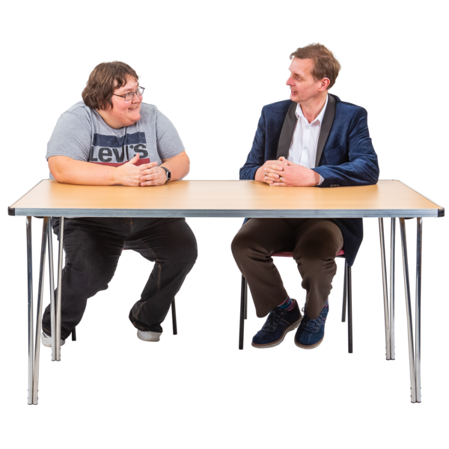 | Morven said that staff are doing Quarterly Reviews at the moment.  Staff meetings have moved to Monday mornings.  Coffee mornings are on Wednesday mornings and staff can choose to join in if they want to.
Other things happening are:
- Morven is meeting Line Managers
- training needs are being talked about
- some staff did a British Sign Language course called Start to Sign

Risk Management (things that might cause problems)
Morven said there are 14 risks at the moment.
She and Linda have looked closely at 2 risks.

1. What budgets there are to keep things going
This was moved from 2 to 3 for how likely it was to happen.
2. People - the risk of not training staff to do reach the targets
This was moved from 1 to 2 for how likely it was to happen.
 | Morven said that the average risk score for April 2021 to June 2021 is 6.
 | What do we need to do in the next three months?
 | Morven said that we need to finish our application with the Equality and Human Rights Fund.
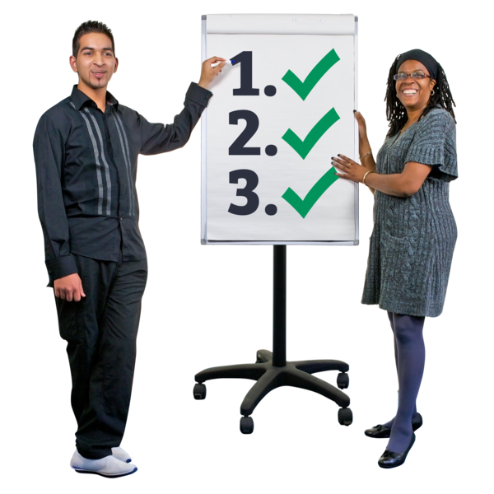 | We are still focusing on:  - hate crime  - inclusive communication  - accessible travel
 | Morven is working on our reply ot the report from the Social Renewal Advisory Board’s report called ‘If Not Now, When?’
Morven said that getting Easy Read work is still a focus.

We now have our Easy Read Trainer to help do this.
 | We need to finish the fundraising plan.
 | We need to join the Chartered Institute of Fundraising.
 | We need to ask our members to agree our Annual Report and our Accounts.
 | What have we agreed today?
 | Action 1: Directors can tell Morven if they want to do the British Sign Language course.
 | Action 2: Morven will share the reply to Social Renewal Advisory Board’s report with the Directors.
Any Other Business

Susan said it was her last meeting today and she thanked everyone for their support while she was a Director.
She wishes everyone well.
The other Directors and staff all thanked Susan for her help and guidance.

The Meeting Ended
Linda thanked everyone and the meeting ended.

