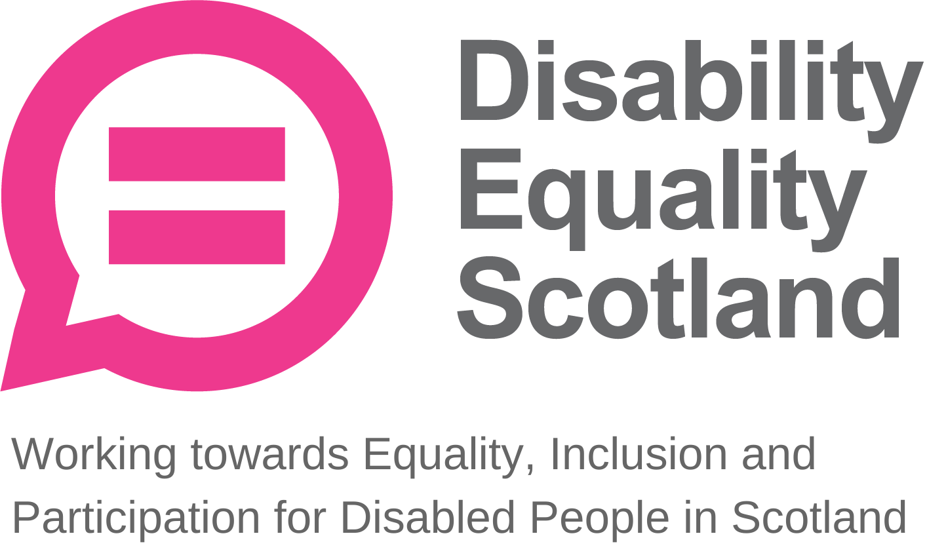
Disability Equality Scotland
Meeting of the Board of Directors
Wednesday 27 October 2021 10.00am
Zoom Virtual Meeting

In Attendance: Linda Bamford (LB) Convener
Scott Stewart (SS) Director
Carolyn Wilson-Smith (CWS) Director
Kenny Milne (KM) Director

Morven Brooks (MB) Chief Executive Officer
Emma Scott (ES) Operations Manager
Ian Buchanan (IB) Access, Training & Engagement Manager
James Davidson (JD) Communications and Research Coordinator
Alistair Bruce (AB) Access and Engagement Administrator
Shona McEwan (SM) Easy Read Worker
Lucy Gibbons (LG) Easy Read Trainer

Apologies: Colin Millar (CM) Director
Rhianne Forrest (RF) Director
Dorothy McKinney (DMcK) Director
Maureen Morrison (MM) Director
Lauren Asher Director

Item 1 Welcome and Apologies

LB welcomed everyone to the meeting and confirmed that the meeting was quorate with four Directors.

LB asked that during discussions if anyone wanted to contribute, they would raise their hands and LB would confirm who wished to contribute and in what order. LB asked everyone to remain on mute unless speaking to limit background noise. During all decision-making, LB will ask who is not in agreement to raise their hand before progressing, and when closing an agenda section, she will ask if there were any further comments before moving on.

It was confirmed that there was no board briefing papers today but added that if any new points were raised that required a decision to progress, the meeting was quorate.

LB stated the agenda timings for the day including the comfort break at 11:00am and close of meeting at 11:30am. LB asked for confirmation that everyone had received their board papers three weeks in advance and had enough information to make decisions and contribute to the board meeting. The board agreed they had.

LB progressed to agenda item 2.

Item 2 Agreement of Minutes from last meeting

LB stated that the minutes were emailed for comment and checking shortly after the July 2021 board meeting and asked for confirmation from the board on accuracy and content.

LB raised a learning point mentioned in the July 2021 minutes regarding a webinar, where a partner had requested, we share the full attendance list and contact details. MB confirmed that we would never share contact details of attendees at our events, however confirmed the names only of those in attendance can be shared for public meetings such as the AGM and with consent for others.

LB confirmed that all actions or matters arising from the minutes had been picked up and asked for agreement of minutes from Directors present at the previous meeting.

Proposed by: CWS
Seconded by: LB

Item 3 Outstanding actions 28 July 2021 Board Meeting

MB confirmed that all actions are closed, but asked IB and JD for a further update on actions 1 and 2.

Action 1 Update: IB provided an update following the Access Language Seminar. IB held the seminar on the 14 October, it was a productive meeting with 17 individual Access Panels represented, which is more than half of the Network. Lots of discussion points came up, not just related to the topic of access language. There were lots of views around the terminology, which we knew already from previous consultation.

IB stated that the high-level feedback was that the word ‘access audit’ is an established term, featuring in the Equality Act terminology. The terminology “access audit” is an established and recognised term used across the UK. The Equality Act 2010 Statutory Code of Practice for Services, public functions, and associations (3.42) does state that service providers will be more likely to meet their obligations if they:
“Carry out and act on the results of an access audit carried out by a suitably qualified person…”.

The Panels heavily disliked the suggestions we had put forward such as ‘lived experience assessment,’ querying why they had to employ a different term just because they are volunteers. It was a unanimous ‘No’ to adopt a new term in this way.

The Panels also dislikes and as such rejected ‘suitably qualified person’ as it could risk creating a two-tiered Network, with ‘qualified’ and ‘unqualified’ persons across Panels.

A Panel member submitted a response paper in advance on who should, and who should not, carry out an access audit. This paper was shared with the Network in advance of the event to allow discussion on the day, and the opinion across the Network disagreed and as such the approach suggested within the paper was rejected due to the numbers (majority) not in favour.

The Panels questioned who would govern such a qualification? and argued that the Equality Act 2010 does not stipulate the need for a specific, formal qualification to fit the ‘suitably qualified person’ description. Panels asking if DES could seek clarification on the term and definition of a ‘suitably qualified person’. IB had agreed to follow this up with the Equality and Human Rights Commission (EHRC) and report back to Panels.

IB added that overall, there was no consensus reached on what sort of language should be used. Panels did like ‘Access Report’, and if any term had to be used, this could be suitable, though they are also happy with the term ‘audit report’. IB concluded that it is such a diverse Network, with such a range of experience and skills, that to restrict terminology to ‘lived experience assessment’ could be an issue and cause confusion for those seeking to engage with Access Panels and looking for guidance and assistance in this area.

IB added that a full summary report will be shared with the board shortly. MB asked for any questions for IB.

LB suggested that the term ‘suitably qualified person’ and how this links to legislation could be a point of unease for the board and Panels. LB asked whether clarification from the EHRC could be helpful here.

SS asked IB for clarification on what organisations tend to expect when they request an audit or report. IB stated that one point of consensus for Panels was, that it does not matter what the assessment is called.
Instead, the methodology for carrying out the assessment, and whether the client is clear on what they are to receive from the Panel (perhaps in the form of a “scope of assessment” or disclaimer) is the most important issue. In a way, discussions around terminology are a distraction.

In terms of litigation, Disability Equality Scotland provides public liability and indemnity insurance, and Panels understand that litigation is a measured risk that comes with carrying out this type of public work, in that one day they may be asked to defend this work in court. If the feedback is made clear that a report is just the perspective from the skills and experience within the Panel, this would not be an issue. IB shared concerns from the Access Panels that discussion around terminology could undermine the legitimacy of Panel work, and that instead the focus should be on skills retention and up-skilling the Panels to carry out this work.

IB added that the majority of businesses and organisations refer to an access audit when seeking this kind of assessment of a premises, for example, if approached by NHS24 or the Police, it is always called as an ‘access audit’. Panels were concerned if a different term was agreed, civic society might question why they are no longer providing the legal requirement referenced in the Equality Act 2010, resulting in Panels potentially missing out on work, paid or otherwise.

LB asked about the scope of our public liability and indemnity insurance in relation to this work. MB stated that this insurance explicitly covers the kind of voluntary work that Panels undertake.

Action 2 Update: MB asked JD to provide an update on the youth membership subgroup held on 6 October.

JD stated that there was good discussion on how to promote the new membership category, and a number of actions for the subgroup to undertake were raised.

For example, linking closer with youth organisations such as YouthLink and Young Scot to ask what kind of content we can take forward. LA suggested connecting with the ‘Year of Stories’ taking place in 2022, as well as looking at new channels and making use of apps such as TikTok to engage with a younger audience. It was however recognised that this kind of work takes time to develop, so it could be possible to promote this content via partner channels. At this stage we need to think about what content we should put together for these channels.

JD added that during the meeting there was general discussion about the benefits we could offer to young people, such as a young access training course to be hosted on our forthcoming e-learning website. Unfortunately, we did not receive funding for a dedicated youth engagement coordinator role, but it was agreed that a workplan for a future funded role is developed; a role which would work with youth organisations and develop dedicated content. Finally, we agreed that we would meet in 5-6 weeks to review the actions.

LB asked if there is an opportunity to reach out to the team leading “The Promise” to make them aware of Disability Equality Scotland’s Youth Membership, which could offer support for disabled children. JD agreed that this would be a good connection to push the membership category.

LB asked for any other questions relating to the action points. No other questions were raised, and LB progressed to agenda item 4, passing over to MB to introduce the paper.

Item 4 Approval of New Members
MB stated that for the period of 1 July 2021 to 30 September 2021, we had 61 new members join, and 1 Corporate Member asked to be removed. This brings our total membership up to 1448.

LB asked if everyone is happy to approve the new members. The board approved the new members.

Item 5 CEO’s Update

MB provided further key updates from her CEO report.

MB plans to meet the CEO of Camphill Scotland on 28 October, after planning to connect for some time about potential inclusive communication work. This follows on from our membership of the Inclusive Communication Alliance, which disbanded following deafscotland closing. MB added that there is an opportunity here for us to start picking up on what happens in this area, for example in working on an Inclusive Communications Bill. MB will update the board on this as it progresses.

MB added on finances that our funding was successful with the Equality and Human Rights Fund, and that the details of all funds will be published in the next week or so. We have been awarded £499,999 for the next three years.

MB updated that she will be meeting with the Scottish Independent Living Coalition, and joined a meeting related to UNCRPD work.

MB and ES met with Vicky Foxcroft MP (Labour’s Shadow Minister for Disabled People) around the national disability strategy for disabled people and Green Paper. MB and ES spent time preparing in advance, but the meeting was less about the National Disability Strategy and more Vicky looking for advice on running accessible events.

It was evident that in Scotland we are further ahead in the development of our Disability Delivery Plan through our discussions with Scottish Government.

MB stated that membership is growing, yet a decrease in numbers is expected in the next quarter due to the cleaning of the membership database, where members have remained uncontactable.

LB asked about horizon scanning and engagement with Sustrans, and whether there is an opportunity for Sustrans to use our Access Panels and/or Membership to inform their projects and assess their design principles. MB stated these meetings have been cancelled but we will contact Sustrans to resume.

MB updated that she has a meeting with Karen Furey, who works on Active and Sustainable Travel at Transport Scotland (TS). They will discuss how Disability Equality Scotland can support TS work on Active Travel and on the Active Travel Delivery Plan. LB suggested DES link Panels in with the work around Spaces for People and to encourage better use of EqIAs for decision-making.

MB mentioned that we have an opportunity to apply for funding to review the place standard tool. LB added that this tool would fit in with work around inclusive environments to support inclusive active travel and our 20-minute neighbourhood work. MB will update ES on this work.

MB concluded her update. MB asked for any questions on the CEO report. There were no further questions.

Operations Manager Report
MB asked ES for any additions to the Operations Manager report.

ES confirmed that we had hosted successful events on behalf of Transport Scotland, on the topic of returning to public transport post-covid, and with Police Scotland on disability hate crime, during National Hate Crime Awareness week. Both were well attended. We also co-hosted an event with the Scottish Government Covid Recovery Bill team.
These events were well attended, and Disability Equality Scotland received good feedback during webinars relating to accessibility, and feedback on the quality of the easy read documents.

The next webinar will take place on 02 November on the topic of on Assistance Cards for Transport Scotland.

We have made good progress with gaining support for the Hate crime charter. ES thanked LB in her role with MACS (Mobility and Access Committee for Scotland) for becoming a supporter. We have also received support from ZetTrans (Shetland Regional Transport Partnership) and Community Transport Association in Scotland taking the total number of supporters of the Charter to 12.

On Face Covering Exemptions Project, we have added a digital download function to the website. This has been highly successful with over 10,000 downloads in the first month. This has dramatically reduced the calls to the Helpline and MB and ES continue to meet with the Scottish Government to keep them updated on the status of this project.

ES noted that the annual members survey closed at beginning of October with over 100 responses. Initial analysis looks positive, and ES will be able to provide detailed feedback soon.

ES is working with our Projects Coordinator on developing a video training resource on disability awareness and hate crime. The aim is to have disabled people on camera talking about their experiences of hate crime and the impact this has on them. Some challenge so far in finding people willing to be filmed. ES asked the Board to consider any individuals they think we could approach.

ES added that the initial work on 20-Minute Neighbourhoods has ended now that the four summer sessions are complete and the findings presented to the National Tenant Information Service Conference. Disability Equality Scotland have had positive feedback on the strong partnership working with the ALLIANCE (Health and Social Care Alliance Scotland) and MACS. Next steps include supporting the production of a final report and disseminating the findings.

Finally, ES gave thanks to the Easy Read team. There has been a huge number of high-profile jobs undertaken in short timescales – well done to SMcE and CJ. Also well done to LGG who has designed and delivered a pilot of our Easy Read Training course and received excellent feedback.

LB added congratulations on easy read work, noting that some of the original documents were not easy to convert due to the complexity of issues. LB also congratulated ES on meeting with Christina McKelvie MSP (early engagement on the Disability Delivery Plan) and suggested it might be good to give reassurance about MS and ES’s meeting with the UK Government representatives (Vicki Fox, MP) evidencing that our work is producing positive results.

SS asked about volunteers for the hate crime video; ES added it is for hate crime in general to provide emotive examples for transport providers to understand the impact of hate crime. SS added that many calls to Disability Information Scotland helpline are examples of neighbour harassment and hate crime. SS happy to offer for people to come speak to us.

MB progressed to IB’s report, asking IB if he had any further updates for the board.

Access Training and Engagement Manager Report

IB stated that he is now through to the second stage of NRAC, with the final submission deadline Friday 29 October. The Board congratulated IB on this achievement, recognising the work he had undertaken to progress to stage 2.

The first Cross Party Group (CPG) on Disability meeting with IB as Secretariat took place in September, with good attendance and speakers. Pam Duncan-Glancy (PDG) MSP spoke about her upcoming young transitions bill. PDG is due to take over the Convenership of the CPG. At that stage is remains unclear if we will continue in our Secretariat position. IB recently met with Jeremy Balfour MSP to plan the agenda for the December meeting. It is the intention to host Shona Robison MSP, but there has been no response to the invitation.

IB updated that responses for the Access Panel survey were low compared to the previous year, which contained more actionable feedback. AB has continued contact with the Panels, so perhaps this has reduced the Panel’s need to respond with feedback.

IB will meet with Form & Function about Access Panel website development work later in November; from what we have seen so far from them this work is promising, including an e-learning website which will give us much more scope to upload DEAL and easy read training, as well as the forum side of things to connect with other Panels across Scotland.

IB visited the Motability offices in Edinburgh Park with Edinburgh Access Panel to conduct an access audit, providing on the day feedback. The building is very accessible and would be suitable for an Access Panel Conference, providing space, parking, electric vehicle charging points and transport links.

IB updated that the Access Panel development has been underway in Inverness and Argyll and Bute Council areas to get new Panels in place. IB thanked AB for taking this work forward as we have received a lot of great feedback here.

CWS added she was aware of some issues locally regarding Motability but that they were agreeable, engaging, and willing to rectify issues.
MB agreed, stating that Motability are a sponsor with Disability Equality Scotland, and there may be an opportunity to connect Access Panels with Motability.

MB asked for any questions on the Access Training and Engagement Manager report.

Item 6 Comfort Break

The board took a short comfort break before progressing to the second part of the agenda.

LB progressed to the Annual Calendar of Activities.

Board Annual Calendar of Activities
LB confirmed that herself and MB reviewed this quarterly along with the risk logs and as part of MB’s interim review and asked if everything remained on target within the annual calendar.

MB stated that we are on track with everything, including performance reviews; finance; and risk review.

LB asked for any questions on the annual calendar. There were no questions from the board.

Quarterly complaints
MB stated that we received one complaint following the AGM this year, a member felt the online event was not accessible for them. Disability Equality Scotland have since agreed to remove the webinar format from our events plan. Discussions also took place on the continuation of online meetings and DES stated that while the Scottish Government still has a ‘work from home policy’ we will align ourselves with this and keep events online-only.

We had talked about a hybrid approach; however, this is not currently in our plans due to government guidance, and we have demonstrated our online events are accessible.

MB had corresponded with this individual and there does now seem to be an acceptance with our position.

SS added that he is fully supportive of our current stance, adding that he would not feel comfortable attending in-person events at this time. MB added that we are also working with clinically vulnerable people and have a responsibility to keep them safe. CWS agreed that the risk could be too high in this regard.

LB asked to move on to the reflective learning log.

Reflective learning log
LB stated that we previously discussed developing a ‘code of conduct” for online events and asked if this was being taken forward. MB added that this was in hand and would be finalised before the next event.

MB asked for any questions from the board on the complaints or reflective learning sections. There were no questions.

Finance
LB asked for additions for finances.

MB added that reserves are building up towards our resilience target due to easy read income and currently sitting at £83,201.25.

MB also gave a brief overview of the budget spends and forecasts then asked for any questions from the board on finances.

There were no questions from the board.

People
MB stated that the organisation is on track with performance reviews; regularly asking for ‘lessons learned’ during staff meetings; and that we maintain good communication between the team working remotely. MB updated on the office, stating that due to COP26, we may have to temporarily close the office, but this should not be an issue in terms of operational activities.

MB asked for any questions from the board on people. There were no questions from the board.

MB moved onto the risk management section.

Risk Management
LB added that both risks (DES05: Finance and DES08: People) have reduced in risk rating, providing background rationale, and asking if the Board and Staff Team were comfortable with this, and if the rationale and risk weighting makes sense. The board were happy with this change and the rationale.

This review brings our overall risk rating down to five, which is very resilient. With the three-year funding, this will help some of that the risks around finance, but some of this funding remains on a one-year basis.

LB asked for any questions around risks and reminded the everyone that the full risk log was available showing the rationale and mitigations to control the risks, impact and likelihood.

Challenges for Next Quarter
MB stated that horizon scanning remains crucial, making sure that we are meeting our aims in our strategic plan. This is the focus for our external stakeholder engagements and meetings will be arranged as appropriate with Minsters and MSPs.

Priorities for Next Quarter
MB stated that next quarter Disability Equality Scotland will be seeking nominations from existing board directors for the office barer positions of Convener and Vice Convener in line with the process laid out in our Articles of Association. This process will run from now until January 2022. This is part of our Board resilience and succession planning as LB and DMcK will be stepping back for the final period of their second term to support the new post holders.

LB requested any existing Directors, who wished to be considered for these positions to self-nominate and encouraged everyone to complete the nomination forms.

MB added that easy read and fundraising strategy development will be a key priority within the next quarter.

MB asked for any questions from the board. There were no further questions.

LB thanked MB for her update.

Item 7 Confirmation of today’s actions

LB shared the following actions that she picked up on:

Action Point 1: IB to share summary report from Access Language Seminar.

Action Point 2: JD to reach out to the board of The Promise to discuss DES work and the young membership category.

Action Point 3: MB to take forward voting for Convener and Vice-Convener roles.

Item 8 AOB
LB asked for any other business from the board.

KM added that the BSL training DES organised was very enjoyable and valuable and thanked the organisation for arranging this.

There was no other business for the board meeting.

LB gave her for thanks to everyone for joining today, adding that it was good to spend more time going over operational reports given how busy the team has been. She concluded by thanking the Team for their contributions and commitment in recognition of the amount of work across several issues aimed at achieving full access and inclusion for disabled people in Scotland.

Item 9 Close
LB closed the board meeting formally.
Minutes reviewed and agreed: 26 January 2022
Proposed: Linda Bamford
Seconded: Scott Stewart
Signed: 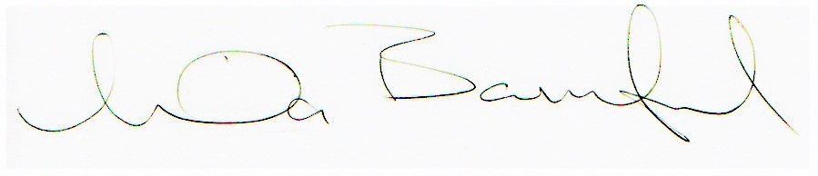
Linda Bamford, Convenor

https://www.equalityhumanrights.com/sites/default/files/servicescode_0.pdf
https://www.equalityhumanrights.com/sites/default/files/servicescode_0.pdf

