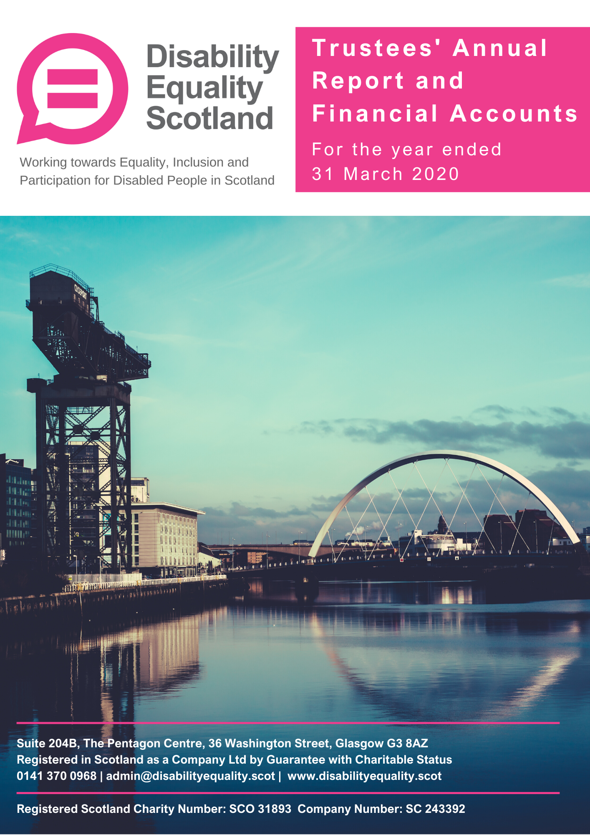

Contents

Page
Report of the trustees 3 to 25
Presentation of Financial Accounts 26 to 27

Introduction from the Convener and
Chief Executive
Moving Forward with Disability Equality Scotland
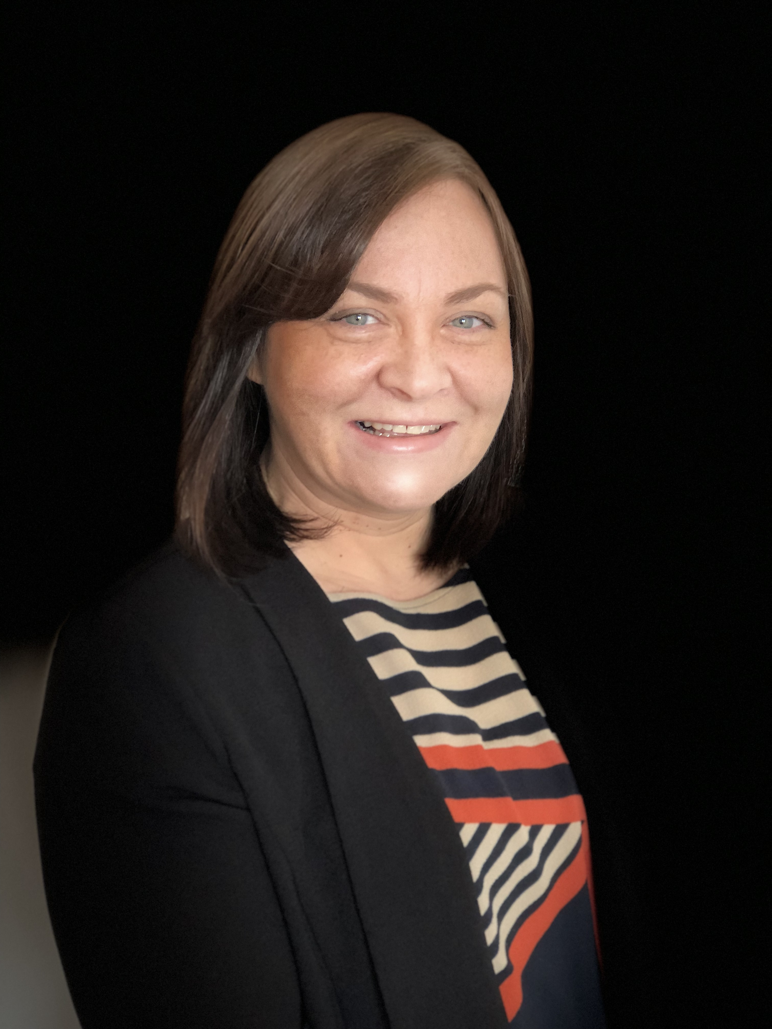
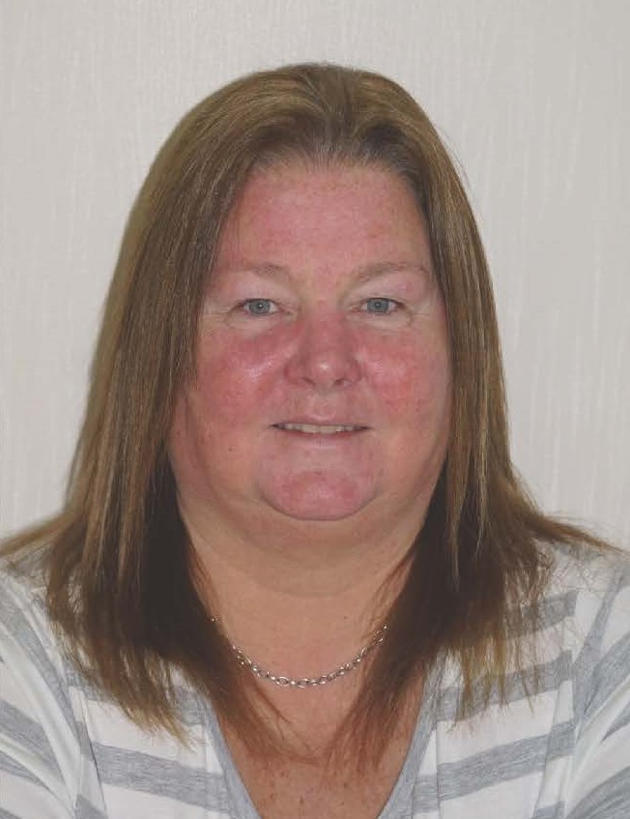
It has been yet another busy and productive year for Disability Equality Scotland.
We strived to improve the lives of disabled people by leading on several projects across accessible transport, hate crime awareness and inclusive communication.
At a local level, Access Panels continued to be a vital resource in improving access to the built environment and wider social inclusion for communities across Scotland. We have taken significant steps to help grow the organisation and identified priority areas that we can focus on going forward.
We have been proactive in engaging and advocating with Scottish Ministers across portfolio areas to ensure the voices of our members was heard and used to inform and influence developing policies such as the Planning (Scotland) Act 2019, Hate Crime Legislation and charter, the Accessible Travel Framework and the National Transport Strategy 2.
Tackling Hate Crime
We launched a successful pilot of our Hate Crime Charter, with three major transport providers. The Charter aims to encourage transport providers, members of the public and other services to support a zero-tolerance approach to hate crime on public transport.
Accessible Travel and Transport
Our work on accessible travel has continued and feedback through our weekly polls indicates the importance of these topics to our members. We have listened to our members’ views on issues like Transport to Health and Social Care, Motability, Passenger Assistance, Thistle Card Assistance, Rail Station Accessibility and relayed these views to key decision-makers on their behalf.
We ensure our member’s views feed into this key policy area, including continuing our work with Transport Scotland’s Accessibility Team on the Accessible Travel Framework’s Annual Delivery Plan, where our work on hate crime was a priority area and we delivered on projects which will benefit disabled people, such as the Hate Crime Charter pilot. This pilot which reached 1.2million passengers and reported directly to the Cabinet Secretary for Justice. We continued to advocate our member’s views on accessible travel by contributing to the Accessible Travel Steering Group and chairing ScotRail’s Stakeholder Equality Group.
We have also continued to work with the Mobility and Access Committee for Scotland (MACS) to ensure our members views and experience underpins the recommendations for improvements and changes needed to progress the transport provision to Health and Social Care facilities and the transparency, flexibility and value for money of the Motability scheme particularly as accountability for this scheme will transfer to the Scottish Government with the devolvement of Disability Assistance (2020-2021).
Demonstrating Digital
We recognise the importance of a strong online presence and we are pleased that our websites themed on accessible transport, inclusive communication and disability hate crime continued to experience increased levels of traffic and engagement.
New Office in Glasgow
We moved to Glasgow from Alloa in September 2019. The new premises offer us a centrally accessible location in Scotland, as well as modern conference and training facilities on our doorstep where we hope to host events and welcome more visitors to see us in Glasgow after COVID-19.
Engaged Board and Robust Governance
We benefit from a fully engaged Board who participate in governance decisions through our board meetings and sub-committee meetings. They have also played an active role in developing our new three-year growth strategy. The skills mix of our Board members gives access to wider knowledge and experience in some of our key areas of work to support our staff team when needed.
Developing our Team
We are a disability confident employer and committed to developing our staff team. This ensures we are well-positioned to offer a wealth of experience and knowledge which will help us move forward into 2020/2021.
The work described within this report was pre Covid-19 and the public health crisis. We have sense checked our recently launched strategy to ensure it remains relevant in light of the changes to respond to the crisis and see opportunities, as the impact of Covid-19 has been disproportionately felt by disabled people, to amplify the changes needed to reduce inequalities as we start to #BuildBackBetter and level up on accessibility and inclusion.
Linda Bamford Morven Brooks
Convener Chief Executive Officer
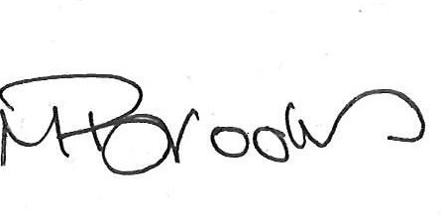

Trustees’ report for the year ended
31 March 2020
The trustees present their report, incorporating their strategic report and financial accounts for the year ended 31 March 2020. The financial accounts have been prepared in accordance with the accounting policies set out in the notes to the financial statements and comply with the charitable company’s Articles of Association and the Companies Act 2006.
Our Vision
Working towards Equality, Inclusion and Participation for Disabled People in Scotland

Objectives and activities
We are a national charity working to make life more accessible, equal, and inclusive for disabled people in Scotland.
Our aim is for every disabled person to have the opportunity to participate in a fulfilling life and to enable them to reach their full potential.
Our Mission
Our mission is to give all disabled people in Scotland a voice with trust, care and empathy.
This annual report covers progress on Disability Equality Scotland’s objectives and activities between 1 April 2019 and 31 March 2020.
Our objectives as set out in our governing document are:
- to promote the benefit of disabled people in Scotland by encouraging communication between disabled people and national and local organisations concerned with the inclusion of disabled people in society.
- to advance the education of the public about disability equality and accessible environments, and to effect positive change in attitude and awareness of disability.

Main Objectives for the Year
Disability Equality Scotland has been involved in many projects, all of which focus on the organisation’s principles to:
- Improve disabled people’s access to participation and engagement in society through increased support, services, and awareness around disability equality.
- Improve understanding and reporting of disability hate crime across Scotland
- Promote connectivity between Access Panels and improve access to support for volunteer members in delivering on equality and inclusion-based work
- Increasing awareness and knowledge of Access, Inclusion and Equality to the Access Panel Network
- Establish a permanent Youth Access Panel in Alloa as a pilot, supporting the local Access Panel with membership, provide a legacy for the Year of Young People, and ensure that disabled young people have a say in their local community
- Planning and design professionals will have access to a range of resources, best practice, advice, and solutions aimed at accessibility / inclusive design.
- Disabled people will have ongoing involvement and further opportunities in providing their views on Accessible Transport in Scotland, contributing to the progress of the Accessible Travel Framework development and implementation.
- Disabled people, transport operators, staff and other stakeholders will have access to accessible travel guidance, information, and signposting via an Accessible Travel Hub.
- There will be a joined-up approach to tackling disability hate crime and negative behaviours towards disabled people on public transport across Scotland.
The following pages are the main areas of work delivered through funding from the Equality Unit, Section 10 (Access Panel Project) and Transport Scotland (Bus, Accessibility and Active Travel Directorate).

Membership
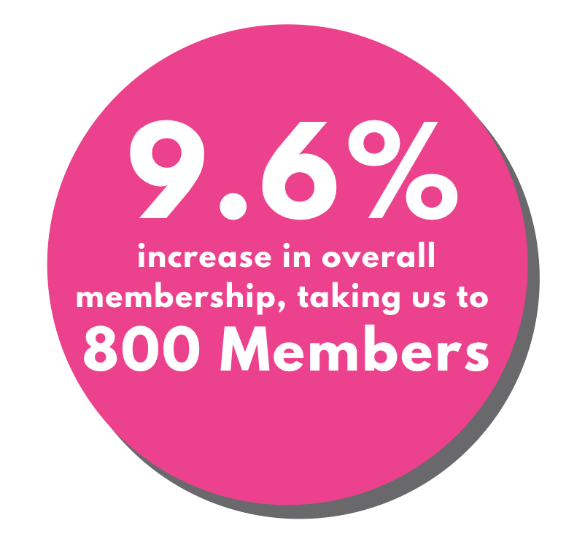
We work with our members to promote equality for disabled people in Scotland.
We regularly ask our members for their views on many diverse policy issues which then directly feed into our policy work and government consultation responses.
We make sure members have opportunities to meet and network with relevant audiences. We help members make the right connections.
During the period from 1 April 2019 to 31 March 2020 we had 70 new members join us, resulting in a 9.6% increase in our overall membership, this brought our membership total to 800 members:
- Individual members: increased by 12.8% from 578 to 652.
- Corporate members: We received 9 corporate membership applications over the year, though 11 corporate members were removed either due to requests from the organisation, or due to the organisation ceasing operation, leaving us with a net decrease of 2. Total 112 Corporate members.
- Access Panels: 2 Access Panel memberships were removed as they had retired from the Panel, there are now 36 Access Panels.
Also note that due to a thorough data clean in preparation for moving to Salesforce customer relationship management database, 6 individual members were removed due to outdated primary and backup contact information.
What difference has our Membership made?
Members are at the heart of all our work and projects. Our members have a direct say in what we do and how we do it, inputting ideas and evidence to direct our work and sharing their lived experiences to allow us to identify what changes are required in our pursuit for full access and inclusion for disabled people.

Disability Equality Scotland News:
Email newsletter and Magazine ‘Open Door’
Disability Equality Scotland News is our members’ monthly email newsletter. It is well received by our members.
"I enjoy getting updates and information via the monthly newsletters and quarterly magazines. Always interesting articles."
“A very interesting edition about inclusive design. Glad we have Scottish tech firms that are leading the way when it comes to accessible design.”
Our Open Door Magazine is our members’ magazine. In the last year, three editions have been published:
Issue 51 - published April 2019: Inclusive Communication

Issue 52 – published August 2019: Accessible Travel

Issue 53 – published December 2019: Hate Crime

“I have just finished reading another excellent issue of Open Door.”
“Thanks once again for a very informative magazine.”
What difference have our Newsletters and Magazines made?
We send Open Door to members, Ministers, key partners, and stakeholders, highlighting and promoting our work widely. Feedback is always very positive.
"Magazine and newsletter are excellent sources of relevant information to me."
To receive a copy of our latest magazine, please sign up to become a member of Disability Equality Scotland. You can do so today for FREE by completing our online membership form http://disabilityequality.scot/membership-application-form/ or contact us direct.

Consultations
From April 2019 to March 2020, we undertook nine full consultations with our members, with 1416 responses received in total. The topics included:
- Automated Vehicles
Consultation responses received across 9 topics
- Motability
- National Transport Strategy
- Disability Assistance
- National Falls and Fracture Prevention Strategy
- Changing Places Toilets
- Building Standards
- Equality and Human Rights Commission Strategic Plan
- Inquiry into the Criminal Justice System

We provided Easy Read versions of each consultation, to make it easier for our membership to respond.
Disability Roadshows
Our roadshows help to bring disabled people together with experts on different topics as well as providing an opportunity to meet with other disabled people.
During the period 2019 to 2020, we delivered four Disability Roadshows across Scotland:
30 May 2019: Rural Banking, Perth
Impact of rural bank closures on disabled people

12 June 2019: Accessibility at the Edinburgh Festival Fringe
Accessibility of venues, booking and the City of Edinburgh

4 November 2019: Transport to Health, Falkirk
Booking and eligibility criteria, rural transport, delays and cancellations
11 March 2020: Gender Inequality, Orkney
In collaboration with the National Advisory Council on Women and Girls (NACWG), focus group with pupils from Kirkwall Grammar School
Access Panels were involved in the planning of the events. Each event welcomed an average of 18 delegates (local disabled people, local authority staff, statutory bodies, MSPs, local private companies and third sector organisations).
What difference have our Disability Roadshow events made?
Our roadshows help to bring disabled people together with experts on different topics and gives an opportunity to mix with other disabled people. The events encourage disabled people to engage with us as an organisation and help to create new memberships. Some feedback from our roadshows include:
“It was absolutely fantastic; really good at explaining how people without disabilities see disabled people.”
“Thank you for an interesting event. Really enjoyed it. Very well organised, inclusive. Great communication.”
“It was great to listen to all presenters. Great opportunity to listen to people with disabilities. Amazing event!!”

Inclusive Communication

Inclusive Communication Hub www.inclusivecommunication.scot
The Inclusive Communication Hub has been redeveloped to align with the six principles of Inclusive Communication, and aiming the content at organisations, while keeping disabled people in mind as the main beneficiaries of this information.
We worked hard to promote the Inclusive Communication Hub and we have given presentations to partners at the Solheim Cup festival in September 2019 and at the launch of the Communication for All Event, by deafscotland. Sense Scotland also continue to promote the Hub at various events and training sessions that they deliver to organisations across Scotland.
We have worked collaboratively with deafscotland and Royal College of Speech & Language Therapists (RCSLT) to further promote and develop good practice for decision makers in terms of quality communications.
We also support the Inclusive Communication Nation Campaign that is developed by the RCSLT. Scotland would be the first nation to remove the persistent and universal barriers to equality and human rights that our present exclusive approach to communication imposes. We use the Inclusive Communication Hub as a platform to promote the campaign.
What difference has our Inclusive Communication Hub made?
We have received a high-profile endorsement from the Minister for Older People and Equalities, Christina McKelvie MSP
“The Inclusive Communication Hub is a lifesaver. Your voice is an important part of who you are, and so that one thing makes it all worthwhile. The Hub provides advice, guidance and support and we are committed to promoting its use, so that more people can have access to the resources and tools available, to improve their communication and make meetings, events and documents accessible.”
Easy Read
www.disabilityequality.scot/easy-read-service
Disability Equality Scotland provides an Easy Read service to all sectors as part of our commitment towards improving access to information for all.
Easy Read is an accessible format that makes written information easier to understand by using simple, jargon free language, shorter sentences and supporting images.
We have worked on 26 Easy Read projects providing Easy Read translations for Scottish Government directorates, and for other partners. These include information on the Human Tissue Scotland Bill, Scotland’s Wellbeing, The National Transport Strategy consultation document, The Scottish Human Rights Commission SNAP2 documents, and work for the National Advisory Council for Women and Girls, Cyrenians and Safe Lives.
We work on the easy read version of the Mobility and Access Committee for Scotland’s (MACS) Annual Report each year. MACS are a non-departmental public body that advise Scottish Ministers of the transport and travel needs of disabled people.
Our dedicated Easy Read worker has promoted our Easy Read service through regular articles in our newsletters and Open Door magazine.
What difference have our Easy Read Service made?
By producing Easy Read documents, we are providing disabled people with the chance to interact and engage with relevant topics and have their views heard. We are encouraged that the Scottish Government continues to recognise the need for Easy Read.
We have received positive comments about our Easy Read Service:
“Thanks so much again – not easy compressing such a policy-laden document into something short, simple and meaningful.”
“Just to confirm we’re delighted with the documents and would love to share this with interested stakeholders.”
Weekly Polls:
www.yoursayondisability.scot
Our weekly polls are a way of gathering feedback from our members on issues that affect everyone. We have conducted 52 poll questions, resulting in a total of 5,597 responses in this reporting period.

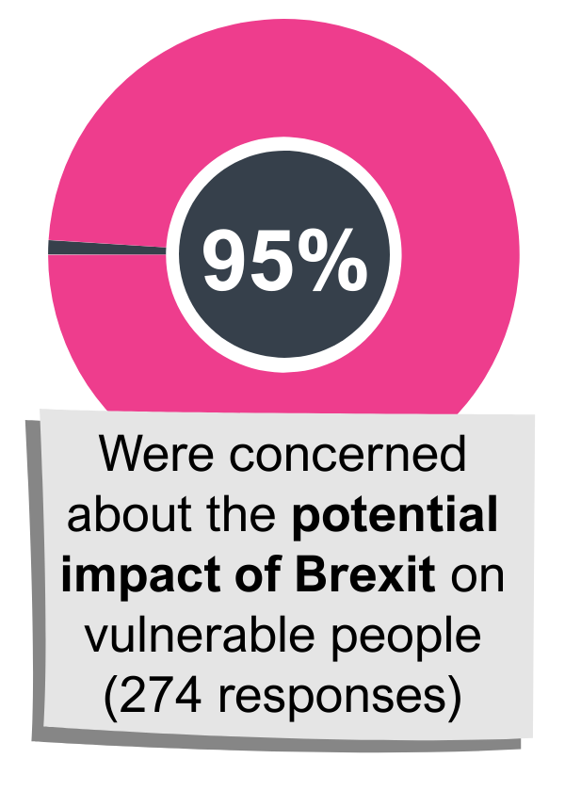
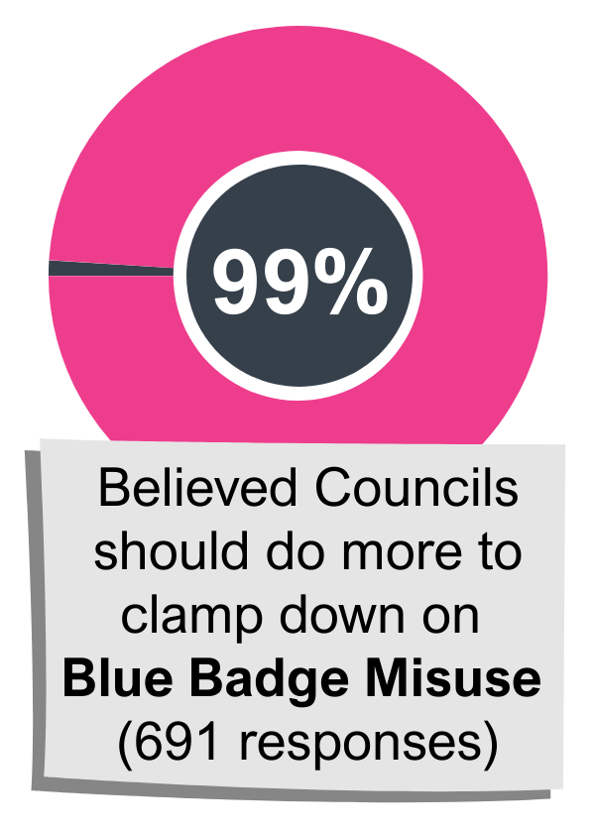
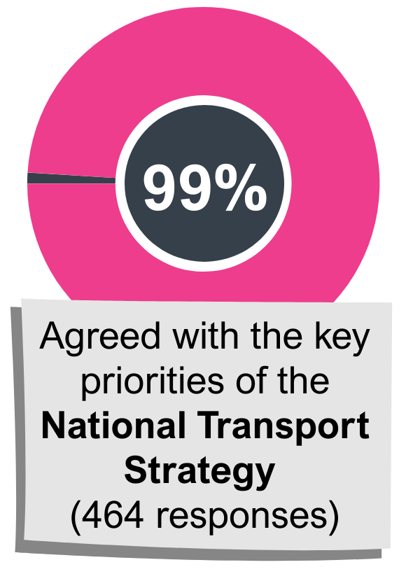
Responses received to weekly polls increased by 128% compared to the previous reporting period. Below is a selection of polls that received high engagement:
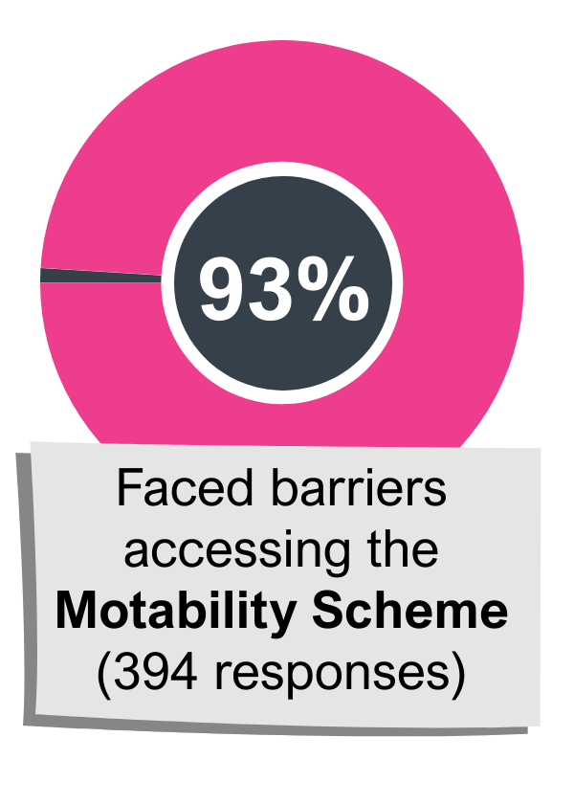
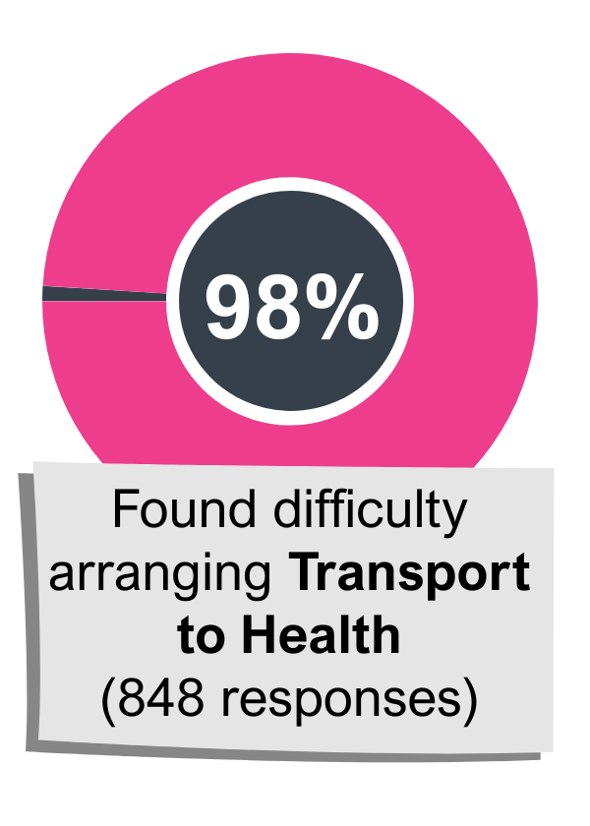

What difference have the Weekly Polls made?
More members have been able to provide their feedback on issues that matter to them and their feedback has been shared with key decision makers and to inform policy development:
Our weekly poll on the closure of BBCs Red Button service, contributed to the campaign to halt the withdrawal of the service, which was led by National Federation of the Blind UK (NFBUK). The poll results were presented by the NFBUK in-front of the BBC Broadcasting House in London.
"Love the opportunity to comment via the Weekly Polls. Keep up the good work!"
"I receive weekly polls, newsletters and e copies of open door. I also find the weekly polls a good way to tell you what matters to me".
"Weekly email through poll questions keeps me up-to-date with the latest disability news and SG consultations, events etc."

Disability Hate Crime
www.disabilitysafety.scot
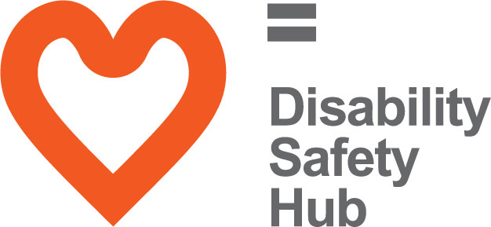
The Disability Safety Hub launched in October 2018 to coincide with National Hate Crime Week.

This hub has two main aims:
- To raise awareness of disability hate crime, helping disabled people to understand what a hate crime is.

- The Hub also wants to help disabled people to report hate crime and shows the different ways you can do this.
On this Hub you will find helpful resources, including case studies and videos of disabled people talking about their own experiences of hate crime.

What difference has The Disability Safety Hub made?
We received positive feedback since the launch of our Disability Safety Hub.
“The website looks great so far, well done on working on it and creating a useful resource for disabled people who face hate crime or want more information about it.” CSREC
“I can see much work has gone into this and this is impressive.” Scottish Ambulance Service
“New web site looks good and much welcomed.” DES member
“Great work, web site is fantastic.” DES member

Accessible Travel
www.accessibletravel.scot
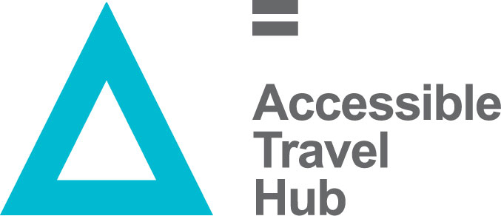
This year, we held three events, bringing together disabled people with transport providers, to discuss experiences of public transport in different regions around Scotland. Events were held in:
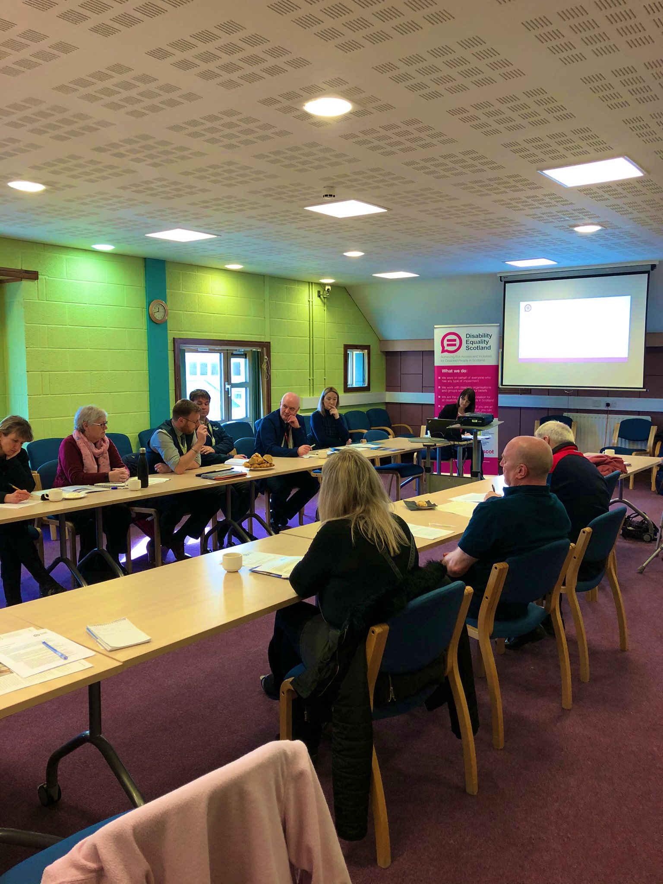
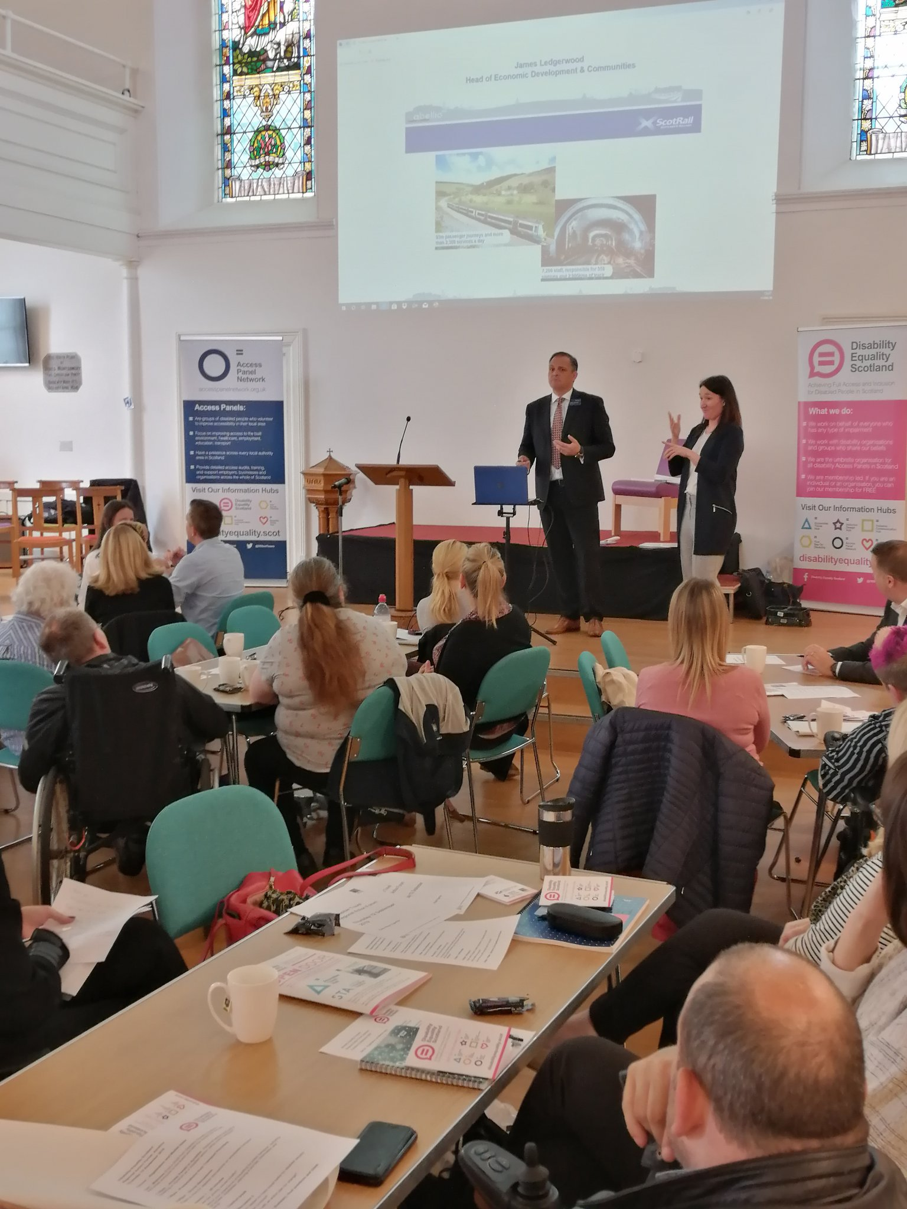
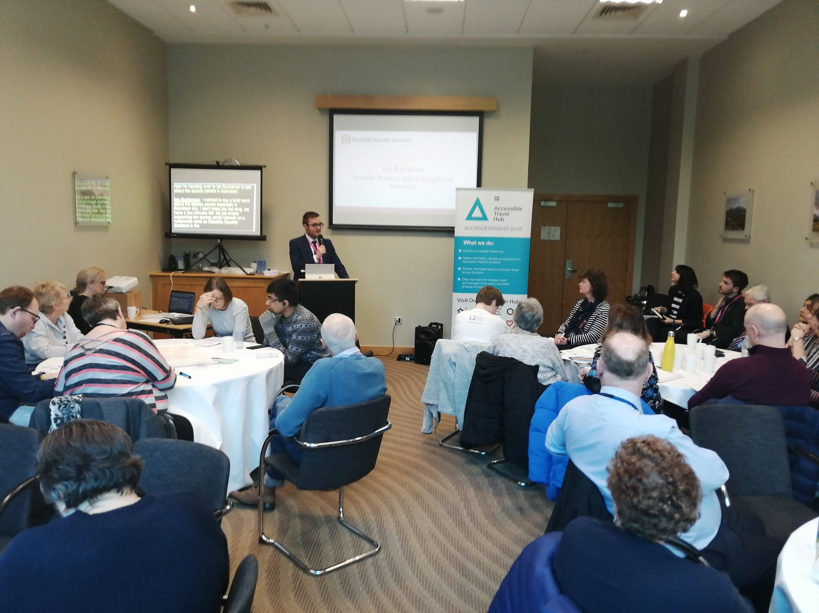

Ayrshire,
12 September 2019

Aberdeen,
19 February 2020

Orkney,
10 March 2020

In total, we engaged with over 100 people, which includes disabled people, transport providers, local authorities, and equality groups about their experiences of accessible travel in their local areas.
Each event had presentations from a number of providers including Stagecoach, ScotRail, Glasgow Airport, Firstbus, NorthLink Ferries, CalMac and Community Transport providers.
What difference have the Accessible Travel Events made?
“Well done in all aspects of the meeting. I thought you all did an amazing job. We all felt very comfortable throughout meeting.”
“Great to interact with different user groups and meet new people.”
“Great that group discussions are not just or only about physical disabilities.”

Hate Crime on Public Transport
During 2019 and 2020 we built on the results of the three public consultation events which took place at the end of 2018. We used the learning from these events to develop and then pilot a hate crime charter for public transport.
We successfully piloted the Hate Crime Charter with three providers between October and December 2019. These were:
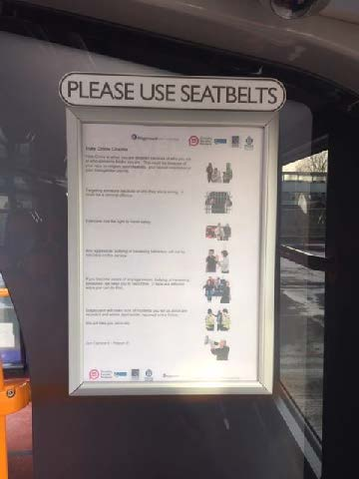
Stagecoach
Stagecoach launched their pilot on 21 October 2019. The pilot launched from their Aberhill depot in Leven, Fife on 75 of their buses.
The Charter was printed in A4 size, and contained simple text accompanied by Easy Read images. It was displayed on the bulkhead (at the stairwell).
The pilot ran for eight weeks over Christmas 2019. Feedback from Stagecoach revealed that 731,402 passengers travelled on buses displaying the Charter, demonstrating its potential reach.

First Bus
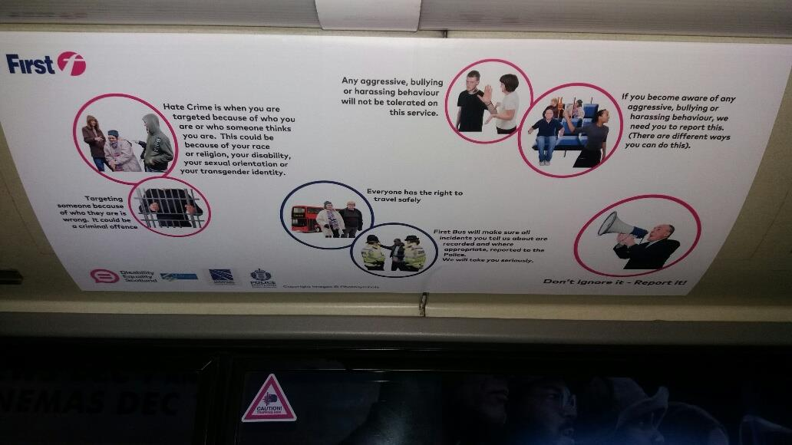
FirstBus launched their pilot from Bannockburn depot, which was seen as an easy and contained site from which to run a pilot. This design was displayed in the coving space, running the length of the inside of the bus. The design uses the Easy-Read images, but with each appearing in a coloured circle. This was displayed on 50 buses in the eight-weeks over Christmas. Feedback indicates that 524,264 passengers were exposed to the messaging over the pilot period.

ScotRail
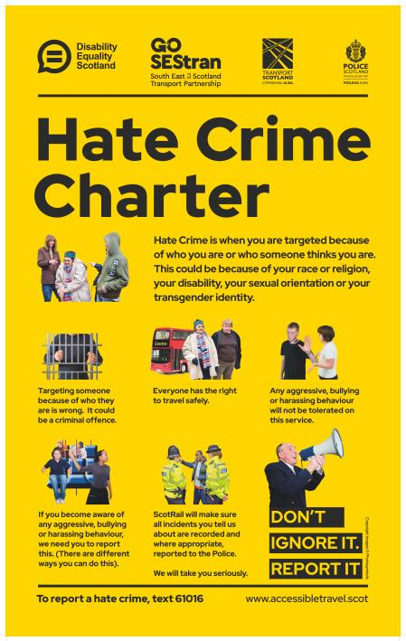
On advice from ScotRail it was agreed the Fife Circle line, with 11 stations was the best place to host a Charter.
Disability Equality Scotland worked with a designer to put the Hate Crime Charter into a format suitable for the station environment, and on the designer’s recommendation, used eye-catching colours of yellow and black, which are dementia friendly to showcase the information. The pilot posters were printed and sent to stations on the Fife Circle during week commencing 9 December 2019.

What difference has the Hate Crime Charter made?
The Hate Crime Charter pilot reached over 1,255,671 passengers in an eight-week period.
The British Transport Police can tell us that 24 reports of hate crime were made during our pilot period. Of these, one came from the pilot area of Fife; specifically, Kirkcaldy train station where our poster was on display.
Awareness has been raised amongst transport staff who feel better equipped to recognise and report hate crime. There is also an acknowledgement from staff that they would benefit from further training. At the pre-pilot stage, 49% wanted further training; by the end of the pilot this figure was 79%.
Interest in the Charter has reached beyond transport providers, with requests from the Scottish Football Association to discuss producing a similar Charter for use in stadiums.

Inclusive Design Hub www.inclusivedesign.scot

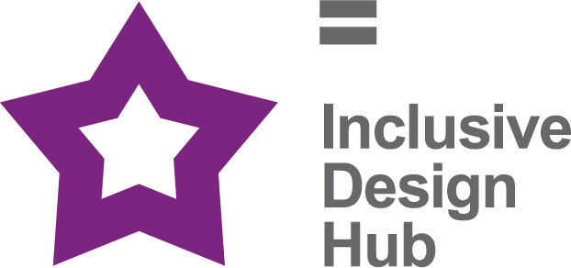
The Inclusive Design Hub is a resource that aims to improve awareness and take-up of best practice in inclusive design for planners, developers, architects, and building professionals in Scotland. The website includes information, articles, access guides, and case studies of best practice. The Inclusive Design Hub will help built environment professionals deliver inclusive environments.

Feedback
The Inclusive Design Hub has received positive feedback and constructive comments, such as additional content and changes to the design and layout:
- Adding additional resources/case studies/news items.
- Suggestions of individuals and organisations to contact for content and to help promote the Inclusive Design Hub.
- Increase accessibility

Monitoring and Future Plans
Content: The Inclusive Design Hub will be updated and revised on an ongoing basis. A feedback form has been created to allow users to submit any comments and suggestions to help to improve the website.
Continue to add fresh content. It is vital to keep users interested so that they are encouraged to come back, as well as recommend the website to others.

Access Panel Network
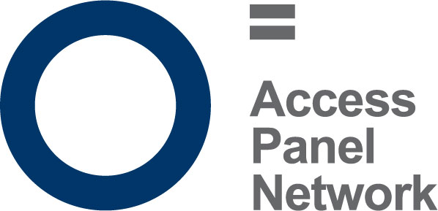
An Access Panel is a group of volunteers, the majority of which are disabled people, or are directly affected by disability, perhaps as a carer or family member. They meet on a regular basis, usually monthly, to discuss issues in their local community which affect disabled people, and work towards removing barriers to independent living in their own locality, to ensure disabled people have access to the same choice, dignity and control as others in our society.
There are currently 36 active Access Panels across Scotland, from Barra and Orkney, to the Scottish Borders and everywhere in between. Panel membership varies between 5 and 150 disabled members, and it is estimated that there are around 1000 Access Panel members in total. Not all members are actively involved volunteers, and many contribute in other ways towards their panel, by sharing information, or participating in consultations; other members may simply wish to be kept informed of disability work in their area.
Access Panels are fully constituted members of Disability Equality Scotland. To be a member a Panel must be recognised by their local authority and be properly constituted. All Panels have access to the Access Panel Grant, provided by the Scottish Government, and administered by Disability Equality Scotland who act at the Umbrella Body for the panels. Access Panels can also access other funding, depending on their status, including local councils, the Big Lottery or other funding resources. Some receive benefits in kind, for example office accommodation or other support. The Office Bearers of each Access Panel oversee the strategic development, finances, management of operations and engagement.
As Panels have typically grown organically around the needs of their locality, they vary greatly in their focus and remit however, they are primarily committed to improving access and equality in its widest form which means access to the physical environment, Education, Housing, Health, Transport, Leisure & Recreation and Social Justice amongst other areas.

Access Panel Grant

Overview and Progress
The Access Panel Grant (APG) is a fund designed to help increase the capacity and outreach of Access Panels right across Scotland. The majority of Access Panels are staffed solely by volunteers who are passionate about increasing access and social inclusion for disabled people in their community. For the period 1 April 2019 to 31 March 2020, £45,000 was received by Disability Equality Scotland from the Equality Unit, The Scottish Government.
Access Panels face many challenges (ageing volunteers, lack of younger volunteers, difficulties in reporting, geographical spread) the Access Panel Grant has been a lifeline for many Panels who would have otherwise faced a year without funding. Its allowed Panels across Scotland to continue the vital work that they have been doing for over 30 years and to build on that success.
Staffing
We have changed a lot in the past year in line with our growing strategic aspirations, and our success is down to the talents and diversity of our staff. That is why we value and develop our employees to succeed in their careers, as well as contribute to our success. We aim to provide purposeful work, along with the structure and skills to make a difference.
Most notably after 15 years’ service, Maeve Bain, Senior Administrator left Disability Equality Scotland prior to our relocation to Glasgow. Her dedication and length of service to the organisation was commendable and highly recognised by staff and directors. Staff who also left during this period, Gillian Smith Events Training and Membership Administrator and Anne-Marie Martin Investing in Access Project Worker. Both provided valuable support to Access Panels and the organisation, there contributions were recognised by staff and directors.

Structure, governance and management
Disability Equality Scotland was established under a Memorandum of Association which established the objects and powers of the charitable company and is governed by the Articles of Association.
Disability Equality Scotland is a charity limited by guarantee and has no share capital. The liability of each member in the event of winding up is limited to £1.

Recruitment and appointment of new trustees
Although not a public body, our board recruitment is competency based.
The skills, knowledge, and experience on our board during 2019-2020 include HR Management, Governance, Strategy Planning, Business Management, Risk Management and Business Continuity Planning, Inclusive Design Principles, Equalities, Access Panel involvement and personal lived experience as a disabled person.
Board members serve a term of three years and are voted in at our Annual General Meeting. The role of the Board is to oversee the work of the organisation and to make strategic decisions about its future.
Our Convener leads the board and offers support to our Chief Executive Officer.

Our Funding

Promoting Equality and Cohesion Fund, The Scottish Government
For this project, we are committed to engaging and disseminating information to disabled people through our publications and online newsletters, easy-read briefings, and events.
We also stated we would improve Access to Social Justice for disabled people, through representation of their views, needs and rights and by supporting the work of those committed to improving equality and inclusion in Scotland.
Finally, we would administer the Access Panel Funding Grant to support and protect ongoing volunteer work, to reduce barriers to inclusion and equality at local and national levels.

Section 10, The Scottish Government
We are the umbrella organisation for Access Panels across all of Scotland and work with other partners to improve access and inclusion. We work to empower and promote the rights of disabled people. Our role is to influence and effect change, both locally and nationally, through the network of Access Panels and to support them to work in partnership to address local issues.

Accessible Transport for Disabled People Grant Funding, Transport Scotland
The aim of this project is to work with Transport Scotland and relevant groups to improve the accessibility of transport in Scotland. Our role is to ensure disabled people are informed and included in each stage of the process, including proposing the issues to agreeing actions, to monitoring and feeding back on successes and areas for improvement

Reference and Administrative Details
Registered Company number
SC243392 (Scotland)
Registered Charity number
SCO31893
Registered office
Suite 204B, The Pentagon Centre, 36 Washington Street, Glasgow G3 8AZ
Board of Trustees
The following trustees served on the board from 1 April 2019 to 31 March 2020.
- Linda Bamford (Appointed 14 November 2016)
- Dorothy McKinney (Appointed 30 March 2017)
- Janis McDonald (Appointed 5 December 2017)
- Maureen Morrison (Appointed 4 December 2017)
- Scott Stewart (Appointed 5 December 2017)
- Susan Fulton (Appointed 24 May 2018)
- Kenny Milne (Appointed 17 May 2018)
- Carolyn Griffiths (Appointed 4 May 2018)
- Colin Millar (Appointed 4 May 2018)
- Steven McGhee (Appointed 4 May 2018, Resigned 1 July 2019)
Independent examiner
Community Accountancy Scotland, Cameron House, Forthside Way, Stirling, FK8 1QZ

Approved by order of the board of trustees on ..24 August 2020......................... and signed on its behalf by:
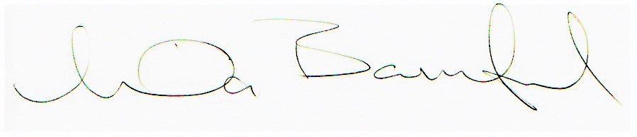
Linda Bamford, Trustee

Presentation of Financial Accounts
1 April 2019 - 31 March 2020
Income 2020 2019
General Fund (Unrestricted Fund) £18,480 £13,632
Bank Interest £0.00 £2.00
Restricted Fund £269,860 £282,858
Scottish Government Equality Unit £95,000 £95,000
Access Panel Grant £45,000 £46,249
Scottish Government Section 10 £80,132 £80,132
Transport Scotland £49,728 £49,798
Awards for All £0.00 £8,900
Community Jobs Scotland £0.00 £2,778

Total Income £288,340 £296,492

Expenditure 2020 2019
Charitable activities
Allocated to Access Panel Grant £26,862 £27,370
Salaries £164,882 £163,387
Employers National Insurance contribution £11,015 £13,972
Employers Pension contribution £10,298 £7,948
Rent and service charges £12,990 £14,860
Telephone £2,994 £1,256
Postage and stationery £6,691 £5,454
Subscriptions. recruitment and training £7,164 £6,526
Travel and subsistence £13,782 £14,291
Computer expenses £5,739 £9,267
Interpretation £2,621 £2,438
Bank charges £97 £71
Depreciation of tangible fixed assets £107 £0.00
Accountancy Fees £6,112 £3,242
Legal and Professional Fees £2,524 £3,406
Insurance £5,224 £5,533
Events, room hire & conference £6,913 £12,390
Governance £1,025 £260
Total £287,040 £291,671

2020 2019
Net income / (expenditure) £1,300 £4,821
Balance Sheet
as at 31 March 2020

Current assets
Debtors £3,893 £3,020
Cash at bank and in hand £89,733 £51,061
Total current assets £93,626 £54,081

Creditors
Amounts falling due within one year £44,224 £5,822

Total assets less current liabilities £50,075 £48,259

Funds
Unrestricted funds £18,202 £17,427
Restricted funds £31,873 £31,348
Total funds £50,075 £48,775
Full financial statements which have been examined by Community Accountancy Scotland are available from the company on request.

Disability Equality Scotland
Scottish Charity Number: SC031893
Suite 204B
The Pentagon Centre
36 Washington Street
Glasgow
G2 8AZ
Tel: 0141 370 0968
Email: admin@disabilityequality.scot
Facebook @DisabilityEqualityScotland
Twitter @DEScotTweets
Website: www.disabilityequality.scot

Our Sponsors
We are grateful for the generosity of our sponsors from 1 April 2019 to 31 March 2020:
- AccessAble
- Blackwood
- Clyde Shopmobility
- deafscotland
- Edinburgh Fringe
- Enable (Falkirk Branch)
- Humanism in Scotland
- Lothian
- Motability
- NHS 24
- RBS
- SEStran
- SPAEN

