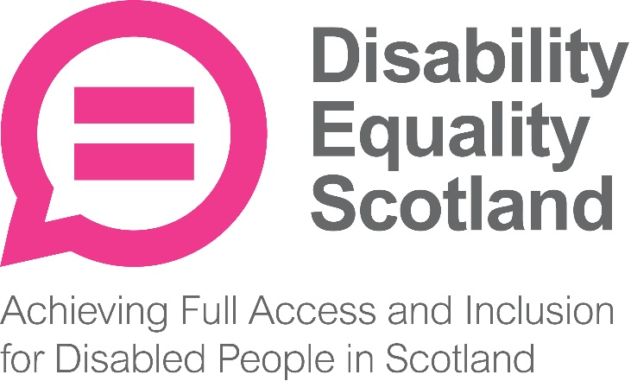

Disability Equality Scotland
Trustees’ Annual Report and Financial Accounts
For the year ended 31 March 2019
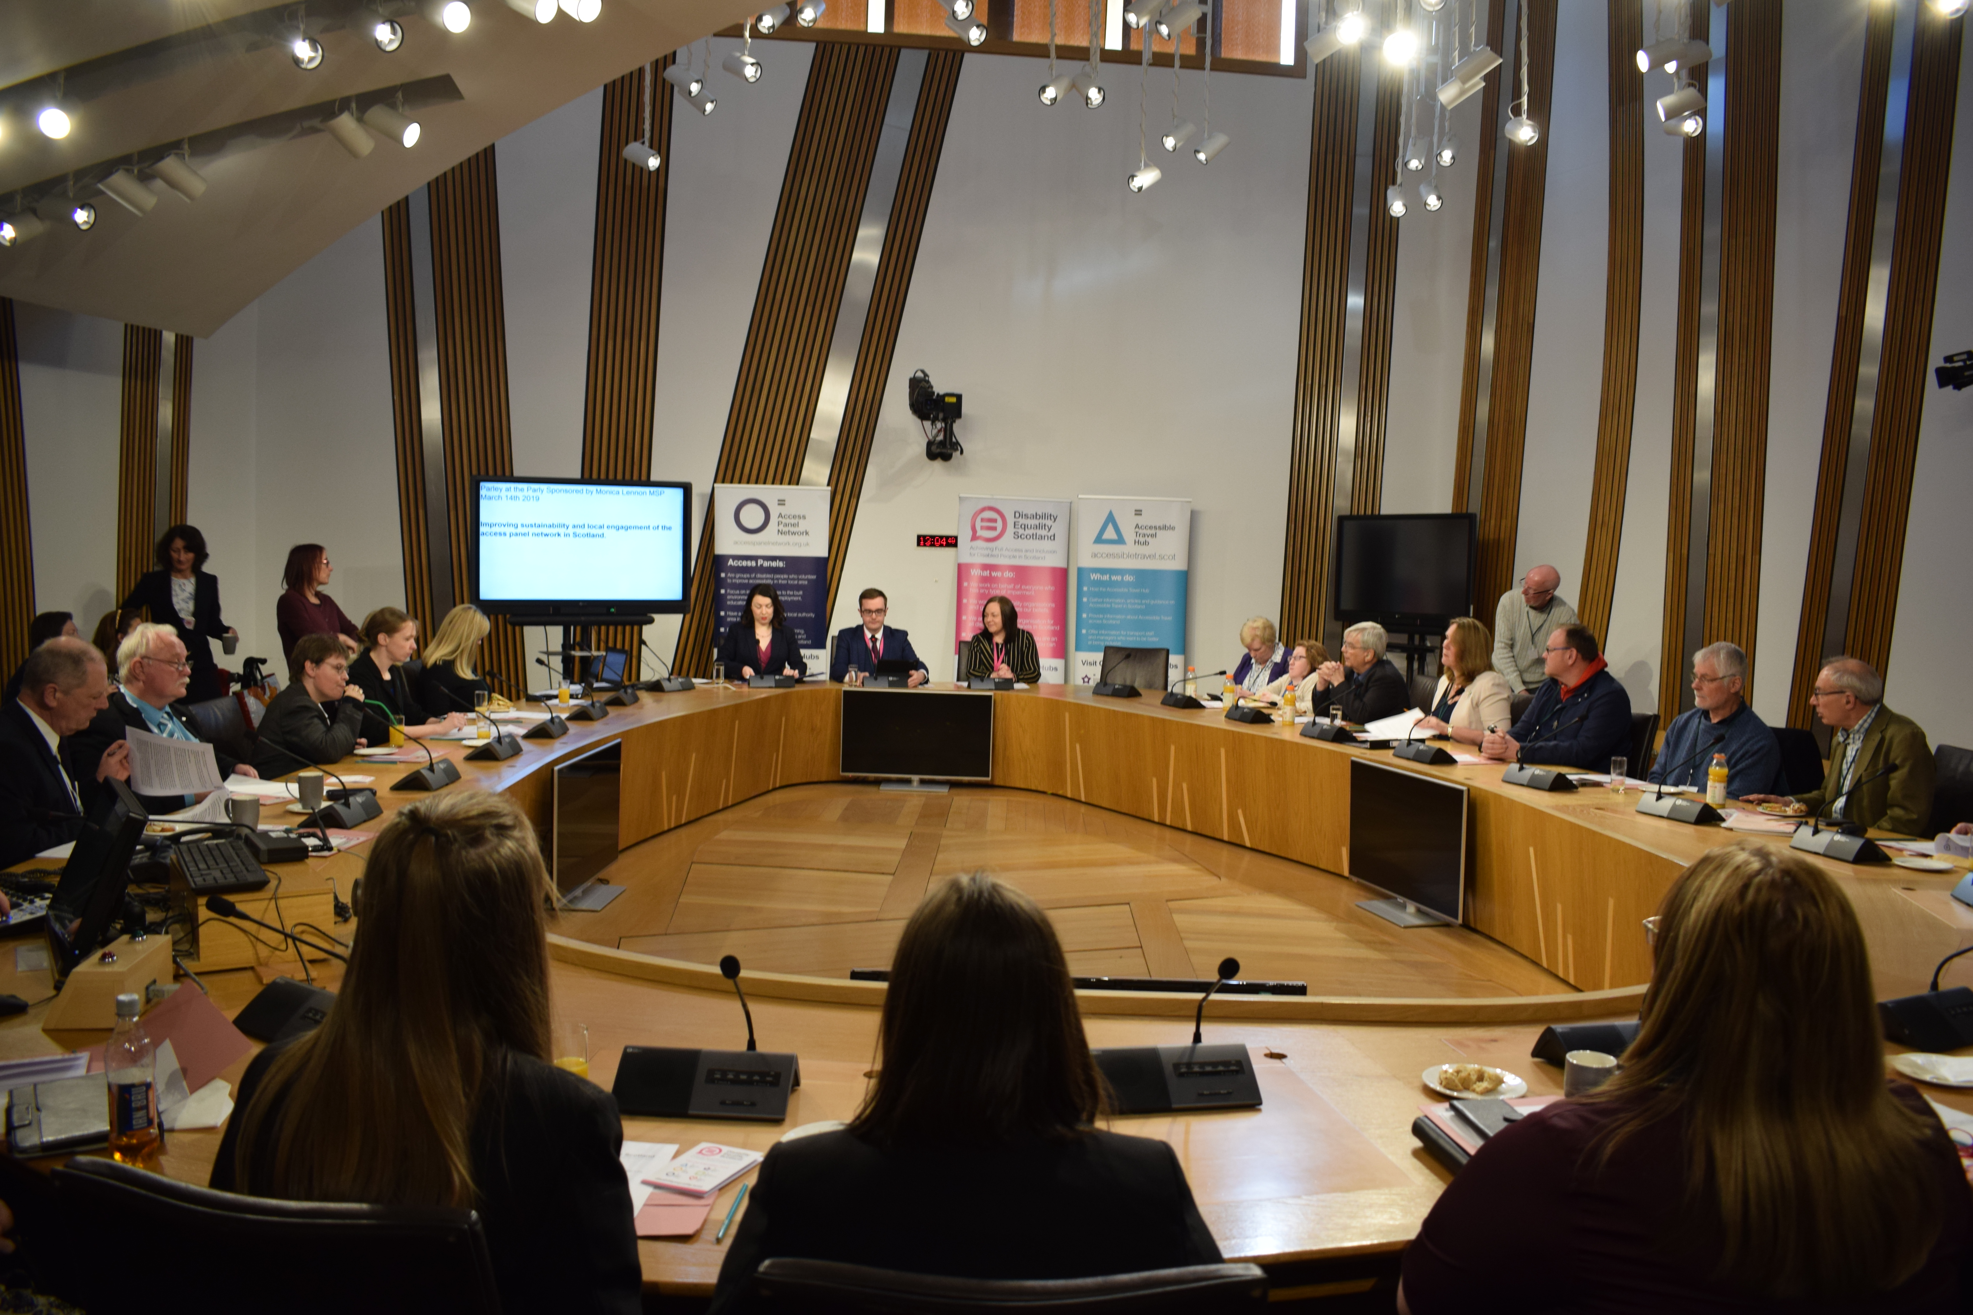

Contents

Page
Report of the trustees 3 to 20
Presentation of Financial Accounts 21 to 22

Introduction from the Convener and
Chief Executive
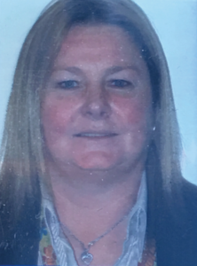
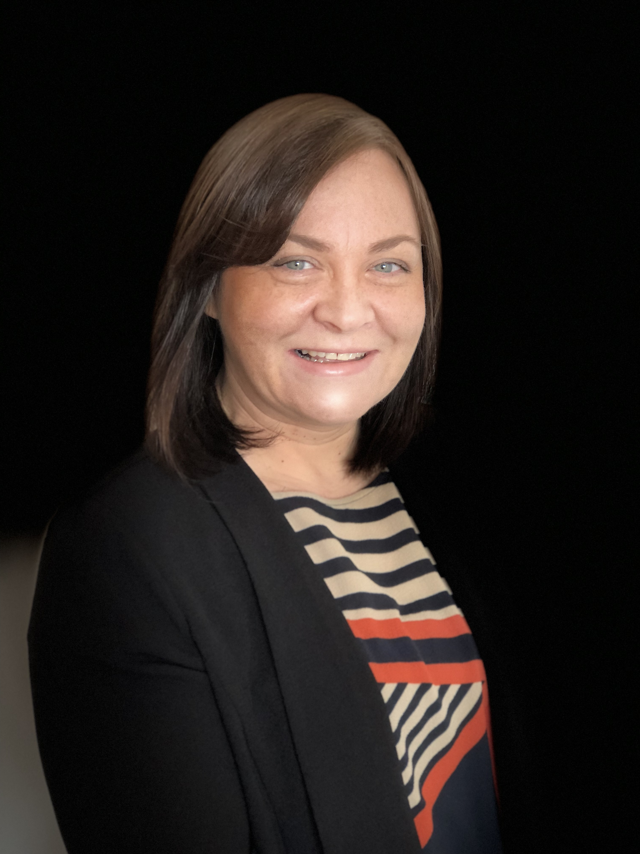
Disability Equality Scotland has had a fantastic year this year.
A year that has seen the Board stabilise and the staff team get down and get on with delivering on the day job.
We again raised our profile with key stakeholders including the Scottish Government and Scottish Ministers.
This allowed us to make sure we get opportunities to pass on what you are telling us needs to change or needs more focus to deliver full access and inclusion for disabled people in Scotland.
The Board of Directors and staff team have met several times this year; during board meetings, strategy days and where the Board have had the opportunity to support our team and the great work they do at external engagements.
The Board has also undertaken further refresher training on Governance to ensure we deliver on our remit of providing good governance and strategic oversight to the organisation.
This year’s activities has allowed us to get to know each other more, get to know the staff team better and challenge each other more confidently (a good thing), agreeing what’s best for our members and our organisation. We truly value the diversity we have within the staff team and the board.
A quote from our Vice Convener Dorothy McKinney:
“Diversity is the art of thinking independently together”
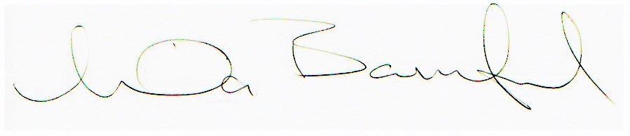
Linda Bamford Morven Brooks
Convener Chief Executive Officer
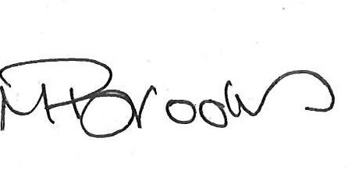

Trustees’ report for the year ended 31 March 2019
The trustees present their report, incorporating their strategic report and financial accounts for the year ended 31 March 2019. The financial accounts have been prepared in accordance with the accounting policies set out in the notes to the financial statements and comply with the charitable company’s Articles of Association and the Companies Act 2006.

Objectives and activities
Our Vision
A better life for disabled people.
We are a national charity working to achieve full access and inclusion for disabled people.
We promote access in its widest sense, including access to the built and natural environment and access to the same opportunities that are enjoyed by others in our communities; promoting a life of dignity, respect and independence.
Our Mission
“Achieving full Access and Inclusion for disabled people in Scotland.”
Our aim is for every disabled person to have the opportunity to participate in a fulfilling life. We represent the views of individuals with any type of impairment, as well as disability organisations and groups who share our values.
This annual report covers progress on Disability Equality Scotland’s objectives and activities between 1 April 2018 and 31 March 2019.
Our objectives as set out in our governing document are:
- to promote the benefit of disabled people in Scotland by encouraging communication between disabled people and national and local organisations concerned with the inclusion of disabled people in society;
- to advance the education of the public about disability equality and accessible environments, and to effect positive change in attitude and awareness of disability.

Main Objectives for the Year
Disability Equality Scotland has been involved in many projects, all of which focus on the organisation’s principles to:
- Promote and raise awareness of equality and access Scotland-wide.
- Improve access to participation and engagement for disabled people in issues, which affect them on a local and national level.
- Promote action to make Scotland, Scottish institutions and services more accessible to disabled people.
- Promote accessibility and equality amongst employers across all sectors, encouraging meaningful and long-term employment for disabled people
- Build good relationships with key players in the disability field and identify opportunities for partnership working.
The following pages are the main areas of work delivered through funding from the Equality Unit, Adult Care and Support (Access Panel Project) and Transport Scotland (Bus, Accessibility and Active Travel Directorate).

Membership

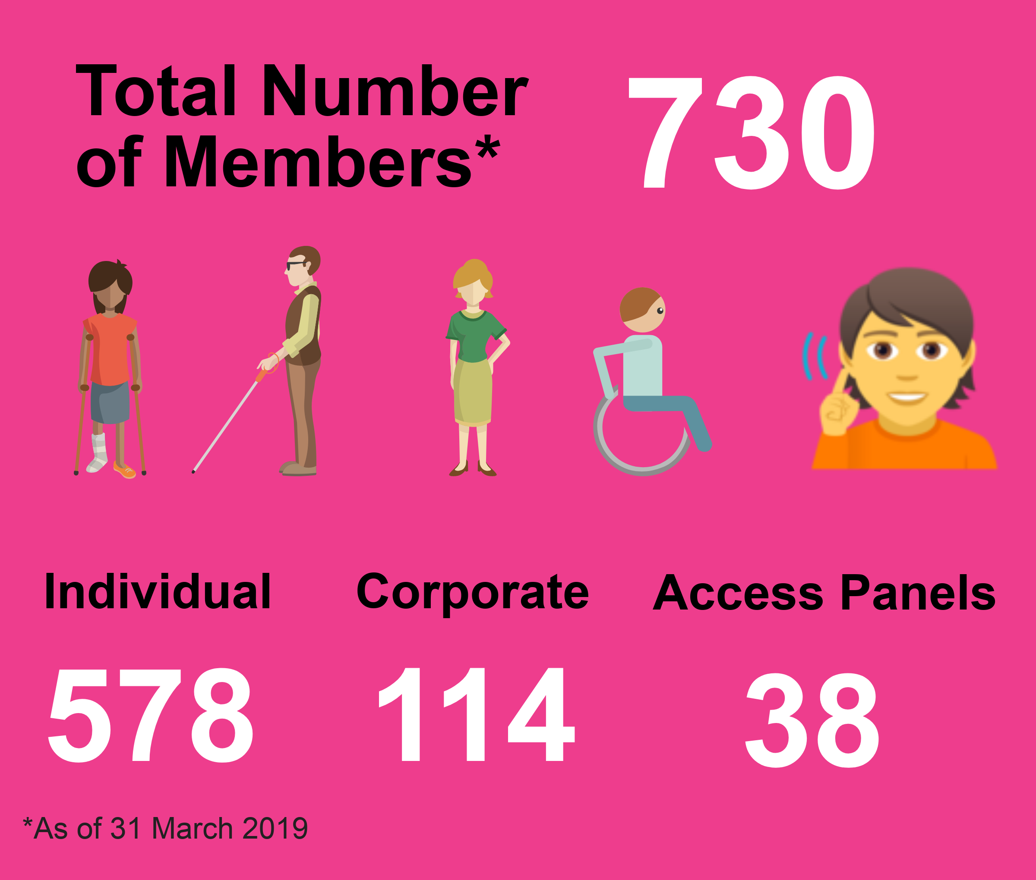
We work with our members to promote equality for disabled people in Scotland.
We regularly ask our members for their views on many diverse policy issues which then directly feed into our policy work and government consultation responses.
We make sure members have opportunities to meet and network with relevant audiences. We help members make the right connections.
During the period from 1 April 2018 to 31 March 2019 we had 83 new members join us. (68 Individual and 15 Corporate), resulting in a 13% increase in our overall membership, this brought our membership total to 730 members:
- 578 Individual members
- 114 Corporate members
- 38 Access Panels
What difference has our Membership made…
Members are at the heart of all our work and projects. Our members have a direct say in what we do and how we do it, inputting ideas and evidence to direct our work and sharing their lived experiences to allow us to identify what changes are required in our pursuit for full access and inclusion for disabled people.

Disability Equality Scotland News:
Email newsletter and Magazine ‘Open Door’
Disability Equality Scotland News is our members’ monthly email newsletter. It is well received by our members.

“Thanks for the newsletters – they’ve been really useful – always something in them to pass on to colleagues or people we support!”
Our Open Door Magazine is our quarterly members’ magazine. In the last year, four editions have been published:
- Issue 48 published April 2018
- Issue 49 published July 2018
- Issue 50 - 'bumper 50th edition' published December 2018
- Issue 51 - published April 2019
What difference has our Newsletters and Magazines made…
We send Open Door to MSPs and key partners, highlighting and promoting our work widely. Feedback is always very positive.
“What an incredibly informative magazine – very well done.”
All issues of Open Door can be accessed on our website: http://disabilityequality.scot/information/open-door-magazine/

Consultations
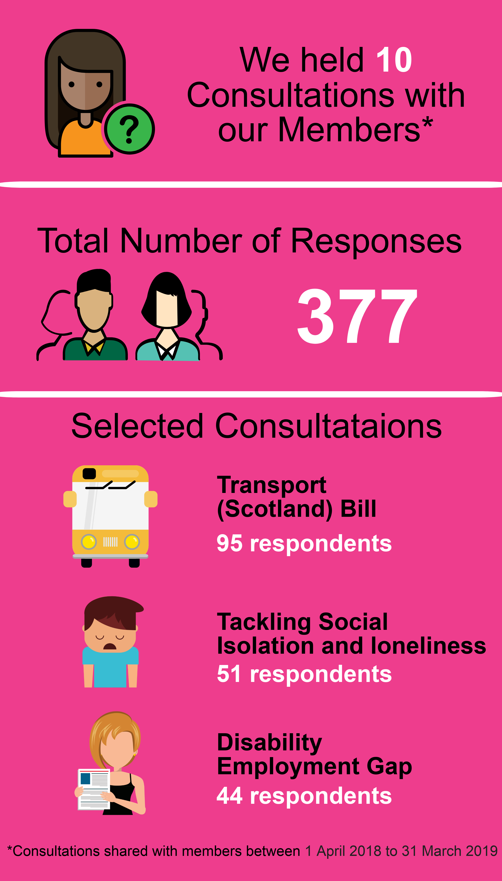
From April 2018 to March 2019, we undertook ten consultations with our members. The topics included:
- Social Isolation and Loneliness strategy
- Scottish Health Council Draft Strategic Plan
- Democracy Matters
- Changing Scottish Hate Crime Legislation
- Disability Employment Gap
- Automated Vehicles - Scottish Law Commission
- Transport Bill - pavement parking
- EHRC Draft Strategy
- Primary Care
- Contacting Police Scotland

We provided Easy Read version of the consultation, to enable our membership to respond.
Disability Roadshows

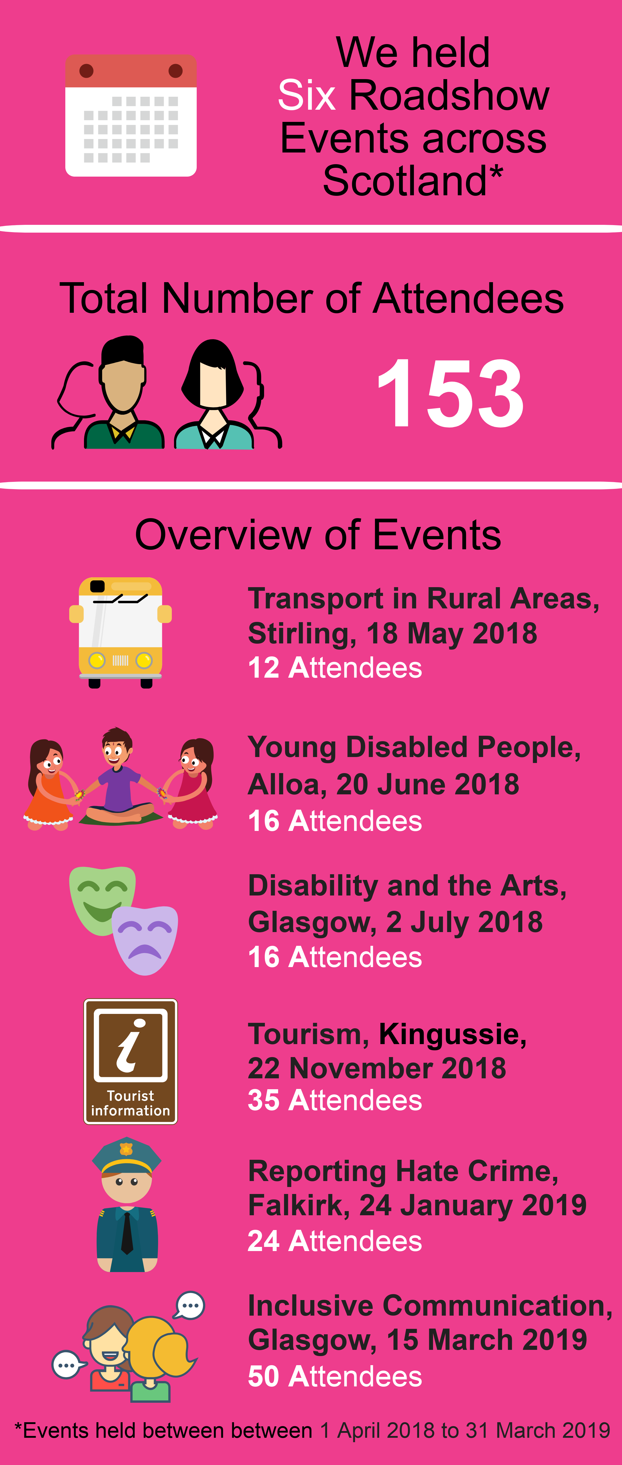
Our roadshows help to bring disabled people together with experts on different topics and gives an opportunity to mix with other disabled people.
During the period 2018 to 2019, we delivered six Disability Roadshows across Scotland:
Access Panels were involved in the planning of the events. Each event welcomed an average of 30 delegates (local disabled people, local authority staff, statutory bodies, MSPs, local private companies and third sector organisations).
What difference has our Disability Roadshow events made…
“Thank you for an interesting event. Really enjoyed it. Very well organised, inclusive. Great communication.”

Inclusive Communication

Inclusive Communication Hub www.inclusivecommunication.scot
We have continued to work with our partners at Sense Scotland in developing the Inclusive Communication Hub, which has case studies and other information and articles for individuals.
This year we delivered a workshop on inclusive communication as part of the Sensory and Equality Conference in March 2019 and worked with partners at deafscotland to develop a BSL homepage welcome video.
We were runner-up in the category ‘Multi-sensory and inclusive communication approach to communication in Scotland’ which was sponsored by STV Signpost. Scottish Parliament Public Information and Resources won the category.
We were acknowledged for our work in promoting inclusive communication. As hosts of Scotland’s first Inclusive Communication Hub www.inclusivecommunication.scot we advocate for the use of plain and simple language to get our message across.
“We are absolutely delighted to accept this award as an acknowledgement of our work promoting inclusive communication. It is so important for disabled people to be able to access information in a format that suits their needs, and our work with the Inclusive Communication Hub promotes the simple changes we can all make so information is inclusive.”
Morven Brooks, Chief Executive Officer, Disability Equality Scotland
What difference has our Inclusive Communication Hub made…
At our Access Panel Conference, on Friday 28 June, the Minister for Older People and Equalities, Christina McKelvie MSP, commended the Hub: “The Inclusive Communication Hub is a lifesaver. Your voice is an important part of who you are, and so that one thing makes it all worthwhile. The Hub provides advice, guidance and support and we are committed to promoting its use, so that more people can have access to the resources and tools available, to improve their communication and make meetings, events and documents, accessible.”
Easy Read
Disability Equality Scotland provides an Easy Read service to all sectors as part of our commitment towards improving access to information for all.
Easy Read is an accessible format that makes written information easier to understand by using simple, jargon free language, shorter sentences and supporting images.
What difference has our Easy Read Service made…
By producing Easy Read documents, we are providing disabled people with the chance to interact and engage with relevant topics and have their views heard. We are encouraged that the Scottish Government continues to recognise the need for Easy Read.
“Just to confirm we’re delighted with the documents and would love to share this with interested stakeholders.”

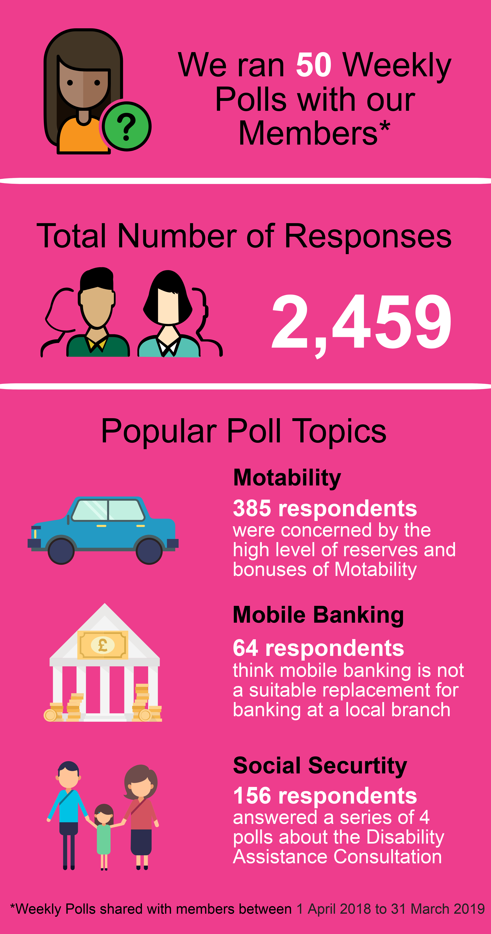
Weekly Polls: www.yoursayondisability.scot

Our weekly polls are a way of gathering feedback from our members on issues that affect everyone. We have conducted 50 poll questions in this reporting period.

What difference has Weekly Polls made…
More members have been able to provide their feedback on issues that matter to them and their feedback has been shared with key decision makers:
Mr. Docherty-Hughes MP “Thanks for sending on the comments from the weekly poll, it made for very interesting reading and highlights the problems faced with accessibility of train stations across the country.”

Disability Hate Crime
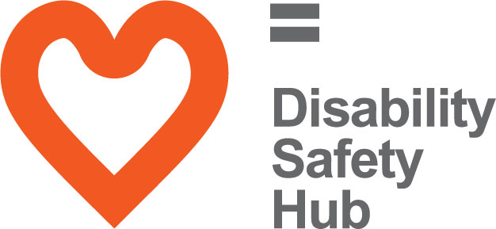
The Disability Safety Hub launched in October 2018 to coincide with National Hate Crime Week. We received positive feedback upon the launch of our Disability Safety Hub from the Cabinet Secretary for Justice, Mr Humza Yousef.
“Congratulations on the launch of your website. The content within the website is clear, concise and informative, and will ensure those looking for help can do so quickly.”
Mr Yousaf also tweeted a response to the Disability Safety Hub Launch:
“Excellent Website! Please share with others. Well done @DEScotTweets”
What difference has The Disability Safety Hub made…
Before we launched our Disability Safety Hub, we sought feedback from our members about their own experiences of hate crime. We found that it was all too common.
We know from our own research and from data collected by Police Scotland that there is a need for this type of resource, as disability hate crime is one of the most under-reported of all crimes; estimated at 97% under-reported. We anticipate that the information contained on this new Hub will make a positive difference to the recognition of hate crime amongst disabled people and the numbers reporting incidents.

Accessible Travel Hub
www.accessibletravel.scot

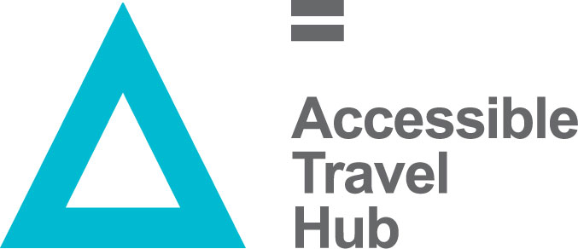
The Accessible Travel Hub contains information and advice about making an accessible journey. Over the last year, we have continued to develop the content, design and accessibility of the website to ensure that it remains fresh and active for users. A significant development was the introduction of a new website template, which incorporates our updated branding to make the website more visually appealing. This also involved the design of a new Accessible Travel Hub logo and the development of a promotional toolkit which is available to download and share on the website: www.accessibletravel.scot/promotional-toolkit

What difference has The Accessible Travel Hub made…
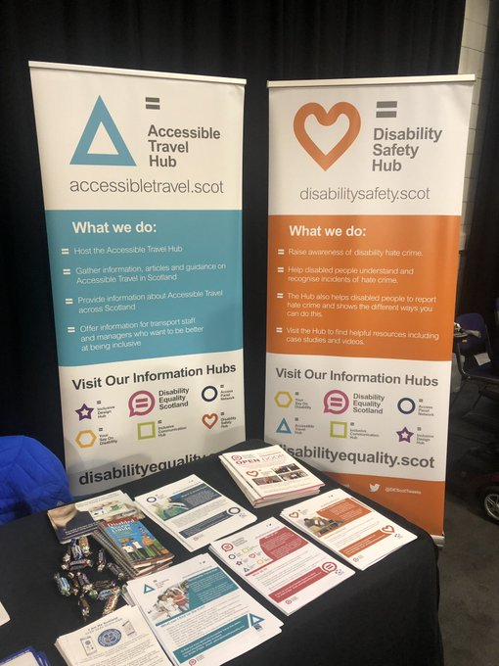
The Accessible Travel Hub has received positive feedback and constructive comments from members of the National Transport Accessibility Steering Group, Access Panels and other organisations and individuals who have visited the Hub. We were delighted that the Hub was recognised for its achievements by being shortlisted in two categories at the Scottish Transport Awards; Excellence in Transport Accessibility and Excellence in Travel Information and Marketing.

Accessible Travel Events
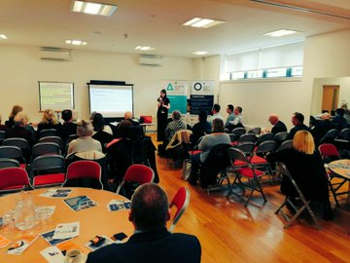
This year, we held three events, bringing together disabled people with transport providers, to discuss experiences of public transport in different regions around Scotland.
Events were held in:
- Orkney, 20 September 2018
- Kingussie, 22 November 2018
- Renfrewshire, 12 March 2019
In total, we have engaged with over 120 people, which includes disabled people, transport providers, local authorities and equality groups about their experiences of accessible travel in their local areas.
Each event had presentations from a number of providers including Stagecoach, ScotRail, Glasgow Airport, Firstbus, NorthLink Ferries, CalMac and Community Transport providers.

What difference has The Accessible Travel Events made…
“Had the pleasure of attending the Renfrewshire accessible travel event – what a well organised and positive event!”

“I wanted to write and advise that I found the event very useful for ScotRail. It was a good opportunity to engage with a broad spectrum of stakeholders and take away a couple of good suggestions from them of how to improve accessibility on our services. I will certainly be looking into these to see if we can implement them.”

Hate Crime on Public Transport
This year, we continued our work with Transport Scotland and partners Police Scotland and SEStran around hate crime on public transport. We held three consultation events to explore the potential for a Hate Crime Charter.
Three consultation events took place in:
- Fife, June 2018
- Clackmannanshire, September 2018
- West Lothian, December 2018
In total, we engaged with 114 people as part of this consultation. This includes representatives from disability groups, race and faith communities, LGBT organisations, transport providers and operators. Each event was supported by Police Scotland, the British Transport Police, SEStran and People First Scotland who shared their own experiences of hate crime.

What difference has The Hate Crime Consultation events made…
We presented our findings at the Transport Scotland annual conference in March 2019 to a positive response.
We have taken the learning from these events and drafted a Hate Crime Charter which will be piloted with transport providers during 2019/20.

Inclusive Design Hub www.inclusivedesign.scot

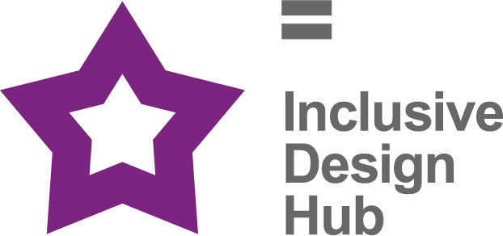
Launched in July 2016; the Inclusive Design Hub is a resource that aims to improve awareness and take-up of best practice in inclusive design for planners, developers, architects, and building professionals in Scotland. The website includes information, articles, access guides, and case studies of best practice. The Inclusive Design Hub will help built environment professionals deliver inclusive environments.

Feedback
The Inclusive Design Hub has received positive feedback and constructive comments, such as additional content and changes to the design and layout:
- Adding additional resources/case studies/news items.
- Suggestions of individuals and organisations to contact for content and to help promote the Inclusive Design Hub.
- Increase accessibility

Monitoring and Future Plans
Content: The Inclusive Design Hub will be updated and revised on an ongoing basis. A feedback form has been created to allow users to submit any comments and suggestions to help to improve the website.
Continue to add fresh content. It is vital to keep users interested so that they are encouraged to come back, as well as recommend the website to others.

Access Panel Network
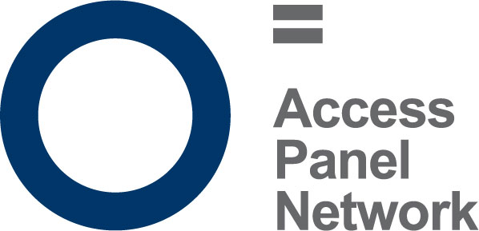
An Access Panel is a group of volunteers, the majority of which are disabled people, or are directly affected by disability, perhaps as a carer or family member. They meet on a regular basis, usually monthly, to discuss issues in their local community which affect disabled people, and work towards removing barriers to independent living in their own locality, to ensure disabled people have access to the same choice, dignity and control as others in our society.
There are currently 35 active Access Panels across Scotland, from Barra and Orkney, to the Scottish Borders and everywhere in between. Panel membership varies between 5 and 150 disabled members, and it is estimated that there are around 1000 Access Panel members in total. Not all members are actively involved volunteers, and many contribute in other ways towards their panel, by sharing information, or participating in consultations; other members may simply wish to be kept informed of disability work in their area.
Access Panels are fully constituted members of Disability Equality Scotland. To be a member a Panel must be recognised by their local authority and be properly constituted. All Panels have access to the Access Panel Grant, provided by the Scottish Government, and administered by Disability Equality Scotland who act at the Umbrella Body for the panels. Access Panels can also access other funding, depending on their status, including local councils, the Big Lottery or other funding resources. Some receive benefits in kind, for example office accommodation or other support. The Office Bearers of each Access Panel oversee the strategic development, finances, management of operations and engagement.
As Panels have typically grown organically around the needs of their locality, they vary greatly in their focus and remit however, they are primarily committed to improving access and equality in its widest form which means access to the physical environment, Education, Housing, Health, Transport, Leisure & Recreation and Social Justice amongst other areas.

Access Panel Grant

Overview and Progress
The Access Panel Grant (APG) is a fund designed to help increase the capacity and outreach of Access Panels right across Scotland. The majority of Access Panels are staffed solely by volunteers who are passionate about increasing access and social inclusion for disabled people in their community. For the period 1 April 2018 to 31 March 2019, £45,000 was received by Disability Equality Scotland from the Equality Unit, The Scottish Government.
Access Panels face many challenges (ageing volunteers, lack of younger volunteers, difficulties in reporting, geographical spread) the Access Panel Grant has been a lifeline for many Panels who would have otherwise faced a year without funding. Its allowed Panels across Scotland to continue the vital work that they’ve been doing for over 30 years and to build on that success.

Structure, governance and management
Disability Equality Scotland was established under a Memorandum of Association which established the objects and powers of the charitable company and is governed by the Articles of Association.
Disability Equality Scotland is a charity limited by guarantee and has no share capital. The liability of each member in the event of winding up is limited to £1.

Recruitment and appointment of new trustees
Although not a public body, our board recruitment is competency based.
The skills, knowledge and experience on our board during 2018-2019 include HR Management, Governance, Strategy Planning, Business Management, Risk Management, Equalities, Access Panel involvement and personal lived experience as a disabled person.
Board members serve a term of three years and are voted in at our Annual General Meeting. The role of the Board is to oversee the work of the organisation and to make strategic decisions about its future.
Our Convener leads the board and offers support to our Chief Executive Officer.

Our Funding

Promoting Equality and Cohesion Fund, The Scottish Government
For this project, we are committed to engaging and disseminating information to disabled people through our publications and online newsletters, easy-read briefings and events.
We also stated we would improve Access to Social Justice for disabled people, through representation of their views, needs and rights and by supporting the work of those committed to improving equality and inclusion in Scotland.
Finally, we would administer the Access Panel Funding Grant to support and protect ongoing volunteer work, to reduce barriers to inclusion and equality at local and national levels.

Adult Community Care Grant Scheme, The Scottish Government
We are the umbrella organisation for Access Panels across all of Scotland and work with other partners to improve access and inclusion. We work to empower and promote the rights of disabled people. Our role is to influence and effect change, both locally and nationally, through the network of Access Panels and to support them to work in partnership to address local issues.

Accessible Transport for Disabled People Grant Funding, Transport Scotland
The aim of this project is to work with Transport Scotland and relevant groups to improve the accessibility of transport in Scotland. Our role is to ensure disabled people are informed and included in each stage of the process, including proposing the issues to agreeing actions, to monitoring and feeding back on successes and areas for improvement
Awards for All
The project consisted of a feasibility study researching the need for a recognised benchmark for accessibility. Working closely with Access Panels, local businesses, and public bodies, to outline what is required to achieve a national standard of accessibility. This is a unique and exciting project that brings the opportunity for innovation in Accessibility for those organisations who would like to be involved in the pilot. The outcomes of this project will help to strengthen the viability and sustainability of local disability Access Panels and can be used as a tool to reinforce the outstanding work these panels already achieve.

Reference and Administrative Details
Registered Company number
SC243392 (Scotland)
Registered Charity number
SCO31893
Registered office
Office 2/4, The E-Centre, Cooperage Way Business Village, Alloa, FK10 3LP
Board of Trustees
The following trustees served on the board from 1 April 2018 to 31 March 2019.
- Linda Bamford (Appointed 14 November 2016)
- Dorothy McKinney (Appointed 30 March 2017)
- Janis McDonald (Appointed 5 December 2017)
- Maureen Morrison (Appointed 4 December 2017)
- Louise Orr (Appointed 5 December 2017, Resigned 11 January 2019)
- Scott Stewart (Appointed 5 December 2017)
- Steven McGhee (Appointed 4 May 2018, Resigned 1 July 2019)
- Susan Fulton (Appointed 24 May 2018)
- Kenny Milne (Appointed 17 May 2018)
- Carolyn Griffiths (Appointed 4 May 2018)
- Colin Millar (Appointed 4 May 2018)
Independent examiner
Mark Stewart CA, ICAS
Stewart Accounting Services Limited
Office 90Alloa Business Centre Whins Road, Alloa, FK10 3SA
Approved by order of the board of trustees on ........................................ and signed on its behalf by:
............................................
Trustee

Presentation of Financial Accounts
1 April 2018 - 31 March 2019
Income 2019 2018
General Fund (Unrestricted Fund) £13,632 £11,611
Bank Interest £2 £394
Restricted Fund £282,858 £274,831
Scottish Government Equality Unit £95,000 £93,848
Access Panel Grant £46,250 £53,820
Scottish Government Section 10 £80,132 £80,133
Transport Scotland £49,797 £46,640
Awards for All £8,900
Community Jobs Scotland £2,779
Total Income £296,492 £286,836

Expenditure 2019 2018
Charitable activities
Allocated to Access Panel Grant £27,370 £31,853
Salaries £163,387 £154,836
Employers National Insurance contribution £13,972 £13,238
Employers Pension contribution £7,948 £7,715
Rent and service charges £14,860 £14,738
Recruitment and training £6,526 £1,179
Telephone £1,256 £1,277
Postage and stationery £5,454 £11,685
Travel, subsistence etc £14,291 £9,805
Bank charges £71 £209
Computer expenses £9,267 £4,475
Interpretation £2,438
Total £266,840 £251,010

2019 2018
Support Costs
Governance Costs
Accountancy Fees £3,242 £7,951
Legal Fees £3,666 £9,441
Insurance £5,533 £5,464
Accountancy training £0.00 £1,176
Events, room hire & conference £12,390 £9,605
Total £24,831 £33,637

Total resources spent £291,671 £284,647
Net income / (expenditure) £4,821 £2,189
Balance Sheet
as at 31 March 2019

Current assets
Debtors £3,020 £9,040
Cash at bank and in hand £51,577 £42,533
Total current assets £54,597 £51,573

Creditors
Amounts falling due within one year (£5,822) (£7,619)

Total assets less current liabilities £48,775 £43,954

Funds
Unrestricted funds £17,427 £20,772
Restricted funds £31.348 £23,182
Total funds £48,775 £43,954
Full financial statements which have been examined by Stewart Accounting Services Limited are available from the company on request.

Disability Equality Scotland
Scottish Charity Number: SC031893
Office 2/4, the e-Centre
Cooperage Way
Alloa, Clackmannanshire
FK10 3LP
Tel: 01259 272064
Email: admin@disabilityequality.scot
Facebook @DisabilityEqualityScotland
Twitter @DEScotTweets
Website: www.disabilityequality.scot

Our Sponsors
We are grateful for the generosity of our sponsors from 1 April 2018 to 31 March 2019:
- AccessAble
- Blackwood Homes & Care
- Clyde Shopmobility
- deafscotland
- Edinburgh Fringe Society
- Enable Falkirk Branch
- Humanism in Scotland
- NHS 24
- RBS
- SEStran
- SPAEN
- UKPIPS

