Dear Applicant

Events, Training and Membership Administrator Application Pack

Thank you for your interest in the post of Events, Training and Membership Administrator with Disability Equality Scotland. This post will be located in our new office at The Pentagon Centre, Glasgow. Please find enclosed the following documents:

- Role Description
- Application Form
- Equal Opportunities Monitoring Form
- Criminal Record Disclosure Form

Please complete the Application Form, Equal Opportunities Monitoring Form and Criminal Record Disclosure Form and return them to:

Emma Scott, Operations Manager, Disability Equality Scotland
Office 2/2, The e-Centre, Cooperage Way, Alloa FK10 3LP

You may also return them by email to emma@disabilityequality.scot

The closing date for receipt of applications is Thursday 12 September 2019. (Please note applications received after this deadline will not be considered).

We will be holding interviews week beginning 30 September 2019.

Should you require this application pack in a different format please do not hesitate to contact our office.

Yours faithfully
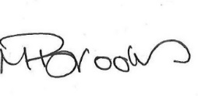
Morven Brooks
Chief Executive Officer
Disability Equality Scotland

