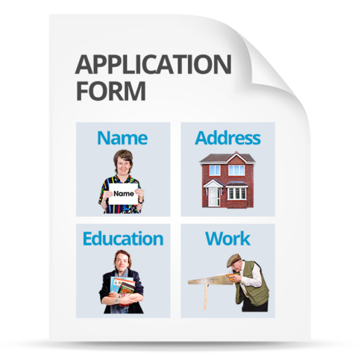
Application Form

Post Applied for: Administrator

Closing Date: Thursday 12 September 2019

- Personal Details

Surname:

First name:

Address:
Postcode:

Telephone Number:

Email:

Do you have a current driver’s license? Yes No

Do you have access to a car? Yes No

Do you have any endorsements? Yes No

If yes, please give details:

- Courses & Qualifications

Please list qualifications you have gained and courses you have attended which you feel are appropriate to this post, starting with the most recent.

Courses and Qualifications (include year achieved):

School / College / Agency (include year attended):

- Present or Most Recent Employment

Name of Employer:

Address of Employer:

Title of Post Held:

Date Appointed:

Leaving Date (if appropriate):

Notice Required:

Salary:

Main duties and responsibilities of present/most recent post:

- Previous Experience
Please show most recent experience first. Use continuation sheet if necessary. (This can be paid or unpaid work)

Name of Employer:

Date From and To:

Reason for Leaving:

Post and Main Duties:

Name of Employer:

Date From and To:

Reason for Leaving:

Post and Main Duties:

Name of Employer:

Date From and To:

Reason for Leaving:

Post and Main Duties:

- Computer Skills

Please describe your level of computing skills and what packages you are familiar with.

- Guaranteed Interview Scheme

Disability Equality Scotland will offer a guaranteed interview to candidates with a disability who meet the essential criteria for this post.

Do you wish to be considered for a guaranteed interview?

Yes No

Do you have any support needs which we should be aware of?

Yes No

If yes, please provide details of any assistance you require.

- Protection of Vulnerable Groups (PVG)

The successful candidate and if applicable to the post, the successful candidate will be subject to membership of the Protection of Vulnerable Groups Scheme.
- References

Please give the names of two referees, one of whom should be your present or most recent employer, who know you well and can provide reliable information about your experience, skills and qualifications which make you suitable for this post. Please note that you may not give the name of someone who is related to you.

Referee One

Name:

Job Title:

Address:

Telephone:

Email:

May we approach referee if shortlisted? Yes No

Referee Two

Name:

Job Title:

Address:

Telephone:

Email:

May we approach referee if shortlisted? Yes No

- Supporting Statement:

State below your reasons for applying for this post and the qualities you consider make you a suitable applicant. Please ensure your statement demonstrates how your skills and experience address the criteria laid out in the attached Person Specification. Please provide any links to websites etc. which may support your application. Please use a continuation sheet if necessary.

I confirm that the information in this application is, to the best of my knowledge, true and complete.

Signed: Date:

