Role Description

Role Title
Easy Read Worker
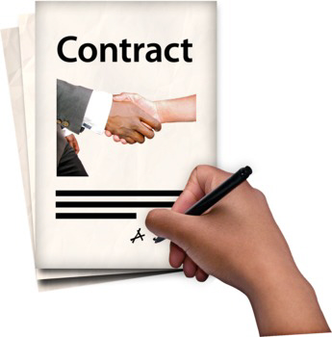 | Hours  This role is for 10 hours per week.  The contract will be from April 2019 to March 2020.
Salary
You would be paid £5,142.86 in total for the year. This is the equivalent of £18,000 if you worked full time.

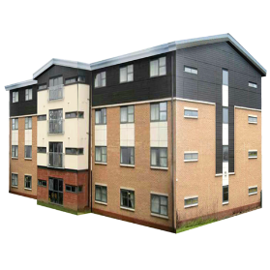 | Location  You can work from your own home to do this job.  You can also work in our office based in Alloa, Clackmannanshire.
Report to
You would be managed by the Operations Manager.

About Disability Equality Scotland
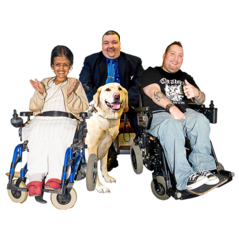  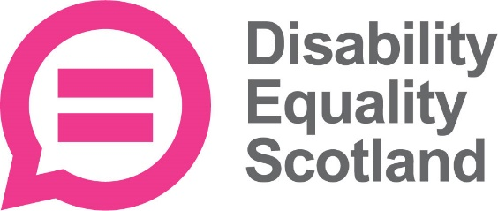 | We are a membership organisation for disabled people and disability groups.  We want to make Scotland fully accessible.
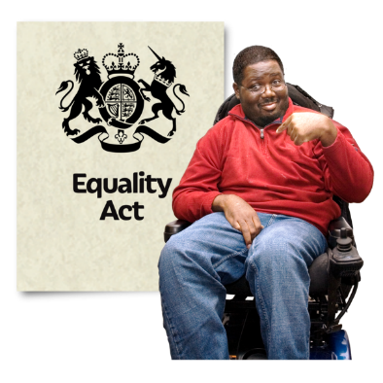 | We want disabled people to have the same opportunities as everyone else.  We work to promote access.  This could be access to the built and natural environment, access to information, to inclusive communication and to decision making.
Easy Read Service
We provide a professional and efficient Easy Read service.
This is part of our aim to improve access to information for everyone.
Easy Read – what is it?
Easy Read is an accessible format.
It makes written information easy to understand.
It uses simple language without jargon, and short sentences.
It has images to help people understand.

Why produce Easy Read documents?
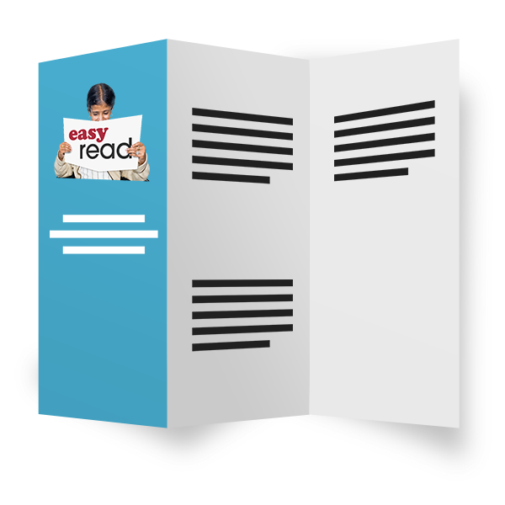 | Easy Read documents make information more accessible for people with learning disabilities.  They can also be useful for people with other communication difficulties.  This includes:  - acquired brain injury  - dyslexia  - people with hearing impairment whose first language is British Sign Language (BSL)  - people who do not speak English as their first language  - people who find reading difficult  - people with cognitive impairments such as dementia.

Job purpose
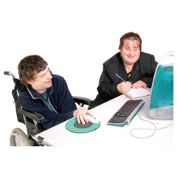 | To do this job you will need to work with different people.  This includes staff at Disability Equality Scotland and our partners.
Key tasks and responsibilities
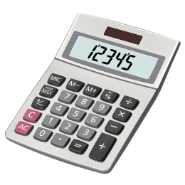  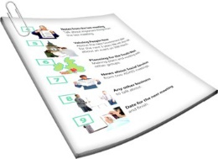  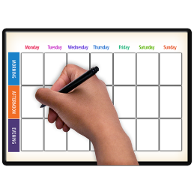  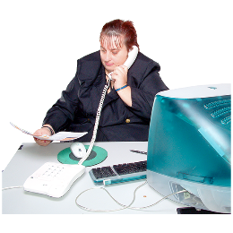  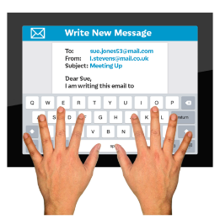 | You will have to:  - Give quotes to customers for Easy Read translation on request  - Turn documents into Easy Read within agreed timescales  - Record all requests and monitor payments  - Make sure Disability Equality Scotland communications are converted into Easy Read  - Promote and communicate our Easy Read Service using all available mediums (Social Media, websites, posters, leaflets, magazine and newsletters)  - Represent the organisation to promote our mission and maintain good working relationships with stakeholders.
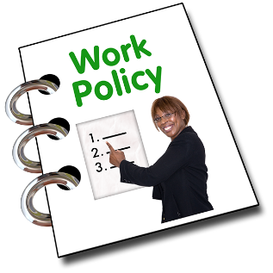  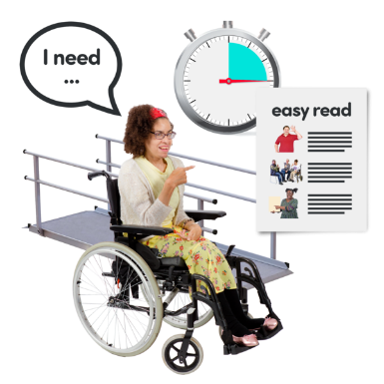 | You will also have to:  - Be a professional member of our staff team and work to the organisations policies and procedures in our employee handbook.  - All employees are also expected to promote and agree with the organisations policies on equality and diversity.

Description of skills, knowledge and experience needed for this role
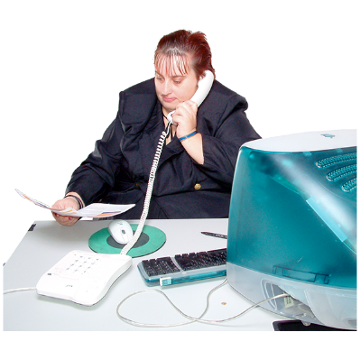  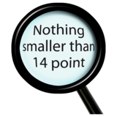  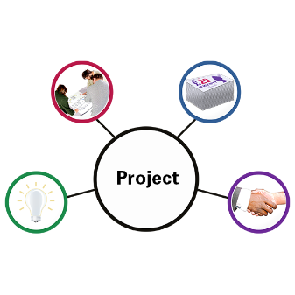 | To get this job it is essential that you:  - Can use Microsoft Office, Outlook, Excel and Internet software to a high standard.  - Have excellent administration and organisation skills.  - Can work effectively on your own as well as in a team and can do lots of different tasks at once.  - Can communicate effectively with different types of people.  - Can show commitment to learning more skills.  - Can be a leader of equality and values diversity.  - Have experience and understand Easy Read.  - Have knowledge and understanding of inclusive communication and delivering information in inclusive formats.  - Can be flexible and have an adaptable approach to work.
It would also be good, but not essential that you:
- Have a degree or relevant Administration Qualification.
- Have experience of equality initiatives: have an interest in / or understanding of disability.
- Have excellent attention to detail.
This role will require a high level of detail in finding the right information.

Equal opportunities
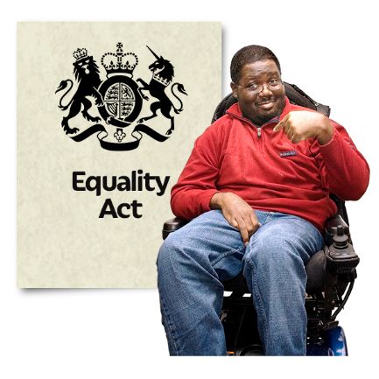 | We are committed to being disability-smart and an employer of choice, regardless of race, sex, sexual orientation, gender reassignment, religion or belief, marital or civil partnership status, age, disability or pregnancy and maternity.
 | We want our staff to be representative of wider society.
 | When we are recruiting, disabled candidates who meet all of the essential criteria will be guaranteed an interview.
 | Disability Equality Scotland is a disability confident employer.
How to apply for this role
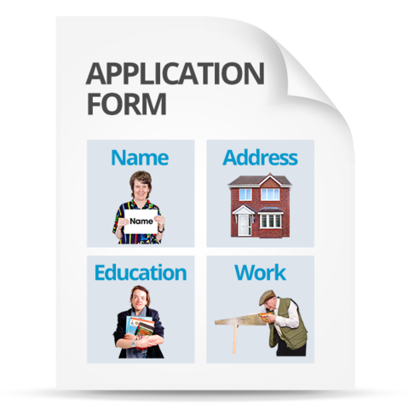 | Go to our website page  http://disabilityequality.scot/work-for-us/ and download and complete application form
Return your completed application form to:
Emma Scott
Operations Manager
Disability Equality Scotland
The E-Centre, Office 2/2
Cooperage Way
Alloa, Clackmannanshire
FK10 3LP
You can also contact Emma Scott if you would like to discuss the role.
Telephone number: 01259 272064
Email: emma@disabilityequality.scot

