Easy Read Worker
Job Advert

Disability Equality Scotland are looking for an Easy Read Worker.

The Easy Read worker would create Easy Read documents helping us to deliver our Easy Read Service.
This role is for 10 hours per week.

The contract will be from April 2019 to March 2020.

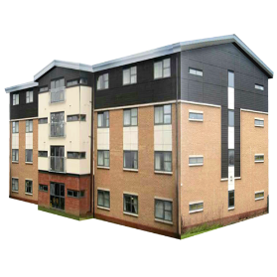 |  |  | You can work from your own home to do this job.  You can also work in our office based in Alloa, Clackmannanshire.
 |  |  | We are a membership organisation for disabled people, and disability organisations.
 |  |  | It is important we communicate clearly to everyone and encourage others to do this too.
 |  |  | Disability Equality Scotland wants to make sure all its information, products and services are accessible to everyone.
How to apply for this role
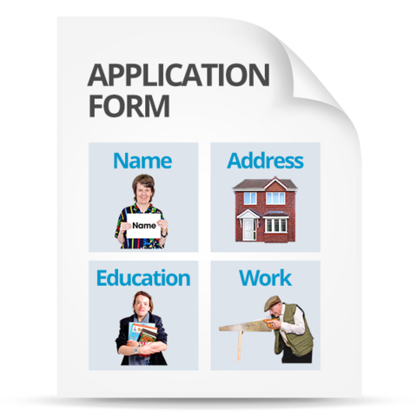 |  | Go to our website page  http://disabilityequality.scot/work-for-us/ and download and complete an application form.
Return your completed application form to:
Emma Scott
Operations Manager
Disability Equality Scotland
The E-Centre, Office 2/2
Cooperage Way
Alloa, Clackmannanshire
FK10 3LP
You can also contact Emma Scott if you would like to discuss the role.
Telephone number: 01259 272064
Email: emma@disabilityequality.scot
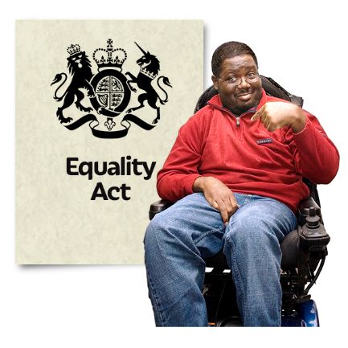 | Equal Opportunities  We are committed to being disability-smart and an employer of choice, regardless of race, sex, sexual orientation, gender reassignment, religion or belief, marital or civil partnership status, age, disability or pregnancy and maternity.  We want our staff to be representative of wider society.
 | When we are recruiting, disabled candidates who meet all of the essential criteria will be guaranteed an interview.
 | Disability Equality Scotland is a disability confident employer.

