disabilityequality.scot ISSUE 50 | 2018

Welcome to the latest issue of
OPEN DOOR, the quarterly magazine from Disability Equality Scotland

OPEN DOOR

Disability News and Views for Disabled People Across Scotland

Issue 50: Raising Awareness of Disability Hate Crime Through Consultations, Campaigns, Events and Our Newly Launched Disability Safety Hub!

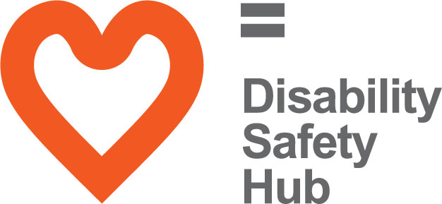
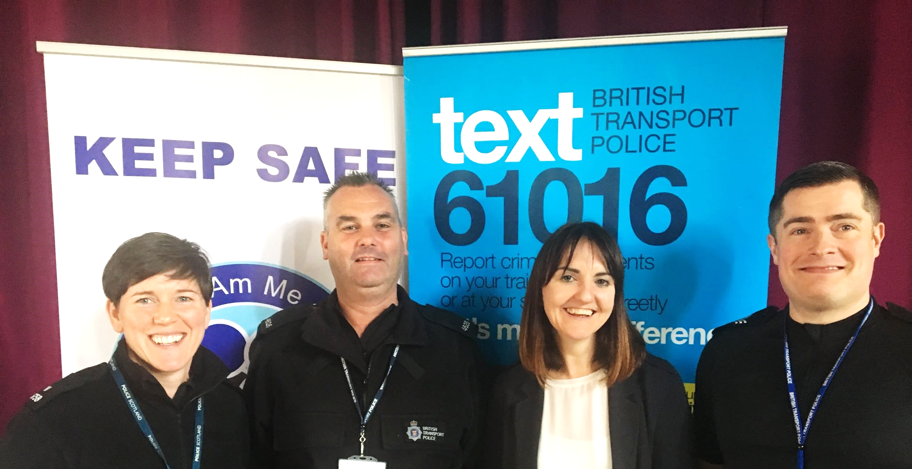

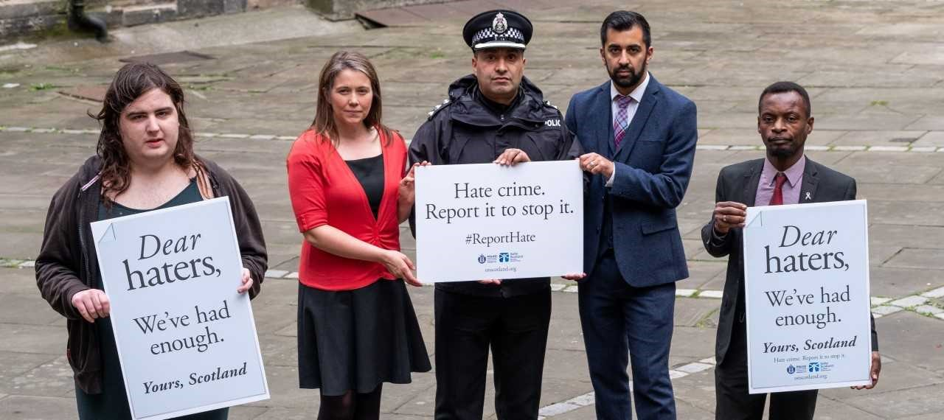
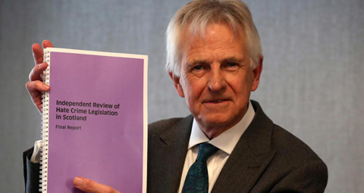

Your Disability, Your Voice, Your Scotland…
Disability Equality Scotland is a member led organisation, so we want to hear from you, our valued members!

Get in touch with us with your disability news by email at:
admin@disabilityequality.scot or by calling on 01259 272064

Page Number
- Contents
- CEO’s Welcome - Introduction from Morven Brooks

Inform

4-5 Our Team
6-7 Our Directors
8 About Us
- Update from Emma Scott, Equality Projects Manager
10 Disability Safety Hub Launched to Tackle Hate Crime!
11-15 Summary of Recent Events
16 Accessible Travel Hub
17 Inclusive Communication Hub
18 Inclusive Design Hub
19 Easy Read Service

Your Say on Disability

20 About Your Say on Disability
21 Changing Scottish Hate Crime Legislation
22 Improving Employability in the Public Sector
23 Democracy Matters
24 Transport (Scotland) Bill
25 Scottish Public Toilet Numbers Plummet
26-27 Weekly Poll Roundup

Support

28-29 Scottish Government Hate Crime Campaign
30-31 Disability Safety Hub – What is Hate Crime and How to Report It
32 Central Scotland Regional Equality Council (CSREC)
33 deafscotland Annual Conference 2019
34 I Am Me
35 Scottish Ambulance Service
36 See Me – Feels FM Campaign
37 Enable (Falkirk Branch)

Access Panel Network

38-39 About the Access Panel Network
40 Access Engagement Officer’s Update
41 Investing In Access Update
42-48 Access Panel Network News

CEO’s Welcome

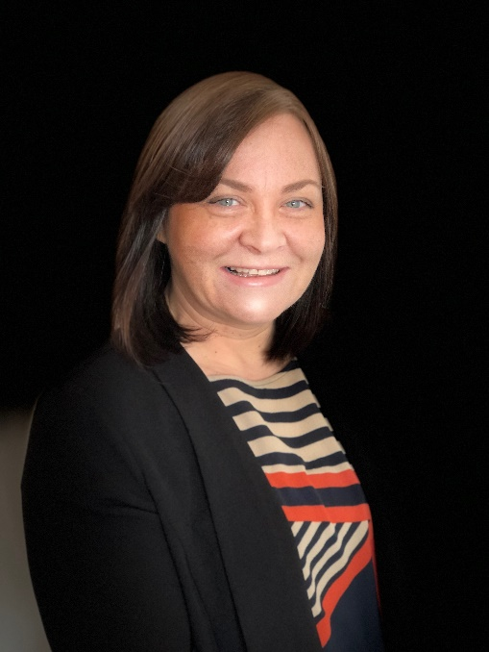
Welcome to the latest edition of our quarterly flagship magazine ‘Open Door’! To celebrate our 50th edition; we have produced a bumper 50-page issue, which is themed around the important topics of hate crime and information to keep you safe.
Morven Brooks

As 2018 draws to a close, I reflect on another incredibly productive year in improving access and inclusion for disabled people across Scotland.

We have been holding consultation events about hate crime on public transport. Your comments from these events will help to inform a Hate Crime Charter to tackle incidents on public transport. October 2018 saw the launch of our latest website, the Disability Safety Hub (www.disabilitysafety.scot). This website will help you to identify and report hate crime, and also provides useful resources that can keep you safe.

In this latest issue of Open Door, you will find a summary of all our recent consultation responses, which are shaped with the valuable input from our members. We also have very informative guest articles; including, Central Scotland Regional Equality Council (CSREC), who discuss barriers to reporting hate crime and See Me tell us about their latest campaign, ‘Feels FM’.

The latest Access Panel updates highlight that it has also been another tremendously productive year for our Access Panel Network. I would like to take this opportunity to thank all of you that dedicate time to volunteer for your local Access Panel; you play a huge part in achieving access for all within your community. To celebrate the Year of Young People, we will soon be launching our first ever Youth Access Panel. More information about this exciting new project will be shared with you in 2019!

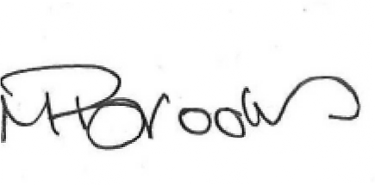
With best wishes

Morven Brooks, Chief Executive Officer

Our Team

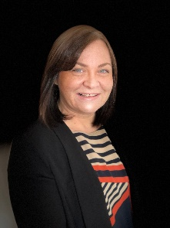
Morven Brooks - Chief Executive Officer
Morven works with the team to ensure that Disability Equality Scotland promotes the value of and represents the opinions of disabled people. Morven provides a strategic and operational understanding of access and inclusion in Scotland including, establishing an evidence base that informs policy and best practice.
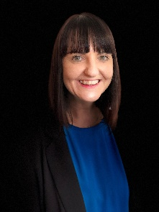

Emma Scott - Equality Projects Manager
Emma is responsible for managing a broad number of projects and initiatives. Emma works closely with the CEO to implement the organisation’s strategy to work towards social inclusion for Disabled People in Scotland.
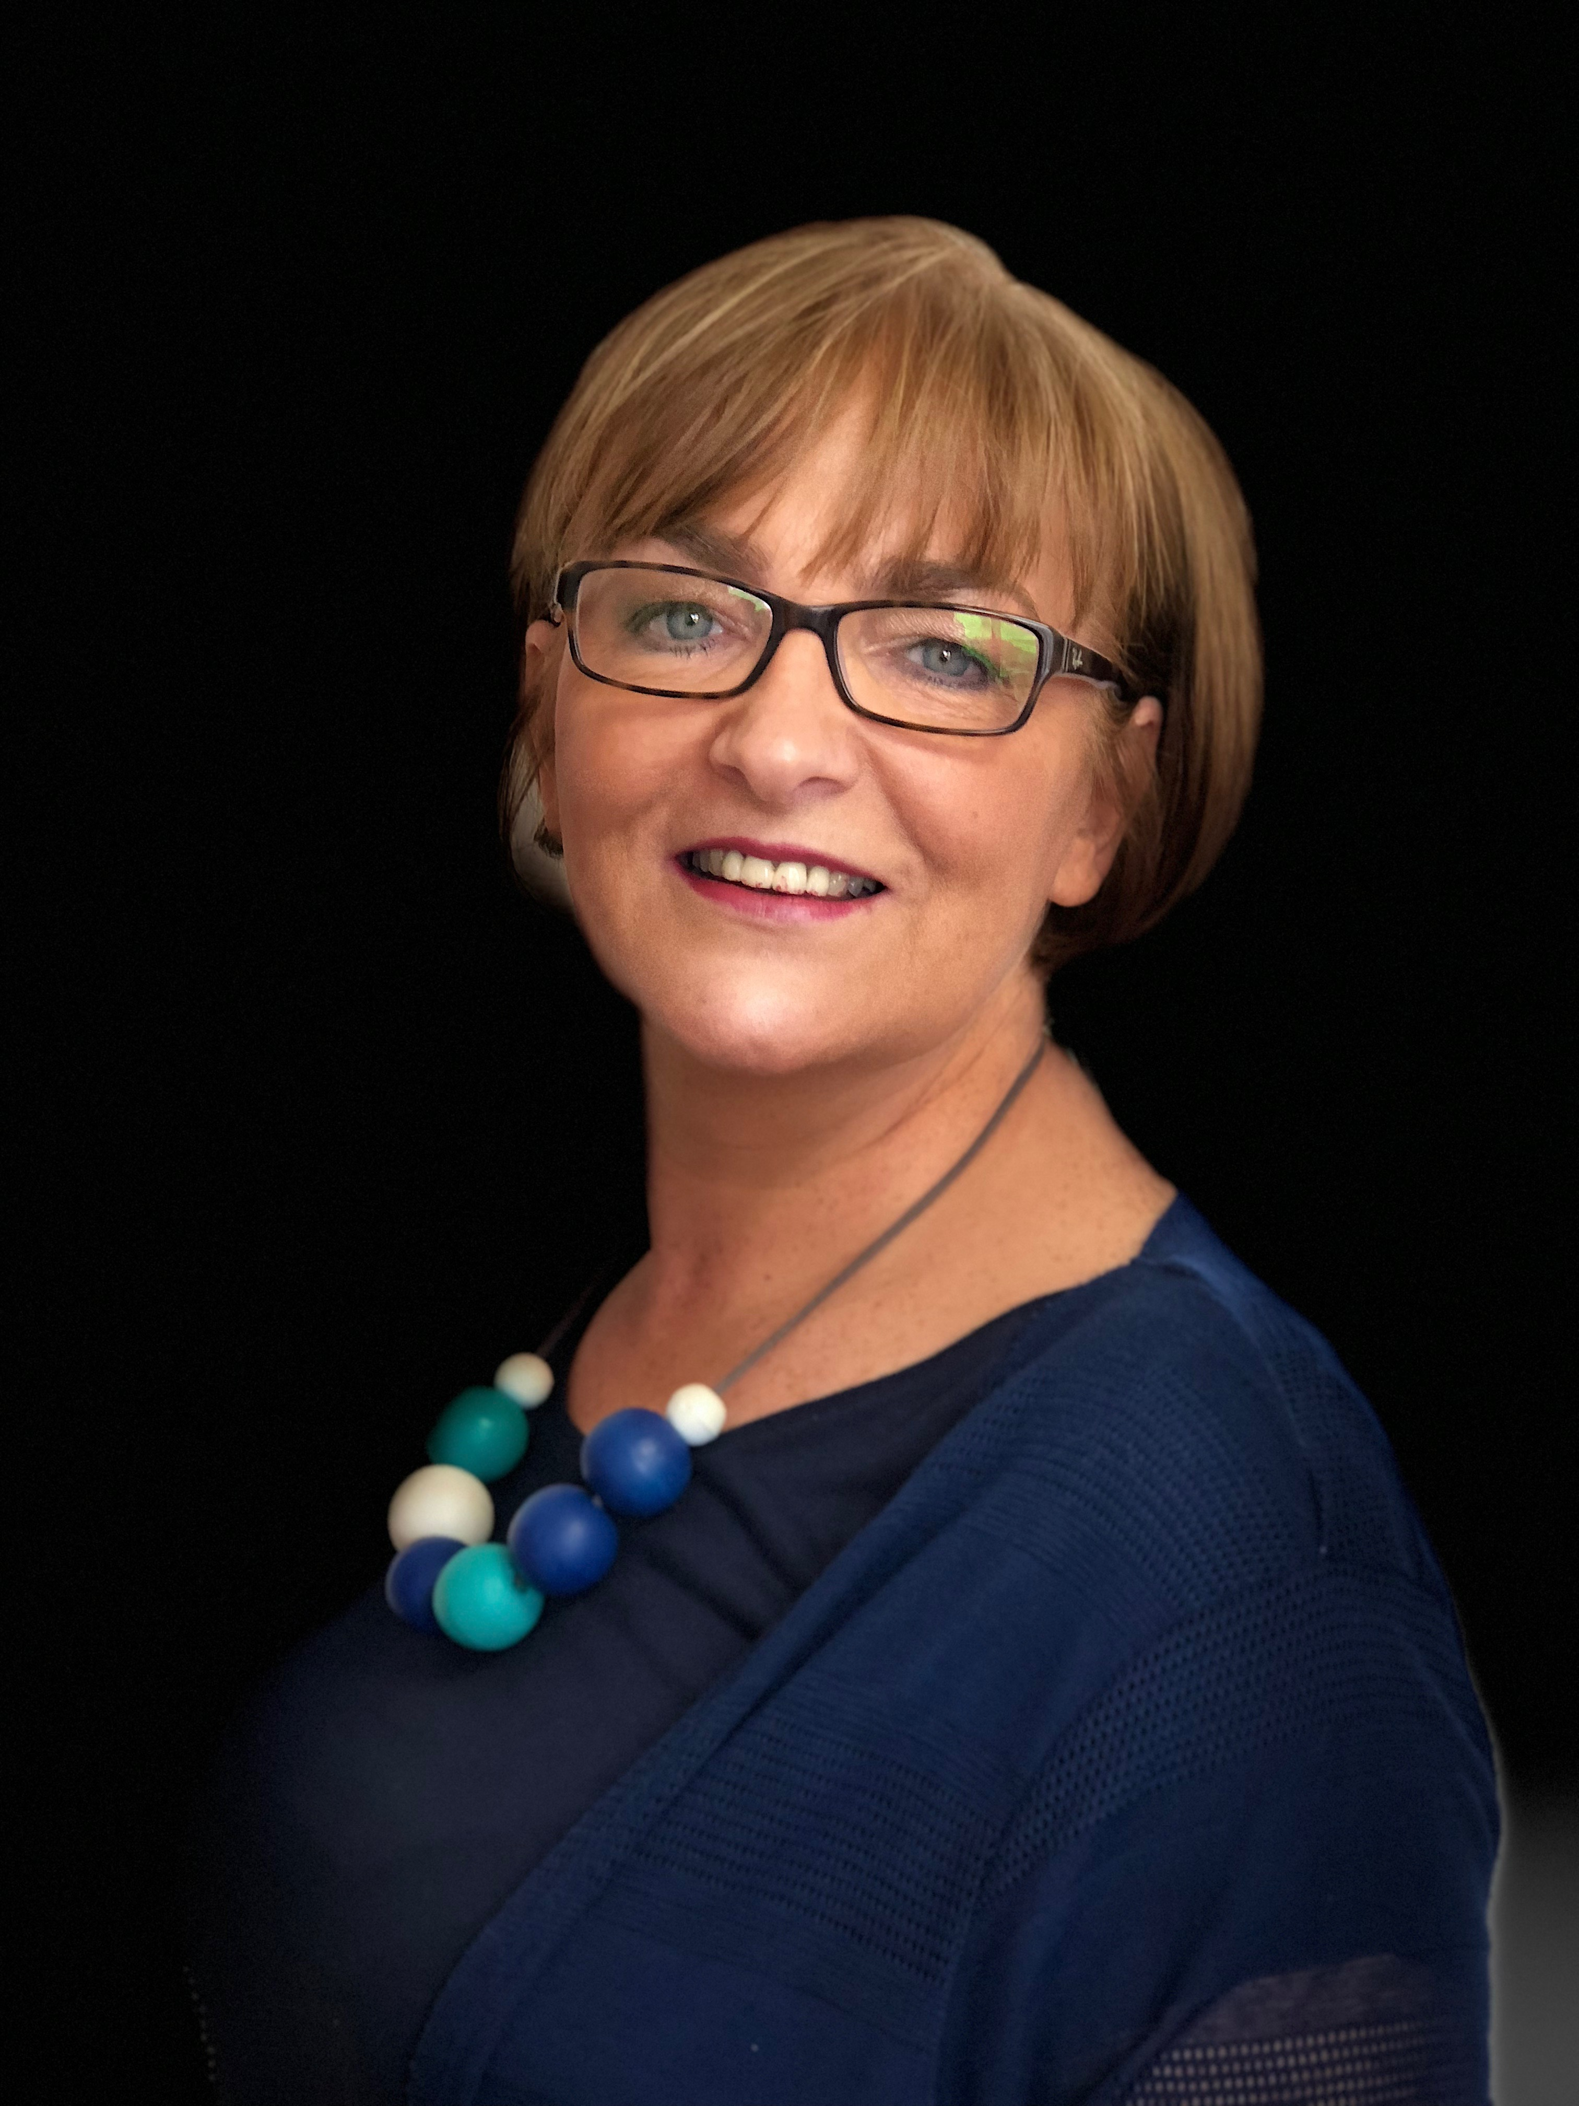

Maeve Bain - Senior Administrator
Maeve is responsible for the administration of our finances, book-keeping and payments, as well as supporting in other areas such as minute-taking and regular Board related duties.

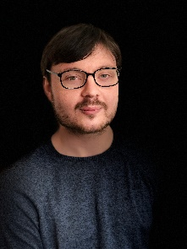
James Davidson - Equality Projects Assistant
James is responsible for sharing and promoting information such as news, events and consultations to our members in a clear and accessible manner. This includes producing our monthly newsletter and quarterly magazine, ‘Open Door’. James is also responsible for the upkeep and population of all website content.

Our Access Team

Ian Buchanan - Access Engagement Officer
Ian’s role is to support, develop and promote the Access Panel Network. He regularly travels around Scotland, meeting Access Panels and stakeholders to encourage partnership working.

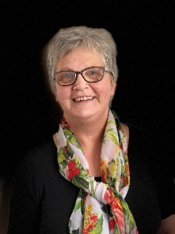
Gillian Smith - Access Administrator
Gillian is our Access Administrator and it is her role to provide administrative support to the Access Engagement Officer and the wider Access Panel Network.

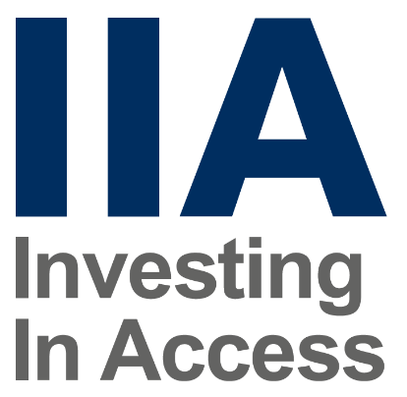
Anne-Marie Martin - Investing in Access Project Worker
Anne-Marie Martin is our Investing in Access Project Worker. This exciting project provides an excellent opportunity for all types of organisations to begin to lead the way on accessible standards in Scotland.

Our Directors

Linda Bamford – Convener
After 13 years as a frontline paramedic in Glasgow, Linda moved into management, holding various senior management positions within the Ambulance Service for a further 15 years. Linda has a passion for equality and doing the right thing and strives through her work and volunteering to bring about transformational changes that will assist everyone to lead their lives as they choose.

Dorothy McKinney – Vice Convener
Dorothy has over 35 years’ experience in Human Resources and has fellowship of the Chartered Institute of Personnel and Development (CIPD). Dorothy is also a Registered Mediator with the Scottish Mediation Network and undertakes pro bono support for Peer Mediators in local schools.

Colin Millar – Treasurer
Colin is currently the Chief Executive Officer (Executive Director) of the Scottish Personal Assistant Employers Network (SPAEN). As a young child, Colin had Legg-Calvé Perthes Disease, a disease which significantly impaired his mobility and independence, an experience he draws on daily as he now seeks to support others to live full, active and inclusive lives and fulfil their potential and ability.

Susan Fulton – Director
Susan is a local authority Chartered Surveyor with a background in the construction industry, diversifying into the field of accessibility in 2004. Susan obtained her MSc in Accessibility and Inclusive Design from the University of Salford. Susan is also a member of the Royal Institution of Chartered Surveyors (RICS) and is a consultant member of the National Register of Access Consultants (NRAC).

Carolyn Griffiths – Director
Carolyn has worked in the public and private sectors: 23 years with Barclays Bank and 12 years in the public sector with a Local Authority and is currently working in the NHS. Her areas of expertise include human resource development, organisational development, project management, consultation and engagement. Carolyn also has a strong sense of fairness and equality.

Janis McDonald – Director
Janis is currently the Chief Officer of deafscotland. Janis has a nursing background and has worked in the Public and Third Sectors. She has thematic specialties covering: addictions, homelessness, equalities and deafness. Janis is now particularly interested in quality and standards, governance and communication equality.

Steven McGhee – Director
Steven has spent the last 11 years living with a complete C3 spinal cord injury, leaving him with no movement from the neck down and requiring a ventilator to breathe 24 hours a day. This situation has not stopped Steven from ensuring he stays positive and an active member of society. Before his injury Steven was a manager for one of Glasgow's largest retailers with responsibility for over 200 employees, budgeting payroll and stock management.

Kenny Milne – Director
Kenny has been mainly employed in various management structures at different levels including site manager on a busy pharmaceutical site. Whilst employed as site manager Kenny had an accident at work leading him to suffer major damage to his lower back. Kenny has since taken up various volunteering roles including chairing The Three Towns Disability Forum and the North Ayrshire Carers Forum.

Maureen Morrison – Director
Maureen has experience working at board level gained through being a Director with Spinal Injuries Scotland for six years before taking up the position of interim General Manager. The skills Maureen brings to the Board are; a lived experience of disability, the ability to connect and develop partnerships and fundraising.

Louise Orr – Director
Louise is a Volunteer Development Officer at the Clackmannanshire Third Sector Interface. She is also a trustee with Home-Start Clackmannanshire. Louise brings previous board experience and an understanding of the sector to help support us to ensure good governance for volunteers.

Scott Stewart - Director
As manager for Disability Information Scotland, Scott is aware of the challenges experienced by disabled people, their families and carers. Scott constantly strives to break down the barriers that hinder the opportunities of disabled people in our society.

About Us

We are a national charity working to achieve full access and inclusion for disabled people.

We promote access in its widest sense, including access to the built and natural environment and access to the same opportunities as are enjoyed by others in our communities, promoting a life of dignity, respect and independence.

Our aim is for every disabled person to have the opportunity to participate in a fulfilling life. We represent the views of individuals with any type of impairment, as well as disability organisations and groups who share our values.

Our Vision…
A better life for people living with disabilities.

Our Mission...
Our mission has always been to increase awareness and knowledge of Access and Inclusion, to improve the lives of disabled people in Scotland.

Achieving full Access and Inclusion for
disabled people in Scotland.

Update from Emma Scott, Equality Projects Manager

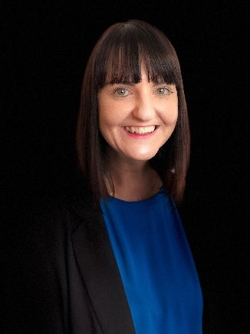
The theme of disability hate crime has been a focus of my work over recent months. I have met lots of inspiring and resilient disabled people who have shared their stories and remind us that our work in this area is so important.

The biggest achievement of late is launching our newest website. The Disability Safety Hub helps to raise awareness of disability hate crime, and how to report it. I met with groups of disabled people in advance of its launch, to ensure that it contains relevant and simple to use information. The website has been endorsed by the Cabinet Secretary for Justice, Mr Humza Yousaf and we were delighted that he thinks it’s a worthwhile website. Check it out here and let us know if you have any comments: www.disabilitysafety.scot

My work with Transport Scotland covers the topic of Hate Crime on public transport. This is one of the key areas of the Accessible Travel Framework that the Government would like addressed. We want to ensure that disabled people feel safe and comfortable to travel on public transport. As such, I have been working with colleagues from Police Scotland, British Transport Police, SEStran and Transport Scotland to host a series of consultation events. We are gathering feedback on the idea of having a Hate Crime Charter on public transport. This would be a series of pledges or promises, which transport providers and passengers would agree to, to help tackle hate crime.

We have held three consultation events and I will work with the team to draft a Hate Crime Charter, that will then be discussed in more detail with transport providers, to ensure that disabled people can travel safely. Our work with Transport Scotland also continues with a series of Accessible Travel Events. We travelled to Orkney in September and to Kingussie in November to host discussions with local people and transport providers about local transport and how it could be improved. We’re planning our next event in Renfrewshire in the new year, so look out for further information on our website.

In the meantime, if anyone wishes to contact me about my work, my number is 01259 272062 or email emma@disabilityequality.scot

Disability Safety Hub Launched to Tackle Hate Crime!

www.disabilitysafety.scot

In October 2018, we launched the Disability Safety Hub, a website to help you identify hate crime and how to report it.

Funded by the Scottish Government, the website aims to tackle the under-reporting of disability hate crimes. We know from our work that too many disabled people face victimisation and harassment but brush it off as ‘banter’ or accept it as part of their day-to-day lives.

The website www.disabilitysafety.scot contains videos, case studies and useful numbers and contacts.

Promotional Toolkit

You can let people know about our new website by downloading and sharing our promotional toolkit: www.disabilitysafety.scot/promotional-toolkit
This includes social media sharing functions, banners, and other materials to promote the Disability Safety Hub with your friends, family, colleagues and members of the community.

Tell Us What You Think!

We are delighted with the positive feedback that we have received so far. It is important that we keep this website up-to-date and fresh, and so we are asking for your continued feedback, comments and any useful resources you think should be included.

Get in touch by email admin@disabilityequality.scot or by calling our office on 01259 272064

Hate Crime on Public Transport – Alloa, 5 September
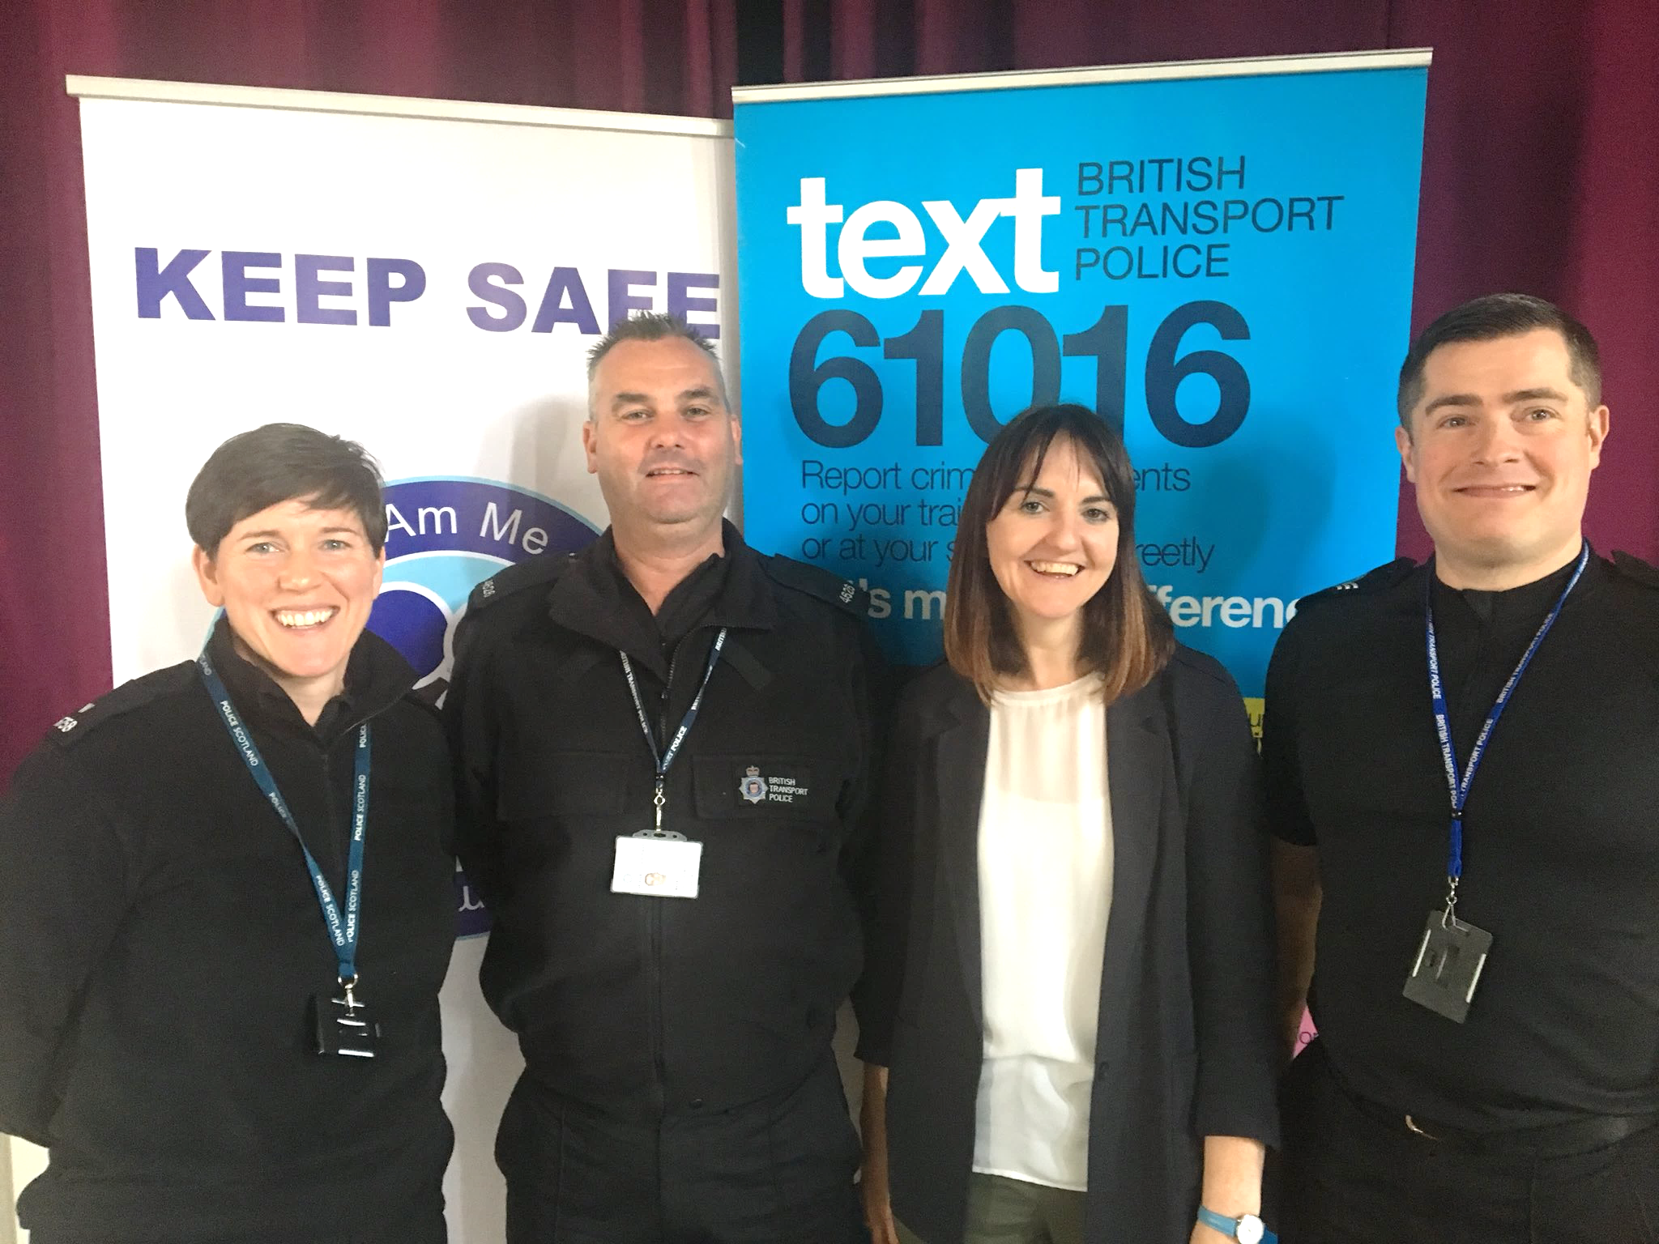
We recently worked in partnership with Transport Scotland, SEStran and Police Scotland, to host an event on the topic of Hate Crime on Public Transport.

This was the second of three consultation events intended to gather feedback on peoples’ experiences and perceptions of hate crime on public transport and more specifically to test the idea of introducing a national hate crime charter to which transport providers and passengers would commit. This would act as a national approach to tackling hate crime.

The day began with a presentation from PCs Stephanie Rose and Mike Parsons from Police Scotland who introduced the topic of ‘hate crime’ including some statistics about the number of reports. We learned that of almost 7,000 reports of hate crime nationally in one year, only 289 are disability related. PC Parsons indicated that this does not reflect the true picture, given that almost 1 million people in Scotland have a disability.

We also heard from PS Frazer Robertson from the British Transport Police which covers 1,200 stations in Scotland. PS Robertson said that during 2015/16 there were 86 million passengers travelling through these stations, and 153 reports of hate crime, which equates to one report of hate crime for every 581,081 journeys.

There were two group discussion sessions during the event. The first was a chance to hear people’s own experiences of hate crime, either as passengers or transport providers; including perceptions of whether it is a problem on some transport services. This discussion also included asking people to consider the idea of a Hate Crime Charter to tackle hate crime and if we were to adopt this approach, what would it be like.

Hate Crime on Public Transport – West Lothian, 13 December

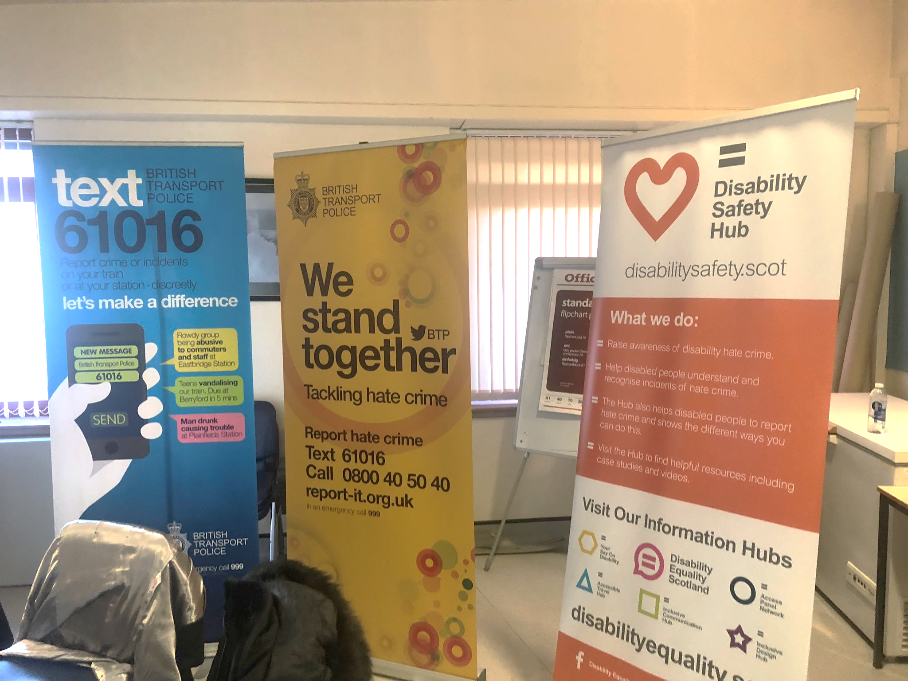
Our final workshop on the topic of Hate Crime on Public Transport took place on 13 December 2018 at the Ability Centre, West Lothian.

This was the third and final event in this series, intended to be a chance for disabled people and equality groups to come together with transport providers to talk about their experiences of hate crime on public transport.

It was also the opportunity to discuss the idea of a national hate crime charter which would form a zero-tolerance approach to tackling hate crime.
The event was well attended, and we were delighted to welcome representatives from the deaf community who were able to share their own experiences of hate crime.

The event heard from PC Ewan Smith who talked about different examples of hate crime and the British Transport Police also talked about the text number 61016, which allows people to contact the Police discreetly if they witness hate crime taking place on public transport.

We were pleased that Keith Lynch and Ivan Cohen from People First Scotland were able to present again, giving insight into the experiences of their members when travelling on public transport.

Group discussions indicated that many people had experiences of hate crime and were in agreement that a Hate Crime Charter would be a useful first step in tackling the issue. Also discussed was the need for the Charter to be monitored and enforced to check that it is making a difference. Groups talked about who should be responsible for this; perhaps a combination of Police Scotland, Transport Scotland and an independent body monitoring its progress.

In January 2019, Disability Equality Scotland, SESTran, Police Scotland and Transport Scotland will review the findings from all three consultation events, and begin to draft a Charter, ready for further consultation.

Accessible Travel Event – Kirkwall, 20 September 2018

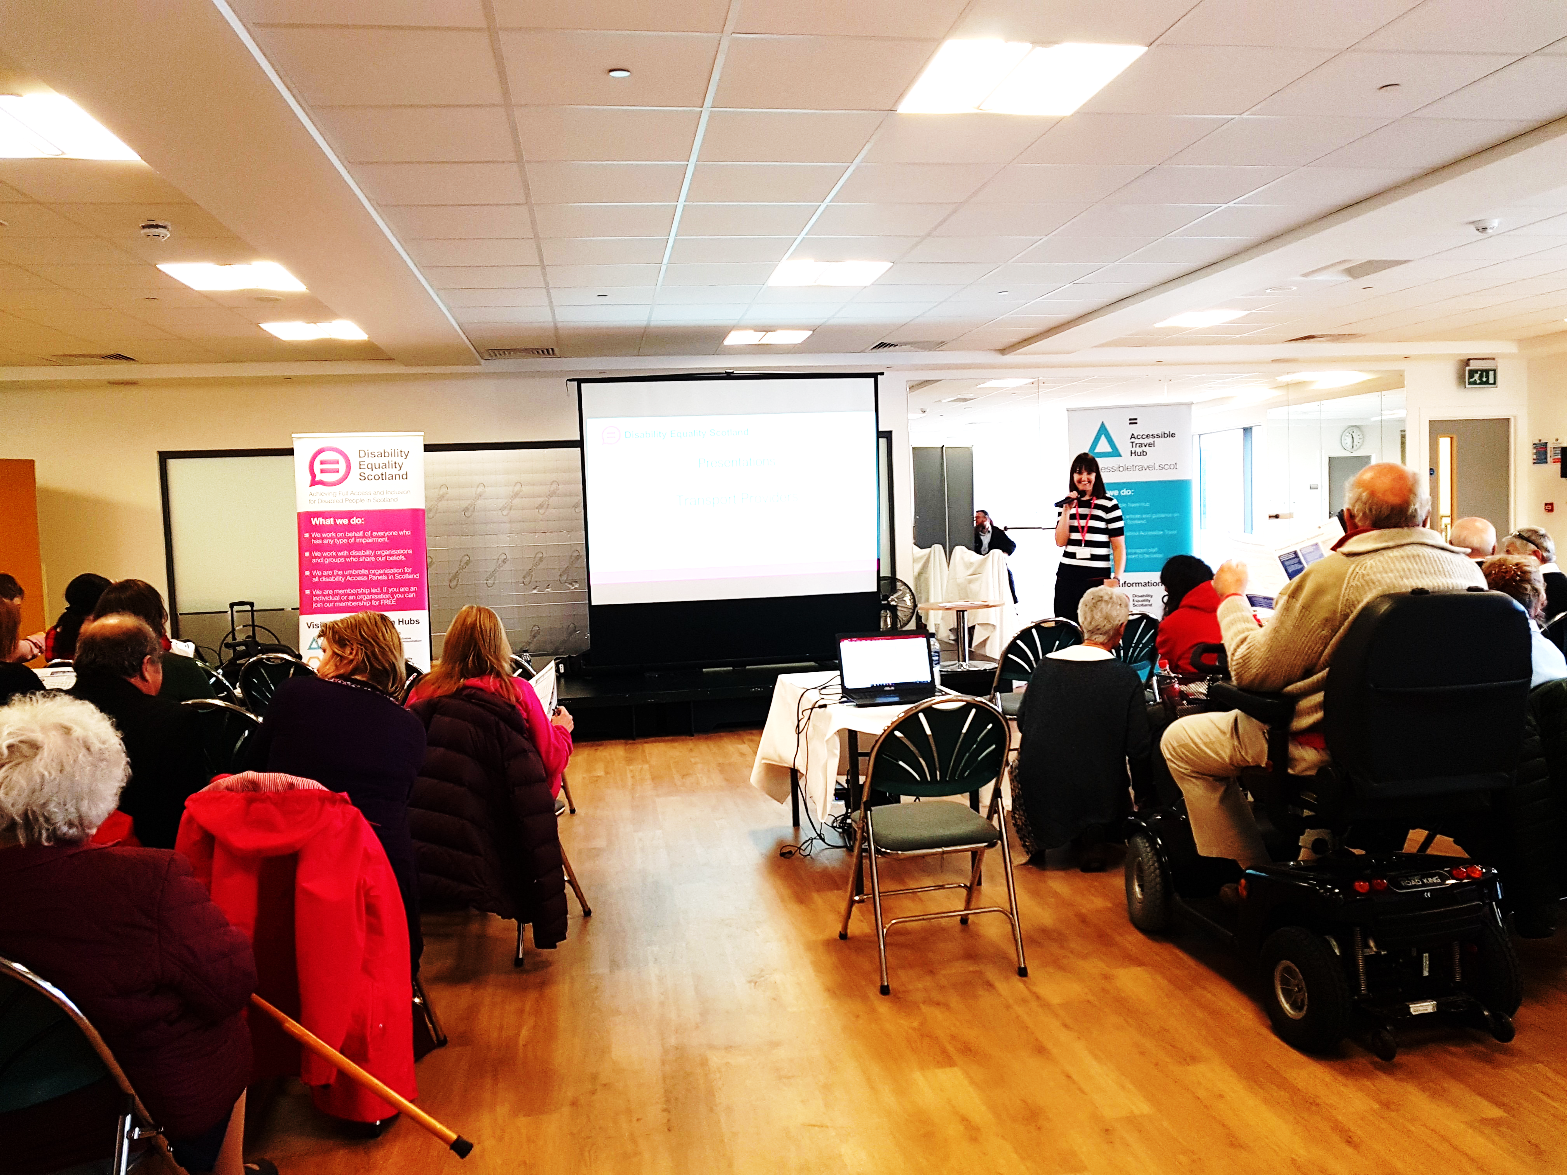
We were delighted with the turnout to our Accessible Travel Event on 20 September 2018 at the Pickaquoy Centre, Kirkwall, which we held in partnership with Access Panel Orkney.

The event was a chance to hear from different transport providers about the work they have been doing to improve accessibility and for frank discussions on the challenges of traveling independently as a disabled person around Orkney.

Emma Scott, Equality Projects Manager said "This was very much an opportunity for disabled people to share their experiences; not to berate or complain to providers, but to have an open discussion about the impact that an inaccessible journey can have on a disabled person. This allowed transport operators to hear first-hand about disabled peoples' experiences and to talk about ways of working together to improve services."

Discussions touched on the poor frequency of bus services around the islands, difficulties physically accessing buses and ferries and how the attitude of transport staff can make or break a journey.

The event saw representatives from NorthLink Ferries, Kirkwall Airport, Caledonian MacBrayne, Dial-A-Bus and J&W Taits to talk about the progress they have made to improve travel and transport for disabled people.

Attendees were encouraged by the progress to date and delighted that providers were up for the challenge to do more. This event is the first step in identifying the issues as well as opportunities to work together to bring about change.

Accessible Travel Event – Kingussie, 22 November 2018

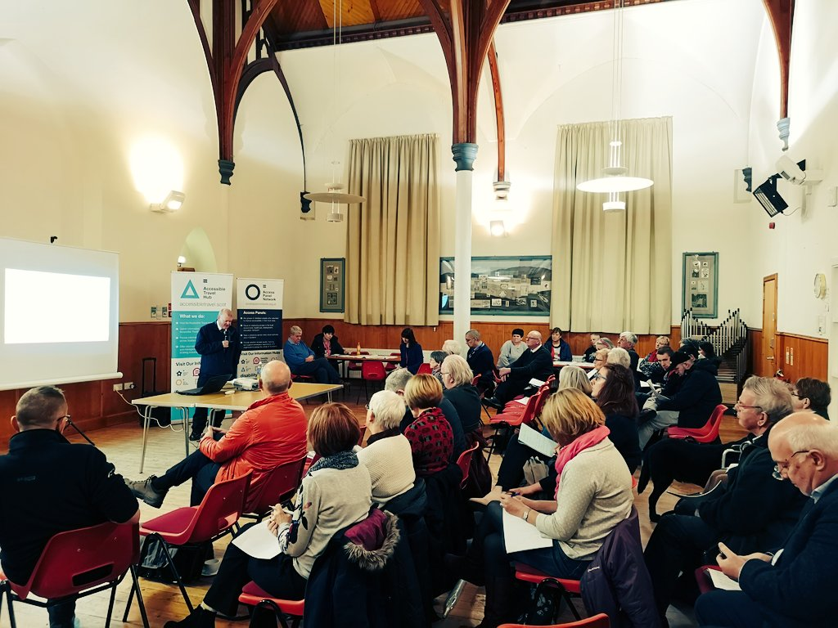
We worked together with Badenoch and Strathspey Access Panel to host an Accessible Travel Event in Kingussie on 22 November 2018. Discussions from this event will contribute to measuring the progress of the Accessible Travel Framework, which is the Government’s 10-year plan to improve public transport for disabled people.

Presentations

Andrew Marshall-Roberts, the Access and Inclusion Manager from ScotRail, spoke of the work they have been doing to improve accessibility; which includes reviewing their current 187-page customer guidance for Passenger Assistance. Maggie Lawson from Badenoch & Strathspey Community Transport Association spoke of how they support many disabled people, with a wide variety of disabilities including hidden disabilities. Pete Crane from the Cairngorm National Park Authority (CNPA), spoke of the work they have been doing to improve accessibility. The CNPA have set up an organisation called ‘Inclusive Cairngorms’ which ensures that their work is more inclusive and involves working in partnership with other organisations.

Group Discussions

Members of the audience then gave their views on what it is like to travel as a disabled person in Kingussie. Some of the key points raised included:

- Buses are a big issue, particularly access for those in a wheelchair or with mobility issues.
- Times of the buses were an issue because you can go out for the day but not necessarily get home if there is no accessible bus available.
- Many people prefer to travel by community transport as it is perceived as a more reliable service than public transport.
- Issues around accessibility at Kingussie train station, particularly getting disabled people on to the train platform, then from the platform to the train.

Hate Crime Reporting Roadshow, Camelon - 24 January 2019

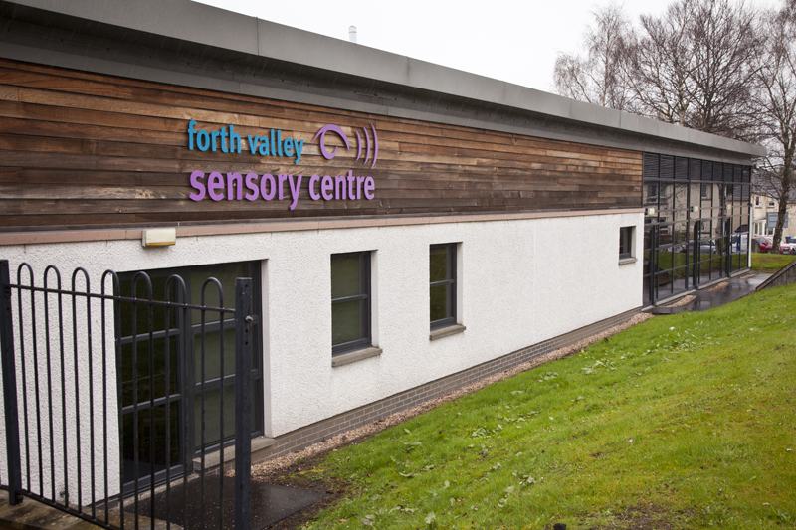
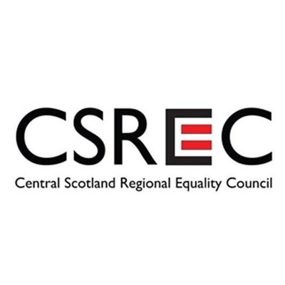
Our first event of 2019 will be a Hate Crime Roadshow, held in partnership with the Central Scotland Regional Equality Council (CSREC). The purpose of the event is to raise awareness of hate crime and how to report it; as well as discussing some of the potential barriers to reporting hate crime. There will be presentations from Police Scotland, CSREC and the chance to discuss personal experiences of hate crime.

CSREC exists and works to promote equality; fight hate crime and discrimination; foster good relations and build partnerships in the Falkirk, Stirling and Clackmannanshire Council areas. You can find out further information about CSREC and the Support and Advice Service that is led by Laura Mallis, Equality Engagement Officer, on page 32.

We will also have a presentation about our recently launched Disability Safety Hub; a website to raise awareness on how to identify and report disability hate crime. We will discuss the various features of the website, and then open the floor up to attendees to share your feedback. Your comments will help us to further develop the website.

To book your free place please contact admin@disabilityequality.scot
Telephone: 01259 272064 or book online at Eventbrite www.hate-crime-reporting-roadshow.eventbrite.co.uk

Date: 24 January 2019
Time: 10:00am – 12:00pm
Venue: Forth Valley Sensory Centre, Redbrae Road, Camelon,FK1 4DD

Accessible Travel Hub – www.accessibletravel.scot

The Accessible Travel Hub is a website for you to find information, articles and guidance on Accessible Travel in Scotland. The Hub launched alongside the Accessible Travel Framework, a ten-year plan by Transport Scotland to improve travel access for disabled people.

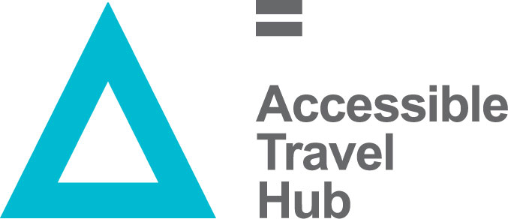

What Can I Find on the Hub?

- Articles and Information on accessible transport in Scotland; including the rules and responsibilities of transport providers.

- Dedicated Transport Mode ‘Area’ for Transport providers /operators to promote good practice in access-related work.

- Links to resources, including; PAMIS’ map of Changing Places toilets, Radar keys, Thistle Cards, Traveline Scotland, Hate Crime Reporting.

- Signpost to relevant training courses, including disability awareness and inclusive communication.

- News and blog featuring up to date accessible travel news in Scotland.

Inclusive Communication Hub – www.inclusivecommunication.scot

Supported by the Scottish Government, we are working with Sense Scotland and other partners to host the Inclusive Communication Hub; a website that has been developed for anyone with an interest in improving their inclusive communication tools and processes.

What Is Inclusive Communication?

Inclusive communication means sharing information in a way that everyone can understand. For service providers, it means making sure that you recognise that people understand and express themselves in different ways. For people who use services, it means getting information and expressing themselves in ways that meet their needs. Throughout this Hub you will find helpful resources such as case studies and blogs from employers and individuals; details of training and the latest news on Inclusive Communication.

Inclusive Communication Champions

We are looking for a network of individuals to step up and be Inclusive Communication Champions. The individuals could be employers from different organisations or Scottish Government Policy Officials. This network of champions will provide feedback into the Inclusive Communication Hub and be asked to promote inclusive communication within their own organisations, ensuring that the topic stays on the agenda.

If you would like to find out more about this exciting opportunity, please contact Emma Scott, Equality Projects Manager:

Telephone: 01259 272062 Email: emma@disabilityequality.scot

Inclusive Design Hub – www.inclusivedesign.scot

The Inclusive Design Hub is a website that aims to improve awareness and encourage the take up of inclusive design in Scotland.

What is Inclusive Design?

Inclusive Design is the design of an environment so that it can be accessed and used by as many people as possible, regardless of age, gender and disability. An environment that is designed inclusively is not just relevant to buildings; it also applies to surrounding open spaces, wherever people go about every day.

What Can I Find on the Hub?

- Articles on the importance of inclusive design.

- Case studies that demonstrate innovative examples of inclusive environments in Scotland.

- A resources library that provides links to inclusive design guidance from a variety of sources.

- An up-to-date blog featuring: interviews, discussion points and all of the latest inclusive design news from across the country.

Disability Equality Scotland Easy Read Service

We have the expertise to produce information in Easy Read

We provide a professional and efficient Easy Read service to all sectors, as part of our commitment towards improving access to information for all.

What is Easy Read?
Easy Read is an accessible format that makes written information easier to understand. The Easy Read format is easy to understand because it uses simple, jargon-free language, shorter sentences and supporting images.

Why produce Easy Read documents?
Easy Read documents make information more accessible to people with learning disabilities. They can also be useful for people with other communication difficulties including:
- acquired brain injury
- dyslexia
- people with hearing impairment whose first language is British Sign Language (BSL)
- people who do not speak English as their first language
- people who find reading, difficult
- people with cognitive impairments such as dementia

The Equality Act
The Equality Act (2010) requires organisations to produce information in an accessible format. Easy Read can ensure that disabled people have equal access to information and are not discriminated against.

Who do I contact?
For more information about our Easy Read service, including examples of our work, please visit our website: www.easyread.scot

You can also contact us by telephone: 01259 272064
or email: admin@disabilityequality.scot

Your Say on Disability - www.yoursayondisability.scot

Gathering the views of disabled people in Scotland
The Your Say on Disability website is a place for you to tell us your views on disability issues in Scotland. This website provides the opportunity for disabled people to help shape Scotland’s future in accessibility and equality.

As someone with lived experience of – or representing someone with – a disability, we would like you to tell us what you feel is working and what needs to change in
Scotland, by completing our surveys. Our surveys are on current policy consultations and are available in alternative formats.

Weekly Poll

The Weekly Poll will allow you to have your say on a number of different topics affecting disabled people in Scotland. The poll is a simple yes/no question that will be published each week, along with the opportunity to leave a comment on the chosen topic.

BSL Videos

This year we launched our official YouTube channel! To start things off, we uploaded eight BSL videos that have been translated from our Weekly Poll questions.

What happens to my comments

- Your comments will be passed on in full to those who have requested the survey, making sure that your views really are counted.
- Your responses are anonymous unless you wish to provide your details.
- The Scottish Government and other bodies want to know what is working, what is not and what needs to happen to improve life for Scottish disabled people, so your comments can really make a difference!

Consultation: Changing Scottish Hate Crime Legislation

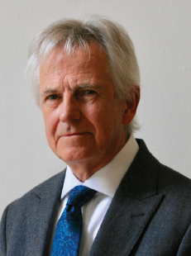
The Scottish Government is calling on the public to help shape hate crime legislation with the launch of a new consultation.
‘One Scotland: Hate Has No Home Here’ follows on from Lord Bracadale’s ‘Independent Review of Hate Crime Legislation in Scotland’ which was published in May 2018.
The consultation calls for views on a number of issues including how best to tackle age-based prejudice and the impact of hate crime law on vulnerable groups.
The public responses will inform the development of a hate crime bill which will be laid before Holyrood later in this session of Parliament.
The hate crime legislation consultation ‘One Scotland: Hate Has No Home Here’ is now open and will run until 24 February 2019.

To contribute to the Disability Equality Scotland response to this consultation, please complete our online survey: www.surveymonkey.co.uk/r/QPST2KM

Please contact us if you require the consultation in an alternative format: admin@disabilityequality.scot

We are currently producing an Easy Read version of this consultation. This version will be available in late January 2019.

Consultation: Improving Employability in the Public Sector

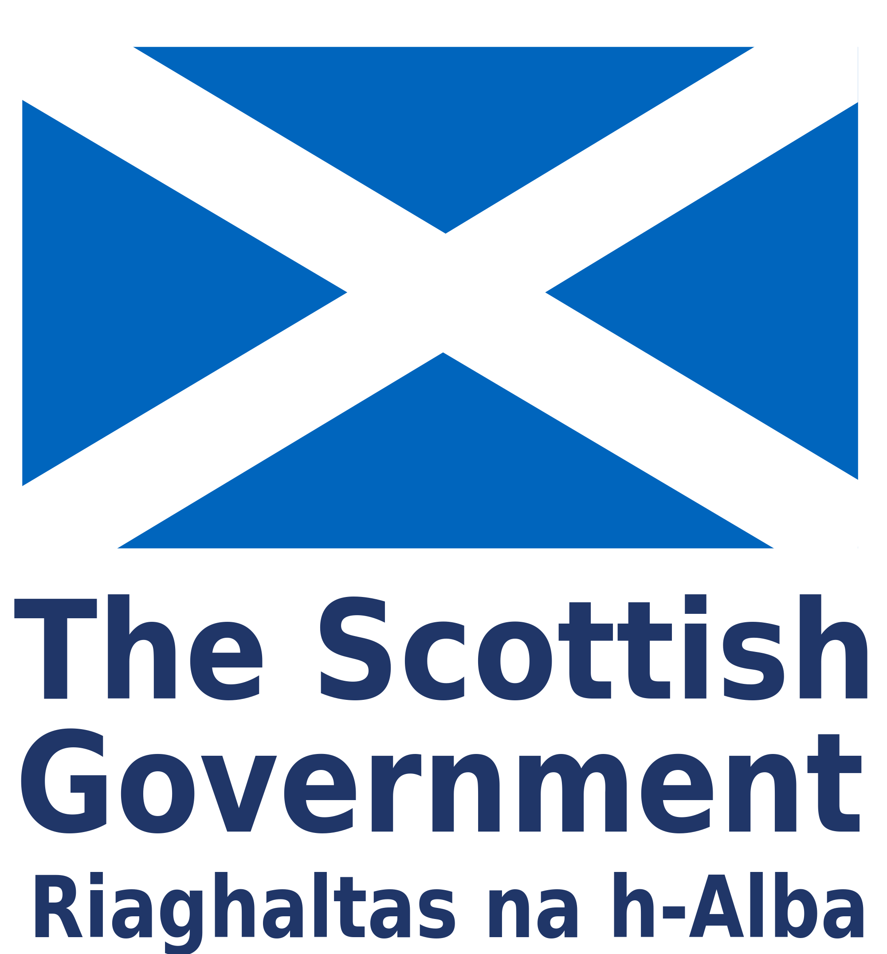
The Scottish Government wants to close the disability employment gap by at least half. For this to happen, the public sector needs to employ more disabled people. This consultation aimed to find the best ways to make sure that more disabled people get jobs in the public sector.

We circulated the consultation to all members in April 2018. To maximise the number of responses, the consultation was available in a variety of accessible formats, including Easy Read. The consultation was also available on our social media platforms. We received a total of 55 responses.

Your Responses

The responses from our members identified various measures that can be implemented to increase employability in the public sector:

- Attitudinal and cultural change: A change in organisational culture and attitudes to be more open with disabled employees about the support that can be offered through reasonable adjustments.

- Training: Disability awareness training can help to overcome attitudinal and cultural barriers. Greater information on reasonable adjustments.

- Access Panels: Consultation with Access Panels to provide access audits on workplace environments.

- Transport: It is crucial that an accessible transport network exists to ensure that disabled people can travel safely to their place of work. This means making stations, toilets and pathways accessible, as well as the transport modes used.

- Funding: Crucially; to implement these changes, extra funding needs to be made available.

Consultation: Democracy Matters
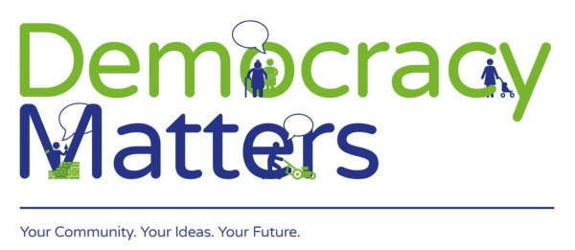
The Scottish Government is carrying out a review of local governance, to consider how powers, responsibilities and resources are shared across the country, local governing bodies and at the community level.

The Democracy Matters initiative aims to generate discussions about community decision-making between now and November 2018. Feedback from the process will help inform new legislation designed to devolve more decision-making powers to a local level.

In our response to the consultation, we highlighted the importance of the following factors:

Access Panel Network: Access Panels build up strong relationships with their local authority by providing advice on accessibility and wider social inclusion. We believe that more could be done to develop existing decision-making processes to include the views of disabled people. Therefore, we have been lobbying the Scottish Government to ensure that Access Panels receive statutory consultee status.

Social Isolation and Loneliness: Disabled people are significantly more likely to experience isolation and loneliness due to a lack of accessible public and community transport, lack of accessible and affordable housing and the low percentage of disabled people in employment. Increased access and engagement reduces the risk of social isolation.

Community Empowerment: Better community engagement leads to the delivery of better, more responsive services and better outcomes for communities. The Community Empowerment Act will empower disabled people to engage more fully with public bodies, transport providers and local employers.

Consultation: The Transport (Scotland) Bill

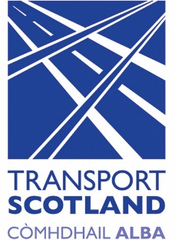
The Transport (Scotland) Bill is designed to help make Scotland’s transport network cleaner, smarter and more accessible than ever before. It aims to empower local authorities and establish consistent standards in order to tackle current and future challenges, while delivering a more responsive and sustainable transport system for everyone in Scotland. Our response was based on the views of our members that we gathered through surveys, and transport engagement events.

Pavement Parking: The Transport (Scotland) Bill proposes new laws that will make it illegal for motorists to park their vehicles more than 50cm over the kerb. If drivers do break the rules they could be fined by councils. Overall, 96% of our respondents (93 people) agreed that this ban should be in place. However, there were strong views that this should be a complete ban, and not include the 50cm allowance.

“50cm is NOT a ban! It is pointless and achieves nothing in many rural areas. This will change nothing! This is not what we have been campaigning for.”

Smart Ticketing: Most of our members (79%) agreed with the introduction of smart ticketing, as long as the technology involved is fully accessible.

“This will transform travel for many people as long as the supporting arrangements are accessible; how do people top up their accounts and will the formats available be accessible to everyone. For example; accessible websites, accessible payment terminals etc”
Road Works: Many of our members had encountered roadworks which have made it more difficult or dangerous to navigate or for you to pass through as a pedestrian.

“Roadworks are always difficult for me because even though I don’t use a wheelchair all the time, when I do, I find that people are not very helpful. Last year, I fell into a pothole in my chair and all that happened was the workman laughed.”

Scottish Public Toilet Numbers Plummet

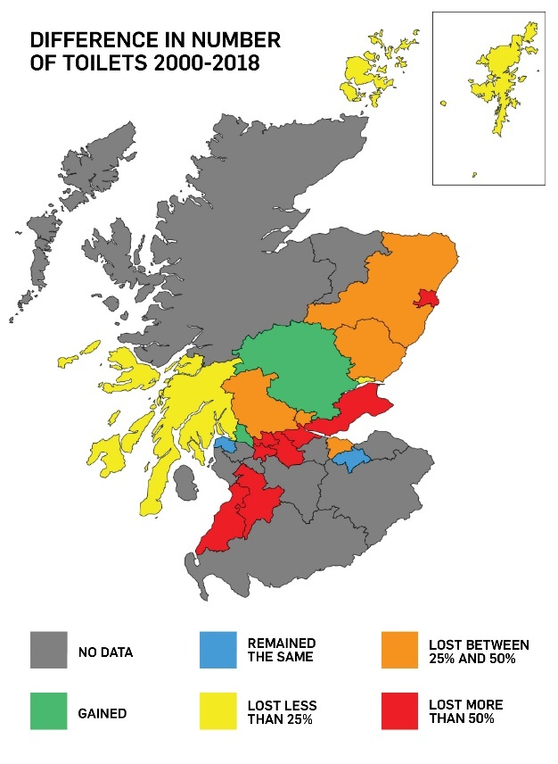
New figures have revealed that the number of council-owned public toilets in Scotland has fallen by almost half since 2000 – from 759 to 421.

One of the worst affected areas is Aberdeen, which has experienced a 73% decline in numbers. While there were 33 local authority-operated toilets at the turn of the millennium, there are just nine today.

We are extremely concerned about the increasing lack of access to public toilets across Scotland.

Our CEO, Morven Brooks, commented:

“Being able to use a toilet is a basic human right, however every day thousands of disabled people across the country are denied that right due to the worrying decline in public toilets and the lack of suitable facilities therein for disabled people.

“A lack of public toilets can also be a health risk, leading to social isolation as it could prevent disabled people from leaving their homes, feeling humiliated, and worried about how they would cope without suitable public toilet facilities being available.

“We strongly believe that more must be done by local councils to maintain public toilets across Scotland to ensure that disabled people are not discriminated against.”

For the week commencing 27 August 2018 we asked our members if they were concerned by the closure of council-owned public toilets. A summary of the responses from this poll can be found on the next page.

Weekly Poll Roundup – August to November 2018

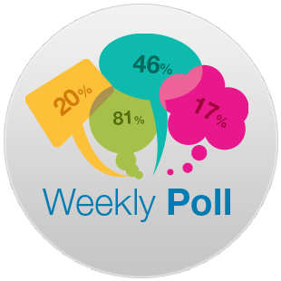
Last year we launched a new way of engaging with our members. Each week, a new Weekly Poll question is shared with our members on a different topic or subject. The aim is to build up a bank of information and views from our members, so we can better understand disabled people. We also want to increase our outreach and gather more evidence that we can use in our business planning and to help respond to consultations. Below is a selection of the weekly poll questions we have asked in the past few months, along with your responses:

Public Toilets - Week beginning 27 August
Question: Are you concerned by the closure of council-owned public toilets across Scotland?

Your feedback: Yes – 95% (79 respondents) No – 5% (4 respondents)

Your comments: “The council should not be relying on the goodwill of local businesses and volunteers to provide a service that should be considered at the top of the list of 21st century services provided by the council.”

What we did next: Your comments contributed to our campaign to raise awareness of public toilet closures.

Disabled Parking Bays (Week beginning 10 September)
Question: Do you think there needs to be a change in legislation to prevent the placing of bollards between disabled parking spaces?

Your feedback: Yes 98% (41 Respondents) No 2% (1 respondent)

Your comments: “Governments, Councils etc, are far too quick to install items without thinking the whole process through. Were any disabled groups consulted before the bollards were installed? Probably not.”

...responses continued on next page >>>

>>> responses continued…

“Sick of having to put my lift down into traffic. Very dangerous.”

What we did next: We shared your comments with the campaign to change legislation to prevent the placing of bollards between disabled parking spaces.

Young Carer Grants - Week beginning 1 October
Question: Should applicants be able to combine hours caring for more than one person to meet the required 16 hours average each week?

Your feedback: Yes–97% (29 respondents) No–3% (1 respondent)

Your comments: “If a carer is caring for more than one person then yes, of course they should be allowed to combine hours! A single carer can only care for one person at once.”

What we did next: The comments were passed on to MSP Shirley-Anne Somerville, Cabinet Secretary for Social Security and Older People during a meeting with Disability Equality Scotland at the Scottish Parliament.

Hate Crime Campaign - Week beginning 8 October
Question: Do you agree with the language used in the campaign?

Your feedback: Yes–47% (14 respondents) No–53% (16 respondents)

Your comments: “It sounds like the beginning of a corny joke. The adverts are in a font which is inaccessible to many partially sighted people and those who use text readers.”

“The language threatens punishment, and might be better promoting understanding.”

What we did next: We fed your comments back to the team behind the campaign at the Scottish Government and also used some feedback to influence our website launch of the Disability Safety Hub.

Scottish Government Hate Crime Campaign

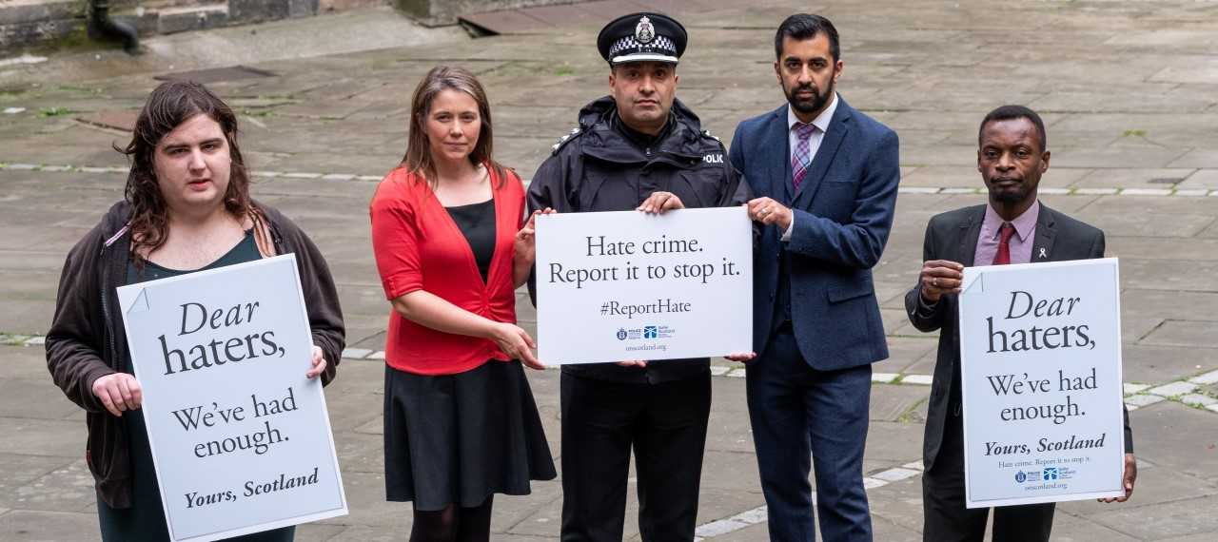
There’s no place for hate in Scotland.

Latest figures show that in the last year there were over 5,300 charges of hate crime reported to the Procurator Fiscal in Scotland, with many other incidents not being reported to the police.

In Scotland, the law recognises hate crimes as motivated by prejudice based on race, religion, sexual orientation, transgender identity and disability. Hate crime can be verbal or physical, is completely unacceptable and will not be tolerated.

The Scottish Government has launched a campaign to encourage those who have witnessed hate crime to speak out and report it.

Through a series of attention grabbing letters, the campaign speaks directly to witnesses of hate crime by using emotive language to highlight the different forms hate crime takes and encourages everyone to report hate crime if they see it.

Hate crime has hugely damaging effects on victims, their families and communities and we all must play our part to challenge it. Don’t assume someone else will report it.

If you witness a hate crime call your local police on 101, or in an emergency always call 999. If you don’t feel comfortable reporting an incident to Police Scotland, there are third party reporting centres across Scotland - www.scotland.police.uk/contact-us/hate-crime-and-third-party-reporting/third-party-reporting-centres

For more information on hate crimes and to report concerns visit www.onescotland.org

#ReportHate

Scottish Government Hate Crime Campaign

The following letter was produced by the Scottish Government and Police Scotland to encourage people to identify and report disability hate crime.
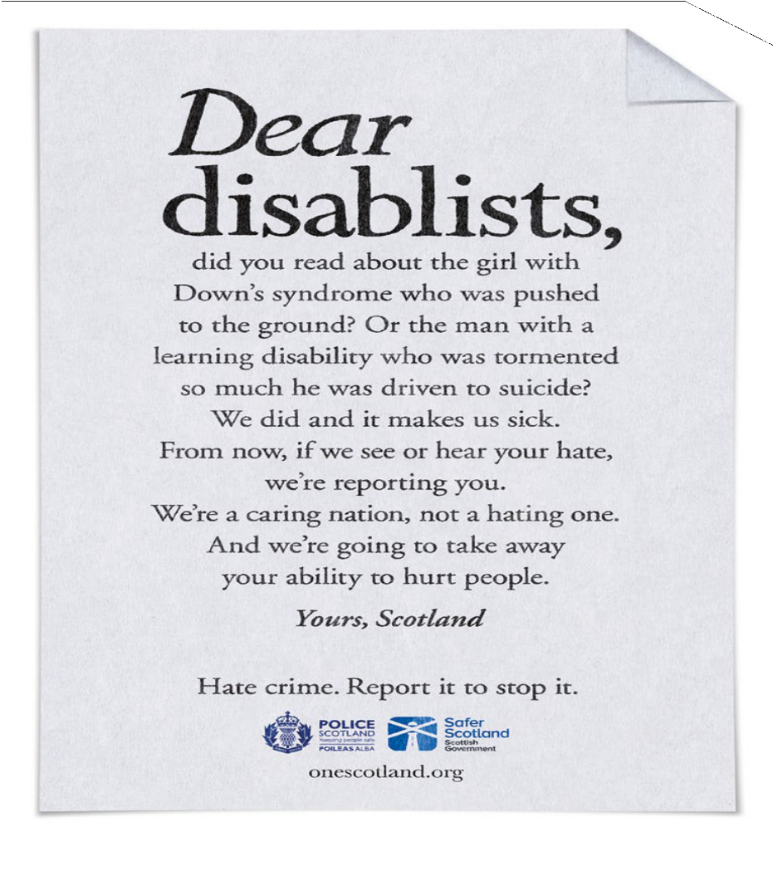

Disability Safety Hub – What is Hate Crime

The following information will help you to identify what hate crime is. You can find further information relating to hate crime and information to keep you safe on our recently launched Disability Safety Hub: www.disabilitysafety.scot

Police Scotland say that hate crime is an offence. An offence is something that is against the law. If you are a victim of crime and you or someone else thinks it was because of your:

- Disability;
- race or ethnicity;
- religion or belief;
- sexual orientation; or
- transgender identity

this is a hate crime.

Here are some examples of what Police Scotland say is a hate crime:

- verbal abuse like name-calling and nasty jokes
- harassment
- bullying or intimidation by people of any age
- physical attacks such as hitting, punching, pushing, spitting
- threats of violence
- hoax calls, abusive phone or text messages or hate mail
- online abuse, for example, on Facebook or Twitter
- writing or sharing stories or posters that say nasty things about someone
- harm or damage to things such as your home, or a pet or car
- graffiti
- deliberately setting fire to your property
- throwing rubbish into a garden
- making a false complaint against you.

Disability Safety Hub – How to report Hate Crime
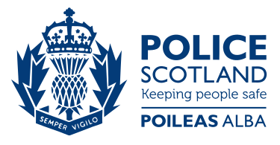
All hate crimes and incidents should be reported. By reporting, you will help people like the police, local councils, and housing associations to see patterns of behaviour locally, and help to show areas that could be a problem within your community. But more importantly, you can get the support you need and help make sure that offenders are brought to justice and cannot do the same to other people.

There are lots of ways you can report a hate crime. You can report if you are the victim, or if you have seen this happen to someone else, or if someone asks you to report it for them.

In an emergency
- call 999
- If you cannot make voice calls, you can now contact the 999 emergency services by SMS text from your mobile phone. However, you will only be able to use this service if you have registered with emergencySMS first. See the emergencySMS website for details.

Contact your local police station
- You can speak to the police in confidence by calling 101. You do not have to tell them your personal details, but any investigation and ability to prosecute the offender(s) is limited if the police cannot contact you. Contact your local police force, either by telephone or by visiting your local police station. Details on how to contact your local police force can be found on the Police Scotland website

Report online
- You can report online using the Hate Crime Form on Police Scotland’s website

3rd party reporting centres
- Sometimes victims/witnesses of Hate Crime do not feel comfortable reporting to the Police and may be more comfortable reporting it to someone they are familiar with.
- 3rd party reporting centres

Central Scotland Regional Equality Council (CSREC)

Barriers to reporting hate crime

Central Scotland Regional Equality Council (CSREC) runs a Support and Advice Service that is led by Laura Mallis, Equality Engagement Officer. The Support and Advice Service offers advice and assistance to people living, working or studying in Forth Valley who are experiencing discrimination, hate crime, welfare; housing and employment issues, among other inequalities. CSREC also delivers equality, diversity, inclusion training and awareness sessions on reporting hate crime and prejudiced behaviours to organisations and community groups.

Through our work we meet and support many people who have experienced or witnessed hate crime. However, a large number of hate crimes and hate incidents go largely unreported. Through our own research, conversations with people in communities and partner organisations, including the police, we know that many people do not report due to several barriers, such as: fear of retaliation; freeze response to trauma: fear of not being taken seriously; fear of not being believed by the police; feeling what’s happened will be perceived as too trivial; previous negative experiences when reporting; fear of being outed if one is LGBTI+, gypsy/travellers or other identities that may face persecution; shame or embarrassment; among other reasons. Although people might not report, it’s really important that people do and an alternative to reporting directly to the police is Third Party Reporting.

CSREC is a Third Party Reporting Centre, so if someone isn’t comfortable reporting their experience directly to the police they can speak to us and we can make a report on their behalf. We work in partnership with the police to help victims and witnesses by facilitating meetings with the police in our office or in other neutral venues where people might feel more comfortable. Through Third Party Reporting one can also report cases anonymously. With your consent, we can also follow up with the police to keep service users updated on the progress of their case. It’s really important to report hate crime if you are a victim or a witness and Third Party Reporting Centres such as CSREC are here to support and assist you. For more information on various options to report hate crime and prejudice visit: www.reporthate.scot Email admin@csrec.org.uk Telephone: 01324 610950

deafscotland Annual Conference 2019
Did you know deafscotland is having their annual conference on Friday 15 March 2019 in Glasgow at the DoubleTree by Hilton Hotel?

This conference is jointly coordinated with Disability Equality Scotland and SCOVI. Our theme is ‘Connect & Communicate – Communicate4all’ and we couldn’t be more excited. Come along and join us!

If you are interested in having a stall, please get in touch with Claire Henderson, Event Organiser by email on admin@deafscotland.org as soon as possible to book your place.

Oh before we forget, we do have sponsorship opportunities, if you are interested in sponsoring a part of the conference by getting in touch with Janis McDonald, Chief Officer: chiefofficer@deafscotland.org

We have a couple of workshop spaces left, if you are interested in presenting a workshop by getting in touch with Claire Henderson, Event Organiser: admin@deafscotland.org.

This conference is too good an opportunity for you or your colleagues at your organisation to miss! After our 2018 Conference, many colleagues and organisations developed new partnerships, projects and opportunities for their members locally. Working with Disability Equality Scotland and SCOVI will raise awareness of deafness, blindness and disability.

Should you have any questions, please don’t hesitate to contact us.

I Am Me
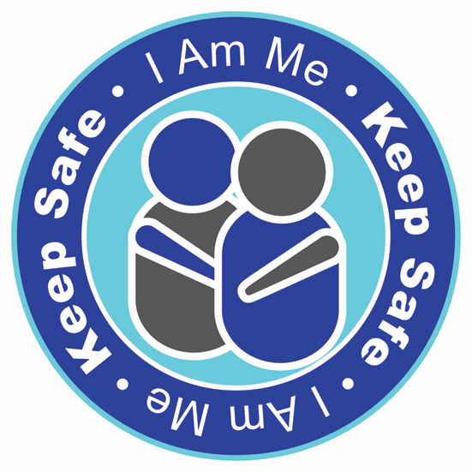
I Am Me is a community group that works in partnership with Police Scotland to raise awareness of and tackle disability hate crime.

Disability Hate Crime is one of the most under reported crimes in the UK, with an estimated 97% going unreported. Many incidents go unreported as disabled people accept abuse and harassment as part of daily life. There are 1 million people in Scotland registered as disabled or with a long term illness. There are two key initiatives; I Am Me and Keep Safe.

I Am Me

I Am Me works with communities to raise awareness of what disability hate crime is and how incidents can affect individuals and the wider community. The project has worked with partners to produce a hard hitting film based on a young adult with autism and a learning disability, and the issues he faces within society. A teaching pack to accompany the film is available at www.iammescotland.co.uk and the film is available to view for free here. I Am Me have also worked with a number of partners to develop a Primary School Resource which is available to download for free at www.iammescotland.co.uk. The resource aims to introduce disability, increase understanding of the range of disabilities, highlight the effects of bullying and inclusion, and highlights the consequences of hate crime. The films to accompany the resource are available for free here.

Keep Safe

Keep Safe works in partnership with Police Scotland and a network of local businesses to create ‘Keep Safe’ places for anyone when out and about in the community. People can access these premises to seek assistance and help if they feel lost, confused, scared, in danger, or have been the victim of a crime. The initiative is being rolled out across Scotland in partnership with other Local Authorities and Police Scotland. An explanation video of Keep Safe can be found here. If you would like to be involved in the roll out of Keep Safe within your Local Authority, please contact us: iamme@renfrewshire.gov.uk, 0141 618 6241/6266

Scottish Ambulance Service

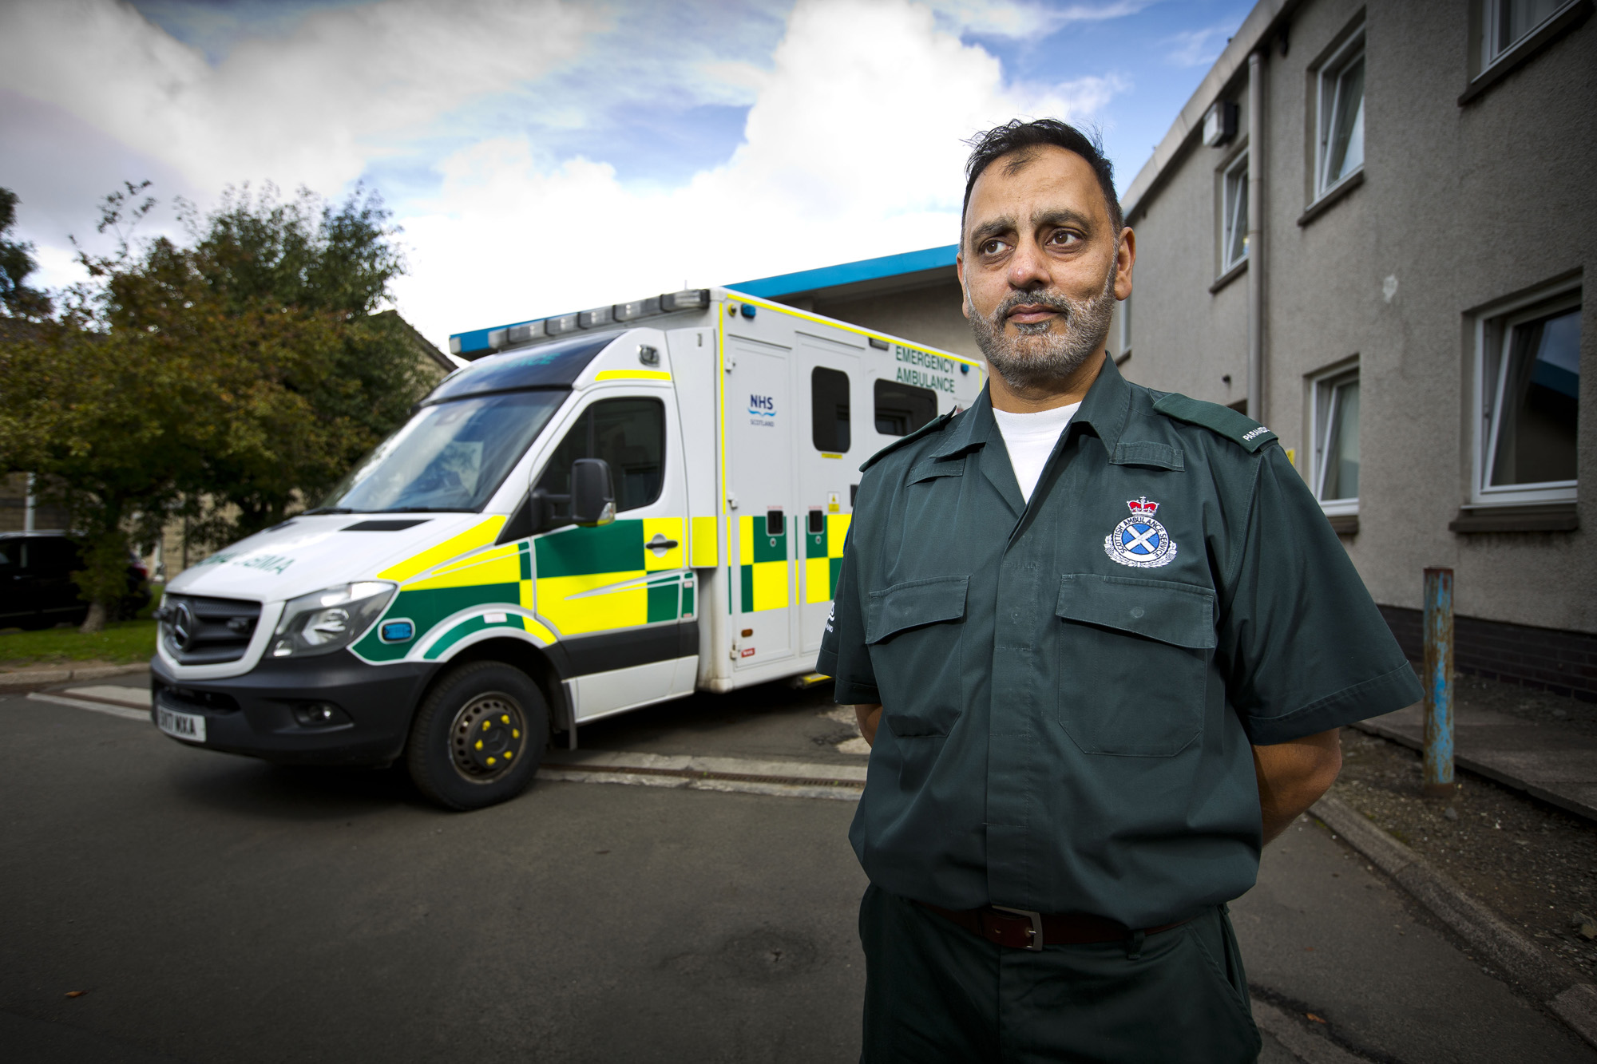
Paramedic Practitioners (Community Paramedics) were first introduced into the Scottish Ambulance Service in 2004, responding to 999 calls and working within out of hours and minor injury units or emergency departments. In 2015, in response to our strategy ‘Towards 2020 : Taking Care to the Patient’ and building on these previous roles, Specialist Paramedic roles were developed.

These new roles provide more comprehensive care at home for patients calling 999. Specialist Paramedics can also provide access to alternative care pathways that may be better suited for patients than A&E, such as a local community care team. They can assess, diagnose and manage patients with acute and/or long-term illness and injury, and have access to additional diagnostic tests and a wide range of medicines that a regular Paramedic doesn’t.

There are currently 90 Specialist Paramedics across Scotland, with many responding to both 999 emergency calls and rotating within primary care settings, like GP surgeries. Working within primary care enables Specialist Paramedics to gain additional experience in managing a wide variety of patients with a wide variety of needs.

As a service we want to know what you think of Specialist Paramedics. Would being treated at home be a good thing for you or someone you care for?

We are always looking to improve and need your help in doing that. Email Chris Purnell: c.purnell@nhs.net for further information.

See Me – Feels FM
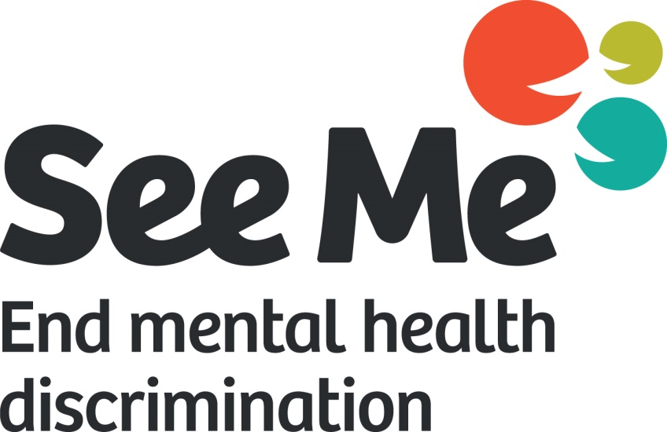
As part of the Year of the Young People See Me have created the world’s first emoji-powered jukebox for mental health. Feels FM is an online platform to help young people express their feelings, use music as a positive coping strategy, and find new ways to talk about mental health stigma and discrimination.

Young people go onto the site, put in an emoji which represents how they feel, and then it creates a playlist to match their mood. While it plays See Me will ask them their opinions on what they think makes it easier or harder for young people to speak about their mental health.

Alongside the online platform, young people have also helped See Me coproduce a Feels FM activity which brings Feels FM to life so it can be used by organisations who work with young people to run Feels FM sessions.

Everything See Me learn from the sessions will go into helping improve mental health for young people, by informing the Scottish Government and the Youth Commission on Mental Health.

The final part of the campaign will ask the young people their ideas on how to tackle mental health stigma. This is the really exciting part because the best two ideas See Me receive will be awarded a £1000 grant from See Me to help bring their idea to life!

To run these sessions you will be able to download a pack from the See Me website, or visit www.feelsfm.co.uk to get music for your mood and join the conversation.

Enable (Falkirk Branch)

This year our Branch celebrates our 50th Birthday!
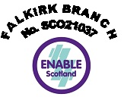
Like most charities we have had to face with dealing with changes in Council Services that effect our members. In the last 12 months we have more than double our usage of our premises. We also have been upgrading our premises. Our arts and crafts room has been painted, new lino, new cupboards, new table which lets us make it wheelchair friendly. We also added a cinema.

Services that we provide at our branch are:

  - Parents/carers meetings.
  - Wednesday club.
  - Tuesday club 18-30 group
  - Ten-pin bowling club every 2nd week
  - Cinema club

Events held this year.

  - Burns night
  - Easter dance
  - Summer dance
  - BBQ disco dance
  - Awakening festival (a first for our charity)
  - Halloween event for both clubs.

Events still to come

  - Our Branches 50th Birthday party
  - Pantomime at the Dobbie hall Larbert - Dick Whittington
  - Christmas dance for both clubs

Access Panels

We are the umbrella organisation for all disability Access Panels in Scotland, providing them with support and guidance to improve the lives of disabled people at a local level throughout Scotland.

What is an Access Panel?

Access Panels can be found in all regions and are made up of groups of disabled volunteers who work together to improve physical access and wider social inclusion in their local communities. We offer support and training opportunities to help them operate efficiently, link together as a network and learn from each other.

Get Involved!

Joining your local Access Panel is easy and a great way to help improve accessibility in your community. You can learn new skills, help with promotional campaigns or give support at events, help with research and publicity. Give the time and commitment with which you feel comfortable and help to make a difference in your community.

To find out more about the Access Panel Network and how to join your local Access Panel contact Gillian Smith:

Tel: 01259 272064 Email: gillian@disabilityequality.scot

Website: www.accesspanelnetwork.org.uk

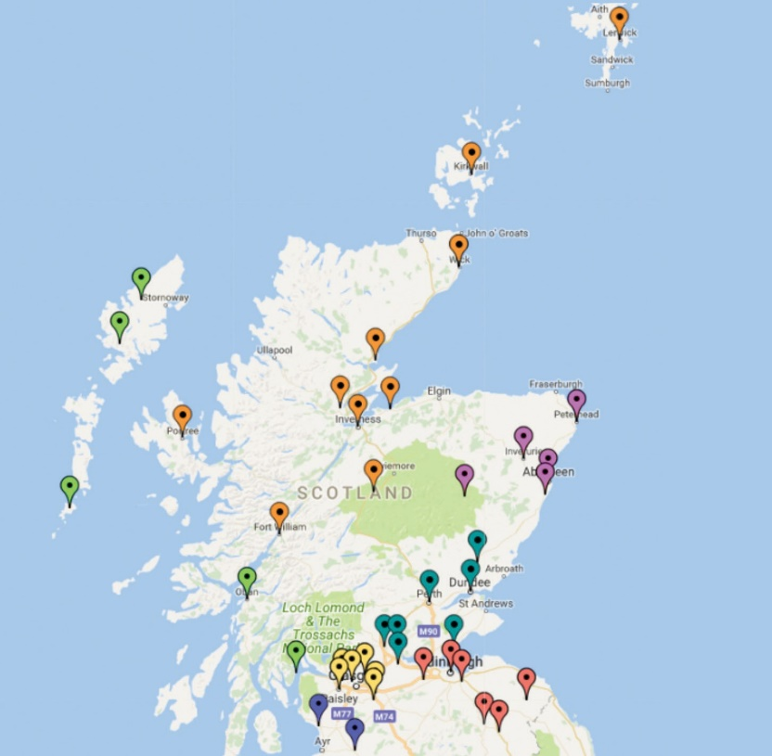
Geographical location of Access Panels in Scotland

Western Isles and Argyll
  - Barra Access Panel
  - Cowal Access Panel (Dunoon)
  - Harris Disability Access Panel
  - Oban & District Disability Forum & Access Panel

South West
  - North Ayrshire Access Panel

Forth Valley and Tayside
  - Angus Access Panel
  - Centre for Inclusive Living Perth & Kinross
  - Disabilities Fife
  - Dundee Access Group
  - Falkirk Area Disability Access Panel
  - Stirling Area Access Panel

Glasgow and Clyde Valley
  - East Dunbartonshire Access Panel
  - Glasgow Access Panel
  - North Lanarkshire Access Panel
  - Renfrewshire Access Panel
  - South Lanarkshire Access Panel
  - West Dunbartonshire Access Panel
  - East Renfrewshire Access Panel

Highlands and Islands
  - Access Panel Orkney
  - Badenoch and Strathspey Access Panel
  - Caithness Disabled Access Panel
  - Inverness Access Panel
  - Lochaber Disability Access Panel
  - Nairn Access Panel

- Ross and Cromarty Access Panel
- Sutherland Access Panel
- Shetland Access Panel
- Skye & Lochalsh Access Panel
- Uist Access Panel

North East
- Aberdeenshire North Access Panel
- Aberdeenshire South Access Panel
- Central Aberdeenshire Access Panel

Lothian and Borders
- AccessAble (Central Borders Access Panel)
- East Lothian Access Panel
- Edinburgh Access Panel
- Midlothian Access Panel
- Tweeddale Access Panel
- West Lothian Access Committee

Access Engagement Officer’s Update

Welcome to yet another edition of Open Door. I’ve been spending even more quality time with Access Panels since I last spoke to you through these pages.

I have been busy with setting up new Access Panels in Aberdeen, South Ayrshire, East Ayrshire, and Dumfries. It’s always an exciting time when a new Panel is being established. It’s a time filled with hope, dreams and aspirations for the future. Hope that the future is going to be better than today and by establishing an Access Panel that better future can become reality.

In addition to working with countless disabled people in communities across Scotland I also had the privilege of being able to attend the AGM for the Scottish Accessible Transport Alliance in Camelon. It was an outstanding day of discussion and intrigue as various disabled people were elected to SATA’s committee to continue their vital work around making transport that little bit better for disabled people in Scotland.

RBS is closing several of their branches in Scotland, but this will have the biggest impact on disabled people living in the Highlands who must now rely on the mobile banks operated by RBS to serve rural communities. I was honoured to be invited to attend a public consultation in Golspie at the beginning of September where we discussed the practical ramifications around disabled people using the mobile banks. Fun fact – Golspie has award winning beaches that are safe to use for swimming, but I don’t think I’d want to go swimming in the North Sea, would you?!
With Christmas just around the corner our attention naturally starts to turn to tinsel, mince pies, and showering our loved ones with gifts. But I’d like for you, our readers, to take a moment and remember those who are less privileged than the rest of us and I’m proud to announce that the new Access Panel in East Renfrewshire is working well!

Speak to you in the next instalment of Open Door and remember that my door is always open for Access Panels.

Investing in Access Update
The Investing in Access (IIA) project is progressing well with input and collaboration with Access Panels, service providers and other disability organisations.

We have organisations who have volunteered to be part of the pilot process and are currently helping us test the feasibility of a national award for Accessibility.

Research and viability studies are under way with service providers to understand the full range of barriers preventing full accessibility of venues.

In addition, during January 2019 we will be holding focus groups with other disability charities. The focus groups are part of the research and viability studies to ensure a national standard for accessibility will embody continuous improvement for all disabilities.

If you have any questions or want to find out more about Investing in Access, then contact Anne-Marie Martin on 01259 272064 or email anne-marie@disabilityequality.scot

You can also follow the latest developments on Twitter: @AnneMarieDEScot

Access Panel News

The following pages provide an insight into the activities and hard work volunteers put into their local Access Panels. If you are not yet a member with your local Access Panel and would like to get involved in improving access in your local community, contact your local Access Panel today.

Contact details of each Access Panel can be found at www.accesspanelnetwork.org.uk/directory-panels or contact Ian Buchanan telephone: 01259 272066 or email: access@disabilityequality.scot
Aberdeenshire South Access Panel
Tel: 01224 7806698 | Email: mhairi_shand@yahoo.com

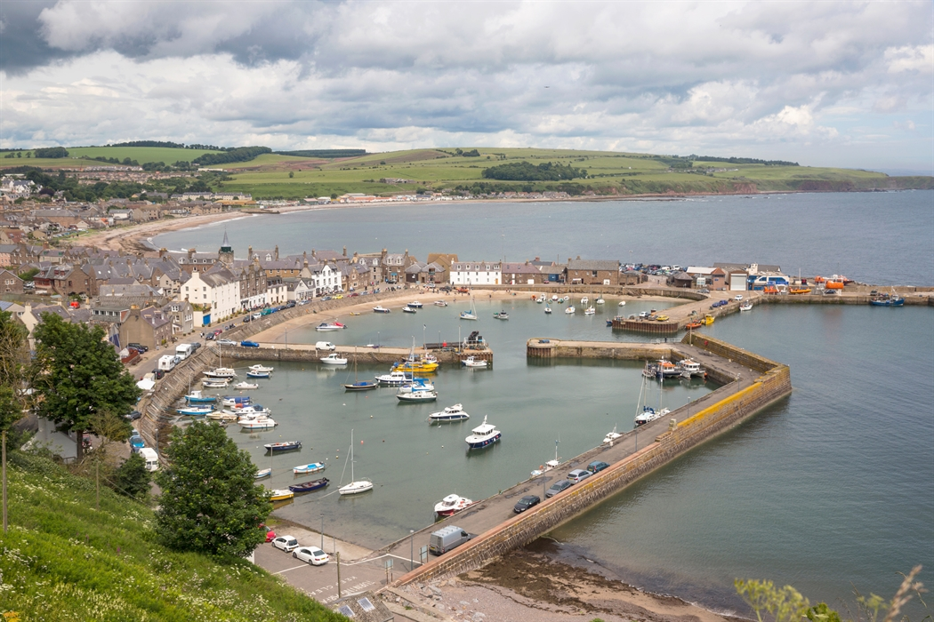
Aberdeenshire South Access Panel has continued to meet monthly on the 3rd Thursday. We have moved location and now meet at Stonehaven Bowling Club, Recreation Ground, AB39 2RD at 11.00 am.

We concentrate primarily on planning applications as this suits the members of the Panel. We have been involved in a piece of filming at Aberdeen Airport with regard as to how the Airport assists wheelchair users when travelling in to and out of Dyce. It is part of a project which the Airport has instigated, and they have also filmed a visually impaired passenger and an autistic passenger.
I understand that their aim is to produce material for their website showing how disabled passengers can be assisted when travelling through the airport. This includes, how to get assistance and how you can be supported from arrival to boarding the aircraft. The finished piece will be on the website for Aberdeen Airport and will hopefully help other passengers who require assistance when travelling through Dyce.

Caithness Disabled Access Panel
Tel: 01593721467 | Email: helenbudge@aol.com

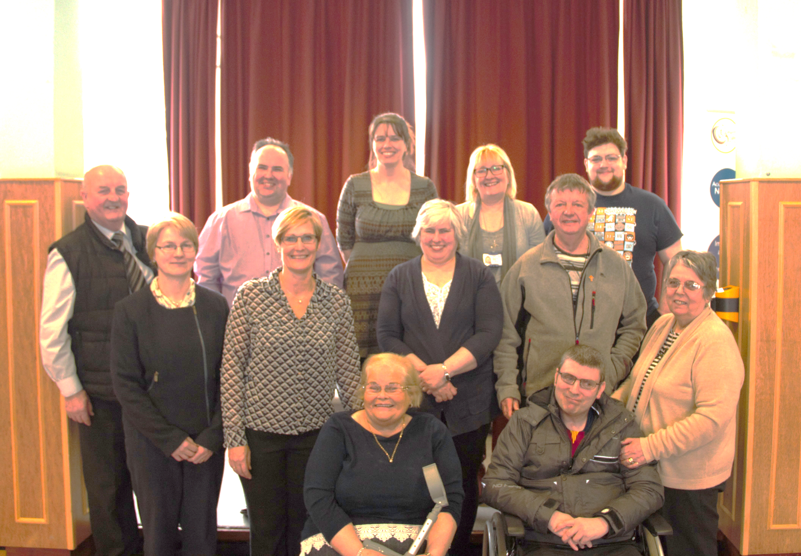
Caithness Disabled Access Panel hold monthly meetings and any problems with access to buildings are brought to us. We pursue shops breaking the equality laws and provide advice on how to adjust their buildings to make them more accessible and inclusive for all. For example, shops with even a small step outside is a barrier for disabled people with reduced mobility. Royal Bank of Scotland (RBS) now uses a van which does not have a ramp. Disabled customers must wait outside the van and an adviser will come to do your business on the street.

We are currently building a website so that people coming to our county can find accommodation and leisure facilities that are accessible and inclusive for disabled people.

Dundee Access Group
Tel: 07922 069039 | Email: dundeeaccessgroup.org@hotmail.co.uk

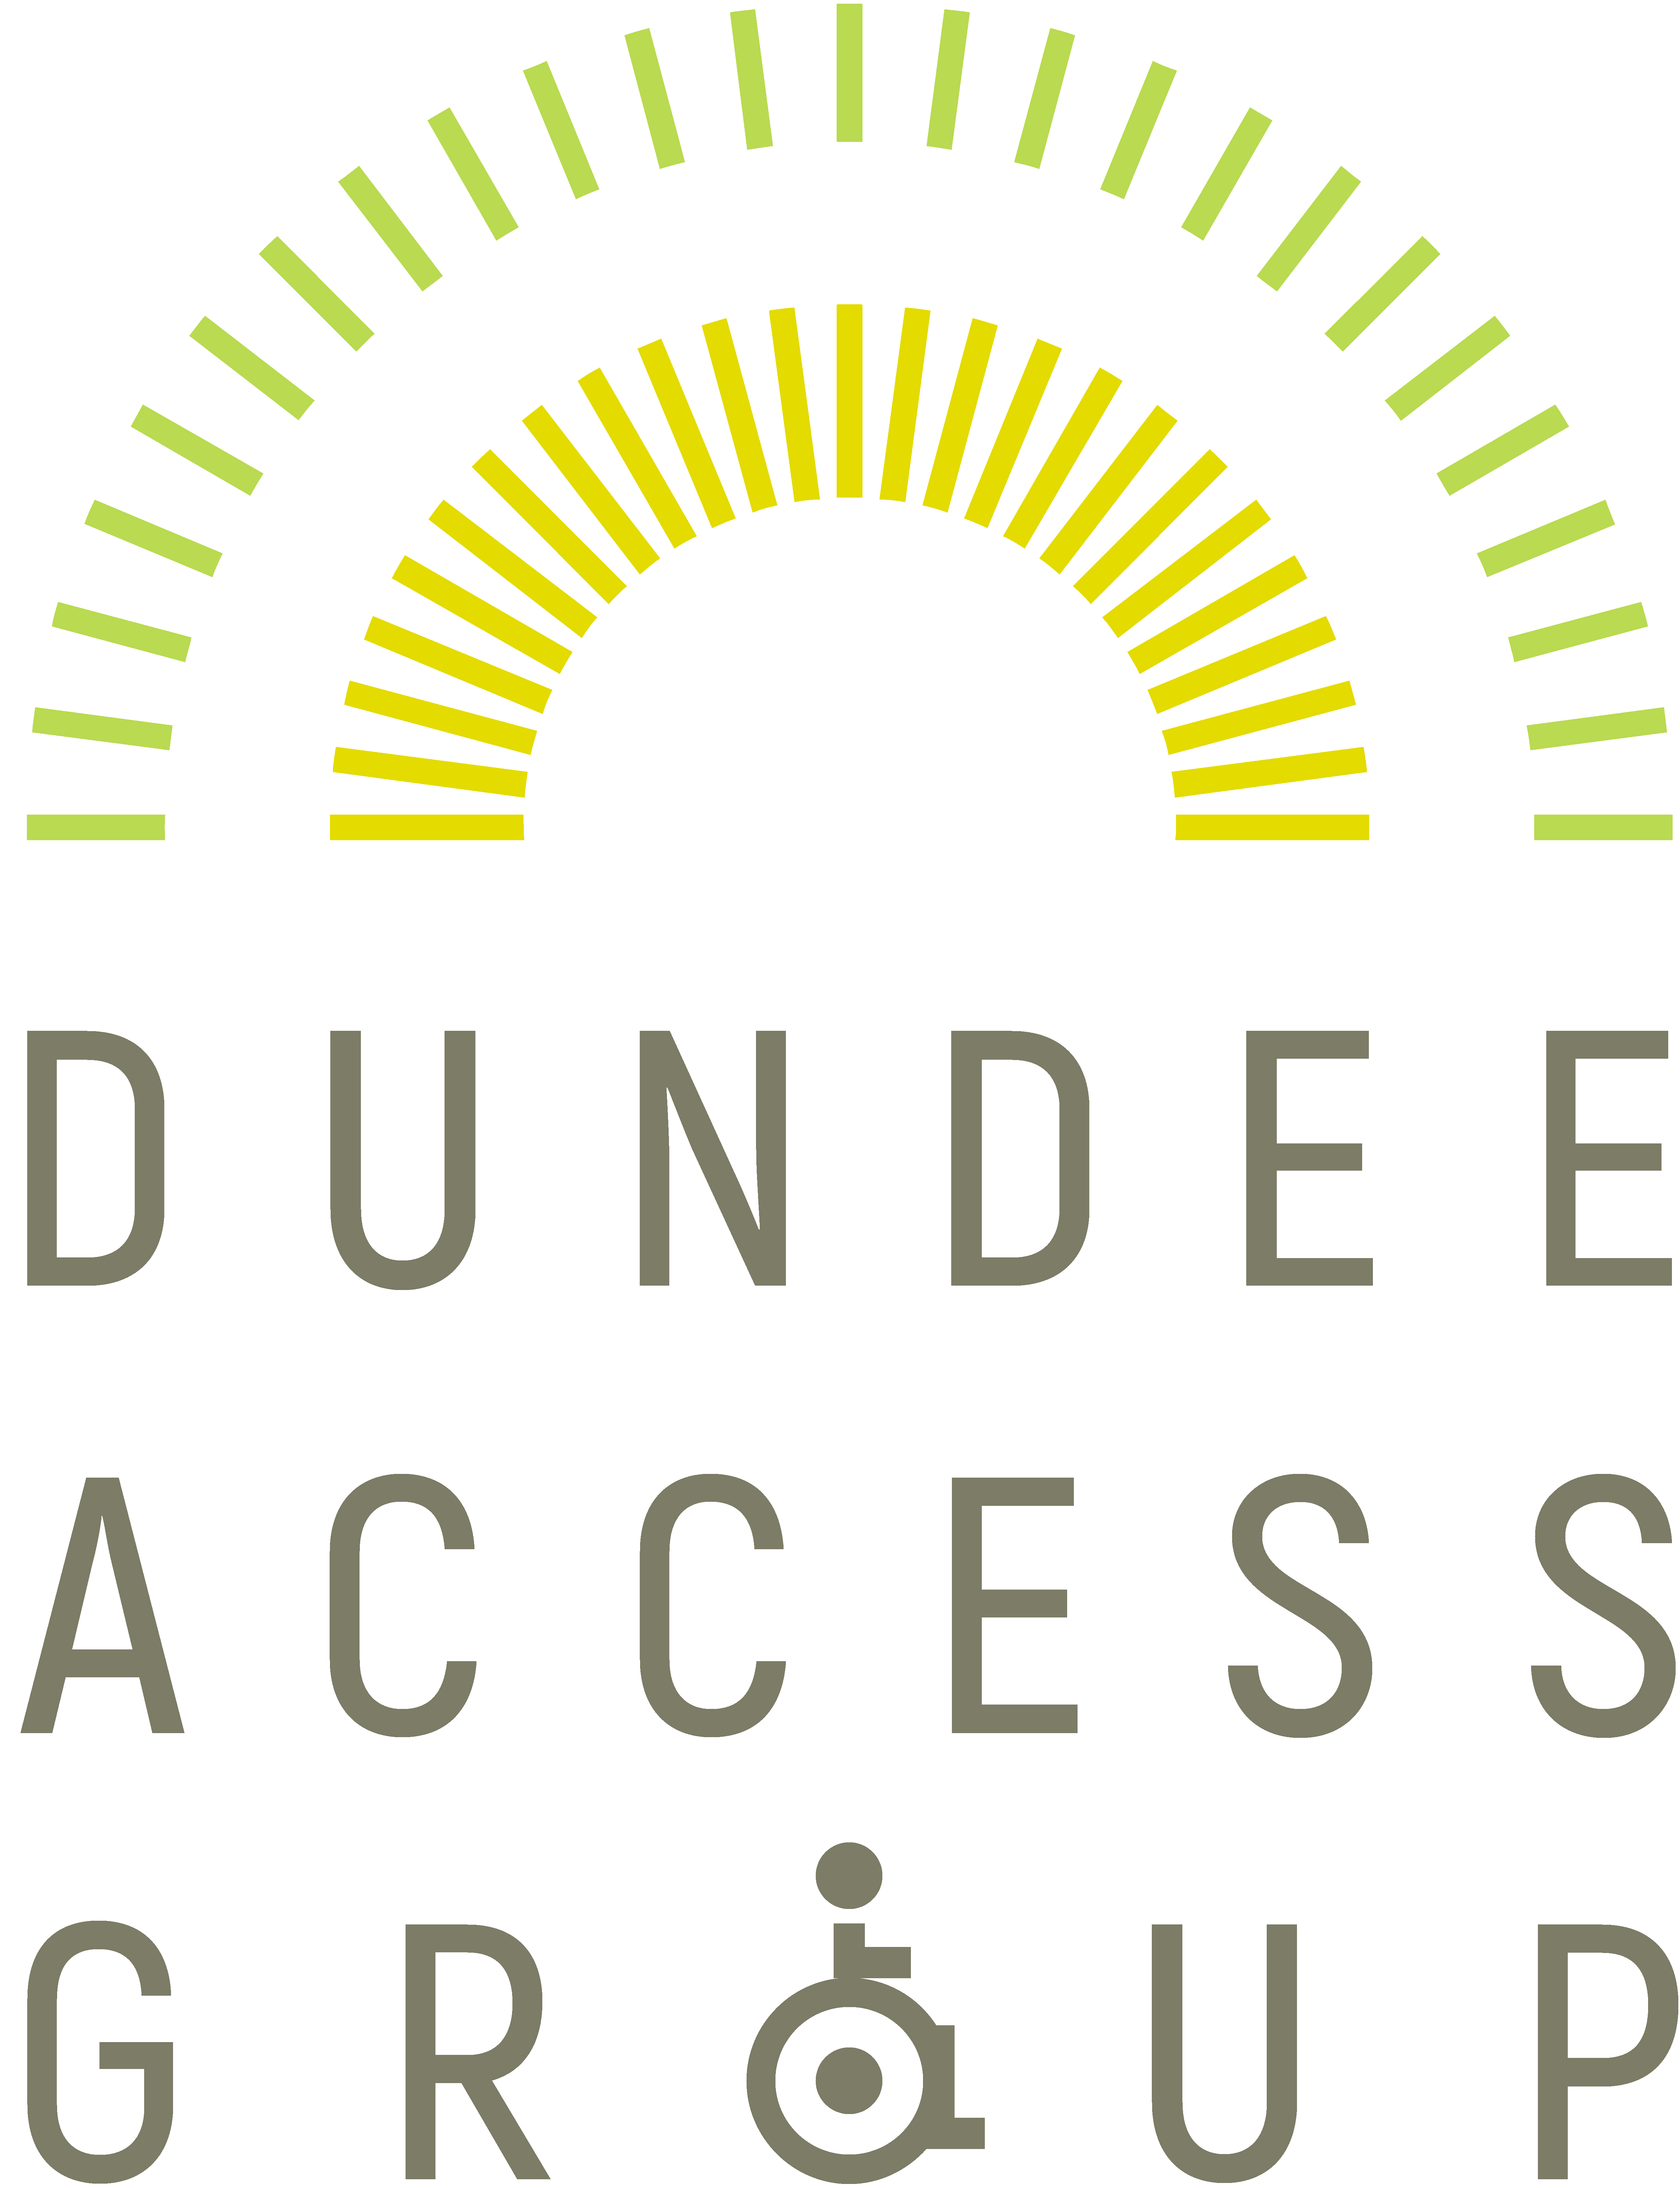
Before the summer we bought 2 portable ramps for the public to borrow and we produced advertising to market them. The ramps were put to good use over the Summer months. We are pleased to introduce our new logo (pictured on the left of the page) which will help to strengthen our brand identity within Dundee and the surrounding area.

A visit was made to a local nursery, at their request, to assess a new ramp. Representatives from DisabledGo came to our September meeting to speak to us about the upgrade of their website.
We are also in discussion with Dundee Council about the disabled toilet provision made at outdoor concerts in Dundee.

Edinburgh Access Panel
Tel: 07969 515296 | Email: edinburghaccesspanel@hotmail.com

It’s been another interesting period for our Panel.

In addition to the customary flow of planning applications which we assess for accessibility, Edinburgh Council have been keeping us very busy with consultations. They have put numerous proposals up for discussion to transform the city – especially the central area – and are holding frequent meetings to seek the views of us and other stakeholders.

These include radical new proposals for transport and streetscape, including measures to make bus travel more appealing and to encourage commuters and shoppers to travel by bike instead of by car.

With cyclists in mind, the plans for a network of cycle paths across the city centre are progressing and our consultation meetings are becoming more detailed and more frequent.

The panel has taken part in meetings with the Council where we have helped them assess the extent to which they have met their agreed equality outcomes We then helped them prioritise next year’s Council services in the light of budgetary constraints.

Although we have not carried out any formal access audits during this period, we have given advice on specific issues to several organisations including the Queens Hall and the Rape Crisis Centre.

Falkirk Area Disability Access Panel
Tel: 07832700130 | Email: jennie1943@virginmedia.com

The Panel managed to meet every third Friday in the month with the exception of July. Meetings were held in Camelon Sensory Centre from 10am until noon.

This was a difficult year for FADAP due to illness and other situations making life difficult for such a small number of people.

However, we had stunning success regarding Changing Places toilets. After a meeting with Councillors, MSPs and interested stakeholders, it was agreed to fund two of these toilets; one in the Mariner Centre and one in Grangemouth Sports Centre. These are now complete and scoring great approval. We are negotiating for more of these toilets to be established in the town centre.

Some research was conducted into whether or not FADAP should become a charity. The thinking behind this was to enable us to raise funds for a portable Changing Places Toilet but in the end it was decided that FADAP was too small for such an ambitious venture.

FADAP managed to convince Falkirk Council to compile a list of designated taxi drivers in compliance with clause 167 of the Equality Act. This made taxi drivers more accountable. But there is much to be done to improve the supply of wheelchair-accessible vehicles in the Falkirk area.

Two areas require our attention in the forthcoming months. We are organising a full meeting with representatives from First Bus, Taxi Forum, ScotRail and local Councillors as well as MSPs. Transport issues will be discussed.

Membership remains a problem so we have decided to rotate our meeting place with one in Grangemouth in an effort to enlist more members. The on-going work dealing with dropped kerbs and general pavement obstacles will of course be continued.
Glasgow Access Panel
Tel: 0141 946 8488 | Email: info@glasgowaccesspanel.org.uk

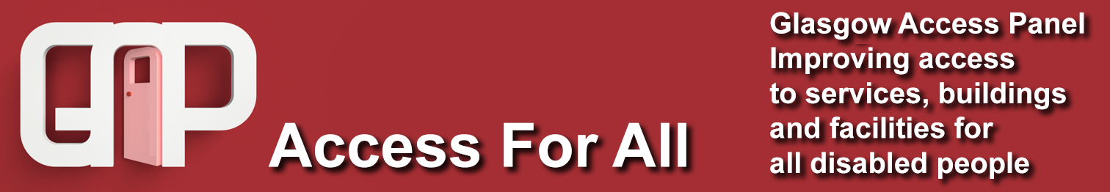

In recent months, our Access Panel Grant funding from Disability Equality Scotland has allowed us to upgrade our office equipment and update our British Standard accessibility documents, in addition to helping with running costs for our organisation. We have now also been able to purchase a GoPro, which will allow for remote access audits and for making educational videos about accessibility in and around buildings.
We are also currently approaching the seventh day of our Easy Access Course, funded by People’s Health Trust using money raised by HealthShine through The Health Lottery. Our grant is allowing us to teach disabled people within Glasgow about access auditing, taking approximately 20 people through the fundamentals of accessibility and giving them the skills and confidence to challenge discriminatory designs and practices around them and improve their local communities.
The course has been well-received to date, and a positive learning experience for everyone involved in developing and delivering materials for an audience with a broad range of access requirements. Day 7 took place on Friday the 26th of October at the Glasgow Centre for Inclusive Living, after the group has visited the Riverside Museum to put some of their new access auditing skills into practice. Our final session of 2018 was held at the Glasgow Centre for Inclusive Living on November 30th.
If you are interested in joining us for our second course in 2019, or if you would like to join the Glasgow Access Panel to become more involved in the work that we do, you can give our office a call on 0141 946 8488, or email info@glasgowaccesspanel.org.uk. You can also find us on Facebook at www.facebook.com/glasgowaccesspanel. We look forward to hearing from you!
Nairn Access Panel
Email: info@accessnairn.co.uk

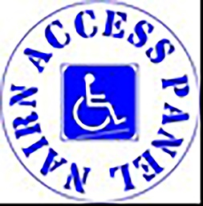
After many months of campaigning and emails we are pleased that a feasibility study is being carried out at Nairn Railway Station to look at the options to improve inclusivity of access between platforms. This should report in the New Year. In the meantime, a shelter will be provided on Platform Two (for all customers) and the rough ground to the approach to the platform will be improved and marked out as a car-park with accessible spaces.

The council administer a ‘Shop Front’ scheme which supports local businesses financially to improve the look of their premises. The Panel have successfully argued that if the business were to concentrate on improving access to their premises, the Shop Front scheme will give a grant of 75% of the costs of the improvements. The Panel have worked with the council to improve the walk along the West side of the River Nairn. Funding for the upgrading of the East Beach All-Abilities path has been granted and is now out for tender.
North Lanarkshire Disability Access Panel
Tel: 01236 590457| Email: jane_arnott@sky.com

The Panel are continuing to work with North Lanarkshire Council (NLC) in relation to the accessibility of new school plans and applications for building upgrades. We also worked with NLC & Network Rail on plans to redevelop Motherwell Train Station and surrounding infrastructure, alongside access issues at Shotts and Coatbridge Stations. We promoted our wheelie bin campaign to NLC Councillors and community groups, alongside awareness of our Access Panel and its work whilst, hopefully encouraging others to join us.

We have also been working with NHS Lanarkshire on plans for the redevelopment/ replacement of University Hospital Monklands. Lastly, we worked in partnership with Disabled Go on 28 access audits in Airdrie Town Centre.

Centre for Inclusive Living Perth and Kinross
Tel: 01738 587282 | Email: info@cilpk.org.uk

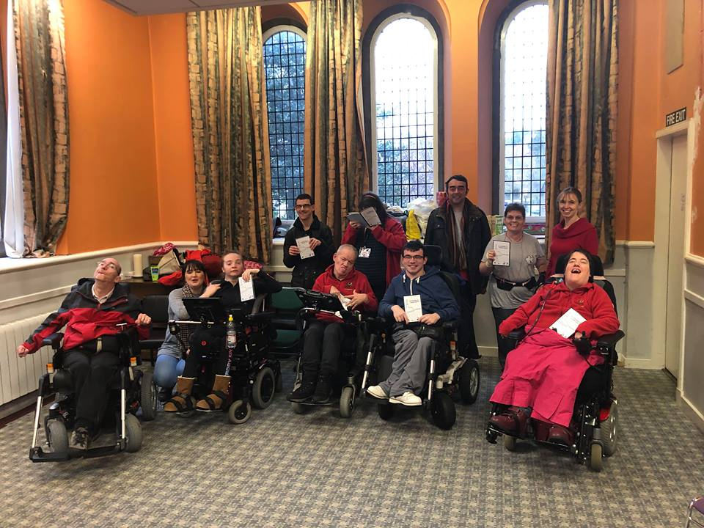
The Accessibility Guide for Perth City was produced by the members of the Centre For Inclusive Living Perth and Kinross with help from Perth College and funded by the Creative Community Fund. Our members chose the most accessible venues in the area focusing on Places of Interest, Cafes and Restaurants, Parking and Toilets. We hope that people will find this guide helpful and give them confidence to try new venues knowing that they are accessible.
To view the Accessibility Guide, here is the link to our website www.cilpk.org.uk/wp-content/uploads/2018/12/Accessibility-Guide-Perth.pdf
Tweeddale Access Panel
Email: tweeddaleaccesspanel@gmail.com

The main activity was the continuation of the Access Surveys in Peebles which is nearly completed. Discussions are currently ongoing with Disability Equality Scotland regarding the development of a new software to improve the display of the results on our website. Consultation meetings were carried out by some members of the Panel, including the following:

- Consultations on “Improving Parking in Scotland.

- A session at the Eastgate Theatre on ideas for improvements in the theatre; this included discussions on possible improvements with accessibility for disabled people.

- Discussions with members of the Scottish Borders Council concerning the possible relocation of the pedestrian refuge island in the middle of the road at Eddleston.

- Concerns were raised with the Scottish Borders Council regarding the time allowed for disabled and elderly people to cross the Peebles High Street which was considered to be too short.

6 ways to get involved
- Join your local Access Panel

www.accesspanelnetwork.org.uk/directory-panels

- Be on our mailing list and join Disability Equality Scotland

www.disabilityequality.scot/membership/

- Like our Facebook Pages Disability Equality Scotland Access Panel Network

- Follow us on twitter

@DEScotTweets
@AccessPanelNet

- Come along to our events

- Spread the word and encourage your friends, family and colleagues to join

Our Sponsors...
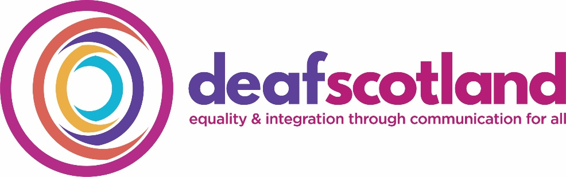
Disability Equality Scotland is grateful for the generosity of its sponsors and their ongoing support as we work together toward achieving the goals of the organisation.
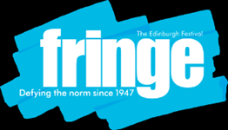

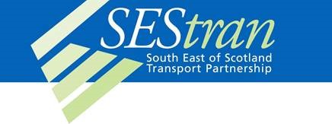

If you are interested in sponsoring our magazine OPEN DOOR, please complete our online registration form - www.disabilityequality.scot/our-sponsors
Alternatively, please contact email admin@disabilityequality.scot

OPEN DOOR is published by
Disability Equality Scotland
Office 2/4, The e-Centre Cooperage Way Alloa, FK10 3LP
Telephone: 01259 272064
Email: admin@disabilityequality.scot

Connect with us...
disabilityequality.scot Disability Equality Scotland @DEScotTweets

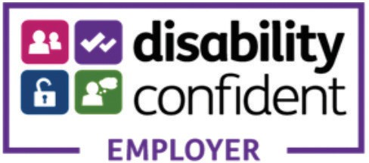
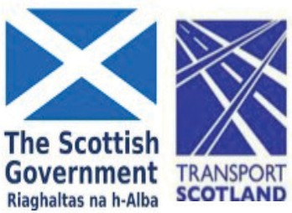
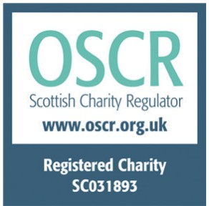
Disability Equality Scotland is funded by

Disability Equality Scotland is Registered in Scotland
as a Company Limited by Guarantee with Charitable Status Charity Number SC031893, Company Number SC243392

