Date
Wednesday 17 October 2018
to | Time  1.30pm until 3.30pm
Venue
The Ochil Suite
The Scottish Prison Service College
Newlands Road
Brightons
Falkirk
FK2 0DE
1.30pm – 1.45pm
Arrival and Registration
Tea and Coffee available
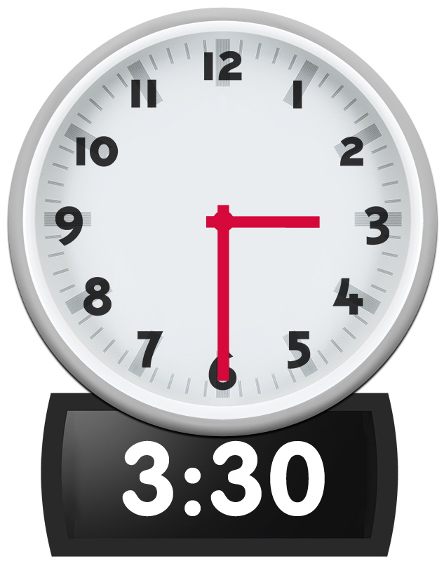  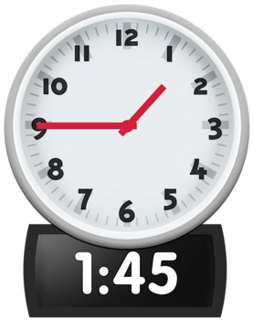  to | AGM Formal Business  1.45pm – 3.30pm
Welcome
1.45pm – 1.50pm
Linda Bamford, Convenor
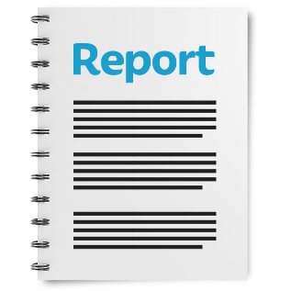  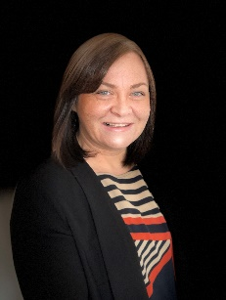  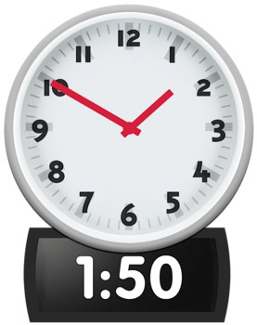 | Presentation of the Annual Report and Accounts 2017-2018  1.50pm – 2.10pm  Morven Brooks, Chief Executive Officer  Colin Millar, Treasurer
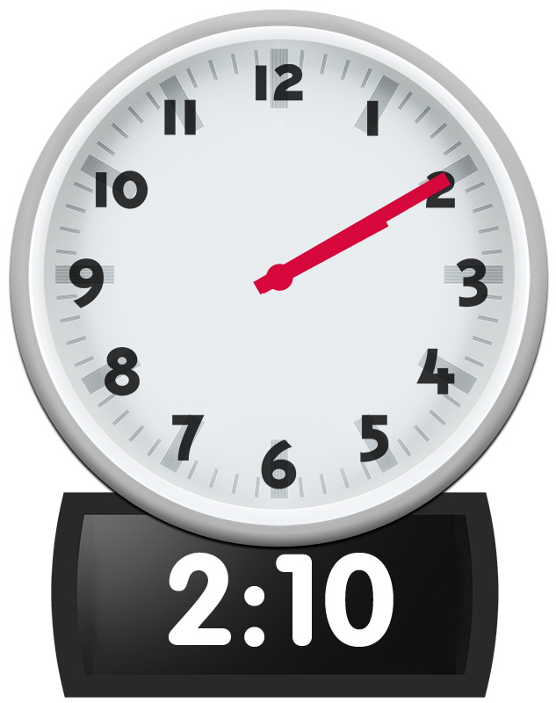 | Members Questions  2.10pm – 2.20pm
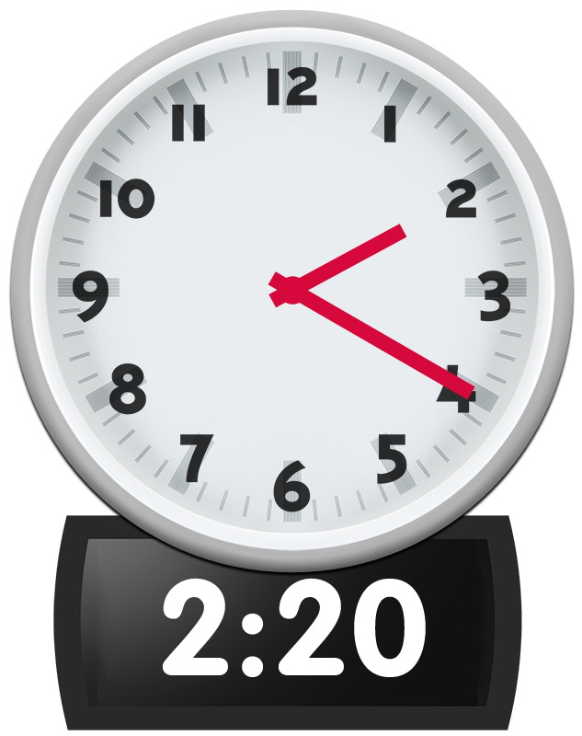 | Review of Fees and Subscriptions payable by Members  2.20pm – 2.25pm  Colin Millar, Treasurer
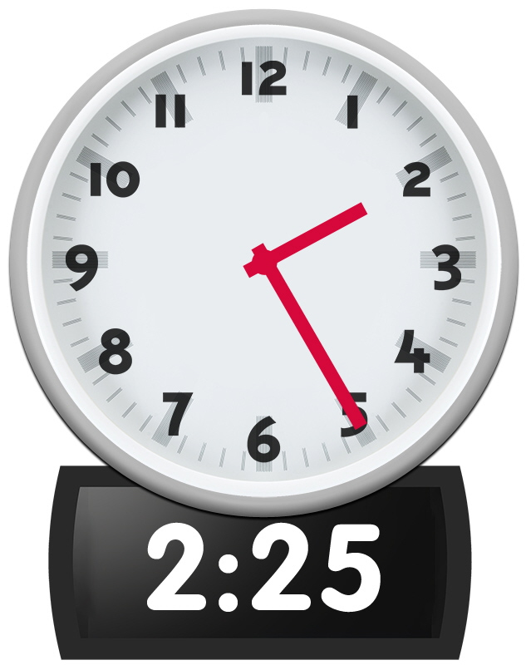 | Resolution 1: The Appointment of Directors  2.25pm – 2.35pm  To vote the following people onto our Board of Directors:  - Carolyn Griffiths  - Colin Millar  - Kenny Milne  - Steven McGhee  - Susan Fulton
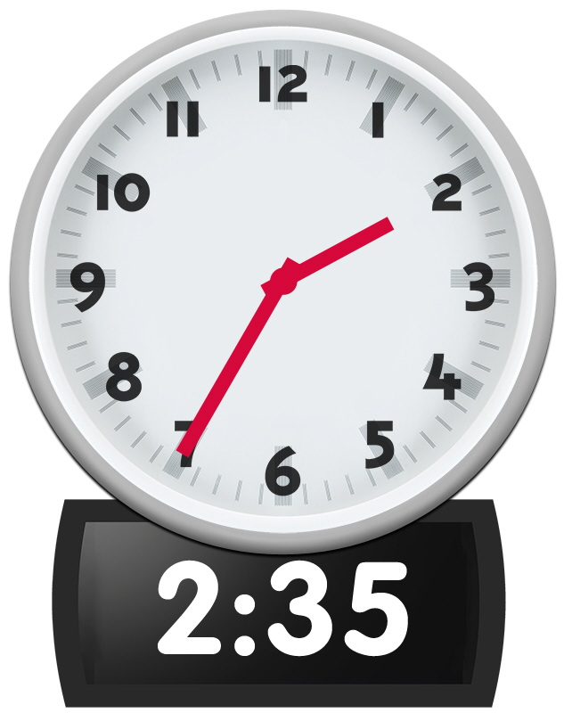 | Count and Confirm Votes  2.35pm – 2.45pm  Staff will count and confirm each resolution vote and announce results to members
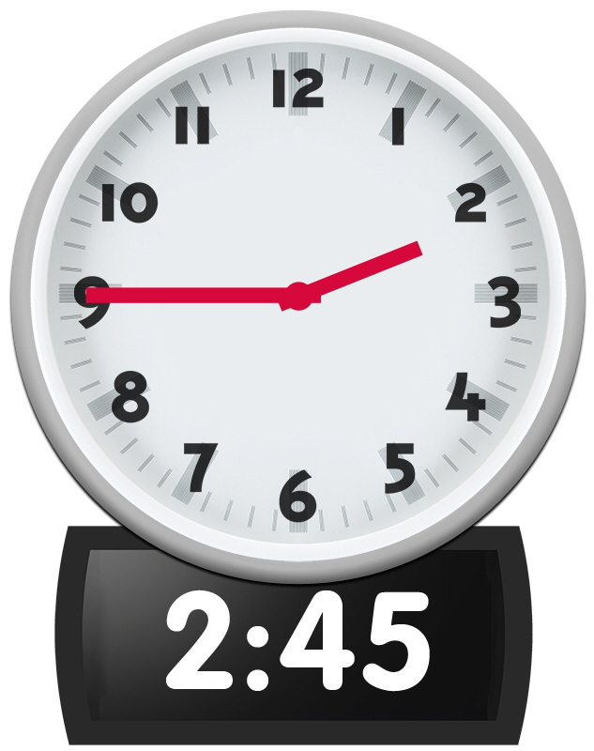  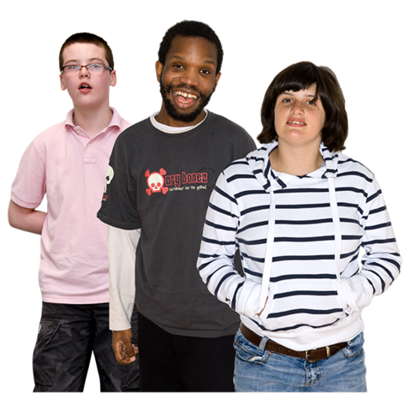  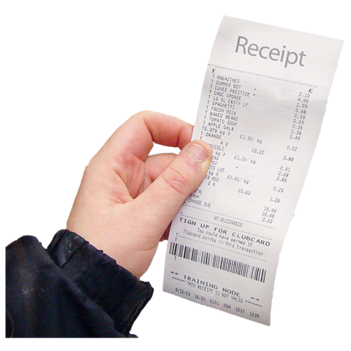 | Special Resolution 1: Adopting Changes to the Articles of Association  2.45pm – 3.15pm  To vote on the following changes to our Articles of Association.  Our Articles of Association is a document which explains the purpose of the organisation.  - Article 4: Change of wording:  ‘Forum’ to ‘Organisation’  This means we will be using the same language in the document.  - Article 10.1 and 10.3: Change of wording:  Change wording from 18 years and over to 12 years and over  We want more young people to be members with us and this change will help make that happen.  - Article 13: Change of wording:  Add in wording Only members aged 18 years and over can vote  This change means that only members age 18 years and over can vote at our General Meetings.  - Article 21: Change of wording:  The words ‘General Meetings’ also means Annual General Meetings and Extraordinary General Meetings.  This change is to make it clear that any Annual General Meeting or Extraordinary General Meeting held, is worded under the heading of General Meeting in this document.  - Article 21.b: Change of wording:  We have changed the wording Annual General Meeting to General Meeting.  This change will let members vote for Directors at General Meetings (both Annual General Meetings and Extraordinary General Meetings).  - Article 27: Change of wording:  ‘show of hands’ to ‘on a vote’  This wording has been changed because we want to show our membership has many different people and abilities.  - Article 33: Change of wording:  Add in wording re-election provided that no-one may serve for more than six consecutive years.’  This change means Directors cannot be on our board for more than six years. This means we give other people a chance to come on our board.  - Article 46.c: Change of wording:  Add in wording as per our policies and procedures  This change means Directors can only claim expenses which are stated in our policies and procedures.  - Article 11.4: New Article:  ‘Young Person members, being individuals aged 12-17 years whom the Directors deem appropriate to be represented among the membership of the Company, providing parental consent is received from young person members ages 12-15 years;’  This is a new membership category to encourage young people to join Disability Equality Scotland.
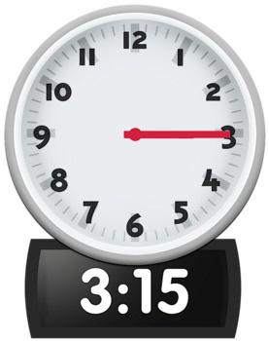 | Count and Confirm Votes  3.15pm – 3.30pm  Staff will count and confirm each resolution vote and announce results to members
Close
3.30pm
Thank you and safe journey home

