disabilityequality.scot **ISSUE 48 | 2018**

Welcome to the latest issue of



**OPEN** DOOR, the quarterly magazine from Disability Equality Scotland.

**OPEN** DOOR

## Disability News and Views for Disabled People Across Scotland

## This magazine brings you the latest news and information from Disability Equality Scotland, Access Panels, and Disabled Peoples’ Organisations across Scotland.

**From left to right, the image features
Emma Scott - Equality Projects Manager
Gillian Smith - Access Administrator
James Davidson - Equality Projects Assistant
Morven Brooks - Chief Executive Officer
Maeve Bain - Senior Administrator
In Buchanan - Access Engagement Officer
**

**Your Disability, Your Voice, Your Scotland…**

Disability Equality Scotland is a member led organisation so we want to hear from you, our valued members!

Get in touch with us with your disability news by email at:

[**admin@disabilityequality.scot**](mailto:admin@disabilityequality.scot) or by calling on **01259 272064.**

### Page Number

1. Contents
2. CEO’s Welcome - Introduction from Morven Brooks

### Inform

4 Meet the Team

5 About Us

6 Big Lottery Funding

7 Update from Emma Scott, Equality Projects Manager

1. Transport Scotland Connectivity Event

9 Accessible Travel Summit

10 Intern Report

11 Disability Equality Scotland launches YouTube Channel

12 Easy Read Service

### Your Say on Disability

13 Have Your Say On Disability

1. Consultation: Access to Voting

15 RBS Branch Closures

16-17 Weekly Poll Roundup

### Support

1. The ALLIANCE - Health and Social Care Alliance Scotland
2. Birds of Paradise Theatre Company
3. Euan’s Guide
4. Humanism in Scotland
5. Neatebox
6. PAMIS
7. Scottish Post Polio Network (SPPN)
8. See Me
9. The South East of Scotland Transport Partnership (SEStran)

### Access Panel Network

27-35 Access Panel Network Scotland News

# CEO’S Welcome

As we get into full swing with the new year activities, it is my pleasure to report to you on what has been a very busy and productive 2018 so far.

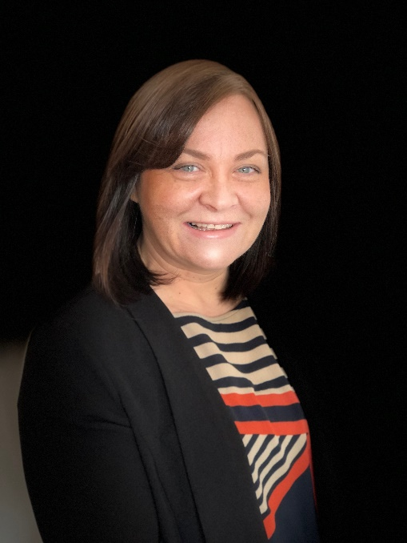

Morven Brooks

Firstly, thank you to all our members who have been providing feedback from our Extraordinary General Meeting held on 2 February 2018 and throughout the course of this year. I appreciate your comments and enjoy hearing from you, both through my direct e-mail account and also via our Facebook page and weekly polls. These mediums as well as our own website are without doubt the best way to keep up with what is happening.

It is also great to see so many of you attending our member events, which continue to enjoy good attendances across the country.

It is very exciting to see the organisation grow, modernise and develop. We do currently have our Members and Access Panel surveys live at the moment. So far the feedback is encouraging and members feel they are being updated with relevant news regarding disability access in Scotland. Of course, with any survey, the purpose is for us to understand where we can make improvements to our membership, and this feedback is allowing us to develop this in the coming year. If you have not yet answered our members survey, I would encourage you to do so. We have extended the closing date, and the online survey can be found on our website - <http://disabilityequality.scot/news/disability-equality-scotland-members-survey-2018/>

If you require the survey in an alternative format, please contact us and we can arrange this.

I hope you enjoy reading this quarterly edition of our magazine.

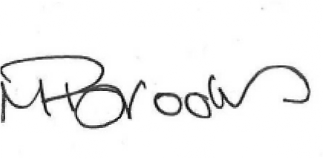With best wishes

## Morven Brooks, Chief Executive Officer

### Morven Brooks - Chief Executive Officer

Morven works with the team to ensure that Disability Equality Scotland is effective in its aims to promote equality and to reduce barriers to Independent Living. Morven is responsible for the strategic development of the organisation.

### Emma Scott - Equality Projects ManagerEmma Scott - Equality Projects Manager

Emma is responsible for managing a broad number of projects and initiatives. Emma works closely with the CEO to implement the organisation’s strategy to work towards social inclusion for Disabled People in Scotland.

### Maeve Bain - Senior Administrator

Maeve is responsible for the administration of our finances, book-keeping and payments, as well as supporting in other areas such as minute-taking and regular Board related duties.

### James Davidson - Equality Projects AssistantJames Davidson - Equality Projects Assistant

James works across the business with publicity, promotion and events. He also develops and sources content for Disability Equality Scotland online Hubs, monitoring and reporting progress of each.

### In Buchanan - Access Engagement OfficerIan Buchanan - Access Engagement Officer

Ian’s role is to support, develop and promote the Access Panel Network. He regularly travels around Scotland, meeting Access Panels and stakeholders to encourage partnership working.

### Gillian Smith - Access AdministratorGillian Smith - Access Administrator

Gillian is our Access Administrator and it is her role to provide administrative support to the Access Engagement Officer and the wider Access Panel Network.

## About Us

We are a national charity working to achieve full access and inclusion for disabled people.

We promote access in its widest sense, including access to the built and natural environment and access to the same opportunities as are enjoyed by others in our communities, promoting a life of dignity, respect and independence.

Our aim is for every disabled person to have the opportunity to participate in a fulfilling life. We represent the views of individuals with any type of impairment, as well as disability organisations and groups who share our values.

## Our Vision…

A better life for people living with disabilities.

## Our Mission...

Our mission has always been to increase awareness and knowledge of Access and Inclusion, to improve the lives of disabled people in Scotland.

**Achieving full Access and Inclusion for**

**disabled people in Scotland.**

## Disability Equality Scotland awarded Big Lottery Funding!

We are pleased to announce the successful application to Awards for All and the Big Lottery in Scotland for £8,900. This funding is for a pilot project – Investing in Access – (IIA) to assess the need for and develop, a recognised benchmark for accessible buildings and venues of all kinds.

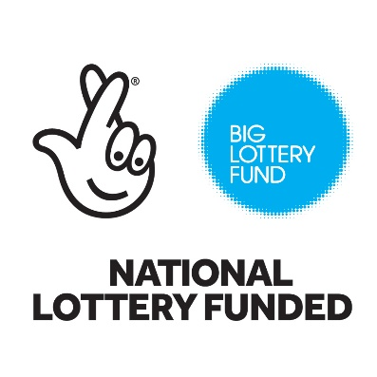

The Investing in Access feasibility study will develop a Scotland-wide quality standard in the built environment, for accessibility.  Like Investing in Volunteers and Investing in People, Investing in Access (IIA) aims to create a recognised benchmark for accessible buildings and venues of all kinds.

The idea for IIA was developed in response to the need for improved building access, identified through our own research, the lived experience of the disabled volunteers in local Disability Access Panels across Scotland and the Scottish Government’s Fairer Scotland Ambition 3, and Articles 8, 9, 19, 27, 29 and 30 within The United Nations Convention on the Rights of Persons with Disabilities (UNCRPD).

This is a unique project as there is no national standard for accessibility drawing on the skills and knowledge of disabled volunteers, to help shape a community that works for everyone.

IIA aims to strengthen the relationships between disabled people, businesses and public bodies initially in Forth Valley and Tayside, improving access for all.

Ian Buchanan, Access Engagement Office explained -

“The Access Panel Network covers the whole of Scotland, with just under 40 Panels in existence. This exciting new project will initially scope out and assess need in one local authority area, with a view to broadening this out throughout Scotland, creating a more recognisably accessible built environment and will help to develop the viability and sustainability of local Disability Access Panels”.

## Update from Emma Scott, Equality Projects Manager

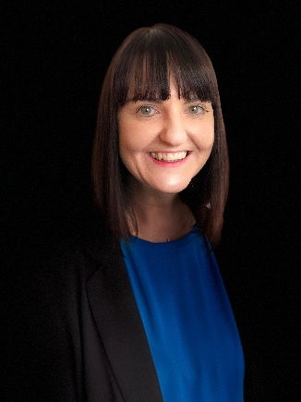

The last few months have kept me very busy around our work with Transport Scotland, the Accessible Travel Hub, Inclusive Communication and Disability Hate Crime.

Emma Scott

### Transport Scotland

In January, we held an event in Oban on the topic of Connectivity. This event brought together disabled people and local transport providers to discuss issues affecting the local area, including making connections between the train and ferry services. Feedback from the participants was positive and in one example, the local bus company has agreed to work with the Oban Access Panel to test the introduction of audio announcements on its services.

Another event took place onboard the NorthLink ferry in Aberdeen. Sixty delegates, including disabled people and transport operators such as Aberdeen Airport, Stagecoach, and ScotRail discussed local transport issues. Unfortunately, our event about Transport in Rural Areas was snowed off, but will be rescheduled later this year.

### The Accessible Travel Hub

Our website, the Accessible Travel Hub has had a makeover in line with our new branding and still offers information to disabled travellers on accessible transport and is a place for transport providers to share their news around accessibility. The Hub can be accessed here: [www.accessibletravel.scot](http://www.accessibletravel.scot)

### Hate Crime

I am working closely with Transport Scotland, SEStran and Police Scotland to plan consultation events around the introduction of a Hate Crime Charter for public transport. The events will bring together transport providers, disabled people and other equality groups, to talk about the difference such a Charter could make to travel.

## Transport Scotland Connectivity Event Oban, 31 January 2018

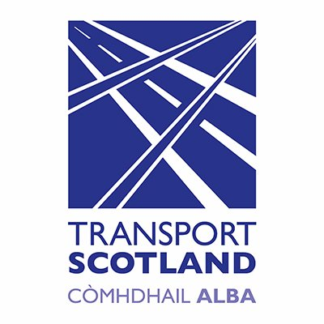Working in partnership with Transport Scotland, we hosted an event in Oban on 31 January. The event was an opportunity to bring together local disabled people and transport providers, to discuss key issues on the topic of transport accessibility and connectivity.

Group discussions took place covering topics such as changing between modes of transport, clear pathways, accessible buses and taxis and accessible information prior to and during travel.

Representatives from the bus company, West Coast Motors, were present and discussed ways in which their buses could become more accessible. The bus company will now work with the Oban Access Panel to take forward plans for a pilot program where audio announcements are made on the buses, to improve accessibility for visually-impaired passengers.

Local council representatives commented that taxis that are more accessible have been introduced to Oban, however disabled passengers were not yet using them. An awareness -raising campaign, promoting the accessible taxis on other local transport services, would be beneficial.

Another issue raised for consideration was Accessible parking spaces at the ferry, which were felt to be too far from the ferry entrance.

Participants felt the event was productive, raising issues that the local council, Transport Scotland and local transport providers can take forward with the Oban Access Panel.

Karl Zaczek from Transport Scotland said “This event has shown that a one-size-fits all concept for accessibility is not realistic. It is essential for all members of the community and transport providers, to work together and be involved at the tender stage of planning of services and not as an afterthought”.

## Disability Equality Scotland in partnership with Transport Scotland present a summit on ‘Accessible Transport.’

In March 2018, together with Transport Scotland, we hosted the first joint Accessible Travel Summit. The event brought together almost 60 delegates including transport providers, equalities groups, council members and disabled people, to discuss issues relating to accessible travel. This included topics such as frequency of service, cost of transport provision and ease of travelling by public transport as a disabled person.

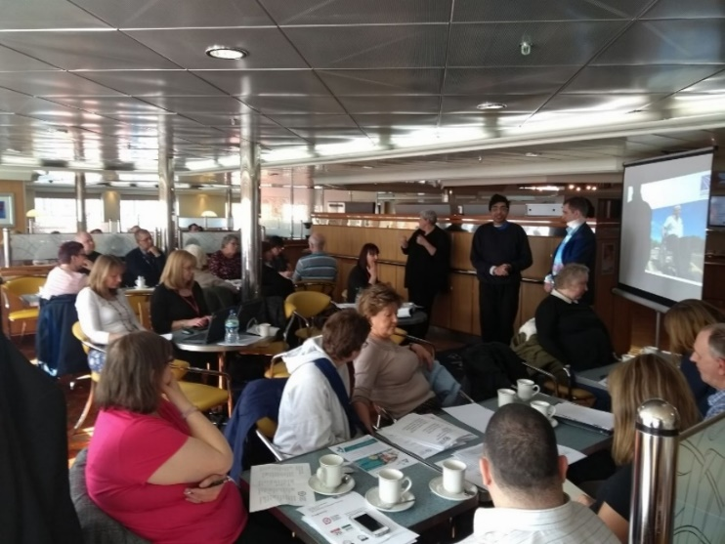Karl Zaczek from Transport Scotland introduced the Accessible Travel Framework; Transport Scotland’s ten-year plan to improve the accessibility of public transport and was supported by Hussein Patwa who spoke of his experiences of public transport as a visually impaired person. Emma Scott, Equality Projects Manager, then presented key findings from surveys on the topics of connectivity, rural travel and accessible information.

Karl Zaczek and Hussein Patwa presenting at the Summit

Group discussions took place, giving participants the chance to discuss their own experiences of accessibility on public transport, including its impact on independent travel, and what they believe needs to be improved.

Participants were positive about the opportunity to engage with one another; transport providers talking to different equalities groups at the event and getting a better understanding of the issues.

“I liked that transport providers seemed to be listening and respecting my views and it was good to be in a group that represented the area I travel in”. (Disabled participant)

Overall, the Summit successfully raised important issues in terms of accessibility and transport.

## Former intern to run marathon for Disability Equality Scotland!

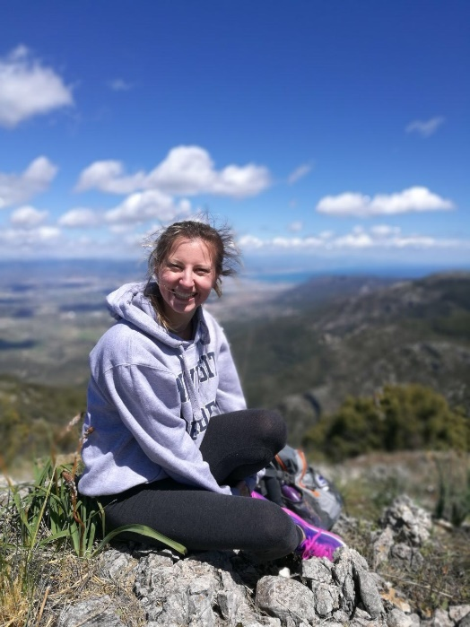

In January, Marissa Schlemmer joined our team for a 10-week work placement as part of her Masters in Global Health and Management at the University of Aberdeen. Over the course of the placement, Marissa worked closely with Emma and James to support our work with Transport Scotland. This involved helping to organise and promote transport engagement events in Oban, Stirling and Aberdeen.

Marissa also helped to analyse the findings of each event, creating reports highlighting the barriers that disabled people face when travelling in Scotland. The findings were shared with Transport Scotland and are also featured in the transport related articles in this issue of Open Door and on the Accessible Travel Hub: <http://accessibletravel.scot>

Marissa Schlemmer

We would like to say a huge thank you to Marissa for her time and contribution to the team. This was the first time Disability Equality Scotland has taken on a student-intern and we will definitely look to doing it again!

Marissa has very kindly decided to raise funds for us by running the Dundee Marathon, which takes place on 15 July 2018!

Marissa commented on her decision to run the Dundee Marathon for Disability Equality Scotland:

“Growing up with Juvenile Rheumatoid Arthritis and Complex Regional Pain Syndrome type l, I was introduced to so many strong individuals who made me realise that a disability never has to define who you are. Equality for people with every range of ability has been a passion of mine for as long as I can remember. If you would like to support my marathon and the amazing people I have been fortunate enough to meet through Disability Equality Scotland, please donate!”

To donate, visit Marissa’s JustGiving page:

<https://www.justgiving.com/crowdfunding/marissa-schlemmer>

We are extremely grateful that Marissa decided to choose us and we wish her the very best of luck!

## Disability Equality Scotland Launches YouTube Channel!

We are excited to announce the launch of our official YouTube channel: <https://www.youtube.com/channel/UCMoBgB3fQSptt9q0skTzLeA>

[](http://yoursayondisability.scot/bsl-videos/)

To start things off, we uploaded eight BSL videos that have been translated from our Weekly Poll questions.

The Weekly Polls have been very popular with our members and to increase our level of engagement with BSL users, we have decided to translate eight of the Weekly Poll questions to BSL:

* Hate Crime - <https://youtu.be/5KuI1fzcGmY>
* Brexit - <https://youtu.be/kB9Z6eI2ak4>
* Universal Credit - <https://youtu.be/gW8yuWIilw8>
* PIP -<https://youtu.be/MrPWeNQhLkU>
* Autism Review - <https://youtu.be/yd_OpicdM5Y>
* Accessible Housing - <https://youtu.be/QjrVdG3LtbY>
* Free Bus Travel - <https://youtu.be/S2DbJ4-OBbI>
* Mental Health - <https://youtu.be/d7gWKRvfmkE>

### How to respond?

You can respond in English or BSL. To respond in BSL, you can upload your video responses to YouTube or Vimeo and then copy and paste the links into an email and send to [james@disabilityequality.scot](mailto:james@disabilityequality.scot)

Please do not attach videos to the email, as we cannot receive large files.

### Share and Subscribe!

Please like and share our BSL videos. More content will follow soon, so subscribe to our YouTube channel to receive the latest videos!

If you have any ideas for future videos, please contact James: [james@disabilityequality.scot](mailto:james@disabilityequality.scot)

## Disability Equality Scotland Easy Read Service

### A woman holding open a book with the text 'Easy Read' featured on the coverWe have the expertise to produce information in Easy Read

We provide a professional and efficient Easy Read service to all sectors, as part of our commitment towards improving access to information for all.

### What is Easy Read?

Easy Read is an accessible format that makes written information easier to understand. The Easy Read format is

easy to understand because it uses simple, jargon-free language, shorter sentences and supporting images.

### Why produce Easy Read documents?

Easy Read documents make information more accessible to people with learning disabilities. They can also be useful for people with other communication difficulties including:

* acquired brain injury
* dyslexia
* people with hearing impairment whose first language is British Sign Language (BSL)
* people who do not speak English as their first language
* people who find reading difficult
* people with cognitive impairments such as dementia.

### The Equality Act

The Equality Act (2010) requires organisations to produce information in an accessible format. Easy Read can ensure that disabled people have equal access to information and are not discriminated against.

### Who do I contact?

For more information about our Easy Read service, please contact us by telephone:

### 01259 272064 or email: [admin@disabilityequality.scot](mailto:admin@disabilityequality.scot)

## Your Say on Disability… Gathering the views of disabled people in Scotland

**Your Views Count!**

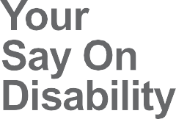The Have Your Say on Disability website is a place for you to tell us your views on disability issues in Scotland. This website provides the opportunity for disabled people to help shape Scotland’s future in accessibility and equality.

To have your say, visit our Your Say on Disability website on our updated web address: www.yoursayondisability.scot

As someone with lived experience of – or representing someone with – a disability, we would like you to tell us what you feel is working and what needs to change in

Scotland by completing our surveys. Our surveys are on current policy consultations and available in alternative formats.

### Weekly Poll

The Weekly Poll will allow you to have your say on a number of different topics affecting disabled people in Scotland. The poll is a simple yes/no question that will be published each week, along with the opportunity to leave a comment on the chosen topic.

### BSL Videos

This year we launched our official YouTube channel! To kick things off, we uploaded eight BSL videos that have been translated from our Weekly Poll questions.

### What happens to my comments

* Your comments will be passed on in full to those who have requested the survey, making sure that your views really are counted.
* Your responses are anonymous unless you wish to provide your details.
* The Scottish Government and other bodies want to know what is working, what is not and what needs to happen to improve life for Scottish disabled people, so your comments can really make a difference!

[www.yoursayondisability.scot](http://www.yoursayondisability.scot)

## Consultation: Access to Voting



Setting up a polling station in a way that makes the voting process accessible to all, is key to ensuring a positive voter experience. It is important that polling stations have appropriate signage, parking provision and low level polling booths and ballot boxes. The Scottish Government wanted to know how voting in elections could be made more accessible in Scotland.

**What We Did Next**

We consulted with our members from 12 January 2018 until 5 March 2018, which prompted 30 responses. Your responses were submitted to Jeane Freeman MSP, as part of the consultation on Electoral Reform and making voting more accessible.

**Your Responses**

Access to polling stations can be challenging for disabled people with reduced mobility, due to physical barriers. Members had experienced issues with a lack of parking provision, steps and uneven ground, inaccessible routes to voting booths and limited access to accessible toilets.

Some of our members raised concerns about the lack of communication support on polling day. These concerns related to the limited information available in BSL and other alternative formats such as Easy Read. There were also concerns about the lack of staff awareness of disabilities and subsequent communication support needs.

Our members suggested the following improvements to make voting more accessible:

* Staff Training – It was suggested that staff should be trained in disability awareness and be able to assist disabled voters to help make the process more inclusive.
* Online Voting – Our members indicated that a move to electronic voting, using an online method, would allow more people to participate, using their own software, such as screen-readers and alternative text size.
* Accessible Formats – There are simpler changes that could be introduced to the physical ballot paper to ensure that it can be used by those with visual impairments.

## RBS Branch Closures

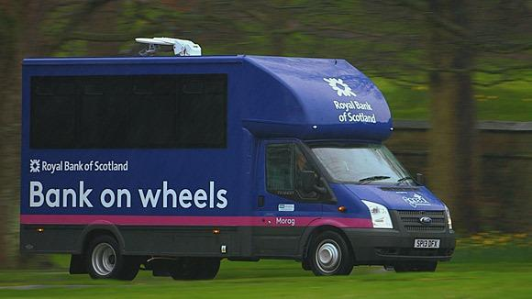Royal Bank of Scotland (RBS) has drawn up plans to close more than one in three of its Scottish branches. A total of 62 branches will be closed, with the loss of about 158 jobs. RBS is planning to replace many local branches with a mobile banking vehicle that will visit local areas as per a fixed timetable. For the week commencing 19 March 2018, we asked our members to comment on the question: “Is a mobile banking vehicle a suitable option?” A total of 79 members answered the poll, with the majority (81%) stating that a mobile banking vehicle is not a suitable option to replace local branches.

**Your Responses**

Responses were shared with Sottish Rural Action, who are working with Jeane Freeman MSP to approach the Equality and Human Rights Commission (EHRC) and request that they investigate the RBS plans to replace branches with banking vehicles. The comments that we received from our members raised a number of concerns about the introduction of a mobile banking vehicle.

**Physical Access -** Access to mobile banking vehicles can be challenging for disabled people due to physical barriers. “If you cannot access the van, the bank teller has to leave the vehicle and attend to the customers’ banking needs, in the supermarket car park, which is humiliating and an unacceptable form of inequality.”

**Frequency of mobile banking service -** Another concern about mobile banking that was raised by our members is the inconvenience of having to adhere to a fixed timetable.“Set times will not suit many disabled people since they are dependent on carers/family taking them to the bank and the time of the mobile bank might not coincide with the time their carer is available.”

**Lack of information -** Limited information about the introduction of mobile banking has resulted in frustration and confusion with regards to where and when the service will run. “Our local branch didn't actually officially inform anyone it was happening, we knew through word of mouth but we have never received any information on what the closure means or when the mobile banking bus will be around”.

## Weekly Poll Roundup

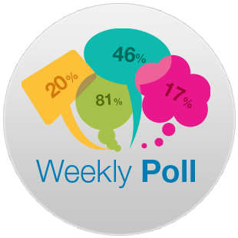One year ago, we launched a new way of engaging with our members. Each week, a new Weekly Poll question is sent out on a different topic or subject. The aim is to build up a bank of information and views from our members, so we can better understand disabled people. We also want to increase our outreach and gather more evidence that we can use in our business planning; and to help respond to consultations.

Below is a selection of the weekly poll questions we have asked in the past few months, along with your responses:

## NHS Delays – Week Commencing 8 January 2018

**Question**: Have you faced delays in NHS treatment over the Winter?

**Your feedback:** Yes – 26% (14 respondents) No – 74% (39 respondents)

**Your comments:** “NHS in Scotland is outperforming the rest of the UK. Staff work extremely hard and should not be blamed for the demand on the service as this is a result of an increase in the number of flu cases.”

“Being a cynic by nature, I think a lot of people are getting paid a lot to do a little. You could probably take out every other layer of management without the organisation suffering, it would probably work better.”

**What we did next –** We shared your comments with Shona Robison, Cabinet Secretary for Health and Sport.

## Arts Funding – Week Commencing 29 January 2018

**Question:** Will you be affected by the cuts to disabled arts and theatre funding?

**Your feedback:** Yes – 45% (10 respondents) No 55% (12 respondent)

**Your comments:** “Disabled people must be empowered to express themselves and increase their confidence and ability through performing arts. To single them out for this treatment is the very worst of discrimination.”

**What we did next**: We shared your comments with Birds of Paradise Theatre Company.

...responses continued on next page >>>

responses continued...

## PiP – Week Commencing 5 February 2018

**Question:** Do you welcome a review of every Personal Independence Payment (PIP) claim over a 5five year period at a possible cost of £3.7 billion?

**Your feedback:**Yes – 47% (26 respondents) No 53% (29 respondents)

**Your comments:** “I welcome a review as I think a significant amount of people have been adversely affected by inept decision making and assessment process – leaving them in debt, poverty and impacting on their mental health.”

“The review is a good idea but should only be done by request from each claimant (unless reviewing all is more cost effective).”

## Medical Cannabis – Week Commencing 19 February 2018

**Question**: Do you think medical cannabis should be legalised in the UK?

**Your feedback:** Yes – 90% (54 respondents) No 10% (6 respondents)

**Your comments:** “Yes medical cannabis should be legalised in the UK it has been shown that it benefits people with a range of long term conditions and disabilities.”

“Long term use of cannabis causes depression, anxiety and mental health problems. Formulate a drug to alleviate the pain that does not have these side effects”

## Extreme Weather – Week Commencing 2 March 2018

**Question:** Were you affected by the recent heavy snowfall?

**Your feedback:** Yes – 88% (49 respondents) No 12% (7 respondents)

**Your comments:** “I think employers who dock wages for absence during extreme conditions should be at least named and shamed. They have an obligation not to put their staff at undue risk.”

## Mobile Banking – Week Commencing 26 March 2018

**Question:** Have you encountered any problems with passenger assistance at airports in Scotland?

**Your feedback:** Yes – 19% (15 respondents) No 81% (64 respondents)

**Your comments:** “If you cannot access the van, the bank teller has to leave the vehicle and attend to the customers’ banking needs, in the supermarket car park, which is humiliating and an unacceptable form of inequality.”

## The ALLIANCE

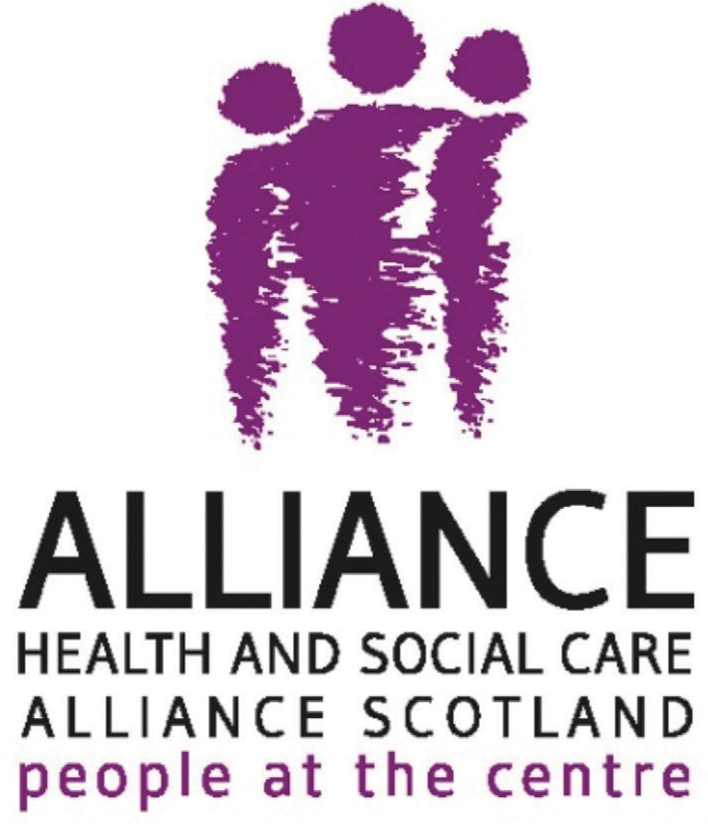The people of Scotland living with long term conditions, disabled people and unpaid carers should be able to access the information they need to help them live well.

The ALISS (A Local Information System for Scotland) Programme is funded by the Scottish Government and delivered by the Health and Social Care Alliance Scotland (the ALLIANCE).

The way the ALISS Programme shares information has changed with the launch of a new improved website.

ALISS has been in a period of development and after listening to people’s feedback we’ve updated the technology that ALISS runs on and improved the way people search and find services that can help them to live well.

The ALISS team have been working hard over the past few months to ensure we have a range of services that support health and wellbeing in the new website.

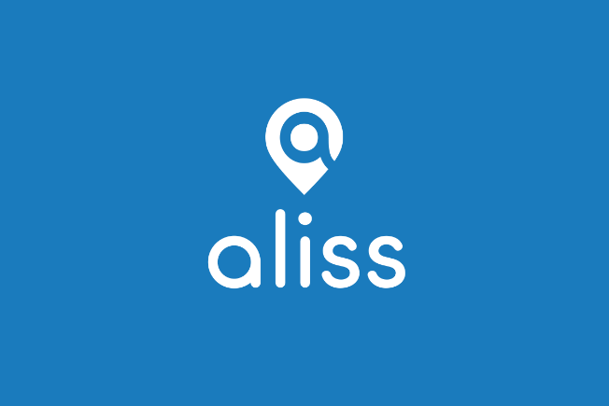

You can access service information by searching [www.aliss.org](http://www.aliss.org)

By signing up for an account, you can access a range of features that can help you find great information on services for yourself or for the people you work for.

The ALISS team will be running information sessions across Scotland, developing a range of support material and working hard to help people make the most of the website and features.

To get involved email [hello@aliss.org](mailto:hello@aliss.org) or call 0141 404 0239

## Birds of Paradise Theatre Company

Birds of Paradise Theatre Company have been going for 25 years – 2018 marks our silver anniversary. Over that time the company has developed from a group of physically disabled adults looking to expand their performance skills into Scotland’s only disability-led theatre company that tours Scotland, the UK and the world with hit productions that entertain audiences with stories that haven’t been told before.

Some people expect us to have a core group of actors – we don’t – our approach is to employ professional non-disabled and disabled actors on a per project basis, depending on what the production demands. In this way we’re pretty similar to any other touring theatre company – we pay Equity rates, work to a three-week rehearsal period and we make shows that audiences want to see. Our 2014 co-production of ‘Wendy Hoose’ by Johnny McKnight was a riotous comedy about a women with no legs that toured Scotland, Spain and had a four-week London run – one of it’ stars has now been in Hollyoaks for over a year.

In 2016 we created a dance theatre piece - ‘Purposeless Movements’ - which received a host of five-star reviews and Critics’ Awards for Theatre in Scotland nominations in the categories of Best Ensemble and Best Director. We also run a variety of development programmes to support aspiring disabled actors and we work strategically with arts companies throughout Scotland to enable them to be more accessible and inclusive.

We were obviously worried when Creative Scotland – one of our key funders – told us last month that we’d no longer be core funded. The outpouring of support for BOP that followed from the arts sector, our audiences, our colleagues and our partners was incredible and the decision has now been reversed. So our programme for the next three years is secure but will still want to hear from disabled people about what you want to see on stage and how we can work with you.

Visit us at [www.boptheatre.co.uk](http://www.boptheatre.co.uk) and get in touch.

## Euan’s Guide

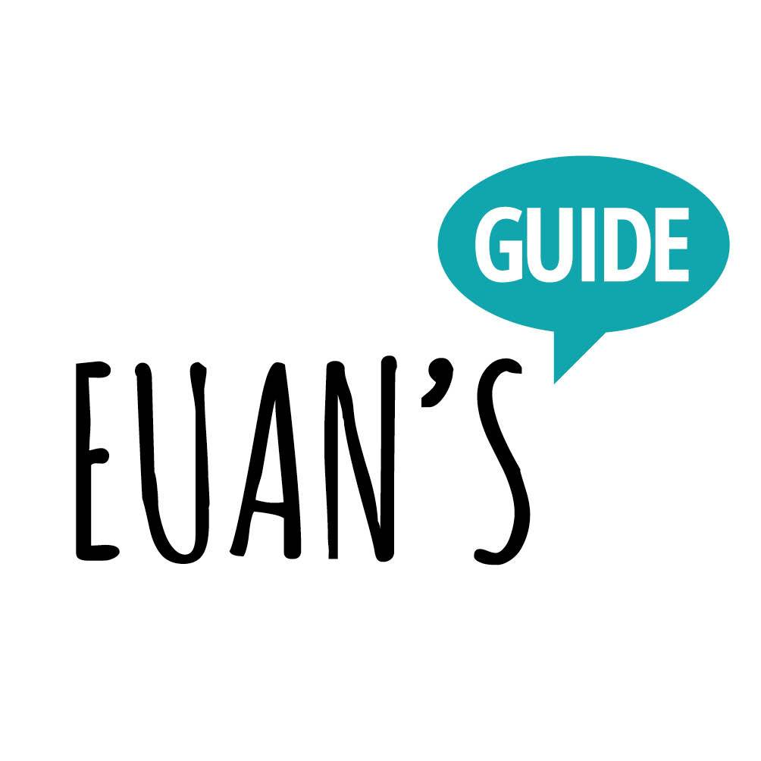

The Access Survey 2017 revealed that 92% of disabled people do not feel very confident in visiting new places when thinking about disabled access. The survey by Euan’s Guide and Disabled Access Day was completed by over 700 people who shared their experiences of disabled access at all kinds of places.

The findings also revealed that 83% of disabled people have been affected by poor accessibility, and 95% will search for disabled access information about somewhere before visiting. It was found that being able to see pictures and read what others have said about a venue is particularly helpful when deciding where to go.

Euan’s Guide helps to address this with its website that is used by disabled people, their families and friends to rate the accessibility of places they have visited. People can find disabled access information for over 6,000 places, including reviews written by people with similar requirements to them.

**Euan MacDonald, co-founder of Euan’s Guide said:**

“Euan’s Guide is all about sharing, and it was fantastic to have over seven hundred disabled people, their families, friends and carers join in by sharing their thoughts and experiences in The Access Survey 2017. The opinions expressed in this survey will help to raise awareness and improve understanding of accessibility and I am hopeful that future surveys will show positive trends and improvements among venues and the confidence that disabled people have in visiting them.”

Contact Euan’s Guide for more information:

Email - [hello@euansguide.com](mailto:hello@euansguide.com)

Website - <https://www.euansguide.com/>

Twitter - <https://twitter.com/EuansGuide>

Facebook - <https://www.facebook.com/EuansGuide/>

## Humanism in Scotland

Our world often seems chaotic but with inclusive cooperation and a positive mindset, we have the competency and opportunity to address the issues we face.



As part of our commitment and sponsorship of Disability Equality Scotland, we at Humanism in Scotland enjoyed our presence at theAGM 2017. We were there, not to pursue members, but to increase awareness of our beliefs andvalues such as ‘free thinking’; ‘personal autonomy’ and ‘individual and collective responsibility’ Our beliefs also include the views that age is just a number, and not a measure of worth, and that disabled people can valuably contribute their views to society.

Humanism in Scotland offers support to help individuals enhance their resilience. This could include bereavement support, ‘decluttering’ of the mind, and skills like active listening, which help to react to and deal with life. Humanism in Scotland also offer ceremonies, such as weddings, renewing vows, baby naming and funeral ceremonies.

A working group established in 2008 by the Scottish Government acknowledged that we are all part of a multi-cultural society which incorporates a variety of beliefs. It recognised that we all share equal rights and responsibilities. It set out ways to facilitate dialogue so that belief groups, whether religious or not, could work together constructively to make better, a society for all of the people who live and work in 21st century Scotland. It is all about our Common Humanity with shared belonging as people living here, contributing to Scotland’s future, listening to one another and working together for the common good.

For more information, contact Humanism in Scotland:

Telephone - 01337 842352 Mobile - 07854 114898

Web - [www.humanism-scot.org](http://www.humanism-scot.org)

## Neatebox

Edinburgh-based company, Neatebox, looks to improve the lives of disabled people through the application of solutions using smart technology. We believe that no person should feel concerned about being able to enjoy their independence.

Our solutions use Proximity Aware Technology to communicate with smartphones to improve the ability for users to interact with their local environment in an easier way. With our apps, ‘Button’ and ‘Welcome’, we aim to reduce anxiety and increase social mobility and sense of community.

With Button by Neatebox you can use your mobile phone or smart watch to press the buttons at pedestrian crossings. It aims to make crossings much more accessible for a person with a mobility or visual impairment.

“To push the pedestrian box button, I have to turn my chair side on and it becomes really unbalanced. It’s quite scary. With the Button app, I don’t have to get near the pole. It helps me to cross the road more safely and confidently.”

Zoe

Learn more: [www.neatebox.com/button](http://www.neatebox.com/button)

Welcome by Neatebox addresses the issue of inadequate customer service for visitors with specific accessibility requirements caused by a lack of disability awareness and confidence of staff members. Venues are notified that you want to visit and receive an overview of your disability and top tips to aid their interaction with you.

“Currently, I can’t find staff in shops if I need assistance. This app solves this, as staff know I am here and how to best assist me.”

Angela

Learn more: [www.neatebox.com/welcome](http://www.neatebox.com/welcome)

## PAMIS logoPAMIS

Laura is a member of her local disability Access Panel in Falkirk (FADAP) and works for PAMIS (Promoting A More Inclusive Society). Laura campaigns for Changing Places toilets.

Before I had my son Brody, I thought that an accessible toilet catered for everyone who had a disability that meant that they couldn’t use a standard toilet. I’m embarrassed to say that it didn’t cross my mind how people with continence issues who wear pads get changed when out of the house. And I never thought about how people who can’t self-transfer onto a toilet would be able to get onto one either. Now that I have a six-year-old son who is doubly-incontinent, I am aware that standard accessible toilets do not cater for all disabilities – just some. The truth is that our toileting options for Brody in public places are undignified, unhygienic and unsafe - change him in our car boot or a public toilet floor, leave him in a dirty nappy or stay at home. Horrific, isn’t it?

That is why I campaign for Changing Places toilets - a twelve square metre room with specialist equipment such as a tracking hoist, a height adjustable changing bench and a peninsular toilet. However, there are only 1,080 Changing Places toilets in the UK and just 157 in Scotland. You might be able to appreciate how much our world has shrunk when you consider that there are 2,500 toilets in Wembley Stadium alone.

Scotland doesn’t feel like an accessible place to live or a place that promotes inclusion when I am changing my precious son in my cold, uncomfortable car boot. We feel excluded and like we don’t matter. It’s isolating, heart-breaking and the reality for thousands of disabled people as well as their carers and families who all face the same dilemma. Going to the toilet is one of the most basic human rights. Yet in 2018, thousands of Scottish people are unable to safely and with dignity. This should not be the case in 21st century Britain.

Contact PAMIS for more information about Changing Places toilets – <http://pamis.org.uk/> / [pamischangingplaces@dundee.ac.uk](mailto:pamischangingplaces@dundee.ac.uk) / 01382 385154

## Scottish Post Polio Network (SPPN)

The Scottish Post Polio Network (SPPN) is a small charity, which campaigns for improved facilities and services for people suffering from the Late Effects of Polio (LEoP) and Post Polio Syndrome (PPS).

After years of working in partnership with senior NHS managers and Scottish Government representatives addressing many Polio related issues – a breakthrough has been made in the field of Orthotics with Lothian Health Board.

Their SMART centre opened the doors to 25 Polio survivors, (patients of LHB). Most of them had either had a recent consultation or are looking forward to one in the near future. Hannah Cairns, Head of the SMART centre chaired the event which enabled staff to explain their operations, and Polio patients to express their opinions of the service and highlight their needs and desires.

One of many examples of patient need- was the need for lighter, better fitting calipers. Ageing patients and the onset of PPS make hauling heavyweight calipers very difficult.

The day was really successful. Centre staff have a greater awareness of PPS and are working to improve Patient engagement. Appointment times have been extended and many patients have had a reassessment of their condition. Patients have reported a great deal of satisfaction with the new approaches.

Over the next year a whole range of the issues raised will be addressed culminating in a review meeting. A full report of this event is available electronically via SPPN. Email [scottishpostpolio@gmail.com](mailto:scottishpostpolio@gmail.com)

This is just the start – we want to see good practice like this across Scotland.

## See Me

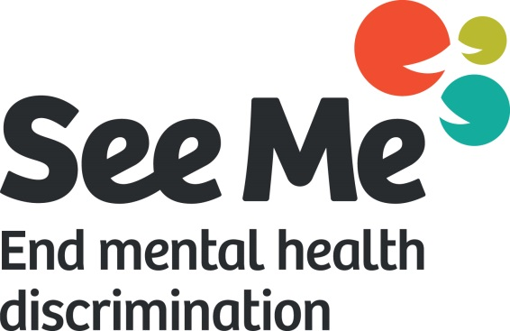

See Me is Scotland’s national programme to end mental health stigma and discrimination, enabling people who experience mental health problems to live fulfilled lives. Their campaigning, influencing, and actions are driven by a social movement of people across Scotland who are determined to end mental health stigma and discrimination.

At the heart of that they support a group of volunteers with lived experience of mental health problems, who are taking action to make changes.

Their knowledge and passion is helping deliver the change, so whenever any of us experiences tough times with our mental health, we can be confident that recovery is possible and we can live happy and fulfilled lives.

The core of this group is the Community Champions. Latest figures, from a poll commissioned by See Me, show that 35% of people in Scotland have either experienced stigma and discrimination because of their mental health, or know someone close to them who has.

Community Champions are making positive changes to how people think and behave in workplaces, universities and with health and social care providers, among other important areas.

Some champions have focused on specific areas where they know stigma is having a devastating impact on people’s lives, such as working to reduce male suicide, or supporting people experiencing PTSD. Others work in their local communities, holding walks, working with libraries and community groups or using the arts.

If you’re interested in volunteering, See Me holds rolling recruitment for the Champions role, among other opportunities.

Contact Toni Groundwater at See Me for more information about volunteering: <https://www.seemescotland.org> / [volunteer@seemescotland.org](mailto:volunteer@seemescotland.org) / 0141 530 1125

## The South East of Scotland Transport Partnership (SEStran) and Young Scot Partnership

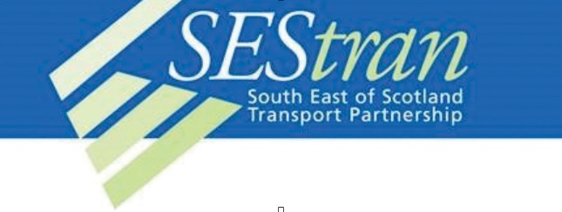

Scotland’s local transport networks are the focus of a new youth-led investigation taking place in the Year of Young People 2018.

yTravel is a new project by the South East of Scotland Transport Partnership working with Young Scot – Scotland’s national youth information and citizenship charity. The partners are currently looking for youth groups who are interested in getting their young people involved in shaping the future of transport in Scotland.

Regional Design Teams of fifteen young people will be set-up in four areas of Scotland; The City of Edinburgh, Clackmannanshire, Fife, and Midlothian. The Teams will create and develop ideas and recommendations for the South East of Scotland Transport Partnership.

In the new year, a final report will be delivered to regional transport partnerships across Scotland, Transport Scotland, the Scottish Government and public transport companies to shape the future of public transport systems in Scotland.



Youth groups or organisations who work with young people aged 16-25 who are interested in promoting the project to their young people can contact Young Scot for more information or encourage young people to sign up directly online.

Young people can sign up directly here: <https://young.scot/things-to-do/events/edinburgh/ytravel/>

### Geographical location of Access Panels in Scotland

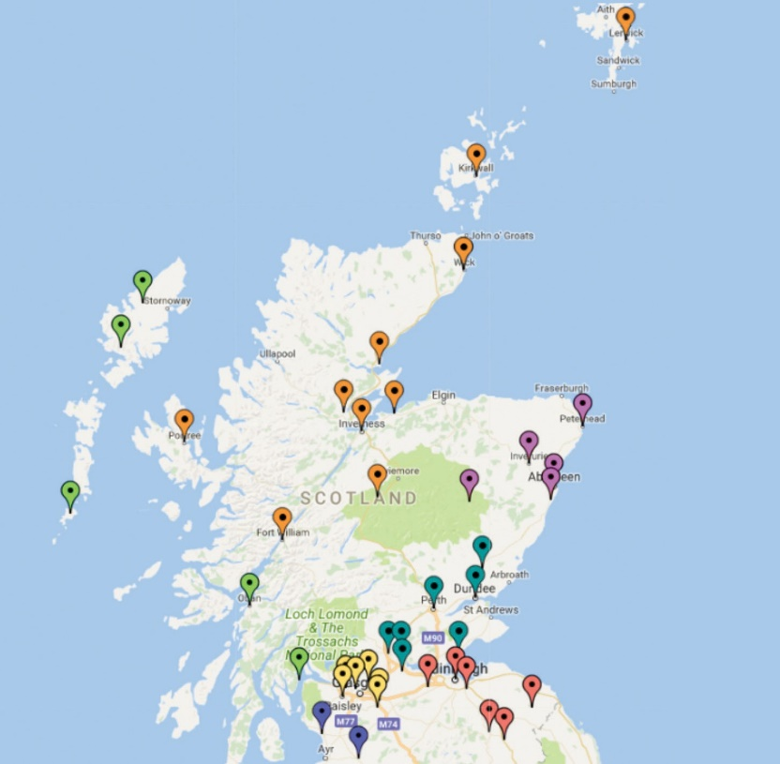

**Western Isles and Argyll**

* + Barra Access Panel
  + Cowal Access Panel (Dunoon)
  + Harris Disability Access Panel
  + Isle of Lewis Access Panel
  + Oban & District Disability Forum & Access Panel

### South West

* + North Ayrshire Access Panel

### Forth Valley and Tayside

* + Angus Access Panel
  + Centre for Inclusive Living Perth & Kinross
  + Clackmannanshire Disability Awareness Group
  + Disabilities Fife
  + Dundee Access Group
  + Falkirk Area Disability Access Panel
  + Stirling Area Access Panel

### Glasgow and Clyde Valley

* + East Dunbartonshire Access Panel
  + Glasgow Access Panel
  + North Lanarkshire Access Panel
  + Renfrewshire Access Panel
  + South Lanarkshire Access Panel
  + West Dunbartonshire Access Panel

### Highlands and Islands

* + Access Panel Orkney
  + Badenoch and Strathspey Access Panel
  + Caithness Disabled Access Panel
  + Inverness Access Panel
  + Lochaber Disability Access Panel
* Nairn Access Panel
* Ross and Cromarty Access Panel
* Sutherland Access Panel
* Shetland Access Panel
* Skye & Lochalsh Access Panel

### North East

* Aberdeenshire North Access Panel
* Aberdeenshire South Access Panel
* Bon Accord Access Panel
* Central Aberdeenshire Access Panel West
* Aberdeenshire Access Panel

### Lothian and Borders

* AccessAble (Central Borders Access Panel)
* Berwickshire Access Panel
* East Lothian Access Panel
* Edinburgh Access Panel
* Midlothian Access Panel
* Tweeddale Access Panel
* West Lothian Access Committee

## Access Engagement Officer’s Update

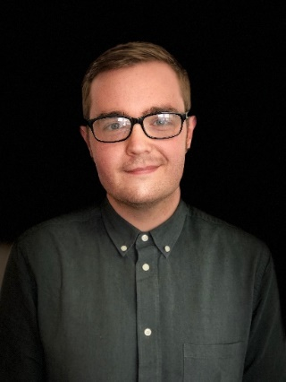

First off, I’ve been holding a series of consultation events with the Access Panels over the past year, seeking their views on a new structure for the Network. It gives me great pleasure to inform you now that the response from Panels concerning the new regional set up has been overwhelmingly supportive and I will work with my colleagues to start implementing this new structure as soon as possible. However, I wish to allay some worries that may still exist. Disability Equality Scotland is neither seeking to govern the Access Panels nor are we asking Panels to do anything that isn’t being done already. Our effort to put in place a new structure is merely a way at simplifying a network which can be at present somewhat unorganised and disjointed.

Ian Buchanan

February and March saw my work to establish more Access Panels around Scotland pick up pace. Within the coming months we should be welcoming new Panels in East Renfrewshire, East Ayrshire, South Ayrshire, and Dumfries into our network and I know that you’ll all be looking forward to giving them a warm welcome into our Access family once they’re up and running. I’ll also be paying a visit to the Western Isles soon to help support the local Third Sector Interfaces in setting up new Access Panels for Uist and Lewis so I’ll be sure to update you on my explorations in the next edition of Open Door magazine and if I have time in my busy schedule I might even snap a couple of pictures for you, our readers.

Lastly, Gillian and I have been working hard behind the scenes to organise your Access Panel Conference. 2018 is a special year for our network, marking the 15th anniversary of the Access Panels coming under the metaphorical umbrella of Disability Equality Scotland. Our keynote speaker this year is Monica Lennon MSP and she’ll be chatting to Panels about planning and statutory consultee status. The event registration has gone live, but tickets are selling fast. I would hate for anyone to miss out on what promises to be a marvellous conference, ram packed full of stimulating speakers and captivating workshops.

As always though, if you have any questions or constructive ways in which we can work together, please do not hesitate to get in touch with me.

Ian Buchanan Access Engagement Officer

## Access Panel News

The following pages provide an insight into the activities and hard work volunteers put into their local Access Panels. If you are not yet a member with your local Access Panel and would like to get involved in improving access in your local community, contact your local

Access Panel today. Contact details of each Access Panel can be found at [**www.accesspanelnetwork.org.uk/directory-panels**](http://www.accesspanelnetwork.org.uk/directory-panels) or contact Ian Buchanan telephone: **01259 272066** email: [access@disabilityequality.scot](mailto:access@disabilityequality.scot)

**Angus Access Panel**

**Tel: 01307 465161| Email: anguspanel@tiscali.co.uk**

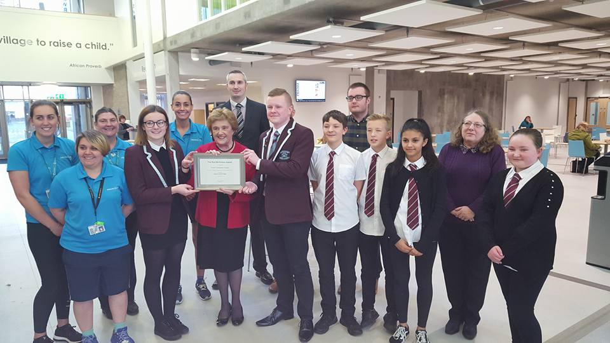

Angus Access Panel is delighted to announce that the Rod MacFarlane Award 2017 has been awarded to Forfar Community Campus. A new building, which opened its doors to the public and to the pupils of Forfar Academy earlier this year, the campus replaces the old Academy, as well as ANGUSalive’s Lochside Leisure Centre and Forfar Swimming Pool.

The Rod MacFarlane Award is presented annually to buildings or facilities buildings or facilities in Angus that demonstrate the most positive efforts being made to encourage the inclusion of disabled people.

Chief Judge and chairperson of the Angus Access Panel, Agnes Mackay said: “Forfar Community Campus is an outstanding building, which is well thought out and goes to great length to provide accessibility for all those who will use it. There is a varied mix of spaces available to pupils and the public, with level controlled access for the different groups.”

**Badenoch and Strathspey Access Panel**

**Tel: 01540 661797| Email: basapanel@gmail.com**

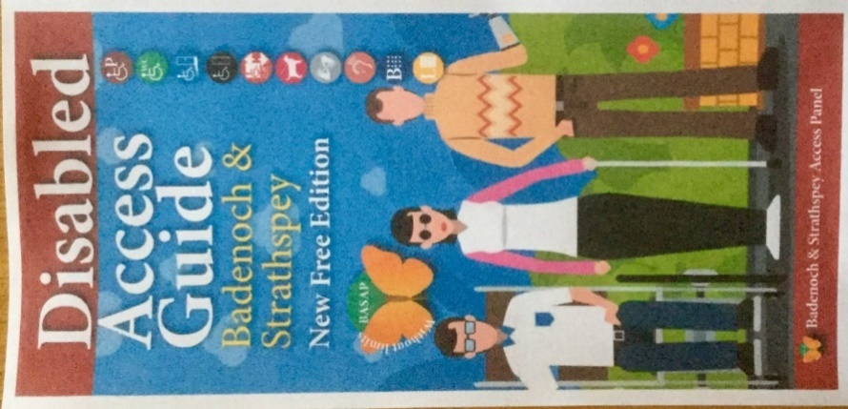Our Panel hold 7 meetings in the year. Since we cover a wide rural area other communications are by email. Meetings are held on the second Tuesday of the month in Boat of Garten Community Hall. Any member of the public can join our Access Panel. The latest new members have been an ex councillor (our new chairman) and a newly elected councillor.

We work closely with the senior building control officer who attends our meetings. We have had many guest speakers to our meetings and given a number of presentations to local organisation. A major work has been with NHS Highlands about the new hospital being built in Aviemore. This also involved full Access Audits of local hospitals and medical centres.

Badenoch & Strathspey new Access Guide

We have been grateful for the funding from Disability Equality Scotland which helped make possible both the Awareness Days and the publication of our new Disabled Access Guide.

**Dundee Access Group**

**Tel: 07922 069039 | Email: dundeeaccessgroup.org@hotmail.co.uk**

We held two meetings in February and March and one new person has joined our Panel. At our meeting in February, we had a visitor from the Department for Work and Pensions (DWP), who spoke about his job to provide disabled people aged 16 - 30 with specialist support to enable them to gain sustainable employment. At our next meeting, a local taxi driver spoke about Dundee Council's changes to their taxicard scheme.

This year we have bought ramps to lease to businesses and/or individuals. We have had complaints about the lift in the Wellgate Shopping centre and are dealing with this. We are keeping our website up-to-date: <http://dundeeaccessgroup.co.uk/>

**Oban & District Disability Forum & Access Tel: 07881 626750**



The Oban & District Access Panel has highlighted the wide range of opportunities for improving the accessibility of public transport for residents and visitors to Argyll and the West Highlands.

During an innovative and well attended event, which was held in the Corran Halls and chaired by the Panel’s chairman, Jim Tolmie, Karl Zaczek from Transport Scotland presented and explained the Scottish Government’s Accessible Travel Framework which aims to support disabled people’s rights by removing barriers and improving access to travel.

Karl spoke about the government’s 10 year 48-action points plan to achieve a barrier-free public transport and travel system making it more accessible to disabled people.

He said “Disabled people have absolute rights to live a life of equal opportunities. The ability to travel is an important enabler to access these opportunities”.

Other topics included the need to quickly introduce the successfully-piloted “Thistle Assistance Card”, which advises drivers of a person’s disability and the help they need, in the West Highlands, to improve local connectivity between bus, rail and ferry, and to improve staff awareness to the needs of disabled travellers.

Jim Tolmie said “The workshop identified a huge range of opportunities for improving access to public transport. We are actively following up on all of these points and we are committed to working with Disability Equability Scotland and the Scottish Government to enable disabled people to be as independent as possible, to be able to make door-to-door journeys and to travel with freedom, choice and dignity and with the same opportunities as other citizens”.

**Skye and Lochalsh Access Panel**

**Tel: 01859 530273**

**Email:** [**skyeandlochalshaccesspanel@gmail.com**](mailto:skyeandlochalshaccesspanel@gmail.com)

We have advised on accessibility/inclusion for a Visitor Centre and a new hospital on Skye, a large community project on the mainland, on various planning applications, have undertaken Access Audits.

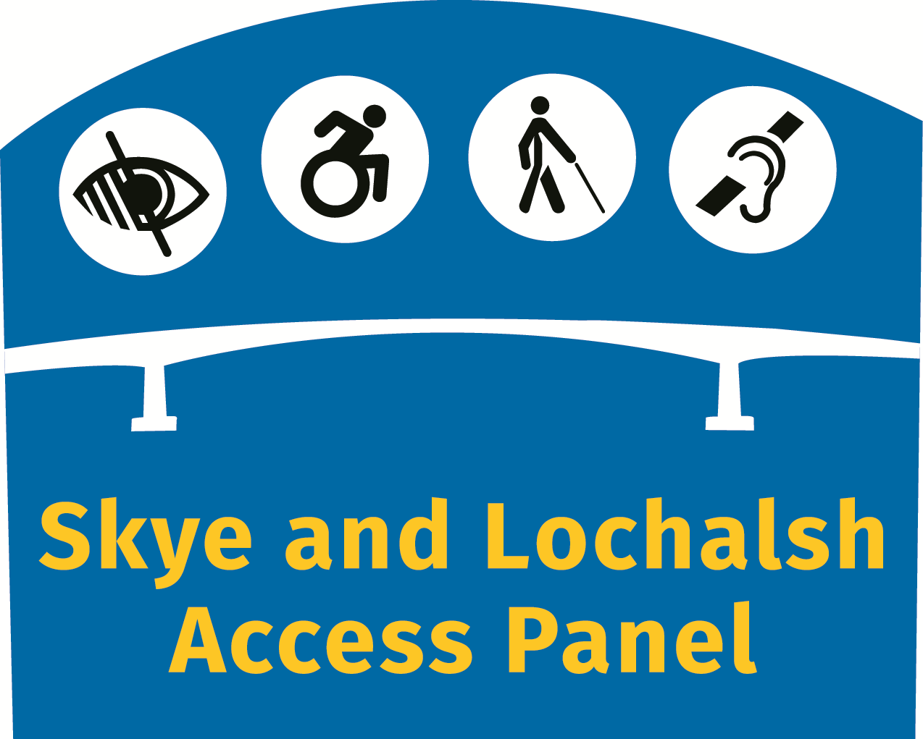

Currently, we are organising a Wheelchair Awareness Event in May for our local Councillors. Four Councillors will attend for the whole day. Starting in Broadford, there will be an introduction to four different types of wheelchair which will be used for the event. Each Councillor will be accompanied by a supporter who will read out their first task. Once each task is completed, the next task is read out. After two tasks, each councillor changes to a different type of wheelchair, completes another two tasks and then attends lunch (on us – to which the press will be invited) but they have to stay in their wheelchairs throughout lunch!

Afterwards they swap to a different type of wheelchair and then have to drive/travel 26 miles to the capital of the island, Portree. A wheelchair accessible vehicle will be provided for the powered wheelchair. In Portree, they will undertake two more tasks (including shopping – and the experience of carrying their shopping with them for the rest of the event). They will change to a different type of wheelchair and do two more tasks. All councillors will experience all types of wheelchairs and will meet up only to swap wheelchairs. Afterwards, the Councillors join the Access Panel to share their experiences – if they haven’t become lost for words!

Our Local Councillors have been great to put aside a whole day for this event and, hopefully, they will be more aware of the access issues for wheelchair users. If the event is a success, we propose to repeat it on different service providers and expand the event to include different impairment experiences.

**Stirling Area Access Panel**

**Tel: 01360 440741| Email: rh.dick@btinternet.com**

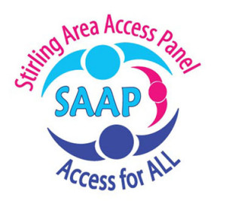

Stirling Area Access Panel has had a very busy year so far, involved in many different projects to improve access and inclusion in Stirling, and surrounding areas.

**Engine Shed** – Disabled Parking, Aug.’17 to current date – This is an ongoing issue since the mandatory Sect. 5 Planning was removed, access to the Engine Shed with the provision of accessible parking has been dismissed. We have sought the assistance of Stephen Kerr MP to rectify this, but we are still running into barriers as an ever changing City Centre Masterplan now seems to be dominating the decision-making in this area.

**New Doune Health Centre** – After a formal discussion with the project team over the layout design, we highlighted access issues to the entrance (door types) and also the accessible WC door and Baby Changing facilities. The main issue was that the admin offices and manager’s offices were located in the area that should have been the clinical consultation area, so their proposed layout makes patients walk further. We managed to get the layout improved very slightly, but the overall design is still lacking ‘good practice’ elements.

**G1768 Campus Central MacRobert** Art Centre Expansion – Stirling University met SAAP in January to discuss a radical change to the frontage of the building incorporating a glazed extension with two floors. The size of extension does affect the current road system and will preclude vehicles entering the area. We argued for more disabled parking within a drive-thru route; all bays should be within 45m of the entrance. Many other points were discussed and overall we could not support the project as access to the buildings for a wheelchair user is now actually more challenging. We don’t know what the final design position will be.

**Stirling University Performance Sports Centre** – In stark contrast to the project above, accessibility and inclusion has been carefully considered. We supported the student position for including Non-Binary changing and shower facilities. Overall, this is an excellent project which will span 2 years of work.

Stirling Area Access Panel update continued…

**Parking, Stirling City –** This was a public complaint relating to non-Blue Badge Holders abusing the use of accessible parking bay, yet not being prosecuted. We raised this with the Council and on clarification they advised that any illegal parking users would be fined.

**Parking, Off-Street**, Council Facilities – Again, a public issue relating to schools in particular: patrons are abusing disabled parking without fear of prosecution. Legally, the council should and can take action and we await a reply from the council.

**Parking, Stirling Castle** – We have highlighted to Historic Environment Scotland via Stephen Kerr, the poor disabled parking access, which we hope can be improved a little. Outcome is not known as yet.

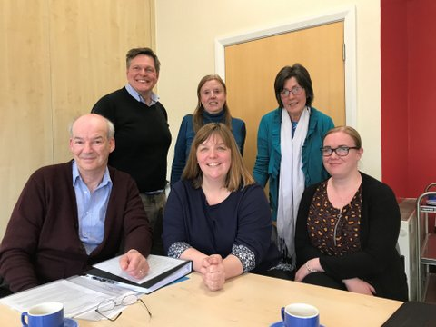**Changing Places WC (CPs)** – Discussed a strategy with Stephen Kerr MP to increase CPs in Stirling. This involved the release of £60K for Stirling Council to potentially help in the development of:

* Bannockburn Battlefield Centre (unfinished CP since 2014. Discussions ongoing)
* The Peak Sports Centre (Requested in 2016 at Planning stage for a CP. Awaiting developments)

Stirling Area Access Panel Meeting Stephen Kerr MP

* Stirling University Sports Centre.

**Housing Need and Demand Assessment Consultation** - Stirling Area Access Panel – This extensive submission to the council in March 2018 covers a wide range of features relating to the need for 16% of all housing to be made accessible and will be quoted in their Policy Document.

**Scottish Fire and Rescue Services** – In February, we drew to their attention the narrow passageway of the ground floor toilets in Sainsbury’s which don’t comply with Scottish Building Standards. Similarly the curved screen which covers the entry/exit to the accessible WC’s at the entrance lobby to the MacRobert Centre, is a needless barrier to their use. Still waiting for a response.



**6 ways to get involved**

1. Join your local Access Panel

### [www.accesspanelnetwork.org.uk/directory-panels](http://www.accesspanelnetwork.org.uk/directory-panels)

1. Be on our mailing list and join Disability Equality Scotland

### [www.disabilityequality.scot/membership/](http://www.disabilityequality.scot/membership/)

1. Like our Facebook Pages **Disability Equality Scotland Access Panel Network**
2. Follow us on twitter

### @DEScotTweets

**@AccessPanelNet**

1. Come along to our events
2. Spread the word and encourage your friends, family and colleagues to join

# Our Sponsors...

Disability Equality Scotland is grateful for the generosity of its sponsors and their ongoing support as we work together toward achieving the goals of the organisation.

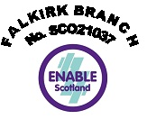

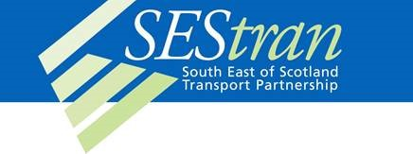

If you are interested in sponsoring our magazine OPEN DOOR, please complete our online registration form - [**www.disabilityequality.scot/our-sponsors**](http://www.disabilityequality.scot/our-sponsors)

Alternatively, please contact email [**admin@disabilityequality.scot**](mailto:admin@disabilityequality.scot)

### OPEN DOOR is published by

Disability Equality Scotland



Office 2/4, The e-Centre Cooperage Way Alloa, FK10 3LP

Telephone: 01259 272064

Email: [admin@disabilityequality.scot](mailto:admin@disabilityequality.scot)

**Connect with us...**

disabilityequality.scot Disability Equality Scotland @DEScotTweets



### Disability Confident EmployerDisability Confident Employer logoOSCR logoDisability Equality Scotland is funded by

Disability Equality Scotland is Registered in Scotland

as a Company Limited by Guarantee with Charitable Status Charity Number SC031893, Company Number SC243392