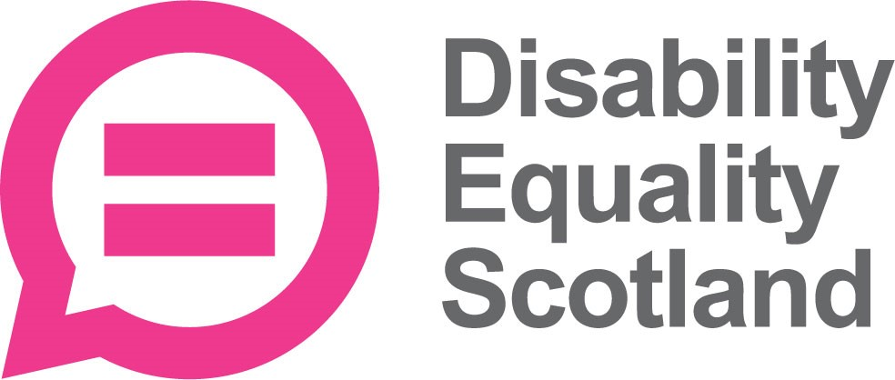
disabilityequality.scot ISSUE 47 | 2017
Disability News and Views for Disabled People Across Scotland

Welcome to the latest issue of Open Door, the quarterly magazine from Disability Equality Scotland
OPEN DOOR
This magazine brings you the latest news and information from Disability Equality Scotland, Access Panels, and Disabled Peoples’ Organisations across Scotland.
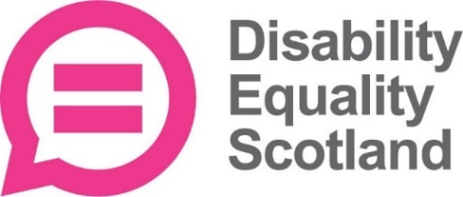
New Branding!
Have Your Say
Access Panels
New Branding!

Your Disability, Your Voice, Your Scotland…
Disability Equality Scotland is a member led organisation so we want to hear from you, our valued members!
Get in touch with us with your disability news by email at: admin@disabilityequality.scot or by calling on 01259 272064.

Contents

Page Number
- Contents
- CEO’s Welcome, Introduction from Morven Brooks
Inform

- Meet the Team
- New Branding
6-8 Disability Equality Scotland Strategic Plan 2017-2020
9-10 Update from Emma Scott, Equality Project Manager
- Poll Highlights Ticket Discrimination
- 12 Disability Equality Scotland Easy Read Service
Your Say on Disability
- Have Your Say On Disability
- 14 Transport Scotland – Improving Parking in Scotland
- 15 Clinical Governance – Call for Views
- 16 ScotRail Blue Badge Consultation
  - Weekly Poll Roundup
Support
19 The ALLIANCE - Health and Social Care Alliance Scotland
20 Breathing Space
21 Food Train
22 Guide Dogs Scotland
23 Humanism in Scotland
24 Independent Living Fund Scotland
25 PAMIS - The Pamiloo
26 The South East of Scotland Transport Partnership (SEStran)
27 Spinal Injuries Scotland
Access Panel Network
28-35 Access Panel Network Scotland News
Page 2 Issue 47 - 2017

CEO’S Welcome

Annual General Meeting 2017
We would like to say a big thank you to members who made it along to our Annual General Meeting on Tuesday 12 September 2017 at Perth Concert Hall.

This year has seen the best attended AGM in the history of Disability Equality Scotland, with 17 stallholders enhancing the experience for attendees.
All of the Resolutions passed, formally adopting Linda Bamford, Gordon Mungall and Dorothy McKinney as Directors and also including Special Resolution 1 to change the name of the organisation to Disability Equality Scotland.
Thank you again for your commitment and dedication and most importantly for the positive results that you achieved on behalf of, and for, disabled people in Scotland.
If you attended and would like to share your experience and feedback from the day, please do get in touch. It is important we can learn from our events to make them better in the future.
Presentations are now available to download from our website www.disabilityequality.scot/annual-report/ . They are available in PDF, Word and Plain Text. If you require an alternative format, please do get in touch.
Thank you again

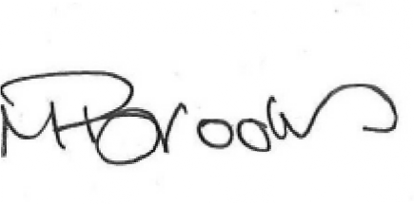
With best wishes

Morven Brooks, Chief Executive Officer

Page 3 disabilityequality.scot
Inform

Staff Team

Morven Brooks- Chief Executive Officer
Morven works with the team to ensure that Disability Equality Scotland is effective in its aims to promote equality and to reduce barriers to Independent Living. Morven is responsible for the strategic development of the organisation.

Emma Scott - Equality Projects Manager
Emma is responsible for managing a broad number of projects and initiatives. Working closely with the CEO to implement the organisations’s strategy to work towards social inclusion for Disabled People in Scotland.

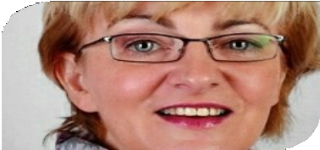
Maeve Bain - Senior Administrator
Maeve is responsible for the administration of our finances, book-keeping and payments, as well as supporting in other areas such as minute-taking and regular Board related duties.

James Davidson - Equality Projects Assistant
James works across the business with publicity, promotion and events. He also develops and sources content for Disability Equality Scotland online Hubs, monitoring and reporting progress of each.

Ian Buchanan - Access Engagement Officer
Ian’s role is to support, develop and promote the Access Panel Network. He regularly travels around Scotland meeting Access Panels and stakeholders to encourage partnership working.
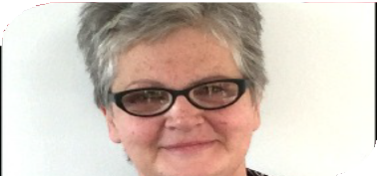

Gillian Smith - Access Administrator
Gillian is our Access Administrator and it is her role to provide administrative support to the Access Engagement Officer and the wider Access Panel Network.
Page 4 Issue 47 - 2017

Inform
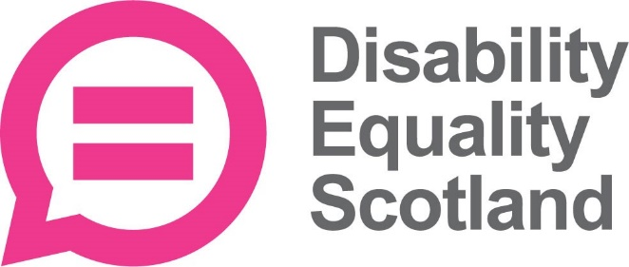
Disability Equality Scotland Branding

We recently implemented a full rebrand and unveiled a new corporate identity. After extensive consultation with members, and effective immediately, we will be known as Disability Equality Scotland, a name that better reflects our goal of achieving full access and inclusion for disabled people in Scotland.
Morven Brooks, our Chief Executive Officer commented:
“This rebranding goes much further than just changing our name and our logo. This is our opportunity to promote wider discussion on disability equality issues. It is important that Disability Equality Scotland retains its established values but at the same time, develops a new and modern identity.”
We are the umbrella body for Access Panels in Scotland and since 2003 have worked at a local level to promote independent living for disabled people and to make sure their voice is heard and their views are represented at a government level. The new website (www.disabilityequality.scot) which also launches on the same day, will seek to increase our online presence and help to communicate clearly the projects established to improve access and inclusion for disabled people in Scotland.
Alex Thorburn, acting Convenor, concluded:
“Our new name and branding will ensure that we get the right message out there. I feel it’s important to let people know what Disability Equality Scotland stands for and our new strapline ‘Achieving Full Access and Inclusion for Disabled People in Scotland’ signifies this clear definition of wanting to improve the lives of disabled people in Scotland.”
For more information about Disability Equality Scotland and to sign up for news, information and membership, please visit www.disabilityequality.scot

Page 5 disabilityequality.scot
Inform

About Disability Equality Scotland

We are a national charity working to achieve full access and inclusion for disabled people.
We promote access in its widest sense, including access to the built and natural environment and access to the same opportunities as are enjoyed by others in our communities, promoting a life of dignity, respect and independence.
Our aim is for every disabled person to have the opportunity to participate in a fulfilling life. We represent the views of individuals with any type of impairment, as well as disability organisations and groups who share our values.

Our Vision…
A better life for people living with disabilities.

Our Mission...
Our mission has always been to increase awareness and knowledge of Access and Inclusion, to improve the lives of disabled people in Scotland.

“Achieving full Access and Inclusion for disabled people in Scotland.”
Page 6 Issue 47 - 2017
Inform

Disability Equality Scotland Strategic Plan 2017-2020

Our Principles
Positive Approach. We are a solutions focused organisation. We want to hear what is working well and what is not working, to approach the issues in a positive way.

Promoting Equality. We are a proactive and media aware organisation. We look to promote good/best practice and achieve a greater awareness of disability equality and accessibility across Scotland.

Partnership-focused. We are a collaborative organisation. We work with partners across all sectors to achieve real, measurable change across Scotland, with regard to access and equality.

Our Strategic Priorities
We are committed to working in line with the Scottish Government’s policies and procedures. Below is a list of relevant policies to which we align.

- A Fairer Scotland for Disabled People

- Scottish National Action Plan for Human Rights

- Equality Act 2010

- Going Further, 2016—Transport Scotland’s Accessible Travel Framework
Page 7 disabilityequality.scot

Inform

Disability Equality Scotland Strategic Plan 2017-2020

Our Strategic Aims

Strategic Aim One

We believe increased awareness and knowledge of access and inclusion will improve the lives of disabled people in Scotland.
To effectively communicate, promote and campaign the importance of social inclusion, ensuring the opinions of disabled people are taken into account from the first point of planning.

Strategic Aim Two

We believe that access and inclusion are vital to the independence of disabled peoples’ lives.
To increase awareness, knowledge and understanding of access and inclusion across Scotland.

Strategic Aim Three

We believe that a sustainable organisation is focused on mission, outcomes and demonstration of impact.
To develop a creative and adaptive organisation.

Please visit our website to download our full Strategic Plan, which is available in a number of alternative formats: www.disabilityequality.scot/about-us/
Page 8 Issue 47 - 2017
Inform

Update from Emma Scott, Equality Projects Manager

It has been a very busy few months for me. I have led several projects, sat on different advisory groups and have met with a large number of organisations. Some of my work to date is outlined below.

Transport Scotland

I used the findings of our national survey around disabled peoples’ experiences of travelling on public transport to develop a shorter, more focused survey on Connectivity, to understand more about the issues of changing between modes of transport. I presented the findings of both the baseline survey and topline findings from the Connectivity survey at Transport Scotland’s Accessible Travel Summit in October. This event led to some very useful discussions and contacts which I hope to build on in the coming months.
I’ve also attended meetings with Transport Scotland, SEStran and Police Scotland, to take forward a pilot project around Hate Crime. The Equality Transport Advisory Group, based in Edinburgh has drafted a Hate Crime Charter for use by transport providers. I will work with SEStran to run some pilot events, to gather feedback from disabled people on this Charter.

Inclusive Communication
I have been working with James on our Inclusive Communication Hub, which is undergoing a make-over in line with our new branding. All the same features are available and the Hub can be accessed via www.includeusall.org.uk/

Page 9 disabilityequality.scot
Inform

Update Continued…

The Advisory Group held their first meeting in some time, in early September and had good discussion and debate about the content and layout of the website. James and I will be working with the Advisory Group to take forward some suggestions for improvements. I also met with some members of the Scottish Government’s communications team to give them an introduction to the Inclusive Communication Hub and I have been invited to write an article for their intranet, which will reach all the Scottish Government employees, which is great promotion for the Hub.
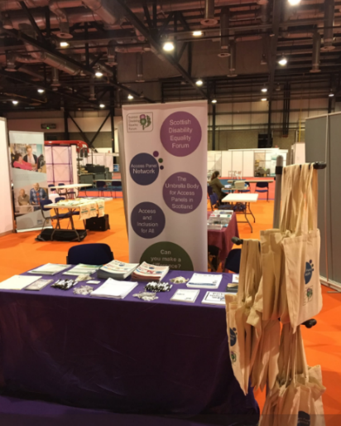

Independent Living Scotland
The Disability Equality Scotland team had a very productive few days at Independent Living Scotland, held in the SEC in Glasgow. We met with many people who were interested in finding out more about Disability Equality Scotland and we recruited some new members too.

Strategic Planning
A lot of my time is also spent working with Morven our CEO on the strategic plans for the business. We now have performance reviews in place to help keep the staff focused on how their day-to-day work contributes to the overall aims of the organisation. As manager, I will be speaking to all staff to ensure everyone is working to their agreed outcomes.

Get In touch!
In the meantime, if anyone wishes to contact me about my work, my number is 01259 272062 or you can email me on: emma@disabilityequality.scot

Page 10 Issue 47 - 2017
Inform

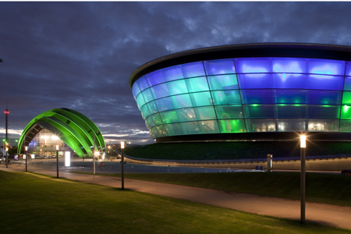
Disability Equality Scotland Poll Highlights Ticket Discrimination
We recently conducted a poll with our members which highlights the discrimination disabled people face when purchasing accessible tickets for events.
A total of 81 per cent of people who completed the poll had experienced difficulties buying accessible tickets for events such as live music, theatre, comedy and sport. Many ticket companies and venues do not offer an online service for purchasing accessible tickets. Instead, these must be purchased by telephone.
One of our members explains why this is perceived as discrimination against disabled people:
“I have tried on many occasions to buy accessible tickets to events without success. I have now given up as it's not worth the stress of phoning a premium-rate booking line that is permanently engaged.
When you eventually get someone on the phone all tickets are sold. My wife usually goes to events on her own because of this inaccessible ticket booking system”
The respondent added:
“Ticket sellers clearly have no concept of equal opportunities, accessibility or disability discrimination.”
Linda Bamford, a Director of Disability Equality Scotland, who has also experienced difficulties purchasing accessible tickets, commented on the results of the poll:
“This is quite an emotive subject for me but reading through the comments it would appear that I am not alone. It also appears that one of the major ticket organisations (Ticketmaster) is one of the main problems and I would go so far as to say are discriminating against people who require accessible tickets.”
“I find it hard to read that some people just stay at home and sometimes even their partners just go without them. This is so sad and should not be happening.”
Page 11 disabilityequality.scot
Inform

Disability Equality Scotland Easy Read Service

We have the expertise to produce information in Easy Read
We provide a professional and efficient Easy Read service to all sectors, as part of our commitment towards improving access to information for all.

What is Easy Read?
Easy Read is an accessible format that makes written information easier to understand. The Easy Read format is easy to understand because it uses simple, jargon-free language, shorter sentences and supporting images.

Why produce Easy Read documents?
Easy Read documents make information more accessible to people with learning disabilities. They can also be useful for people with other communication difficulties including:
  - acquired brain injury
  - dyslexia
  - people with hearing impairment whose first language is British Sign Language (BSL)
  - people who do not speak English as their first language
  - people who find reading difficult
  - people with cognitive impairments such as dementia.

The Equality Act
The Equality Act (2010) requires organisations to produce information in an accessible format. Easy Read can ensure that disabled people have equal access to information and are not discriminated against.

Who do I contact?
For more information about our Easy Read service, please contact us by telephone: 01259 272064 or email: admin@disabilityequality.scot
Page 12 Issue 47 - 2017

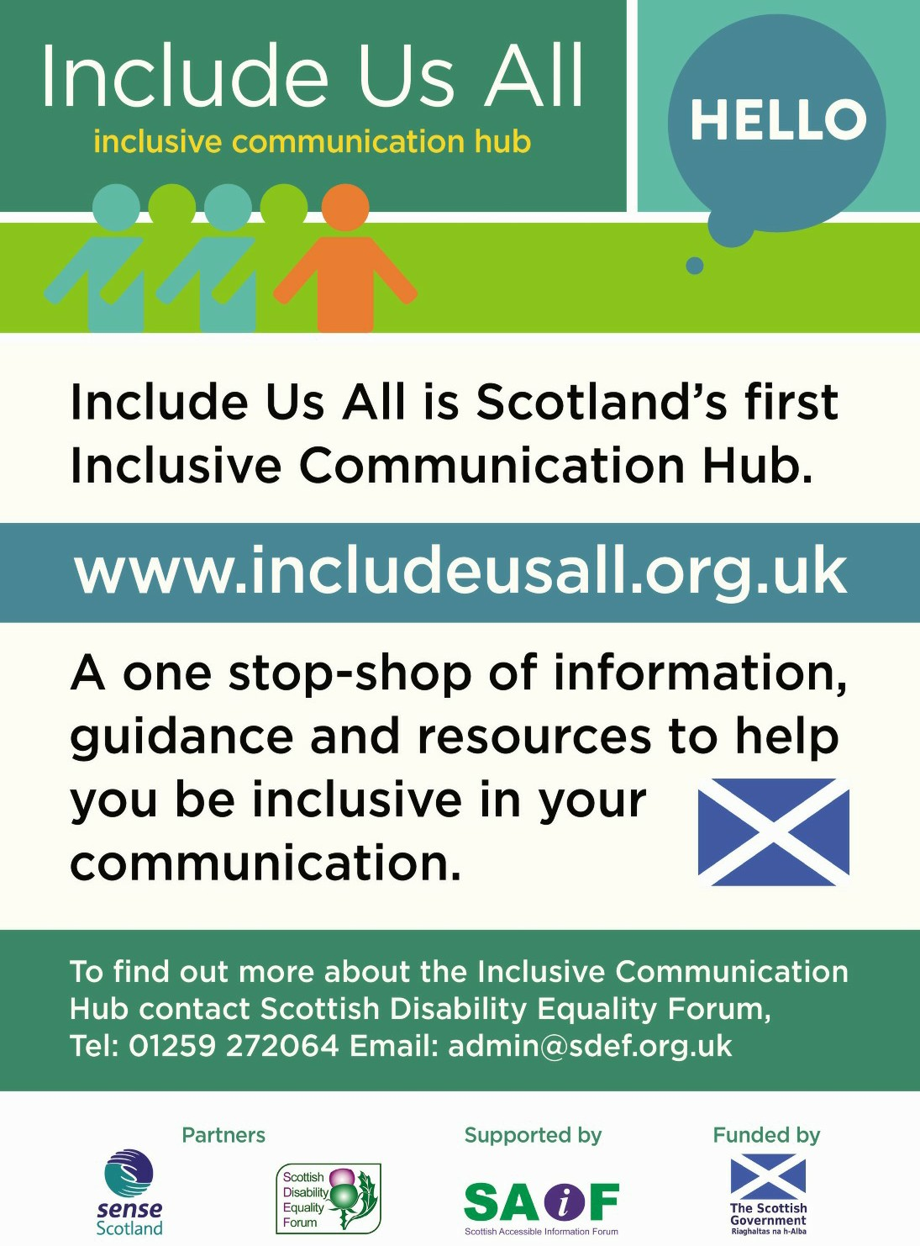
Your Say on Disability

Your Say on Disability…

Gathering the views of disabled people in Scotland

Your Views Count!
The Have Your Say on Disability website is a place for you to tell us your views on disability issues in Scotland. This website provides the opportunity for disabled people to help shape Scotland’s future in accessibility and equality.

As someone with lived experience of – or representing someone with – a disability, we would like you to tell us what you feel is working and what needs to change in Scotland by completing our surveys. Our surveys are on current policy consultations and available in alternative formats.

What happens to my comments
- Your comments will be passed on in full to those who have requested the survey, making sure that your views really are counted.
- Your responses are anonymous unless you wish to provide your details.
- The Scottish Government and other bodies want to know what is working, what is not, and what needs to happen to improve life for Scottish disabled people, so your comments can really make a difference!

www.your-say-on-disability.org.uk
Page 13 disabilityequality.scot

Policy
Your Say on Disability

Transport Scotland – Improving Parking in Scotland
The Scottish Government wanted views on improving the management of parking across Scotland and making regulation more consistent. The consultation asked how the Scottish Government could improve the clarity of the laws on parking, what restrictions should be applied and the exceptions that should be granted. The Scottish Government also aimed this consultation at local authorities to ask them how they can deliver an integrated approach to managing parking, how we should tackle displacement of vehicles and support town centre regeneration, as well as improving accessibility for all.

What Disability Equality Scotland did next
We held an online consultation from 31 March 2017 until 30 June 2017, which prompted 70 responses.

Your Responses
Some of the key findings included that cars parked on pavements caused our members considerable inconvenience, whether they were wheelchair users or relied on assistance dogs. Having to negotiate round parked vehicles, or use the road to get past, makes independent travel much more difficult for disabled people and more hazardous than it needs to be.
A large number of our members are wheelchair users, or have mobility scooters. Equally, our visually impaired members travel with the use of an assistance dog. All had experienced issues with parking on dropped kerbs. This inevitably means a longer journey, with disabled people having to locate the next, unobstructed dropped, kerb to be able to cross the road.
Double parking was not raised as an issue in the same way as pavement parking or parking at dropped kerbs, but was still an issue for some of our members. For example, in rural areas, double parking occurs quite frequently, especially along streets in shopping areas, causing problems for passing traffic. Commercial vehicles double-park for various lengths of time to unload, while private cars tend to park for a short time, while they visit local shops.
Disabled people have expressed their frustration at the current situation of parking on pavements, on dropped kerbs and double parking. They felt that new legislation would go some way to alleviating the issues, but only if the new legislation was suitably enforced.
Page 14 Issue 47 - 2017

Your Say on Disability

Clinical Governance call for views

About the Consultation
As part of the inquiry into the culture of the NHS in Scotland, the Health and Sport Committee agreed to look at clinical governance. This refers to the systems through which NHS organisations are accountable for continuously monitoring and improving the quality of their care and services, ensuring they safeguard high standards.

What Disability Equality Scotland did next
We held an online consultation from 11 July 2017 until 9 August 2017, which prompted 30 responses.

Your Responses
We asked our members to comment on the question “Are patient and service user views taken into account in the planning and delivery of services?” Overall, three-quarters (76%, 22 respondents) said no, patient views are not considered, while just under a quarter (24%, 7 respondents) felt that patients and service users were part of decision-making.
Overall, our members felt that there was direct conflict between the aims of clinicians and the aims of NHS managers. It was felt that clinicians are trying to improve patient care, while managers are trying to offer a service within reducing budgets. There was also a strong view that decisions are taken before the public are involved, and so it is rarely true consultation. Those who answered ‘yes’ to this question, also indicated that “more could be done” or that there was “room for improvement”.
Our members suggested that funding and resources drive the decision-making, rather than the quality of service. Our members felt more needs to be done to gather the views of patients and service users, such as holding meetings with NHS managers and clinicians, out with normal working hours, to allow people to participate. It was also suggested that the NHS could be flexible to different types of meetings, such as Skype or video-conferencing.

Page 15 disabilityequality.scot

Your Say on Disability

ScotRail Blue Badge Parking

Consultation

About the Consultation

ScotRail launched a consultation to improve its car parking offering to all customers and we invited our members to contribute to this process.

ScotRail want to ensure that its car parks play a positive role in peoples’ lives providing access to places of employment, education, health and leisure facilities.

This consultation focused on how ScotRail can address the issue of usage, balancing provision, increasing or decreasing provision based on demand, as well as views on how best to manage Blue Badge parking provision.

What Disability Equality Scotland did next
We held an online consultation from 1 August 2017 until 30 August 2017, which prompted 55 responses.

Your Responses
This is a summary of the most popular answers:
- 76% (42 respondents) did not think that ScotRail provided enough blue badge parking spaces
- 58% (32 respondents) did think the spaces were of the correct size and clearly marked.
- 98% (54 respondents) felt ScotRail should enforce blue badge parking to ensure the spaces are not abused.
- 9% (5 respondents) had witnessed a ScotRail member of staff patrolling the car park.
- 98% (54 respondents) had never seen a ScotRail staff member challenge a non-Blue Badge holder over misuse of a parking space.

Page 16 Issue 47 - 2017

Policy
Your Say on Disability

Weekly Poll Roundup

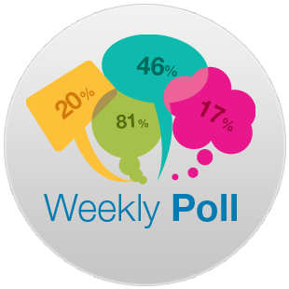
This year we launched a new way of engaging with our members. Each week, a new Weekly Poll question is sent out on a different topic or subject. The aim is to build up a bank of information and views from our members, so we can better understand disabled people. We also want to increase our outreach and gather more evidence that we can use in our business planning; and to help respond to consultations.
Below is a selection of the weekly poll questions we have asked in the past few months, along with your responses:

Access to Voting – w/c 13 June 2017
Question: Do you think voting is accessible in Scotland?
Your feedback: Yes- 36% (10 respondents) No - 64% (18 respondents)
Key comment: “Physical access can be difficult. Access to communication support, better acoustics and hearing loops never seem to have been considered either.”

Accessible Parking – w/c 27 June 2017

Question: Do you think parking, including parking on pavements, at dropped kerbs and double parking is a problem in your area?

Your feedback: Yes – 93% (28 respondents) No 7% (2 respondents)

Key comment: “Parking on pavements, at dropped kerbs and double parking are a problem that I regularly meet as I go about my job in the community, which can be very frustrating.”

Personal Care – w/c 4 July 2017

Question: Do you think personal and nursing care should be free for disabled people under the age of 65?

Your feedback: Yes - 95% (36 respondents) No - 5% (2 respondents)

Key comment: “It is everyone’s right to live a life with dignity, respect with choice and independence, therefore it is only right and proper that all disabled people receive free personal and nursing care free, at the point of delivery and that the care given meets the needs of the individual.”
Page 17 disabilityequality.scot

Policy
Your Say on Disability

Clinical Governance – w/c 18 July 2017
Question: Are patient and service user views taken into account in the planning and delivery of services?
Your feedback: Yes – 25% (7 respondents) No 75% (21 respondents)
Key comment: “I think more could be done, but it needs to be done in a way that is interesting for people. Having meetings that take place Mon to Fri 9 to 5 may suit staff, but as most people are working then, flexibility of involvement is the key.”

Accessible Postal Services – w/c 25 July 2017
Question: Have you experienced any difficulties accessing postal services, for example travelling to depots to collect mail delivered when you were out, or arranging redelivery of items?
Your feedback: Yes – 59% (23 respondents) No 41% (16 respondents)
Key comment: “My biggest difficulty is being able to access post offices that have been moved into local grocery shops. On one recent occasion, I had to get my son to come with me to move crates of lemonade and boxes of stock from the floor, to allow me access the counter. The shop owner watched as we moved items.”

Brexit – w/c 8 August 2017
Question: Do you think the Scottish Budget will be worse off as a result of Brexit?
Your feedback: Yes – 88% (28 respondents) No – 12% (4 respondents)
Key comment: “As there does not seem to be any plan for exit and disability still low on government priority, I think things will be worse off.”

Passenger Assistance at Airports - w/c 22 August 2018
Question: Have you encountered any problems with passenger assistance at airports in Scotland?
Your feedback: Yes – 81% (42 respondents) No 19% (10 respondents)
Key comment: "These are training issues. There is sometimes information board and acoustic issues in the smaller airports - Shetland, Orkney and Stornoway come to mind.”
Page 18 Issue 47 - 2017

Support

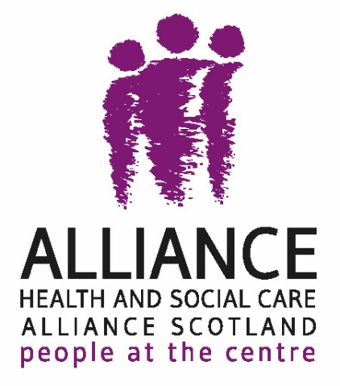
The ALLIANCE
The ALLIANCE has called for a focus on supporting people to hold the new social security system to account, in response to a Scottish Parliament call for evidence on the Social Security (Scotland) Bill.
Over the Summer, the Scottish Parliament's Social Security Committee has been consulting with people from across the country on the new Social Security (Scotland) Bill.
The Bill, introduced by the Cabinet Secretary for Communities, Social Security and Equalities, Angela Constance MSP, sets out principles, rules and further detail on how eleven social security entitlements devolved to Scotland will be administered.
The ALLIANCE's response, informed by recent research with seldom heard people and our Welfare Advocacy Support Project, proposes a number of amendments to the legislation, including:

- Setting out the overall purpose and what the Bill seeks to achieve
- Explicit reference to key elements of a human-rights based approach throughout the Bill
- Automatic access to an independent advocate – as a distinct form of supported decision-making – at any point in the process
- Stronger and clearer language that directly refers to a truly co-produced system
- Firm enough commitment to actual continuous improvement

The ALLIANCE have also called for more detail in the Bill on what people can expect when things go wrong with social security assessments, payments and appeals.
For more details visit the ALLIANCE website www.alliance-scotland.org.uk call 0141 404 0231 Follow us on twitter @ALLIANCEScot

Page 19 disabilityequality.scot

Support
Support

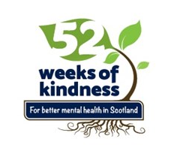
Breathing Space

Kindness at home, at work and to ourselves
We've all experienced little acts of kindness – whether it's a door being held open by a stranger, a friendly wave from a neighbour, or the offer of a comforting cup of tea from a friend.

Research suggests that helping others may have benefits both to our mental and physical health. One study showed that performing acts of kindness may help people with social anxiety feel more positive. Another suggested there are protective effects on the body, such as lowering blood pressure.

That's why Breathing Space, Scotland's mental health phone service, launched their '52 Weeks of Kindness' campaign this year. Acts of kindness can make our day that little bit brighter and help improve mental wellbeing.

Breathing Space's 52 Weeks of Kindness calendar provides inspiration to 'spread a little kindness' for every week of the year. The calendar also highlights the work of Breathing Space, who provide compassion, listening and advice over the phone to anyone in Scotland feeling low, stressed or anxious.

Tony McLaren, who is National Coordinator of the Breathing Space service at NHS 24, said: "The final message of the campaign is for us to be kind to ourselves. This could mean making simple changes to your day such as getting some fresh air, relaxing with a book or even practicing mindfulness. Taking some time out for your own mental wellbeing is too often neglected and is perhaps even more important for disabled people and those facing life's challenges".

Spread a little kindness today
Breathing Space is a free and confidential phone service, available in the evenings and weekends for anyone feeling low, stressed or anxious. Call freephone 0800 83 85 87 or visit www.breathingspace.scot

Page 20 Issue 47 - 2017

Support
Support

Food Train
Food Train is an award winning Charity that supports Scotland’s older people to maintain their independence and stay at home for longer. Food Train provides a range of services to more than 2,800 registered members, with the support of nearly 1,000 volunteers.

The Charity was founded in 1995 in Dumfries & Galloway and now has regional branches in West Lothian, Stirling, Dundee, Glasgow, Renfrew, North Ayrshire and is just launching in the Scottish Borders. Volunteers donate in excess of 140,000 hours per year helping our customers access food with our low-cost grocery shopping and delivery service, carrying out household tasks, befriending on a one to one basis or on social outings, bringing library books to the home and most recently, sharing a meal with an older person in their neighbourhood, as part of our innovative Meal Makers project.

Anyone aged over 65, who is struggling with accessing food, can register to join Food Train and get support with their shopping. There is a delivery charge of £4 and an annual membership fee of £1. We will collect your list, do your shopping and then our delivery teams will take it home for you and help to put it away if needed.

If you are over 55 you can sign up for our neighbourhood meal share project Meal Makers, where a volunteer ‘cook’ will make an extra portion of home cooked food and take it around for you to enjoy.

Joining Food Train is easy, just visit our website at www.thefoodtrain.co.uk to find our regional numbers or email everything@thefoodtrain.co.uk for more information about the services offered where you live. If you have spare time and would like to get involved as a volunteer with Food Train in your local area, please contact us via our website.

Page 21 disabilityequality.scot
Support

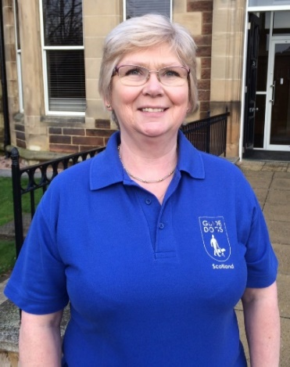
Guide Dogs Scotland
My name is Pamela Munro (pictured to the right) and I am the Engagement Officer for Guide Dogs Scotland. My role is very varied. Part of my remit is to support our service users who have been refused access to businesses because of their guide dog.
Being turned away and ushered out the door is upsetting, stressful and embarrassing, and access refusals can have a lasting effect on a guide dog owner’s confidence.
I generally make contact with the business, explaining that Guide Dogs are working animals, not pets, and that their owners rely on them for both independence and mobility. When contacting restaurants, I explain that the Chartered Institute of Environmental Health and the Royal Environmental Health Institute Scotland have confirmed that guide dogs and other assistance dogs should be allowed entry to restaurants, food shops and other food premises as their special training means that they are unlikely to be a risk to hygiene.
Supporting our clients and allowing them the same freedom to use services as everyone else is really important, and educating business owners is also paramount. Unfortunately, access refusals occur within all types of businesses, from taxi firms to leisure centres, and restaurants to retail shops, to name just a few.
While as a charity we are best known for our world-famous guide dogs, our work now encompasses so much more. In recent years we have extended our work to help people with sight loss tackle obstacles they face on a daily basis. In addition to our guide dog service, we support children, young people and their families, and our My Guide services matches a person with sight loss to a trained volunteer, enabling them to get out and about and do the things they want to do.
For more information, please visit www.guidedogs.org.uk.
You can also keep up to date with our latest news by following Guide Dogs Scotland on social media:
Facebook: facebook.com/guidedogsscotland Twitter: twitter.com/guidedogsscot
Instagram: instagram.com/guidedogsscot
Engagement Officer contact details:
pamela.munro@guidedogs.org.uk - 07799 342604 (East of Scotland)
emma.brown@guidedogs.org.uk - 07500 823894 (West of Scotland)
Page 22 Issue 47 - 2017
Support

Support

Humanism in Scotland
Much of what happens in our world is what we humans cause to happen, but with a positive mindset and inclusive cooperation, we are capable of addressing the many issues that we face.

As part of our commitment and sponsorship, we at Humanism in Scotland were pleased to have a stand at the recent Disability Equality Scotland AGM. We are not a membership organisation and so we were not in pursuit of members, but rather promoting our beliefs of ‘free thinking’; ‘personal autonomy’; and ‘individual and collective responsibility’.

Our beliefs also include the views that age is just a number, and certainly not a measure of worth, value or contribution, and that those with disabilities or impairments can contribute their views to help right wrongs in society.

Humanism in Scotland offers support aimed at empowering people and their resilience to enhance their lives, whether through bereavement support or ‘declutter your mind’ sessions, all of which help reacting to and dealing with the roller coaster of life. And we offer unique rites of passage ceremonies, including weddings, baby naming ceremonies, and funerals.

A working group established in February 2008 by the Scottish Government acknowledged that we are all part of a multi-cultural society which incorporates a variety of beliefs. It recognised that we all share equal rights and responsibilities. It set out ways to facilitate dialogue so that belief groups, whether religious or not, could work together constructively to make our society better for all of the people who live and work in 21st century Scotland.

It is people recognising and appreciating our diverse multiple identities as well as some key things which bind us together as a society: Our common humanity with shared belonging as people living in Scotland, contributing to its future, listening to one another and working together for the common good.
Page 23 disabilityequality.scot
Support

Independent Living Fund (ILF) – Transitions Fund
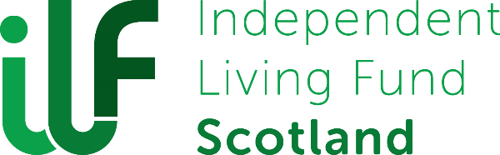
On 29th June 2017, the Minister for Public Health and Sport, Aileen Campbell, launched the new Independent Living Fund (ILF) scheme, which will be implemented by the Independent Living Fund Scotland.

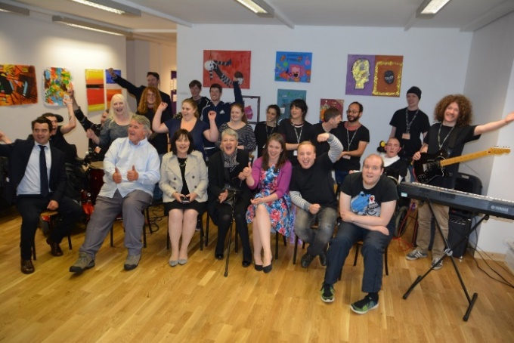
The new ILF scheme will be a broad, discretionary fund that will provide short term awards to support disabled people to live independently.
In its first phase, the new ILF – Transitions Fund will specifically focus on supporting young disabled people, between the ages of 16 and 21, who are at an important transitional stage in their lives, to take up opportunities to contribute to and participate in their communities, which will have a lasting impact on their lives.
In order to be eligible for the new ILF – Transitions Fund, applicants must be resident in Scotland; be aged 16 – 21 inclusive; and have evidence of a disability or impairment (within the meaning of the Equality Act 2010).
ILF Scotland is currently looking at the application process, in co-production with young disabled people and other organisations, such as the Scottish Transitions Forum. We are specifically working with these groups to identify what this will look like and how we can make it as accessible as possible for any young disabled person who is eligible and who may want to apply when the scheme opens.
Pictured above, ILF recipients Upward Mobility

The ILF – Transitions Fund will be open to new applications towards the end of the year.
You can find more details on the new ILF scheme on ILF Scotland’s website www.ilf.scot. If you have any questions please contact the ILF team by phone on 0300 200 2022 or by email enquiries@ILF.scot
Page 24 Issue 47 - 2017
Support

PAMIS - The Pamiloo

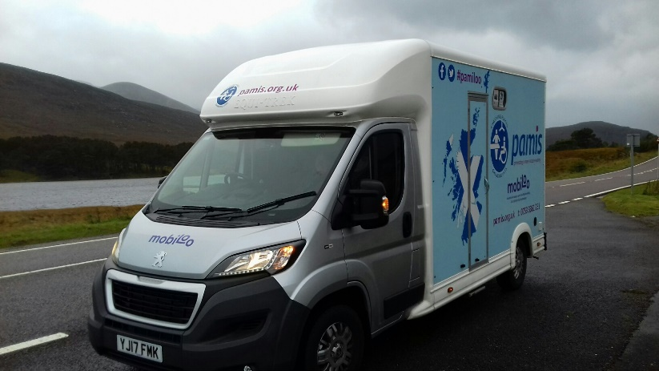
PAMIS (Promoting A More Inclusive Society) is the leading Scottish charity for the Changing Places Toilet Campaign. There are an increasing number of people who require this facility - a twelve square metre room with specialist equipment such as a tracking hoist, an adjustable height changing bench and a peninsular toilet.

PAMIS have been campaigning for over 10 years for this facility and although over the past 2 years there has been a sharper increase there are still only 160 across Scotland. This means that many people who require this facility in order to meet their personal care needs are being excluded from the places and things they want to do; or that they are changed on a dirty toilet floor or in the back of the car.

PAMIS support families and people with profound and multiple learning disabilities and provide a range of activities and family support. Finding suitable venues with changing places toilets to run family fun days and holiday clubs has been a constant challenge. So they purchased the first mobile changing place toilet in Scotland in time for this year’s Edinburgh Fringe. Pamiloo has also supported family days at the pony access events at beaches and country parks across Scotland; been available at conferences and the Scottish Independent Living Show; supported PAMIS fun days as well as supporting other charities to host inclusive for all events. Next June, Pamiloo is proud to be supporting a young lady to attend her 6th year prom.

The vehicle is also raising awareness of the need for the resource. The most recent visit was to the Western Isles, meeting with local groups, families and MSPs, highlighting the equipment required and supporting discussion regarding funding.

Pamiloo activity can be followed on Facebook and Twitter @pamiloocp. Although available for events via PAMIS, commercial hiring is through info@mobiloo.org.uk
Page 25 disabilityequality.scot
Support

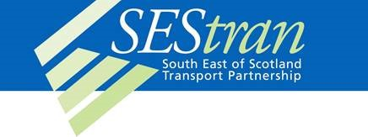
The South East of Scotland Transport Partnership (SEStran)
The South East of Scotland Transport Partnership has developed the Thistle Assistance Card and App to make using public transport easier for older people and those with disabilities or illness.
The card and App, is supported by a wide variety of voluntary organisations across Scotland and by most bus, train, tram, ferry and airport operators. It is credit-card sized and comes with a supply of peel-off stickers, which advise the driver or conductor of your disability and the help you need in an easy-to-read format.
The Thistle Assistance Card and App were developed with the help of transport providers and users, to provide a useful means of displaying the right information for the passenger, with symbols indicating the type of disability and a short message indicating the help required that could be read at a glance by bus drivers, train and tram conductors and other staff. The card comes with an information leaflet showing customers how to use the card and highlighting that it has no monetary significance – it is purely an information card.
From discussions with transport providers, older and disabled people and our Equalities Forum, the South East of Scotland Transport Partnership was able to understand the problems and worries faced by many when using public transport. By providing a simple form of communication between the provider and the passenger, in the form of the Thistle Assistance Card, the gap between disabled and non-disabled passengers begins to close. It also gives passengers (who wish) a form of discretion, and can reduce the worries faced when using public transport.
The simple design of the Thistle Assistance Card and App ensures that anyone coming across it would understand its meaning. One of the major benefits of the Thistle Assistance program is that it allows transport operators to better understand a passenger’s needs, especially when many disabilities are often hidden. Through consultation with operators and user groups we have tried to ensure that the appropriate nationally established logos and layout were also suitable for the purpose.
The card is available to all people who require it, through bus companies, libraries, health centres and on request, with no eligibility criteria required. For more information please e-mail thistlecard@sestran.gov.uk or call 0131 524 5153
Page 26 Issue 47 - 2017
Support

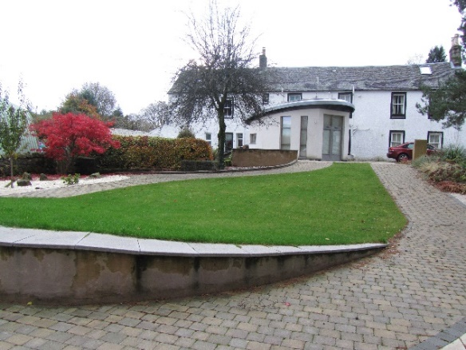
Spinal Injuries Scotland
Spinal Injuries Scotland is proud to present Clober Farm – our 3-bedroomed apartment in Milngavie, seven miles from Glasgow city centre. The apartment is part of an old farm house which was donated to the charity and has been renovated to a very high standard to provide a full accessible living accommodation. It also has an accessible garden. The accommodation:
- Level access throughout
- Combined Kitchen/Living area with patio
- Three bedrooms, two of which are wheelchair accessible
- One bedroom hosts a tracking hoist, height adjustable profiling bed with air mattress, ensuite wet room and shower chairs
- Separate bathroom with bath and shower
- Fully accessible kitchen with fridge freezer, microwave, induction hob and oven
- Washing machine
- Wi-fi internet
- Private parking
Spinal Injuries Scotland (SIS) has existed for over 50 years since its initial inception as the Scottish Paraplegic Association in 1960. Later its name changed to the Scottish Spinal Cord Injury Association (SSCIA), as its focus developed from purely sport into dealing with other aspects of living with the injury.
In 1994 the SSCIA became SIS and since then our focus has been primarily education, advice and support for people with a spinal cord injury, their family, friends and those that care for them. No medical advice is given and any issues in this field are referred back to the medical profession.
In recent years, the organisation has gone from strength to strength and reacted to its changing role within the wider community of people with Spinal Cord Injury in Scotland.
Our remit has widened and we now have a presence at outreach clinics held by the Queen Elizabeth National Spinal Unit (QENSIU), at outpatient clinics across Scotland, as well as having a regular input to the inpatients in Glasgow. Please contact us on free phone: 0800 0132 305 http://www.sisonline.org and http://www.cloberfarm.co.uk

Page 27 disabilityequality.scot
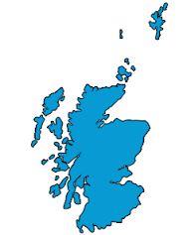
Access Panel Network

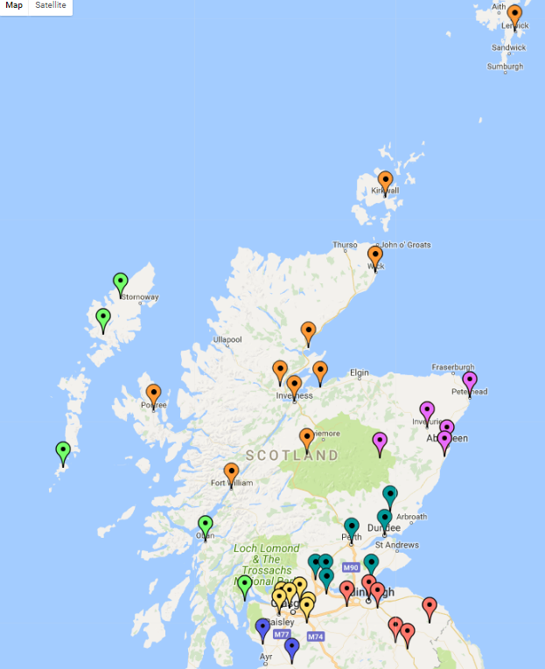
Geographical location of Access Panels in Scotland

WESTERN ISLES AND ARGYLL
Barra Access Panel
Cowal Access Panel (Dunoon) Harris Disability Access Panel Isle of Lewis Access Panel
Oban & District Disability Forum & Access Panel

SOUTH WEST

North Ayrshire Access Panel

FORTH VALLEY AND TAYSIDE
Angus Access Panel
Centre for Inclusive Living Perth & Kinross

GLASGOW & CLYDE VALLEY
East Dunbartonshire Access Panel Glasgow Access Panel
North Lanarkshire Access Panel Renfrewshire Access Panel

Clackmannanshire Disability Awareness Group South Lanarkshire Access Panel

Disabilities Fife Dundee Access Group
Falkirk Area Disability Access Panel Stirling Area Access Panel
HIGHLANDS AND ISLANDS

Access Panel Orkney
Badenoch and Strathspey Access Panel Caithness Disabled Access Panel Inverness Access Panel
Lochaber Disability Access Panel Nairn Access Panel
Ross and Cromarty Access Panel Sutherland Access Panel Shetland Access Panel
Skye & Lochalsh Access Panel
West Dunbartonshire Access Panel
Page 28 Issue 47 - 2017

NORTH EAST
Aberdeenshire North Access Panel Aberdeenshire South Access Panel Bon Accord Access Panel
Central Aberdeenshire Access Panel West Aberdeenshire Access Panel
LOTHIAN AND BORDERS
AccessAble (Central Borders Access Panel)
Berwickshire Access Panel East Lothian Access Panel Edinburgh Access Panel Midlothian Access Panel Tweeddale Access Panel
West Lothian Access Committee

Access Panel Network

Access Engagement Officer’s Update
Hi everyone, I’m Ian and I’m your Access Engagement Officer. I manage the Access Panel Network here at Disability Equality Scotland – we’re super excited about our new name and hope you are too!
I’ve been really busy over the last few months since I gave my last update on my work. I’ve been involved with helping to establish a new Access Panel on Shetland; I’ve worked with the community partnership down in Moffatt and I helped to make our recent AGM in Perth a roaring success. We had stallholders and workshops which were all complimented by the fantastic input from members and Access Panels and to top it all off, members gave us permission to change our name to Disability Equality Scotland – thanks members!

In August I had the privilege of being able to attend the AGM for the Centre for Inclusive Living Perth and Kinross, where we were treated to a speech by the sitting MP, Pete Wishart (fun fact – Pete used to be in the popular Celtic rock group Runrig!)

September was equally as busy for me, seeing me driving to Renfrewshire and being treated to a tour of Renfrewshire Access Panel’s offices just outside Paisley. They’ve got a smashing set up and are clearly a dedicated and determined Panel, keep going guys! After Paisley it was back onto the motorway, home to Stirling but with a detour to visit Stirling Area Access Panel. Robert Dick, who’s the chairman of the Panel, allowed me to sit in on one of their governance meetings, where we talked about the many issues that face the disabled residents of the Stirling council area. It was certainly a busy day zooming across the central belt and I felt honoured to be able to see two Panels who take their roles so seriously and really want to make a difference in their local communities.

Over the next few months I’ll be working just as hard to make sure our special network is stronger than ever. I can’t do it without you though, our devoted team of volunteers who work tirelessly for your community, so make sure you come along to one of my consultation events coming to a community centre near you soon! Remember though, if you ever need to speak to me, don’t hesitate to get in touch and if you’re in the area drop in and pay me a visit, you’re always welcome.
Page 29 disabilityequality.scot

Access Panel Network

Access Panel News
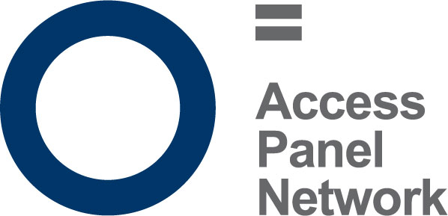
The following pages provide an insight into the activities and hard work volunteers put into their local Access Panels. If you are not yet a member with your local Access Panel and would like to get involved in improving access in your local community, contact your local Access Panel today. Contact details of each Access Panel can be found at www.accesspanelnetwork.org.uk/directory-panels or contact Ian Buchanan telephone: 01259 272066 email: ian@disabilityequality.scot
Harris Disability Access Panel
Tel: 01859 530 273 Email: info@hdap.org.uk

The last three months have been relatively quiet for us. We were finalising some small issues with the waiting room at Leverburgh ferry terminal – a project we had input with at the beginning of the year.

Some members attended a public engagement event with Caledonian Maritime Assets Ltd (CMAL) concerning the proposed improvement works on the new dual fuel ferry on the Skye Triangle Route. HDAP are hoping CMAL and Transport Scotland will consider installing a lift for passengers with mobility issues and also a Changing Places facility in the new waiting room. The Changing Places facility would be the first in the Western Isles, so there is a good PR opportunity for them here. Our written comments were submitted for their consideration.

In August we had our Annual General Meeting and were delighted to welcome two new members aboard and we look forward to their input.

Page 30 Issue 47 - 2017

Access Panel Network
Dundee Access Group
Tel: 07922 069039 Email: dundeeaccessgroup.org@hotmail.co.uk

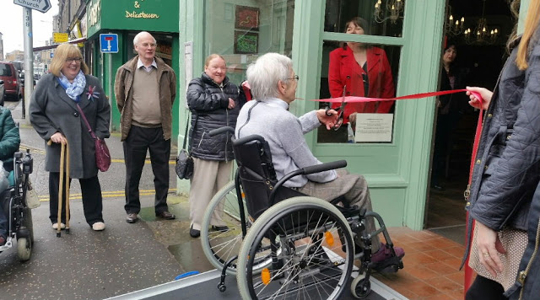
We had an approach from Scott Mands, the Council’s Equality and Diversity Co-ordinator on behalf of DAAG (Disability and Age Action Group) to see if the Access Group might take on the much wider range of responsibilities undertaken by DAAG. Due to changes in Council structures they are no longer getting the level of support they previously enjoyed. Their’s has been an extensive task undertaken nobly, but we decided we do not have the capacity to undertake more than we are currently engaged upon. In fact, but for the indefatigable support of Dorothy Wilson from Dundee City Council, our current activity would be dramatically reduced.

Although our ‘Ramp it Up’ campaign has stalled for the moment, it will be picked up and pursued in the months ahead.

Our current activities are numerous and the past year has been very busy indeed. We have been in numerous consultations about accessible toilets and about parking issues. We are engaged in regular conversations about access to the new V & A Museum, about access on our trains and in railway stations. We are keeping a close eye on the local effects of the Supreme Court judgement about the priority of wheelchairs over buggies on buses. We are happy to have established a relationship with Avril Smith Hope, the Access Engagement officer for the Health & Social Care Partnership and with Steve Emmonds, head of parking in Dundee, about the Blue Badge Scheme. The Chamber of Commerce have received details of The Walkaway Pound campaign and we are involved in the Dundee Funeral Poverty Project. We have been able to make donations to Shopmobility and to the Dundee Blind and Partially Sighted Society who have so generously hosted our meetings in recent years.

Page 31 disabilityequality.scot

Access Panel Network

Edinburgh Access Panel
Tel: 07969 515296 Email: edinburghaccesspanel@hotmail.com

The Edinburgh panel has been kept very busy in recent months with a number of interesting and productive projects.It’s been Festival time and we had a consultation with the Fringe organisers about accessibility improvements both to the venues themselves and to the booking systems. We also carried out an access audit of a specific Fringe venue – an ancient church which has been converted into a theatre.

Hate crime has been on our agenda too, especially hate crime that takes place on public transport. The panel took part in a project which developed a Transport Charter, which is a commitment by transport providers to combat hate crime. The charter was launched at Haymarket Station by the Transport Minister and publicised by a series of roadshows where we handed out leaflets and talked to the public about the recent increase in hate crime and the importance of reporting it. Although the current scope of the charter is the Edinburgh area, it looks as though it will eventually be rolled out across other parts of the country.
Another interesting project was Voices of Edinburgh. This was organised by Edinburgh’s Equality and Rights Network and consisted of an exhibition of photographs and voice-recordings about what “equality” means to individuals with protected characteristics. Five of our panellists took part in the project, each providing either a photograph or a recording.
These projects took place against a background that included our customary ongoing activities. For example, access issues at Waverley Station are still demanding a lot of attention, especially now that we’ve escalated to the Scottish Government for support. Streetscape is a very active area too, with particular focus being applied to proposals for Edinburgh’s new network of cycle paths. And of course there’s always lots of work to do assessing planning applications for accessibility. Now that we have two architects on our panel we are putting in place a new way of doing these assessments, based on pro-actively going through the online weekly lists of applications and taking any contentious ones to a meeting either of the whole panel or to a sub-group that we’ve set up.
Page 32 Issue 47 - 2017
Access Panel Network

Centre for Inclusive Living Perth & Kinross
Tel: 01738 587282 Email: info@cilpk.org.uk

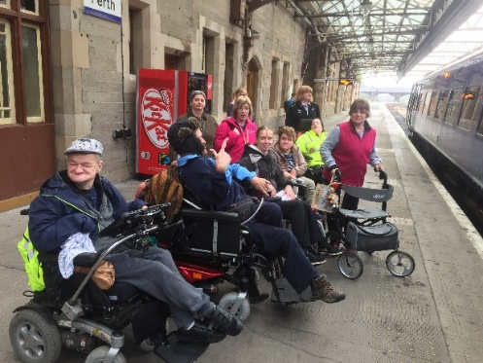
CILPK members went for a day out in Edinburgh on 19th September. Our members sometimes experience difficulties when booking passenger assistance on the trains and also with the assistance when at the train station so we decided to test this out and go to Edinburgh by train.

Tickets and assistance were all booked in advance for 5 wheelchair users and 2 mobility impaired members. On turning up at the station we were told that there was only 2 spaces for wheelchair users on the train, thankfully there was another train leaving shortly after so we managed to get everyone on the train even though the group had to be separated.

The first train had two wheelchair users on it and a mobility walker. There was not much room and the seats for the PA’s were obstructed by the wheelchairs. The second train had more room for the wheelchair users but because staff could not remove the bike rack only 2 wheelchair users could get on the train compared to the 4 that we were told. There was nowhere for the manual chair to be stored so it was left in the middle of the area. We all got to Edinburgh safely and had a lovely lunch.

We had been told in Edinburgh that there would be no problem getting home as we were not all coming back together. Passenger assistance told us that the 3 wheelchair users would all get on the same train.

When we arrived at Edinburgh station to go home it turned out there was only one wheelchair space on the train. The next train was not for another hour which was no use for our members to get home. One wheelchair user got on the train and the manual user got on and transferred to a seat.

The wheelchair user and his PA, who did not get on the train, were offered a taxi but by the time that the next train arrived, an hour later the taxi had not arrived so they ended up getting on the next train. We all had a good day out but there are a lot of improvements needed to the train journey to make it more accessible and stress free.

Page 33 disabilityequality.scot

Access Panel Network

The Tweeddale Access Panel
Email: tweeddaleaccesspanel@gmail.com

The Tweeddale Access Panel (TAP) is currently involved in several activities including raising issues of concern to local disabled people such as dropped kerbs, pedestrian crossings and so on. We have also started a second round of surveys in Peebles to assess the accessibility of local shops and businesses; it is hoped to have the information available online in due course.

One of the important issues we are dealing with concerns the use of mobile SMS text messaging. Using SMS is very popular nowadays with many people for sending messages to other people rather than speaking on the phone. We support the social model of disability and the definition of deafness promoted by the Sottish Council on Deafness (SCoD) which suggests a spectrum with four key pillars: Deaf/BSL (British Sign Language) users; Deafened; Deafblind and Hard of Hearing. This method is more useful, in some cases even vital, for Deaf/BSL users, Deafened and Hard of Hearing people since they cannot hear very well and many are not able to use the telephone. A number of public bodies and service providers, such as the Automobile Association and others, offer this method so that deaf people can contact them directly by SMS whenever necessary.

A few years ago NHS Borders carried out a pilot project to allow deaf people to contact the Audiology Department and a few other departments at the Borders General Hospital by using SMS. In this way they are able to be independent and contact the hospital without having to resort to asking other people to phone on their behalf. However, after a few years this service was terminated due to low usages by the local population. When TAP contacted NHS Borders to say that we were not happy with this decision NHS Borders decided to reinstate the SMS service but only for the Audiology Department.

Members of TAP were still not happy with this decision. However, after discussing the issues with the SCoD it was suggested that rather than pursuing the SMS route we should look to the future and try to promote and encourage the use of new technology such as contactSCOTLAND-BSL and the Next Generation Text Service.

The contactSCOTLAND-BSL service is Scotland’s British Sign Language Interpreting Video Relay Service. This service works by the caller communicating via a Sign Language Interpreter who speaks with the service provider and vice versa. This system is especially useful for deaf people whose first language is BSL rather than English. Further information about this service is available on the following website: www.contactscotland-bsl.org/
Page 34 Issue 47 - 2017
Access Panel Network

Access Panel Network

6 ways to Get Involved
- Join your local Access Panel
www.accesspanelnetwork.org.uk/directory-panels

- Be on our mailing list and join Disability Equality Scotland www.disabilityequality.scot/membership/

- Like our Facebook Pages Disability Equality Scotland Access Panel Network

- Follow us on twitter @DEScotTweets @AccessPanelNet

Come along to our events
- Spread the word and encourage your friends, family and colleagues to join
Page 35 disabilityequality.scot

Our Sponsors...
Disability Equality Scotland is grateful for the generosity of its sponsors and their ongoing support as we work together toward achieving the goals of the organisation.
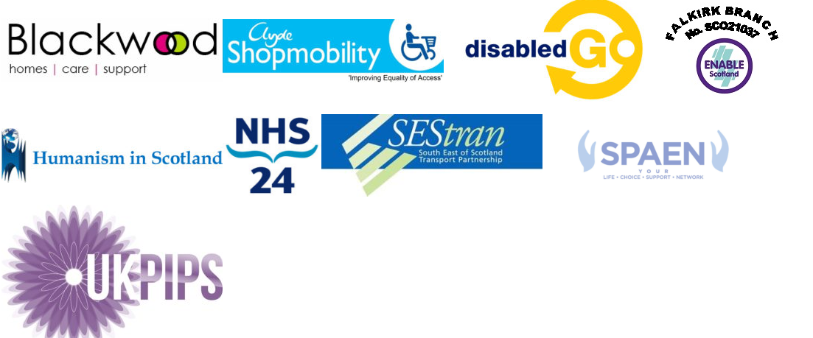

If you are interested in sponsoring our magazine OPEN DOOR, please complete our online registration form - www.disabilityequality.scot/our-sponsors
Alternatively, please contact email admin@disabilityequality.scot
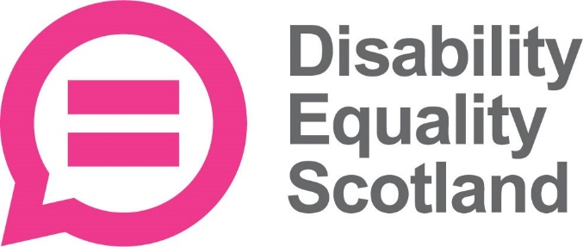
OPEN DOOR is published by
Disability Equality Scotland Office 2/4, The e-Centre Cooperage Way Alloa
FK10 3LP
Telephone: 01259 272064
Email: admin@disabilityequality.scot

Disability Equality Scotland is Registered in Scotland as a Company Limited by Guarantee with Charitable Status

Charity Number SC031893, Company Number SC243392
Connect with us...

disabilityequality.scot Disability Equality Scotland @DEScotTweets
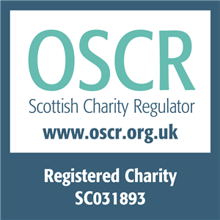
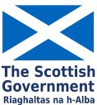
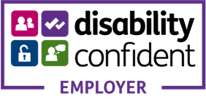
Disability Equality Scotland is funded by

