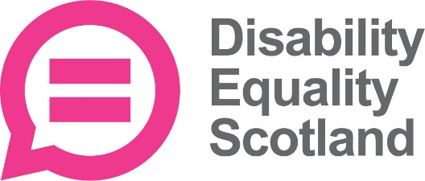
Disability Equality Scotland
Survey for Member’s 2018
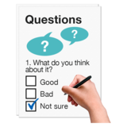  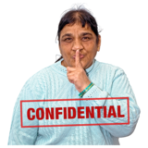 | Each year Disability Equality Scotland surveys its members so as to better understand the ways that we can deliver a service to you.  This is a survey to gauge your satisfaction with us as an organisation and to test out some new ideas we have for the future.  All your responses will be confidential and any personal details we seek will be held securely.

 | Engaging with Disability Equality Scotland
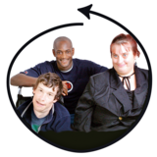 | How important is it to be in contact with Disability Equality Scotland? Tick one box.  Very important  Quite important  Not important
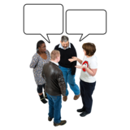 | Please write in any comments you have about contacting Disability Equality Scotland.

How engaged with Disability Equality Scotland do you feel? Tick one box.

Very engaged

Quite engaged

Not engaged

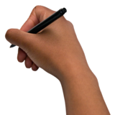 | Please write in any comments.

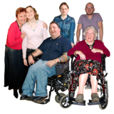 | How important is it to be in contact with other Disability Equality Scotland members?  Very important  Quite important  Not important
 | Tell us why it is important to be engaged with other members?
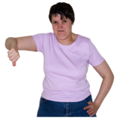 | How engaged with other Disability Equality Scotland members do you feel?  Very engaged  Quite engaged  Not engaged
 | Please tell us why you feel this way?

 | Word of Mouth
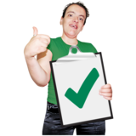 | Have you said good things about Disability Equality Scotland to other people? Tick one box  Yes  No  Not sure
 | If yes, can you tell us what you said?
 | If you said bad things about Disability Equality Scotland, can you tell us why?
Have you told anyone else to become a member of Disability Equality Scotland?
Yes

No

Not sure
 | Satisfaction
Please tell us how happy you are with different aspects of Disability Equality Scotland.
How happy are you with the contact you have with staff?
Very happy

Happy

Unhappy

Very unhappy

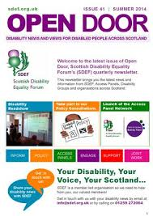 | How happy are you with the communication you get from Disability Equality Scotland?  Very happy  Happy  Unhappy  Very unhappy
How happy are you with the events and roadshows?
Very happy

Happy

Unhappy

Very unhappy

How happy are you with your chance to have a say?
Very happy

Happy

Unhappy

Very unhappy

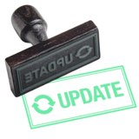 | How happy are you with being kept up to date about disability news?  Very happy  Happy  Unhappy  Very unhappy
Please read these statements. Tell us which ones are true for you. Tick the boxes.

I read Open Door regularly

I read Disability Equality Scotland News regularly

I visit the Disability Equality Scotland website regularly

Disability Equality Scotland events are held in accessible locations

I am too busy to get involved

I go to events regularly

I would like more information events
Disability Equality Scotland services are not relevant to me.

 | Value
We want to know how much you value being a member of Disability Equality Scotland. Value is about how much we help you.

Please pick a number from 1 to 5. 1 is low value, where you think Disability Equality Scotland don’t help you, and 5 is where we help you a lot.

Please circle a number.

1 2 3 4 5
Low High

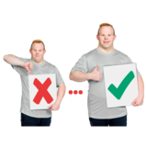 | How could Disability Equality Scotland provide more value to you as a member? Write in
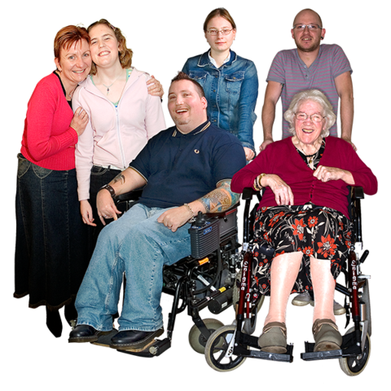 | How much do you agree that Disability Equality Scotland is good for disabled people?  Strongly agree  Agree  Neither  Disagree  Strongly disagree

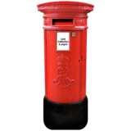 | Tick the box that shows the ways you would like to hear from Disability Equality Scotland.  Weekly poll by email  Open Door by email  Open Door by post  Disability Equality News  by email  Events in person

 | Data Protection
Data protection laws are changing. This means that Disability Equality Scotland has to make sure it has the right information about its members.

We have to ask you for some personal details. We will add these to our list of members. The list is secure and protected. We wont tell anyone else your details.

Please tell us your name, address and postcode. We also need your date of birth. Please also tell us if you have a disability.

 | What is your first name?
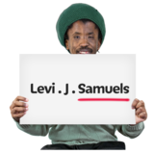 | What is your family name?
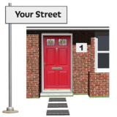 | What is your address?
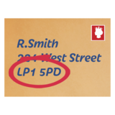 | What is your postcode?
 | What is your email address?
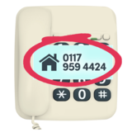 | What is your telephone number?
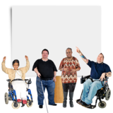 | Do you have a disability?  Yes  No
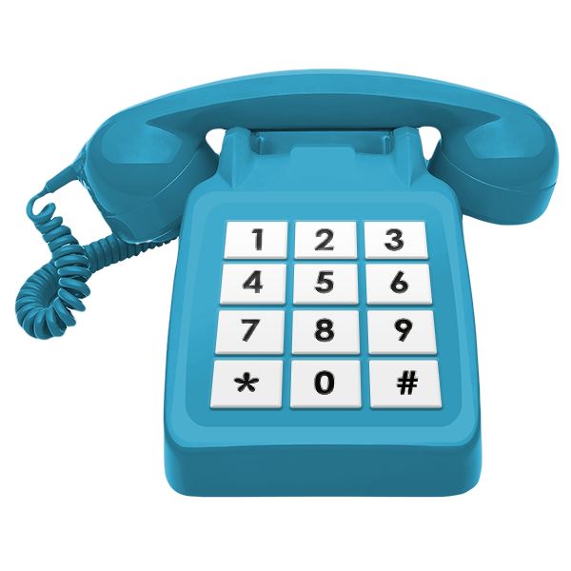 | Sometimes, Disability Equality Scotland is contacted by organisations with information about their service. These might be of interest to you.  Would you be happy for us to give these organisations your contact details? Tick the boxes  Yes – my email address  Yes – my telephone number  Yes – my address  No – do not give them my details.

Paying for membership
Last year, our members told us that they would be happy to pay to be a member of Disability Equality Scotland.

We think there should be different types of membership. Junior members who are under 17 years old. Individual members who are over 18 years and organisations.

We think that Junior and Individual members should be free.

We think organisations should pay depending on how much money they make.
If the organisation makes less than £100,000 a year, they would pay £10 a year to be a member.

If the organisation makes between £100,000 and £250,000, they would pay £20 per year to be a member.

If the organisation makes between £250,000 and £500,000 they would pay £50 per year to be a member.

If the organisation makes more than £500,000, they would pay £75 per year to be a member.

Do you agree with this plan?

Yes

No

Not sure

Do you have any comments about this plan? Write them here

 | Your Commitment
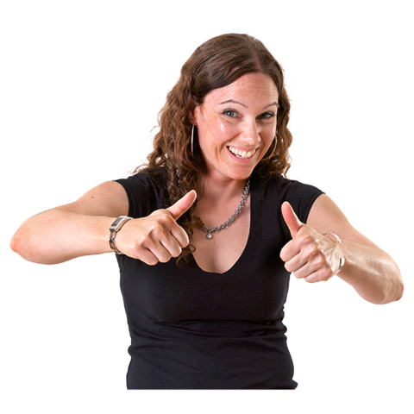 | When you became a member of Disability Equality Scotland, you agreed to support our aims and provide feedback to help our work.  We would like this support to continue.  Please tick the box that best describes you.  I support the aims of Disability Equality Scotland and will continue my support.  I don’t support the aims of Disability Equality Scotland and don’t want to be a member anymore.
 | Do you have any final comments about the work of Disability Equality Scotland? Write them here
 | Thank you for taking our survey. Your views are important to us. All your details will be confidential.

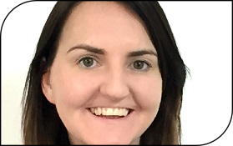  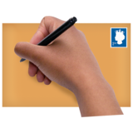  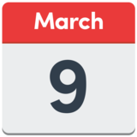 | Send your complete survey to:  Emma Scott  Equality Projects Manager  Disability Equality Scotland  Office 2/4  The E-Centre  Cooperage Way  Alloa  FK10 3LP  01259 272064  emma@disabilityequality.scot  Send your survey by the 9 March 2018

