Dear Applicant

Board of Director Appointment:
Voluntary Position

Thank you for your interest in the post of Voluntary Board member with Disability Equality Scotland. Please find enclosed the following documents:

- Role Description
- Application Form
- Disclosure Form
- Equal Opportunities Monitoring Form

Please complete the Application Form, Equal Opportunities Monitoring Form and Disclosure Form and return them along with a copy of your latest CV to:
Morven Brooks, Chief Executive Officer
Disability Equality Scotland
Office 2/4, The e-Centre, Cooperage Way, Alloa FK10 3LP

You may also return them by email to admin@disabilityequality.scot
The closing date for receipt of applications is Wednesday 28 March 2018. (Please note: applications received after this deadline will not be considered).

Should you require this application pack in a different format please do not hesitate to contact the office.

Yours faithfully
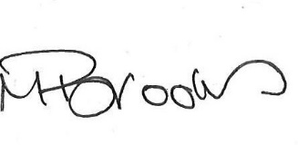

Morven Brooks
Chief Executive Officer
Disability Equality Scotland

Enc.

